英语错题本

Another vs Other vs The other
One of the best things to do in the Lake District is to ___(1)__ the fresh air and take a walk by the lakes, such as Windermere and Ullswater.
Rowing a boat on the lakes is__(2)___ popular activity. You can rent(租) ____(3)_
small boat and see swans and other wild birds on the lake there.
- A. the other B. another c. other D. others
Another:
含义: “另外一个，再一个”。指 不定数目 中的 另一个（通常是单数）。
用法:
- 后面接 单数可数名词：another + 单数名词
- 也可以单独使用（代词），后面不跟名词。
- 也可以接 数词 + 复数名词，表示“额外的几个”。
- another + 单数名词
- another + 数词 + 复数名词
Other:
含义: 其他的、别的（复数或不可数），泛指，不指明具体是哪些。
用法:
- 不能单独作主语/宾语，必须跟名词。
- other + 复数名词：other people，other options
- other + 不可数名词：other information，other water（少见，但语法正确）
The Other:
强调：特指某个范围内的“另外的”。
- 单数：两者中的“另一个”（one... the other...）
- 复数：特定群体中“其余所有的”（the other + 复数名词）
例句：
- She has two cats. One is white, **the other** is black.（两个中的另一个）
- I finished my homework, but **the other** students are still working.（这个班级里其余所有学生——特指）
- Where is **the other** sock？
Others:
- 强调：other 的复数代词形式，泛指“另外一些（人/物）”，不等于全部。常与 some 搭配：some... others...
- 不能接名词（因为它已经包含了名词的含义）。
- 例句：
Some people enjoy classical music; **others** prefer rock.（另一些人——泛指，不是全部）
This book is better than **others** I’ve read.（我读过的其他一些书——不是所有）
Be respectful to **others**.（他人——泛指）
对比：the others（特指其余全部）
Some students passed. **The others** failed.（指这个班级里剩余的所有学生都挂了）

- another 再一个（单数，不限范围）
- other 跟复数（泛指，后面必有名词）
- the other 特指（两个里的另一个，或其余全部）
- others 是代词（等于 other + 复数，泛指一部分）
Don't always compare(比较your looks)with others’, The inner beauty is the most important

A rich man wants to go to State Chu, a country in the _31__ but he makes his carriage (马车) head for the north. On the way, he meets a local farmer and __32_ . for a short chat. The farmer asks him where he is going. The man answers, “I'm going to State Chu.’"
The farmer is surprised. Then he asks, “Then why do you make your _33__ in the opposite direction(相反方向)?”
The man said, “It doesn't matter, My horse can run _34__.
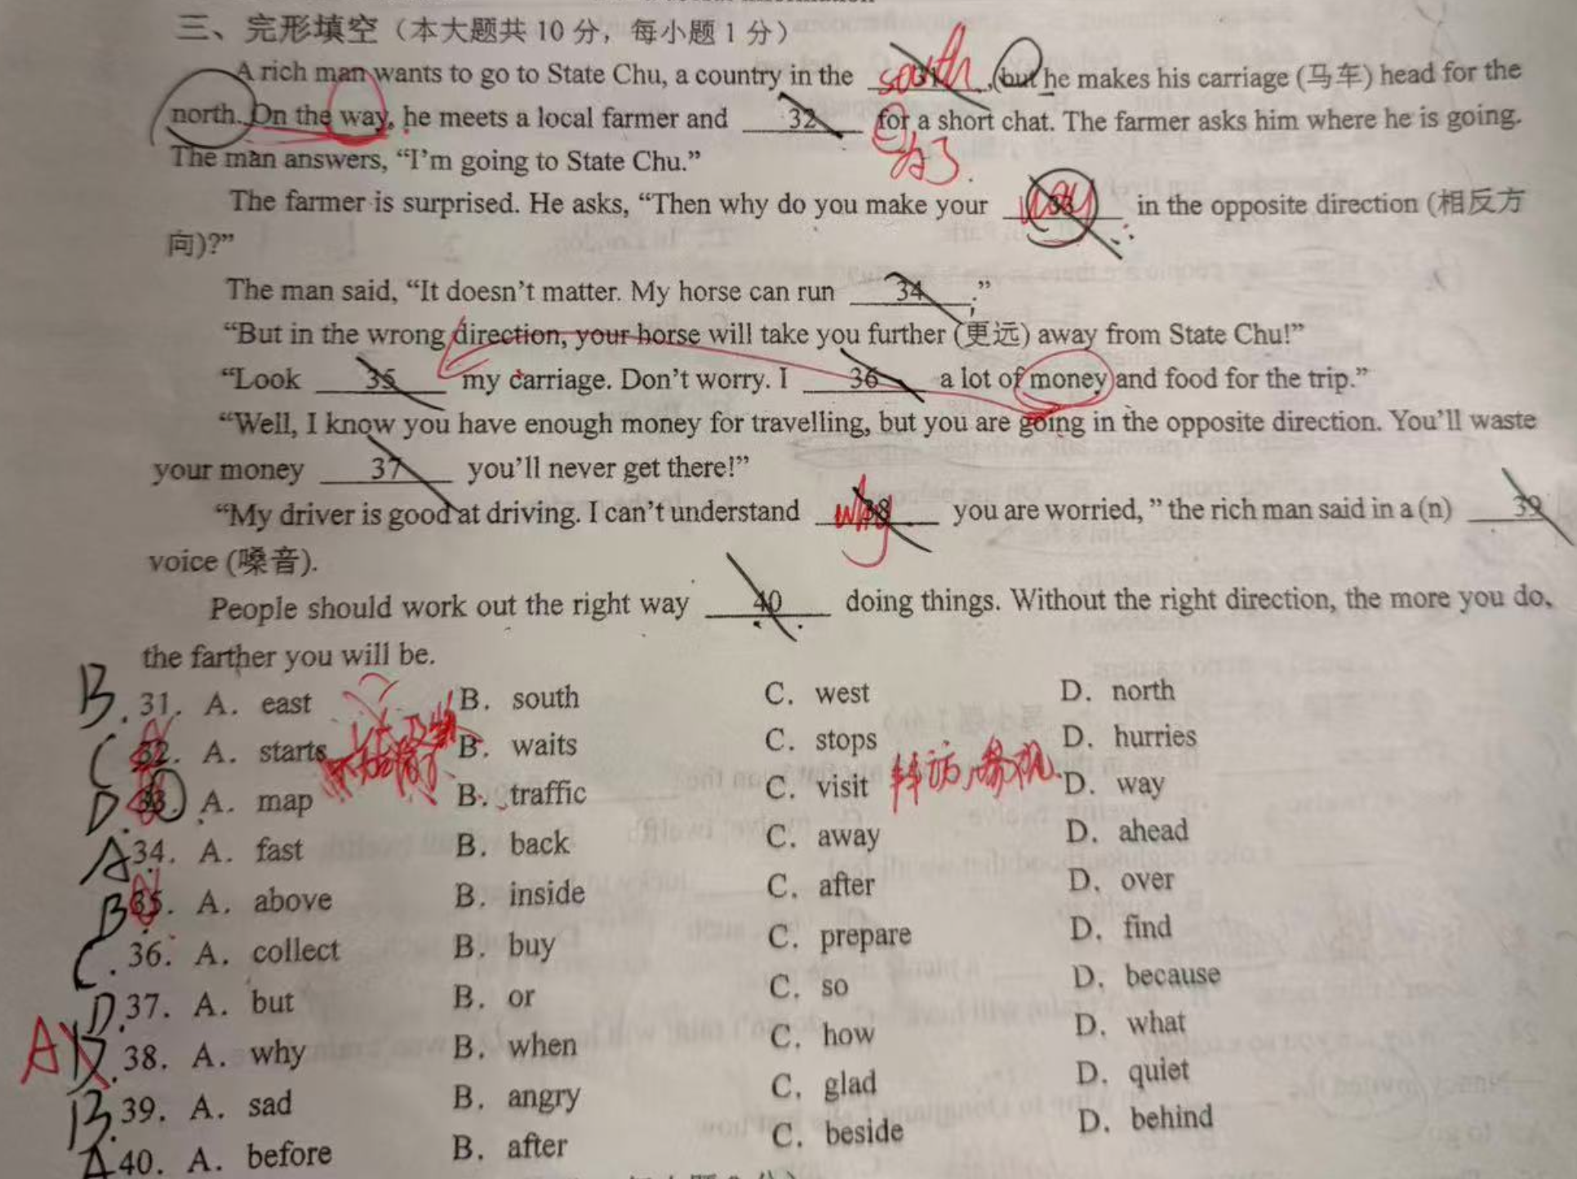

Starts for vs stops for
Starts for: 意思是“启程前往某地”，后面通常跟地点.
例如：The train starts for Shanghai.（火车开往上海。）不能用 “starts for a short talk”，因为“简短交谈”不是目的地。
可以说 “starts a short talk”（开始一段简短交谈），但这时后面没有介词 for。
stops for：表示“停下（手头的事）以便做另一件事”。

Why you are worried vs what you are worried about ?
What 表示内容，担心什么，需要用worry about表示具体担心的内容。
Why 表示原因，why + worry不需要about。

语句不理解

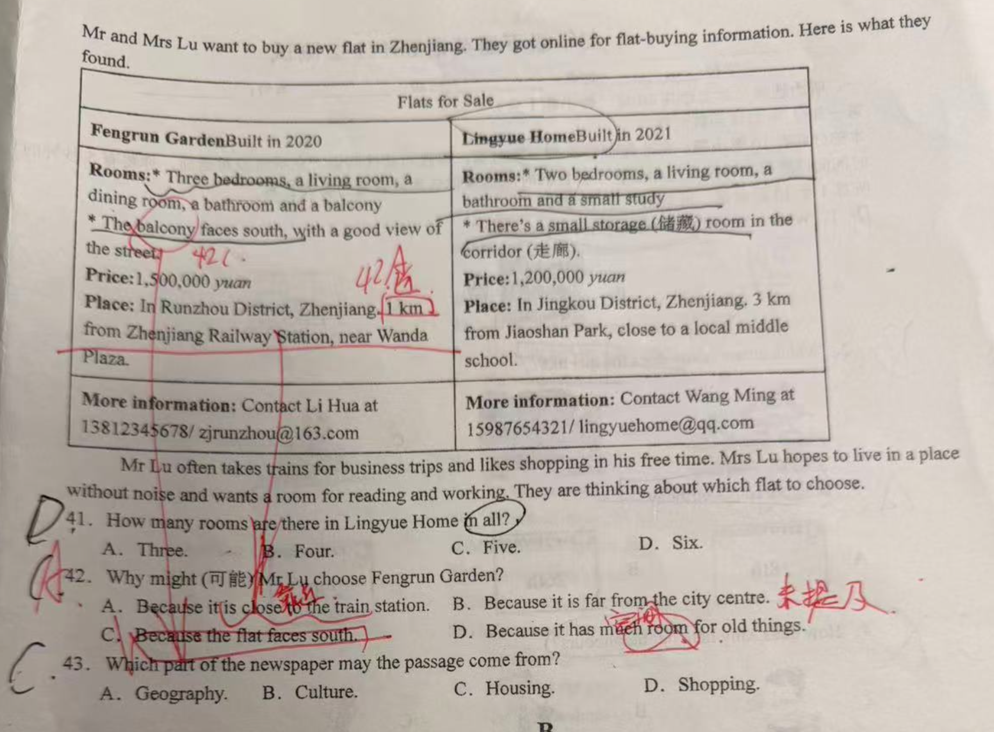
Close: 接近，关系亲近。V： 关闭
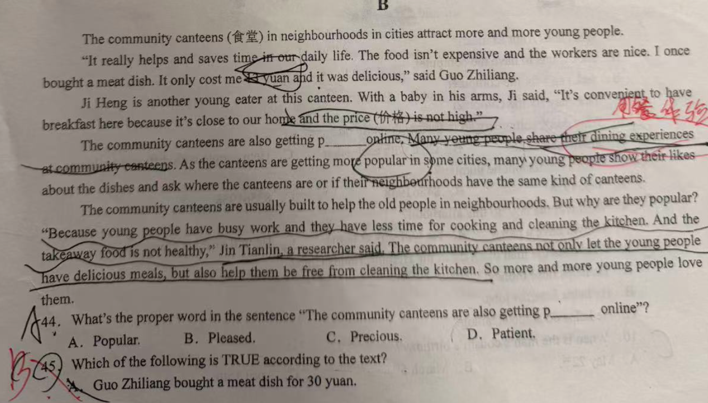
Neighbourhood: 邻居, Neighbour
Community : n 社区, 社会 adj 公共的
Dining : 用餐 , dinner : 晚餐, diner 餐馆
Be popular in : 流行



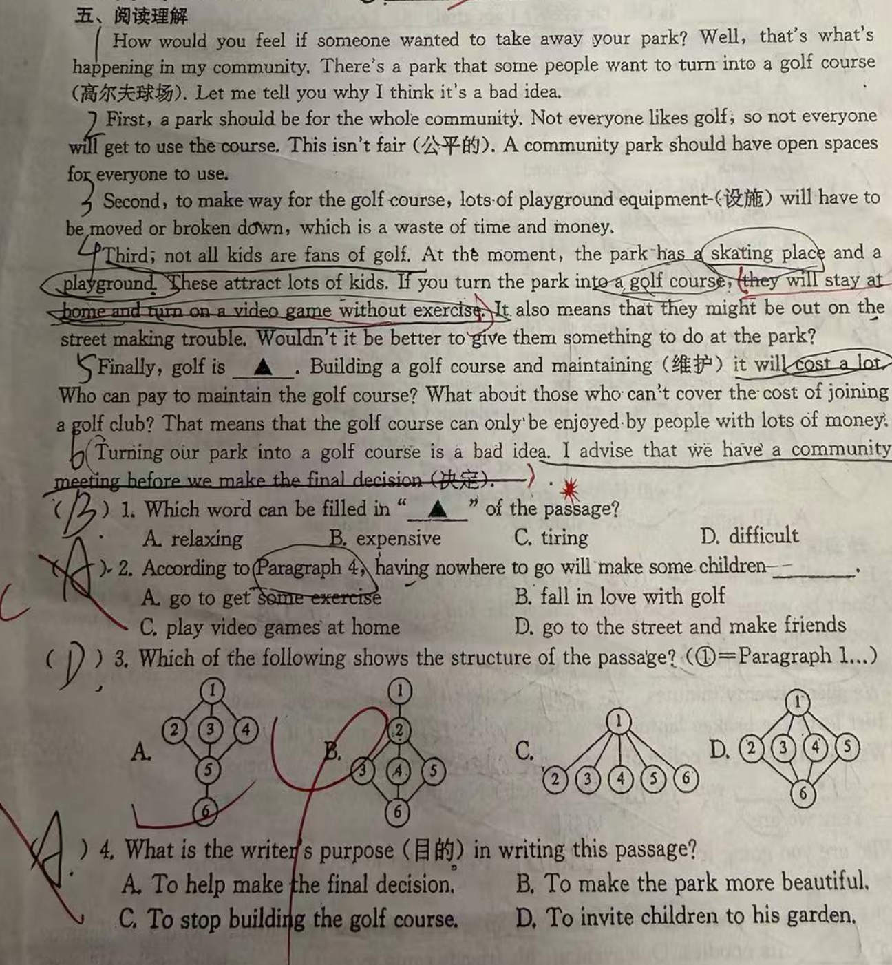

near vs next to VS beside
Far away from 离什么远
Near 近
The flat is _near___my office, so I can walk to work.
I walk to school every day because my home is near to our school.
Near to 和 next to 的区分。
中间可以放其他物品的用near to，无法放其他的用next to。Beside 一般可以和next to互换。

Far away from vs far from
- Far away from, 强调 away，是中间有分离的距离。Almost always literal (physical space); “away” adds a sense of “being removed from”. literal, more emphatic on physical removal.
- Far from: At a great distance (physical or figurative, 比喻). general, flexible, literal + figurative

But 转折在文中的作用
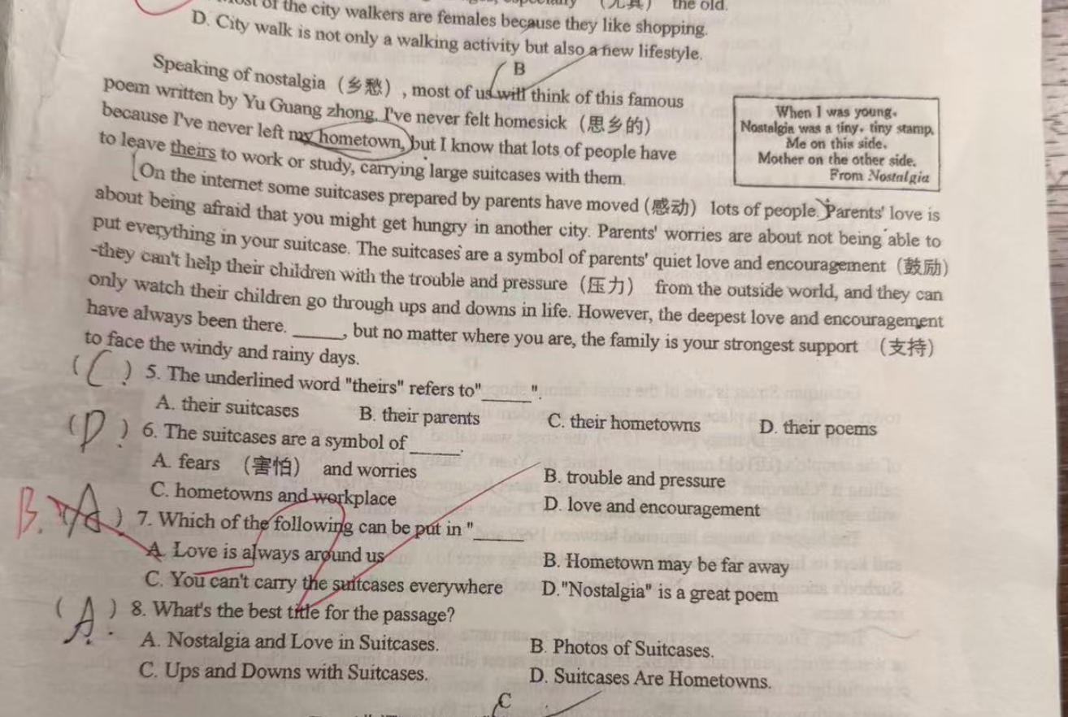

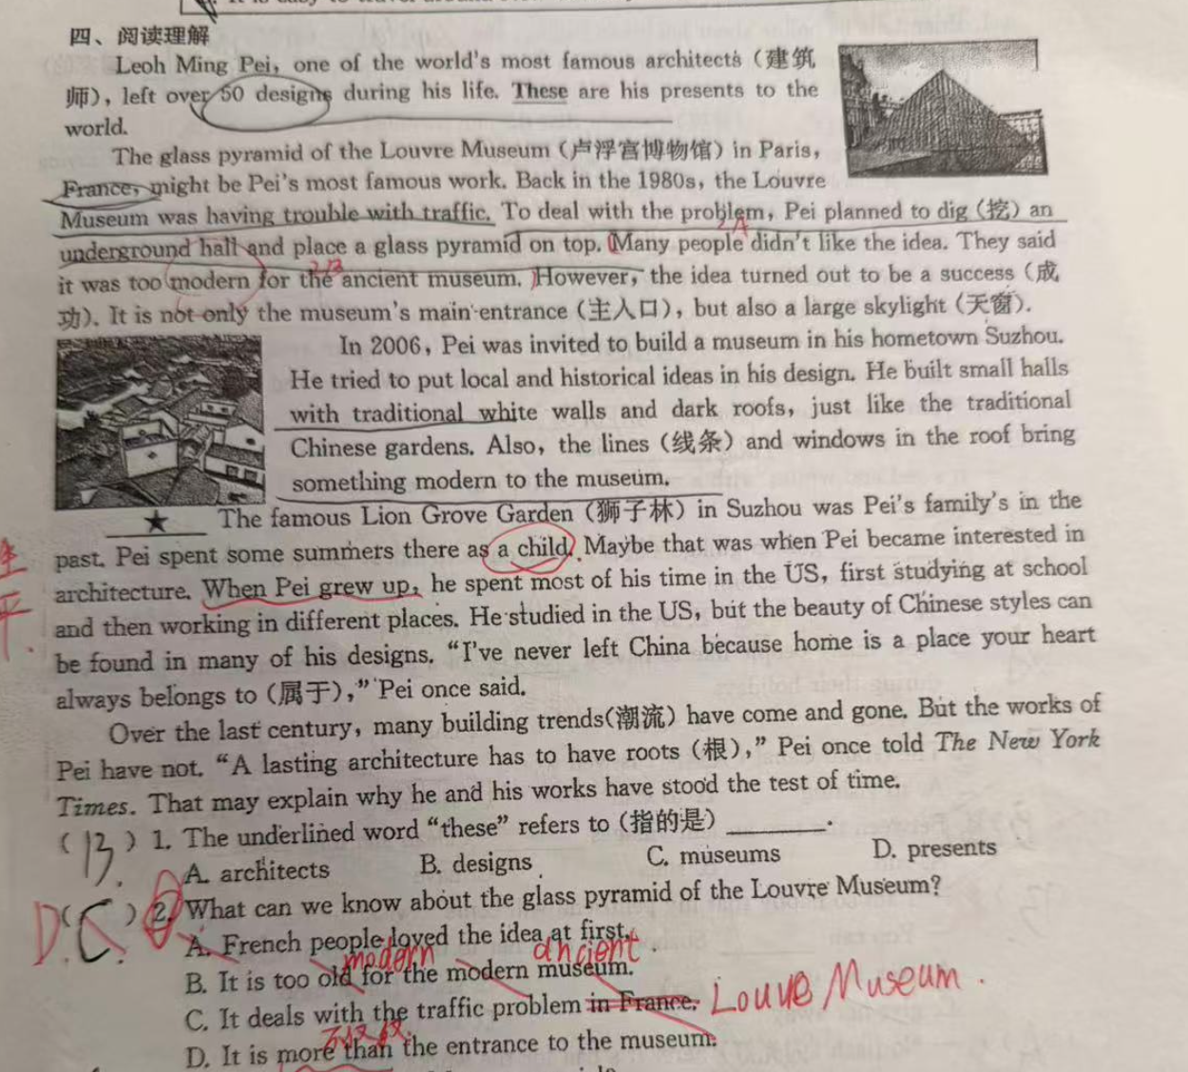
- To deal with the problem, xx
- However, the idea turned out to be a success
- It is not only the museum's main'entrance(主人口), but also a large skylight.
- Over the last century, many building trends(潮流) have come and gone,.

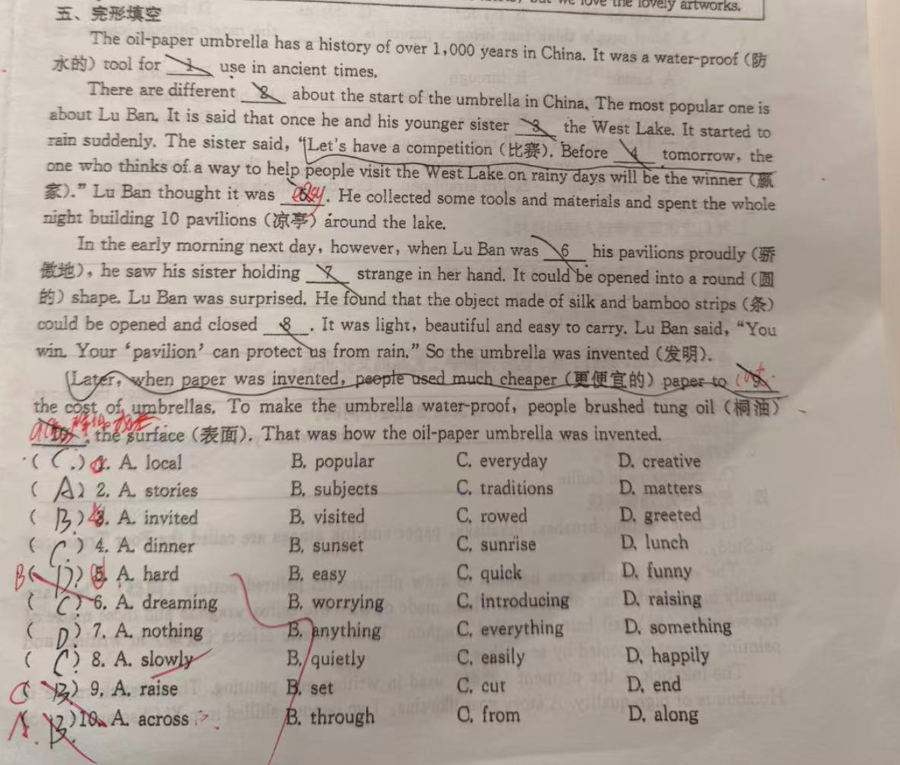

Cut VS Set
Set标设定， cut表示消减

Through VS across
Through 从内部穿过。 Across 表示从表面穿过。

填空

Exchange vs Enjoy vs Explore
we decide to e__ story book after school because we both love mystery story.
Exchange 交换 Enjoy 享受/欣赏 Explore 探索

Next to vs beside vs besides
Tom is my classmate, he sits _next to_ me and we are good friends..
Next to : 更强调 紧挨着、没有间隔
Beside: 只表示“在旁边”，不一定完全没有间隔
Besides : 除……之外（还） / 而且

have trouble 后面的动词要用 -ing 形式
They have trouble __ jobs, so they have to keep attending job interview.
have trouble (in) doing something. 即：动词要用动名词（-ing 形式），介词 in 可以省略。
补充：
- 如果后面跟名词，可以用 have trouble with + 名词
例：He has trouble with math.（他数学有困难。）
- 类似用法的词还有：
have difficulty / a hard time / a good time + (in) doing

Wait a minute, 强调动作的正在进行
Wait a minute, the police _are checking_ the car ahead.

Be going to 的否定回答
No, 主语 + be + not (going to).
其中 be 要根据主语变化（am / is / are），not 可以缩写。
Is Mile going to reading in the Reading Club? No, he isn’t.

Give away VS Give back VS Give up VS put up VS make up
短语 | 核心意思 | 常见搭配
give away | 赠送 / 泄露 | give away secrets, old clothes
give back | 归还 / 回馈 | give back money, to society
give up | 放弃 / 戒掉 | give up hope, give up doing sth
put up | 举起 / 张贴 / 提供住宿 | put up a poster, put up a friend
make up | 编造 / 和解 / 化妆 | make up a story, make up with sb

Take away VS take in VS take off VS take up
-Where do you want to send your holiday?
Mount Maoshan, I like to take in the mountain air and enjoy the beautiful view there.
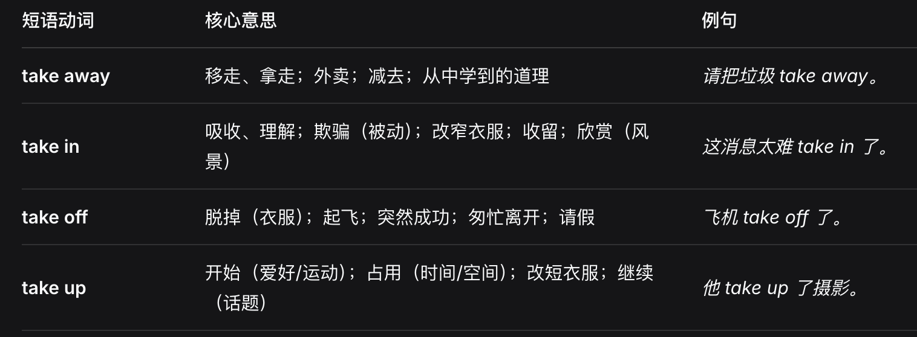

A. take in (吸收) B, take on (承担) c. take up(占据) D. take off (脱掉)
- Take on 是“往身上揽”——揽责任、揽员工、揽特征。
- Take off 是“离开地面”——脱衣服、飞机起、事业火、人早走。

In the end VS At the end of
In the end the police found the missing child at the end of road.
- In the end: 最终、最后, 等于 finally
In the end 单独使用，后面不接任何名词。
- At the end of
At the end of 后面必须跟名词（时间、事件、地点、物品等）。

make up VS put up VS pick up VS get up VS come up & give up &
make up: 组合、弥补、编造、化妆、和好 (做”出原本没有的东西（故事、妆容、和解）)
put up: 搭建、张贴、提供住宿、忍受(常用于否定句)( “放置”到高处或表面（张贴、搭建），或给人“安放”住处)
pick up: 捡起、接人、学会、接收信号 (挑选”并“拿起来”，引申为接人或学到东西)
get up: 起床、起身、安排(“得到”站起/起床的状态)
come up: 出现、发生、上升、被提及、即将到来 (事物“来到面前”或“上升到表面”（问题、太阳、话题）)

put in VS put off VS put up VS put on
put in: 核心意象：把某物“放入”某个空间、时间或精力。
投入时间/精力, 安装设备, 正式提出请求：提出申请、索赔等.
put off: 核心意象：把事物从原计划的位置“推开”或“移走”。
推迟/延期, 敷衍/搪塞
put up: 核心意象：把东西“向上”举高或“架设”起来。
put on: 核心意象：把东西“加到”身体表面或某种状态上
穿上/戴上, 增加体重

hold up VS hold on
Hold on: 保持。Hold on = Wait (for a short time). Also means to physically grip something.
Hold up: Delay (cause someone to be late). Also means to rob someone or to support weight.

短文
She said, “Suzie's in the corner because she doesn't do well. She doesn't listen to a word I say or do the things she should." In the corner l saw her baby doll. It was clear that she was there to sit by herself and think.
My daughter went on with her own “conversation” as I sat on the floor, She said, “I'm all fed up, I just don't know what to do with her any more ! She never lets me do the things that I just have to do! I have a lot of work to do and a big house to keep clean. I don’t have time to sit and play, don’t you know what I mean?”
That day, I thought a lot about making some changes in my life as I listened to her work.

Talk VS Speak VS tell VS say
- Say = Focuses on the exact words you use. (Say something)
Say + (something) + (to someone)
- Tell = Focuses on giving information to a specific person. (Tell someone something).
Tell + someone + (something)
- Speak = Focuses on the action of talking or language ability. More formal.
Speak + to/with + someone (formal conversation)
Speak + about + something
Speak + language

- Talk = Focuses on a conversation between people. More casual.
Talk + to/with + someone
Talk + about + something

show (great/deep/little/no) interest in + noun / gerund
interest 表示不可数名词。
表可数名词
Her interests include dancing and painting.
- As a noun (countable) – meaning an activity or subject you enjoy可数名词，表示喜欢的活动或者主题:
  - Her interests include dancing and painting.
- As a verb – meaning to attract someone’s attention，动词，表示吸引某人的注意力:
Dancing interests my cousin greatly.
- With prepositions 介词:
- interest in (curiosity or liking): She has an interest in music.
- of interest (important or exciting): This topic is of great interest to me.

Through vs across vs along
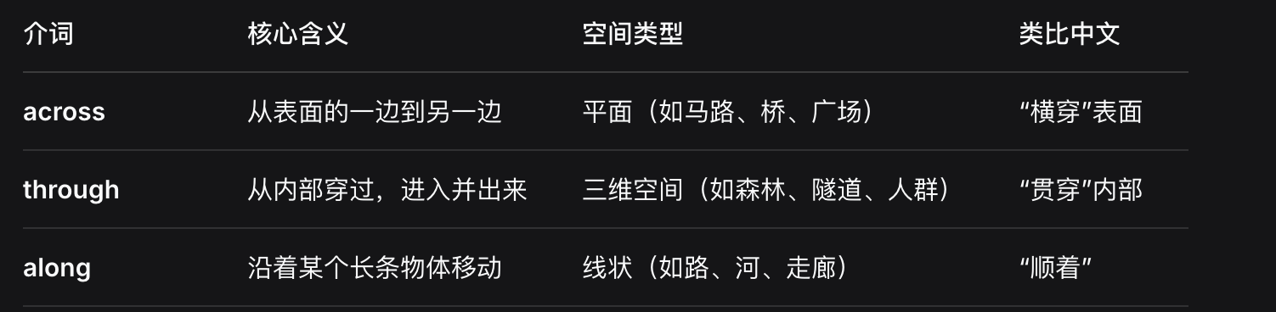
-The young man is walking through the forest.
- Yes. After that, he will swim across the river.

In VS To 表示方位
FuJian is in the south east of China, Taiwan is to the south east of FuJian.
- in – 在范围内部
- 表示某个地点 属于 或 位于 另一个较大区域的边界之内。
- to – 在范围外部
- 表示某个地点 在另一个区域之外，两者可能相邻，也可能有一定距离。

Amazing VS suitable VS comfortable VS relaxing
Amazing : 惊讶的，神奇的。
Suitable: 适合的
Comfortable: 舒服的
Relaxing: 放松的
But no one of them suitable for him.

Be made of VS Be made from
be made of：原材料在成品中仍能看出或辨认出，物理形态改变但材质未变。
例如：The table is made of wood.（桌子是木头做的，木头依然可见。）
be made from：原材料经过化学或物理变化，在成品中已无法直接看出原始材料。
例如：Paper is made from wood.（纸由木材制成，木材已转化为纸浆，不可见原貌。）
What are the Huishan clay figure made from?
Black clay, they look lively and cute.
clay figures: 黏土人偶, clay 黏土

Views 表 观点，景色Put yourself in others shoes
It is nature that the people have different views, learn to put yourself in others shoes.

Smells VS Looks
Smells 闻起来
The fish smells nice, you are a really good cooker.

错误的回答语句

Please give my best wishes to your friends.
Thanks, I will.

时态问题

介词in 表将来时， soon表进行时
-The meeting _will start_ in 30 minutes, I _am coming_ soon.
- Many people say the computers will take the place of books in the futures.
- The wang family will fly to Gui Lin for their holiday in two weeks.

May / must 等情态动词，使用动词原形
Life may sometimes ___(看起来)smooth, but it is full of ups and downs.
May + seem 动词原形，所以没用用seems

现在进行时
The leaves are waving in the soft wind, making beautiful sounds.
对称句

用现在进行时表示按计划和安排将要发生的事情。
在英语中，现在进行时（如 "is showing"）常用来表示按计划或安排将要发生的将来动作，尤其适用于表示移动、行程或活动的动词（如 show, go, come, leave, arrive 等）。句子中的时间状语 "tomorrow" 明确指向将来，所以 "Who is showing us around your school tomorrow?" 意思是“明天谁将带我们参观你们学校？”——这里的 "is showing" 表达的是已经安排好的将来事件。
Ex:
Who is showing us around your school tomorrow?

一般现在时

客观事实
My parents told me that light travels much faster than sounds.

现代分词

表伴随
Don’t sit there, doing nothing, Jill.
“doing nothing” 是现在分词短语，作伴随状语。它表示与主句动作 “don't sit there” 同时发生的状态，即：不要坐在那里，并且（同时）什么也不做。

介词使用

With vs for
- with 的核心是 “伴随、拥有、使用”，强调两者在一起或是一种工具/方式。
- for 的核心是 “目的、原因、对象、交换”，强调为了谁/什么、出于什么原因。
快速判断技巧
with = “一起 / 用 / 带着”
for = “为了 / 因为 / 给”

in font of VS in the font of
in font of xx， 在xx的前面，外部的前面。
In the font of xx, 在xx的前面，特指xx的前面，属于xx的一部分。
Don't talk with the bus driver when he is driving in the font of bus.

Worth VS Be worth doing
接动名词 (-ing form) (表示“值得做某事”) —— 最重要、最常用
The movie is worth watching.
快速总结与记忆口诀
- 表价格：be worth + $ / 价格
- 表值得：be worth + doing (主动表被动，千万别加 to do 或 being done)
- 表划算：It is worth it.
- 对比记忆：worth doing | worthy of being done | worthwhile to do

倒装句

Between the two ancient vilages ___ a clean and long river.
run：可作不及物动词，表示河流“流淌、延伸”。本句是倒装结构，正常语序为 “A clean and long river runs between the two ancient villages.” 倒装后动词应置于主语前，但形式仍需与主语一致（应为 runs）。然而，选项中只有 run，且 has 明显错误，故选 run。
has：意为“有”，及物动词，后面必须接宾语。句中无宾语，且河流不能“拥有”一条河，逻辑错误。

祈使句
Let’s to do something.

名词短语和复合形容词
11 kilometres 是一个名词短语，其中 “kilometres” 是复数形式，表示具体的距离。
通常用作主语、宾语或跟在介词后。
11-kilometre 是一个复合形容词，用于修饰名词，表示“11公里长的”。
注意：有连字符，且 kilometre 用单数形式（即使数字大于1）。
EX:
Fhe highest peak (高峰)of Mount lluangshan is Lianhua Peak. it is about ____
B. 1,864-metres-high D. 1,864 metres high

祈使句 What VS How
Can you believe that Lora made the beautiful kits by herself?
What a creative girl she is !
How creative the girl she is!
What 后面跟名词，名词前需要限定词。
How 后面跟形容词/副词。

Self & Myself VS yourself
The cat is looking itself in the mirror.
Itself 用于无生命活着无法判断性别的动物.
Itself → used for inanimate objects, animals of unknown/irrelevant gender, or concepts/things without gender.
Himself → used for a male person or a male animal (especially when the gender is known), or for personified masculine nouns.

Have sb do something

Forget to do sth VS forget doing sth
forget to do sth | 忘记 要去做 某事 | 动作 没发生
forget doing sth | 忘记 做过 某事 | 动作 已发生

By hand VS with Hands
短语 | 核心含义 | 常见程度 | 例句对比
by hand | 手工方式（非机器） | 非常常见 | The quilt was sewn by hand.
by hands | 不标准，通常 avoid | 罕见 | 不建议使用
with hands | 使用手（作为工具） | 常见 | He caught the ball with his hands.

Each VS every VS both 区别
There are trees on each side of road
- Each: 个体、独立看待, 两者或以上. 可作代词、形容词；可接 of（each of us）
- Every: 整体、全体成员. 三者或以上（通常）. 只作形容词；不能直接接 of（要说 every one of）

How long VS How often VS how soon VS how far
- How long: 时间长度（duration）或 物体的长度。 后跟时间介词为for. 回答用：for two hours, ten minutes, three days, five meters, etc.
- How often: 问频率。询问 事件发生的频率
- How soon 问从现在到未来某个动作发生的时间间隔（强调“快”或“早”）。 回答常用：in ten minutes, by tomorrow, as soon as possible, soon, etc.

Well VS Good VS Nice
This kind or fruit looks good/nice. - Yes, it tastes even better.
- Well, 作副词, 修饰动词，表示 做事的方式好.
  - 作形容词, 只表示 身体健康（in good health）。
- Good – 形容词 “好的. 用于修饰名词，表示 质量高、能力强、令人满意、品行好。
注意： I'm good 可以表示“我很好（状态/情绪/技能）”，但不用于回答“身体有没有生病”——那时要用 I'm well。
- Nice – 形容词 “令人愉快的、友好的、精致的”.
与 good 的区别：
- Good 强调客观质量（a good car = 性能好/耐用）
- Nice 强调主观愉悦（a nice car = 外观漂亮/坐着舒服）
- 口语中的特殊用法（地道但非正式）
- I'm good. = 不用了，谢谢 / 我现在状态不错（拒绝offer时）
A: Want more coffee? B: I'm good.
- All good. = 没事，没问题
- Well done! = 做得好！（固定短语）
- Nice one! = 干得漂亮！（英式/澳式口语）
- 总结句型记忆
- 修饰 名词 → good / nice
(a good book, a nice day)
- 修饰 动词 → well
(run well, work well)
- 表示 健康 → well（形容词）
(feel well, be well)
- 表示 友好/愉悦感知 → nice
(nice smile, nice to see you)

Could 语句的回答
语境 | 肯定回答 | 否定回答
请求（现在或将来的动作） | Yes, I can. | Sorry, I can't. / I'm afraid not.
过去的能力 | Yes, I could. | No, I couldn't.
可能性推测 | Yes, it could. | No, it can't be. / No, it couldn't.

- Could I bring my pet dog into the cinema?
- Sorry, you can’t. Look at the sign. It says “No pets".

Can VS Could
Could 比 can 更委婉，是can的过去时态。
