## Purpose

The purpose of this instruction is to provide step-by-step guidance as to how to assign Referees to Matches in ZAYSO.

## Useful Links

* National Games: <http://50.ayso.org/>
* National Games ZAYSO (Schedules, Results & Referees Assignments): [http://2014nationalgames.org//](http://2014nationalgames.org/)
* Create a ZAYSO account: <http://2014NationalGames.org/create>
* Login to your account: <http://2014NationalGames.org/referees>

## System Configuration

This has been tested with:

* Windows 7 Operating System, Mac OS X (Maverick)
* iOS Operating System (iPad)
* Browsers: Internet Explorer 9 & 10, Chrome, Safari, Firefox

## Known Issues

There are no known issues at this writing.

## Requirements

It will be assumed that you have:

* Registered an account in ZASYO. If not, please do so at <http://2014NationalGames.org/create>
* Appropriate privileges have been granted to you. Privileges can be:
  1. Public (no account required): View game schedule and match results
  2. User: Able to see personal schedules and link schedules to other users
  3. Score Entry: Able to input match results
  4. Score Admin: Able to update game schedules and match results and publish results
  5. Assignor: Able to assign Referees to matches individually or assign the entire schedule
  6. Administrator: All of the above plus able to update registration records
* You have received the list of matches for you are responsible to assign from the Lead Assignor
  1. With Administrative privileges (c, d, e & f above) you will see an **Admin** menu item when you login to ZAYSO at <http://2014NationalGames.org/referees/>. This will take you to the administrative functions for the role you’ve been assigned.
  2. If you do not see the ***Admin*** menu item, send the [Referee Administrator](mailto:ayso1sra@gmail.com?subject=I%20need%20privleges%20for%202014%20National%20Games) a note requesting Assignor privileges ([referees.ng2014@gmail.com](mailto:ayso1sra@gmail.com?subject=Request%20for%20Assignor%20Privileges))
* It is a requirement of the National Games Advisory Commission that the referees you assign have current MY registration and have completed Safe Haven. Accordingly, Referees will neither be able to take assignments nor view their schedules until they do so.

Getting Started

1. [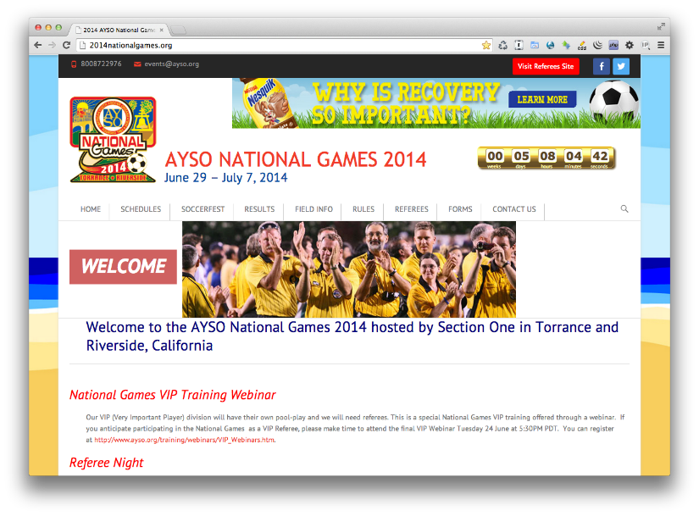](http://2014nationalgames.org/)Go to the Referee page at <http://2014NationalGames.org/referees>.
2. Click Referee menu item.

[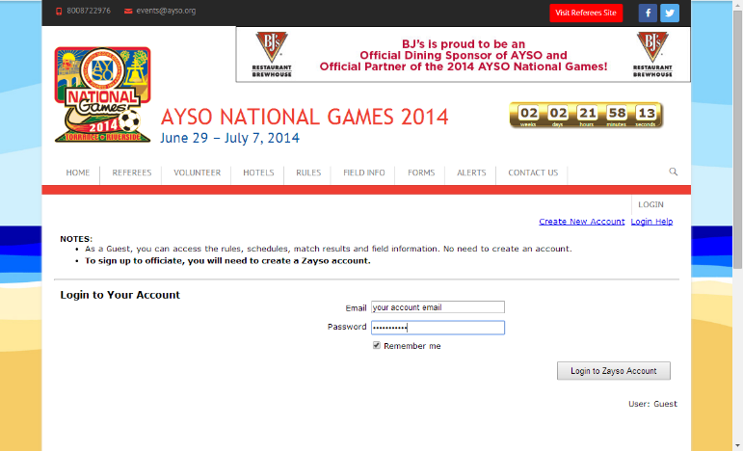](http://2014nationalgames.org/referees/)

1. Login to see your information. Click the “Admin” menu item.
2. 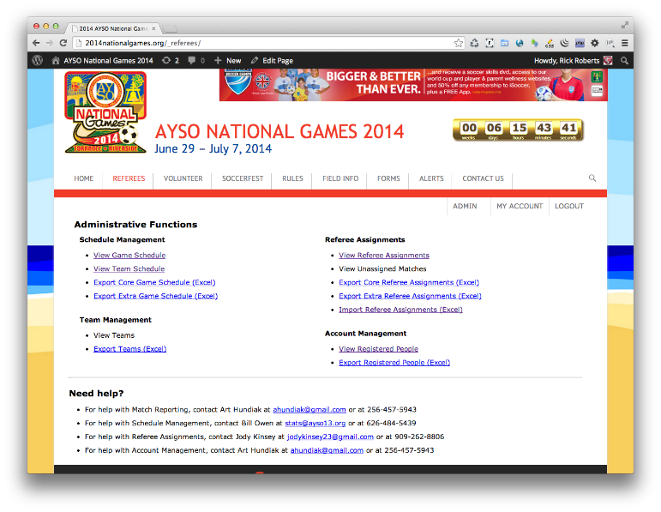The Administration page contains functions for:
   * Schedule Management
   * Game Management
   * Referee Assignments
   * Account Management
3. What you see will depend on your role.

## Assignor: Assigning Registered Referees to Matches

1. To assign referees to matches, click on “View Referee Schedule”
2. 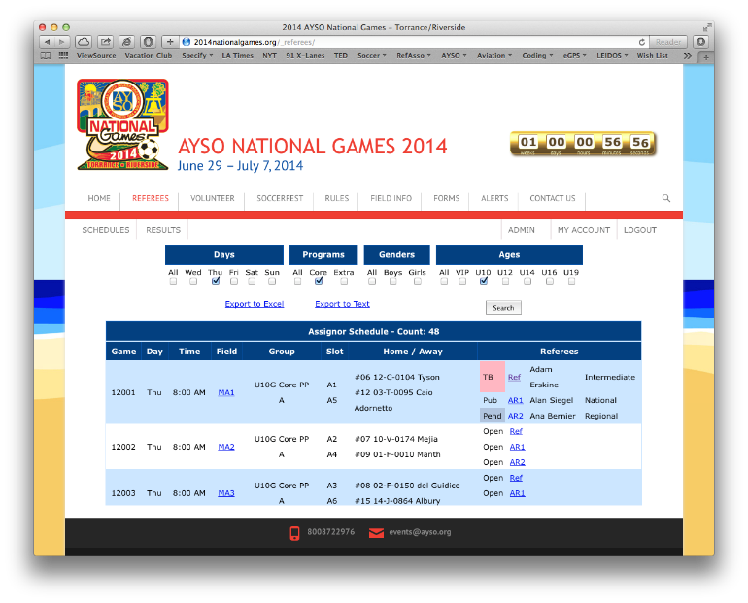Click on the field under “Referee”, “AR1” or “AR2” for the match you wish to assign. In the figure on the right, Match #12001 is being selected.
3. Match Assignment page will show fields for “Ref”, “AR 1”, “AR 2” assignments.

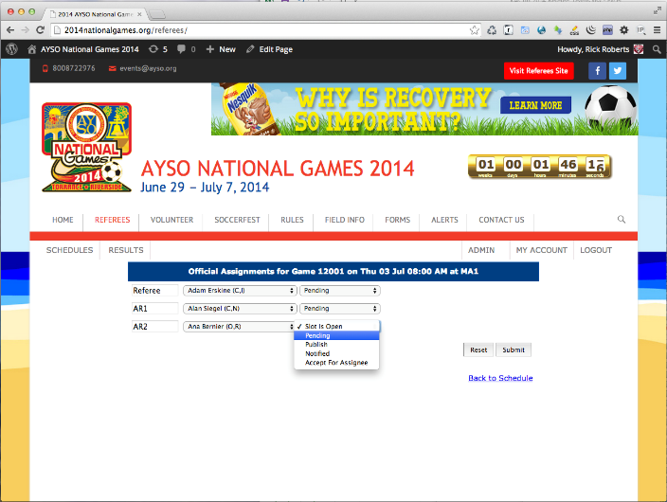

1. To select a referee from those registered,

click the dropdown for the position. A list of all registered referees will be displayed (alphabetically sorted by Last Name). Select the Official by clicking their name.

1. Repeat for all positions.
2. From the “Assignment Status” dropdown, select the status “Pending”, “Publish”, “Accept for Assignee”.
   * “Pending”: Reserves the match. No further action can be taken until an Assignor changes the status to” Publish”, “Accept” or “Remove Assignee”.
   * “Publish”: The match is published. The Referee must Accept or Decline.
   * “Accept for Assignee”: The match is assigned to the selected official.
3. Click the ***Submit*** button to assign the selected officials the match. Click “Back to Schedule” link when you are done.

## Referee: Accept or Decline

1. The Referee may Accept or Decline assignments.
2. If they Accept, the match is theirs and the Schedule shows “Acc” highlighted in green.
3. If they Decline,
4. Referees may rescind their matches before the Assignor approves the request by simply “Removing the Request” on their schedule.
5. The match will show as OPEN on the Assignor Schedule

## Referee: Turnback Matches (after Accept)

1. 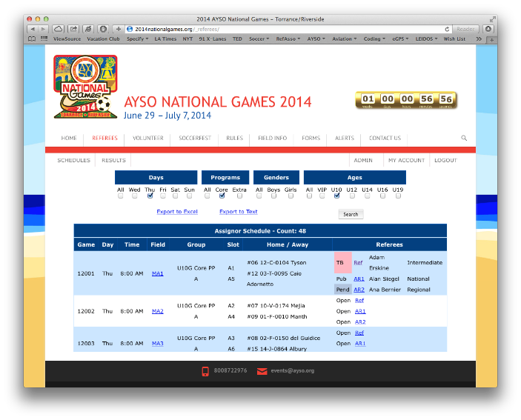After the match has been assigned, Referees may request a turnback of the match.
2. The Assignor Schedule show the request “TB” in pink.
3. The Assignor may approve the turnback (the match status returns to Open) or reject the turnback (the match remains assigned to the Referee).

## Referee: Request a Match

1. 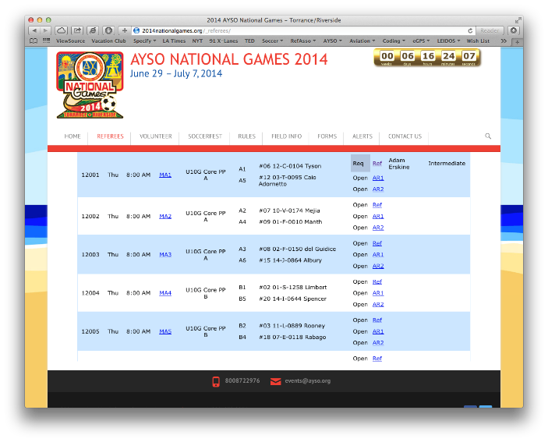Referees may request a match by selecting the match from the schedule
2. The match shows “Req” in grey on the Assignor Schedule

## Assignor: Accept or Reject the Request

1. The Assignor may “Reject” the Referee’s request for assignment.
2. The match status remains Open
3. 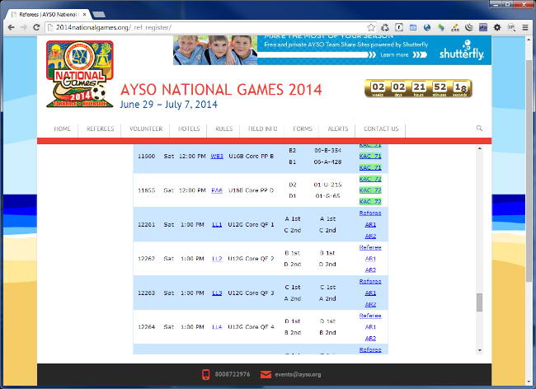The Assignor may “Approve” the Referee’s request for assignment. The match status shows “App” with the Referee’s name and appears on the Referee’s schedule
4. As of this writing, no notice is sent to the Referee so a phone call would be in order by the Assignor to the Referee.
5. Referee contact information may be found under Account Management group, “View Registered People”

## Assignor: Remove the Assignment

1. 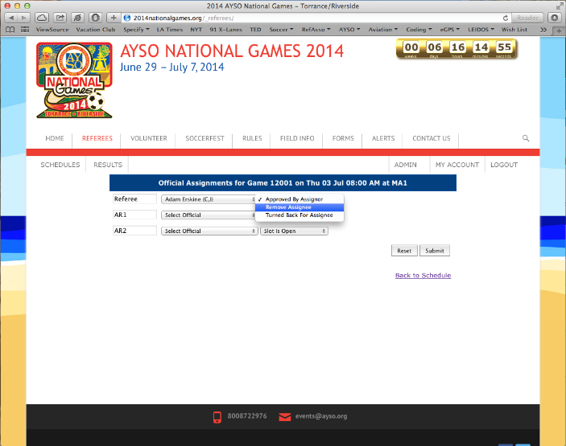The Assignor may later remove the assignment by selecting the match, selecting “Remove Assignee” and Submit.
2. The assignment is removed from the Referee’s Schedule

## Exporting the Schedule

1. 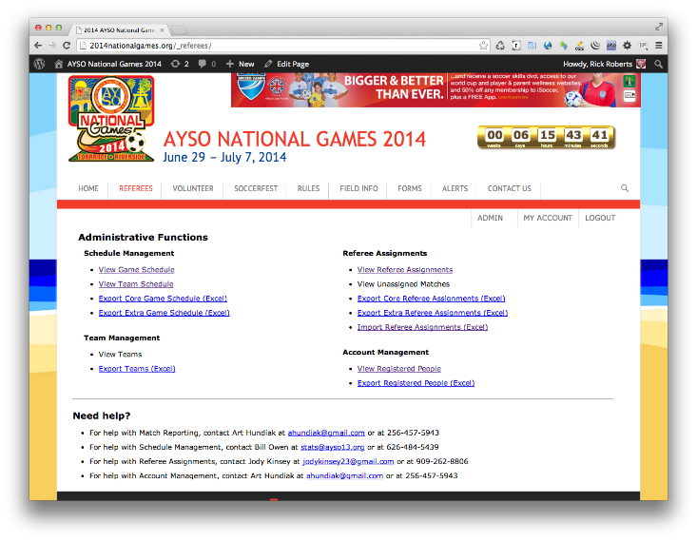The Assignor may export the schedule to Excel for use at the field
2. The exported schedule may be modified in Excel and imported to apply changes in bulk
3. The only proper way to do this is to:
   * Export the schedule of officials by clicking “Export Referee Assignments” on the Admin page.
   * Update the last three columns with the names of the Referee, Assistant Referee 1, Assistant Referee 2
   * Save the modified schedule of officials
   * 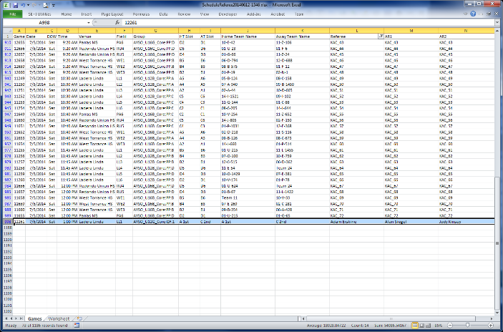Using the controls below, select the modified worksheet by clicking the "Choose File" button.
   * Complete the import by clicking the "Import Referee Assignments" button.
   * View Referee Schedule to confirm the changes.

## Questions?

For help with Referee Assignments, contact Jody Kinsey at [jodykinsey23@gmail.com](mailto:jodykinsey23@gmail.com) or at 909-262-8806.