**Emenido, Renvic C. MTH103L(6573)**

1. Use R Studio and provide the result using the DESCRIPTIVE STATISTICS. (15pts)

For the following questions:

Answer each item using ***R Studio*** and provide the null and alternative hypotheses, alpha level, mean, standard deviation, decision, interpretation, and conclusion.

Null Hypothesis: The mean difference between book scores and DVD scores is zero or less.

Alternative Hypothesis: The mean difference between book scores and DVD scores is more than zero.

Alpha Level: **0.05**

Mean Difference: **5.714286**

Standard Deviation: The standard deviation for book scores is **5.715176**, and for DVD scores, it is **4.690416**.

Decision: Because the p-value (**0.04091**) is below the alpha level (0.05), we reject the null hypothesis.

Interpretation: There is sufficient evidence to suggest that book scores are higher than DVD scores for non-English majors at the chosen college.

Conclusion: With a significance level of **0.05**, we can conclude that book scores are higher than DVD scores.

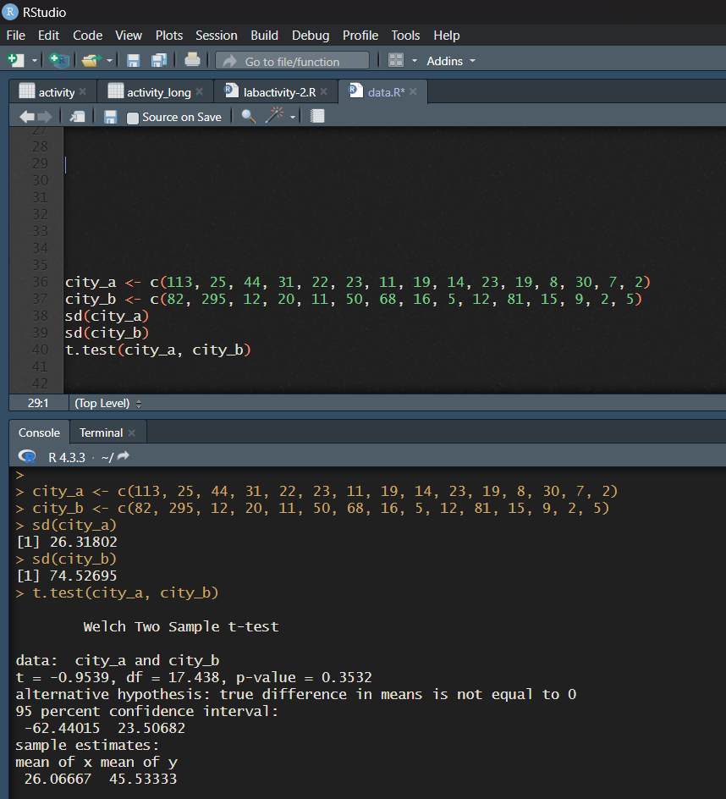

Null Hypothesis: The mean values of tax-exempt properties are the same in both cities.

Alternative Hypothesis: The mean values of tax-exempt properties are different in the two cities.

Alpha Level: **0.05**

Mean of City A: **24.60**

Mean of City B: **63.40**

Standard Deviations: The standard deviation for tax-exempt property values in City A is **29.94305**, and in City B it is **90.21587**.

Decision: Since the p-value (**0.1653**) is higher than the alpha level (**0.05**), we do not reject the null hypothesis.

Interpretation: There is not sufficient evidence to support the claim that the average values are different between the two cities.

Conclusion: With a significance level of **0.05**, we cannot conclude that the average values of tax-exempt properties differ between the two cities.