

Deliverable 4 - Diagrams

group 2 | CS386 SPRING 2017 | Marco Gerosa | [GitHub Link](https://github.com/jjg297/CS386-Software-Project)

CS386 – Software engineering

Jesus Garcia

Matthew Burns

Vincent Mcivor

2017

Due: 3/2/17

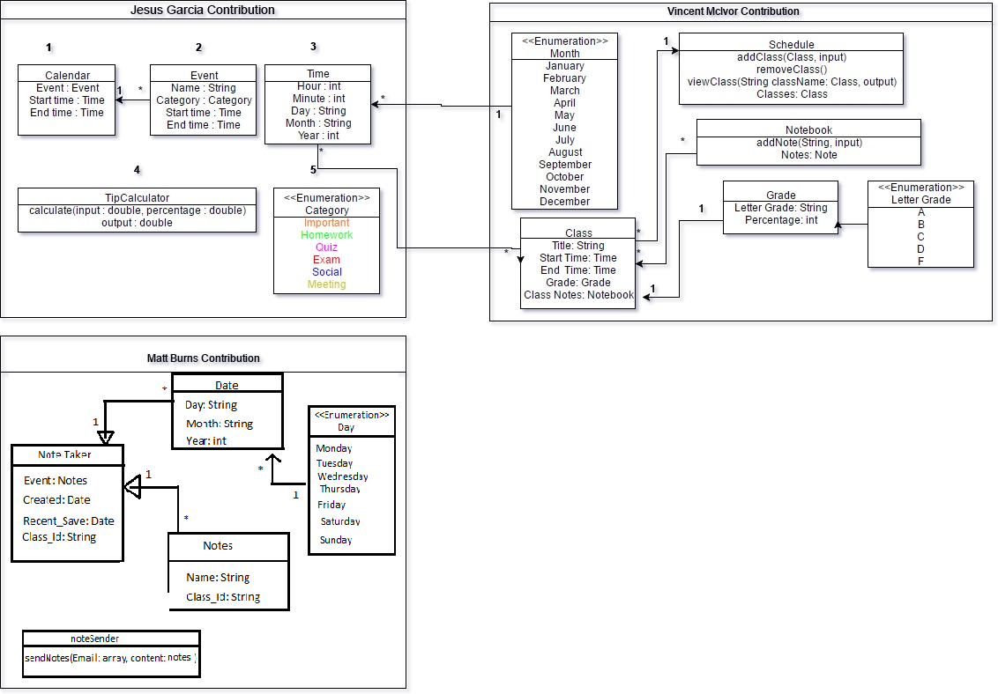Deliverable 4