**IF100**

**Practice 2**

**Introduction**

The aim of this example is to practice the basics of programming.  
 **Description**

Assume that two automobiles are approaching each other in adjacent highway lanes, as shown in the figure given below. In this exercise, you are expected to calculate and display the time (in terms of hours) needed for the automobiles to cross each other, given the distance between the initial positions of the vehicles in terms of meters and the speeds of the automobiles in terms of km/h. You may assume that the vehicles have constant speeds during the journey.

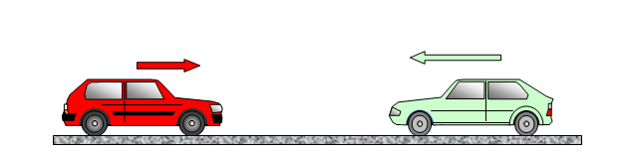

**Outputs**

There are two outputs of your program: (i) initial distance between the vehicles in kilometers, and (ii) time needed for the vehicles to cross each other in hours.   
  
For the first output, you need to perform a unit conversion operation, where the distance information should be exactly of two digits after the decimal point, and the format must be exactly as follows:

*Initial distance between the vehicles is distance km(s).*

As for the second output, again, there should be exactly two digits after decimal point and the format must be exactly as follows:

*They will meet after time hour(s).*

Note: You will learn about formatting the output so as to display exactly two digits after the decimal point in the recitations this week.

**Sample Runs**

Below, we provide some sample runs of the program that you will develop. All the prompts, results and order must be exactly the same with the sample runs.  
  
The sample run given below is constructed with the following values:

* Initial distance = 72589.5 meters
* Speed of vehicle A = 87.9 km/h
* Speed of vehicle B = 65.7 km/h

**Sample Run**Initial distance between the vehicles is 72.59 km(s).  
They will meet after 0.47 hour(s).