**IF100**

**Practice 5**

**Description**

In this practicing example, you will answer the following two questions.

1. Assume that you are a tourist in Istanbul and you want to visit some regions in both Anatolian and European sides on a single day. We defined some regions below; assume that you are in Region 1 and you want to visit all the other regions, i.e. Region 2, Region 3, Region 4, and Region 5. Given below is the map of Istanbul, in which the areas of interest and the bridges/tunnels between them are marked. You have to use a bridge or a tunnel while going from one region to another. In other words, you are not allowed to walk or use public transportation in between the regions that are not connected via a bridge or a tunnel, i.e. you cannot visit Region 5 (Eyüp) after visiting Region 4 (Topkapı). *Each consecutive district should be reachable through either a bridge or a tunnel*. Additionally, you have to use one of the connected bridges/tunnels, i.e. from Region 2 you can only use Yavuz Sultan Selim Bridge or Fatih Sultan Mehmet Bridge. You can find the related regions and connection list below.  
     
   Can you design a tour satisfying the above-mentioned restriction in which you pass each one of the bridges and the tunnel exactly once starting from Region 1 (you can visit a specific region several times)? If so, provide the path; otherwise, describe why it is not possible and suggest minimum number of new bridge(s) and/or tunnel(s) between the regions so that the path can be constituted. ***You MUST clearly indicate how you utilized the component(s) of computational thinking.***

Following list defines the regions

Region 1 → Kadıköy, Üsküdar, Kavacık  
 Region 2 → Sarıyer, Emirgan  
 Region 3 → Karaköy, Beşiktaş  
 Region 4 → Eminönü, Topkapı, Sirkeci  
 Region 5 → Eyüp, Balat

Following list defines which bridge/tunnel to be taken from which region

* REGION 1 → 15 Temmuz Şehitler Bridge / Avrasya Tunnel /  
   Fatih Sultan Mehmet Bridge / Yavuz Sultan Selim Bridge
* REGION 2 → Fatih Sultan Mehmet Bridge / Yavuz Sultan Selim Bridge
* REGION 3 → 15 Temmuz Şehitler Bridge / Atatürk Bridge /   
   Galata Bridge / Haliç Bridge
* REGION 4 → Avrasya Tunnel / Atatürk Bridge / Galata Bridge
* REGION 5 → Haliç Bridge

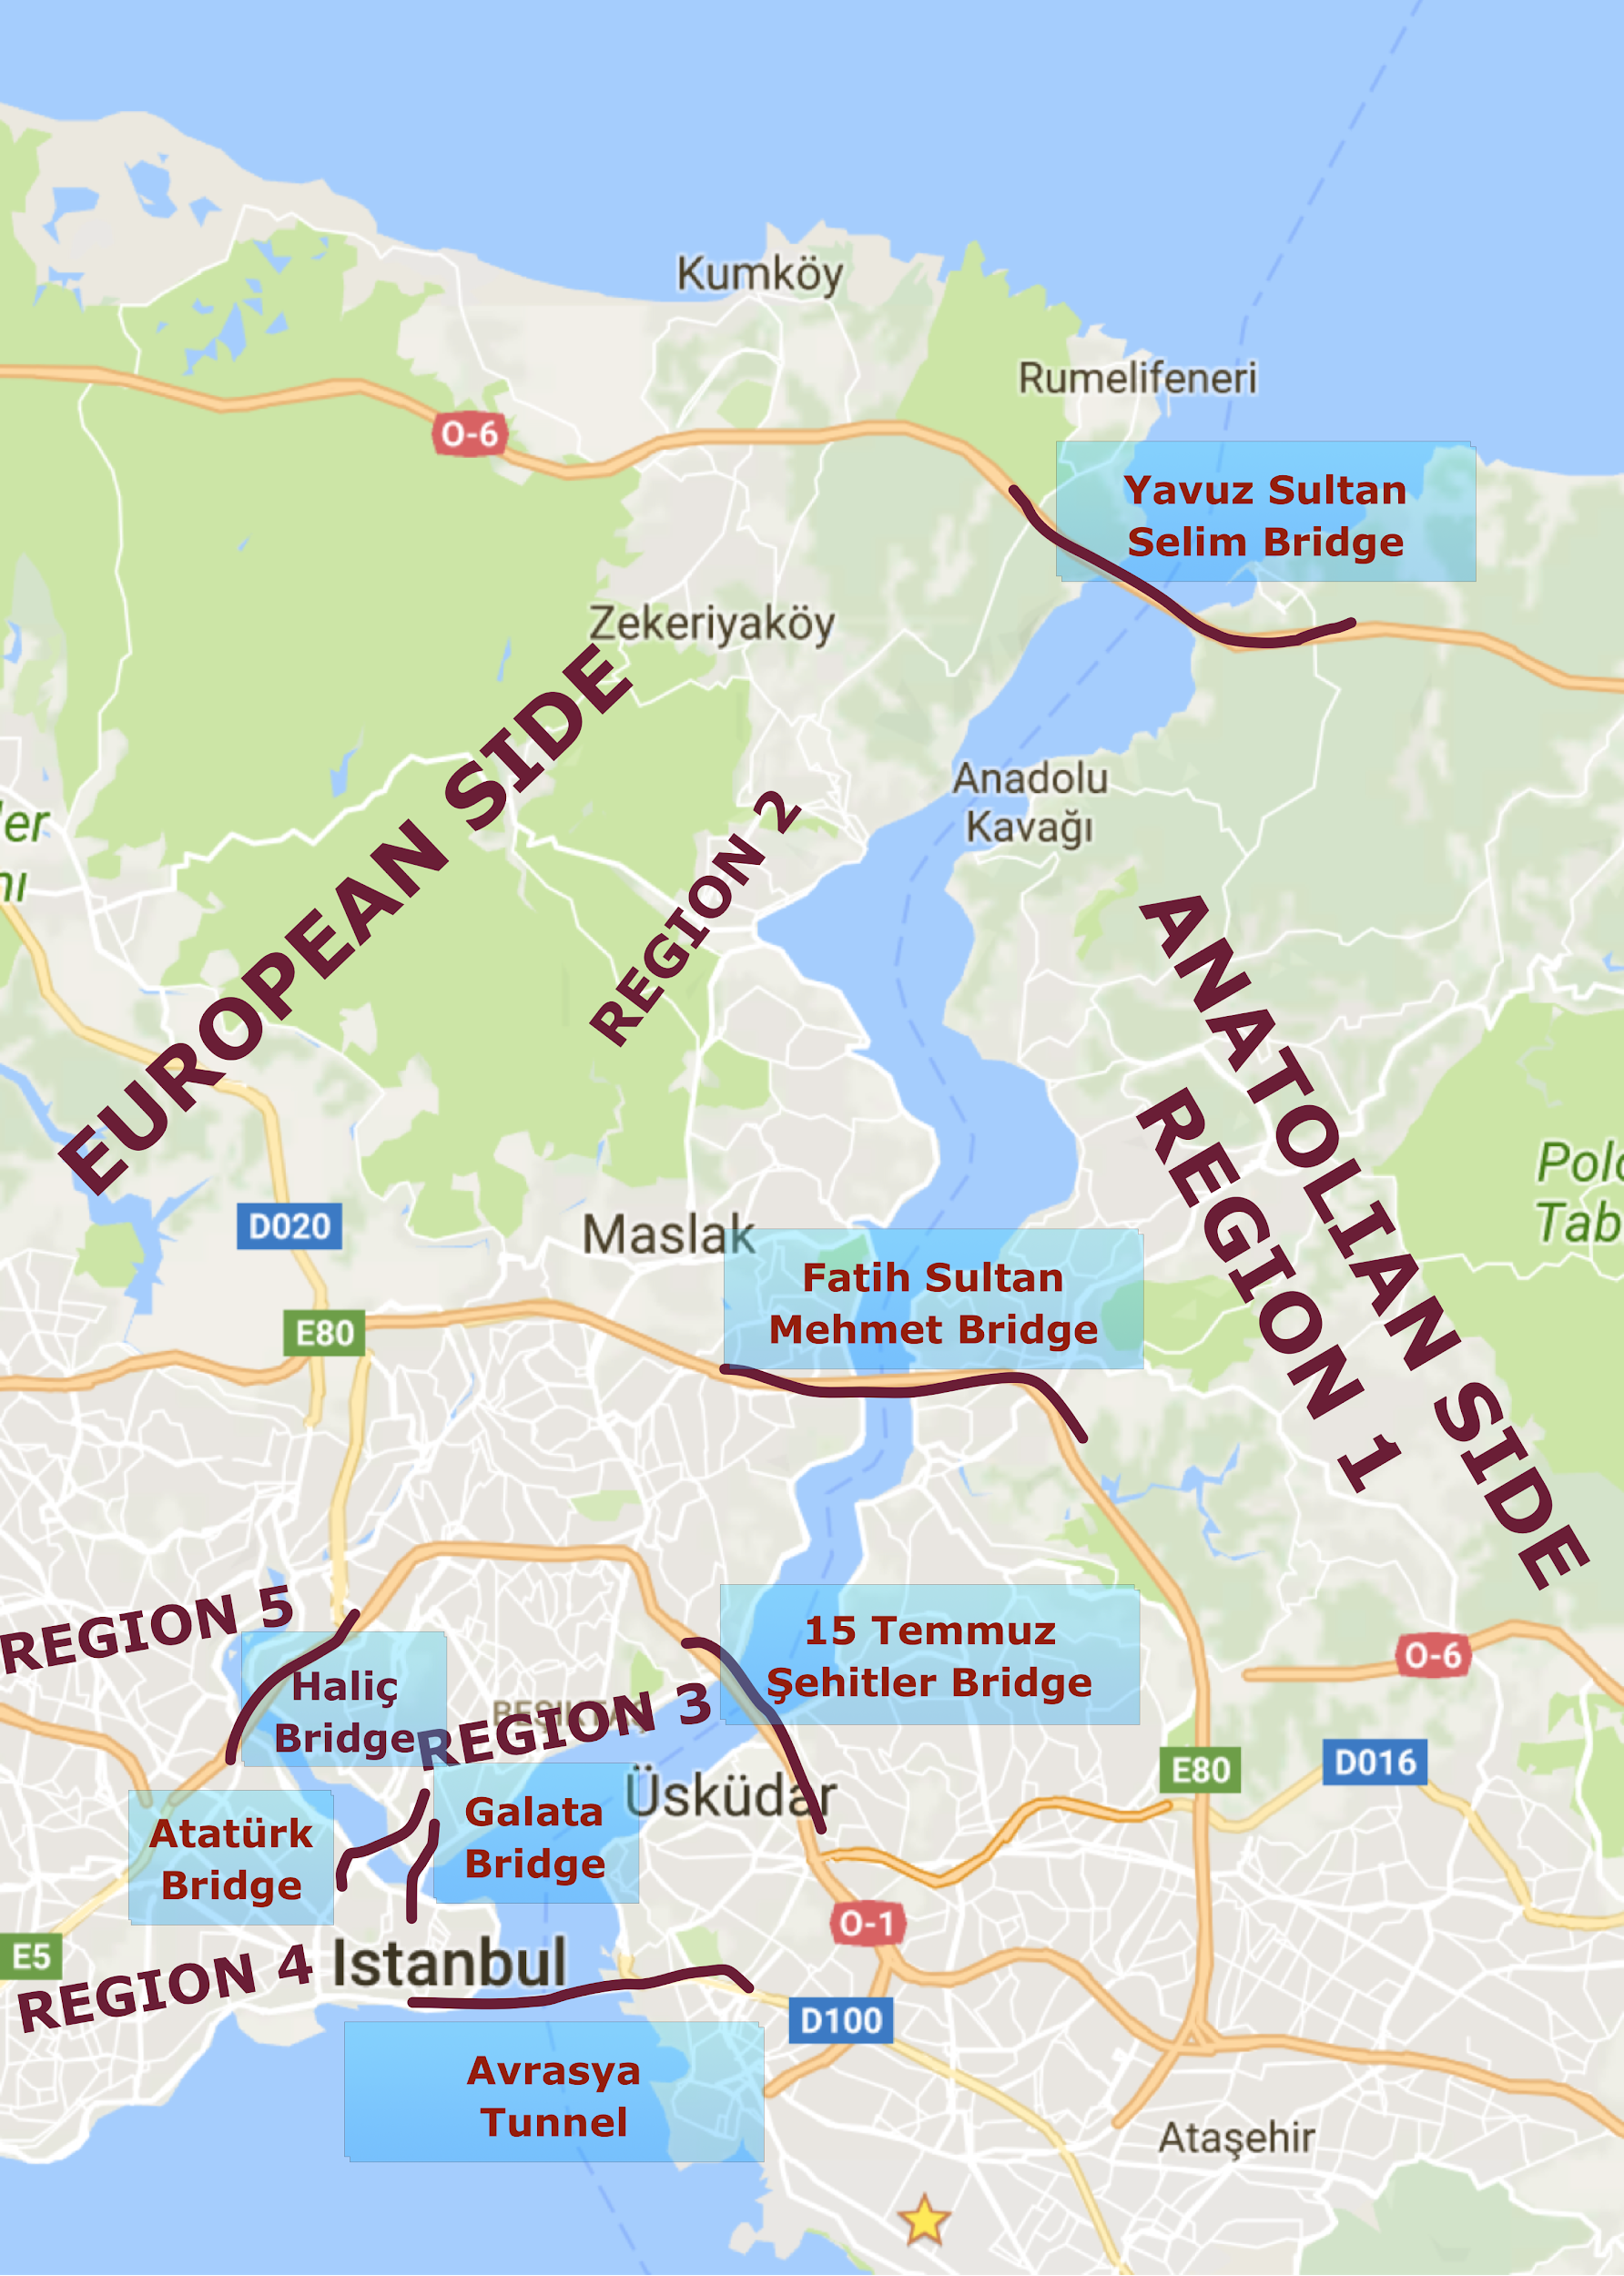

1. Since Magellan stated that the earth is not flat, many people got excited with the idea of sailing around the world. After the invention of the aircrafts, pilots started to desire going all over the world at once. They wanted to take-off from their base, fly over the continents and land to their base without any other touchdown attempts.

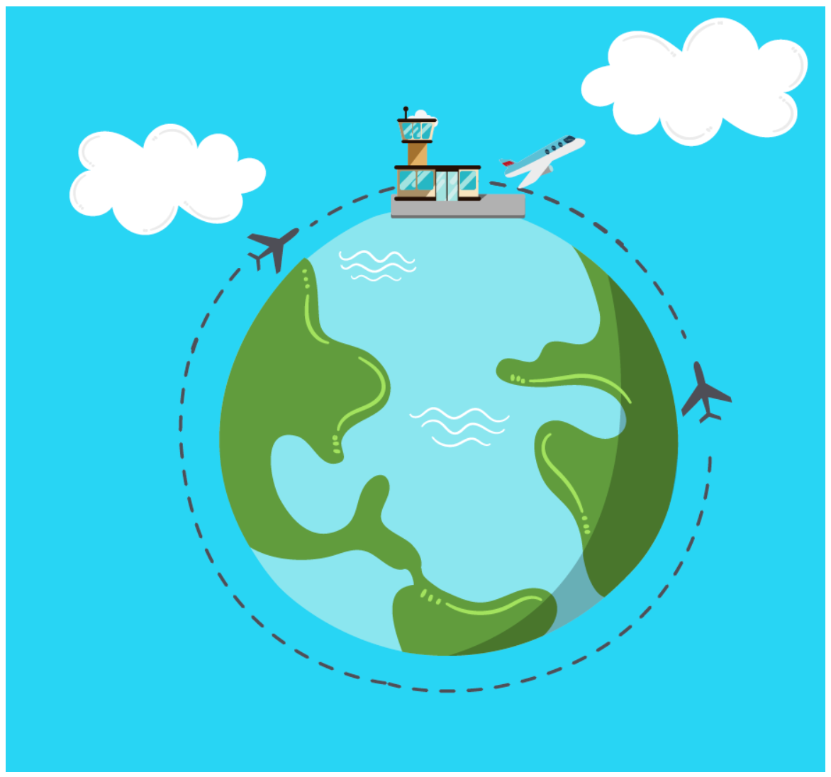

Assuming that we have 3 such enthusiastic pilots, here are the information regarding the planes with which they can fly: The first plane is made up of iron and it has a machine gun; its name is Thunderbolt. The second plane can carry mails and its name is Poseidon, and the last plane has a big graffiti paint on the surface and it is called Memphis Belle. These three planes have also some other properties as well: All of them have the same fuel tank and the same engine. Besides, all of these planes’ weight is same and they can get 180 liters of jet fuel. The planes can travel half of the world with full fuel tank at the maximum speed. Thus, the engines are uber-efficient at the maximum speed. If the speed decreases they cannot go as far as they go with the maximum speed. So you may assume that these planes will always go with the maximum speed. Additionally, the planes have a system using which they can transfer their fuel to each other when they are in the air.  
  
The plan of the pilots is ideally very simple: with the fuel transfer technology, they want to transfer fuel to each other to travel all around the world, at once, at the maximum speed and without any touchdown attempts. These three pilots need to find a combination of movements such that at least one pilot will travel all around the world at once. Of course, each pilot and his/her plane need to land in one piece. Let us help these pilots to solve their problem by applying computational thinking concepts.

Following are the information that you may require in the solution of this problem: (1) The planes can go to either of the possible directions when they take off from the base, (2) The planes can go back to their base and get fuel, and (3) The planes cannot exceed their maximum fuel capacity, which is 180 liters.

* + List the information that will be used for sure in the solution of the problem and state the computational thinking concept that you applied for this purpose.
  + Describe the algorithm that these pilots can follow to accomplish the objective and state (discuss) whether you can use decomposition and/or pattern recognition while solving this problem.

***You MUST clearly indicate how you utilized the component(s) of computational thinking.***