Appendix D3. Influence Diagnostics
Rows are ranked by Cook's distance. Sensitivity models drop the top four rows for each model.
Model | Row | Cooks_D | Hat | Studentized_Residual
FKGL FE model | 123 | 0.06 | 0.15 | -3.23
FKGL FE model | 107 | 0.05 | 0.11 | 3.62
FKGL FE model | 248 | 0.04 | 0.15 | 2.48
FKGL FE model | 89 | 0.04 | 0.15 | -2.51
FKGL FE model | 84 | 0.03 | 0.12 | -2.74
FKGL FE model | 126 | 0.03 | 0.12 | 2.69
FKGL FE model | 110 | 0.03 | 0.13 | -2.40
FKGL FE model | 257 | 0.02 | 0.11 | 2.49
FKGL FE model | 115 | 0.02 | 0.10 | -2.50
FKGL FE model | 48 | 0.02 | 0.10 | -2.39
Dale-Chall FE model | 107 | 0.05 | 0.11 | 3.61
Dale-Chall FE model | 89 | 0.05 | 0.17 | -2.69
Dale-Chall FE model | 123 | 0.05 | 0.11 | -3.48
Dale-Chall FE model | 84 | 0.04 | 0.10 | -3.26
Dale-Chall FE model | 186 | 0.03 | 0.11 | -2.46
Dale-Chall FE model | 257 | 0.03 | 0.10 | 2.54
Dale-Chall FE model | 255 | 0.02 | 0.10 | -2.54
Dale-Chall FE model | 115 | 0.02 | 0.10 | -2.49
Dale-Chall FE model | 126 | 0.02 | 0.12 | 2.22
Dale-Chall FE model | 48 | 0.02 | 0.12 | -2.14

FKGL influence plot
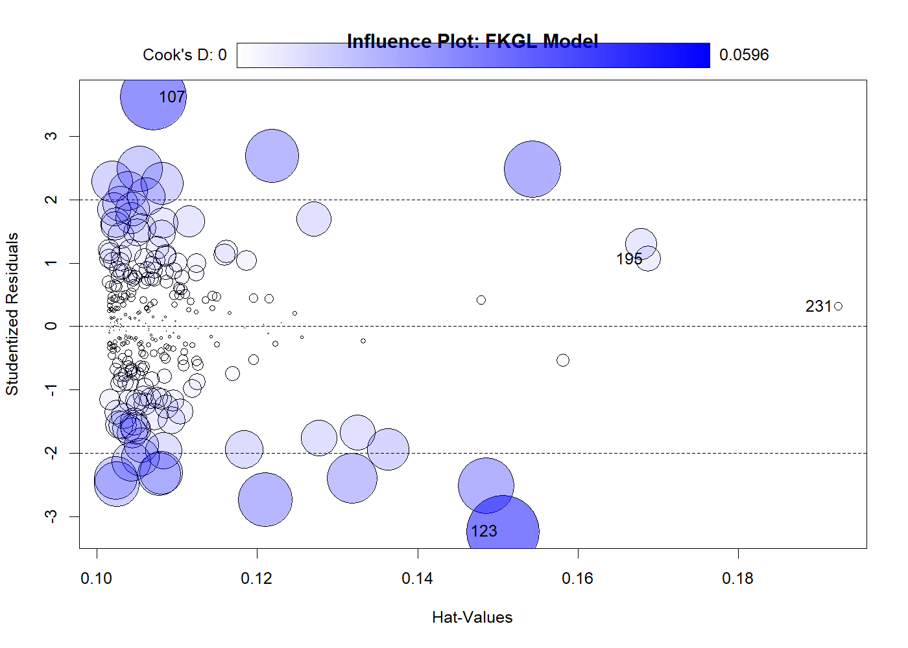

Dale-Chall influence plot
