Appendix D4. Residual Normality Diagnostics
Shapiro-Wilk tests and Q-Q plots are reported. Robust standard errors are used for inference.
Model | W Statistic | p-value
FKGL FE model | 0.99 | 0.01
Dale-Chall FE model | 0.99 | 0.01

FKGL model Q-Q plot
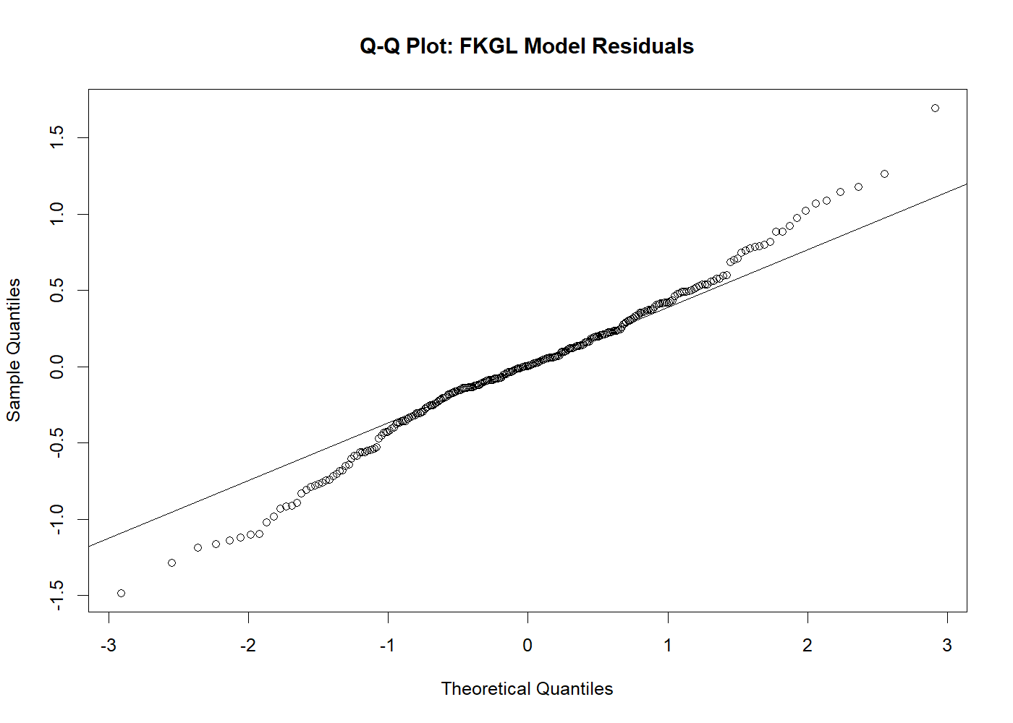

Dale-Chall model Q-Q plot
