 **Bilkent University**

**CS319 - OBJECT-ORIENTED SOFTWARE ENGINEERING**

**Final Report**

**Group 1E : Tank Zone**

**Aybüke Ceren Duran**

**Hakan Türkmenoğlu**

**Mert Sezer**

**Supervisor: Eray Tüzün**

**1. Status of the Project**

Currently the game is in primitive state. It draws tanks and their barrels. These tanks can move and change their angles accordingly. Player can manage its own tank.

**2.** **Changes in the Implementation**

There were major changes in the implementation compared to our design report.

2.1 Architectural Design Changes

We went from traditional inheritance based design to Entity-Component-System which is a composition based design. For instance, suppose we have a base GameObject that provides x,y coordinates and texture. Then we provide StaticObjects that don’t move and DynamicObjects that move. Later on we discover that we want an invisible ForceField that should move but it’s not clear where this entity should come from. Then we remove the texture property from GameObject. Then we discover we need similar kind of variations for things related to angles. The list goes on. This is illustrated in Figure 1.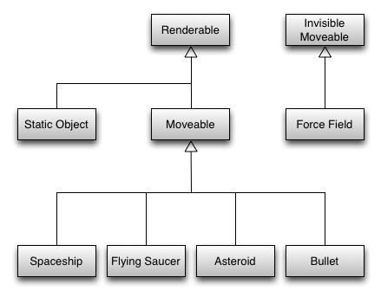

*Figure 1: Inheritance based design* [1]

What we can do is instead of a making an IS-A relationship we can have a HAS-A relationship. This will provide flexibility for us.

In Entity-Component-System,

* + **Component:** Component just holds data like models and doesn’t contain business logic. E.g, PositionComponent holds x and y coordinates.
  + **Entity:** Adds or removes components and is a general purpose object. E.g Tank entity has components PositionComponent, VelocityComponent, TextureComponent.
  + **System:** Runs through the list of entities in the program and applies business logic to the entities that has specific components. E.g MovementSystem handles the movement for entities that has PositionComponent and VelocityComponent.

This way we will eliminate most of the exceptional codes for entities that don’t map to the general idea of our object, which means adding specialized objects is easy. Figure 2 illustrates this composition based mechanism.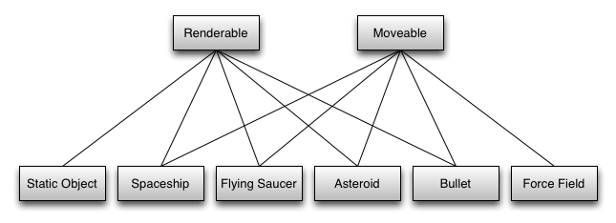

*Figure 2: A composition based design* [2]

2.2 Change in Libraries

We found that Java’s AWT/Swing libraries are difficult to use for things that they are not designed for. Therefore we though of using a minimal 2D library for at least drawing objects which will remove the burden of using OpenGL. Fortunately such library exists and is called Slick2D however it was stated that the library is no longer maintained and it is superseded by LibGDX, which is a more comprehensive library. However we will be careful about using its features since it can both serve as an engine and a library at the same. Therefore we will use its features as least as we can like for drawing things etc. Use of its frameworks will be discouraged.

2.3 Other changes

Since this is a major change that affects every object in our game we expect that almost all objects in our game will be different compared to our design report so listing these changes one by one will be difficult.

Additionally, we plan to use Strategy pattern for making our AI easy, medium and hard difficulties. Factory and Builder pattern will be used for constructing game objects. Composite pattern and singleton pattern may be used.

3**.** **Users’s Guide**

3.1 System Requirements

Since Tank zone will be implemented in Java 8, users will be have to install JRE (Java Runtime Environment) 8. Minimum requirements include:

* + **Operating System:** Windows 7, macOS Sierra or Ubuntu 16.04 (or equivalent Linux desktop distribution).
  + **RAM:** 1024 MB
  + **GPU:** Any graphics card with at least 1024 MB VRAM
  + **CPU:** Intel® Core™2 Duo Processor E4500
  + **Resolution:** 1280x720

3.2 Installation

Currently the only way to play the game is to compile either with the help of an IDE (Eclipse, IntelliJ IDEA…) or gradle. Work directory from the project settings should be set to “src/desktop/assets” in order to let the game load the assets. In the future we plan to distribute the game with a JAR file.

3.3 Controls

- W: Move upward

- A: Move left

- S: Move downward

- D: Move right

- User can also move with arrow keys:

- Mouse: Aim

- Mouse Left Click: Shoot

3.4 Game Overview

There is a map lower right of the screen. There is only a player icon on the map; which is showing where the user’s tank is in the playground. Player can move around the playground with using W,A,S,D keys or arrow keys. Player has a tank and can take aim through moving the mouse, can shoot by left clicking the mouse. There are enemies in the playground; which also have tanks. There are also stationary objects with different shapes and sizes in the playground. Stationary objects and tanks’ health are visible on their icons and decreases when a bullet hits them or when there occurs a collision between them and other tanks or stationary objects. If these stationary objects or tanks take damage that is equal or more than their health, they will disappear from the playground. If a tank destroys a stationary object or another tank; its’ score increases depending on the size of the stationary object or another tank’s level. If the tank can collect enough score in a level, its’ level increases by 1.

Both scores and levels are in the lower side of the screen. There are some visible power-ups in upper left of the screen and when the tank’s level increases by 1, the tank can use these power-ups by clicking and increase its’ health regen, max health, body damage, bullet speed, bullet penetration, bullet damage, reload or movement speed by 1 by clicking “+”; which is in the right of these power-ups. Also there are some surprise power-ups in the game and in some moments, the game is showing some of these surprise power-ups to the tanks and ask them whether they want to choose a surprise power-up among the showed ones. If they choose one power-up, they continue to game with that. If they reject these showed surprise power-ups, they can’t choose the same surprise power-ups again unless the game shows them these surprise power-ups again.

Also there are 2 type of game modes: Free For All, Capture The Flag. In Free For All game mode, the main purpose is collecting the highest score and killing all enemy tanks. Different from free for all game mode, in Capture The Flag game, there are 2 teams. Each team has a castle and the main purpose is destroying other team’s castle before they destroy your team’s castle. Castles have also health and their health decreases if they collide with enemy team’s tanks, stationary objects, and if other team’s bullet hits them. Also in Capture The Flag game mode, a tank, a stationary object and the castle can’t take damage from the same team’s tanks and stationary objects.

3.5 Menu Overview

**Pause Menu:** When player decides to pause the game, this menu will appear. Player can choose continuing the game or quitting the game and going to main menu.

**Game Over Menu:** If player completes the game successfully, or his/her tank is destroyed, this menu will appear. Player can play a new game or can go to main menu.

**Main Menu:** In Main Menu, there are 5 buttons. The user can press one of these buttons.

**Start Game Menu:** If player presses “START GAME” button in the main menu, this menu will appear. In this menu, the player must select the game mode(Free For All or Capture The Flag) and then the climate and then the difficulty level before starting to game.

**Settings Menu:** If player presses “SETTING” button in the main menu, this menu will appear.

The player can choose the controller settings and can arrange the sound options in that menu.

**Help Menu:** If player presses “HELP” button in the main menu, this menu will appear. In this menu, there is a document explaining purpose of game, player controls, power-ups, traps and the gameplay screen showing the amount of remaining health, weapon, etc..

**Achievements Menu:** If player presses “ACHIEVEMENTS” button in the main menu, this menu will appear. In this menu, the player can see his/her highest score he/she has achieved so far.

**Credits Menu:** If player clicks “CREDITS” button in the main menu, this menu will appear. In this menu, there are the names and contact informations of the developers of the game.

3.6 Game Screenshots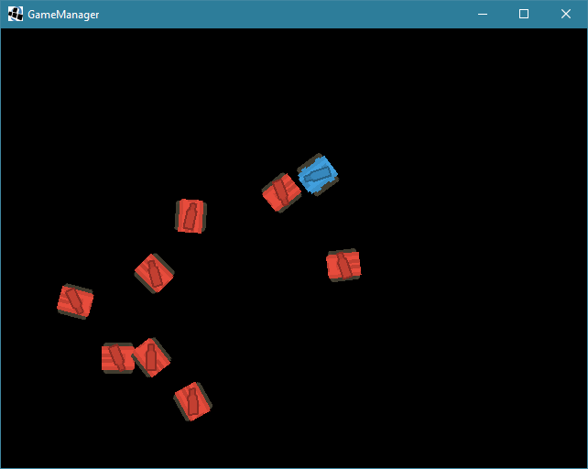

*Figure 3: Tanks moving at random directions with random speeds*

4.0 References

[1] Accessed March 17, 2018. [Online]. Available: <http://www.richardlord.net/images/blog/entity3.png>

[2] Accessed March 17, 2018. [Online]. Available: http://www.richardlord.net/images/blog/entity4.png