

**EE463 - STATIC POWER CONVERSION**

**Hardware Project: AC to DC Motor Drive**

**Members:**

**Hakan Saraç**

**Yusuf Yılmaz**

**Ceren Yalçın**

**Table of Content**

Design decisions

* Topology Selection: Discuss the advantages and disadvantages of each topology, and decide on a topology.

Computer simulations

* Computer Simulations: According the your topology selection, you are going to run computer simulations, to prove the performance characteristics of your drive. It is best to simulate as detailed as possible to catch possible hardware problems (for example, how to generate control/gate signals).

Component selection

* Component Selection: According to your analytical calculations and computer simulations decide on which components you are going to use. Not only choose the power components, but also decide on the control, and axillary components.

Test Results

* It should contain your results with the motor running (data can be collected on the demo day, but preferably earlier). The report can contain any other useful tests (i.e. functionality of the switches, tests with R load etc.)

**Design decisions**

**Topology Selection**

We have discussed the advantages and disadvantages of each three topology to make a controlled rectifier that will be used to drive a DC Motor.

|  |  |  |
| --- | --- | --- |
| Topology | Advantages | Disadvantages |
| 3-Phase Thyristor Rectifier | - Easier 4 Quadrant Operation Implementation  - Low Output Ripple  - Less Passive Elements | - Thyristor Control |
| 1-Phase Thyristor Rectifier | - Easier 4 Quadrant Operation Implementation  - Less Passive Elements | - High Output Ripple  - Thyristor Control |
| Diode Rectifier + Buck Converter | - Easier Control of Semiconductors  - Easier Implementation  - Low Output Ripple | - Hard Implementation of 4 Quadrant Operation  - More Passive Elements |

At first sight, 3-Phase Thyristor Rectifier is the best option because it requires less passive elements and 4-quadrant operation is easier to implement. However, the control of the thyristor rectifiers is hard to implement, because sampling of the phases is necessary for the gate driving. Therefore, we decided not the use thyristors to rectify the AC voltages.

The implementation of the diode rectifier with a buck converter is easier because no synchronization is needed. Even though this topology requires more passive elements, the control signals for the semiconductors is much easier compared to the thyristor rectifiers. Furthermore, the number of passive elements can be reduced if THD and efficiency of the drive is not an important issue.

Considering all these, we have decided to move on with the diode rectifier with a buck converter topology. The schematic of the circuit is given below.

**Modeling of the topology**

After deciding on the converter topology. The model is constructed on Simulink and component selection is made accordingly. The DC Motor to be driven has 220V voltage rating and 2800W power output. The other specifications of the DC motor are as follows:

- Armature Winding: 28 Ω, 13.3 mH

- Series Winding: 65 mΩ, 260 uH

- Shunt Winding: 8.26 kΩ, 6.4 H

- Interpoles Winding: 0.8 Ω, 5.8 mH

We modeled the motor with the shunt field because it is more suitable for the no load operations.

In order to satisfy continuous conduction mode, the inductance at the buck converter must be high enough along with the switching frequency. The inductor current at the boundary between the DCM and CCM can be calculated from

$$I_{LB}=\frac{V_{d}T_{s}}{2L}D(1-D)$$

With high switching frequency and high inductance, the CCM mode can always be ensured, even though it is not necessary. The control of the output voltage is straightforward in the CCM. We have chosen switching frequency at 31250Hz and inductance value around 2mH.

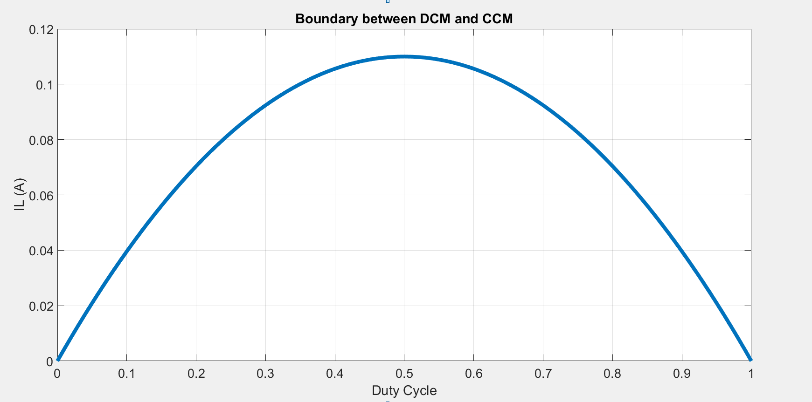

As seen in the Figure the maximum current value for DCM is around 100mA, that value is enough for us because our load current is much higher.

**Simulation Results**

* At 99% Duty Cycle

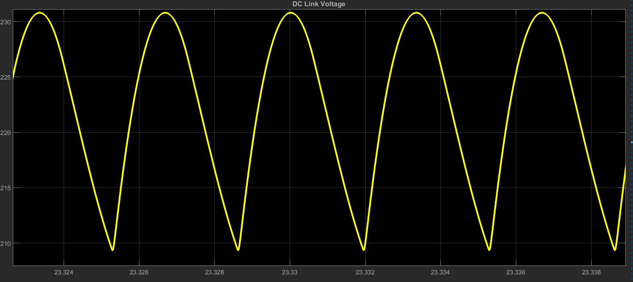

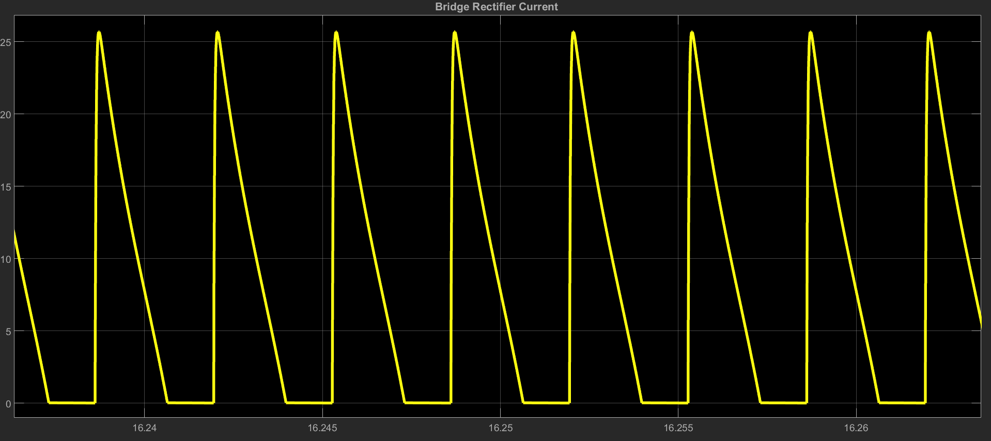

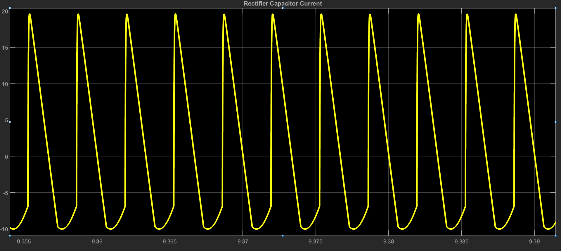

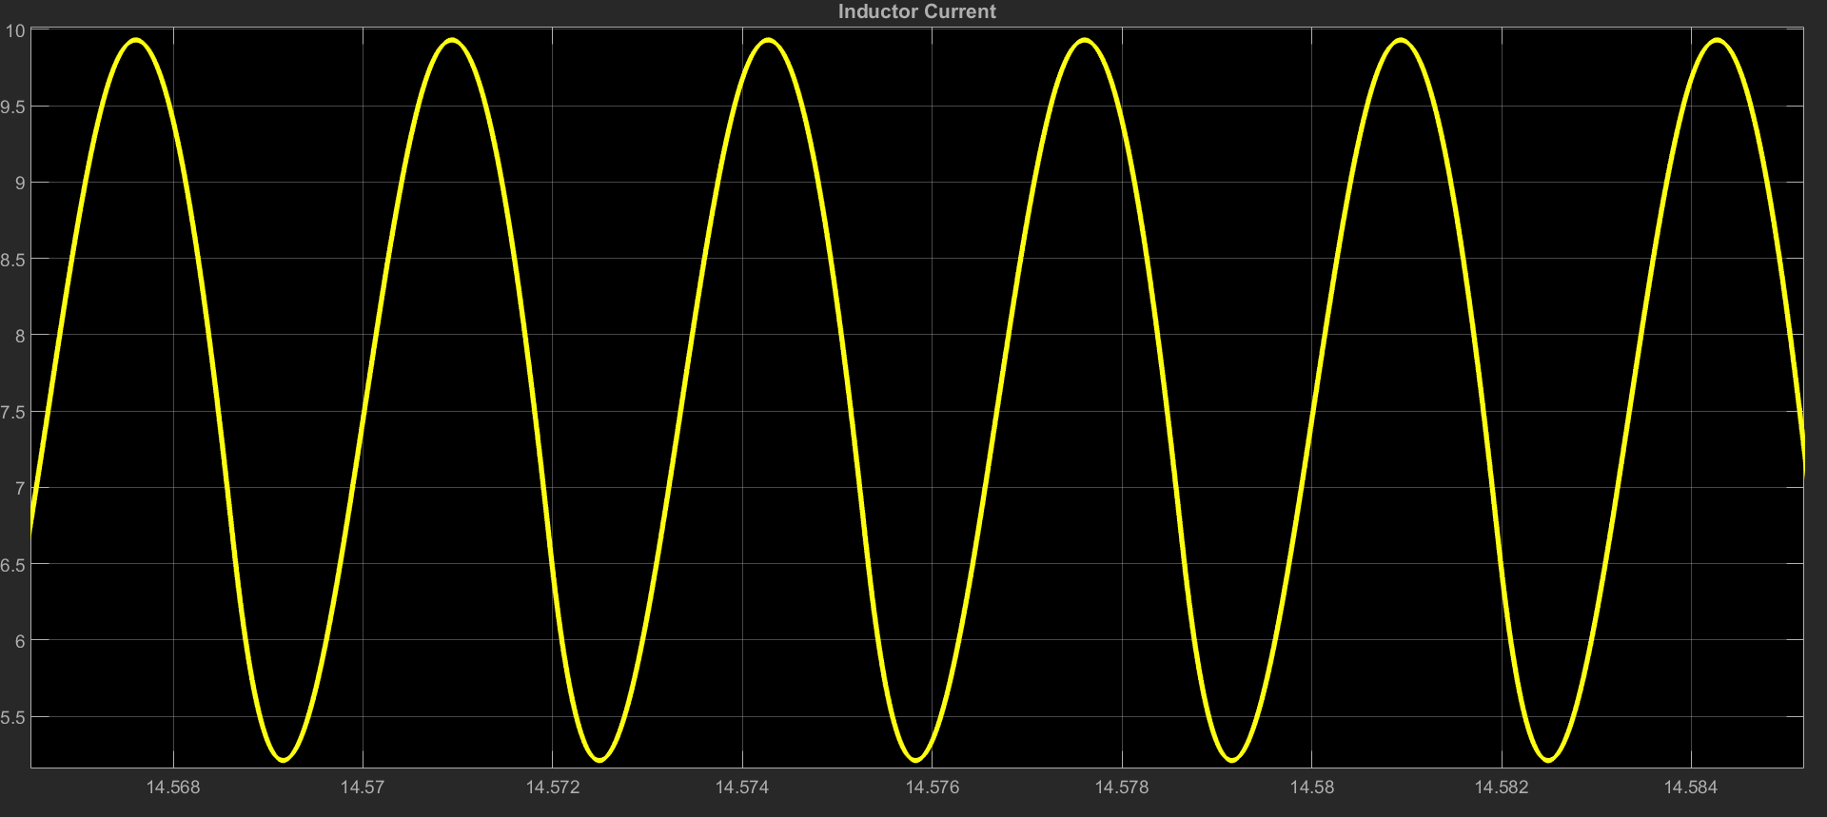

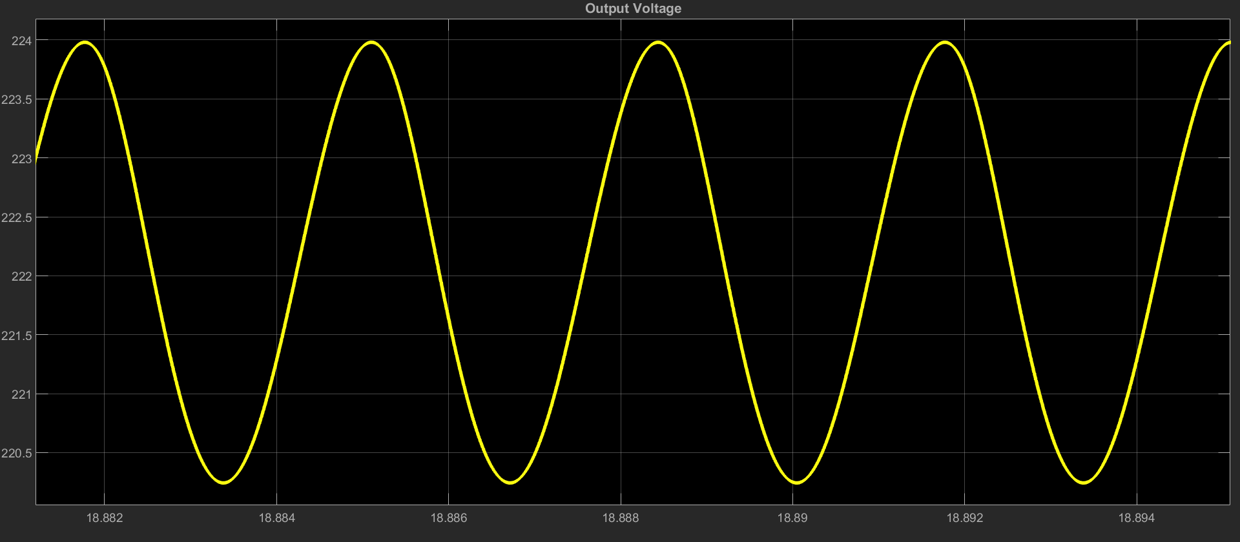

* At 50% Duty Cycle

**Component Selection**

The RMS of the line to neutral voltage of the 3-phase line is chosen as 95V which provides around 220V DC voltage at the output of the diode rectifier. At no load, the voltage and current values are observed for each components and ratings of the components is made accordingly.

The capacitors are chosen as aluminum electrolytic whose ratings are 450V 680µF. We couldn’t find the datasheet of the capacitors. They are named Kendeil K01450381.

The average voltage across the 3-phase diode bridge rectifier is 222V. However, while starting the voltage value reached up to 383.6V. The maximum average output current is 7.46A however the current swings between 0 and 28.65A. The reason for this swing is because we only used a capacitor for the filtering at the output of the rectifier. The component we chose is named SBR3516 which is capable of carrying 35A and can withstand up to 1600V.

The maximum voltage across the switching element is around 231.8V and average current flowing through it is around 7.48A and swings between 9.7A and 5A (at 100% duty cycle). Considering these, we have decided to use RJH60F7ADPK IGBT. VCE and IC ratings are 600V and 50A(100°C) respectively.

The maximum voltage across the freewheeling diode is 234V and average current flowing through is 2A at %50-60 duty cycle. We have used DSEI30-26A fast recovery diode. It has voltage and current rating of 1200V and 26A respectively. The reverse recovery time is 40 ns.

The average current through the inductor is around 7.66A at 99% duty cycle. To achieve continuous conduction mode the inductor value must be high enough. The components we found in the market were quite expensive for us. Therefore, we have bought a ferrite core and enameled wire. The diameter of the wire was around 2mm. datasheet of the core was not available; however, we have obtained 2.9mH inductance at 10 turns.

In order to drive the IGBT, isolation between the control signal and the power circuit is necessary. Moreover, the microcontroller cannot provide enough voltage to the gate of the IGBT. TLP250 optocoupler is used for this purpose. It provides isolation up to 2500V. The maximum switching time is 1.5µs.

**Component selection**

**Test Results**