PROGRESS REPORT

END-TO-END FRAUD DETECTION PIPELINE USING SNOWFLAKE STREAMS AND DYNAMIC SQL
Domain: Fintech Data Engineering

B-Number: B01100564
Name: Cerin Rose Chelladurai

Advisor Name: Professor. Patrick Madden
Github Link: fraud_detection-snowflake

ABSTRACT
This project is an end-to-end fraud detection pipeline based on Snowflake. This is used to identify suspect credit card transactions, particularly in near real time. It begins by generating a snowflake environment and attaching snowsql to it. Once the ingestion is configured, the system injects raw transactional data into the raw layer. Later, I created a streaming change-tracking layer that runs through the rules database whenever the rule-based procedure engine is enabled. It is a cloud native architecture that is primarily used for large-scale analysis and streaming, with the setup controlled and data recorded and scaled automatically. It complies with industry standards.
Keywords: Snowflake, Cloud Data Platform, Fraud Detection, Streaming Pipeline, Change Data Capture, SnowSQL, RAW Layer, Analytics Layer, Rule-Based Engine, Stored Procedure, Dynamic Rules, Data Ingestion, Snowflake Streams, Near Real-Time Processing, Scalable Architecture, Cloud-Native Workflow, Credit Card Transactions, Data Engineering, Enterprise Analytics, Industry-Standard Pipeline.

INTRODUCTION
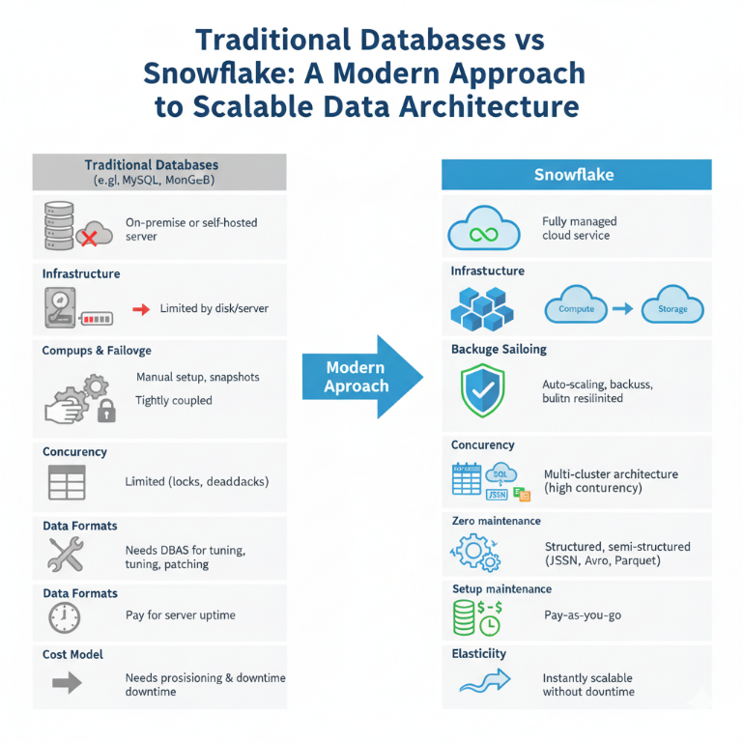
Snowflake is used to process big data and is widely used in real-world industry for large-scale analysis and streaming. The setup is fully managed, the data is tracked automatically, and the system scales without manual effort. Compared to traditional storage methods like CRUD applications, MongoDB, or MySQL—which require running a server (local or cloud), handling storage limits, managing backups, doing manual performance tuning, and writing complex scripts for streaming—Snowflake provides built-in capabilities.Traditional systems require separate tools for scheduling, streaming, machine learning, and dashboards, whereas Snowflake combines these functions directly.
Snowflake is a popular tool utilized by major firms such as Netflix, Stripe, Airbnb, Walmart, Robinhood, Capital One, and DoorDash. It is most commonly used for data engineering, streaming, and rule-based processing. In my project, I used a rule engine with a dedicated rule table. ML can also be used in this setup: the rules detect fraud patterns specific to a company, while ML identifies generalized or historical patterns. The architecture is multi-layer and near real-time. Real-time data ingestion can be achieved with Kafka or Snowpipe, which processes ongoing transactions automatically. Dashboards can be built using React or Streamlit with the Snowflake connector.
Snowflake supports scheduling, streaming, scaling, and automation out of the box.It does not require external maintenance, and new rows are processed progressively with Streams. In traditional systems, you must scan the entire table, write scripts separately, and manage everything manually. In my project, rules are stored in a table, and the stored procedure automatically applies them to new rows and flags suspicious ones.
This setup can be used across many domains. In finance: payment fraud, credit card fraud, and e-commerce order fraud. In IoT and applications: detecting unusual sensor activity, application logs, and server events. In compliance, identify illegal access, policy violations, and questionable login attempts. In healthcare, this includes identifying abnormal vital signs, strange patient behavior, and dubious medications. Identification of bots and location abnormalities on social media. In operations, notice CPU spikes, API failures, and service faults. This architecture is applicable to the vast majority of areas that require continuous monitoring or anomaly detection.

For this project, I'd use Snowflake's multilayer technique to build an end-to-end fraud detection pipeline. First, the raw credit card transactions are ingested into the RAW layer, which stores them in raw form in the table. Then, over this database, a stream is built to track added transactions, which effectively processes the data sequentially without requiring continuous scans of the entire dataset. Every single incoming transaction from the Stream is processed by a rule-based stored procedure called a rule engine, and all the rule conditions are kept in a separate FRAUD_RULES database. Each and every transaction which breaks a rule will be immediately recorded in the RULE_HITS table, along with all its details, timestamps, and which rule flagged it. In fact, this is the core fraud-monitoring workflow.
The overall system is designed to be modular, scalable, and cloud-native. It supports the extension of machine learning models for deep pattern detection, and it can be upgraded for real-time ingestion by using either Snowpipe or Kafka. The dashboards can be further built using Streamlit or React with the Snowflake connector for fraud alert and rule performance visualization among other analytics.

NEED OF STUDY
- Industry-Relevant Tools: Traditional methods are outdated; this project uses real technologies like Snowflake used in modern enterprises.
- Scalable Architecture: Growing data demands flexible, cloud-native systems that support modular and layered designs.
- Real-Time Detection: Delayed fraud response is risky; stream-based processing allows near real-time monitoring.
- Data Integrity & Auditability: Keeping raw data unchanged ensures transparency and traceability, which are critical in fraud systems.
- Rule-Based & ML Ready: Combines current rule-engine logic with scope for future machine learning integration.
- Beginner Learning Path: As a first project, it helps understand modern data workflows practically, not just theoretically.

PROBLEM STATEMENT
In the FinTech sector, especially with credit card transactions, traditional fraud detection methods struggle to keep up with the scale, speed, and complexity of modern threats. There is a need for a real-time, scalable, and rule-based fraud detection pipeline that uses industry-standard technologies to ensure accurate monitoring, data integrity, and adaptability for future enhancements like machine learning.

OBJECTIVES
- To build a complete end-to-end fraud detection pipeline using Snowflake.
- To ingest and store raw credit card transactions with full traceability.
- To implement real-time data tracking using Streams.
- To design a dynamic rule-based engine for fraud detection.
- To log and monitor rule violations with detailed records.
- To ensure the system is modular, scalable, and cloud-native.
- To create a foundation for future integration with machine learning models.

PROPOSED METHODOLOGY

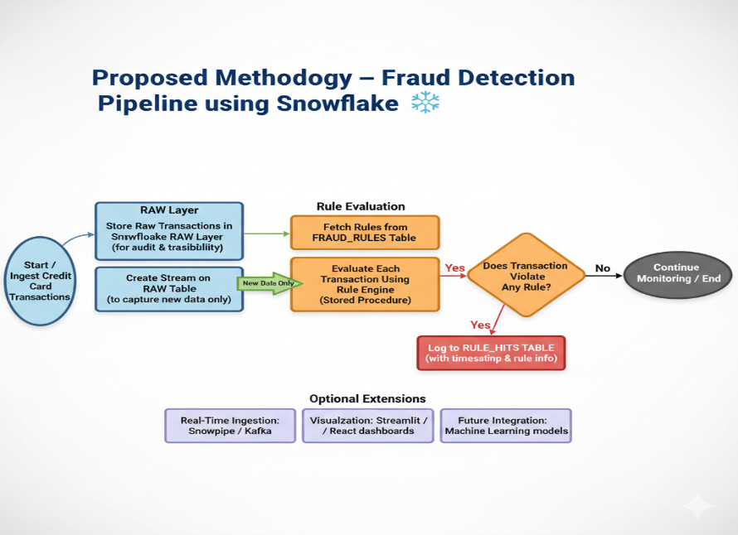

Data Ingestion: Credit card transaction data is ingested into Snowflake’s RAW layer to retain original records for audit and traceability.
Stream Creation: A Stream is created on top of the RAW table to capture only new or recently added transactions.
Rule Management: A separate FRAUD_RULES table is maintained to store dynamic fraud detection rules.
Rule Engine Execution: A stored procedure (rule engine) reads rules from the table and evaluates each incoming transaction from the Stream.
Violation Logging: Transactions that match any rule conditions are logged in the RULE_HITS table along with timestamps, details, and rule references.
Scalability & Modularity: The pipeline is designed to be modular and cloud-native, supporting future integration with real-time ingestion tools (like Snowpipe/Kafka) and ML models.
Visualization Ready: The setup can be extended with dashboard tools (e.g., Streamlit or React) using Snowflake connectors for fraud monitoring and analytics.

DATASET
- Source of the dataset:
  - Kaggle: Credit Card Fraud Detection
- No. of Observations:
- Columns or Features:

CONCLUSIONS
This project successfully demonstrates the design and implementation of a modern, end-to-end fraud detection pipeline using Snowflake's cloud-native architecture. By leveraging features like the RAW layer, Streams, and dynamic rule-based procedures, the system efficiently processes credit card transactions and flags suspicious activities in near real-time. The modular design ensures scalability and flexibility, allowing for easy integration with machine learning models and real-time ingestion tools in the future. Overall, this project not only meets the technical objectives but also serves as a strong foundation for understanding real-world data workflows and industry-relevant solutions in the FinTech domain.

LIMITATIONS
- Only rule-based detection is implemented; no machine learning integration yet.
- Not tested with real-time ingestion tools like Snowpipe or Kafka.
- Rules must be manually defined and updated in the FRAUD_RULES table.
- Dashboard and visualization layer not fully developed.
- Scalability and performance not tested on large-scale, real-world datasets.

FUTURE ENHANCEMENTS
Data Ingestion & Formats
- Switch from CSV to JSON, Parquet, or Avro formats
- Ingest data from APIs or webhook endpoints
- Use Kafka or AWS Kinesis for real-time streaming data
- Integrate Snowpipe for continuous and automated ingestion
- Pull data from cloud sources like AWS S3, Azure Blob, or GCP Storage
Automation & Orchestration
- Use DBT for modular, version-controlled SQL transformations
- Automate workflows using Apache Airflow or Prefect
- Add CI/CD pipelines for versioning rules and deployment
Monitoring & Visualization
- Build live dashboards with Streamlit, React, or Power BI
- Set up alerting systems (email, Slack, etc.) for fraud hits
- Track rule performance metrics and false positives over time
Advanced Analytics & Intelligence
- Integrate ML models for behavior-based fraud detection
- Use time-series analysis for detecting unusual patterns
- Apply anomaly detection using tools like PyCaret, H2O.ai, or native Snowpark ML
Scalability & System Design
- Test performance on larger, production-scale datasets
- Implement multi-layer Snowflake architecture: RAW → STAGE → CURATED
- Introduce data partitioning, clustering, and caching for optimization
Security & Governance
- Implement role-based access control (RBAC) in Snowflake
- Enable data masking for sensitive fields (e.g., card numbers)
- Set up audit logging and monitoring for rule modifications
AGILE SPRINT PLAN (AUGUST TO NOVEMBER)
Total Duration: ~13 weeks
Sprint | Timeline | Sprint Focus / What You Did
Sprint 1 | Early August | - Started researching fraud detection in FinTech, especially credit card-related cases  - Watched YouTube tutorials on Snowflake basics and architecture  - Set up Snowflake account and began exploring the environment  - Installed and tested SnowSQL for local development
Sprint 2 | Mid August | - Learned how Snowflake handles data layers and warehousing  - Created initial RAW layer and practiced creating tables  - Loaded sample credit card transaction data (CSV) using both UI and SnowSQL
Sprint 3 | Late August – Early September | - Learned about Streams for tracking new data  - Implemented a Stream on top of the RAW table  - Validated Stream behavior by inserting new records
Sprint 4 | Mid September | - Designed and created the FRAUD_RULES table  - Drafted initial rule conditions (simple SQL-based rules)  - Studied stored procedure scripting in Snowflake
Sprint 5 | Late September – Early October | - Developed a dynamic rule engine stored procedure that reads from FRAUD_RULES and processes transactions from the Stream  - Inserted fraud hits into the RULE_HITS table for traceability
Sprint 6 | Mid October | - Enhanced rule engine logic to handle more rules and edge cases  - Added audit columns like timestamps and rule IDs in RULE_HITS  - Verified end-to-end logic with test data
Sprint 7 | Early – Mid November | - Documented the full process and structured the code for clarity  - Explored future upgrade paths (Kafka, Snowpipe, ML, dashboards)  - Final review and submitted project for evaluation

Key Skills & Tools Used
- Snowflake (Layers, Streams, Tables, Stored Procedures)
- SnowSQL CLI (for loading data and running scripts)
- SQL + JavaScript scripting (inside Snowflake procedures)
- CSV data files (used for testing and logic validation)
- YouTube, blogs, official docs (for self-learning and troubleshooting)

KANBAN BOARD – FRAUD DETECTION PROJECT
To Do | Doing | Done
Explore dashboard options (Streamlit, React, etc.) | Final documentation and project formatting | Researched fraud detection in FinTech
Learn Snowpipe/Kafka for real-time ingestion | Organizing SnowSQL scripts and test cases | Set up Snowflake account and environment
Explore ML integration (basic anomaly detection) | Final touch-ups for submission or presentation | Installed and practiced using SnowSQL
Add support for other formats (JSON, Parquet) |  | Loaded test data (CSV) into RAW layer
Learn DBT for future transformation management |  | Created Stream over RAW table
Research alerting or email notification system |  | Created and tested FRAUD_RULES table
Performance testing on larger datasets (optional) |  | Built rule engine (stored procedure) for applying rules dynamically
 |  | Logged fraudulent records into RULE_HITS table
 |  | Verified full pipeline logic with test runs
 |  | Explored future enhancements (real-time sources, ML, dashboards, etc.)

Research Papers:
- https://ijrpr.com/uploads/V6ISSUE9/IJRPR52840.pdf?utm_source=chatgpt.com
- https://www.snowflake.com/en/developers/guides/credit-card-fraud-detection-using-snowflake-ml/?utm_source=chatgpt.com
- file:///C:/Users/cerin/Downloads/IJAIDSML-V6I1P116%20(1).pdf
- https://www.getdbt.com/blog/data-pipelines-snowflake-dbt?utm_source=chatgpt.com
- https://arxiv.org/abs/2309.07067?utm_source=chatgpt.com
- https://www.cs.cmu.edu/~15721-f24/papers/Snowflake.pdf?utm_source=chatgpt.com

S.No | Title of the Paper | Authors | Journal Name/ COnference Title & Publisher | Year of Publication | Methodology used | Performance of the proposed Algorithms | Limitations of the Research | Future approach if any
 | Employing Real Time Analytics in Fraud Detection andPreventionMechanism for Financial Transactions | Titilope Akinyemi | International Journal of Research Publication and Reviews, Vol 6, Issue 9, pp 2824-2835 September, 2025 | 2025

