Your paper title goes here

Author one, University of somewhere, [one@roulette.mx](mailto:one@roulette.mx)

Author two, University of elsewhere, [algo@rave.ac.uk](mailto:algo@rave.ac.uk)

# Abstract

Replace this text with a 100-250 word abstract.

# 1 Introduction

Welcome to the template for the first International Conference on Live Coding, 2015.

We suggest you take a copy of it, and use it as a starting point for your ICLC paper.

# 2 Formatting

All text must be formatted using the provided styles.

Headings should be numbered.

Use the Linux Libertine font, which is available for free from the following website:  
<http://www.linuxlibertine.org/index.php?id=91&L=1>

## 2.1 Bibliographic references

When making bibliographic references, authors may be referenced inline, e.g.; Schwitters (1932) wrote the Ursonate sound poem, or in parenthesis, e.g. Ursonate is a sound poem (Schwitters 1932). Multiple references should be grouped together like so (Schwitters 1932; Miller 1956; Greenewalt 1946).

The references should be included in an unnumbered section at the end of your document, using the Chicago author-date style.

## 2.2 Figures

Images should be included as figures, with captions provided and formatted as shown in Fig. 1.

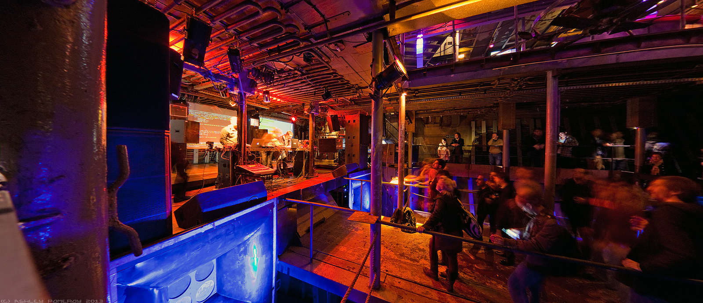

*Figure 1. A descriptive caption should be given for all figures, understandable without reference to the rest of the article.*

For photographs, please provide a resolution of at least 300 DPI. Be prepared for the page layout and image sizes to change during the print design process, and therefore refer to figures by number rather than location.

# 3 Conclusion

If you have any questions or problems, please share them on the forum: http://lurk.org/groups/lcrn/

Alternatively, you may email the conference organisers directly: livecodenet@gmail.com

# References

Greenewalt, Mary H. 1946. *Nourathar, the Fine Art of Light Color Playing*. Philadelphia. Pa. Westbrook.

Miller, G. A. 1956. “The Magical Number Seven Plus or Minus Two: Some Limits on Our Capacity for Processing Information.” *Psychological Review* 63 (2): 81–97.

Schwitters, Kurt. 1932. “Ursonate.” *Merz* 24. Merz.