08
Fall
Tape-bridge Requirements, Analysis and Design
CERN
Author: Steven Murray

October
2010

Table of Contents
Introduction 3
The purpose of this document and the intended audience 3
The structure of this document 3
Requirements 4
Analysis 6
The structure of this section 6
The additional daemons of the legacy remote tape-copy protocol 6
Getting a tape to write to 8
Starting an rtcpclientd worker process and an rtcpd child process 9
Coordinating a remote-copy 11
Design 16
The structure of this section 16
Remote tape-copy protocol between bridge, gateway, vdqm and rtcpd 16
Remote tape-copy protocol between the bridge and gateway 23
Format of messages sent between bridge and gateway 25
Inheritance hierarchy of bridge and gateway message classes 28
The internal design of the tape-bridge daemon 29

Introduction

The purpose of this document and the intended audience

This document attempts to describe in one place the tape-bridge daemon from problem statement, to analysis through to design. This document should be read by developers responsible for maintaining the tape-bridge and by developers working on the tape-gateway daemon who need a detailed description of the interface between the tape-gateway and tape-bridge daemons.

The structure of this document

The next section of this document describes the requirements that are addressed by the tape-bridge daemon. The following section analyses the problem further by describing the legacy remote tape-copy protocol that the tape-bridge daemon will need to both interact with and replace. The design section follows with the description of the new remote-tape protocol that the tape-bridge daemon will introduce into CASTOR in order to carry out its tasks. The design section then finishes by describing the internal design of the tape-bridge daemon.

Requirements

A typical CASTOR installation can be divided into four types of server: central, stager, disk and tape. A central-server runs one or more CASTOR daemons that are responsible for managing the site-wide state of CASTOR. This state includes the file namespace, the tape-catalogue and the tape-drive scheduler. A stager-server runs one or more CASTOR daemons that are responsible for managing the state of a single stager. There is usually one stager per virtual organization at a site. A disk-server is physically connected to some disk-based storage and runs CASTOR daemons responsible for accessing that data. A tape-server is physically connected to one or more tape-drives and runs CASTOR daemons responsible for accessing tapes.

CASTOR currently uses a pair of remote tape-copy daemons to coordinate the movement of data from disk to tape and from tape to disk. One member of the pair is called the remote tape-copy daemon, hereafter referred to as rtcpd. One instance of rtcpd runs on each of the CASTOR tape-servers. The other member of the pair is called the remote tape-copy client daemon, hereafter referred to as rtcpclientd. There is one instance of rtcpclientd per stager, meaning that one instance of rtcpclientd runs on one and only one of the possibly many stager-servers that make up a CASTOR stager.

The tape hardware cost of CASTOR is currently considered to be too high due to the relatively inefficient write performance of CASTOR. The problem lies with the fact that CASTOR uses a tape-format that requires 3 tape-marks per user-file written to tape. A normal tape-mark, hereafter referred to as a flushed tape-mark, marks the end of the current file on tape and flushes to tape all of the data currently cached between the writing process and the physical tape. A flushed tape-mark can take around 3 seconds to complete due to the flushing of the data. Considering the write speed of a tape-drive is currently 160 MB per second, the write performance of relatively small files is seriously reduced by their need to have 3 tape-marks each. It has been demonstrated that tape write-performance can be significantly improved by writing many small files using buffered tape-marks and then making a slower but safer flushed tape-mark.

Major modifications would need to be made to rtcpclientd in order to implement the idea of buffered tape-marks being enclosed between relatively longer period flushed tape-marks. The protocol used between rtcpclientd and rtcpd would need to be modified such that rtcpclientd would veto flushed tape-marks until a reasonable amount of data had been written to tape. Rtcpclientd would also have to be modified so that it only updated the CASTOR namespace for a group of small files once they had all been written to tape and most importantly a flushed tape-mark had been written behind them.

Unfortunately the code maintenance costs of rtcpclientd have reached the point where it is impractical to add such a new major feature. To make matters worse, it has also been requested that rtcpclientd be modified to keep all of its state in a database so that the daemon itself could be re-started without losing state. Given these two major feature requests and the high maintenance costs of rtcpclientd it has been decided to replace rtcpclientd with a new daemon called the tape-gateway daemon, hereafter referred to as tapegatewayd.

Three major constraints were imposed on the development of tapegatewayd. Firstly rtcpd should not be significantly modified due to its critical role in the data path to tape. Secondly it must be easy to switch from using rtcpclientd to using tapegatewayd and vice averse. Thirdly a tape-server should be compatible with stager-servers running rtcpclientd and with stagers running tapegatewayd. The rational behind this latter constraint is the CASTOR tape system is shared by all of stagers of a site and the stagers are upgraded one by one to reduce the risk of a site-wide failure. As a result of the problem statement and these three constraints the tape-bridge daemon, hereafter referred to as tapebridged, was invented. Tapebridged will allow a complete re-design of the remote tape-copy protocol to live alongside the legacy protocol. One instance of Tapebridged will run on each tape-server and will act as a bridge between the new remote tape-copy protocol of tapegatewayd and the legacy protocol of rtcpd.

Analysis

The structure of this section

This section describes the legacy remote tape-copy protocol used mainly between rtcpclientd and rtcpd. This section is divided into five subsections including this one. The next and second subsection describes the additional CASTOR daemons that participate in the legacy remote tape-copy protocol. With the daemons described the third subsection explains how rtcpclientd obtains a tape to write to. The tape required when recalling is known in advance. The actual work of coordinating the transfer of files from disk to tape or from tape to disk is carried out be a pair of child processes. One of the pair is called the worker process and is forked and execed by rtcpclientd on a stager-server. The other process of the pair is a child process forked by rtcpd on a tape-server. The fourth subsection explains when in the legacy remote tape-copy protocol these two processes are created. The fifth and final subsection explains how an rtcpclientd worker process and an rtcpd child process work together to coordinate the remote tape-copy of files from disk to tape or from tape to disk.

The additional daemons of the legacy remote tape-copy protocol
Before designing tapebridged it was necessary to reverse engineer the existing remote tape-copy protocol used between rtcpclientd and rtcpd. In order to describe this protocol it is first necessary to briefly describe the following additional daemons:

- Volume and drive queue manager daemon (vdqm)
- Volume manager daemon (vmgr)
- Remote file access daemon (rfiod)
- Tape daemon (taped)

The vdqm is a site-wide drive scheduler that runs on the CASTOR central-servers. The vdqm supports redundancy by allowing more than one instance of itself to be ran across the CASTOR central-servers. The VDQM allocates free tape-drives to compatible mount requests. Free tape-drives are matched with mount requests via device-group-names (DGNs). A DGN is a unique string identifier used to map tape libraries to physically compatible tape-drives. For a drive to be physically compatible with a tape-library it must be located within the same tape-silo and must be able to both read and write all of the tapes within that tape-library.

The vmgr is a site-wide tape-catalogue that runs on the CASTOR central-servers. Unlike the vdqm, only one instance of the vmgr can be ran at a site. The information stored by the vmgr about each tape includes the used and free space, the tape-library where the tape is located and the logical tape-pool to which the tape belongs. The tape-library of a tape indirectly gives the DGN of that tape, which in turn is used by the vdqm to find a free and compatible drive when servicing a request to mount the tape. A tape-pool is an arbitrary grouping of tapes defined by the administrators of the CASTOR installation. A tape-pool can be composed of tapes from more than one tape-library. The vmgr does not store any information about the individual files stored on a tape. The CASTOR name server, which is not described any further by this document, stores this information.

Each disk-server runs an instance of rfiod. This daemon is responsible for providing remote access to the files located on the attached disk-based storage.

Each tape-server runs an instance of taped. This daemon is responsible for mounting, positioning and unloading tapes and for configuring tape-drives. The taped daemon listens on a TCP/IP port for mount, position and unload requests. When a request is received, the daemon forks and execs a helper process to service the request. The helper processes used by the taped daemon include confdrive, mounttape, posovl and rlstape.

Each tape-server runs an instance of rtcpd. This daemon is responsible for transferring data from disk to tape and from tape to disk. The daemon moves data to and from disk via connections made with the rfiod daemons running on the disk-servers. Rtcpd moves data to and from tape via the appropriate Linux device driver (e.g. /dev/nst0). Rtcpd delegates the tasks of mounting, positioning and unloading tapes to taped.

Getting a tape to write to

It is the responsibility of rtcpcld to ask for tapes to be mounted for either reading or writing. The tape to be mounted is known when a file needs to be recalled from tape. In the case of migration an appropriate tape needs to be found.

The following sequence diagram describes how rtcpclientd asks the vmgr for such a tape to write to.

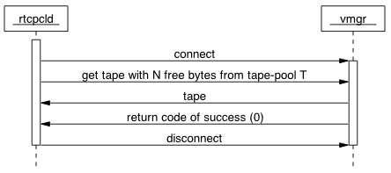

Rtcpclientd connects to the vmgr via TCP/IP and sends a message requesting a tape that can be written to and that satisfies two conditions. The tape should have a specified amount of free space and it must belong to a specified tape-pool. In response to the request, the vmgr finds an appropriate tape and sets its status within the tape catalogue to BUSY. The volume identifier of the tape along with the position of the next file to be written is sent back to rtcpclientd.

Starting an rtcpclientd worker process and an rtcpd child process

The following sequence diagram shows how rtcpclientd asks for a tape to be mounted and when rtcpd and rtcpclientd will fork their child processes to coordinate the remote tape-copy of one or more files.
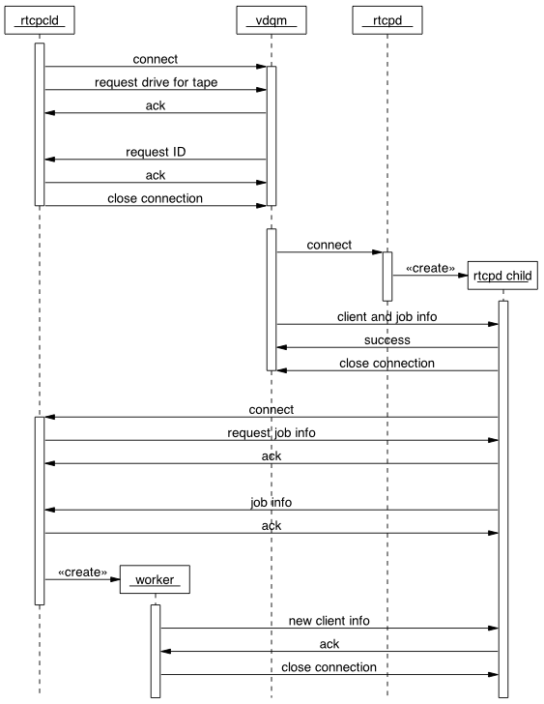
1
2
3
4

The above sequence diagram has been divided into 4 steps to help describe the details.
At step 1 rtcpclientd has determined that a tape needs to be mounted for either migration or recall. As a result, rtcpclientd sends a mount request to the vdqm for a free and compatible tape drive. The request includes the volume request identifier and the DGN of the tape. In response the vdqm queues the request from rtcpclientd and replies with a unique request identifier.

At step 2 the vdqm has asynchronously found a free and compatible drive that it can allocate to the pending mount request received earlier from rtcpclientd. The vdqm subsequently connects via TCP/IP to the rtcpd instance running on the tape-server connected to the free tape-drive. The rtcpd instance immediately forks a child process to handle the request and passes it the accepted connection. The vdqm sends to the child rtcpd process, the TCP/IP connection details of the rtcpclientd instance that requested the mount and information about the remote tape-copy job to be carried out. The job information includes the unique request identifier and the identity of the physical drive-unit to be used for the mount. The individual drive-unit needs to be identified because a single tape-server and its single instance of rtcpd may be associated with more than one physical drive. The volume identifier of the tape to be mounted is not passed from the vdqm to rtcpd.

At step 3 the rtcpd child process connects to rtcpclientd, which immediately sends back a request for the remote tape-copy job information. The rtcpd child process sends the information to rtcpclientd, which in turn uses the information to determine the volume identifier of the tape to be mounted and whether to mount the tape for read or write access.

At step4 rtcpclientd forks and execs a worker process in order to coordinate the reading or writing of the tape. When reading from a tape the worker process used is called the recaller process and when writing to a tape the name of worker process used is the migrator process. The worker process creates its own TCP/IP listening port, the details of which it then sends to the rtcpd child process via the TCP/IP connection made between the rtcpd child process and the parent rtcpclientd process. The worker process then closes the TCP/IP connection it inherited from its parent and waits for the rtcpd child process to reconnect using the newly created listening port of the worker process.

Coordinating a remote-copy

The migrator worker process exchanges more initial messages with the rtcpd child process than the recaller worker process does. When migrating files from disk to tape there is the opportunity to start copying data from disk into the memory of the tape-server whilst the tape is being mounted. Such an optimization is not possible when recalling files from tape to disk.

The following sequence diagram shows the initial messages exchanged between a migrator process and an rtcpd child process.

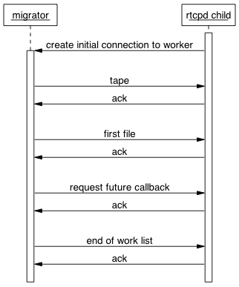

The rtcpd child process connects to the migrator process that was waiting for the connection after sending the details of its own newly created TCP/IP listening port. The newly created connection with the migrator process will hereafter be referred to as the initial connection to the worker, because more connections will be made latter between the rtcpd child process and the worker process and they will be treated differently during the shutdown logic of the legacy remote-copy protocol. Once the initial connection to the migrator has been made, the migrator process immediately sends a work list to the rtcpd child process containing the tape to be mounted, the first file to be migrated and a request that the rtcpd child process must callback the migrator process again for more work.

The following sequence diagram shows the initial messages passed between a recaller worker process and an rtcpd child process. The messages are the same as those exchanged between a migrator process and an rtcpd child process except the first file to be transferred is not sent because the tape has to be mounted before any data can be transferred to the memory of the tape-server.
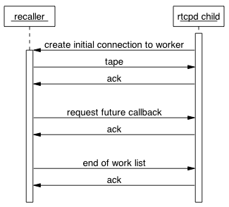
Once the rtcpd child process knows which tape to mount it internally creates one tape IO thread for reading or writing files to tape and one or more disk IO threads for remotely reading or writing disk files using TCP/IP connections to the rfiod instances running on the disk-servers. A separate control-connection between the rtcpd child process and the worker process is made for each of these IO threads as shown by the next sequence diagram. Please note that the number of disk IO threads is configurable and the following sequence diagram assumes the rtcpd child process has two.
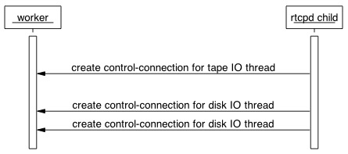
The main loop of the legacy remote-tape copy protocol can now begin given the fact that the IO threads of the rtcpd child process are created and they have access to a set of TCP/IP control-connections with the worker process. For the sake of simplicity this document will temporarily treat all of the connections between the rtcpd child process and the worker process as if they were one, and in fact the protocol does not rely on a specific connection sending and receiving specific messages until the shutdown logic starts.

The main loop of the legacy remote-tape copy protocol can be divided into two message sequences. The first, hereafter referred to as the “what’s next?” sequence, is the sequence of messages that exchanges which file should be transferred next and when the session of all the files to be transferred is finished. The second sequence of messages, hereafter referred to as the “transfer feedback” sequence, is the sequence of messages used to give feedback on individual files being transferred to tape or to disk.

The following sequence diagram describes the “what’s next?” message sequence.

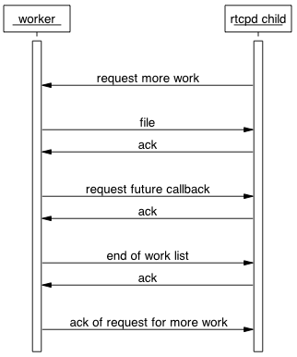

Each iteration of the main loop starts with the rtcpd child process requesting more work from the worker process. In response the worker process replies with a work list of one file to be transferred and a request for the rtcpd child process to callback again for more work.
A session of transferring one or more files can end in two ways. The worker process could run out of files to be transferred or an error could occur on either the worker process side or the rtcpd child process side. Reaching the physical end of tape when migrating files from disk to tape is considered and error, though an expected one at that.

The following sequence diagram shows the end of the “what’s next?” sequence when the worker process has ran out of work to do (files to transfer).

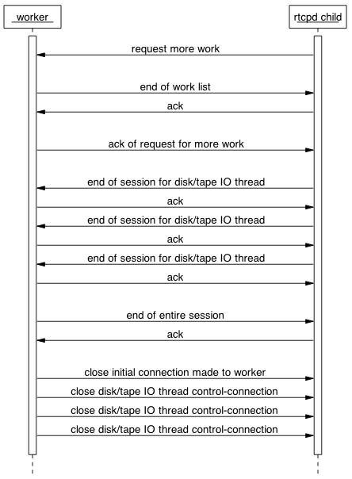
The exit process starts with the rtcpd child process asking for more work and the worker process replying with an empty work list because there are no more files to be transferred. The tape and disk IO threads of the rtcpd child process then start to individually send end of session messages when they have finished all the work they have been each assigned to do. When all the tape and disk IO threads have sent their end of session messages, the worker process sends an end of entire session message to the rtcpd child process over the initial connection to the worker process. The worker process then closes all of its connections with the rtcpd child process.

If an error occurs on the rtcpd child process side of the protocol, then the rtcpd child process sends an error message to the worker process. As mentioned before, reaching the end of a tape when migrating files to tape is considered an error, though a normal and expected one. On receiving an error message the worker process usually tries to start an abort sequence. This sequence has been seen to fail and for the purpose of designing tapebridged the simpler solution of just closing all TCP/IP connections with the rtcpd child process has been proven to be safe and adequate. This document therefore does not describe the broken abort message sequence between a worker process and an rtcpd child process.

If an error occurs on the worker process side of the protocol, then the worker process starts the broken abort message sequence with the rtcpd child process. Again, this abort sequence will not be describes because the design of tapebridged incorporates the simpler solution of just closing all TCP/IP connections with the rtcpd child process.

The following sequence diagram describes the “transfer feedback” message sequence.
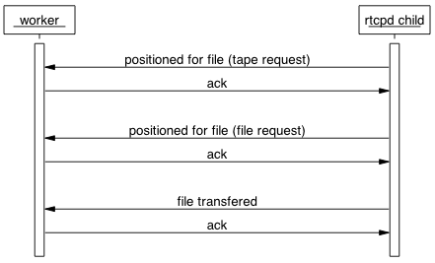
For each file transferred the rtcpd child process sends three messages. The first two signal that the tape has been positioned for the file transfer and the third states that the file in question has been successfully transferred. The two messages signaling that the tape has been positioned are semantically equivalent but are sent using two different messages structures, the tape request structure and the file request structure. This document does not go into any more detail about these structures, as will be discussed later, these two messages are only acknowledged by tapebridged and are not relayed to tapegatewayd. Tapebridged is only really interested in the file-transferred message.

Design

The structure of this section

This section is divided into five subsections including this one. The next and second subsection describes the message sequences that make up the new remote tape-copy protocol to be used between tapegatewayd, tapebridged, vdqm and rtcpd. The third subsection gives a summary of the message sequence used between just tapebridged and tapegatewayd. This summary is targeted at developers of tapegatewayd who are only interested in the interfaces of tapegatewayd as opposed to how tapebridged works. The forth subsection describes the format of the messages sent between tapebridged and tapegatewayd. The fifth subsection gives the hierarchy of the C++ classes that represent the messages sent between tapebridged and tapegatewayd. The sixth subsection gives a brief overview of the internal design of tapebridged. The idea of the sixth subsection is not to give all the low-level details, but to give the reader enough information to be comfortable navigating through the source code, which is has doxygen comments in the C++ header files.

Remote tape-copy protocol between bridge, gateway, vdqm and rtcpd

In order for a tape-server to support legacy stagers running rtcpclientd and also newer stagers running tapegatewayd, a tape-server should provide direct access to rtcpd as well as access to tapebridged. Providing support for both the legacy and new remote tape-copy protocol poses a problem for the vdqm when it wishes to start a remote tape-copy job on a tape-server with a free tape-drive. The vdqm has to know whether it must contact rtcpd directly or whether it should contact the newer tapegatewayd. The solution taken is to introduce a new type of vdqm request that asks for a free drive and explicitly asks the vdqm to connect to tapebridged.

Tapebridged acts as both the vdqm and rtcpclientd to rtcpd and its child process. The following sequence diagram shows how tapebridged effectively wraps rtcpd when tapegatewayd requests a free drive to mount a tape. Please note that the name tapegatewayd has been shortened to gateway and the name tapebridged has been shortened to bridge in order to keep the sequence diagrams less cluttered.
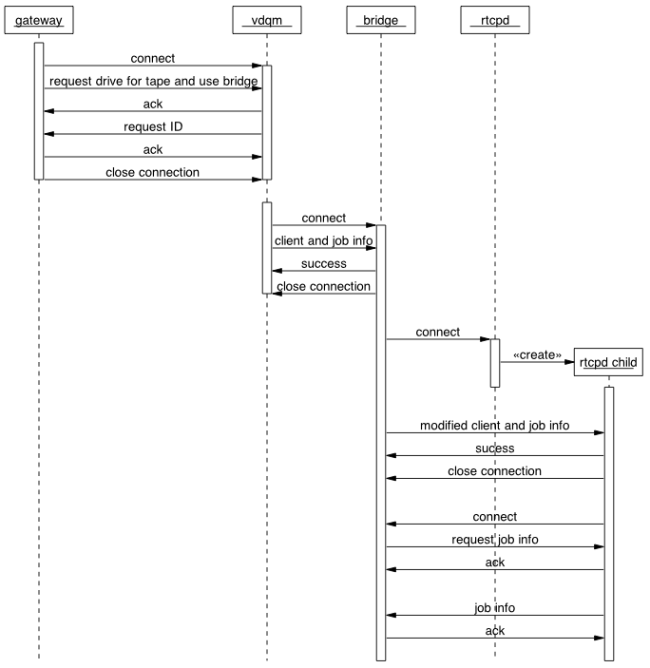

Once tapebridged has effective wrapped the rtcpd child process, it asks tapegatewayd for the volume to be mounted and whether it should be mounted for read or write. The sequence of messages exchanged is as follows.

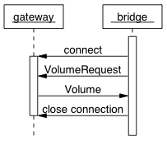

When designing the new remote tape-copy protocol it was decided to create a new connection for each request made from tapebridged to tapegatewayd. This decision was taken to keep open the possibility of supporting redundancy by being able to load balancing requests across many instances of tapebridged.

The following sequence diagram shows how in the case of migrating a file from disk to tape, tapebridged asks tapegatewayd for the first file to be migrated before sending the work list of tape-volume to be mounted, first file to be migrated and request for a future callback to the rtcpd child process.

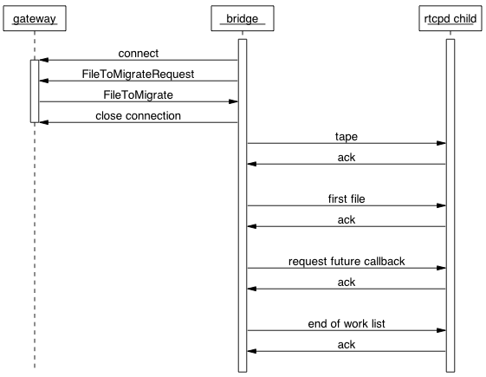
In the case of recalling a file from tape to disk, tapebridged sends a work list containing only the tape-volume to be mounted and the request for a future callback, as shown by the following sequence diagram.

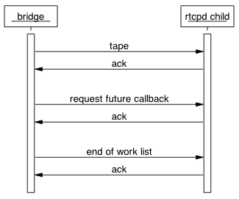
As already described in the analysis section, once the rtcpd child process knows which tape to mount it internally creates one tape IO thread for reading or writing files to tape and one or more disk IO threads for remotely reading or writing disk files using TCP/IP connections to the rfiod instances running on the disk-servers. A separate control-connection between the rtcpd child process and tapebridged is made for each of these IO threads as shown by the next sequence diagram. Please note that the number of disk IO threads is configurable and the following sequence diagram assumes the rtcpd child process has two.
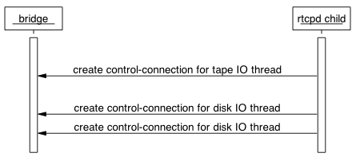
The multiple connections between the rtcpd child process and tapebridged are purposely hidden from tapegatewayd.

With the disk/tape IO control-connections made, the rtcpd process enters the main loop of asking for the next file to be transferred.

The main loop of the new remote-tape copy protocol can be divided into two message sequences. The first, hereafter referred to as the “what’s next?” sequence, is the sequence of messages that control which file should be transferred next and when the transfer session of all the files to be transferred is finished. The second sequence of messages, hereafter referred to as the “transfer feedback” sequence, is the sequence of messages used to give feedback on individual files being transferred to tape or to disk.

The following sequence diagram shows the main “what’s next?” loop.
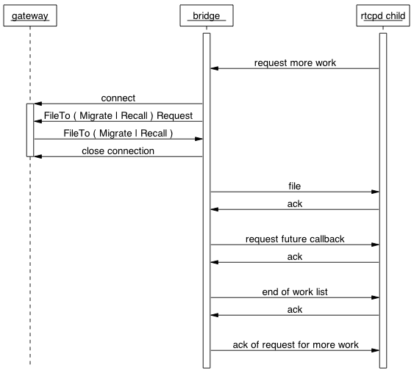
The rtcpd child process effectively loops requesting the next file to be transferred until there are no more files or an error is encountered, which as stated earlier could be generated by reaching the end of tape during a migration session. Tapebridged translates each of these requests into a connection to tapegatewayd, followed by a request for either a file to migrate or a file to recall.

The following sequence diagram shows how the protocol shutdown sequence is started when tapegatewayd has no more files to be transferred.
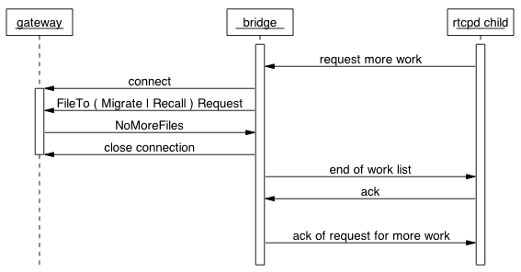
The rtcpd child process involuntarily starts the shutdown sequence by requesting more work as usual, tapebridged relays this request to tapegatewayd, which having no more files to transfer, replies to tapebridged with an explicit NoMoreFiles message. Tapebridged then sends an empty work list back to the rtcpd child process and acknowledges its request for more work.

The next sequence diagram shows that once the shutdown sequence is started the disk/tape IO threads of the rtcpd child process begin to send their individual end of session messages as they each finish the work they were assigned to do.
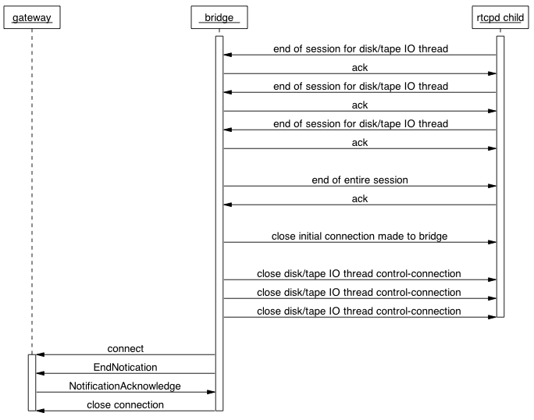

Once tapebridged has seen the end of session messages from each of the disk/tape IO control-connections, it sends the final end of rtcpd session message to the rtcpd child process. With the session now completed between tapebridged and the rtcpd child process, tapebridged connects to tapegatewayd and sends an EndNotification message that is acknowledged by tapebridged. The transfer session is now finished for all three parties: tapegatewayd, tapebridged and the rtcpd child process.

The following sequence diagram shows the “transfer feedback” message sequence.
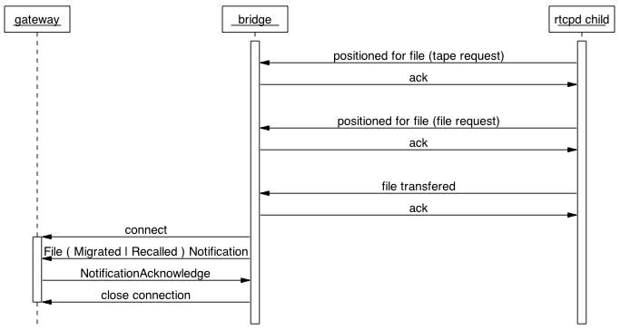

The rtcpd child process sends three messages to tapebridged for each file successfully transferred. The first two messages indicate the tape was positioned and the third and final message signifies the successful transfer of the file. Tapebridged acknowledges the two tape-positioned messages, but does not relay them to tapegatewayd. Tapebridged is only really interested in the file-transferred. Tapebridged relays the file-transferred message to tapegatewayd in the form of either a FileMigratedNotification or a FileRecalledNotification message.

Remote tape-copy protocol between the bridge and gateway

The following sequence diagram shows only the messages sent between tapebridged and tapegatewayd. This diagram is a convenience for developers and maintainers of tapegatewayd.
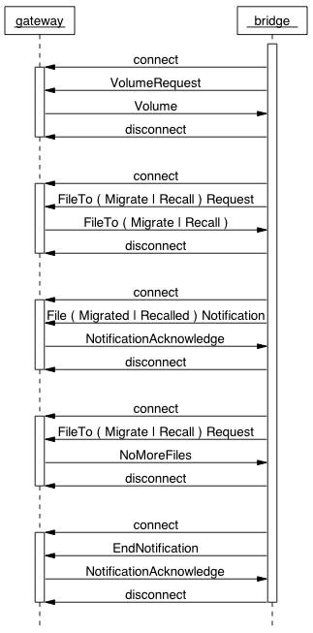
Not shown on the diagram is the fact that the vdqm has just sent tapebridged a remote tape-copy job. Tapebridged connects to tapegatewayd in order to request the tape-volume to be mounted and whether the tape-volume should be read or written. The above sequence diagram describes the scenario of a single file being transferred, therefore tapebridged gets to ask for work twice, the first time it gets a file to transfer and the second time it receives a NoMoreFiles message. Tapebridged sends tapegatewayd a FileMigratedNotification or a FileRecalledNotification message when the transfer of the file has completed successfully. When tapebridged has determined that there are no more files to be transferred and all files have been transferred (in this case there is only one), tapebridged sends an EndNotification message to tapegatewayd. The file transfer session is now complete.

The following table lists each message that can be sent from tapebridged to tapegatewayd. For each message the table gives the possible messages with which tapegatewayd can reply.

Bridge to Gateway | Gateway to Aggregator | Comment
VolumeRequest | Volume | Good day
VolumeRequest | NoMoreFiles | Good day
VolumeRequest | EndNotificationErrorReport | Bad day – Abort mount
FileToMigrateRequest or FileToRecallRequest | FileToMigrate or FileToRecall | Good day
FileToMigrateRequest or FileToRecallRequest | NoMoreFiles | Good day
FileToMigrateRequest or FileToRecallRequest | EndNotificationErrorReport | Bad day – Abort mount
FileMigratedNotification or  FileRecalledNotification | NotificationAcknowledge | Good day
FileMigratedNotification or  FileRecalledNotification | EndNotificationErrorReport | Bad day – Abort mount
EndNotification | NotificationAcknowledge | Good day
EndNotification | EndNotificationErrorReport | Bad day – Abort mount
FileErrorReport | NotificationAcknowledge | Bad day – Abort file
FileErrorReport | EndNotificationErrorReport | Bad day – Abort mount
EndNotificationErrorReport | NotificationAcknowledge | Bad day – Abort mount
EndNotificationErrorReport | EndNotificationErrorReport | Bad day – Abort mount
DumpNotification | NotificationAcknowledge | Good day
DumpNotification | EndNotificationErrorReport | Bad day – Abort mount

Format of messages sent between bridge and gateway

The following tables describe the format of the messages sent between tapebridged and tapegatewayd.

VolumeRequest message
Member | Type | Description
mountTransactionId | Unsigned 64-bit integer | Uniquely identifies the mount across all tape servers
Unit | String

Volume message
Member | Type | Description
mountTransactionId | Unsigned 64-bit integer | Uniquely identifies the mount across all tape servers
vid | String
mode | Enumeration | READ =0 WRITE = 1 DUMP = 2
density | String
label | String
dumpTapeMaxBytes | Integer
dumpTapeBlockSize | Integer
dumpTapeConvert | Integer
dumpTapeErrAction | Integer
dumpTapeStartFile | Integer
dumpTapeMaxFile | Integer
dumpTapeFromBlock | Integer
dumpTapeToBlock | Integer

FileTo Recall / Migrate Request message
Member | Type | Description
mountTransactionId | Unsigned 64-bit integer | Uniquely identifies the mount across all tape servers

FileToRecall message
Member | Type | Description
mountTransactionId | Unsigned 64-bit integer | Uniquely identifies the mount across all tape servers
fileTransactionId | Signed 64-bit integer | Uniquely identifies the file transfer within the namespace of the mountTransactionId
nshost | String
fileid | Unsigned 64-bit integer | CASTOR names server file ID
fseq | Signed 32-bit integer | CASTOR tape file sequence number
positionCommandCode | Enumeration | TPPOSIT_FSEQ, TPPOSIT_FID, TPPOSIT_EOI, TPPOSIT_BLKID
path | String
blockId0 | Unsigned 8-bit integer
blockId1 | Unsigned 8-bit integer
blockId2 | Unsigned 8-bit integer
blockId3 | Unsigned 8-bit integer

FileRecalledNotification message
Member | Type | Description
mountTransactionId | Unsigned 64-bit integer | Uniquely identifies the mount across all tape servers
fileTransactionId | Signed 64-bit integer | Uniquely identifies the file transfer within the namespace of the mountTransactionId
nshost | String
fileid | Unsigned 64-bit integer | CASTOR names server file ID.
fseq | Signed 32-bit integer | CASTOR tape file sequence number
positionCommandCode | Enumeration | TPPOSIT_FSEQ, TPPOSIT_FID, TPPOSIT_EOI, TPPOSIT_BLKID
path | String
checksumName | String
checksum | Unsigned 64-bit integer
fileSize | Unsigned 64-bit integer

NotificationAcknowledge message
Member | Type | Description
mountTransactionId | Unsigned 64-bit integer | Uniquely identifies the mount across all tape servers

NoMoreFiles message
Member | Type | Description
mountTransactionId | Unsigned 64-bit integer | Uniquely identifies the mount across all tape servers

EndNotification message
Member | Type | Description
mountTransactionId | Unsigned 64-bit integer | Uniquely identifies the mount across all tape servers

FileToMigrate message
Member | Type | Description
mountTransactionId | Unsigned 64-bit integer | Uniquely identifies the mount across all tape servers
fileTransactionId | Signed 64-bit integer | Uniquely identifies the file transfer within the namespace of the mountTransactionId
nshost | String
fileid | Unsigned 64-bit integer | CASTOR names server file ID.
fseq | Signed 32-bit integer | CASTOR tape file sequence number
positionCommandCode | Enumeration | TPPOSIT_FSEQ, TPPOSIT_FID, TPPOSIT_EOI, TPPOSIT_BLKID
fileSize | Unsigned 64-bit integer
lastKnownFileName | String | Last known filename as cached in the stager database. This maybe days old.
lastModificationTime | Unsigned 64-bit integer | Number of seconds since the EPOCH GMT. The timestamp for the lastKnownFileName
path | String

FileMigratedNotification message
Member | Type | Description
mountTransactionId | Unsigned 64-bit integer | Uniquely identifies the mount across all tape servers
fileTransactionId | Signed 64-bit integer | Uniquely identifies the file transfer within the namespace of the mountTransactionId
nshost | String
fileid | Unsigned 64-bit integer | CASTOR names server file ID.
fseq | Signed 32-bit integer | CASTOR tape file sequence number
positionCommandCode | Enumeration | TPPOSIT_FSEQ, TPPOSIT_FID, TPPOSIT_EOI, TPPOSIT_BLKID
fileSize | Unsigned 64-bit integer
checksumName | String
checksum | Unsigned 64-bit integer
compressedFileSize | Unsigned 64-bit integer
blockId0 | Unsigned 8-bit integer
blockId1 | Unsigned 8-bit integer
blockId2 | Unsigned 8-bit integer
blockId3 | Unsigned 8-bit integer

FileErrorReport message
Member | Type | Description
mountTransactionId | Unsigned 64-bit integer | Uniquely identifies the mount across all tape servers
fileTransactionId | Signed 64-bit integer | Uniquely identifies the file transfer within the namespace of the mountTransactionId
nshost | String
fileid | Unsigned 64-bit integer | CASTOR names server file ID.
fseq | Signed 32-bit integer | CASTOR tape file sequence number
positionCommandCode | Enumeration | TPPOSIT_FSEQ, TPPOSIT_FID, TPPOSIT_EOI, TPPOSIT_BLKID
errorCode | Signed 32-bit integer
errorMessage | String

EndNotificationErrorReport message
Member | Type | Description
mountTransactionId | Unsigned 64-bit integer | Uniquely identifies the mount across all tape servers
errorCode | Signed 32-bit integer
errorMessage | String

DumpNotication message
Member | Type | Description
mountTransactionId | Unsigned 64-bit integer | Uniquely identifies the mount across all tape servers
message | String | The message string sent to the aggregator by RTCPD via a GIVE_OUTP message

Inheritance hierarchy of bridge and gateway message classes
The following class diagram shows the inheritance hierarchy of the C++ classes representing the messages sent between tapebridged and tapegatewayd.

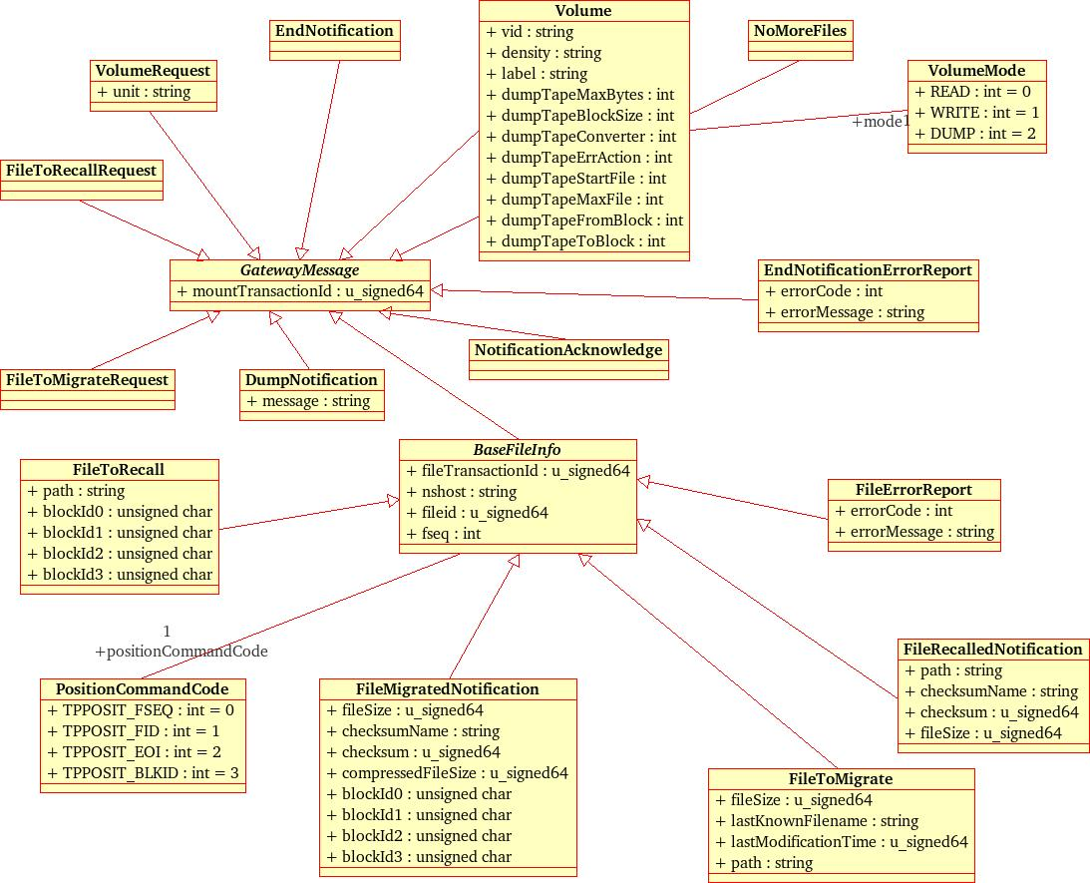

The internal design of the tape-bridge daemon

The following class diagram shows the main classes making up the static structure of tapebridged.
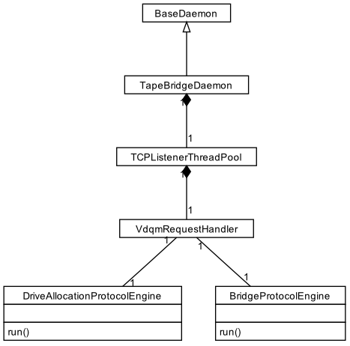

The C++ class named TapeBridgeDaemon represents tapebridged. The class uses the CASTOR framework by inheriting from BaseDaemon.

TapeBridgeDaemon assigns one thread to each concurrent tape mount, as a single tape-server may be connected to more than one tape-drive. TapeBridgeDaemon implements this threading strategy by containing a TCPListenerThreadPool of VdqmRequestHandlerThreads. The number of threads in the pool is set to the number of drives found in the following configuration file on the tape-server:

/etc/castor/tpconfig

When the vdqm connects to tapebridged, the TCPListenerThreadPool gives the newly accepted connection to the run() method of one of the contained VdqmRequestHandler threads. The thread in question then uses a DriveAllocationProtocolEngine object to get to the stage in the new remote tape-copy protocol where the tapebridged has just got the tape-volume to be mounted from tapegatewayd.

Now that the VdqmRequestHandler thread being used for the mount knows the tape-volume to be mounted it then calls the run() method a helper BridgeProtocolEngine object to iterate through the main loop of the new remote tape-copy protocol. The run() method effectively results in the VdqmRequestHandler thread spinning in a TCP/IP select() loop until the file transfer session is completed by either tapegatewayd indicating there are no more files to be transferred or by an error occurring which includes the physical end of tape being reached in the case of files being migrated from disk to tape.

The BridgeProtocolEngine uses the select() loop to decouple the sending of requests for more work to tapegatewayd from reading back the replies. This decoupling is crucial in gaining good performance with the design choice of one VdqmRequestHandler thread per ongoing tape-mount. Requests from the individual disk/tape IO threads of an rtcpd child process must not be blocked by the relatively slow responses of tapegatewayd to requests for more work.

The end of this document has now been reached as the main classes making up the static structure of tapegatewayd have been described.

