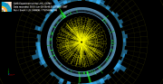**ACTIVITY ONE: HUNTING PARTICLES AFTER A COLLISION**

**Description of the activity**

In this activity students will explore the particles obtained from a two proton collision in the CMS detector. For this, they will use the even visualizer

**Objective**

To understand the basics of the CMS detector system and how and where the particles are detected. This activity will also consolidate knowledge about how the properties of the particles can be used to detect them in different ways.

**Needed background**

Students need to understand the basics about the Large Hadron Collider and the CMS detector.

* Suggested video about the LHC: <https://www.youtube.com/watch?v=pQhbhpU9Wrg>
* Suggested video about the CMS: <https://www.youtube.com/watch?v=S99d9BQmGB0>

Moreover, students need to be familiar with the particles from the standard model. At the end of this activity there is a key with basic information about the particles needed for this activity.

The file used for this activity is found in the Education folder of the visualization event: dimuon_0.ig

This data corresponds to the decay of a Z boson into two muons (muon-antimuon). The Z boson is an exchange particle mediating weak interactions. Z is neutral, so, the sum of the charges of its decay products must be zero. When the Z boson decays there are different possibilities but we will only focus on the dimuon decay.[1]

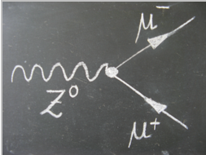

*Feynman diagram of the decay of the Z boson into two muons.*

**Lesson plan:**

* Teacher shows videos about the LHC and CMS. (10 min)
* Students need to first explore the different parts of the detector in the visualizer with the help of the interactive CMS slice. (10 min)
* Students open an event in the visualizer and learn the basic functions of it. (10 min)
* Each student needs to select one event by using the arrows to move between events.(1-100)
* Students need to identify the different objects that they see in the event display and answer a set of questions (20-30 min).

Note: most of the events show two muons, but in some events only one muon is shown. This is due to the fact that the track of the muon in the tracker did not match with the track in the muon tracker. It is important to mention that the data in the visualizer is not the original “raw” data from the detector. It has been processed and only the relevant data is shown.

[1] http://atlas.physicsmasterclasses.org/en/zpath_lhcphysics2.htm

**HUNTING PARTICLES AFTER A COLLISION**

**Objective**

Today you are going to be a Scientist and you will try to identify the particles created in a collision in the CMS detector of the LHC.

**Instructions**

* You have seen two videos about the LHC and the CMS detector. Now you are going to explore in a much more detailed way the different parts of the CMS detector and how particles are detected depending on their characteristics. Use this link to access the interactive slice of the CMS detector: <https://www.i2u2.org/elab/cms/graphics/CMS_Slice_elab.swf>

At the end of this worksheet you can find a key with basic information about the particles.

* Now you are going to learn how to open an even an visualize it in the event display:

You can find the visualizer here:

<http://opendata.cern.ch/visualise/events/CMS>

Some basics about the functionalities of the top up buttons.

Different axes

Open files

Initial orientation

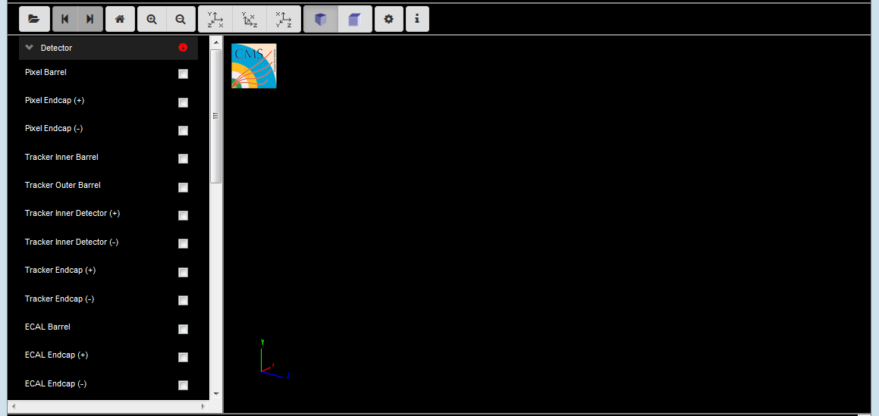

Basic information about the menu.

Navigate between events

Zoom in/zoom out

The menu on the left contains the different detector parts. Before starting using it, is important to be familiar with the different CMS detector parts and the function of each of them. You can select the different parts and you will see how do they look like in three dimensions.

**Open a set of data:**

* Click the open data button 
* This window will appear:

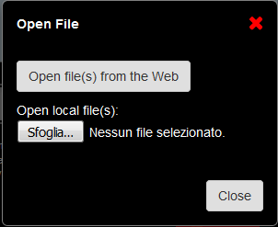

* Choose to open file(s) from the Web. These files are found in the Open data portal from CERN.

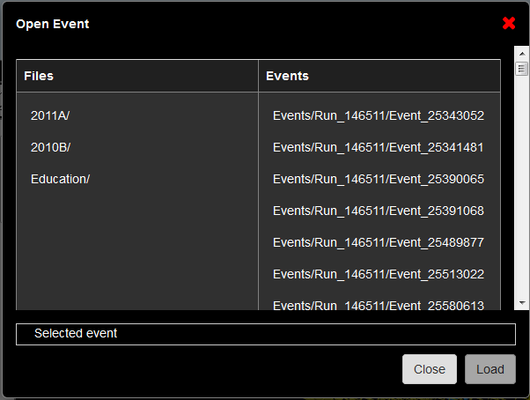

* Within the folder education you can find several interesting examples.

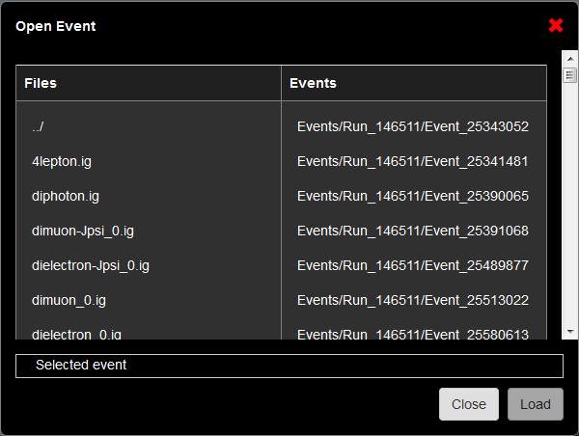

We are going to open the dimuon_0.ig file. Click on the first event and select “Load”.

Once is loaded, select “Close”.

* Once you see your event, you will see in the upper part that there are 100 events in the file. Navigate between the events with the help of the arrows in the top up menu and select one of the events.

**Event number selected:**

* Now you have to identify the different tracks and hits that you see in the detector:

|  |  |  |
| --- | --- | --- |
| Visualiser | Where are they detected? | Which particle is it? |
| Yellow tracks |  |  |
| Green dots |  |  |
| Blue volumes |  |  |
| Red tracks |  |  |

**Questions**

Do your results fit with the detection of the different particles in the interactive slice CMS?

Compare your results with your classmates and see if you can arrive to an agreement.

**Particles Key**

**Electron**: A stable elementary particle belonging to the first generation of the lepton family of particles. It has a -1 electrical charge, while its anti-particle, the anti-electron or positron, has a +1 electrical charge. Atoms are made of electrons orbiting positively charged nuclei. An electron has a mass of approximately 0.5 MeV/c^2, or about 1/1836 times the mass of a proton.

**Photons**: A stable elementary particle belonging to the “boson” family of particles. Photon is the carrier of the electromagnetic force and is massless with no electrical charge. It is represented by the Greek letter gamma.

**Hadron**: A composite particle made of two or more quarks. There are two sub-categories of hadrons: baryons such as protons and neutrons are made of three quarks (or three anti-quarks), while mesons are made of a quark and an anti-quark.

**Muon**: An elementary particle belonging to the second generation of the lepton family of particles. It has a -1 electrical charge, while its anti-particle, the anti-muon, has a +1 electrical charge. Muon properties are similar to those of an electron but it is around 200 times more massive. It is represented by the Greek letter mu.

**ACTIVITY TWO: CALCULATION OF INVARIANT MASS**



**Description of the activity**

In this activity we will calculate the invariant mass from the data obtained in a dimuon event. Students will learn the meaning of invariant mass and how can we mathematically calculate it.

What is invariant mass?

Is a characteristic of the total [energy](https://en.wikipedia.org/wiki/Energy) and [momentum](https://en.wikipedia.org/wiki/Momentum) of an [object](https://en.wikipedia.org/wiki/Physical_body) or a [system](https://en.wikipedia.org/wiki/Physical_system) of objects that is the same in all [frames of reference](https://en.wikipedia.org/wiki/Frames_of_reference). This quantity remains invariant in particle collisions.

**Objective**

Learn how to calculate invariant mass in a two-particle decay.

**Needed background**

The students need to have previous knowledge about what happens in a collision and how particles are detected. It is recommended to do activity one before this one.

The file we will use for this activity is the same file used before, which is found in the Education folder of the visualization event: dimuon_0.ig

This data corresponds to the decay of a Z boson into two muons (muon-antimuon). The Z boson is an exchange particle mediating weak interactions. Z is neutral, so, the sum of the charges of its decay products must be zero. When the Z boson decays there are different possibilities but we will only focus on the dimuon decay.[1]



*Feynman diagram of the decay of the Z boson into two muons.*

In a two-particle collision (or a two-particle decay) the square of the invariant mass is:

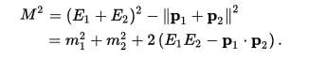

In particle collider experiments, one often defines the angular position of a particle in terms of an angle *φ* (phi) and the spacial coordinate *η* (eta). Additionally, the transverse momentum, pT is usually measured. [2]



This is the equation that we will use to calculate the invariant mass.

**Lesson plan**

* Introduction about invariant mass (10 min). What is invariant mass?
* Introduction about the collision we are going to use- decay of a Z boson into two muons (10 min)
* Students explore the data of one of the events with two muons. It is important that there are two muons in the even to be able to use the data for the calculation. (20 min)
* Discussion about what will happen with this data after: the data of every invariant mass could be plotted in a histogram. Discussion about the need of more data to obtain a conclusion. (20 min)

[1] http://atlas.physicsmasterclasses.org/en/zpath_lhcphysics2.htm

[2] https://en.wikipedia.org/wiki/Invariant_mass

**CALCULATION OF INVARIANT MASS**

**Objective**

The objective is to calculate invariant mass from a decay of a Z boson into two muons.

**Instructions**

Before you are doing this activity you should be familiar with the event display.

Now you are going to **open a set of data**:

* Click the open data button 
* This window will appear:



* Choose to open file(s) from the Web. These files are found in the Open data portal from CERN.



* Within the folder education you can find several interesting examples.



We are going to open the dimuon_0.ig file. Click on the first event and select “Load”.

In this event we are interested in the two muons. We can obtain information about the data associated with these two muons by using two different options.

* Clicking the muon track in the visualizer. You will obtain this window:

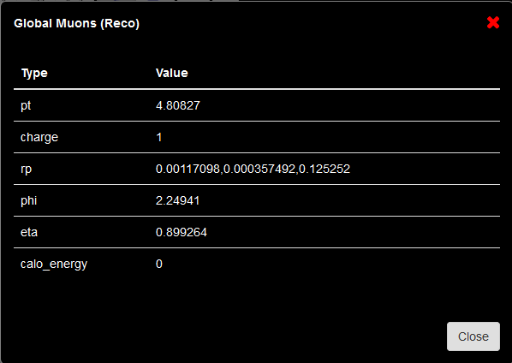

* By clicking the menu option Global Muons. Just click over the name and at the bottom of the visualizer a new table with the data will appear. It will look like this:

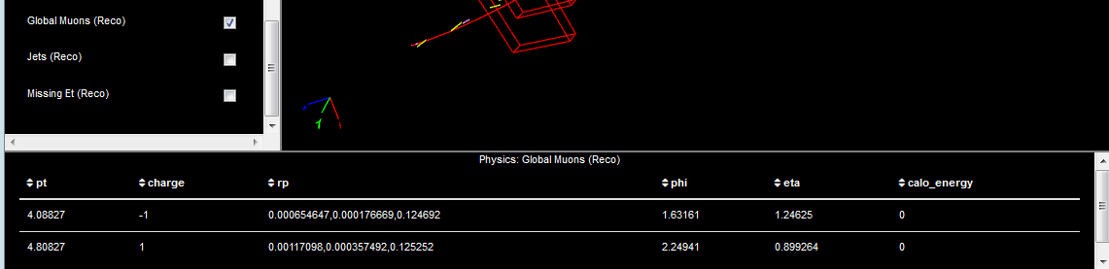

Click here!!

**How are we going to use this data?**

This data corresponds to the decay of a Z boson into two muons (muon-antimuon). The Z boson is an exchange particle mediating weak interactions. Z is neutral, so, the sum of the charges of its decay products must be zero. When the Z boson decays there are different possibilities but we will only focus on the dimuon decay.[1]



*Feynman diagram of the decay of the Z boson into two muons.*

In a two-particle collision (or a two-particle decay) the square of the invariant mass is:



In particle collider experiments, one often defines the angular position of a particle in terms of an angle *φ* (phi) and the spacial coordinate *η* (eta). Additionally, the transverse momentum, pT is usually measured. [2]



This is the equation that we will use to calculate the invariant mass.

Complete the following table with the data from each of the muons:

|  |  |  |  |  |
| --- | --- | --- | --- | --- |
| Muons | pT | *φ* (phi) | *η* (eta) | M |
| 1 |  |  |  |  |
| 2 |  |  |  |

**What do we do with the invariant mass?**

Scientist at CERN would plot all the invariant mass values in a histogram. You could try to plot a histogram with all the data from your class and see if you can see any peak.

Do you think you have enough data to obtain any conclusion from this histogram?