TUTORIAL AND CLASSROOM ACTIVITIES

What does this document contains?

CERN has made available in their homepage data from the CMS detector. This data can be visualized, for example, in an interactive visualizer that can be found in the Opendata portal in cern ([www.opendata.cern.ch](http://www.opendata.cern.ch)). This document contains a tutorial to learn about the visualization display. There is a second document associated to this documents that contains two classroom activities. In each of these activities, instructions for the teacher are included and a worksheet to be used by the students during the lesson. It is important that you familiarize with the visualization display and the different parts of the detector and the particles detected in each part.

VISUALISATION OF DATA FROM CMS DETECTOR

**VISUALISATION DISPLAY**

The CMS visual display can be used to visualize data obtained in the CMS detector. It can be found here:

<http://opendata.cern.ch/visualise/events/CMS>

Some basics about the functionalities of the top up buttons.

Different axes

Initial orientation

Open files

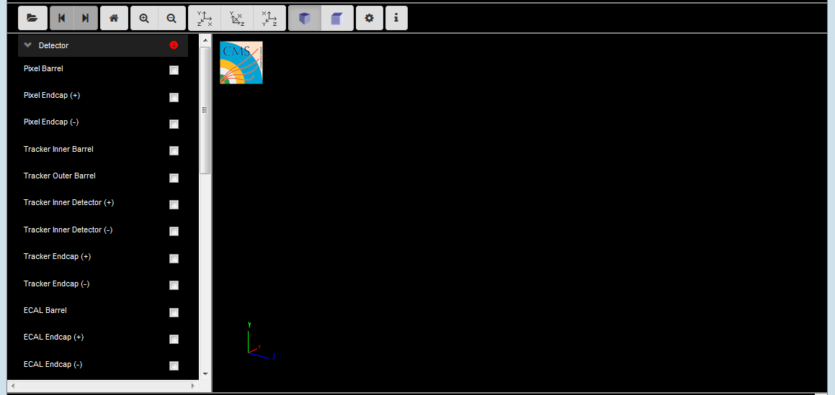

Basic information about the menu.

Zoom in/zoom out

Navigate between events

The menu on the left contains the different detector parts. Before starting using it, is important to be familiar with the different CMS detector parts and the function of each of them.

**WHAT IS CMS?**

The Compact Muon Solenoid (CMS) is a detector at the large hadron collider (LHC). The CMS detector is built around a huge solenoid magnet. This takes the form of a cylindrical coil of superconducting cable that generates a field of 4 tesla, about 100.000 times the magnetic field of the Earth. The complete detector is 21 meters long, 15 meters wide and 15 meters high [1].

To understand it better we can use a very nice interactive CMS detector slice that can be found here:

<https://www.i2u2.org/elab/cms/graphics/CMS_Slice_elab.swf>

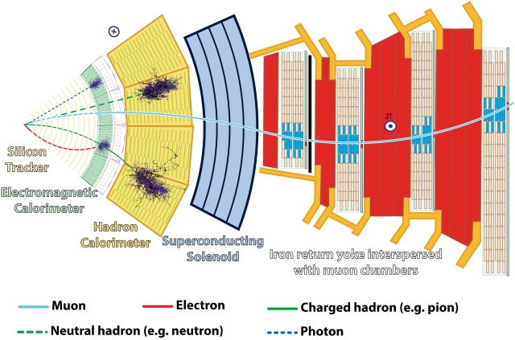

Information about each part:

**Tracker**

The tracker is the inner layer of the detector and allows the momentum of particles to be calculated by tracking its path through a powerful magnetic field. The tracker is made entirely of silicon and particles leave energy when they “hit” the silicon detectors allowing their paths to be tracked through each layer. The very core of the tracker is called the crystal barrel, this has the highest resolution and is essential for detecting the vertex (or creation) of an event. There are also the inner and outer trackers, in total there are 10 layers where particles are detected.

**Electromagnetic Calorimeter**

The Electromagnetic Calorimeters (ECAL) is made of lead tungstate (PbWO4) crystals which measure the energy of electrons and photons. Lead tungstate crystals can withstand large amounts of radiation and cause high energy electrons to lose energy (by bremsstrahlung) and high energy photons to lose energy (by e+e- pair production). Detectors connected to each crystal measure the energy deposited and create an electrical signal, allowing scientists to visualise the distribution of energy throughout the calorimeter.

**Hadron Calorimeter**

The Hadron Calorimeter (HCAL) measures the energy of “hadrons” particles made of quarks and gluons. The HCAL measures energy, position and arrival time using alternating layers of “absorber” and fluorescent “scintillator” materials that produce rapid light pulses when particles pass through. It consists of four sections, the hadron barrel (HB), the hadron outer (HO) detector, the Hadron endcap (HE) and the forward (HF).

**Muon Detector**

Muons can penetrate many meters of iron without interacting and are not stopped by any of CMS’s calorimeters and are the only particles which reach the muon detector. The muon detector consists of 250 drift tubes and 540 cathode strip chambers which track the muons’ position and 610 resistive plate chambers which form a trigger system which quickly decides to keep the acquired data or not. The momentum of the muons is determined by the muon bending in the 4 Tesla magnetic field.

**VISUALISATION OF AN EVENT**

So, now we are ready to open an event and look at real data:

**What is an event?**

An event is a fundamental interaction that takes place when particle collide in the detector. In a particle physics event incoming particles are scattered or destroyed and depending on the energy hundreds of particles can be produced. Events can be visualised and examined using the “visualise events” tool.

How to open a set of data:

* Click the open data button 
* This window will appear:

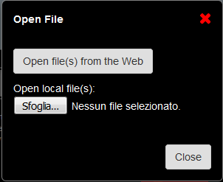

* Choose to open file(s) from the Web. These files are found in the Open data portal from CERN.

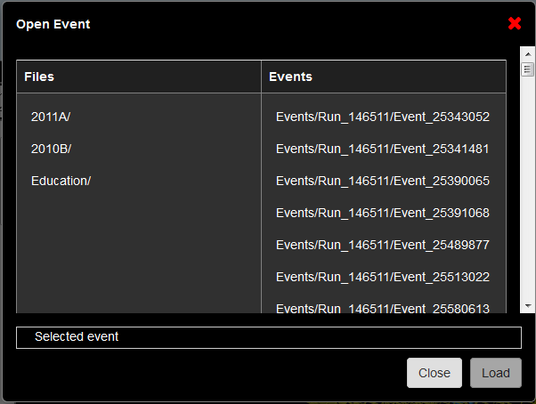

* Within the folder education you can find several interesting examples.

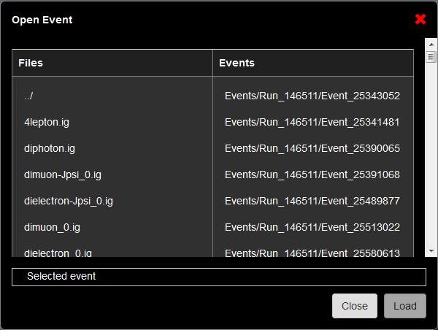

As an example we are going to open the dimuon_0.ig file. Click on the event and select “Load”.

Once is loaded, select “Close”. This is what you will see:

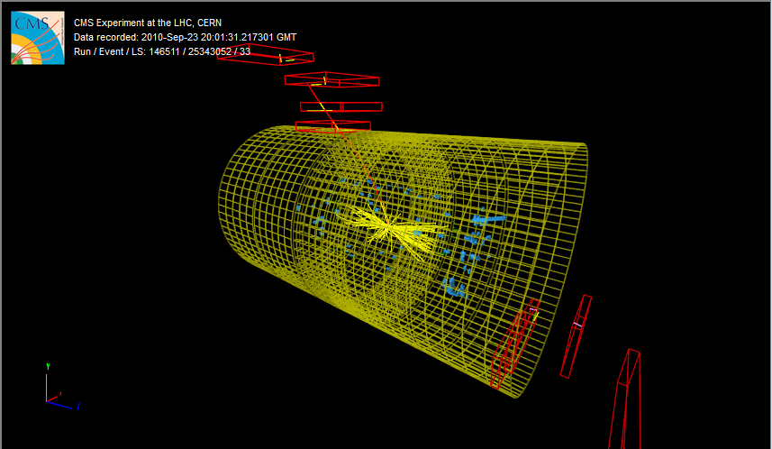

What do we see?

Let’s look at the left menu of the visualizer. There are 8 sub-menus:

* **Detector:** Corresponds to the different detector parts. We have learned all these parts previously. Only the HCAL outer is selected as a reference
* **Imported**: N.A.
* **Provenance**:
  + Event: see the event information in the screen.
* **Tracking**: Corresponds to the tracking system.

We obtain first the hits in the clusters. From these we can obtain the reconstructed tracking hits and the matching tracker Dets (detector), which will help us to obtain the reconstructed tracks. Try to select them and see how the clusters and reconstructed tracking hits look like in the detector.

* + Si Pixel Clusters: (red points)
  + Si Strip Clusters: (red points)
  + Tracking Rec Hits: (yellow dots)
  + Matching Tracker Dets: (yellow rectangles)
  + Tracks (rec.) (yellow tracks): Reconstructed tracks (selected) of electrons and photons
* **ECAL**

Reconstructed hits in the barrel and endcap ECAL detectors.

* + Barrel Rec Hits (Selected) (green dots)
  + Preshower Rec. Hits : NA
  + Endcap Rec. Hits (Selected) (green dots)
* **HCAL**

The reconstructed hits are shown in every part of the detector.

* + Barrel Rec. Hits (Selected) (Blue volumes)
  + Endcap Rec. Hits (Selected) (Blue volumes)
  + Outer Rec. Hits (Blue volumes)
  + Forward Rec. Hits (Blue volumes)
* **Muon**
  + Matching Muon Chambers (Selected): correspond to the reconstructed muons. (red empty volumes)
  + CSC Segments (Selected): Cathode strips chambers hits. (pink segments)
  + RPC Rec. Hits (Selected): Resistive plate chambers hits. (yellow segments)
  + DT Rec. Segments (4D) (Selected): Drift tubes reconstructed segments. (yellow segments)
  + DT. Rec. Hits: Drift tubes reconstructed hits. (green segments)
* **Physics**
  + Electron tracks: it will only appear in the menu if electrons have been found. (green tracks)
  + Tracker Muons (Reco) (Selected): Track of the muon in the tracker. (red tracks)
  + Stand-alone Muons (Reco): detection in the muon chambers. (red tracks)
  + Global Muons (Reco) (Selected): reconstructed track of the muons. (red tracks)
  + Jets(Reco): shower of particles in the ECAL and HCAL (yellow pyramids)
  + Missing Et (Reco): N.A.

In this event we are interested in the two muons. We can obtain information about the data associated with these two muons by using two different options.

* Clicking the muon track in the visualizer. You will obtain this window:

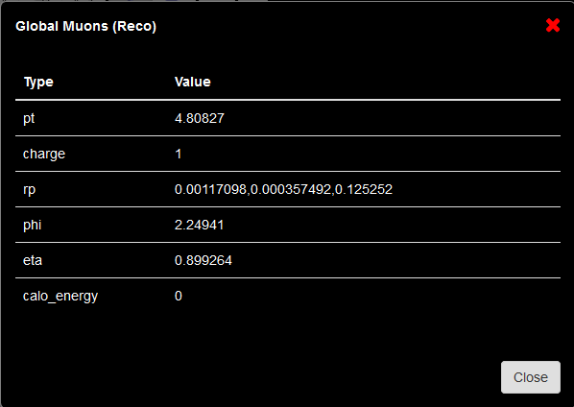

* By clicking the menu option Global Muons. Just click over the name and at the bottom of the visualizer a new table with the data will appear. It will look like this:

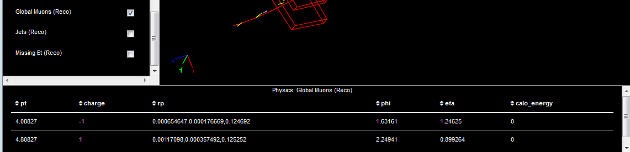

Click here!!

We are going to use this data for the classroom activities. Use time to familiarize with the different parts of the detector and the different particles hits and tracks.

**General ideas for using other datasets:**

There are different data sets you can open from the education folder. We have used the example of a Z boson decay into two muons. Depending on the data set you open, the visualization can be different and it can be that some of the options are not shown, as for example, the matching muon chambers. This is related with the nature of the data and the time when it was acquired.

References

[1] <https://home.cern/about/experiments/cms>