These are instructions for creating an invariant mass histogram using EXCEL and CERN’s open data. The data is from dimuon decay and will peak at around 90 GeV for the Z boson. This is actual data from the Compact Muon Solenoid (CMS) which has been acquired, analyzed, filtered and identified as collisions in the Large Hadron Collider (LHC) as those that exhibit two muons.

**Instructions for acquiring the open data:**

1. Download the comma separated(.csv) file at: <http://opendata.cern.ch/record/700>. Or go to the opendata homepage and

* + - click education (start learning)
    - click explore CMS
    - type dimuon event information into the search field
    - click the first search result

1. It is the largest file, MuRun2010B.csv, around 15 MB in size.

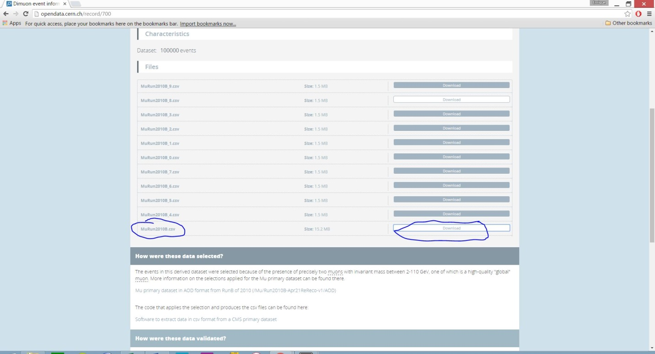

Figure 1: download MuRun2010B.csv (This is data from the first LHC run, taken in 2010)

Note: you can have students download the other files too. The largest dataset contains 100,000 collisions. The more data you have in the histogram, the more statistically accurate it will be.

**The physics involved:**

It is known that Z bosons can transform(decay) into two muons. When analyzing the dimuons invariant masses from the data, it is possible to find out the masses of the particles which they are transformed(decayed) from.

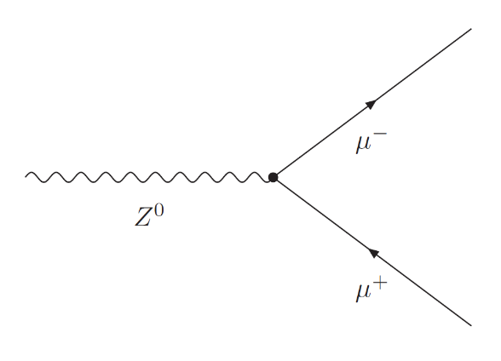

Figure 2: Feynman Diagram of Z-boson decay.

|  |  |
| --- | --- |
| http://1.bp.blogspot.com/-0LH8t5hJ-rE/UpNA7S4l2OI/AAAAAAAAAPY/kw5EYUqs5OQ/s320/Screen+Shot+2013-11-25+at+8.20.32+PM.png | We can calculate the invariant mass using a right triangle analogy between mass, energy and momentum. This equation simplifies if we set the speed of light, c =1.  We get $E^{2}=m^{2}+{\overline{p}}^{2}$   Solving for mass m, $$m=\sqrt{E^{2}-{\overline{p}}^{2}}$$ |

When we have 2 muons, in order to get the invariant mass of the particle which produced the muons, we have to add the energies and momenta, so our equation becomes:

$$m=\sqrt{{(E_{1}+E_{2})}^{2}-{({\overline{p}}_{1}+{\overline{p}}_{2})}^{2}}$$

Momentum is a vector quantity and must be summed in accordance with vector rules. To get a resultant vector, we add the components first, and then get the magnitude of the resultant vector by using the Pythagorean theorem in 3-dimensions.

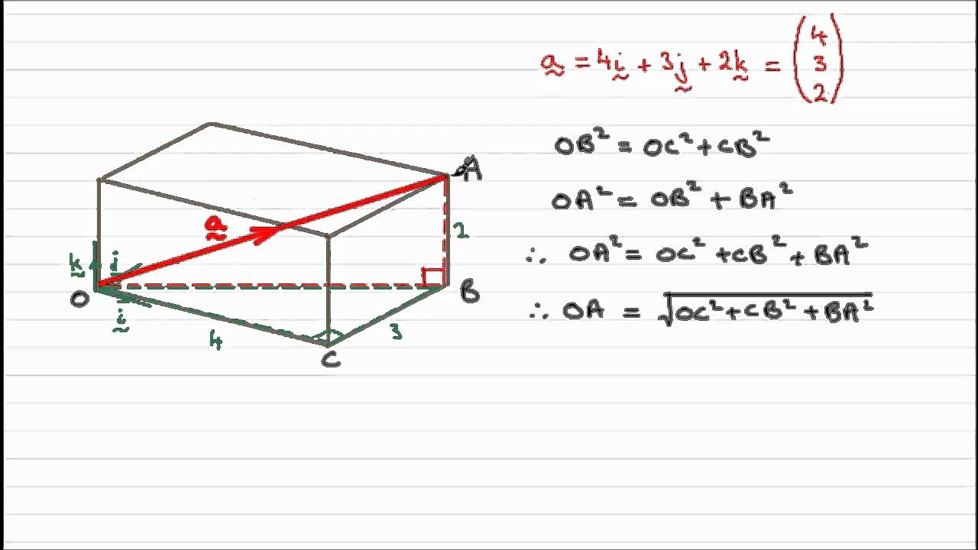

Figure 3: The magnitude of a 3d vector is just the sum of the squares, rooted.

**Using open data:**

1. Open the downloaded file with EXCEL or other spreadsheet program

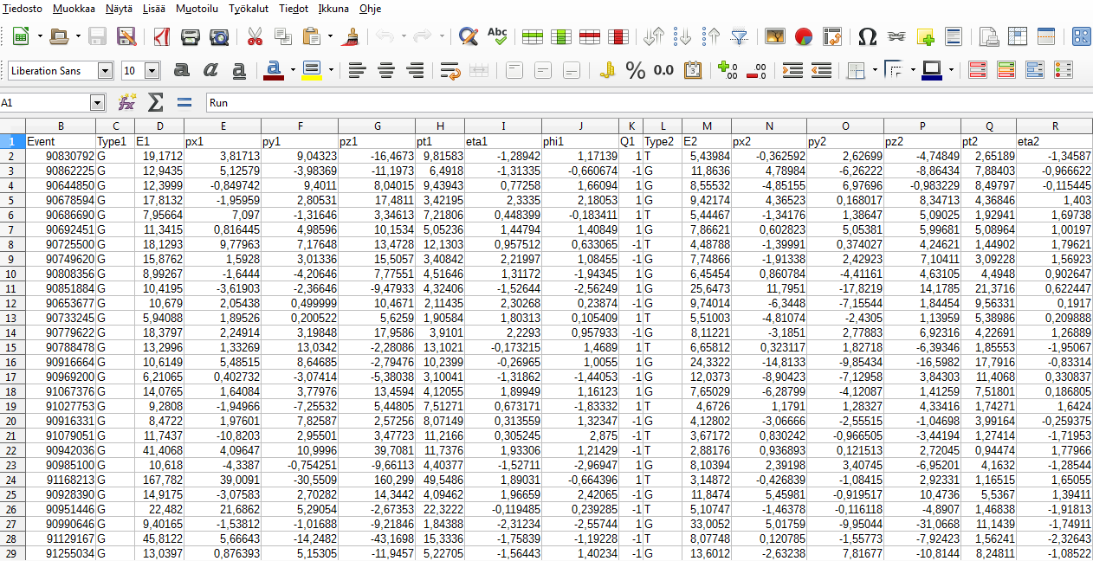

Figure 4: .csv file opened in LibreOffice

Note!: Differences in notations can cause troubles. (for example . vs ,)

Glossary for the columns:

* Run: The data collected by CMS in a given year are divided into sets called “Runs”. For example, the data from 2010 were divided into “RunA” and “RunB”, the latter being from the second part of the year. Run is a data collection period with a variable length of time
* Event: One proton - proton collision
* Type1: G = global muon, T = tracker muon (observed only in tracker)
* E1: energy of muon number 1
* px1: momentum in the direction of the x-axis of muon number 1
* py1: momentum in the direction of the y-axis of muon number 1
* pz1: momentum in the direction of the z-axis of muon number 1
* pt1: transverse momentum of muon number 1
* eta1 = in experimental particle physics, pseudorapidity *η,* is a commonly used spatial coordinate describing the angle of a particle relative to the beam axis. It is defined as
$$η=-ln⁡[\tan\left(\frac{θ}{2}\right)]$$

* phi1 = is the azimuthal angle, *φ*, and is measured from the positive x-axis in the x-y-plane.
* Q1: charge of muon number 1
* Type2: G = global muon, T = tracker muon (observed only in tracker)
* E2: energy of muon number 2
* px2: momentum in the direction of the x-axis of muon number 2
* py2: momentum in the direction of the y-axis of muon number 2
* pz2: momentum in the direction of the z-axis of muon number 2
* pt2: transverse momentum of muon number 2
* eta2 = in experimental particle physics, pseudorapidity *η,* is a commonly used spatial coordinate describing the angle of a particle relative to the beam axis. It is defined as
$$η=-ln⁡[\tan\left(\frac{θ}{2}\right)]$$

* phi2 = is the azimuthal angle, *φ*, and is measured from the positive x-axis in the x-y-plane.
* Q2: charge of muon number 2

Note: Energy and momenta are given in GeVs (Gigaelectronvolts)

* M: Invariant mass

1. To calculate the invariant mass, we need to first calculate the total momenta of both muons:
   1. First we calculate the sum of momenta of both muons in x, y & z-directions.
   2. To do this, create a new column (named for example vector sum px) and type =(E2+N2)
      1. Then copy the equation for each of the cells in the column (to do this select cell V2, scroll all the way down to cell V100001, press down shift and select cell V100001. Then press ctrl + d.

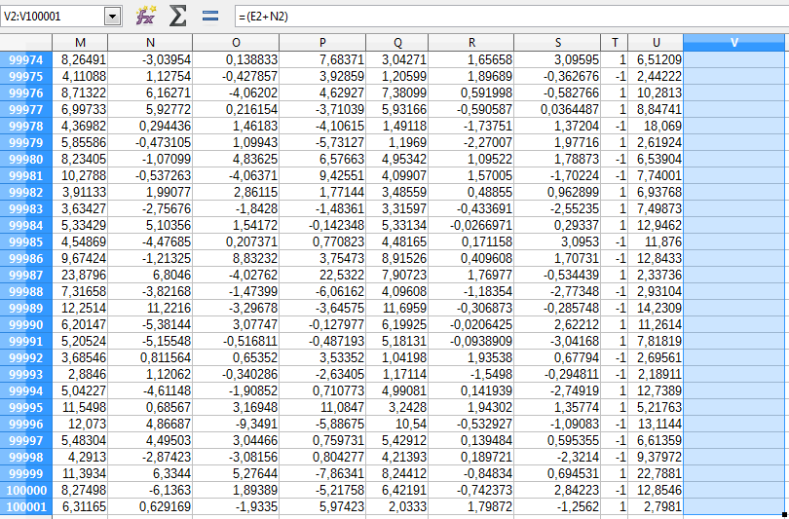Figure 5: Before copying the function to column V

* + 1. Repeat for y and z axises

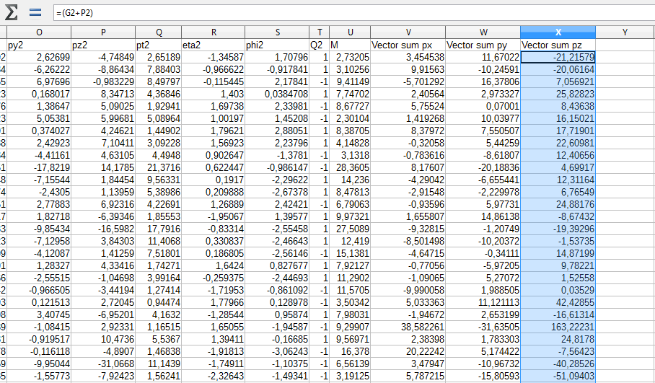

Figure 6: Your spreadsheet should look like this after calculating the x, y & z momenta

* 1. Next we need to calculate the sum of the total momenta of both muons. Name the column resultant momentum sum. Type =(V2^2+W2^2+X2^2)^0,5 into cell Y2.
     1. Copy the equation to all the cells in the column (up until Y100001)

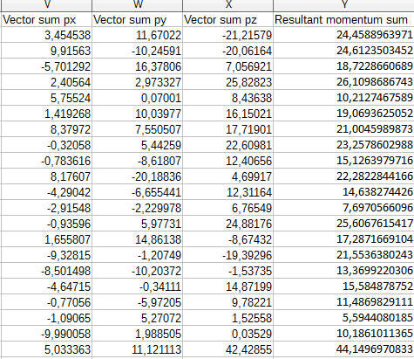

Figure 7: Our accomplishments so far

* 1. Now we can calculate the invariant masses related to each of the dimuon events. To do that name the next column Invariant mass. Type =((D2+M2)^2-Y2^2)^0,5 into cell Z2.
     1. Copy the equation to all the cells in the column (up until Z100001)

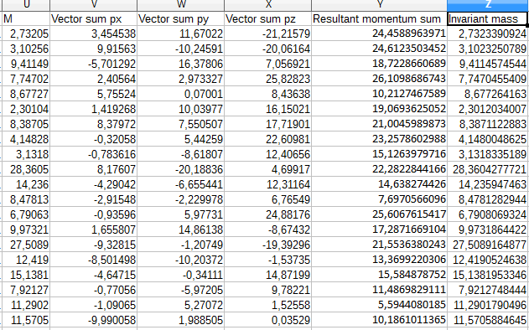

Figure 8: Calculated invariant masses. Comparing the results with the values in column U would suggest that we have gotten our physics right!

1. Next we want to present our data in a histogram. The phases for doing that are:
   1. Create a new column named Bin. We need this column to use as our vertical axis. It will allow us to count the number of events in specific energy ranges (called bins). Type 0 into cell AA2 and 1 into cell AA3. Then select cells AA2 and AA3 and drag down from the highlighted point until you reach cell AA117 and release.

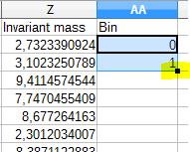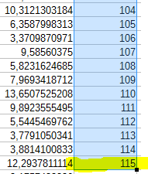

Figure 9: On the left – drag from the highlighted point. On the right – column AA filled with values from 0 to 115

* 1. To create the histogram, we need to acquire the number of events in each of the previously created energy ranges (bins). To do that we need to use the frequency function. Create a new column called Number of events. Use the function wizard to get the frequency of the events on each bin.

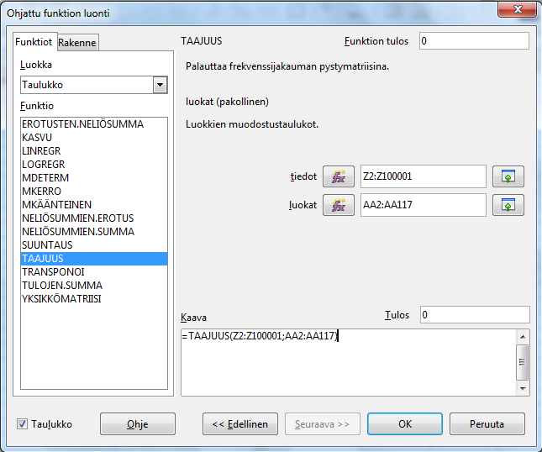

Figure 10: Finnish function wizard and frequency function

* 1. The last thing left to do is the drawing of the histogram itself. Select all the cells in the Bin and Number of events column and plot a bar graph with the graphing tool
     1. Name the axles

NOTE: See APPENDIX for detailed instructions for making a histogram with EXCEL

* + 1. Change the y-axle as logarithmic

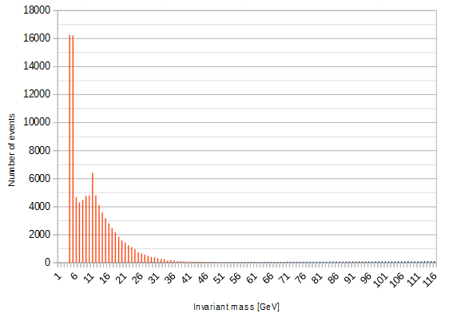

Figure 11: Amount of events in different energy ranges

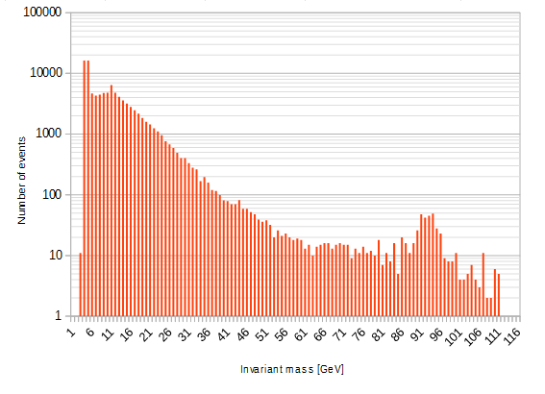

Figure 12: Amount of events in different energy ranges with a logarithmic scale

1. Analyzing the data
   1. Why is there a bump at the 92 GeV range in the logarithmic histogram?
   2. To what particle is the bump linked to?
   3. Are there hints about other particles in the histogram?

**APPENDIX:**

**Instructions on how to create a histogram with EXCEL:**

**1) Active Excel Histogram package**

Click “File” on the top left-hand side of the screen.

Click “Options” tab on the lower left hand side of screen.

Click “Add-ins” tab on the lower left hand side of the window. Then select “Excel Add-ins” and click “Go”.

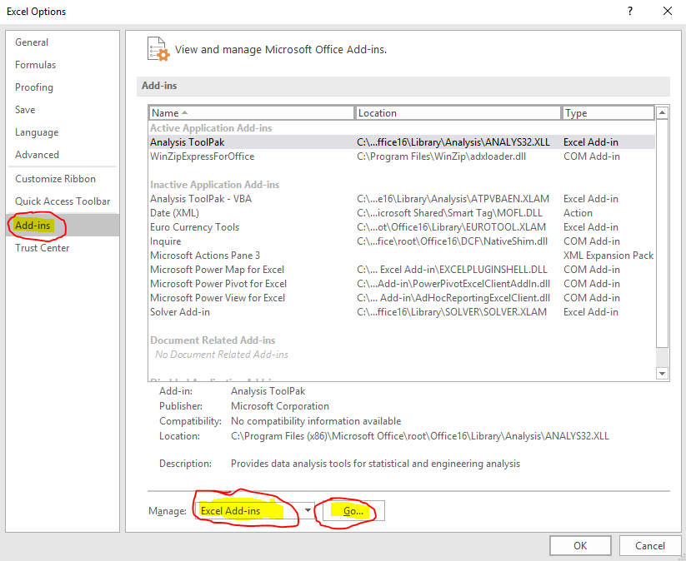

Tick the Analysis ToolPak box and click OK.

**2) Prepare Data for Histogram**

Click on the data tab.

“Data Analysis on the right hand side”.

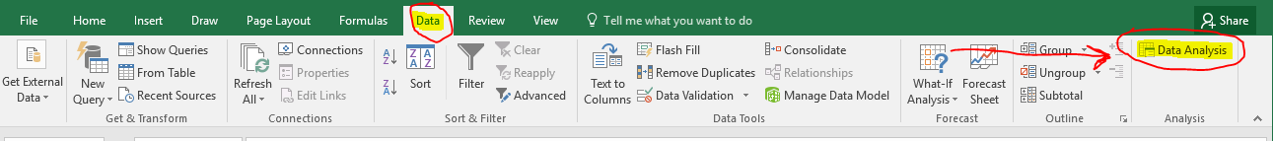

Select “Histogram” and click “OK”.

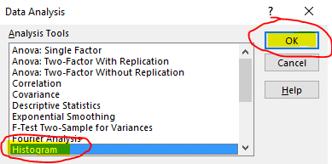

In the “Input Range” type “$A$2:$A$2001”. In “Bin Range” type “$B$2:$B$31”. Click OK.

