Sharing Jupyter Notebook Instructions

1. You need to save your files to a github repository, which means you need to create a free account with github.com

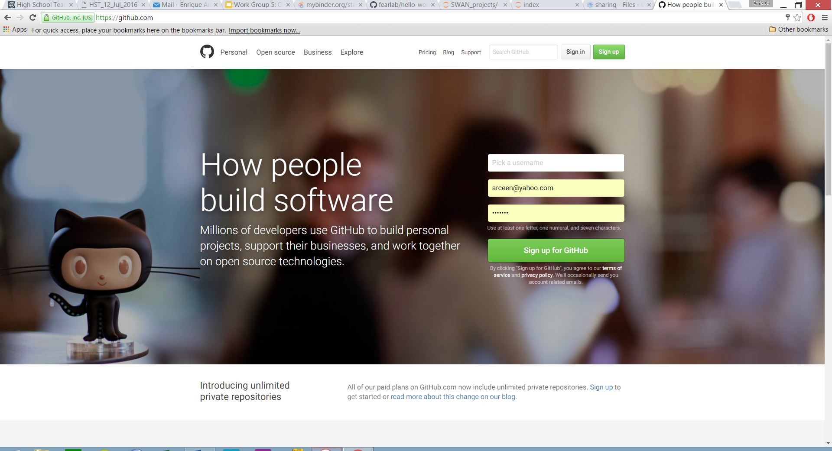

1. After making an account, create a new github repository, perhaps named “hello-world” . You are now ready to upload your Jupyter notebook files to github. If you don’t have access to Jupyter notebooks, you can download a basic notebook from my github account: <https://github.com/fearlab/opendata2>

Also, if you need data, then go to the CMS github repository: <https://github.com/hs-coder>

Also, if you need to import ROOT, then you will need a dockerfile in your repository, download from <https://github.com/fearlab/opendata2>

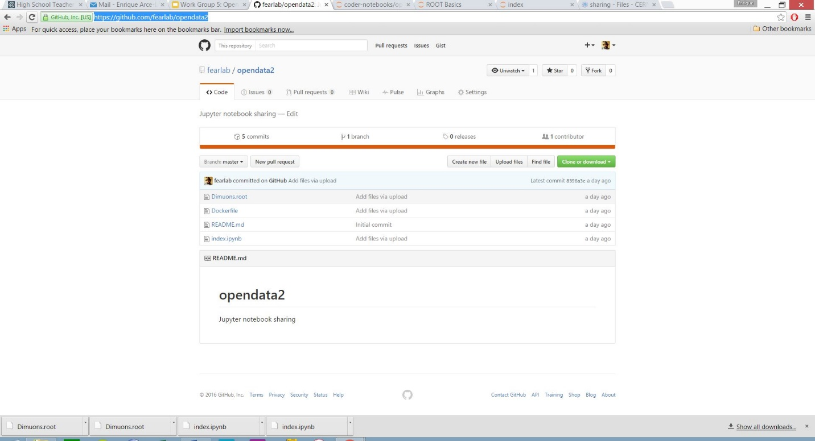

1. Now open mybinder.org and enter your github url and click submit.

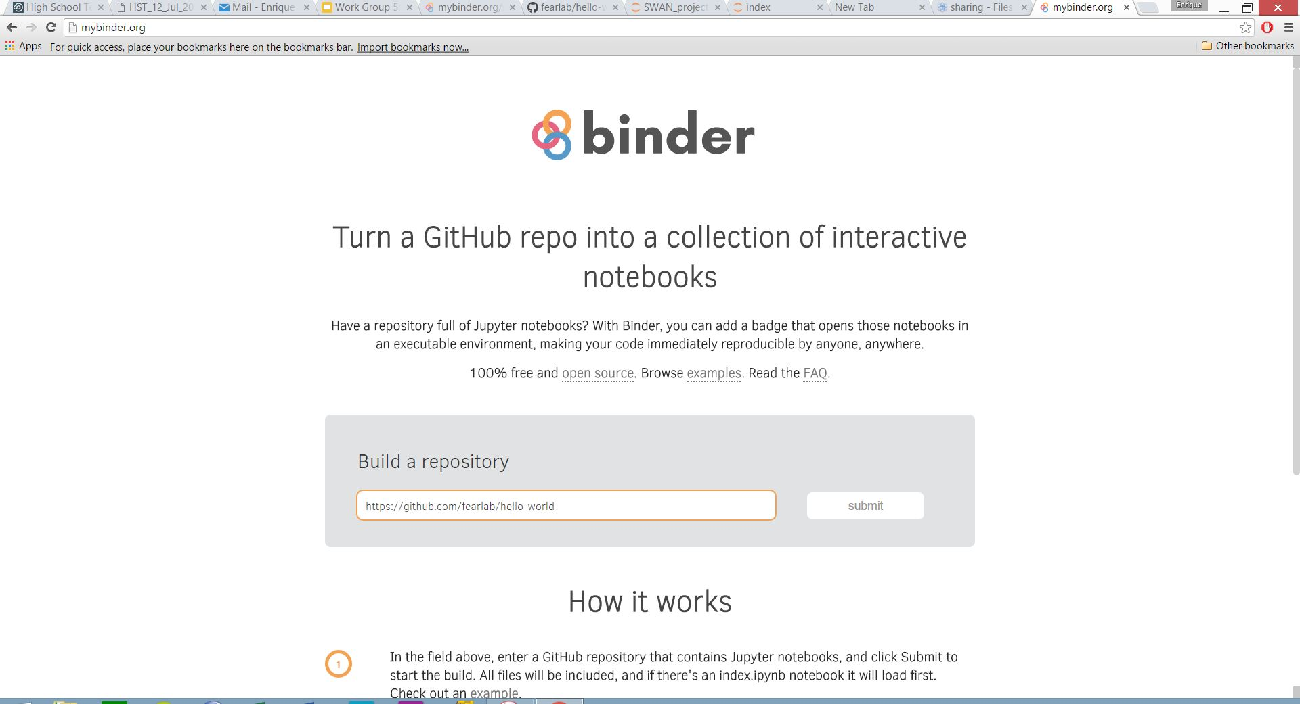

1. The building process takes several minutes and is fine time to go get COFFEE.

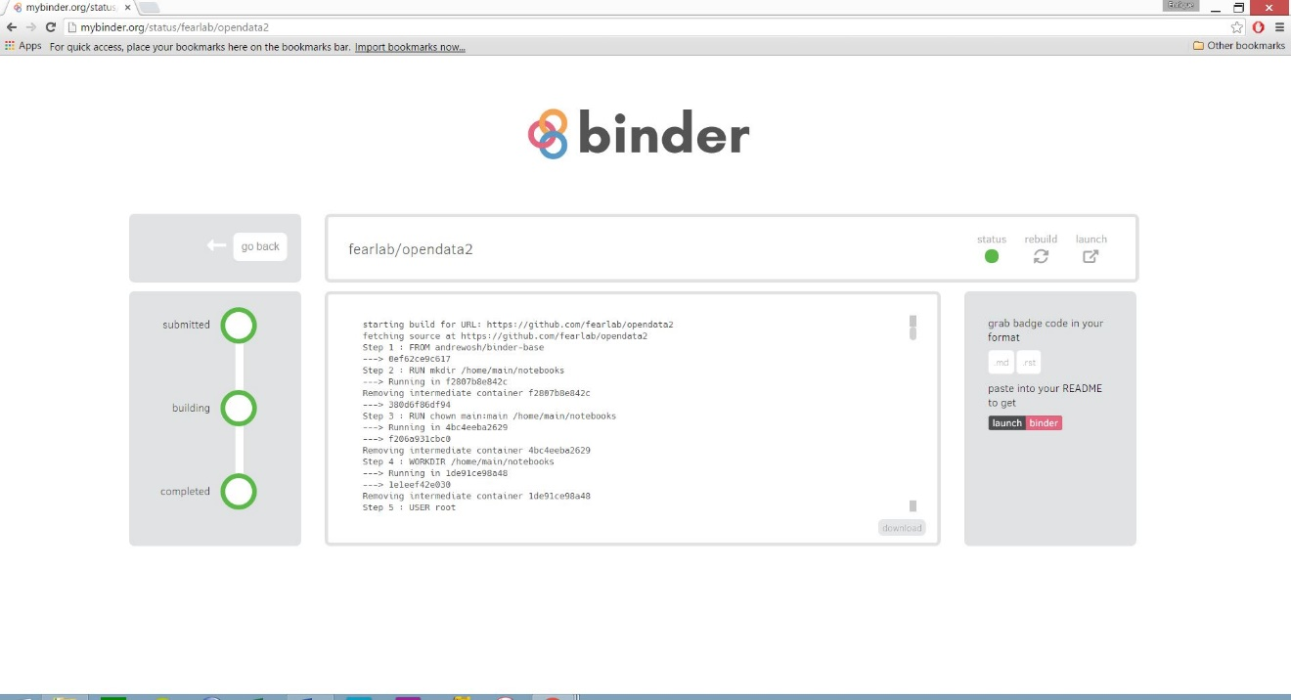

1. When its done everything will be green. Click the launch button.
2. You now have a link you can share with students to build notebooks via mybinder. I suggest using tinyurl.com to abbreviate the long link.

