Course Project - Computer Vision – Object tracking in Video
Chakib Cerny
UCF - CAP5415
Fall 2020
ccerny@knights.ucf.edu

Abstract

The objective of this project is to be able to track an object instantly from a streaming source. In our case, the source is a webcam. Different tracking techniques exist, this project focuses on two method, the first one is using the widely available YOLO V3 data, the second is defined by a region of interest selected by the user using Open CV as main library.

Introduction
As the computers are able to identify an object on an image and draw a bounding box around it, the idea would be to do the same on a video since the video is just a sequence of multiple images (frames).
To do so, two approaches are being used, the first one consisting of manually selecting a region of interest in a fix image from the stream flow, which has some glitches as we will describe later.
The second approach is to use the YOLO V3 data and its collection of Object. This solution also has many advantages and some inconveniences.

Programming Language
This project has been using Python (3.8) language

Methods
  - Region of Interest (ROI) Approach
During the first implementation of this project, the idea was to be able to track any object on a given video and the most efficient way to do it is to manually select a specific object and track its movement. This capability has been made possible by the functionalities open-CV offers. Since open-CV has its own tracker, we can implement any of them. The available options are the following:
Boosting, CSRT, GOTURN, KCF, Median Flow, MIL, MOSSE and TLD.
In this case, we have been using the KCF tracker which uses Kernelized Correlation Filter and as we are streaming live content, we want a tracker as fast as possible so can hold up with the frames and we won’t be
dropping frames or displaying empty frames because the tracker did not have enough time to process the object bounding box.
The advantage of this ROI approach is that we have no upstream work such as network training and testing with large data set, the features are directly extracted from the selected ROI and we keep working with this only data set. As expected, this straightforward technique comes with some issue. Having a very limited amount of object features, the tracker can easily loose track of the object. It also displays all the issue object tracking can have as we discussed it in class, for example scaling. This technique does not handle any scale change. If the selected object is being pushed away from the web cam and therefore gets smaller, they are high chances that the tracker loses track of the object as the extracted features are not being scaled down or up. Another similar issue is that since we have only one static image as reference to extract features, if the object does not have the same angle and slightly spins for example, it might also not be detected by our tracker.
On the other hand, this tracker that I would more define as a region of interest tracker than object is really helpful when we want to detect objects or aspects on a video that are not common or changes a lot. For example, a car with a very specific shape like the ones used for advertisement and following a specific path, as a road at the same distance with a horizontal movement. We would be able to very quickly set the ROI and track the vehicle every time it passes in front of the camera. This object tracking that we implemented with the web cam would also work with a given recorded video or any stream.
During the implementation, few challenges appeared, the first being the tracker used, some, like the boosting tracker seemed to run slow so I first had to resize the frame in order to improve the performance. Once this issue solved the open cv documentation provided all the necessary information to successfully implement this tracker with the different options it has.

Demo:

When the code is being run, a window with the camera intake appears. The instructions are displayed at the bottom left corner of the video and as soon as the user pressed the key ‘p’ to pick the desired ROI they can directly select is using the cursor and the mouse:

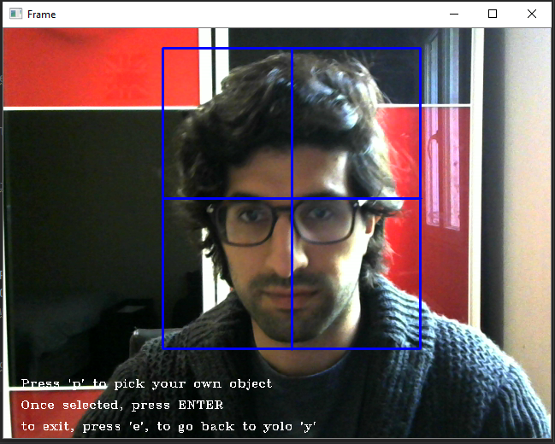

Once the ROI selected and the user pressed ENTER, the tracking automatically starts.

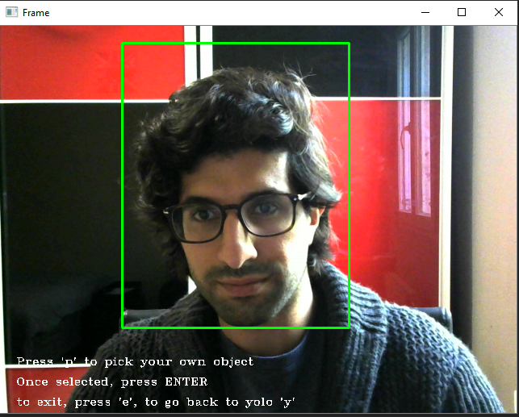

As the object moves, the bounding box moves along

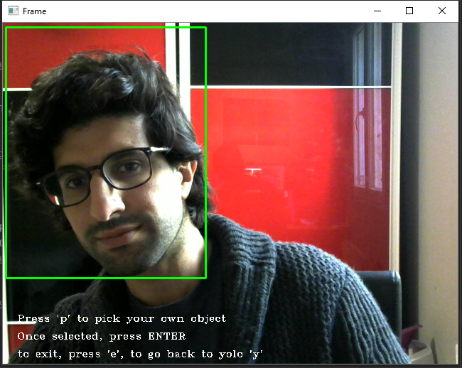

The object keeps getting tracked as long as the user does not press ‘e’ to exit or ‘y’ to switch back to YOLO method.

YOLO V3 Dataset
The second implementation was to include a full network with multiple classes so the user would not have to select the object every time as well as getting a better result as of the object features. However, creating my own network with multiple objects was taking too long and I could not find all the training and testing set for all the objects I was hoping to detect, but while searching online for data set to use for my network I found the YOLO V3 which was a network of 80 object that could be easily implemented on my program. This package consists of 3 files, the first one containing all the objects name, they are about 80 classes in this network which mean 80 different objects that can be detected. The second file contains all the network layers such as filters information for convolution layers for example and the last file has all the network weights. These all 3 files can then be used through darknet and for each frame of our video, we will get for each class of the network a value that represents the probability the network considers the object to be. In this case, we only consider a probability or in other words confidence of at least 60% to make sure the network will only consider the class that has more chances to be the correct object.
However, during the implementation of this object detection, an issue already covered in class came up and as the program ran for the first couple of times, I noticed that the boxes were not center to the object and after some research I found out that the coordinates return by the network were corresponding to the center of the object so I had to define the rectangle to draw using these coordinates and the with and height of the bounding box.
Another issue I faced while implementing the YOLO network was that I had multiple boxes for one object so I had get rid of the extra boxes and to do so I created my own Non Maximum Suppression (NMS) which means that for all the boxes returned from the network, I would only keep the box that has the highest confidence and discard the other. After doing so, I was able to keep only one box that was the most accurate one to track the object.
Once properly implemented, the YOLO can also offer more possibilities which I am still working on and hope to finish before the deadline. It is possible to identify multiple objects and track them all at the same time. However, this implies deep modification as we would have to assign an ID to each detected object in order to keep track of it.
As of now the main difficulty I am facing is with non-maximum suppression (NMS when I have two similar objects close to each other with overlapping frame I end up deleting the bounding box of the second object instead of keeping one box for each object so I would have to find a way to only perform NMS on each object instead of the whole frame.

Demo:

By default, the program is set to identify cellphones, the class Id in YOLO of a cellphone is 67. When the cellphone is not present in the frame there should be no bounding boxes.

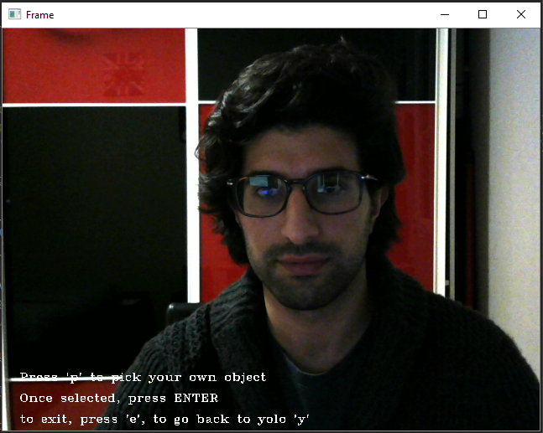

As soon as the cellphone appears in the frame, the program should be able to identify it without any user intervention which gives us the following bounding box:

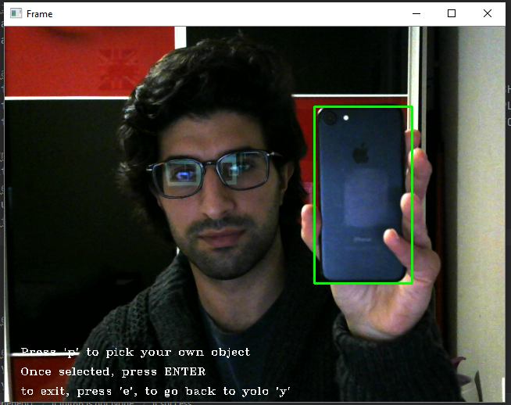

As discussed earlier, the advantage of have a whole trained network implemented in our code is that when the object is scaled down or in a different angle it is still properly recognized as below.

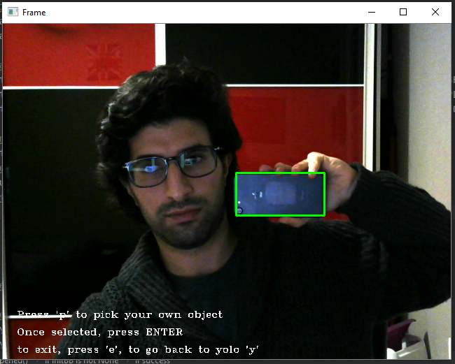

Results
The first implementation, CV2 tracker were below my expectation, but it should’ve been expected, the fact that we just have a define region of interest on one of the video frames limits the abilities of our program to identify features in order to properly track the object. However, the Open-CV documentation available online made the implementation easier than I thought. On top of that, the different trackers that can be used with open-cv makes the testing part interesting as multiple trackers can be tested and it was interesting to read about each method.
Concerning the Yolo, the results were much more satisfying as we can accurately track 80 different object that are part of the YOLO classes and as we look at the confidence the network returns for a cellphone in my case, the are most of the time over 90%.
Being put together, this program allows user to reliably track 80 different objects but also give the user the ability to select their own object and track it with limits.
All the options for the open cv tracker and the YOLO information will be added to the README file so they can be easily updated by the user.

Conclusion
When I picked the topic, I unfortunately did not know how to implement an object tracker in videos, so it was extremely interesting to work on this project. From the begging, when I first though I could track object by just converting the image into grey scale, manually extracting features, and loop through each frame to find similar features but the results were not good and the time constraint would have not allowed me to deliver a reliable object tracker on time, so I decided to do some research. The resources online were endless and with the topics covered in class, such as object detection that is the main challenge of object tracking in video, I was able to look into a different network than the one we work in previous assignment. It was fascinating to see a complex and fast network such as YOLO V3 be available to everyone and that can be implement easily. I really felt that this project was the perfect sum-up to what we have covered this semester and to make it real and see it successfully work brought me a big satisfaction and a skillset that I can’t wait to improve.

References
- https://docs.opencv.org/3.4/d0/d0a/classcv_1_1Tracker.html

- https://docs.opencv.org/3.4/df/ddd/tracker_8hpp.html

- https://docs.opencv.org/3.4/d2/d0a/tutorial_introduction_to_tracker.html

