### CS443 Assignment 2

# Question 1

You are given a task to create a Database for Holiday Inn. Here is some of the information you have.

1. Draw your ERD based on the above assumptions and data

**Check attached paper for ERD**

1. Draw tables from the initial ERD and normalize them. Place all tables in 3rd normal form (if necessary)

Hotel (**hNum**, hNoOfRooms, hPhone, hAdd, ***mId***)

Room (**rNum**, ***hNum***, rRate, rSize, rOccupied, rLoc)

Manager (**mId**, mName, mAdd, mPhone, mEmail ,mSal)

Caretaker (**ctId**, ctName, ctAdd, ctPhone, ctEmail, ctSal, ***hNum)***

Customer (**cNum**, cSSN, cCreditCard, cAdd, cStartDate, cEndDate ***rNum, hNum***)

**Check attached paper for SQL code**

**Question 2:**

Do the following SQL questions. The resulting columns must all have descriptive names

1. Write a select statement to list all the columns from the Offices table. 'Select *' is not allowed. Return the list in Office order.

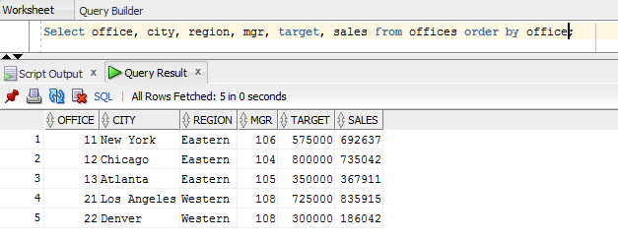

1. List the Product Name (its description), and dollar value of quantity on hand (price * quantity) . Return the list in descending order by value.

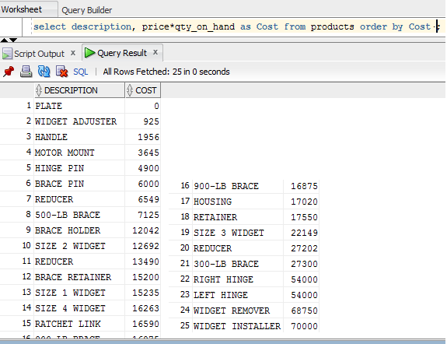

1. List the Order Number, Order Date, Customer Number and Sales Rep Number for orders for part 'XK47' or '775C'. (Use a compound search condition - OR.)

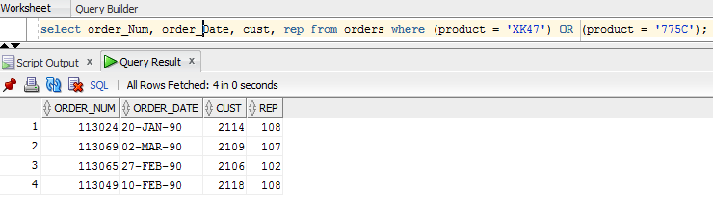

1. List the Name and Age for all Sales Reps in the following offices: 12; 21; 13. (Use the set membership test - IN.)

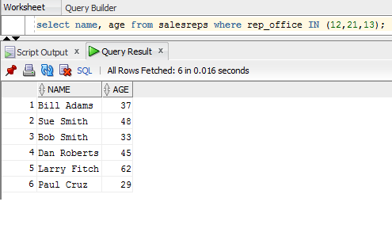

1. List the names of all Sales Reps who have the letter 'o' (this is lower case o) as th**e third character of their name.**

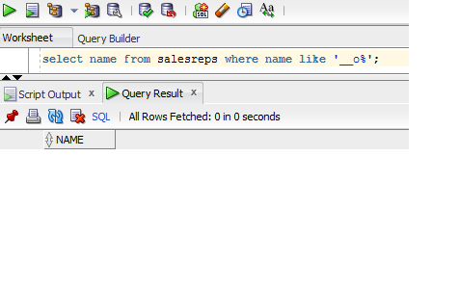

1. Return the Sales Rep ID and Name of any Sales Rep not assigned to an office yet.

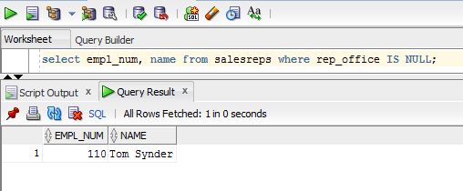

1. Show all the sales rep names with last name “Smith”.

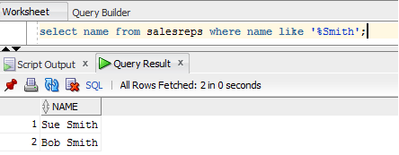

1. List different titles in the sales reps table. Only list each title once and unknown titles should be ignored.

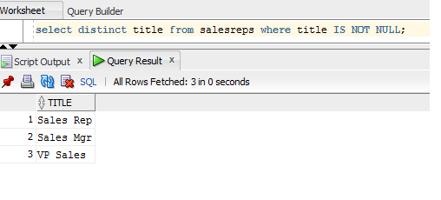

1. List the description of the products which are **at least 6 character and less than or equal to 10 characters long**. No duplicate row is allowed. You can use the build in function length() to do this. For example, length(name) return the number of characters for attribute called “name”.

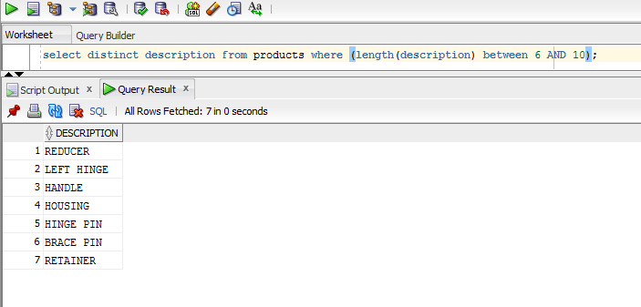

1. List the the order nums with the name of the rep who placed the order and the name of the customer who made the order and the name of the rep for that customer

**Question 3:**

1. List the Mfr Id, the Product Id, Company and PRICE of all products brought by customers where customer number is one of (2112,2105,2119) and where the amount of the **order < $5500.00**. Order the results by ascending Company.

**SELECT product, mfr, amount, company**

**FROM orders, customers where cust_num**

**IN (2112, 2105,2119) AND amount < 5500 AND cust = cust_num;**

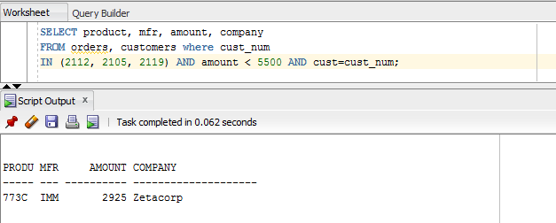

1. **List all salesreps (id and names) and all orders (orderNumber) in which the salesrep is the company’s (i.e. the customer) rep (Cust Rep), but didn’t take the order. Order the result based on name in ascending order.**

**SELECT empl_num, name, order_num**

**FROM salesreps, orders, customers**

**WHERE (customers.cust_rep = salesreps.empl_num AND orders.cust = customers.cust_num AND salesreps.empl_num != orders.rep)**

**ORDER BY salesreps.name;**

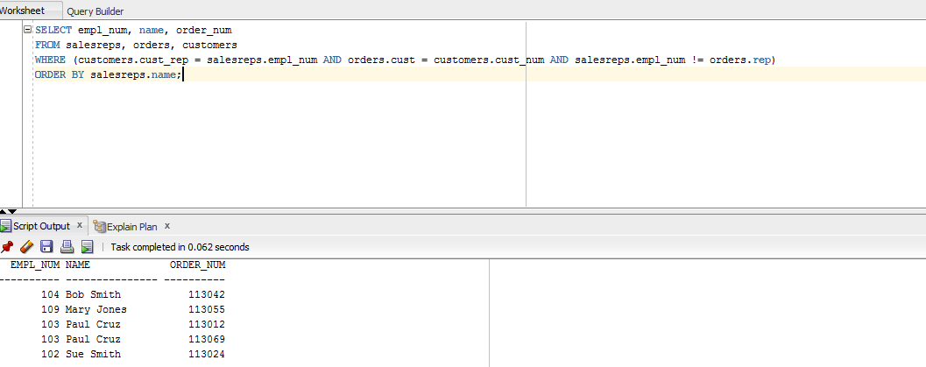

1. List all customers (Customer number, Company, and Credit Limit) and orders (Order Number, Amount) where the order is within $1000.00 of the Credit Limit **(less than or equal to $1000).** Sort the result by Customer number in descending order.

**SELECT cust_num, company, credit_limit, order_num, amount**

**FROM customers, orders**

**WHERE (orders.cust = customers.cust_num) AND (customers.credit_limit - orders.amount) <= 1000**

**ORDER BY cust_num;**

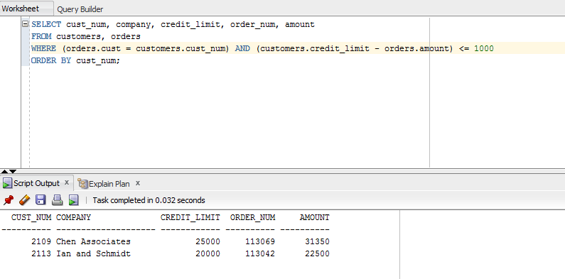

1. List all salesreps names and their managers’ names where the salesrep is at least as old as the manager.

**SELECT employee.name AS employee, managers.name AS managers**

**FROM salesreps employee, salesreps managers**

**WHERE managers.empl_num = employee.manager AND employee.age >= managers.age;**

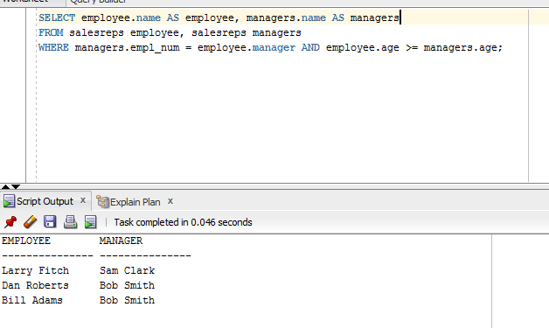

1. List all salesreps (Name) and the City they work in where the sales of the salesrep < Quota and the sales for the office is < Target.

**SELECT salesreps.name, offices.city**

**FROM salesreps, offices**

**WHERE salesreps.rep_office = offices.office AND salesreps.sales < salesreps.quota AND offices.sales < offices.target;**

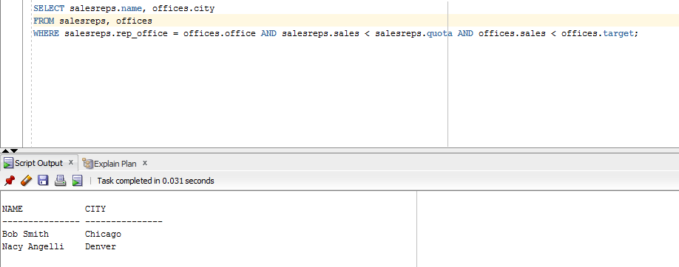

1. List the name, id, and hire date of the salesreps where at least one of the two conditions hold:

* The salesrep sales should be greater than the quota
* The salesrep has taken an order from Customer number 2117, 2111, or 2101.

Sort the result by the salesrep’s id.

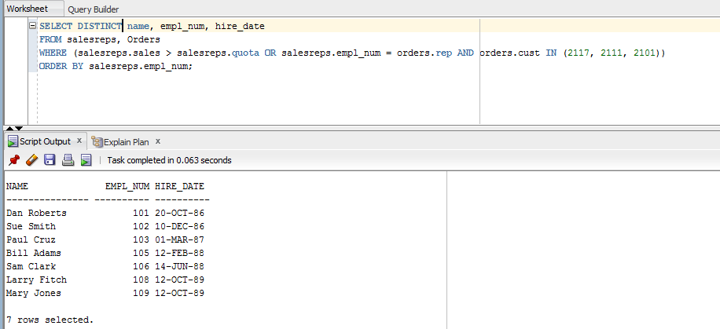

**SELECT DISTINCT name, empl_num, hire_date**

**FROM salesreps, Orders**

**WHERE (salesreps.sales > salesreps.quota OR salesreps.empl_num = orders.rep AND orders.cust IN (2117, 2111, 2101))**

**ORDER BY salesreps.empl_num;**

1. List all orders (Order Number) over $25500 showing the company placing the order, the Customer Rep assign to the company, the Office id and the city where the Customer Rep works in, such that the Customer Rep’s manager is not the person who actually took the order.

**SELECT DISTINCT order_num, company, city, rep_office, name**

**FROM salesreps, customers, orders, offices**

**WHERE orders.amount > 25500 AND orders.cust = customers.cust_num AND customers.cust_rep = salesreps.empl_num AND salesreps.rep_office = offices.office AND salesreps.manager != orders.rep;**

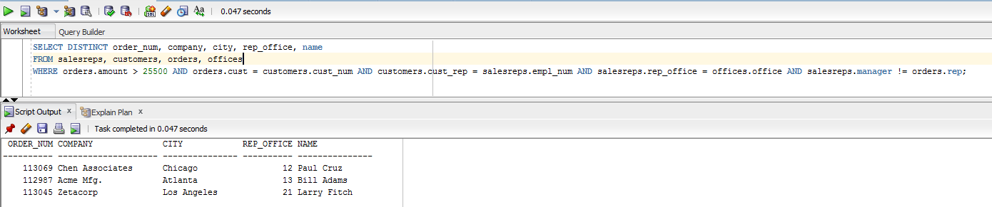

1. List all customer reps (their name and their id) and their managers name in which the manager has taken an order for the customer Rep’s company or the manager is based in New York or Denver. Use appropriate column header
2. List all products (ProductId, and Description), customers (CustNum, Company) who have bought that product, and orders (Order Number, and Order Date) where the order < $1500. Sort the rows by the OrderDate.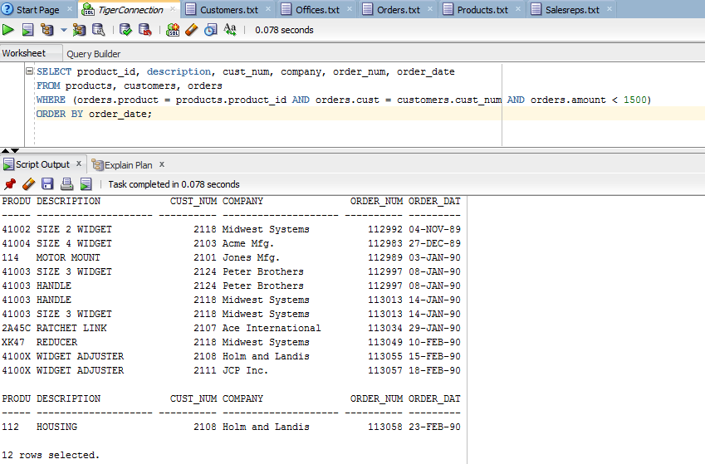
3. List the name of the salesreps and the name of their managers only if the manager has taken care of some orders.