**User Action 1** – select firstname, lastname of user with an email of apache.org domain

**Query Executed :** SELECT firstname, lastname FROM users WHERE email REGEXP '.*@apache.org';

**Screen shot Before:**

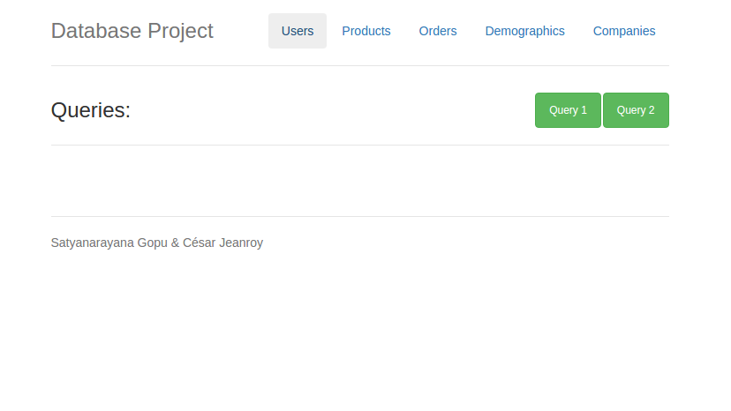

**Screen shot After:**

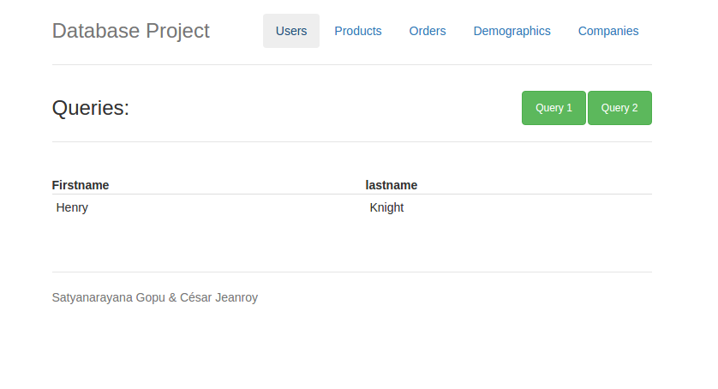

**Constraints enforced:** none

**User Action 2** – Find the youngest user

**Query Executed :** SELECT CONCAT(lastname, ' ', firstname) AS 'Youngest User' FROM users WHERE date_birth <= ALL(SELECT date_birth FROM users);

**Screen shot Before:**



**Screen shot After:**

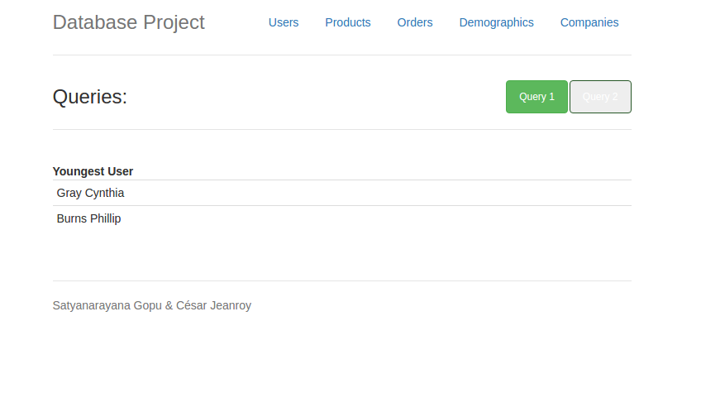

**Constraints enforced:** none

**User Action 3** - select the products linked to a deleted category

**Query Executed :** SELECT product_id, price FROM products WHERE category_name IN (SELECT category_name FROM categories WHERE deleted_at IS NOT NULL);

**Screen shot Before:**

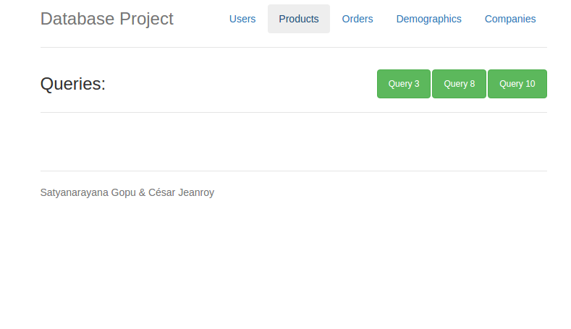

**Screen shot After:** (* query resulting way too many results to fit in a screen shot)

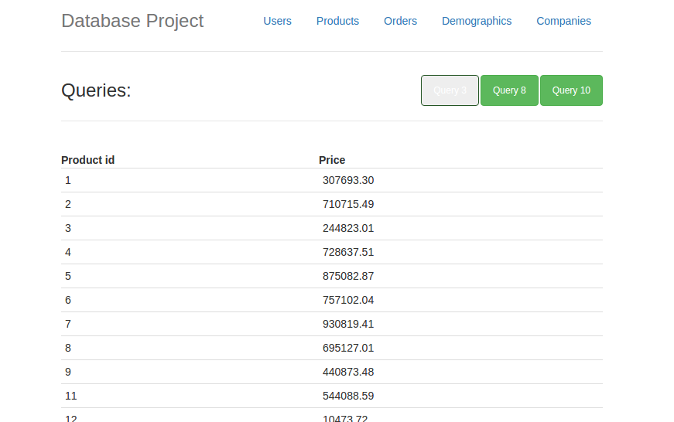

**Constraints enforced:** none

**User Action 4** – Find the countries that have at least one city name in common.

**Query Executed :** SELECT A.country, B.country, A.state FROM demographics A, demographics B WHERE A.country != B.country AND A.city = B.city;

**Screen shot Before:**

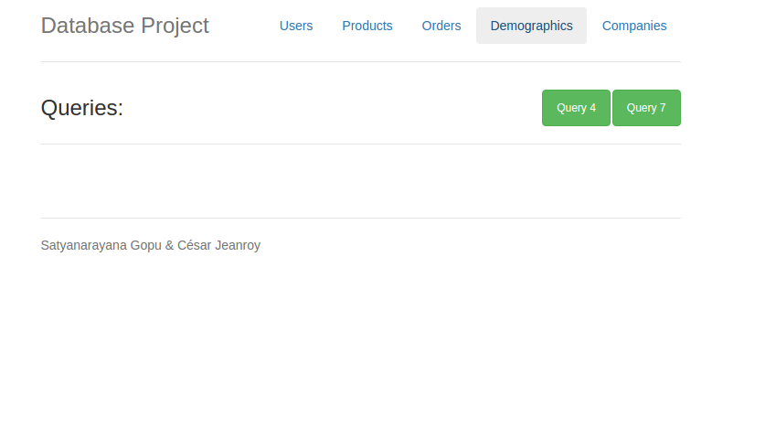

**Screen shot After:**

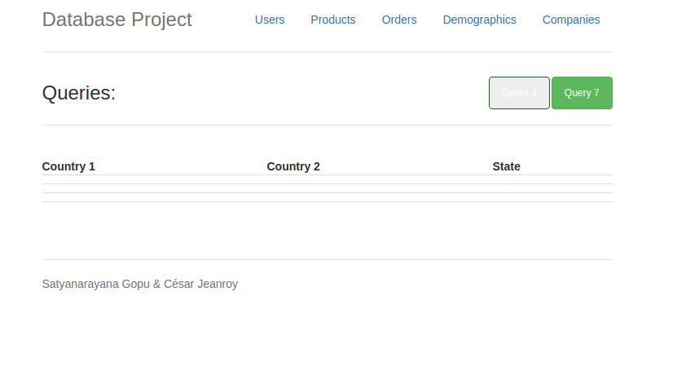

**Constraints enforced:** none

**User Action 5** – select the email of users who have submitted an order with one item and a three day delivery.

**Query Executed :** SELECT DISTINCT o.email FROM orders o NATURAL JOIN items i NATURAL JOIN deliveries d WHERE d.type = '3 days' AND i.quantity = 1;

**Screen shot Before:**

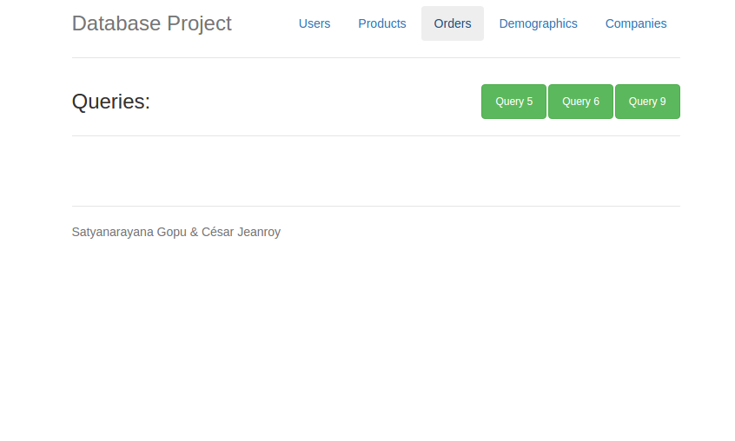

**Screen shot After:**

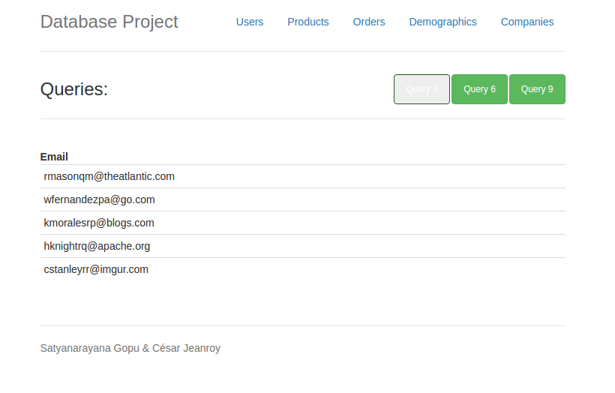

**Constraints enforced:** none

**User Action 6** – Find the user(s) who bought the most expensive product

**Query Executed :** SELECT email FROM orders NATURAL JOIN items NATURAL JOIN products WHERE price >= ALL(SELECT price FROM products NATURAL JOIN items NATURAL JOIN orders);

**Screen shot Before:**



**Screen shot After:**

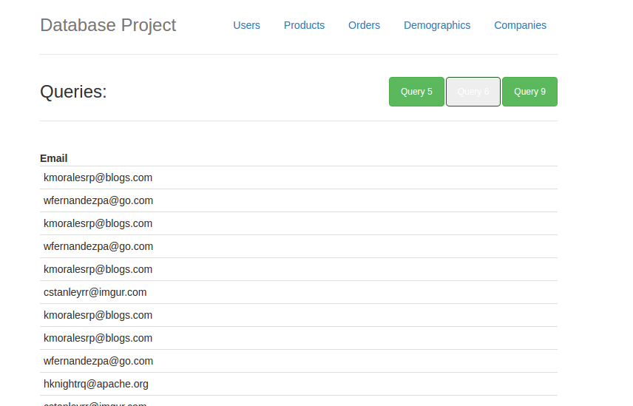

**Constraints enforced:** none

**User Action 7** – select all the countries listed in the database.

**Query Executed :** SELECT country AS 'countries listed' FROM ((SELECT country FROM companies) UNION (SELECT country FROM demographics) UNION (SELECT country FROM addresses)) A;

**Screen shot Before:**



**Screen shot After:**

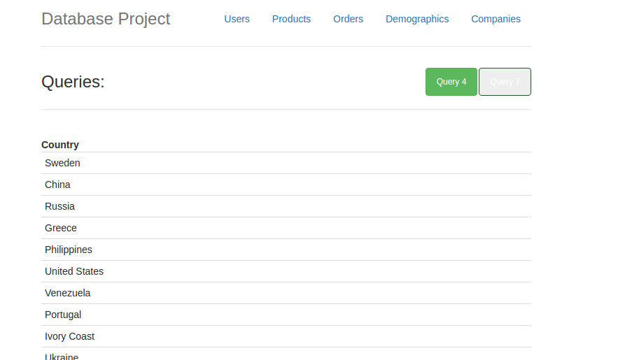

**Constraints enforced:** none

**User Action 8** – Display each category with the number of products in it sorted on the number of products

**Query Executed :** SELECT category_name, count(category_name) FROM products GROUP BY category_name ORDER BY count(category_name) DESC;

**Screen shot Before:**



**Screen shot After:**

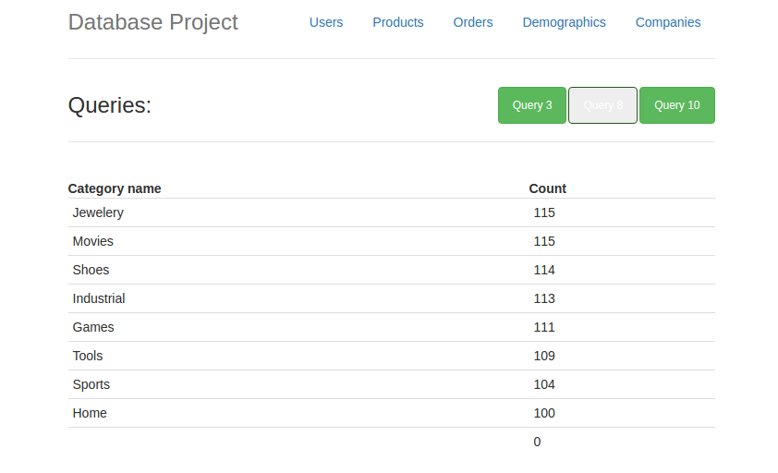

**Constraints enforced:** none

**User Action 9** – select orders sorted on quantity of their items.

**Query Executed :** SELECT order_id, status, email, quantity FROM orders NATURAL JOIN items ORDER BY items.quantity DESC LIMIT 1000;

**Screen shot Before:**



**Screen shot After:** (* query resulting way too many results to fit in a screen shot)

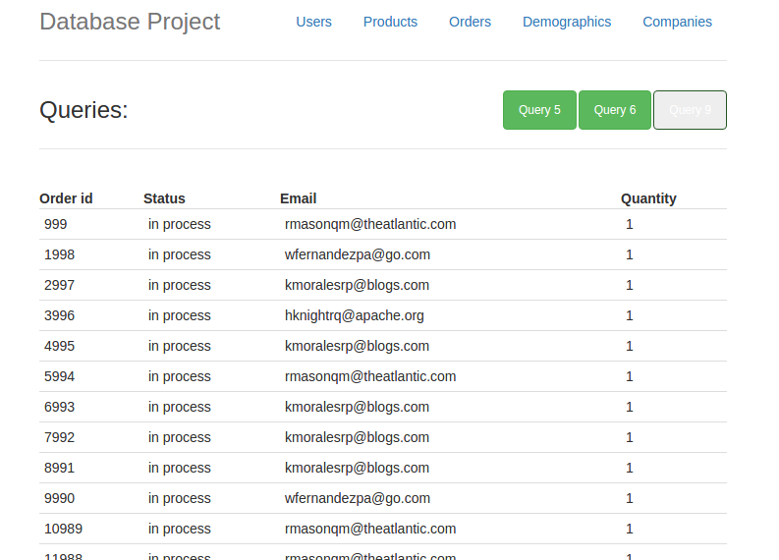

**Constraints enforced:** none

**User Action 10** – Return the list of products that have never been bought

**Query Executed :** SELECT DISTINCT name FROM products where product_id NOT IN (SELECT DISTINCT product_id FROM items);

**Screen shot Before:**



**Screen shot After:** (* query resulting way too many results to fit in a screen shot)

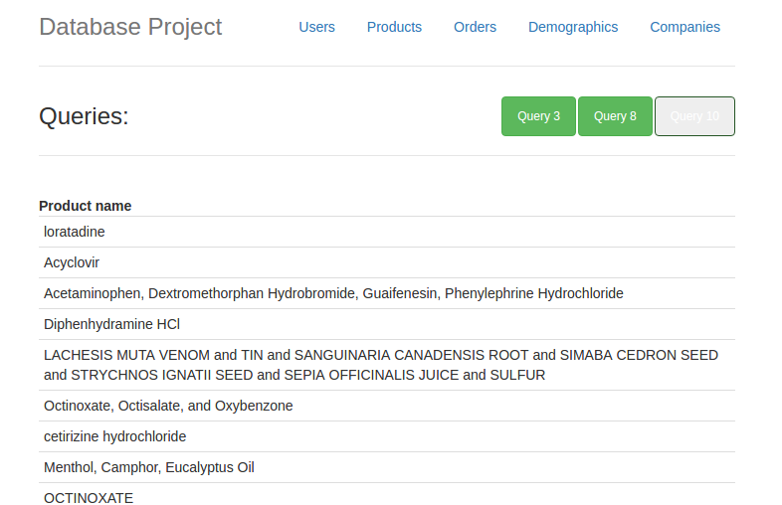

**Constraints enforced:** none

**User Action 11** – Find the companies that sell a minimum of 10 products

**Query Executed :** SELECT company_name, count(product_id) 'Number of products' FROM companies A, products B WHERE A.company_id = B.company_id GROUP BY company_name HAVING count(product_id) >= 10;

**Screen shot Before:**

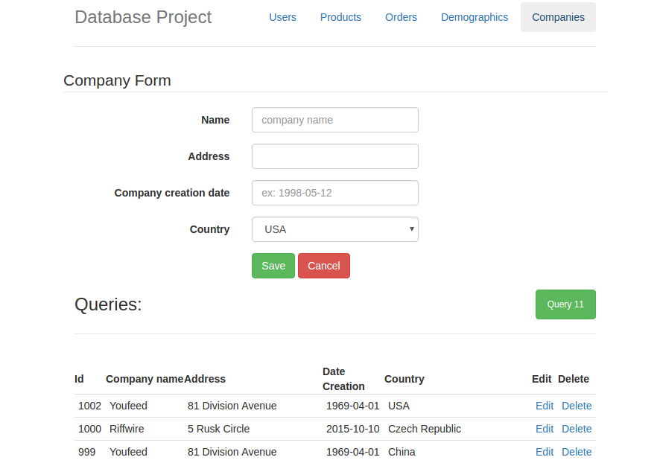

**Screen shot After:**

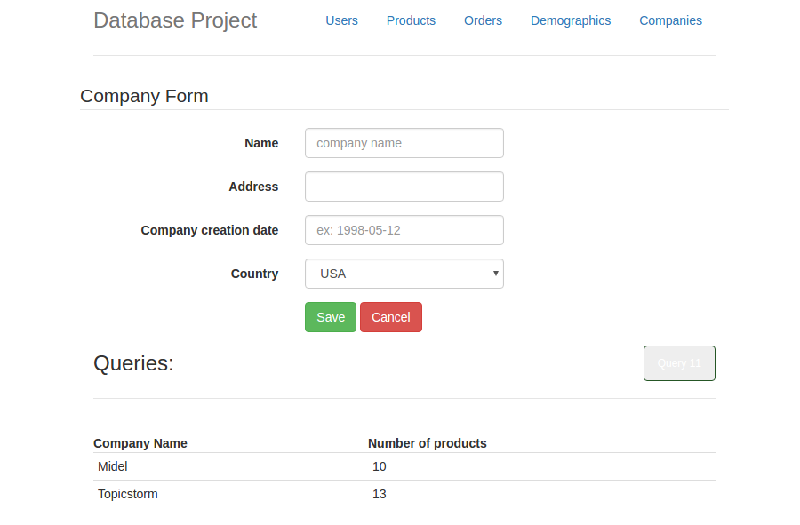

**Constraints enforced:** none

**User Action 12** – Insert into companies

**Query Executed :** Insert into companies(company_name,hq_address,date_creation,country) VALUES();

**Screen shot Before:**

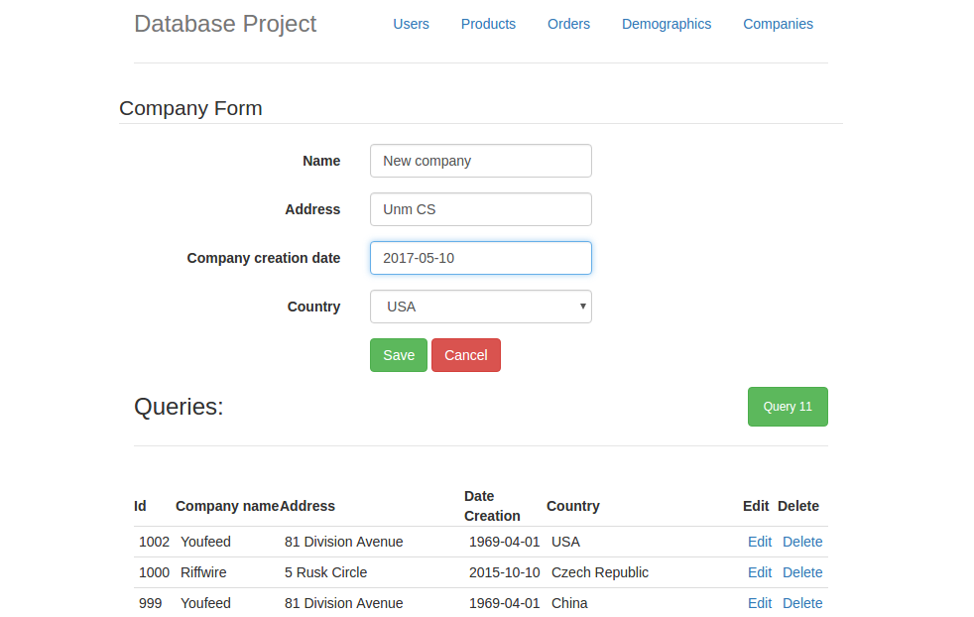

**Screen shot After:**

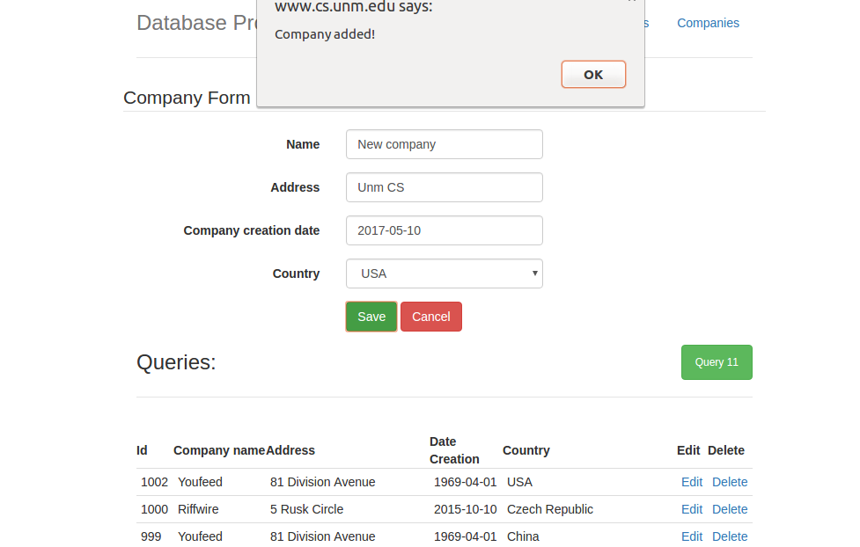

**Constraints enforced:** no null values are accepted, and date should be properly formatted and after 1990.

**User Action 13** – delete from companies

**Query Executed :** Delete from companies where id = x;

**Screen shot Before:**

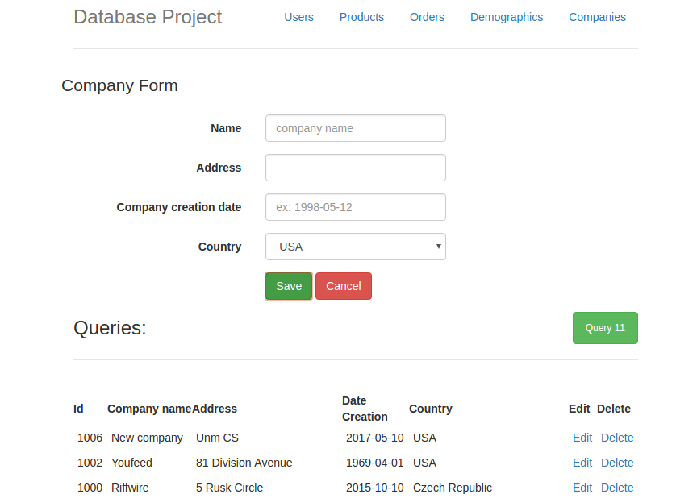

**Screen shot After:**

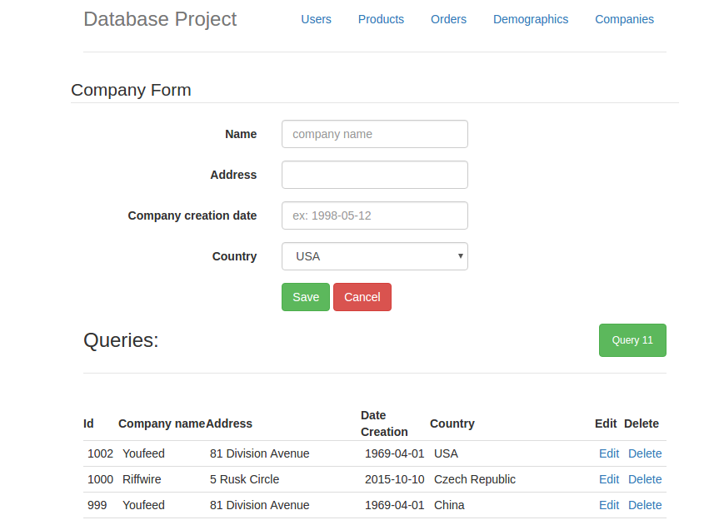

**Constraints enforced:** none