Business Plan for a Pet App Startup Business

Owners: Nicolas Kadri, Cesar Abboud and Jean-Pierre Sassine.

Business Name: Pet Society.

Location: Beirut, Lebanon.

Telephone: 71/616424 , 81/249602, 71/344412.

E-mail: [nicolaskadri02@gmail.com](mailto:nicolaskadri02@gmail.com) , [cesarabboud112@gmail.com](mailto:cesarabboud112@gmail.com) , [jeanpierresassine@gmail.com](mailto:jeanpierresassine@gmail.com) .

**III. General Company Description.**

1. Our business will be involved in taking care of pets, providing them vaccine and food, breeding pets, adopting them, offering training programs, selling supplies and helping animals owners what to do with their pets in order to avoid hurting/damaging them.
2. Our mission in not only about adopting and taking care of pets, but also to spread awareness because we see nowadays especially in Lebanon people torturing their pets by attaching them to a car/pick-up through a chain and accelerating. Unfortunately, this hurt and to avoid this the government can assign sanctions so the number of pets killed can decrease in a certain way. In addition, we care about making our customer satisfied with our professional services we provide.
3. Our goals are to have a highly successful company in the future where we, as a company, will be trusted by several customers while providing them all vaccines and supplies without any cutout.
4. X
5. Products will be sold to people who want to get food for their pets, sick pets (ex: allergy), people who work all day … Let’s take an example of a bank employee working 9-5, owning one pet and having two kids. As this man does not have this much time and his family does not know well how to treat this dog, he will send him to us and we will do the job for him (adopt, vaccine, feed …)
6. Our industry is considered a large one where we present nine services, we will talk about later on so the industry covers the tertiary sector. The services are: shopping products, adoption, pet medical report, providing training programs, offering vaccines, pet sitting, pet breeding, live assistance and low-cost supplies. What makes us unique is that:
7. We encourage adoption which prevents pets’ overpopulation and discourages the breeding of unwanted pet litters.
8. Low-Cost Supplies by having 3rd party brands that offers the same quality of the original brand.
9. Offering Vaccines even if we aren’t vet. Having mandatory Vaccines reminder for our app users.
10. Having a Report case feature that notifies every user when a disturbing occurrence occurs.
11. As a team, we provide great customer service to the fullest having incomparable value. We are all clever, consistent and take the work seriously.

**IV. Products and Services.**

1. List of products and services:
2. Shop products: users can discover different types of food, vaccines and toys for pets
3. Adoption: We ONLY adopt pets and do not buy pets.
4. Pet Medical Report: A report is displayed about a pet owned by the user through the app.
5. Training programs: Our professional vets provide programs to be done in order to maintain pets’ good health.
6. Offering vaccines: Ability to offer vaccines even if we are not vets.
7. Pet sitting:

* People who like to own a pet but aren’t qualified for this because they don’t know how to interact with them. If this is the case, they return it and from this we can know why the number of stray dogs is increasing simultaneously. Otherwise, they keep it.
* Let’s use the case of a dog owner who needs to leave the house for a while but is unsure about where to put his pet. The best course of action is to use the pet sitting option where a trusted user accepts to take care of the dog in the meantime.

1. Live Assistance: Our team is ready and available 24/7.
2. Pet breeding: Pet owners who like to marry their pet but don’t know for who they are going to marry them so this will be done through our app with trusted users.
3. Low-cost supplies: As a company, we provide low-cost supplies that suits all classes.
4. Advantages: fast replies to customers, having professional vets, adopting pets, live pet assistance, offering pet training programs, low-cost supplies and offering vaccines even if we are not vets.

Disadvantages: not owning a pet shop at the moment.

1. We will offer advertising services for 100$, and 2 types of memberships, standard and ambassador. The standard one is for $1.99 and the other one is for $6.99. Subscription fees will be annual.
2. Market Size: 15,000

The demand on our innovation is enormous because of lack of vets and people unawareness.

Online purchasing is currently popular so that’s why we worked on a pet app where customers buy products directly from us without the need of communicating with suppliers. As a team, we are the ones who deal with suppliers.

Barriers:

* + - Consumer acceptance and brand recognition.
    - Spread awareness to the audience.

We will overcome the barriers by having alternatives that suit rich and poor people who are in need of food, vaccine and training programs for their pets.

How could the following affect your company?

* + - Change in government technology

1. Benefits: Our products satisfy customers concerning the pricing, comfortability and customer satisfaction.

Features: Our products include warranty in case of any malfunction and we can deliver instead of customer going to pet shelters.

1. The special about our services is that we quickly respond at anytime and we have a professional team ready to take care of the customers’ pets so the customer does not have to worry about anything.
2. Our target customers are pet owners and those who like to own pets and are qualified to own pets of course regardless of their age, gender and education.
3. There aren’t a lot of competitors existing in Lebanon. Some of them are: Own Puppies, A La queue, Pegasus Pet Shop, Pet Mart …

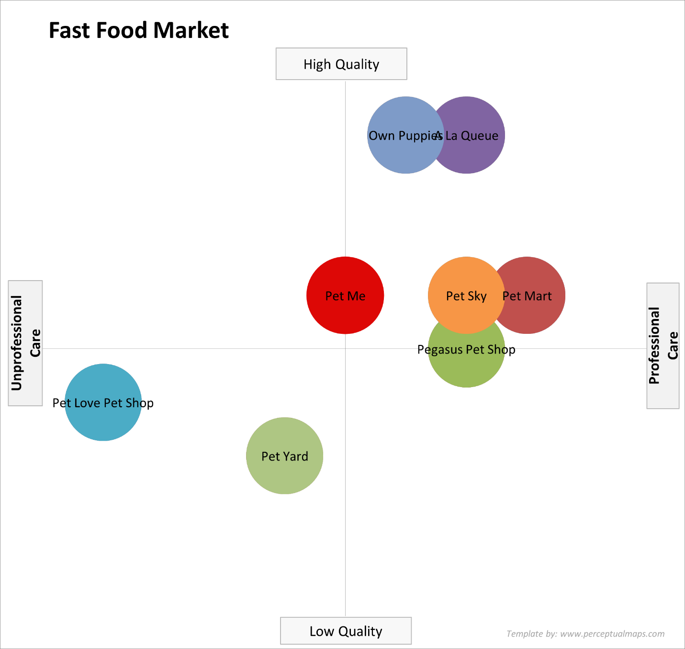

**V. Marketing Plan**

1- The main reason behind stray dogs is the financial status of families and lack of awareness as there exist some people who torture and attack their pets every single day. In 2018, there existed 20,000 to 35,000 stray dogs continuing to increase and attained 50,000 stray dogs in 2021, said ArabNews.

2- Our research was done by making a questionnaire so we knew that most of pet owners’ own dogs rather and a lot of families face problems in terms of taking care of it to the fullest, that’s why we made the app where its role is to solve customer issues concerning adoption, treatments, training programs and food.

3-Our customers will be gotten through social media platforms firstly as people spend most of their time scrolling on Facebook and Instagram. When they will know about the services we provide and our products quality, customers will then refer to their friends, cousins and tell them about what services do we provide as a pet app. (Word of mouth)

4-The budget spent on social media ads during our first year of the startup is going to be approximately 2000$.

5-Our main focus will these three channels: social media, flyers and word of mouth.

6-Concerning the pricing, standard users pay $1.99 and ambassadors pay $6.99 and those are yearly payment apart of the products we sell from toys, vaccine, food, pet medical report and training programs.

7-The expected number of app users is around 15k and this number was reached after the questionnaire knowing people that will bring us their pets, maybe adopt them, breed them…

**VII. Financial Statement.**

1. Costs:
   * + Toys, food, vaccines. (Around 5000$).
     + App Development (Free because we know how to develop an app from scratch).
     + Vets Salaries.
2. Revenues:

* Offers and deals making us a revenue of $3.99 from registered users(ambassadors).
* Profitable Ads like Google Ads (Around $1 per ad).
* Ad program where app users can boost their post ($1-$30).