Review of Related Literature and Works
- This section provides a critical analysis of existing studies and systems relevant to the capstone project. It summarizes and synthesizes prior research to identify key themes, common findings, and research gaps that justify the proposed study. Related Literature focuses on scholarly sources aligned with the study objectives, while Related Works discuss existing systems similar to the proposed solution.
- Minimum of 16 resources such as journals, research papers, technical reports, etc. which are not older than 10 years.
- A tabular comparison of related works highlighting system functionalities, algorithms, parameters, and performance metrics is required. All sources must be cited using IEEE in-text citation format.
Definition of Terms
- This section lists all operational and technical terms used in the project. Each definition should explain how the terminology is applied within the system. All entries must be relevant to the document and arranged in alphabetical order. (WITH CITATION)
Methodology
- Methodology refers to the systematic approach, techniques, and processes used to carry out a study or develop a project. It explains how the research or system is designed, developed, and implemented to achieve its objectives.
- Agile
- Waterfall
- Scrum
- Kanban
- Spiral Model
- V-Model (Verification and Validation Model)
- Iterative Model
- Incremental Model
- Rapid Application Development (RAD)
- DevOps
- Lean Software Development
- Extreme Programming (XP)
- Prototype Model
- Big Bang Model
System Planning
- This section outlines the planning phase and project conception. It must include:
  - Project Team Organization: Organizational chart showing team composition. Include pictures and your adviser as the top of the tree.
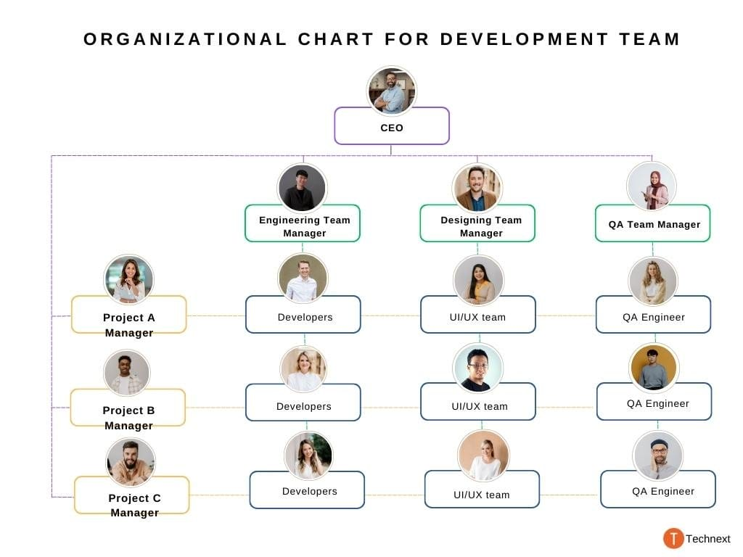
  - Work Breakdown Structure (WBS): Phase-based breakdown of all activities, preferably following PADIM stages.
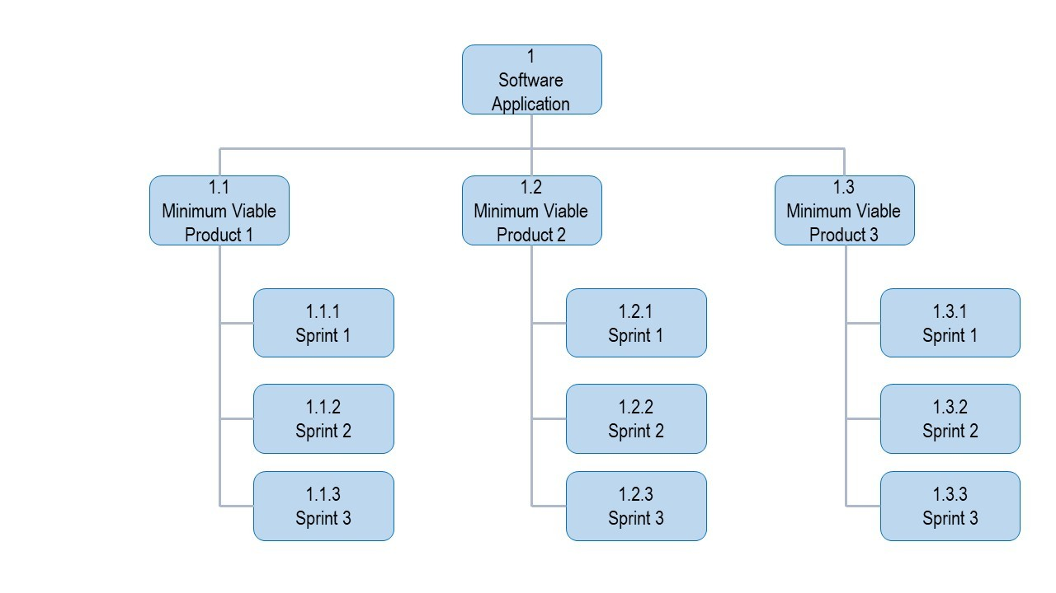
  - Gantt Chart: Project schedule depicting tasks from the WBS with month and year formatting.
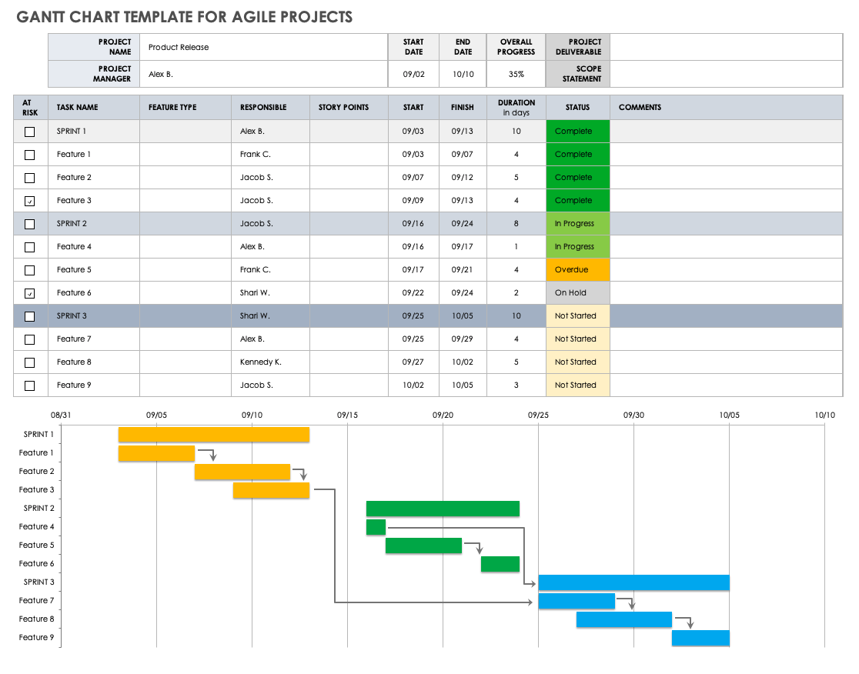
System Analysis
- System Architecture: Conceptual framework showing system components (hardware, software, data), users, and interactions, supported with diagrams.
Conceptual framework
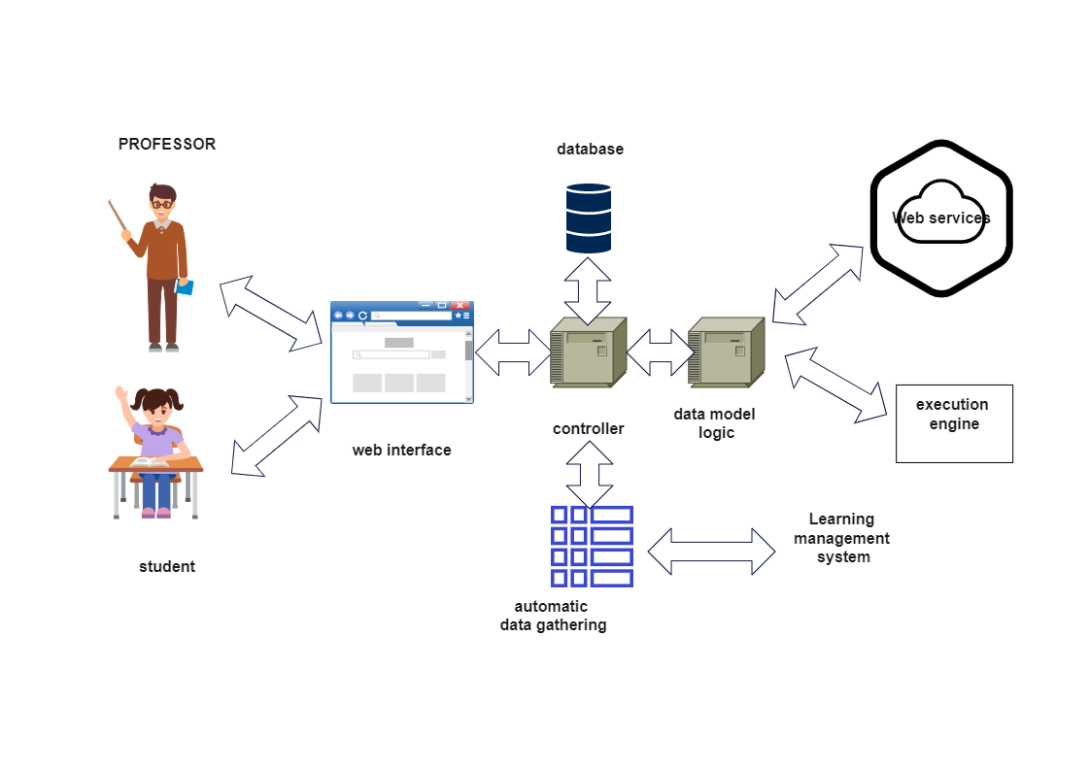
Prototype (with IoT or Infrastructure)
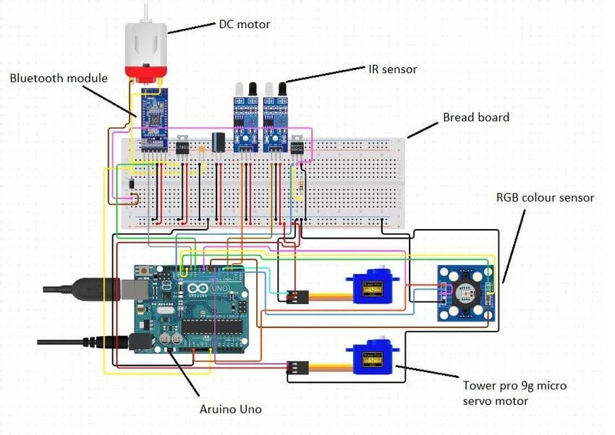
Floor Plan (Physical Layout Design)
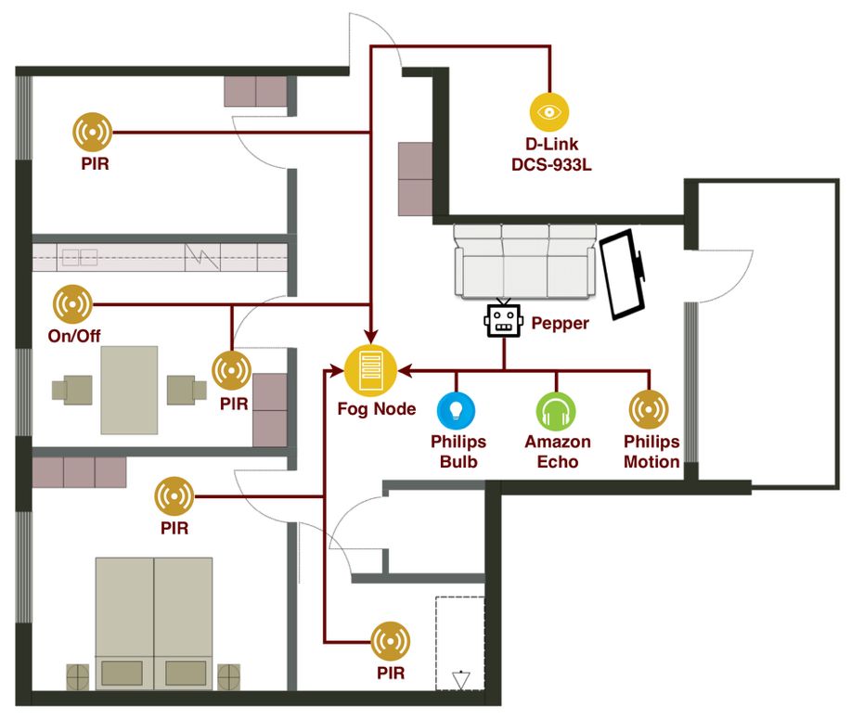
- Functional and Non-functional Requirements: Expected system functionalities and quality attributes, presented in brief discussion and numbered lists.
- Use Case Diagram: Shows system users (actors) and their interactions.
- Context Flow Diagram (Level 0 DFD): Illustrates business actions and data flow with external entities. Physical DFD may be used for game development projects.
- Level 1 DFD: Expands Level 0 DFD to show modules, subprocesses, and detailed data flow. Use Gane and Sarson notation for logical diagrams.
System Design
- Entity Relationship Diagram (ERD): Shows database entities and relationships. Omit if using NoSQL.
- JSON Schema Diagram: Defines the structure of JSON documents for validation and automated testing. Omit for SQL-based databases.
- Data Dictionary: Table listing all tables, fields, and descriptions.
- Technologies, Concepts, and Theories: Discussion of models, algorithms, or emerging technologies used, including:
Type of Data
- Primary data (directly collected from users/sensors)
- Secondary data (from existing records, databases, or APIs)Data
Sources
- User inputs (forms, transactions)
- System-generated data (logs, records)External sources (APIs, datasets)
- IoT devices (if applicable)Data Collection Method
- Manual input (user entry)
- Automated collection (system logs, sensors, API integration)
Time of Collection
- Data start and end of data collection
- Real-time (continuous monitoring systems)
- Periodic (daily, weekly, monthly)
- One-time (initial setup data)
Dataset Overview
- Number of records
- Expected growth over time
Data Structure
- Key fields (ID, name, date, status, etc.)
- Grouped into categories (e.g., users, transactions, devices)
Data Cleaning
- Removing duplicates, errors, and irrelevant data
- Handling missing or incomplete values
Data Transformation
- Converting data into usable format (e.g., normalization, encoding)Standardizing units, formats, or values
Data Integration
- Combining data from multiple sources into one dataset
- Ensuring consistency across different data inputs
Data Reduction
- Removing unnecessary fields or features
- Selecting only relevant data for analysis or system use
Data Validation
- Checking accuracy and consistency before processing
- Ensuring data follows required rules and constraints
System Testing
- Provide what are the fields and columns in determining such successful result.
- Define your confidence level.
