Avaliação dados MBA

Objetivo:

Análise do salário inicial de recem formados em MBA

1. Leitura dos dados

library(readxl)

## Warning: package 'readxl' was built under R version 3.5.1

mba <- read_excel("C:/Users/cesar/Desktop/Analise Exploratória MBA/mba.xlsx")  
View(mba)  
str(mba)

## Classes 'tbl_df', 'tbl' and 'data.frame': 274 obs. of 13 variables:  
## $ age : num 23 24 24 24 24 24 25 25 25 25 ...  
## $ sex : num 2 1 1 1 2 1 1 2 1 1 ...  
## $ gmat_tot: num 620 610 670 570 710 640 610 650 630 680 ...  
## $ gmat_qpc: num 77 90 99 56 93 82 89 88 79 99 ...  
## $ gmat_vpc: num 87 71 78 81 98 89 74 89 91 81 ...  
## $ gmat_tpc: num 87 87 95 75 98 91 87 92 89 96 ...  
## $ s_avg : num 3.4 3.5 3.3 3.3 3.6 3.9 3.4 3.3 3.3 3.45 ...  
## $ f_avg : num 3 4 3.25 2.67 3.75 3.75 3.5 3.75 3.25 3.67 ...  
## $ quarter : num 1 1 1 1 1 1 1 1 1 1 ...  
## $ work_yrs: num 2 2 2 1 2 2 2 2 2 2 ...  
## $ frstlang: num 1 1 1 1 1 1 1 1 2 1 ...  
## $ salary : num 0 0 0 0 999 0 0 0 999 998 ...  
## $ satis : num 7 6 6 7 5 6 5 6 4 998 ...

1. Analise do Salários e limpeza do banco

mean(mba$salary)

## [1] 39025.69

median(mba$salary)

## [1] 999

hist(mba$salary)

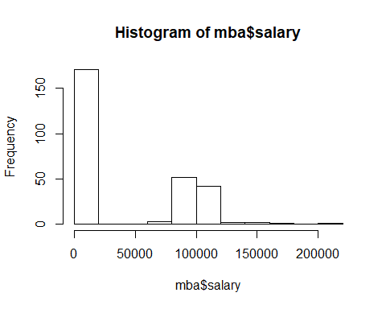

# Estudantes que revelaram o seu salario  
responderam <- mba[which (mba$salary > 1000) , ]  
dim(responderam)

## [1] 103 13

View (responderam)  
hist(responderam$salary)

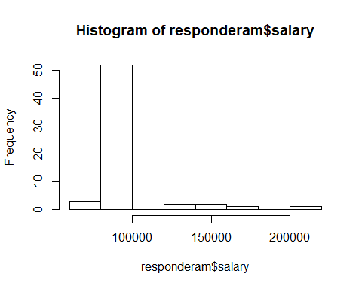

describe(responderam)

## vars n mean sd median trimmed mad min  
## age 1 103 26.78 3.27 2.60e+01 26.30 2.97 22.0  
## sex 2 103 1.30 0.46 1.00e+00 1.25 0.00 1.0  
## gmat_tot 3 103 616.02 50.69 6.20e+02 615.90 59.30 500.0  
## gmat_qpc 4 103 79.73 13.39 8.20e+01 81.05 13.34 39.0  
## gmat_vpc 5 103 78.56 16.14 8.10e+01 80.33 16.31 30.0  
## gmat_tpc 6 103 84.52 11.01 8.70e+01 85.60 11.86 51.0  
## s_avg 7 103 3.09 0.38 3.10e+00 3.10 0.44 2.2  
## f_avg 8 103 3.09 0.49 3.25e+00 3.13 0.37 0.0  
## quarter 9 103 2.26 1.12 2.00e+00 2.20 1.48 1.0  
## work_yrs 10 103 3.68 3.01 3.00e+00 3.11 1.48 0.0  
## frstlang 11 103 1.07 0.25 1.00e+00 1.00 0.00 1.0  
## salary 12 103 103030.74 17868.80 1.00e+05 101065.06 7413.00 64000.0  
## satis 13 103 5.88 0.78 6.00e+00 5.89 1.48 3.0  
## max range skew kurtosis se  
## age 40 18.0 1.92 4.90 0.32  
## sex 2 1.0 0.86 -1.28 0.05  
## gmat_tot 720 220.0 0.01 -0.69 4.99  
## gmat_qpc 99 60.0 -0.81 0.17 1.32  
## gmat_vpc 99 69.0 -0.87 0.21 1.59  
## gmat_tpc 99 48.0 -0.84 0.19 1.08  
## s_avg 4 1.8 -0.13 -0.61 0.04  
## f_avg 4 4.0 -2.52 13.86 0.05  
## quarter 4 3.0 0.27 -1.34 0.11  
## work_yrs 16 16.0 2.48 6.83 0.30  
## frstlang 2 1.0 3.38 9.54 0.02  
## salary 220000 156000.0 3.18 17.16 1760.67  
## satis 7 4.0 -0.40 0.44 0.08

boxplot(responderam$salary,  
 main= "Boxplot do salario",  
 horizontal=TRUE,  
 xlab="salary")

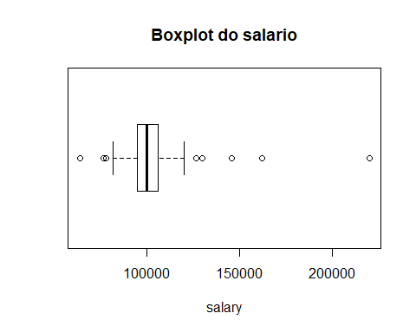

oneway.test(responderam, formula=salary~sex)

##   
## One-way analysis of means (not assuming equal variances)  
##   
## data: salary and sex  
## F = 1.8573, num df = 1.000, denom df = 38.115, p-value = 0.1809

boxplot(responderam$salary ~ responderam$sex)

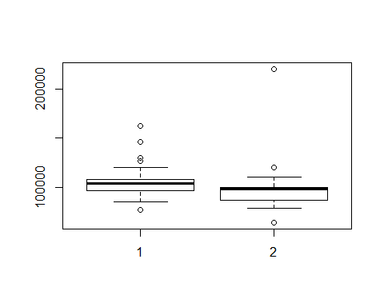

#Valor p alto, aceita a Hipotese Nula, os salários de homens e mulheres em média são iguais

Retirada do Outlier

responderamsoutlier<- responderam[which (responderam$salary < 200000) , ]  
  
boxplot(responderamsoutlier$salary,  
 main= "Boxplot do salario sem outlier",  
 horizontal=TRUE,  
 xlab="salary")

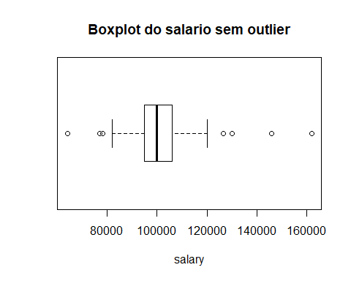

oneway.test(responderamsoutlier, formula=salary~sex)

##   
## One-way analysis of means (not assuming equal variances)  
##   
## data: salary and sex  
## F = 17.729, num df = 1.000, denom df = 70.693, p-value = 7.384e-05

boxplot(responderamsoutlier$salary ~ responderamsoutlier$sex)

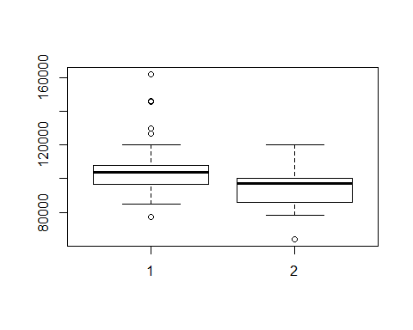

oneway.test(responderamsoutlier$salary ~ responderamsoutlier$quarter)

##   
## One-way analysis of means (not assuming equal variances)  
##   
## data: responderamsoutlier$salary and responderamsoutlier$quarter  
## F = 3.4424, num df = 3.000, denom df = 47.963, p-value = 0.02389

boxplot(responderamsoutlier$salary ~ responderamsoutlier$quarter)

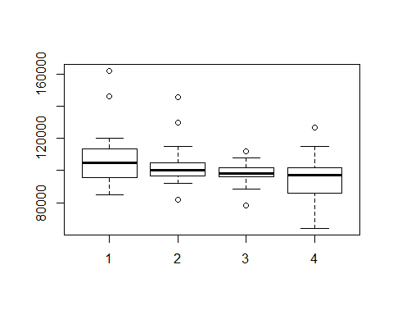

regressao1<-lm(responderamsoutlier$salary ~ responderamsoutlier$quarter)  
regressao1

##   
## Call:  
## lm(formula = responderamsoutlier$salary ~ responderamsoutlier$quarter)  
##   
## Coefficients:  
## (Intercept) responderamsoutlier$quarter   
## 110290 -3744

#Quem está no primeiro quartil tem salário em média mais alto  
  
#redução do salário anual em -3744 por diminuição do quartil

regressao2<-lm(responderamsoutlier$salary ~ responderamsoutlier$gmat_tot)  
summary (regressao2)

##   
## Call:  
## lm(formula = responderamsoutlier$salary ~ responderamsoutlier$gmat_tot)  
##   
## Residuals:  
## Min 1Q Median 3Q Max   
## -36659 -6410 -1745 4405 58340   
##   
## Coefficients:  
## Estimate Std. Error t value Pr(>|t|)   
## (Intercept) 88652.78 16956.49 5.228 9.4e-07 ***  
## responderamsoutlier$gmat_tot 21.44 27.39 0.783 0.436   
## ---  
## Signif. codes: 0 '***' 0.001 '**' 0.01 '*' 0.05 '.' 0.1 ' ' 1  
##   
## Residual standard error: 13650 on 100 degrees of freedom  
## Multiple R-squared: 0.00609, Adjusted R-squared: -0.003849   
## F-statistic: 0.6128 on 1 and 100 DF, p-value: 0.4356

regressao3<-lm(responderamsoutlier$salary ~ responderamsoutlier$frstlang)  
summary (regressao3)

##   
## Call:  
## lm(formula = responderamsoutlier$salary ~ responderamsoutlier$frstlang)  
##   
## Residuals:  
## Min 1Q Median 3Q Max   
## -37749 -6749 -1749 4001 60251   
##   
## Coefficients:  
## Estimate Std. Error t value Pr(>|t|)   
## (Intercept) 99447 6245 15.92 <2e-16 ***  
## responderamsoutlier$frstlang 2301 5758 0.40 0.69   
## ---  
## Signif. codes: 0 '***' 0.001 '**' 0.01 '*' 0.05 '.' 0.1 ' ' 1  
##   
## Residual standard error: 13680 on 100 degrees of freedom  
## Multiple R-squared: 0.001595, Adjusted R-squared: -0.008389   
## F-statistic: 0.1598 on 1 and 100 DF, p-value: 0.6902

#R2 baixo

boxplot(salary ~ work_yrs ,data=responderamsoutlier, main="Experiencia X salário", ylab="Experiencia", xlab="Salario", horizontal=TRUE)

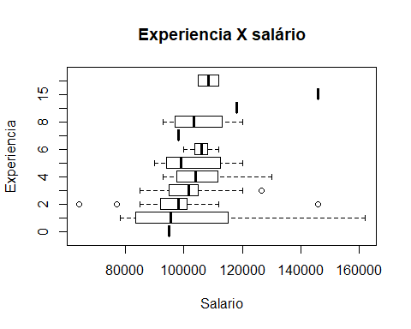

scatterplot(salary ~ work_yrs ,data=responderamsoutlier, main="grafico de dispersão ", xlab="Experiencia (anos)", ylab="Salario")

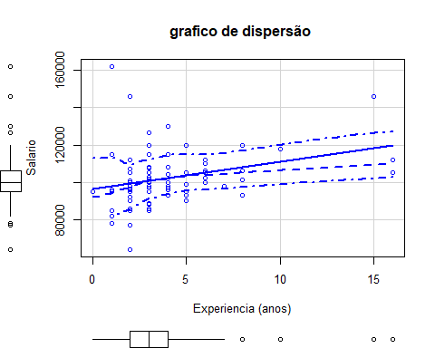

#Análise de correlação ( achei bem legal)  
library(corrplot)

## Warning: package 'corrplot' was built under R version 3.5.1

## corrplot 0.84 loaded

C <-cor(responderamsoutlier [, c("age","work_yrs", "gmat_tot", "gmat_qpc", "gmat_vpc", "gmat_tpc", "s_avg", "f_avg", "quarter", "satis")])   
corrplot(C, method="circle")

