Report — Tsunami Alarm Siren (La Punta)
ER(t) definition: ER(t) = 10·log10(E_alarm/E_), where E_alarm sums STFT power over tonal masks detected only for f ≥ 500 Hz, and E_ sums the remaining (non-tonal) fullband power (including <500 Hz).

PUNTO_01 — Point 01
Date/Time: 2026-01-07 10:05
Coordinates: -12.072392, -77.164504
Distance to siren: 30.7 m
Sound pressure level (SPL): 96.0 dB (ref.)
ER mean (dB): 4.29
ER standard deviation (dB): 12.79
Notes:
Spectrogram (siren)
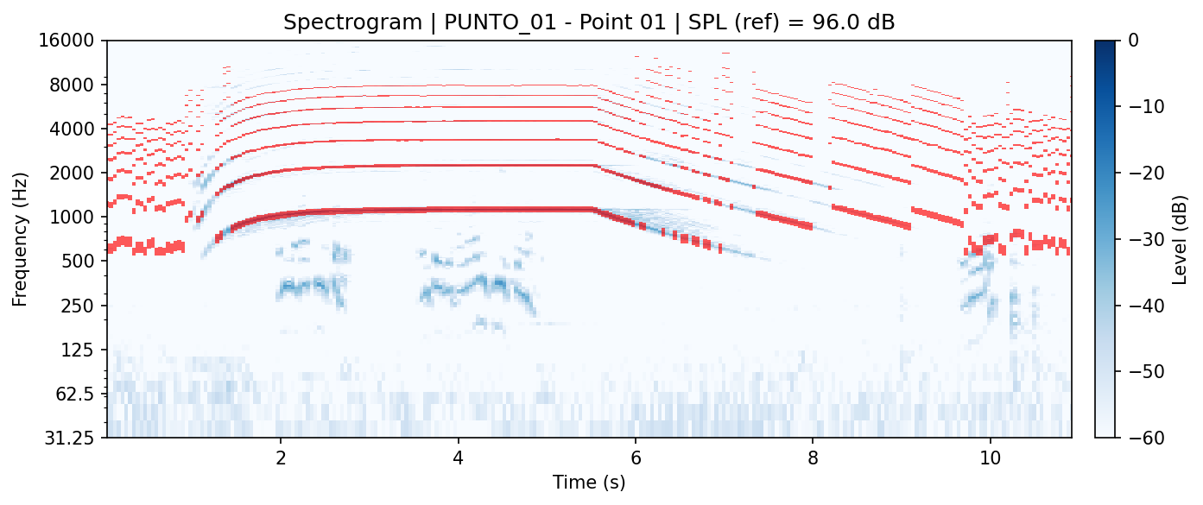
Energy Ratio (ER)
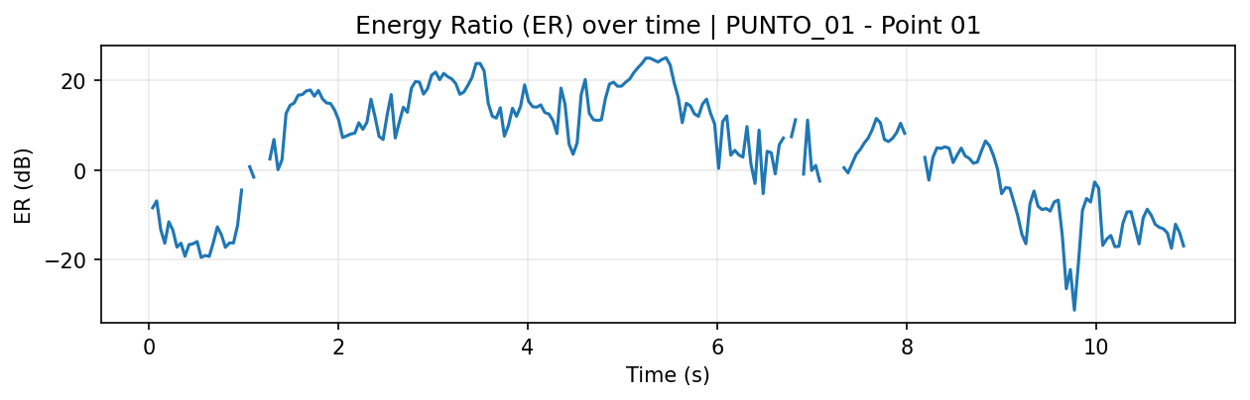
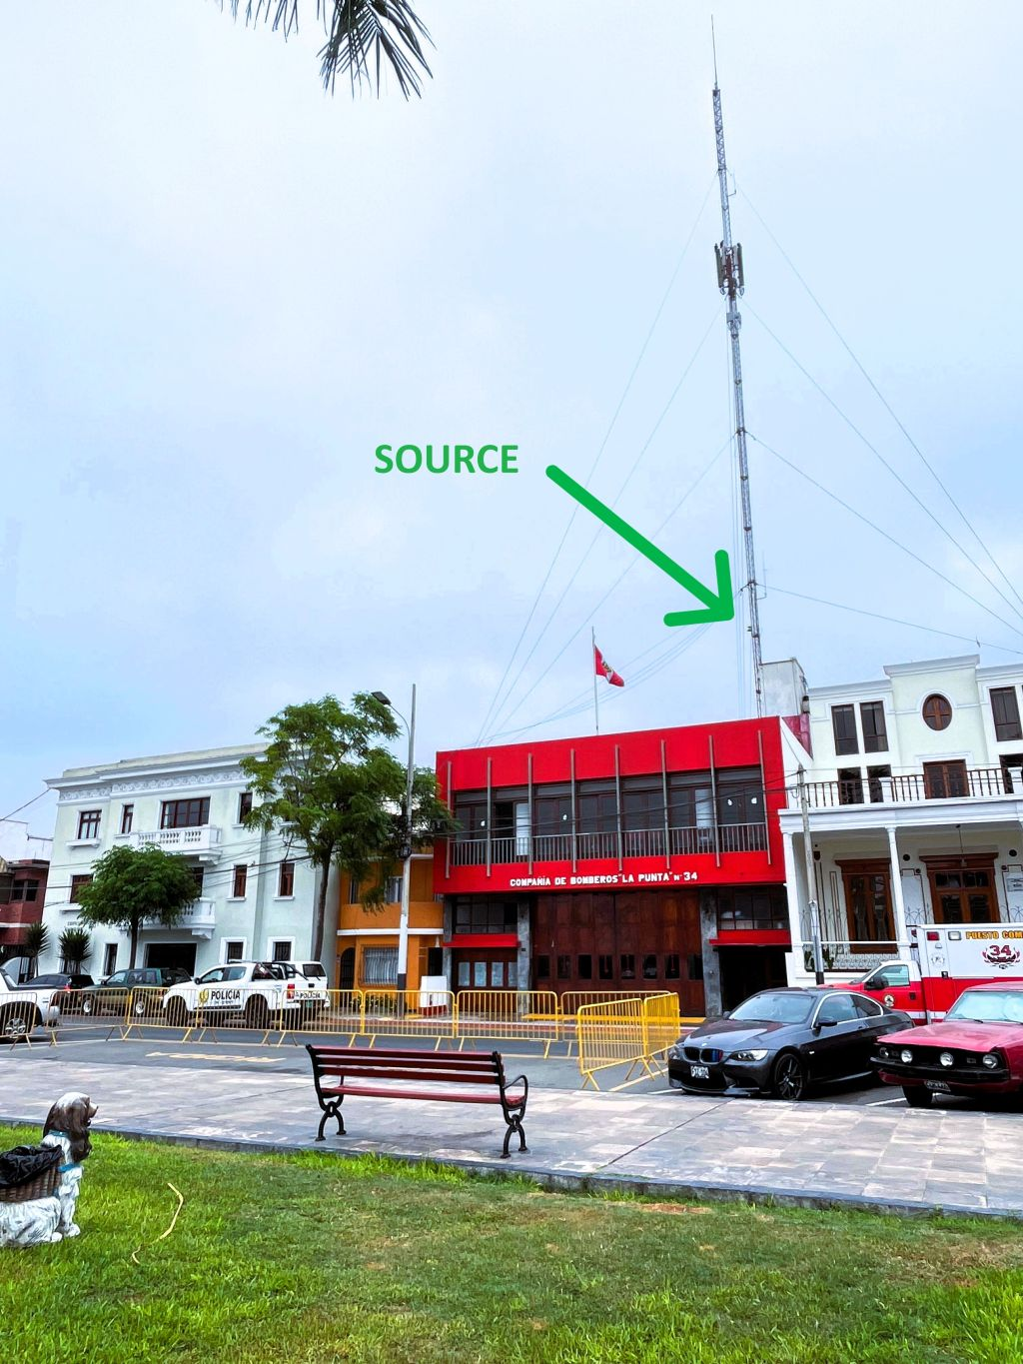

PUNTO_02 — Point 02
Date/Time: 2026-01-07 10:08
Coordinates: -12.073075, -77.164209
Distance to siren: 113.2 m
Sound pressure level (SPL): 84.7 dB (est.)
ER mean (dB): -2.52
ER standard deviation (dB): 12.49
Notes:
Spectrogram (siren)
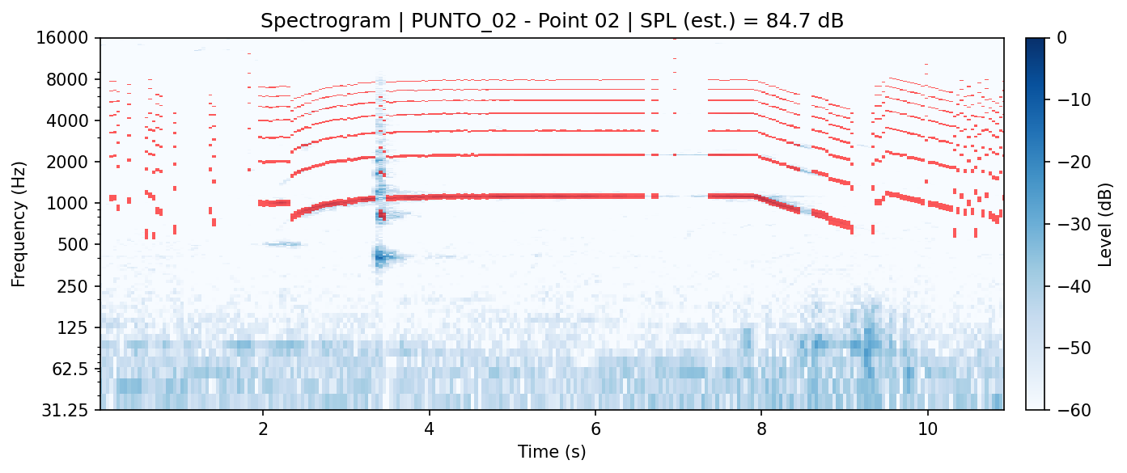
Energy Ratio (ER)
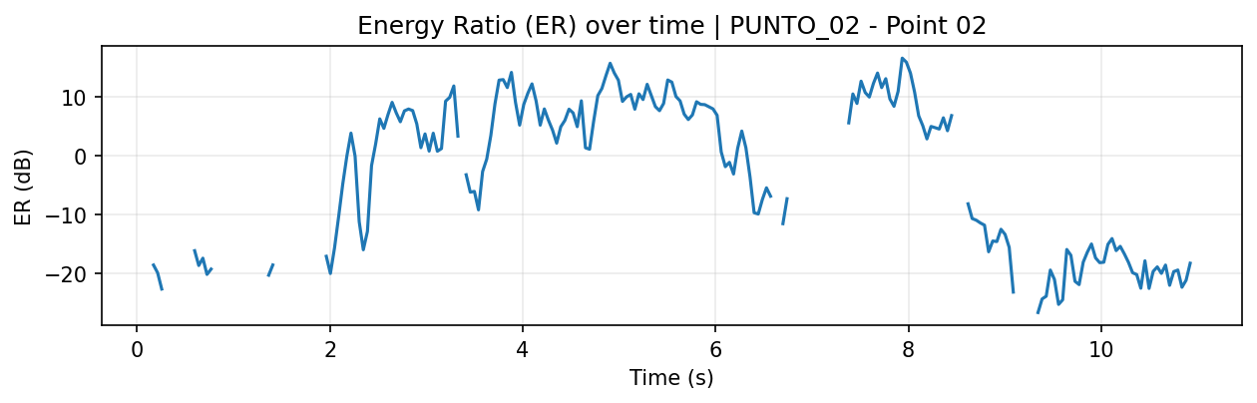
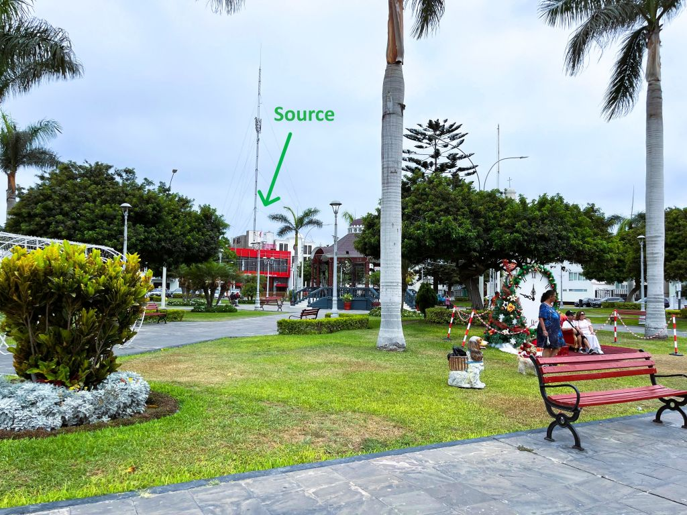

PUNTO_03 — Point 03
Date/Time: 2026-01-07 10:13
Coordinates: -12.073700, -77.165502
Distance to siren: 198.0 m
Sound pressure level (SPL): 79.8 dB (est.)
ER mean (dB): -12.57
ER standard deviation (dB): 14.16
Notes:
Spectrogram (siren)
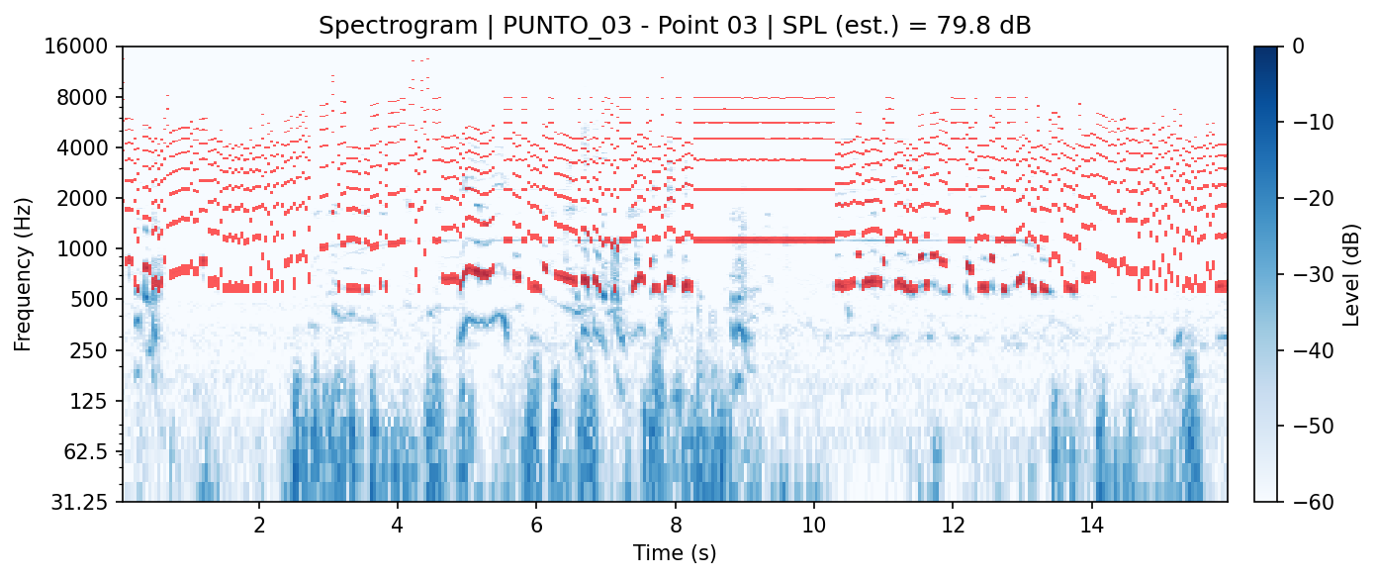
Energy Ratio (ER)
