The Math Club’s reading club

The concept of dimension is present in Calculus, Geometry, Topology, Linear Algebra, Analysis, that is, all the basic topics that a math or related major needs to study. Physicists use this mathematical concept to study the shape of space, and to try and determine the geometry and topology of our universe. Over a hundred years ago (1884), Edwin Abbott Abbott wrote a mathematical adventure set in a two-dimensional plane world. Our math club’s reading club discusses these novels and, more importantly, the mathematical ideas behind them.
Edwin Abbott Abbott’s two-dimensional plane world, was populated by a hierarchical society of regular geometrical figures (criminals were irregular, women were lines).
By imagining the contact of beings from different dimensions, the author fully exploited the power of dimensional analogy.
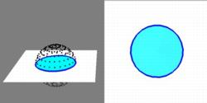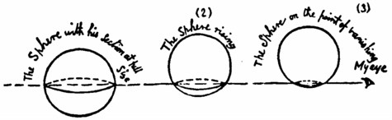
It has been said that there is no better way to begin exploring the problem of understanding higher-dimensional slicing phenomena than reading this classic novel of the Victorian era.
As a satire, Flatland offered pointed observations on the social hierarchy of Victorian culture.
However, the novella's more enduring contribution is its examination of dimensions;

By applying dimensional analogy, one can infer that a four-dimensional being would be capable of similar feats from our three-dimensional perspective.

We could understand a visit from a hyper-sphere from the fourth dimension in the same way a flatlander understands a visit from the third dimension.
We would see a small sphere appear and then grow.
Once past the equator, the spheres begin to shrink again, until the sphere disappears as the hyper-sphere leaves our three-dimensional space again.

Rudy Rucker fictionalizes this in his novel Spaceland, in which the protagonist, Joe Cube, encounters four-dimensional beings who demonstrate such powers. 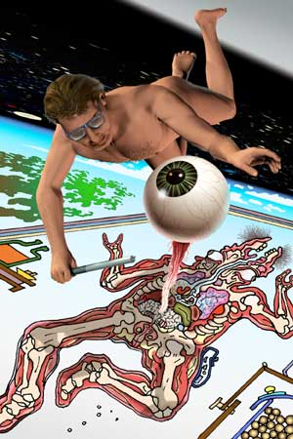

The mathematical fantasy, Sphereland, by Dionys Burger revisits the world of Flatland in to explore the theories created by Albert Einstein, whose work so completely altered the scientific understanding of space, time, and matter.

Come and explore the world of mathematical literature with the math club’s reading club.

