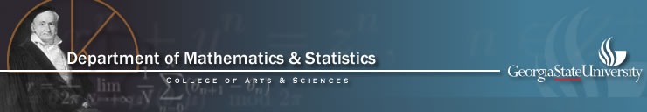

End-of-Semester Celebration of Mathematics and Statistics

Organized by the Mathematics and Statistics Club at Georgia State

Friday April 17, 12:00-2:00 pm, 796 COE (light lunch will be provided)

Presentation of Student Awards ( 12:00-12:15pm)

The following awards will be presented:

The V. V. Lavroff Calculus Award, The Best Teaching Assistant Award and the winners of the Fifth Annual Undergraduate Mathematics Competition.

RIMMES presentations (12:20-1:30 pm):

12:20pm-12:30 pm
Ben Sirb: Musicians, graphs, and set systems
Mentor: Dr. Yi Zhao

12:35-12:45pm
Abby Neal: Mixed Integer Linear Programming with Applications to Routing
Mentor: Dr. Michael Stewart

12:50-1:00 pm
David Brandt: Synchrony in tritrophic food chain metacommunities
Mentor: Dr. Igor Belykh

1:05-1:15pm
Jonathan Cantrell: Rubato Composer and its Functorial Approach: From Morphisms to Gestures through Rubettes
Mentors: Dr. Mariana Montiel

1:20-1:30pm
Rob Burnham: Creating and Implementing a Form Space and Denotator for Bass Using the Category-Theoretic Concept Framework
Mentors: Dr. Mariana Montiel

ALL STUDENTS AND FACULTY ARE INVITED TO ATTEND!

