KISKSTARTER

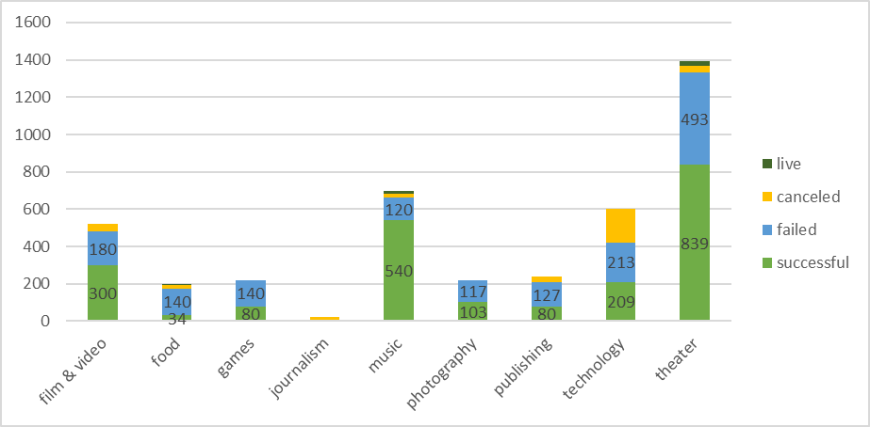

Kickstarter is a sucessful crowdfunding service, but not every project has found success. I analyzed 4,000 project in order to find any trends where it can say why some project failed or success.

The graph above shows that the projects that have founding success are those who their target is the cultural projects such as Film and video, music and theater. This seems to help artists to reach their goals.

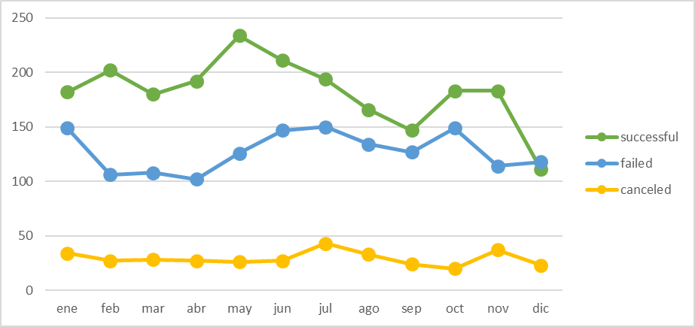

The period which Kickstarter has a huge amount of work is in summer -May, June and July-. I assume that, because founders have a better enthusiasm or more resources to invest. Since 2009 to 2016 summertime has 9.5% of success projects; December has the lowest with 6.2%

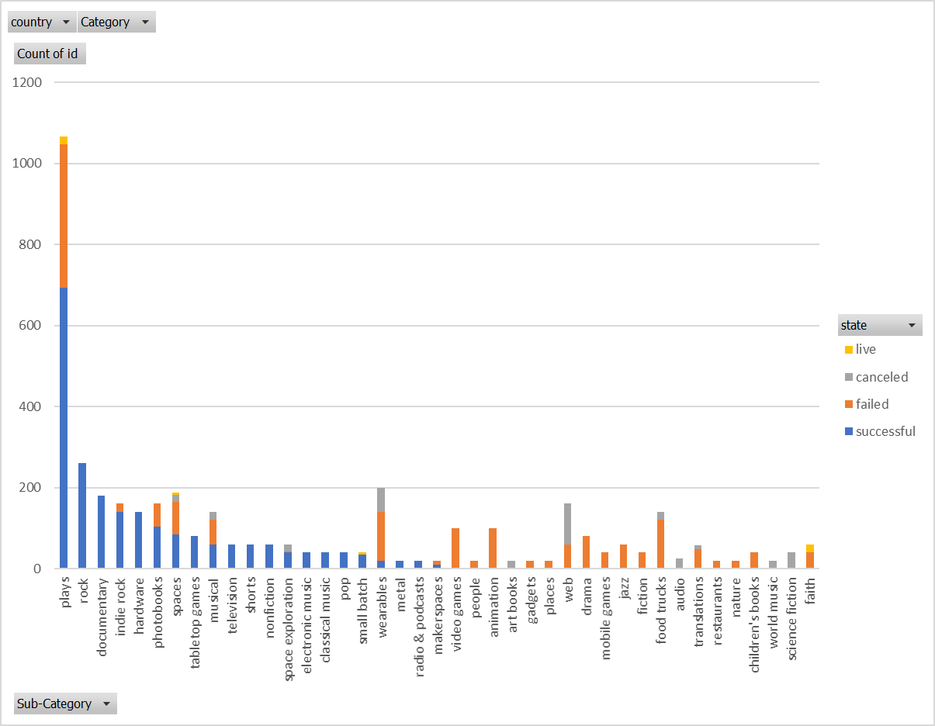

As I mentioned before. Cultural projects are helped by Kickstarter and the have been founded by more inversionists. Within cultural project there are two that have success where they ask for money. They are plays and rock. They have 65% and 100% of success cases when they ask for money.

LIMITATION OF THE DATASET



In the initial statement, it mentioned that a third part had been succeeded. But in the table above, it shows that there are more than 50% as successful projects.

The limitation is that maybe the dataset is incomplete due it’s only until the first quarter of 2017.

OTHER GRAPHS

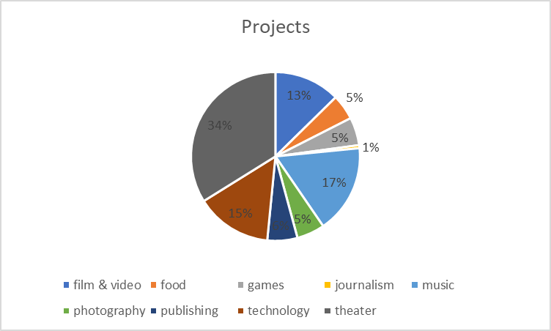

The project that have been asked to find the most is Theater, then music and technology.