
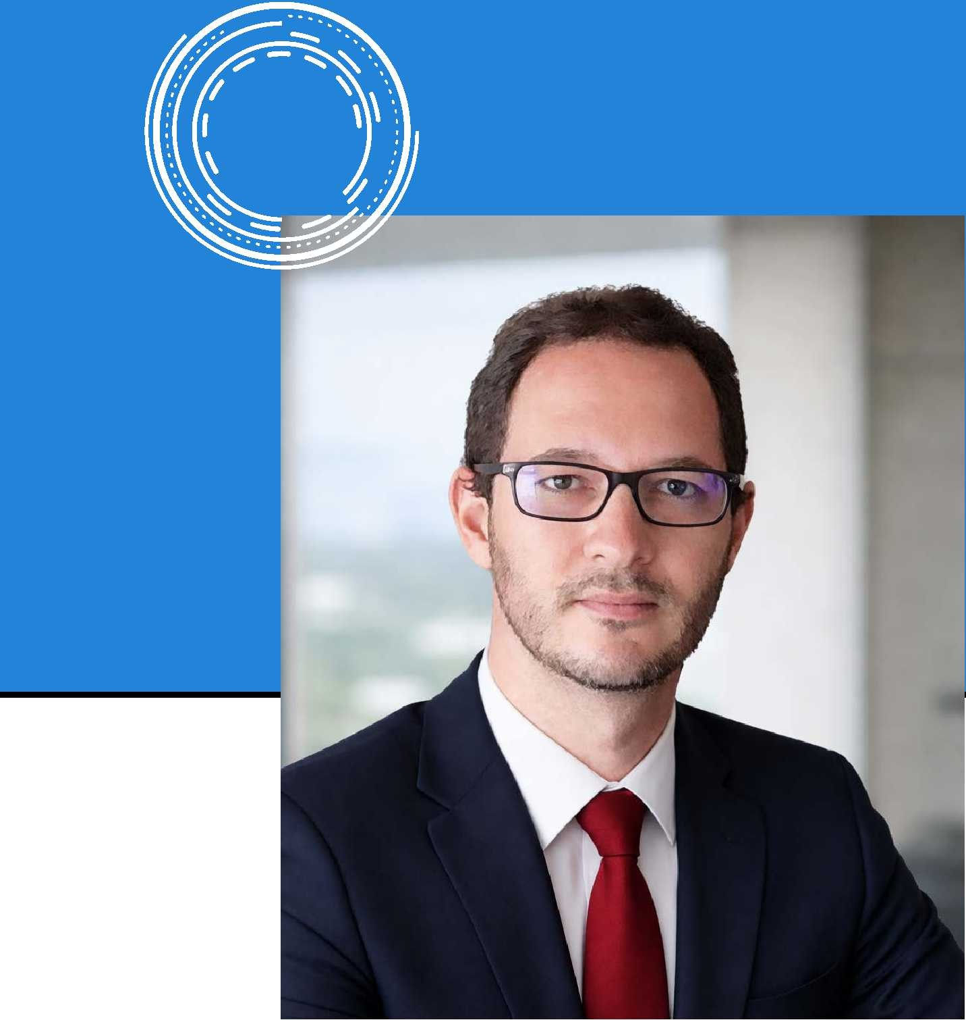
Data Science DS4A - Correlation One Business Intelligence - Uni. Javeriana
Power BI - Uni. Javeriana
Independent Practitioner – Remote

Independent Practitioner – Remote

Operational Management COCICO (Commercial Cycle)
Cartagena, Colombia | 06.2019 - 06.2022:
Performed portfolio data analysis to deliver critical compliance, recovery, and financial reports.
Provided statistical business insights to track default plans and revenue control, strengthening decision-making and data governance.
Location: Berlin. Germany.
Work Authorization: Chancenkarte Visa
Seeking EU Blue Card Sponsorship

•
•
Scheduled recurring data workflows using Python and SQL via Cron jobs to systematically generate and distribute reports.
Parsed and refactored Python code to update data transformations according to stakeholder requirements.

Executed data cleaning, integration, and validation form multiple operational systems in order to report OKR dashboards
Integrations Engineer
Bogota, Colombia | 01.2023 - 05.2024:
ENEL CODENSA – Hybrid

•
•
Senior Professional in Distribution
Bogota, Colombia | 07.2022 - 12.2022:
Developed Python-based risk models for asset optimization, including failure prediction, health index scoring, and remaining useful life (RUL) estimation.
Executed pipeline ingestion and data wrangling from multiple operational systems in order to report Objectives and Key Results (OKR) dashboards.
EPM AFINIA – On-site

Head of Default Management
Cartagena, Colombia | 04.2015 - 07.2018:
•
•
Customer Technical Assistance Analyst
Barranquilla, Colombia | 08.2018 - 05.2019:
•
•
Drove budget planning and variance analysis using historical data and quantitative methods to benchmark efficiency and costs.
Managed databases of supplier contracts, agreements, and external service providers to track performance metrics, quality indicators and compliance criteria.
Designed, implemented and monitored BI frameworks to optimize operational and commercial performance, including EDAs
Extracted and analyzed large customer and operational datasets for reporting integrated by Python, SQL and BI tools.
•
•
Performed data munging, integrity and quality checks on large-scale insurance datasets, ensuring accuracy, consistency and compliance with actuarial, risk and operations business rules.
Conducted Exploratory Data Analysis (EDA) to identify trends, anomalies, customer behaviors, and risk-related patterns, presenting results using clear data-storytelling techniques.

Executed data cleaning, integration, and validation form multiple operational systems in order to report OKR dashboards
•
•
WORK EXPERIENCE
Insurance Data Analyst
Bogota, Colombia | 06.2024 - 12.2025:

GET IN CONTACT
Mobile: +49 171 291 9370
E-Mail: cesarmercado@outlook.com

Data & Business Analyst.
CERTIFICATES
LANGUAGES
•
•
•
English (C1)
German (A1) Spanish (Native)
•
•
•
•
•
•
•
Programming: Python, SQL.
Data Analysis: Data cleaning, EDA, quantitative analysis.
Business Intelligence: Reporting, KPI dashboards, Storytelling.
Operational Analytics: KPI design, performance tracking, optimization.
SKILLS
BUSINESS SCHOOL FE
Madrid, Spain
- MBA - Strategic Business Management | 2022
- Bachelor of Science in Industrial Engineer | 2015
EDUCATION
UNIVERSIDAD DEL NORTE
Barranquilla, Colombia
PERSONAL PROFILE
Industrial Engineer and Data Analyst with 5+ years in utilities and insurance sectors, skilled in data extraction, quantitative analysis and KPI development from complex information sources, complemented by an MBA focused on Strategic Business Management.
César Mercado, Eng, MBA
Industrial Engineer | Master in Business Administration

