

Lab 3 | Attacking a Virtual Private Network

Cesar Munguia

10/16/2023

—

IS-3423-003

—

Darniet Jennings

Learning Objectives
Upon completing this lab, you will be able to: 1) Recognize some of the key characteristics of social engineering attack. 2) Identify some of the key signs of a reverse social engineering attack. 3) Implement countermeasures to social and reverse social engineering attacks. 4) Plan and implement a spear phishing campaign. 5) Conduct a Man-in-the-Middle attack to capture traffic intended for a legitimate VPN server.


Section 1: Hands-On Demonstration

Part 1: Observe a Social Engineering Attack
- From the vWorkstation taskbar, click the File Explorer icon to open a File Explorer window.
- In the File Explorer window, navigate to the Lab Files folder (Local Disk (C:) > VPN_Lab_files).
- In the Lab Files folder, double-click the mandrwebsite.pdf icon to see the Marina and Rita's Cupcakes' website.
- Close the mandrwebsite.pdf file.
- In the Lab Files folder, double-click the darknetwebsite.pdf icon to see the Hackers R Us web page.
- Close the darknetwebsite.pdf file.
- In the Lab Files folder, double-click the newspaper.pdf icon to read the article from the business section of the Cincinnati Journal.
- Close the newspaper.pdf file.
- In the Lab Files folder, double-click the travel.pdf icon to see the travel itinerary for Marina and Rita Sugarton.
- Make a screen capture showing the entire travel itinerary for Marina and Rita.
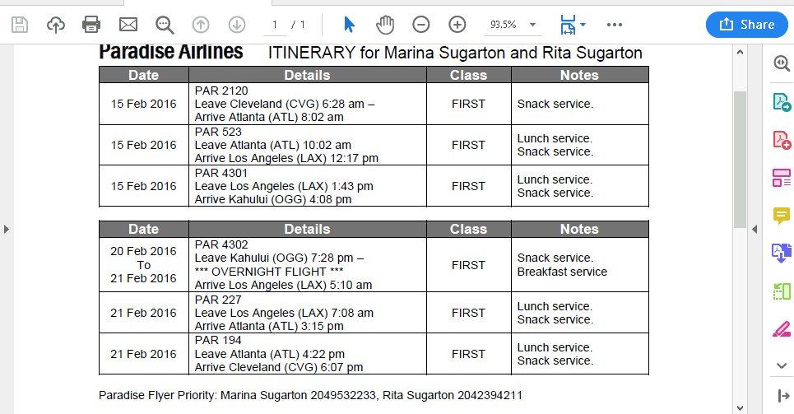
- Close the travel.pdf file.
- On your local computer, open a new browser tab.
- In the browser navigation bar, type https://www.corporatetravelsafety.com/safety-tips/theft_at_airport_screening/ and press Enter to read the travel warning that describes how this type of theft works.
- Close the browser tab.
- In the Lab Files folder, double-click the email.pdf icon to view the email sent by KK to employees of Marina and Rita’s Cupcakes.
- Make a screen capture showing Marina’s email.
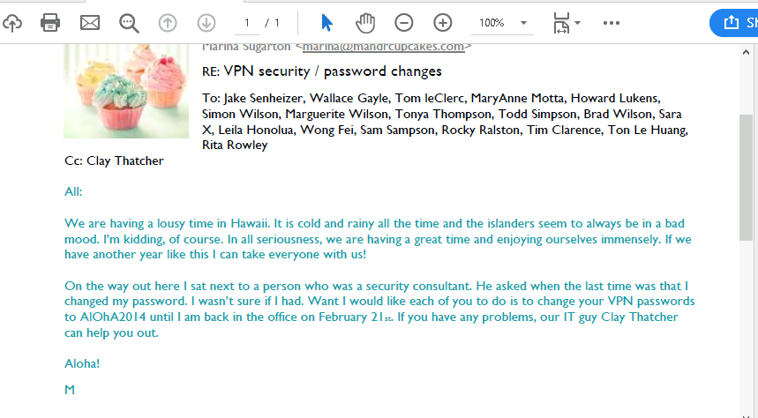
- Close the email.pdf file and navigate back to the Lab Files folder.

Part 2: Craft a Spear Phishing Email
- On your local computer, open a new browser tab.
- In the browser navigation bar, type https://www.consumer.ftc.gov/articles/0003-phishing and press Enter to learn more about phishing scams.
- Read at least three sample scam emails.
- Describe your favorite scam email or an example of a scam email that you have received in the past.
I have not received many scam emails; however, I have received many scams text messages in my phone. It is surprising that I receive many of these in a daily basis
. These scam text come in vary forms but they all follow a particular pattern which is to get me to click a certain link. For example, I received a scam text recently that said that one of my Amazon packages was not able to be delivered to my house because it had incomplete information. So, it asked me to click a link and complete this information, which of course, I did not click.
- Close the browser tab.
- On the Lab View toolbar, select AttackLinux01 from the Virtual Machine menu to connect to the AttackLinux01 machine.
- At the Kali log-in screen, type the following credentials and press Enter to log in as the root user. [Username: root; Password: toor]
- From the AttackLinux01 menu bar, click the Activities menu, then click the Terminal icon to open a new Terminal window.
- At the command prompt, type setoolkit and press Enter to open the Social Engineering Toolkit.
- At the set prompt, type 1 and press Enter to select the Social-Engineering Attacks option.
- At the set: prompt, type 5 and press Enter to select the Mass Mailer Attack menu option.
- At the set:mailer prompt, type 1 and press Enter to select the Email Attack Single Email Address menu option
- At the Send email to prompt, type bobs@securelabsondemand.com and press Enter to specify Bob Singleton as the recipient.
- At the set:phishing prompt, type 2 and press Enter to choose to use your own server or open relay to send the message.
- At the From address prompt type mattr@securelabsondemand.com and press Enter to specify the value of the From field in the mail header.
- At the FROM NAME the user will see prompt, type Matt Ramone and press Enter to provide the email sender’s name. From Name represents the contact’s friendly name and is a field in the message header that is sent alongside the sender’s email address. In the case of a corporate email address, this value is typically the full name of the sender as set in their company user account profile.
- At the Username for open-relay prompt, press Enter to proceed without username authentication.
- At the Password for open-relay prompt, press Enter to proceed without password
- authentication.
- At the SMTP email server address prompt, type 172.40.0.60 and press Enter to specify the open mail server configured in the environment.
- At the Port number for the SMTP server prompt, type 25 and press Enter to specify the common SMTP port.
- At the next three prompts, type the following values and press Enter to set message priority and file inclusion:
Flag this message/s as high priority? no
Do you want to attach a file? n
Do you want to attach an inline file? n
- At the Email subject prompt, type A favor? and press Enter.
- At the Send message as html or plain prompt, type h and press Enter to specify an html message format. This email will place a hyperlink to the false website for Bob to click on. You will do this by adding an anchor tag in the body of the email with a hyper-reference to the false CSCD society site.
- At the Enter the body of the message prompt, type a message to Bob from Matt that might encourage him to make a donation to the Cure Strange Childhood Diseases Society. Once you have finished writing your message, press Enter in preparation to add the hyperlink to the false website, and continue to the next step.
- At the Next line of the body prompt, type <a href="http://cscdsocie, then press the ctrl-shift-u hotkey combination. You should see the u character on your screen. This indicates the terminal is ready to receive a Unicode character code.
- Type 1e6d and press Enter to generate the ṭ character.
- Type y.com"> click here </a> and press Enter to complete the hyperlinked reference to the false donation website.
- At the Next line of the body prompt, type END and press Enter to complete the email composition and send the email.
- On the Lab View toolbar, select vWorkstation from the Virtual Machine menu to connect to the vWorkstation machine (in this context, Bob Singleton’s workstation)
- On the vWorkstation desktop, double-click the Thunderbird icon to open Bob’s Thunderbird email client.
- In the Thunderbird client, double-click the email from Matt to open the message content in a new tab. If you do not see an email, re-check your work on AttackLinux01 to confirm you did not make any mistakes.
- In the Thunderbird client, click More from the top right of the window, then click View Source to open a text document showing the message headers.
- Make a screen capture showing the Blocked by SPF message in the email headers.
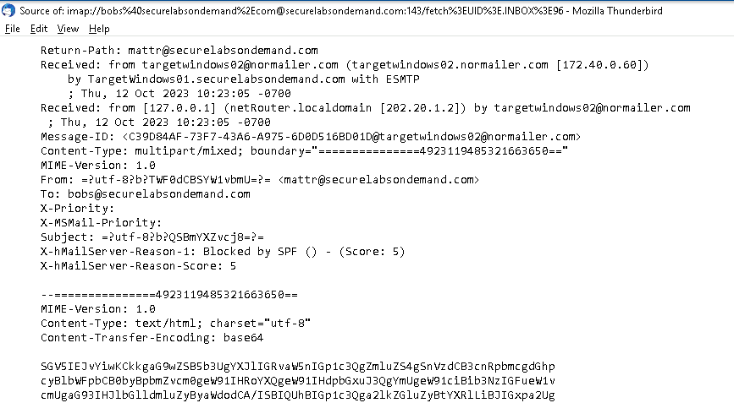
- Close the source text document.
- In the Thunderbird client, click the ”click here” hyperlink to open the false CSCD website in the Chrome web browser.
- On the false CSCD website, right-click anywhere on the page, then select View Page Source from the context menu.
- Close the view-source tab to return to the false CSCD website.
- On the false CSCD website, click the $100 Donation radio button in the Donation Amount section.
- In the Invoice # field, type 00019 to specify the invoice number for accounting purposes.
- In the Memo field, type For the children to add a memorandum to the invoice.
- In the Billing Address section, complete the following fields using your own information:
  - Full Name
  - Institution
  - Email
- Click the green Process Transaction Now button to submit your donation for processing. This will send you to a new page, transaction.php, which will confirm the success of your submission.
- Make a screen capture showing the transaction.php page in the browser. 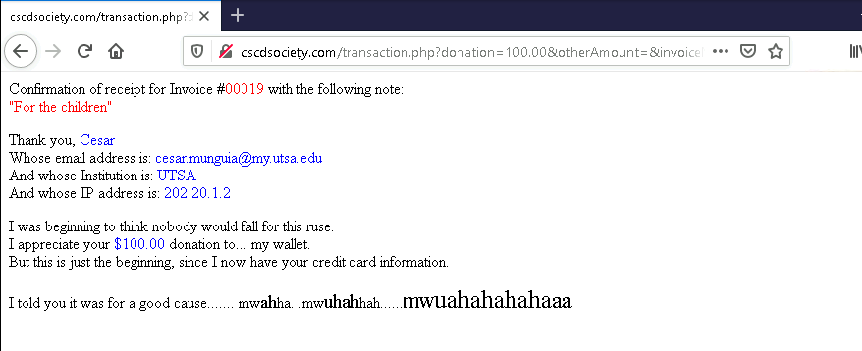

Section 2: Applied Learning

Part 1: Perform a Man-in-the-Middle Attack
- Connect to the RemoteWindows01 machine.
- From the RemoteWindows01 taskbar, launch a Command Prompt window.
- At the command prompt, execute ipconfig to review the network interface configuration of the victim’s machine. Review the configuration for the Student interface, the second interface in the output. More importantly, note the Default Gateway value. This is the IP address of the router to which RemoteWindows01 is connected. It is between this router and the victim’s machine that you want to place yourself in order to view all outbound traffic (traffic sent from the victim’s machine to a resource on another network, typically via the public Internet).
- At the command prompt, execute arp -a to list the ARP table entries on the RemoteWindows01 machine.
- Make a screen capture showing the RemoteWindows01 ARP table.
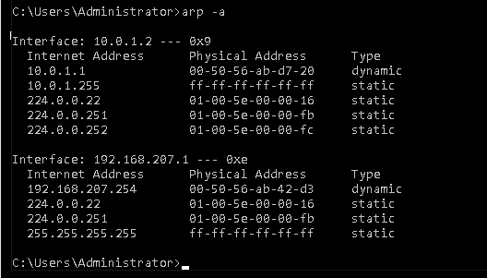
- Connect to the AttackLinux01 machine.
- If necessary, log in using the following credentials.
Username: root
Password: toor
- From the Kali toolbar, launch a Terminal window, then execute wireshark & to launch Wireshark from the command prompt. The & operator places the Wireshark process in the background so that the user can regain access to this terminal. Without it, this terminal instance would be tied up with the Wireshark process, and a new instance would be required in order to perform additional command-line operations.
- In the Wireshark window, start a Wireshark capture on the eth0 interface
- Restore the terminal window.
- At the command prompt, execute arp -a to view the current ARP table entries for the AttackLinux01 machine. Notice that the AttackWindows01 ARP table also contains the same entry for the 10.0.1.1 address. This is not a surprise, considering both machines are on the same local network, and so are using the same default gateway.
- At the command prompt, execute ifconfig eth0 to view the current IP configuration for the eth0 network interface on AttackLinux01. Pay special attention to the “ether” value (short for ethernet). This refers to the MAC address of the network interface. It is this address that you will be injecting into the ARP table of RemoteWindows01 to affect your poison; however, it will be tied to the IP address of the default gateway, 10.0.1.1, instead.
- At the command prompt, execute echo 1 > /proc/sys/net/ipv4/ip_forward to enable routing from this machine. This command enables IP forwarding on the machine, allowing it to forward packets that are not destined for it.
- At the command prompt, execute arpspoof -i eth0 -t 10.0.1.2 10.0.1.1 to flood the RemoteWindows01 target (-t 10.0.1.2) machine with response packets that claim the router (10.0.1.1) is located at the MAC address of the eth0 interface (-i). When no ARP entry exists in the table for a specific IP address, a machine will send out an ARP broadcast, asking “who has this IP Address.” The relevant host will respond with “I do, and this is my MAC address,” and the ARP entry will be submitted to the table. In this case, you are shortcutting the process by jumping straight to the response. Upon receipt, the RemoteWindows01 machine will “correct” its current entry for the 10.0.1.1 host.
- Connect to the RemoteWindows01 machine.
- At the command prompt, execute the command to view the ARP table. Notice the new Physical Address (MAC Address) associated with the 10.0.1.1 (router) address and compare it with the table produced from your previous execution of this command. You should discover that the MAC address for 10.0.1.1 has changed, and that its new address matches the one for eth0 on the AttackLinux01 machine.
- Make a screen capture showing the RemoteWindows01 ARP table after the ARP poisoning.
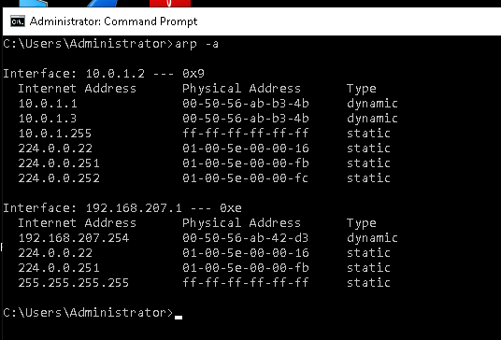
- Close the Command Prompt window.
- From the RemoteWindows01 taskbar, click the Computer connection icon to view the available network connections.
- From the connections list, connect to the VPN Connection. Once the VPN Connected displays a Connected status, you may continue to the next step.
- Disconnect from the VPN Connection.

Part 2: Crack a VPN Password using Captures Packets
- Connect to the AttackLinux01 machine.
- Stop the Wireshark capture and filter the file to show only chap data to display the VPN connection sequence. The Wireshark capture in the following figures is representative of the process and may not perfectly match your own capture, but you should notice that the Response packet contains the target's VPN username in the Info field. You will use this username to help crack the VPN password.
- Launch a new Terminal window. You may minimize your first Terminal window, but do not close it, or Wireshark will close.
- At the command prompt, execute ls to list the contents of the directory, then arrange the windows to view both the new Terminal window and the Wireshark window.
- In the Wireshark packet summary pane, select the first Challenge packet, then navigate to the PPP Challenge Data detail (PPP Challenge Handshake Authentication Protocol > Data) in the frame details pane.
- In the Packet Details pane, right-click the Value line and select Copy > as a Hex Stream from the context menu.
- In the second Terminal window, at the command prompt, type python chap2asleap.py -u vpnuser01 -c and press the spacebar, then right-click to open the context menu, select paste to insert the Challenge value (-c) into the command, press the spacebar again, type -r, and press the spacebar one more time.
- In the Wireshark packet summary pane, select the first Response packet, then navigate to the PPP Challenge Data detail (PPP Challenge Handshake Authentication Protocol > Data) in the frame details pane.
- In the packet details pane, right-click the Value line and select Copy > as a Hex Stream from the context menu.
- In the Terminal window, continue the python command: right-click and select Paste from the context menu to insert the Response value, press the spacebar, type -x -p /usr/bin -d ./words.list, and press Enter to begin the password cracking process.
- Make a screen capture showing the cracked VPN password.
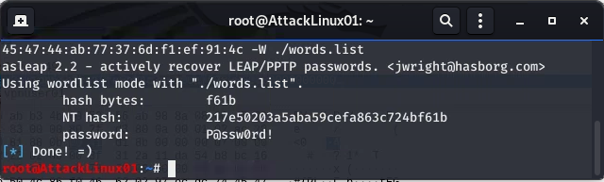

Section 3: Challenge and Analysis

Part 1: Recommend Additional Spam Filtering Mechanisms
Describe the role of the DKIM and DMARC in a mailing infrastructure, and how these implementations help to prevent email forgery. Use the Internet to perform your research on these mechanisms.

DKIM, also referred as DomainKeys Identified Mail, is a standard used to claim responsibility of a message being transmitted via a network. In other words, it is a standard that helps organizations prevent mail spoofing for the sender and recipient. DMARC, also referred as Domain-based Message Authentication Reporting & Conformance, is a security protocol that verifies the sender of a mail transmission. It is also used by companies to prevent spoofing of their domain which can lead to impersonating acts. DKIM protects the sender but not the receiver, DMARC protects both the send and the receiver.

Part 2: Enable Punycode Translation in Firefox
Make a screen capture showing the enabled Display Punycode setting in Firefox.

I typed about:config in the browser, then searched for network.IDN_show_punycode and set the Boolean value to true.
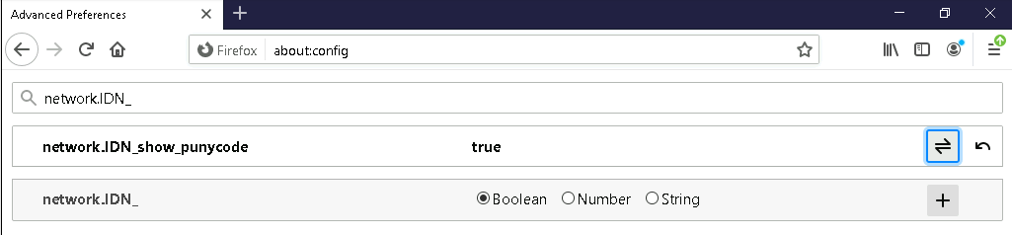

laPart 3: Perform a Phishing Attempt to Test User Security Awareness
Make a screen capture showing the email message headers in Thunderbird.
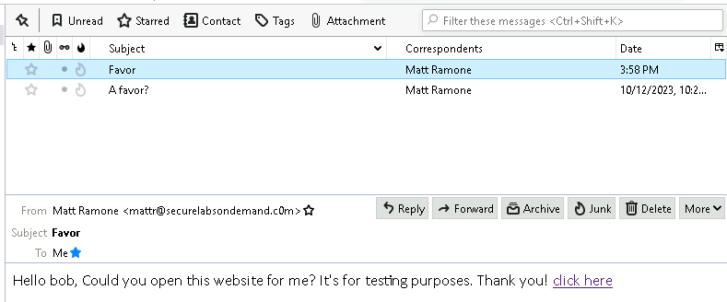
From the email, click the hyperlink to open the fake charity website in Firefox.

Make a screen capture showing the Punycode displayed in the Firefox web browser.


