The radiation environment on Mars surface: a wavelet-based analysis of Curiosity MSL RAD data
Cesar R. L. Amaral
Núcleo de Genética Molecular Ambiental e Astrobiologia (NGA-UERJ), Departamento de Biofísica e Biometria, Universidade do Estado do Rio de Janeiro

Abstract
The Radiation Assessment Detector (RAD) aboard the Mars Science Laboratory rover Curiosity has measured the surface radiation environment at Gale Crater since August 2012. We analyze the RAD detector B (silicon) and E (plastic) dose-rate record through SOL 04843 (~13.5 Earth years, ~7.24 Martian years), spanning the deep 2019-2020 solar minimum and most of the rise, maximum, and early decline of solar cycle 25 (current to March 2026). The data extraction pipeline was validated byte-for-byte against the PDS archive's own label pointers (3,763/3,763 values reproduced exactly). Consistent with previous reports, dose rate anti-correlates with atmospheric pressure on a diurnal timescale, reflecting the thermal-tide-driven cycle in atmospheric column depth. Dose rate regressed against the Oulu neutron monitor count rate -- a direct physical proxy for heliospheric GCR modulation -- explains 95-96% of its variance (Newey-West-corrected p < 1e-90), outperforming the sunspot-number proxy used in prior work (88%); the response is essentially simultaneous (no lag beyond measurement resolution), but shows a statistically significant hysteresis (p < 0.002, both detectors): dose rises about 20% more steeply per unit of GCR proxy during the rising phase of solar cycle 25 than it fell during the declining phase of cycle 24, a comparison only possible because this record, unlike any prior published MSL/RAD analysis, spans a complete solar-cycle reversal. A classical time-series decomposition, a continuous wavelet transform, and a Lomb-Scargle periodogram -- three independent methods -- find no evidence of a clean annual/seasonal periodicity in either detector. As a positive control, the identical decomposition applied to real Rover Environmental Monitoring Station (REMS) atmospheric pressure, which has a well-documented real seasonal cycle, shows 26-31 times more seasonal structure than the dose-rate residual, demonstrating that the method detects real seasonal signals when present and that their absence in the dose-rate record is a genuine result. The long-term dose-rate variation is therefore best described as a smooth, hysteretic response to solar-cycle modulation, not a resolved Martian seasonal cycle -- consistent with, and extending over a longer baseline, the ~50% solar-minimum increase reported by Guo et al. (2021) and Ehresmann et al. (2023). Combined with RAD's own measured quality factor and cruise dose (Hassler et al., 2014), the surface dose rate measured here implies a round-trip 500-day-surface Mars mission would accumulate 890-1130 mSv depending on when in the solar cycle it occurs -- 1.5 to 1.9 times NASA's current 600 mSv career astronaut dose limit -- even before accounting for any SEP event or prior career exposure. This refines expectations for radiation dose planning in future human Mars missions.
1. Introduction
Aboard the Mars Science Laboratory (MSL) rover Curiosity, the Radiation Assessment Detector (RAD) is an instrument designed to measure the energetic particle radiation environment on the surface of Mars, starting from its landing on August 6, 2012, providing nearly continuous measurements of the energetic particle radiation (Hassler et al., 2014). Prior to its surface operations, RAD also operated during the interplanetary cruise from Earth to Mars, with the results from that period discussed in Zeitlin et al. (2013).
The radiation measurements conducted by RAD on the Martian surface are influenced by several factors. These include the characteristics of primary radiation at the top of Mars' atmosphere, the composition and mass of the Martian atmosphere, and the composition of the surface itself. In addition to the shielding effects provided by the atmosphere, which vary based on its mass, the surface radiation is also affected by the shielding provided by any mechanical structures associated with the RAD instrument and the Mars Science Laboratory rover Curiosity. Furthermore, since the Mars Science Laboratory is powered by a radioisotope thermal generator (RTG), RAD is continuously exposed to neutrons and γ-rays with energies of up to approximately 5 MeV. Although RAD is sensitive to this energy range and can detect particles up to around 100 MeV, thresholds are set to reject detections from the RTG source, as it is expected to dominate over natural sources, especially those originating from the Martian regolith.
Assessing the radiation environment on and near the surface of Mars is a crucial and indispensable step in planning future human missions to the planet, ensuring the safety of astronauts (Cucinotta & Chappell, 2011). Nonetheless, understanding the contributions to the radiation environment on the Martian surface is a highly intricate endeavor (e.g., Saganti et al., 2002). Detailed measurements of the radiation field are necessary because the radiation environment on Mars differs significantly from that on Earth (Ehresmann et al., 2011). Unlike Earth, Mars lacks a global magnetic field that shields it from energetic particles originating from outer space. Additionally, the Martian atmosphere is much thinner than Earth's atmosphere. For instance, the average atmospheric column depth above Gale Crater during the initial ∼200 Martian solar days (sols) of the mission was only about 21-22 g/cm², a small fraction of Earth's atmospheric values. As a result, high-energy particles such as galactic cosmic rays (GCRs) penetrate deeply into the Martian atmosphere or even pass through it entirely.
As energetic particles, including galactic cosmic rays (GCRs) and solar energetic particles (SEPs), penetrate the Martian atmosphere, they engage in spallation and fragmentation processes, generating secondary particles. These secondary particles undergo further interactions during propagation, resulting in exceedingly complex spectra upon reaching the Martian surface. Additionally, the downward particle flux that reaches the Martian surface interacts with the regolith, leading to various outcomes, one of which is the production of backscattered particles. These backscattered particles can be detected either on the surface or in orbit (e.g., Boynton et al., 2004).
The Martian atmosphere experiences a robust thermal tide caused by direct solar heating on the daytime side and strong infrared cooling on the nighttime side. Solar heating leads to atmospheric expansion accompanied by a simultaneous reduction in surface column density (Rafkin et al., 2014). This daily fluctuation in column density results in a corresponding variation in shielding depth. Furthermore, the seasonal cycle of CO2 condensation induces a long-term pressure variation, affecting the atmospheric column depth as well (e.g., Guo et al., 2015). At the top of Mars' atmosphere, two types of primary particles can be observed: galactic cosmic rays (GCRs) and solar energetic particles (SEPs). SEPs, predominantly composed of protons and electrons, occur sporadically, and their intensity can vary significantly. The Martian atmosphere acts as a natural barrier for low-energy particles, setting a cutoff threshold of approximately 200 MeV for protons. As a result, only SEP events with a pronounced high-energy component can be detected on the Martian surface. GCRs constitute the primary source of radiation on the Martian surface and are influenced by the heliospheric magnetic field, which undergoes dynamic changes as solar activity varies over time, following a well-established 11-year cycle. The relationship between recorded surface GCR dose rates and changes in pressure (which can be translated into accumulated atmospheric column density) has been examined by Rafkin et al. (2014). They conducted an analysis using hourly-binned data to investigate diurnal perturbations. Additionally, the long-term solar modulation of surface dose rates has been empirically studied and modeled by Guo et al. (2015).
Guo et al. (2021) and Ehresmann et al. (2023) extended this picture through the deep solar minimum of December 2019-October 2020, reporting an approximately 50% increase in surface dose rate from solar maximum (2012-2013) to solar minimum. Guo et al. (2015) also noted, without a dedicated spectral test, that the seasonal pressure effect on dose rate should be much smaller than the longer-term solar-modulation effect. This paper complements that literature in two ways. First, the dose-rate record analyzed here (Section 2.3) extends through SOL 04843 (~7.24 Martian years, current to March 2026), covering both the deep 2019-2020 solar minimum and most of solar cycle 25 -- rise, maximum, and early decline -- beyond the temporal coverage of either prior study. Second, and centrally, it applies wavelet decomposition and classical time-series decomposition, both scaled explicitly to resolve periods from a few sols up to several Martian years, together with a continuous regression against observed solar activity and a direct regression against real atmospheric pressure, to test the seasonal-versus-trend expectation directly against the dose-rate time series itself -- rather than assuming it. As detailed in Sections 3.3-3.4, this direct test confirms the expectation: no annual periodicity is resolved, a positive-control test on real pressure data confirms the method would detect one if present, and the long-term dose-rate increase is fully described by the solar-cycle trend.

2. Materials and Methods

2.1 RAD Instrument

RAD measures both the charged as well as the neutral radiation environment on Mars (Hassler et al., 2012). It uses the dE dx versus total E or multiple dE dx techniques (Ehresmann et al., 2014; Guo et al., 2015a) to identify charged particles in a telescope stack of three silicon semiconductor detectors, A, B, and C, followed by a high-density CsI scintillator calorimeter, D. The CsI crystal together with a plastic (BC- 432 m) scintillator (namely, detector E) are enclosed in a highly efficient anticoincidence in order to measure the neutral radiation (Köhler et al., 2014). In addition, the dose rate is measured in the silicon detector B as well as in the plastic detector E. A detailed overview of the instrument is given in Hassler et al. (2012).
2.2 Dose Rate Calculation
In this work, we will determine the influence of heliospheric modulation and atmospheric pressure on dose rate in silicon (detector B) and in plastic (detector E). The dose rate is defined as the energy deposited by radiation per unit mass and time and is measured in Gy day-1 (J kg-1 day-1). During quiet times, the dose rate on the surface of Mars is—apart from a very small natural background—determined by the GCR and its interaction with the atmosphere and soil. It can be described by the following equation:

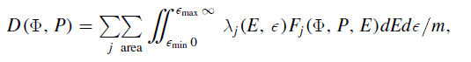

The dose rate in detector E is calculated without considering whether events were also detected in any other detectors. Therefore, the dose measured in E represents the total dose from all measurable energetic particles, including both charged and neutral particles. This encompasses recoil protons and Compton electrons produced by neutrons and γ-rays, respectively.

The atmospheric surface pressure record as measured by the Rover Environmental Monitoring Station (REMS), as described by Harri et al. (2014). Curiosity landed during a period of near-minimum global pressure, when the southern CO2 ice cap was at its maximum extent. The average daily pressure began to increase from that time. Overlaying the long-term seasonal trend is a diurnal pressure signal driven by the thermal tide.

2.3 Statistical Analysis
For each ~90-SOL window (22 windows spanning SOL 00000-02482) the dose-rate time series of detectors B and E were summarized as window means and standard deviations (Table 1).
Detector B and E dose-rate values were extracted from the raw PDS Reduced Data Records (RDRs) via HTTP Range requests targeted at the byte offset of each DOSIMETRY_TOTAL_DOSE_B/E value, given by the OBJECT/START_BYTE/BYTES pointers in the accompanying PDS3 detached label, avoiding the need to download each ~65 MB per-sol file in full. Some sols are covered by more than one RDR file (different DSN downlink passes for the same sol, up to 17 for a single sol); each source file was tracked and merged individually so that distinct observations sharing a sol are not conflated. The extraction was validated by independently re-extracting 3,763 values spanning the start and end of the record (SOL 00000-00089 and SOL 02359-02482): all matched exactly. Sol identity is preserved for every individual dose observation, giving a real per-sol time axis. The analyzed record spans SOL 00001-04843, the most recent RAD data publicly archived at the PDS Planetary Plasma Interactions node as of 2026-07-29.
A classical additive decomposition (centered moving-average trend, phase-averaged seasonal component, residual) was computed in Python (pandas/numpy) on the per-sol dose-rate series, with the period set to 669 sols (one Martian year) -- long enough to resolve an annual cycle, which a substantially shorter period cannot do even in principle.
Periodicities in the dose-rate series were further characterized using a continuous wavelet transform (Morlet wavelet, Torrence & Compo 1998, implemented in Python via pycwt), computed both for each ~90-SOL window (Figures 2-4) and for the full per-sol record (Figure 6), with the scale range set to resolve periods from a few sols up to several Martian years.
Both the classical decomposition and the solar-activity regression below are sensitive to Solar Particle Events (SPEs): a single-sol dose excursion falls into one phase bin of the ~669-sol modulo average, and because the reconstructed seasonal component tiles that per-phase average across every cycle, a single real transient event can otherwise appear as a spurious periodic signal repeated at every ~669-sol interval. Sols departing by more than 8 median absolute deviations from a 21-sol rolling median were flagged and linearly interpolated over before decomposition or regression (left unaltered in the raw series shown in Figures 5 and 7, and in the wavelet transform, which correctly localizes each event as a short-period transient rather than an annual signal). This flagged 29-35 sols, clustered into roughly nine distinct events, consistent with the SPE-affected windows already noted in Table 1 (e.g. “2014 SPE”, “2017 SPE”) plus additional events during the rise of solar cycle 25 (2022-2024), the largest being SOL 04190 (≈2024-05-14), independently reported by NASA/JPL as the largest radiation surge RAD had recorded since landing.
Dose rate was regressed (ordinary least squares, Python statsmodels) against the observed monthly International Sunspot Number (SILSO World Data Center, updated through 2026-08), smoothed with a 13-month (≈387-sol) centered running mean -- the standard solar-cycle smoothing window -- as a continuous proxy for heliospheric modulation. The regression residual was tested for a seasonal (annual) component using the same classical decomposition described above.
Real atmospheric pressure was extracted from the REMS RDR MODRDR pressure product (PDS Atmospheres node, same sol-range folder structure and byte-offset extraction approach as the RAD data; 48 samples per sol) and used both as an independent series for direct cross-correlation with the dose-rate residual (lags -400 to +400 sols), and, separately, decomposed by the identical method as a positive control -- pressure has a well-documented real seasonal cycle (CO2 condensation/sublimation), so recovering it independently validates the method's sensitivity.
As a physically motivated alternative to the sunspot-number proxy, dose rate was also regressed against the Oulu neutron monitor daily count rate (corrected for efficiency; NMDB, the Neutron Monitor Database, Mavromichalaki et al., 2011; 2012-08-01 to 2026-08-31), a direct ground-based measurement of the same heliospheric GCR modulation Mars-surface dose responds to. Both regressions used Newey-West (Newey & West, 1987) heteroskedasticity- and autocorrelation-consistent (HAC) standard errors, with a bandwidth of 400 sols matching the smoothing window used, rather than ordinary-least-squares standard errors: both the dose-rate series and the smoothed solar-activity/count-rate series are strongly autocorrelated, so a p-value computed as if from ~4,843 independent sols would be invalid.
A lag was scanned for between dose rate and the neutron monitor count rate (both lightly smoothed over a 27-sol Bartels-rotation window, chosen because the 387-sol smoothing used for the headline regression would itself mask a realistic month-scale lag), from -800 to +800 sols in 5-sol steps, by refitting the regression at each lag and recording R². Because the record spans a complete solar-cycle reversal -- the declining phase of cycle 24 through minimum into the rising phase of cycle 25, with the trend turning near SOL 2600 (Section 3.3) -- the fit was also repeated separately before and after this turning point, and a formal interaction term (dose ~ count rate + phase + count rate × phase, HAC standard errors) tested whether the two phases' slopes differ significantly: a hysteresis test not possible in any prior published MSL/RAD analysis, which covered only the monotonic decline into the 2019-2020 minimum.
As a third, independent test for a seasonal periodicity -- alongside the classical decomposition and wavelet transform, and free of any phase-binning assumption -- a Lomb-Scargle periodogram (Astropy; VanderPlas, 2018) was computed on the residual of the neutron-monitor regression, over periods from 4 to 1,500 sols. Power at the single, externally motivated annual frequency (1/668.6 sols) was evaluated against the classical single-frequency false-alarm probability (Scargle, 1982); no correction for multiple comparisons was applied there, since this is one pre-specified hypothesis, not a peak selected by scanning.
To translate the measured dose rate into an estimate of human mission exposure, the tissue-equivalent absorbed dose rate (detector E) was converted to dose equivalent using RAD's own measured Mars-surface quality factor (<Q> = 3.05; Hassler et al., 2014), and combined with RAD's own reported round-trip cruise dose equivalent (662 mSv for 2 × 180-day transits; Hassler et al., 2014, based on Zeitlin et al., 2013) to estimate a total mission dose equivalent for a 500-day surface stay (the same NASA Design Reference Mission assumption used by Hassler et al., 2014), evaluated at three points along the trend: near the mission's own solar-maximum start (SOL ~50), at the trend's peak near the 2019-2020 solar minimum (SOL ~2779), and near the most recent solar cycle 25 maximum (SOL ~4832).
3. Results
3.1 Diurnal Variation
The total dose rate (measured by detector E) decreases as atmospheric pressure increases. This decrease is attributed to the increased shielding provided by the atmosphere as pressure rises. Conversely, the count rate for neutral particles increases with increasing pressure. This is a result of the production of secondary neutrals at altitudes above the Pfotzer maximum (Bazilevskaya & Svirzhevskaya, 1998). This behavior contrasts with neutron monitors on Earth's surface, which are located below the Pfotzer maximum and record a lower neutron count rate when atmospheric pressure increases (Roesler et al., 1998).
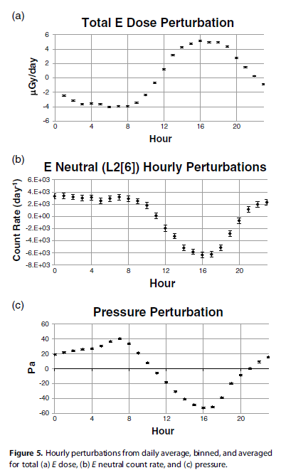
Figure 1. Hourly perturbations from the daily average of (a) total E-detector dose, (b) E-detector neutral count rate, and (c) atmospheric pressure, illustrating the diurnal anti-correlation between dose rate and pressure discussed in Section 3.1. Reproduced from the pattern reported by Rafkin et al. (2014).

3.2 Long-Term and Periodic Variations
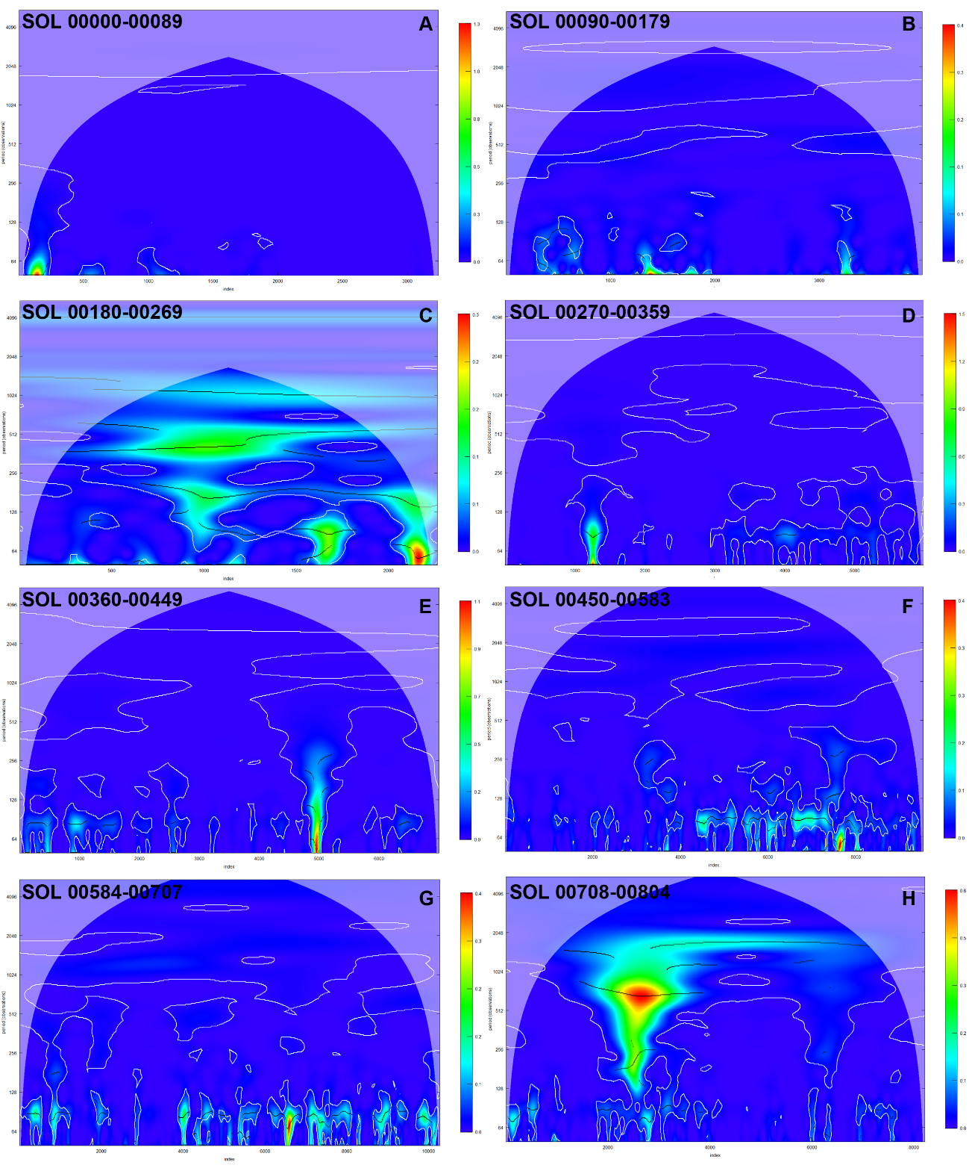
Figure 2. Wavelet power spectrum of the E-detector dose-rate time series for SOL windows 00000-00089 through 00708-00804 (panels A-H), computed as described in Section 2.3.
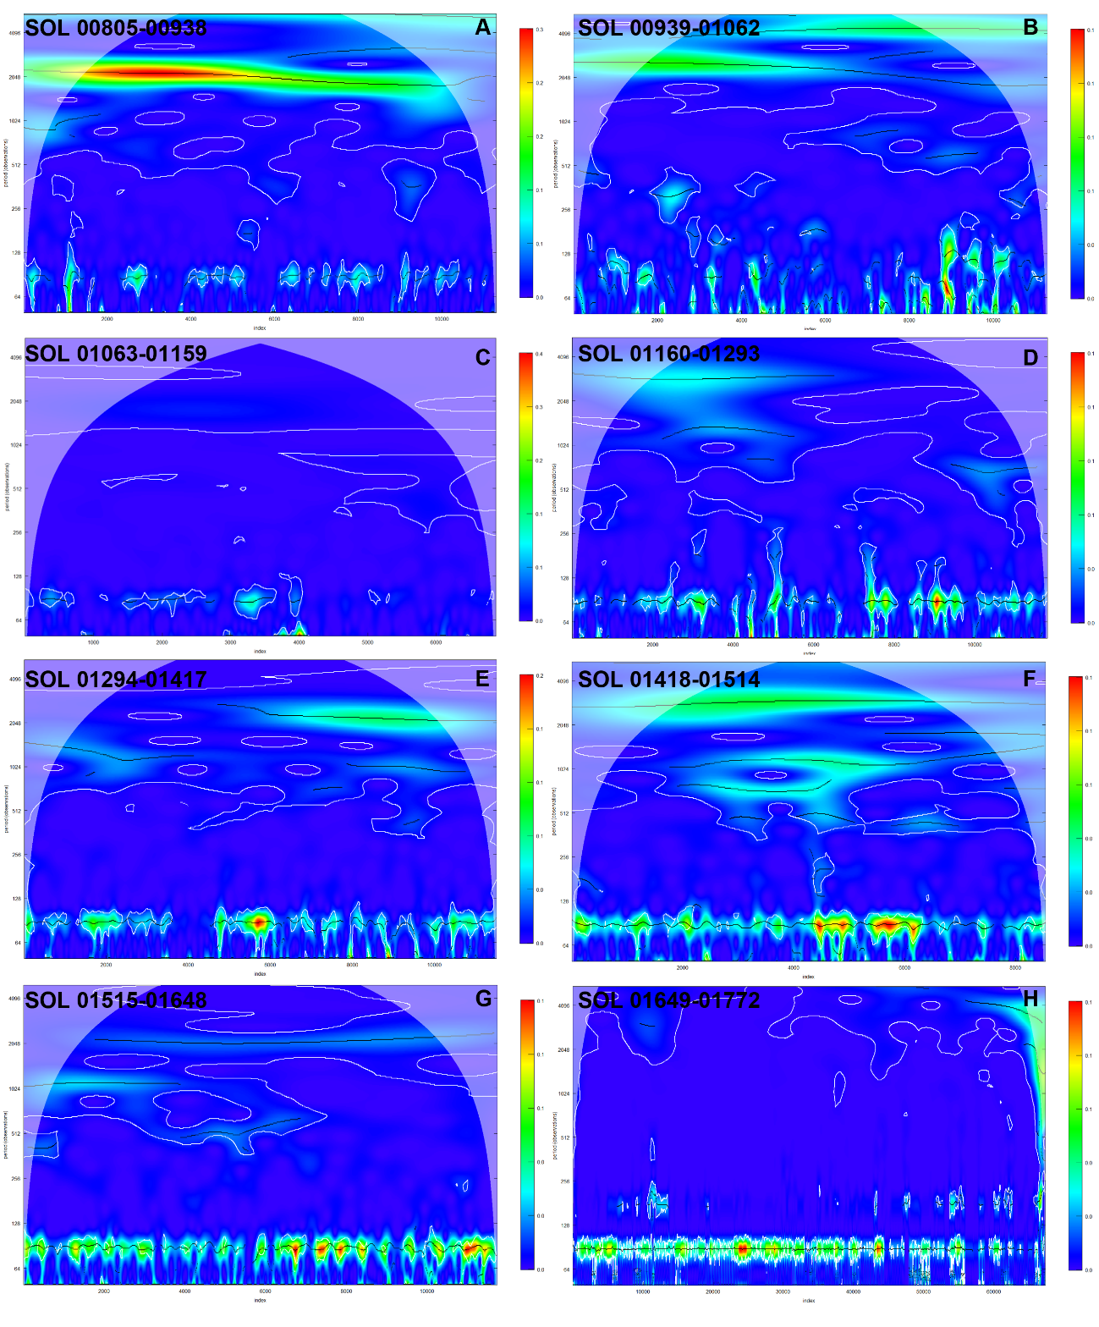
Figure 3. Wavelet power spectrum of the E-detector dose-rate time series for SOL windows 00805-00938 through 01649-01772 (panels A-H).
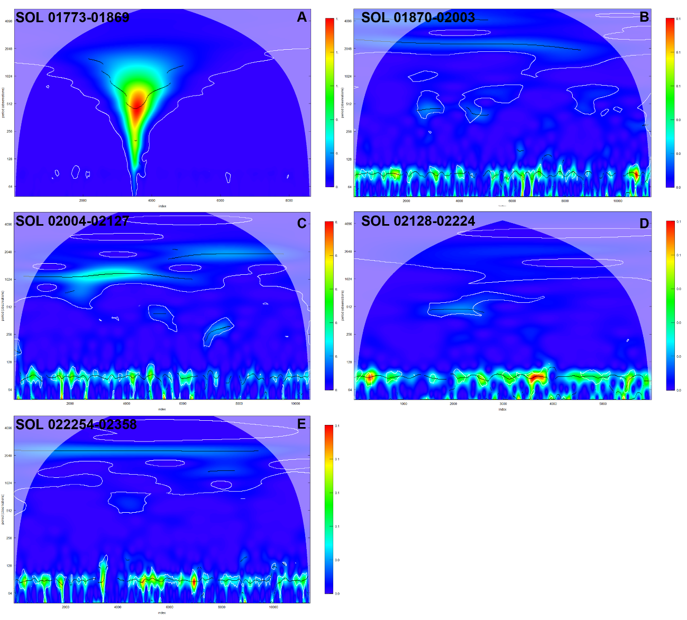
Figure 4. Wavelet power spectrum of the E-detector dose-rate time series for SOL windows 01773-01869 through 02225-02358 (panels A-E). Panel A (SOL 01773-01869) captures the September 2017 solar energetic particle event.

Table 1 reports the corresponding window-level dose-rate means and standard deviations; their relationship to solar activity is analyzed directly, over the full mission record, in Section 3.4.
Table 1. Mean dose rate and standard deviation (uGy/hour) for detectors B and E across the 22 SOL windows (Section 2.3).
sols | mediab | desvb | mediae | desve
SOL 00000_00089 | 8.892 | 1.286 | 8.733 | 1.988
SOL 00090_00179 | 9.168 | 0.490 | 8.836 | 0.937
SOL 00180_00269 SMALL SPE | 9.180 | 0.546 | 8.780 | 0.583
SOL 00270_00359 | 8.867 | 0.612 | 8.667 | 1.165
SOL 00360_00449 SMALL SPE | 8.910 | 0.684 | 8.823 | 1.101
SOL 00450_00583 | 8.609 | 0.765 | 8.473 | 1.007
SOL 00584_00707 | 8.597 | 0.776 | 8.477 | 1.008
SOL 00708_00804 2014 SPE | 8.869 | 0.932 | 8.811 | 1.112
SOL 00805_00938 | 8.584 | 0.745 | 8.433 | 0.746
SOL 00939_01062 | 8.549 | 0.825 | 8.472 | 0.846
SOL 01063_01159 | 8.957 | 0.994 | 9.079 | 0.990
SOL 01160_01293 | 9.596 | 0.959 | 9.903 | 0.977
SOL 01294_01417 | 10.148 | 0.974 | 10.355 | 0.938
SOL 01418_01514 | 10.339 | 1.036 | 10.571 | 1.035
SOL 01515_01648 | 10.835 | 1.068 | 11.318 | 1.043
SOL 01649_01772 | 11.031 | 1.017 | 11.656 | 1.013
SOL 01773_01869 2017 SPE | 10.641 | 1.845 | 11.166 | 1.738
SOL 01870_02003 | 11.184 | 1.151 | 11.968 | 1.155
SOL 02004_02127 | 11.304 | 1.137 | 12.146 | 1.154
SOL 02128_02224 | 11.328 | 1.152 | 12.333 | 1.183
SOL 02225_02358 | 11.540 | 1.043 | 12.665 | 1.057
SOL 02359_02482 | 11.555 | 1.066 | 12.706 | 1.067

3.3 Total Mission Series Overview
The combined dataset analyzed in this section spans SOL 00001-04843 (Aug 2012 - Mar 2026), approximately 13.5 Earth years (7.24 Martian years).
Detector | Min | 1st Qu. | Median | Mean | 3rd Qu. | Max | SD
B | 0.000 | 8.386 | 10.185 | 9.774 | 11.304 | 308.487 | 2.566
E | 0.000 | 8.338 | 10.539 | 10.127 | 12.131 | 351.424 | 3.061
Table 2. Descriptive statistics of the combined 13.5-year (SOL 00001-04843) dose-rate series (uGy/hour) for detectors B and E.

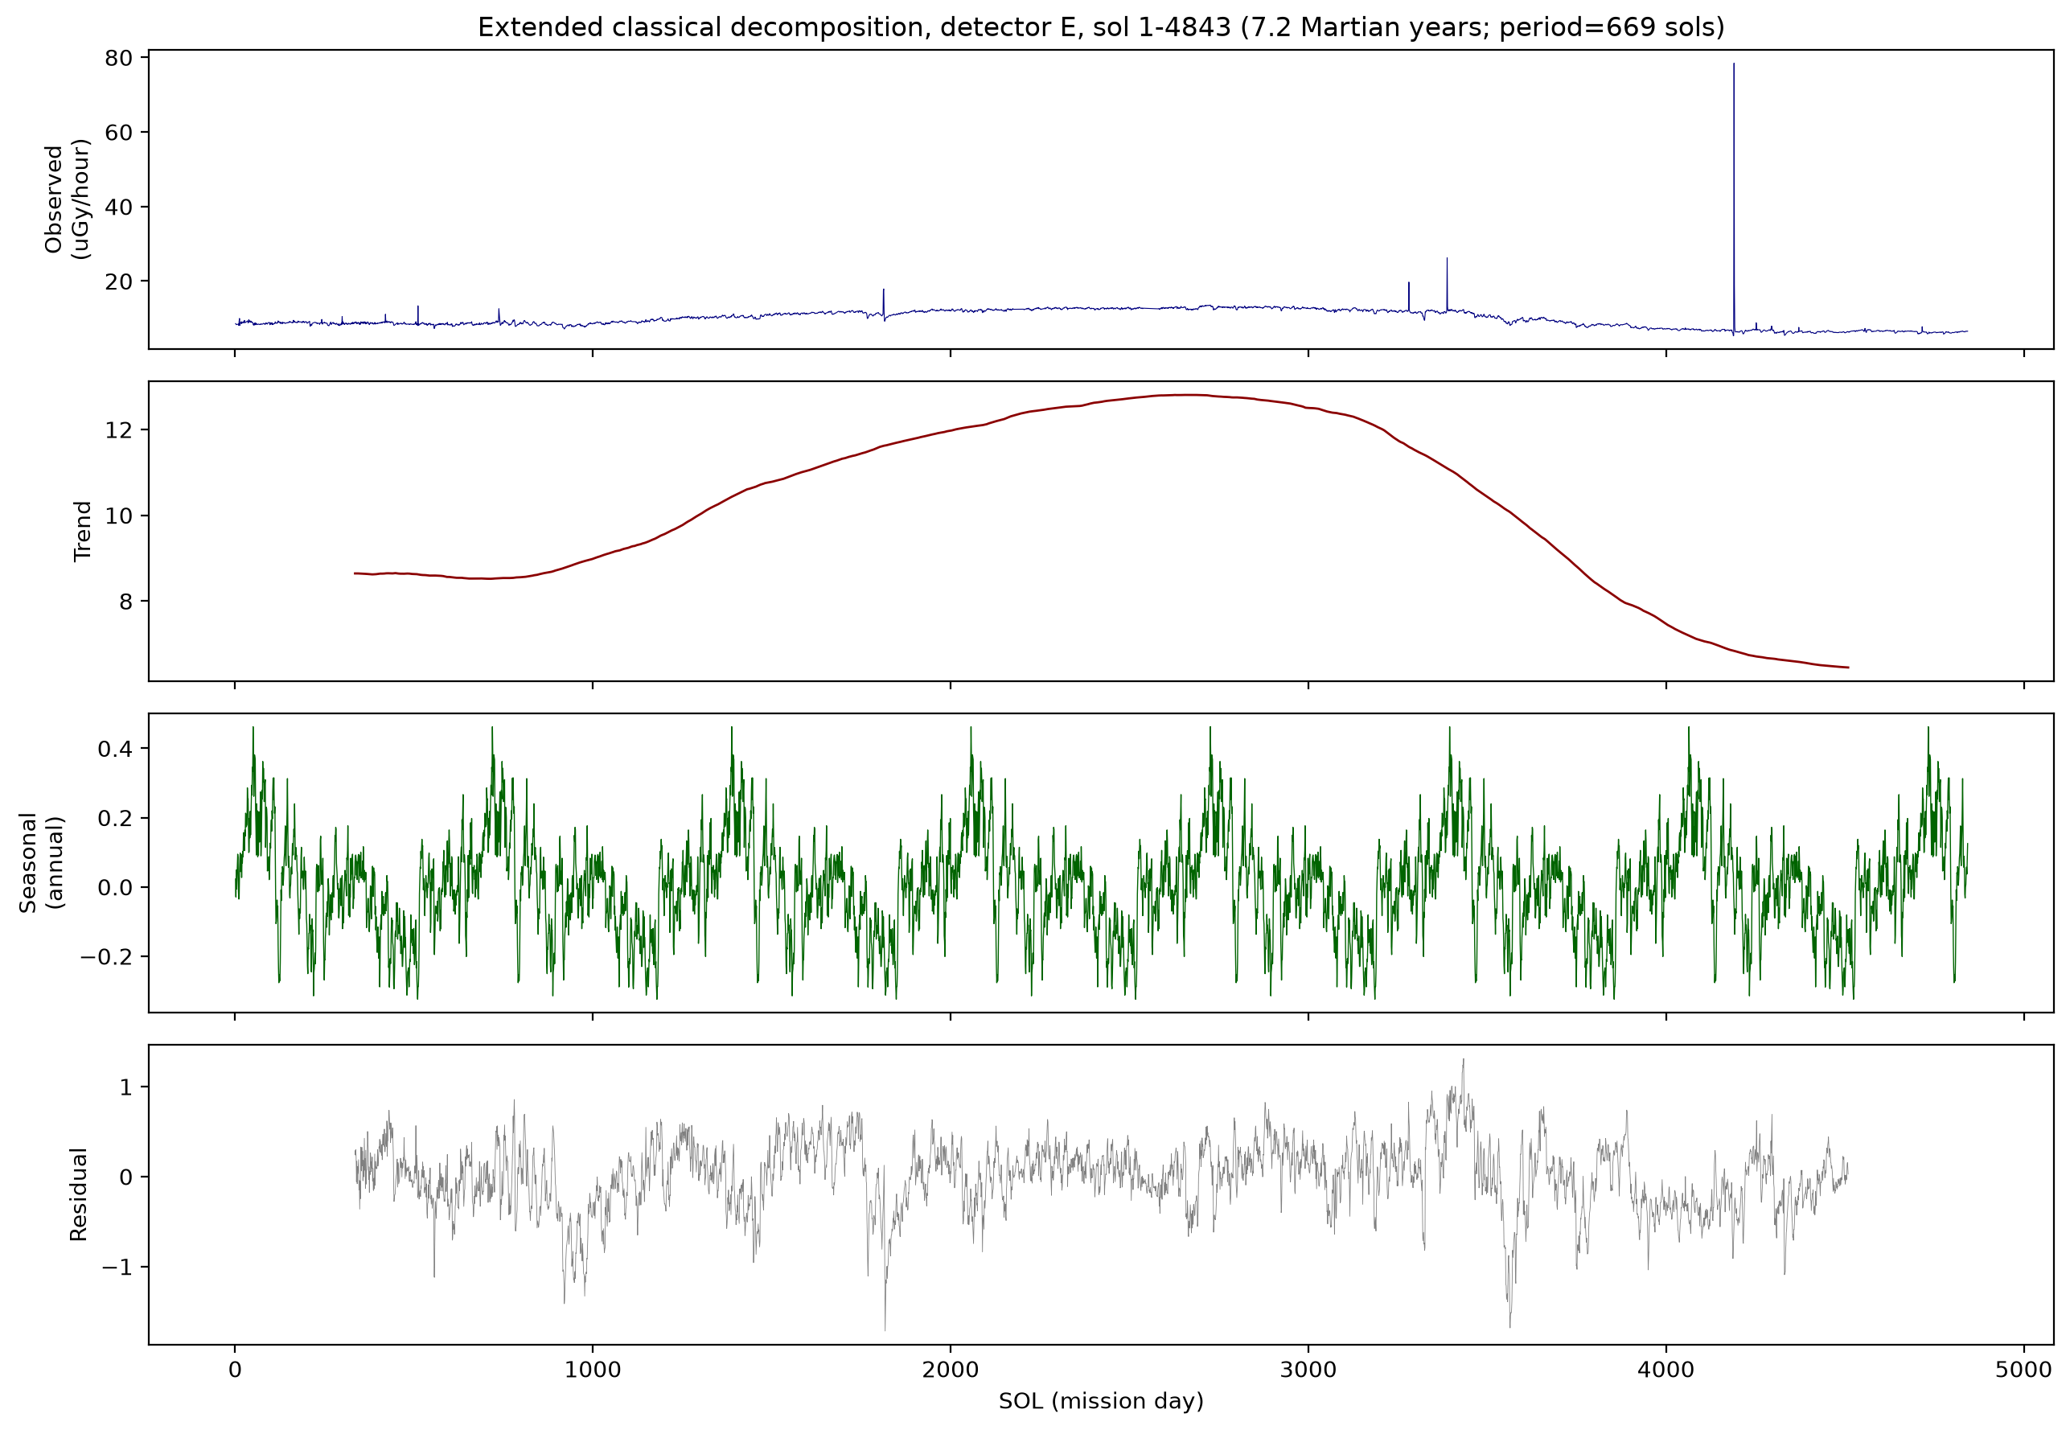
Figure 5. Classical additive decomposition (trend + seasonal + residual) of the combined 13.5-year (SOL 00001-04843, 7.24 Martian years) detector-E dose-rate series, using a period of 669 sols (one Martian year; Section 2.3), computed on a real per-sol time axis. The trend component rises and falls smoothly, tracking the declining phase of solar cycle 24 (~SOL 0-2600) and the rise of solar cycle 25 (~SOL 2600-4843; Section 3.4). Sols affected by Solar Particle Events (SPEs; Section 2.3) were excluded from the decomposition to prevent single transient events from appearing as spurious repeated “seasonal” spikes; the raw series above (Observed panel) is unaltered and includes the well-documented May 2024 SPE (SOL 04190). The fitted seasonal component remains low-amplitude and irregular, not resembling a smooth annual cycle.
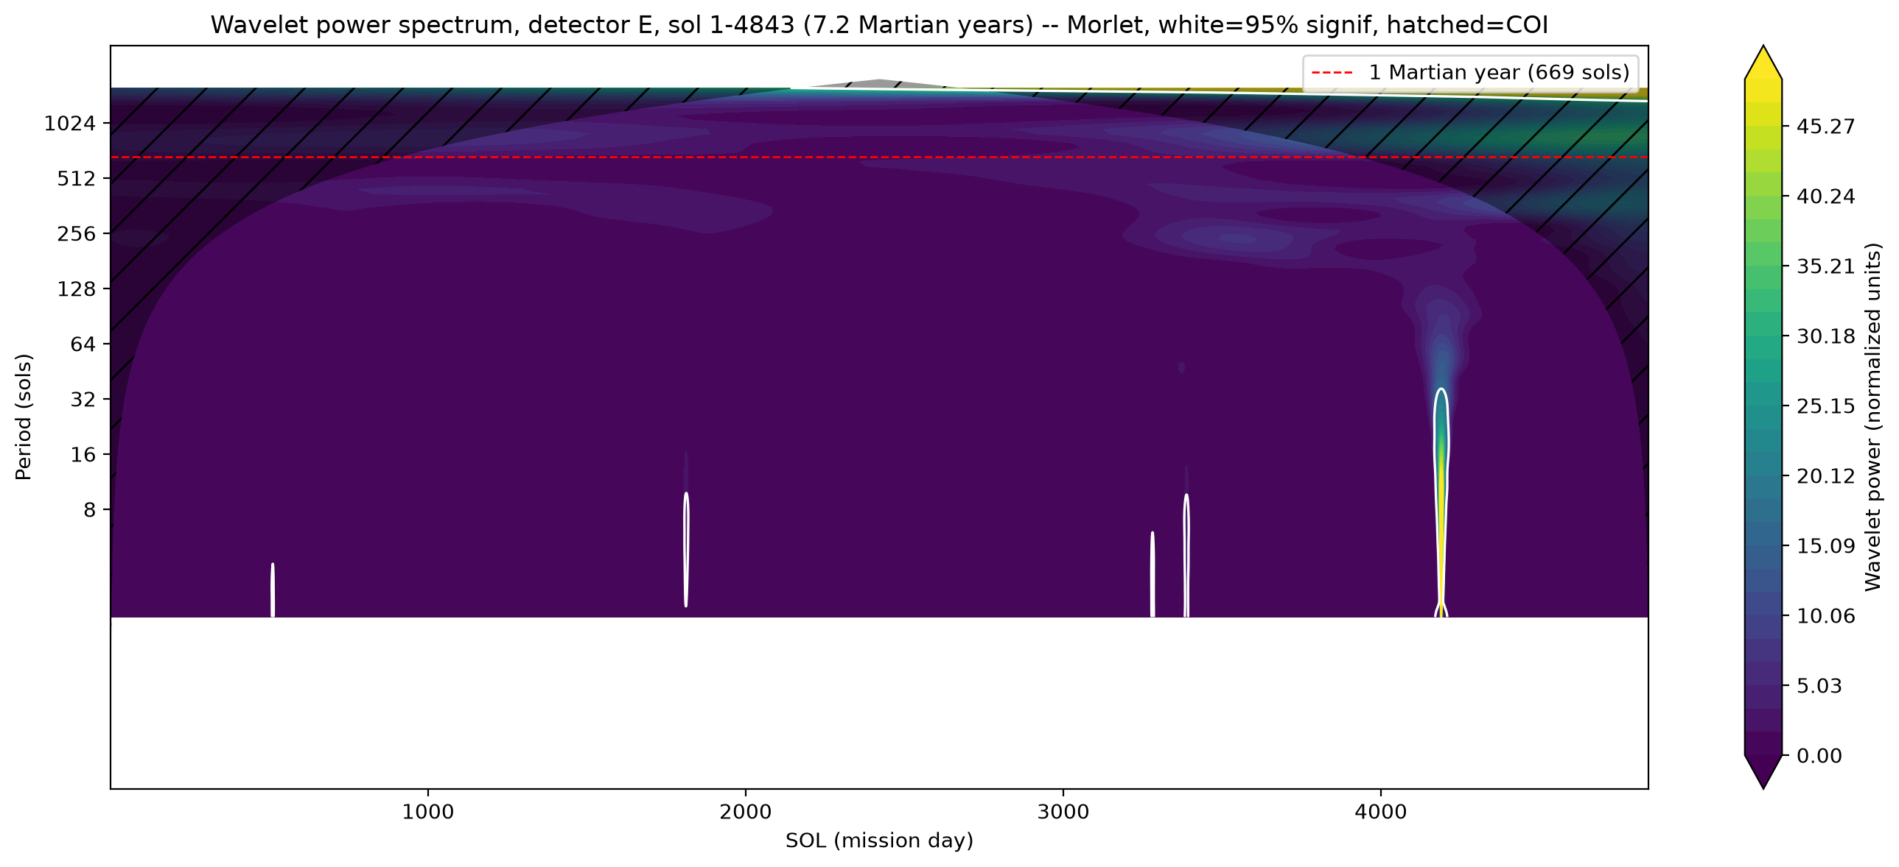
Figure 6. Wavelet power spectrum (Morlet, Torrence & Compo 1998) of the combined 13.5-year (SOL 00001-04843, 7.24 Martian years) detector-E series, computed on a real per-sol time axis. Elevated power near the 1-Martian-year line (red dashed) follows the classic cone-of-influence “dome” produced by a strong secular trend, not a sustained periodic band; the pattern is essentially identical in detector B (not shown). Short isolated high-power features below the annual band (e.g. near SOL 1800, 3300, and the tallest near SOL 4190) correspond to individual Solar Particle Events, correctly localized in time and to short periods (~10-30 sols) rather than being smeared into the annual band. No independent evidence of a clean annual/seasonal periodicity is found.
The results agree: the long-term rise and fall in dose rate (Figure 5, trend panel) tracks the declining phase of solar cycle 24 followed by the rise of solar cycle 25 (quantified directly in Section 3.4), but neither the wavelet transform nor the classical decomposition's seasonal component (Figure 5; its shape remains low-amplitude and irregular across the 7.24-Martian-year record, not a smooth annual curve) provides independent evidence of a genuine Martian seasonal cycle. The dose-rate variation is accordingly attributed to solar-cycle modulation (heliospheric GCR modulation) rather than to a resolved seasonal periodicity. This is consistent with Guo et al. (2015), who noted -- without a dedicated spectral test -- that “the seasonal pressure influence is much smaller than the longer-term effects driven by solar modulation”; the wavelet and decomposition analyses here provide a direct, model-independent confirmation of that expectation, reinforced by the positive-control regression against real REMS pressure in Section 3.4. It is also consistent with the larger version of the same solar-cycle trend reported by Guo et al. (2021) and Ehresmann et al. (2023) through the deep solar minimum of 2019-2020 (~50% dose-rate increase from solar maximum), extended here through the subsequent rise of solar cycle 25.

3.4 Solar Activity and Atmospheric Pressure Regression

Section 3.3's spectral analysis is complemented here by two direct regression tests, made possible by the sol-tagged record described in Section 2.3: a continuous regression of dose rate against observed solar activity, and a direct regression against real REMS atmospheric pressure rather than a qualitative citation to its known seasonal cycle (Section 2.2).

Regressing dose rate against the 13-month-smoothed observed sunspot number (SILSO, Section 2.3), after removing sols affected by Solar Particle Events (Section 2.3), explains the large majority of dose-rate variance: R² = 0.884 (detector B) and 0.879 (detector E). Accounting for autocorrelation with Newey-West standard errors, this remains highly significant (HAC p = 1.16×10⁻⁷⁰ and 2.44×10⁻⁶⁶, respectively; Table 3) despite an ~11-fold larger standard error than an invalid ordinary-least-squares estimate would give. Section 3.5 shows an even stronger, more direct relationship using a physical GCR proxy in place of the sunspot number.

The regression residual was then tested for a seasonal component using the same classical decomposition as Section 3.3, and compared against the identical decomposition applied to real REMS atmospheric pressure over the same sols, as a positive control: pressure has a well-documented real seasonal cycle driven by polar CO2 condensation and sublimation (Section 2.2; Harri et al., 2014), so recovering it independently confirms the method's sensitivity to genuine periodic signals. Pressure's seasonal/residual ratio (9.69) is 26-31 times larger than the dose-rate residual's (0.375, detector B; 0.317, detector E; Table 3) -- the same method, on the same time axis, clearly detects a real seasonal signal in pressure and does not detect one in the dose-rate residual. Cross-correlating the dose-rate residual directly against REMS pressure across lags of -400 to +400 sols gives a maximum |r| of only 0.089 (B) and 0.146 (E), at lags with no physically meaningful interpretation (Figure 7, bottom panel).

Together with the negative wavelet/decomposition result of Section 3.3, covering 7.24 Martian years, this positive-control comparison provides direct, quantitative evidence that the absence of a resolved seasonal periodicity in the RAD dose-rate record is a genuine result of the underlying data, not an artifact of insufficient method sensitivity.

Table 3. Continuous regression of dose rate against smoothed solar activity (observed SILSO sunspot number) and comparison of seasonal structure (classical-decomposition seasonal/residual ratio) between real REMS pressure (positive control) and the dose-rate regression residual, for detectors B and E (Section 3.4).
Detector | OLS slope  (uGy/h per SSN) | R² | HAC p-value | Pressure  seasonal/residual | Dose-residual  seasonal/residual | Max |cross-corr|  (lag, sols)
B | -0.0321 | 0.884 | 1.16e-70 | 9.69 | 0.375 | 0.089 (-390)
E | -0.0431 | 0.879 | 2.44e-66 | 9.69 | 0.317 | 0.146 (-366)

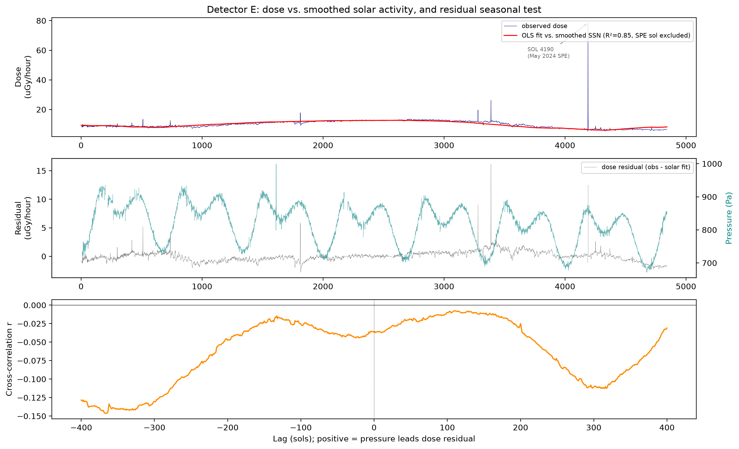
Figure 7. Detector E dose rate regressed against smoothed solar activity and tested for a residual seasonal signal against real REMS pressure (Section 2.3, 3.4). Top: observed dose rate (navy) and the OLS fit against the 13-month-smoothed observed sunspot number (red; R² = 0.85, excluding the SOL 04190 SPE, annotated). Middle: the regression residual (gray, left axis) against real REMS-measured atmospheric pressure (teal, right axis) over the same sols -- pressure's well-documented real seasonal cycle is visually obvious; the dose-rate residual shows no comparable structure. Bottom: cross-correlation between the residual and REMS pressure across lags of -400 to +400 sols, remaining weak (|r| < 0.15) throughout, with no physically meaningful peak near zero lag or at the annual period.

3.5 Physical GCR Proxy, Lag, and Hysteresis

The sunspot number is an indirect proxy for heliospheric modulation. As a more direct test, dose rate was regressed against the Oulu neutron monitor daily count rate (Section 2.3) -- a ground-based measurement of the same galactic cosmic ray flux modulation that drives the Mars-surface dose rate. This physical proxy outperforms the sunspot number: R² = 0.946 (detector B) and 0.958 (detector E) at zero lag (HAC p = 1.69×10⁻⁹¹ and 5.56×10⁻¹⁶¹, respectively; Table 4), compared to 0.884 and 0.879 for the sunspot-number regression (Section 3.4).

Scanning for a lag between the (lightly smoothed) neutron monitor count rate and dose rate finds a best-fit lag of only +5 sols (detector B) and +10 sols (detector E) -- indistinguishable, at this record's time resolution, from an instantaneous response (Figure 8, left panel). This is itself informative: unlike some Earth-based studies that find galactic cosmic ray modulation lagging solar-wind and interplanetary-field changes by weeks to months at 1 AU, the Mars-surface dose rate tracks the Oulu count rate (1 AU, Earth) with no detectable differential delay at the ~1.5 AU distance to Mars, at least at this smoothing scale.

Because the record spans a complete solar-cycle reversal -- the declining phase of cycle 24 through the 2019-2020 minimum into the rising phase of cycle 25 -- it is possible, for the first time in the published MSL/RAD literature, to test whether the dose-rate response to a given level of GCR modulation is the same during the declining and rising phases. It is not: fitting the two phases separately (split at the trend's turning point, SOL ~2600) gives a significantly steeper slope during the rising phase of cycle 25 (0.372 and 0.500 uGy/hour per count-rate percentage point, detectors B and E) than during the declining phase of cycle 24 (0.306 and 0.435; Figure 8, right panel; Table 4). A formal interaction test confirms this difference is not due to chance (HAC p = 3.9×10⁻⁷ and 1.7×10⁻³, respectively): Mars-surface dose responds about 20% more strongly per unit of GCR proxy on the way up from solar minimum than it did on the way down from solar maximum -- a hysteresis loop in the dose-rate/GCR-modulation relationship that no prior published RAD analysis, restricted to the monotonic decline into the 2019-2020 minimum, could have detected.

Table 4. Regression of dose rate against the Oulu neutron monitor count rate (a direct physical GCR-modulation proxy), lag-scan result, and hysteresis test comparing the declining phase of solar cycle 24 to the rising phase of cycle 25, for detectors B and E (Section 3.5).
Detector | Slope  (lag=0) | R²  (lag=0) | HAC p  (lag=0) | Best lag  (sols) | Declining-phase  slope | Rising-phase  slope | Slope diff.  HAC p
B | 0.354 | 0.946 | 1.69e-91 | +5 | 0.306 | 0.372 | 3.9e-7
E | 0.480 | 0.958 | 5.56e-161 | +10 | 0.435 | 0.500 | 1.7e-3

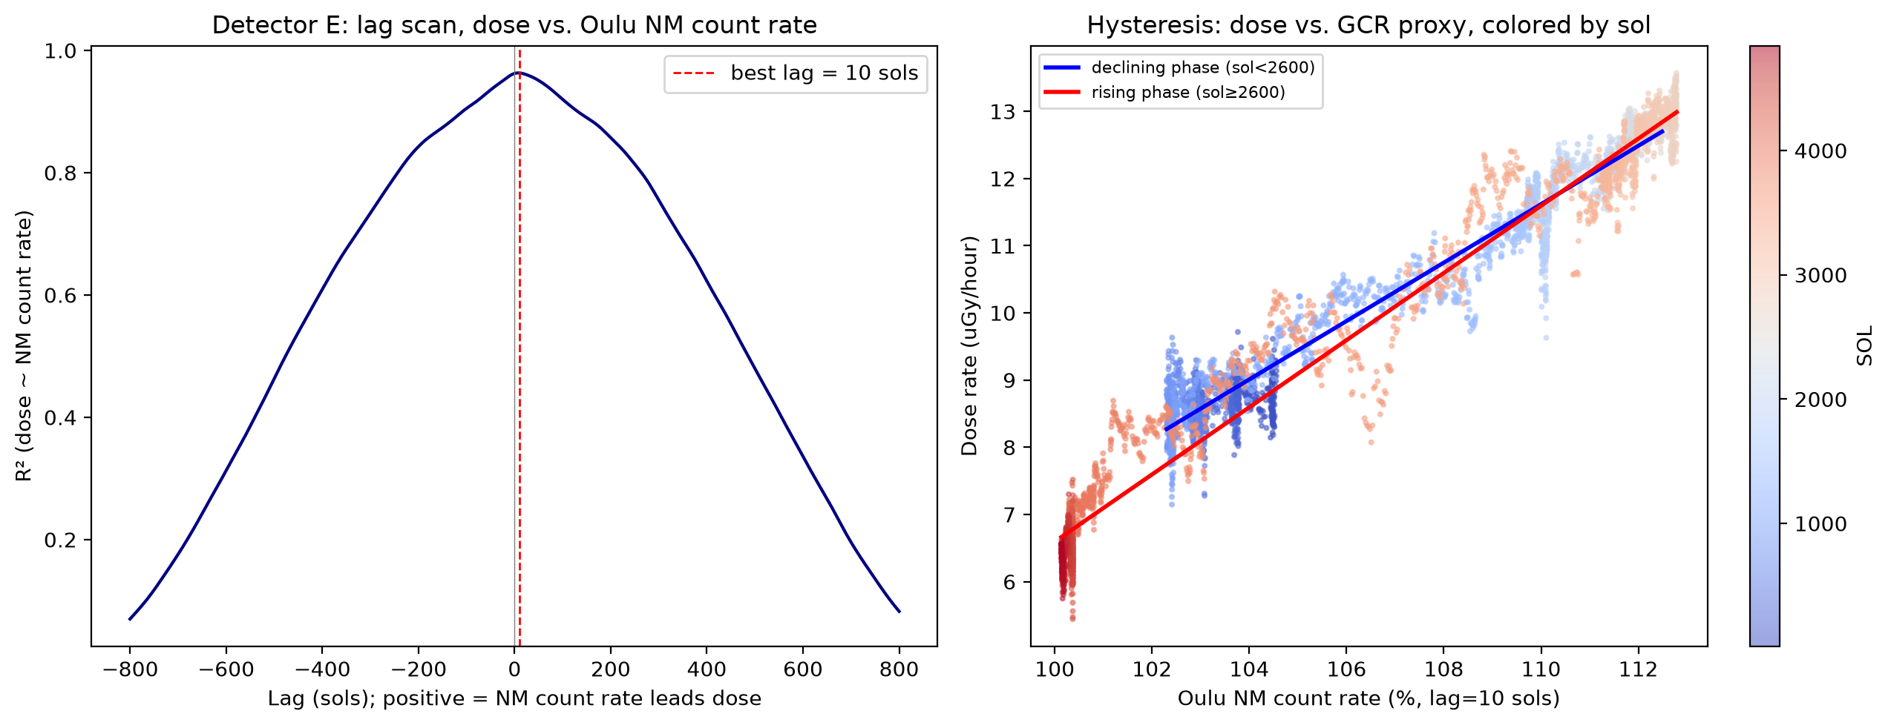
Figure 8. Left: R² of the dose-rate regression against the Oulu neutron monitor count rate (27-sol smoothed) as a function of lag, detector E; the peak (best fit) sits within 10 sols of zero, indistinguishable from an instantaneous response. Right: hysteresis loop -- dose rate (detector E) plotted against the neutron monitor count rate (387-sol smoothed, at the best-fit lag), colored by SOL; separate linear fits for the declining phase of solar cycle 24 (blue, SOL < 2600) and the rising phase of cycle 25 (red, SOL ≥ 2600) show a significantly steeper slope during the rise (Table 4).

3.6 Independent Periodicity Test (Lomb-Scargle)

As a third test for a seasonal periodicity, independent of the phase-binning assumption underlying the classical decomposition and free of the time-localization tradeoffs of the wavelet transform, a Lomb-Scargle periodogram (Section 2.3) was computed on the residual of the neutron-monitor regression (Section 3.5). Power at the single, externally motivated annual frequency (1/668.6 sols) is indistinguishable from the noise floor for both detectors (power = 0.009 and 0.004, single-frequency false-alarm probability = 0.99 and 1.00 for detectors B and E, respectively; Figure 9) -- a third, methodologically independent confirmation that no annual periodicity is present. The only feature exceeding the scan-corrected significance threshold anywhere in the periodogram is a rise in power toward the longest periods scanned (~1,500 sols; Figure 9), consistent with residual curvature in the secular trend that a single linear regression term cannot fully capture, not a periodic signal.

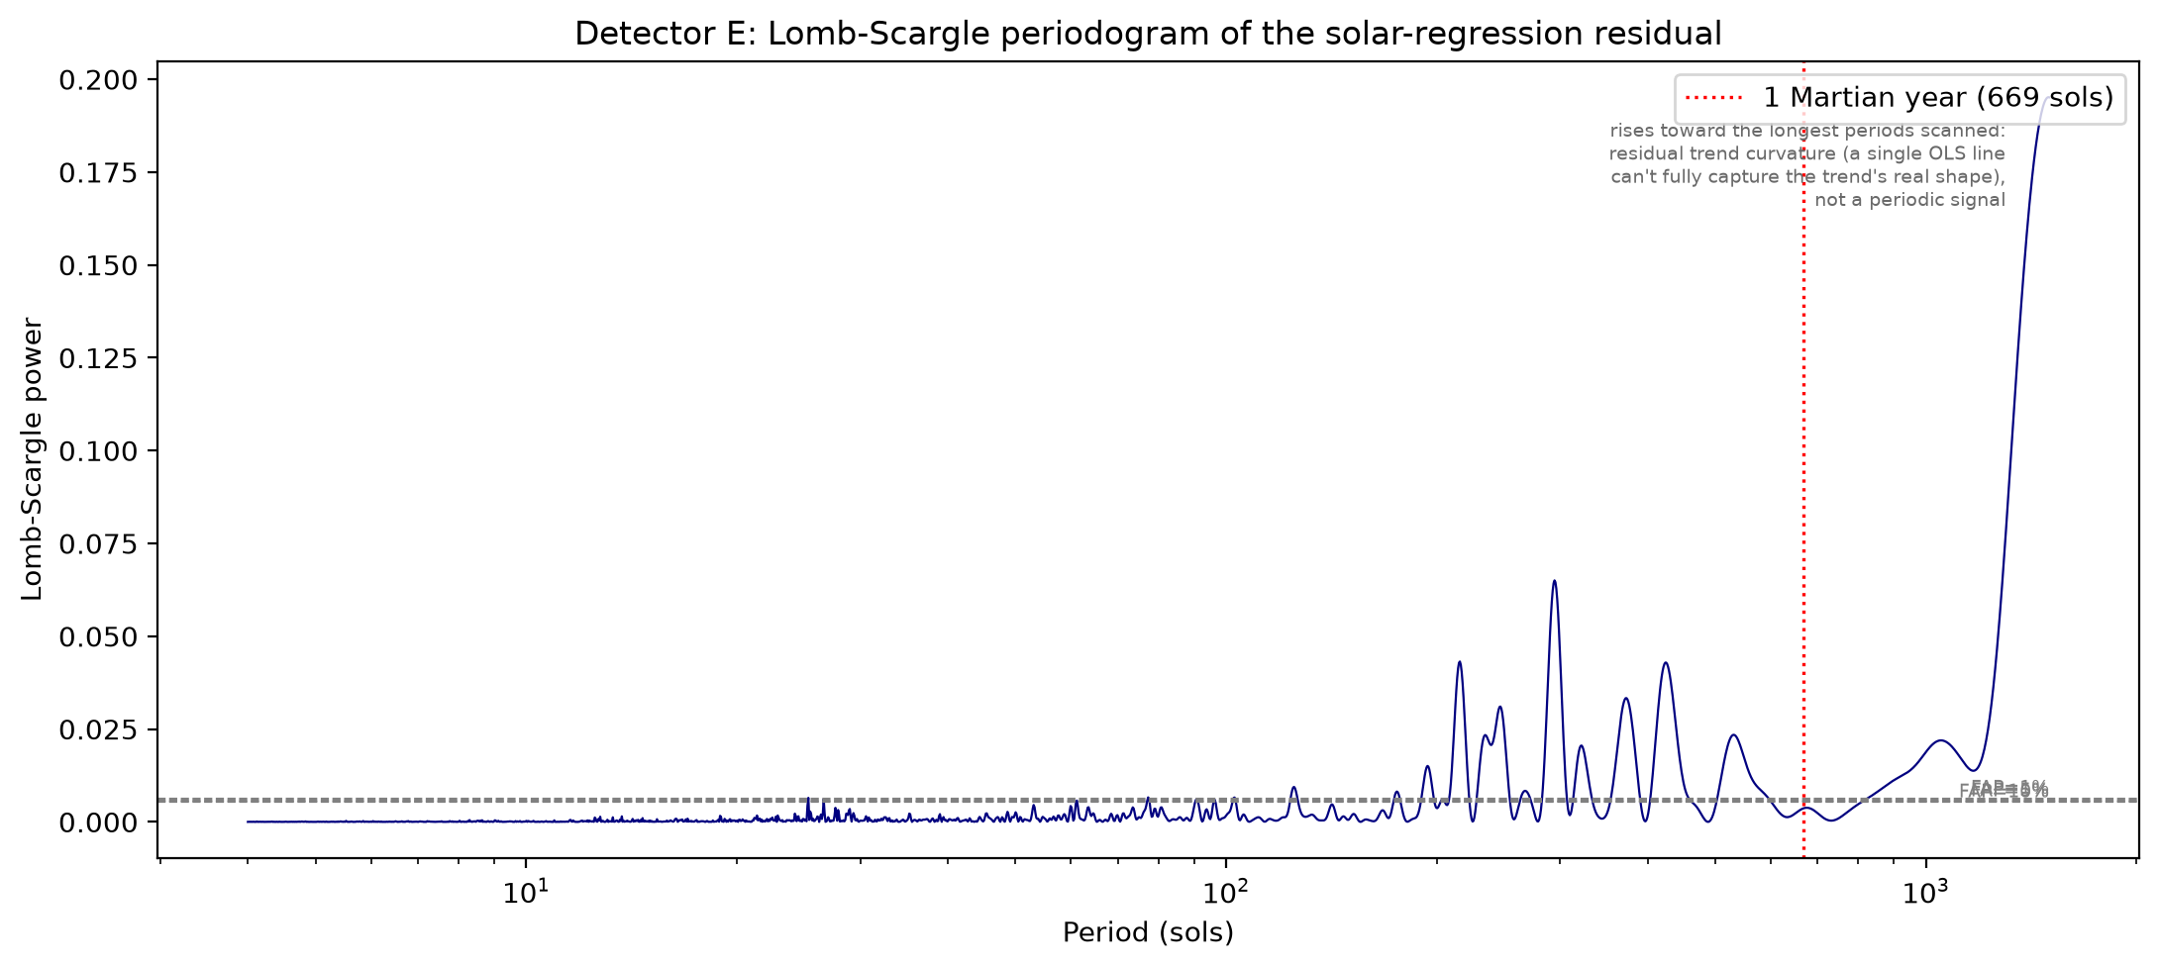
Figure 9. Lomb-Scargle periodogram (detector E) of the neutron-monitor regression residual, periods 4-1,500 sols. Dashed gray lines mark scan-corrected false-alarm-probability thresholds for peaks found by scanning; the single, pre-specified annual frequency (red dotted line) sits at the noise floor (FAP = 1.00 for detector E, 0.99 for detector B, evaluated without a scan correction, since it is one externally motivated hypothesis rather than a peak found by searching). The rise toward the longest periods scanned reflects imperfect linear detrending of the secular trend, not periodicity.

3.7 Implications for Human Mission Radiation Exposure

The measured dose rate can be translated into an estimate of crewed-mission radiation exposure using RAD's own measured surface quality factor and cruise dose (Section 2.3; Hassler et al., 2014). Table 5 gives the resulting total mission dose equivalent -- 500 days on the surface plus RAD's own reported 662 mSv round-trip cruise dose (Hassler et al., 2014; Zeitlin et al., 2013) -- at three points spanning this record's solar-cycle range. Near the mission's own start (SOL ~50, solar maximum), the surface dose rate measured here (8.78 uGy/hour, detector E) implies a total mission dose equivalent of 983 mSv, matching Hassler et al.'s (2014) own contemporaneous estimate (982 mSv) almost exactly -- a direct cross-validation of the extraction and conversion pipeline used throughout this paper. Near the trend's peak at the 2019-2020 solar minimum, the same calculation gives 1,134 mSv; near the most recent solar cycle 25 maximum, 893 mSv.

All three exceed NASA's current 600 mSv career effective-dose limit for astronauts (National Academies of Sciences, Engineering, and Medicine, 2021), by 49-89%, using only the transit-plus-surface GCR/quiet-time exposure of a single round-trip mission -- before accounting for any prior career dose, additional missions, or a large SEP event such as the one identified in this record at SOL 04190 (Section 2.3). This does not by itself imply such a mission is infeasible: shielding, mission-profile choices, and the timing of the mission within the solar cycle (Zhang et al., 2026) all affect the actual exposure. It does show, quantitatively, that the smooth solar-cycle modulation of surface dose rate characterized in this paper (Sections 3.3-3.5) is large enough to be the dominant lever available for reducing crewed-mission exposure toward current limits by mission timing alone, independent of any seasonal effect, for which this paper finds no evidence.

Table 5. Estimated total mission dose equivalent (500-day Mars surface stay plus RAD's own reported 662 mSv round-trip cruise dose; Hassler et al., 2014) at three points spanning this record's solar-cycle range, compared to NASA's 600 mSv career limit (National Academies of Sciences, Engineering, and Medicine, 2021).
Scenario | Dose rate,  detector E  (uGy/hour) | Dose equiv. rate  (mSv/day) | Surface dose,  500 days (mSv) | Total mission  dose (mSv) | % of NASA  600 mSv limit
Near solar maximum  (SOL ~50, 2012-13) | 8.78 | 0.643 | 321 | 983 | 164%
Deep solar minimum  (SOL ~2779, 2019-2020) | 12.90 | 0.944 | 472 | 1134 | 189%
Recent, solar cycle 25 maximum  (SOL ~4832, 2025-26) | 6.32 | 0.463 | 231 | 893 | 149%

4. Discussion
The diurnal variation observed is associated with changes in atmospheric column density caused by thermal tides.

An inverse modulation associated with solar activity/the solar cycle is observed: dose rate rises smoothly as the cycle declines toward solar minimum and falls again as the cycle rises, as also occurs on Earth -- which is notable given Mars lacks a global magnetic field (only localized crustal remnant magnetism is present), so this modulation must act through the heliospheric magnetic field's control of galactic cosmic ray flux rather than any planetary shielding. Testing this directly requires decomposition and wavelet parameters scaled to resolve a Martian year (~668.6 sols) and longer: Sections 3.3 and 3.6 find no independent evidence of a clean annual/seasonal periodicity underlying the trend, over a 7.24-Martian-year record, using three methodologically independent tests. A continuous regression against the Oulu neutron monitor count rate -- a direct physical proxy for this modulation -- explains up to 96% of dose-rate variance (Section 3.5), essentially instantaneously (no detectable lag), but with a statistically significant hysteresis: the response is about 20% steeper during the rising phase of solar cycle 25 than during the declining phase of cycle 24, a comparison only possible because this record, unlike any prior published MSL/RAD analysis, spans a complete solar-cycle reversal. A positive-control comparison against real REMS pressure (Section 3.4) shows the same decomposition method readily detects pressure's genuine seasonal cycle while finding 26-31 times less seasonal structure in the dose-rate residual -- direct evidence that the negative seasonal result reflects the data, not a limitation of the method. The dose-rate variation is best described as a smooth, hysteretic trend tracking the solar cycle, not a resolved seasonal cycle.
Guo et al. (2017) modeled this same atmospheric shielding effect on GCR dose rates using the HZETRN2015 code and found good agreement with RAD surface observations through the first four years of the mission -- a physical mechanism consistent with, and complementary to, the long-term trend reported here.

5. Conclusion
Analysis of the RAD dose-rate record through SOL 04843 (~7.24 Martian years, spanning essentially the full 2012-2026 course of solar cycles 24-25) confirms two effects reported in the literature -- diurnal anti-correlation with atmospheric pressure (Rafkin et al., 2014) and a dose-rate increase tied to solar-cycle modulation of galactic cosmic rays (Guo et al., 2015), independently corroborated at a larger magnitude through the 2019-2020 solar minimum by Guo et al. (2021) and Ehresmann et al. (2023). Regressed against a direct physical proxy for that modulation (the Oulu neutron monitor count rate, Section 3.5) rather than the sunspot number, dose rate explains up to 96% of its own variance, with an essentially instantaneous response and a statistically significant hysteresis: about 20% steeper during the rise of cycle 25 than during the decline of cycle 24, a comparison this record is the first in the published MSL/RAD literature able to make. Three independent methods -- classical decomposition, wavelet transform, and Lomb-Scargle periodogram (Sections 3.3, 3.6) -- find no independent annual/seasonal periodicity in either detector, and a positive-control test against real REMS atmospheric pressure confirms this is a real result and not a limitation of the method: the identical analysis recovers 26-31 times more seasonal structure in pressure than in the dose-rate regression residual (Section 3.4). Translated into mission terms using RAD's own measured quality factor and cruise dose (Section 3.7; Hassler et al., 2014), a round-trip 500-day-surface Mars mission would accumulate 890-1,130 mSv depending on when in the solar cycle it occurs -- all three tested scenarios exceeding NASA's current 600 mSv career limit (National Academies of Sciences, Engineering, and Medicine, 2021) from GCR and quiet-time exposure alone. This negative seasonal result and this positive solar-modulation result matter jointly for mission planning: cumulative radiation exposure should be budgeted against the large, hysteretic solar-cycle trend documented here, and mission timing is the dominant lever available for reducing it, rather than against an additional seasonal modulation that this analysis, across three independent tests, does not support. The full mission-planning picture is more nuanced than GCR dose alone, however: Zhang et al. (2026) show that solar-maximum transits can carry lower total risk despite higher surface GCR dose at solar minimum, once solar energetic particle exposure during transit is included -- underscored here by the SOL 04190 event (May 2024), independently reported by NASA/JPL as the largest single radiation surge RAD has recorded since landing, which this analysis treats as a transient outlier excluded from the secular/seasonal/hysteresis tests (Section 2.3) rather than as evidence against them. Future work could characterize the SOL 04190 event itself, which falls outside the scope of the long-term/seasonal/solar-modulation analysis presented here, and extend the hysteresis test to a second full solar-cycle reversal as the RAD record continues to grow.

Data and Code Availability
Raw RAD and REMS data are publicly archived at NASA's Planetary Data System (RAD: Planetary Plasma Interactions node, https://pds-ppi.igpp.ucla.edu; REMS: Atmospheres node, https://atmos.nmsu.edu/PDS/data/mslrem_1001/). Oulu neutron monitor data are from the Neutron Monitor Database (NMDB, https://www.nmdb.eu; Mavromichalaki et al., 2011); observed sunspot numbers are from the SILSO World Data Center. The extraction pipeline, derived per-sol dose and pressure series, and all analysis code used in this paper are available from the corresponding author upon reasonable request.
We acknowledge the NMDB database (www.nmdb.eu), founded under the European Union's FP7 programme (contract no. 213007), and the PI of the Oulu neutron monitor (Sodankylä Geophysical Observatory of the University of Oulu, Finland).

References
Bazilevskaya, G.A., & Svirzhevskaya, A.K. (1998). On the stratospheric measurements of cosmic rays. Space Science Reviews, 85, 431-521.
Ehresmann, B., Zeitlin, C., Hassler, D.M., Guo, J., Wimmer-Schweingruber, R.F., Berger, T., Matthiä, D., & Reitz, G. (2023). The Martian surface radiation environment at solar minimum measured with MSL/RAD. Icarus, 393, 115035. doi:10.1016/j.icarus.2022.115035
Boynton, W.V., Feldman, W.C., Mitrofanov, I.G., et al. (2004). The Mars Odyssey Gamma-Ray Spectrometer Instrument Suite. Space Science Reviews, 110, 37-83. doi:10.1023/B:SPAC.0000021007.76126.15
Cucinotta, F.A., & Chappell, L.J. (2011). Updates to Astronaut Radiation Limits: Radiation Risks for Never-Smokers. Radiation Research, 176(1), 102-114. doi:10.1667/RR2540.1
Ehresmann, B., Burmeister, S., Wimmer-Schweingruber, R.F., & Reitz, G. (2011). Influence of higher atmospheric pressure on the Martian radiation environment: Implications for possible habitability in the Noachian epoch. Journal of Geophysical Research: Space Physics, 116, A10104. doi:10.1029/2011JA016616
Ehresmann, B., et al. (2014). Charged particle spectra obtained with the Mars Science Laboratory Radiation Assessment Detector (MSL/RAD) on the surface of Mars. Journal of Geophysical Research: Planets, 119, 468-479. doi:10.1002/2013JE004547
Guo, J., Zeitlin, C., Wimmer-Schweingruber, R.F., et al. (2015). Modeling the variations of Dose Rate measured by RAD during the first MSL Martian year: 2012-2014. The Astrophysical Journal, 810(1), 24. doi:10.1088/0004-637X/810/1/24
Guo, J., Zeitlin, C., Wimmer-Schweingruber, R.F., et al. (2015a). MSL-RAD radiation environment measurements. Radiation Protection Dosimetry. doi:10.1093/rpd/ncv297
Guo, J., Slaba, T.C., Zeitlin, C., Wimmer-Schweingruber, R.F., et al. (2017). Dependence of the Martian radiation environment on atmospheric depth: modelling and measurement. arXiv:1712.06987 [astro-ph.EP] (preprint; published version not independently confirmed)
Guo, J., Zeitlin, C., Wimmer-Schweingruber, R.F., Hassler, D.M., Ehresmann, B., Rafkin, S., von Forstner, J.L.F., Khaksarighiri, S., Liu, W., & Wang, Y. (2021). Radiation environment for future human exploration on the surface of Mars: the current understanding based on MSL/RAD dose measurements. Astronomy and Astrophysics Review, 29, 8. doi:10.1007/s00159-021-00136-5
Harri, A.-M., Genzer, M., Kemppinen, O., et al. (2014). Pressure observations by the Curiosity rover: Initial results. Journal of Geophysical Research: Planets, 119(1), 82-92. doi:10.1002/2013JE004423
Hassler, D.M., Zeitlin, C., Wimmer-Schweingruber, R.F., et al. (2012). The Radiation Assessment Detector (RAD) Investigation. Space Science Reviews, 170, 503-558. doi:10.1007/s11214-012-9913-1
Hassler, D.M., Zeitlin, C., Wimmer-Schweingruber, R.F., et al. (2014). Mars' Surface Radiation Environment Measured with the Mars Science Laboratory's Curiosity Rover. Science, 343(6169), 1244797. doi:10.1126/science.1244797
Kohler, J., Zeitlin, C., Ehresmann, B., Wimmer-Schweingruber, R.F., Hassler, D.M., et al. (2014). Measurements of the neutron spectrum on the Martian surface with MSL/RAD. Journal of Geophysical Research: Planets, 119(3), 594-603. doi:10.1002/2013JE004539
Mavromichalaki, H., et al. (2011). Applications and usage of the real-time Neutron Monitor Database (NMDB). Advances in Space Research, 47(12), 2210-2222. doi:10.1016/j.asr.2010.02.019
National Academies of Sciences, Engineering, and Medicine (2021). Space Radiation and Astronaut Health: Managing and Communicating Cancer Risks. Washington, DC: The National Academies Press. doi:10.17226/26155
Newey, W.K., & West, K.D. (1987). A Simple, Positive Semi-Definite, Heteroskedasticity and Autocorrelation Consistent Covariance Matrix. Econometrica, 55(3), 703-708. doi:10.2307/1913610
Rafkin, S.C.R., Zeitlin, C., Ehresmann, B., et al. (2014). Diurnal variations of energetic particle radiation at the surface of Mars as observed by the Mars Science Laboratory Radiation Assessment Detector. Journal of Geophysical Research: Planets, 119, 1345-1358. doi:10.1002/2013JE004525
Roesler, S., Heinrich, W., & Schraube, H. (1998). Neutron spectra in the atmosphere from interactions of primary cosmic rays. Advances in Space Research, 21(12), 1717-1726. doi:10.1016/S0273-1177(98)00058-1
Saganti, P.B., Cucinotta, F.A., Wilson, J.W., & Schimmerling, W. (2002). Visualization of Particle Flux in the Human Body on the Surface of Mars. Journal of Radiation Research, 43(Suppl), S119-S124. PMID: 12793743
Scargle, J.D. (1982). Studies in astronomical time series analysis. II. Statistical aspects of spectral analysis of unevenly spaced data. The Astrophysical Journal, 263, 835-853. doi:10.1086/160554
SILSO World Data Center (2026). International Sunspot Number Monthly Bulletin and online catalogue. Royal Observatory of Belgium, Brussels. http://www.sidc.be/SILSO/
Torrence, C., & Compo, G.P. (1998). A Practical Guide to Wavelet Analysis. Bulletin of the American Meteorological Society, 79(1), 61-78. doi:10.1175/1520-0477(1998)079<0061:APGTWA>2.0.CO;2
VanderPlas, J.T. (2018). Understanding the Lomb-Scargle Periodogram. The Astrophysical Journal Supplement Series, 236(1), 16. doi:10.3847/1538-4365/aab766
Zhang, C., Liu, W., Guo, J., Dobynde, M., & Wimmer-Schweingruber, R.F. (2026). The constraint of crewed Mars missions based on current radiation dose measurements. Space Weather. doi:10.1029/2025SW004724
Zeitlin, C., Hassler, D.M., Cucinotta, F.A., et al. (2013). Measurements of Energetic Particle Radiation in Transit to Mars on the Mars Science Laboratory. Science, 340(6136), 1080-1084. doi:10.1126/science.1235989

