Codebook for dataSet

Autogenerated data summary from dataMaid

2021-07-23 19:22:40

# Data report overview

The dataset examined has the following dimensions:

|  |  |
| --- | --- |
| Feature | Result |
| Number of observations | 1460 |
| Number of variables | 81 |

# Codebook summary table

|  |  |  |  |  |  |
| --- | --- | --- | --- | --- | --- |
| Label | Variable | Class | # unique values | Missing | Description |
|  | **Id** | integer | 1460 | 0.00 % |  |
|  | **MSSubClass** | integer | 15 | 0.00 % |  |
|  | **MSZoning** | character | 5 | 0.00 % |  |
|  | **LotFrontage** | integer | 111 | 17.74 % |  |
|  | **LotArea** | integer | 1073 | 0.00 % |  |
|  | **Street** | character | 2 | 0.00 % |  |
|  | **Alley** | character | 3 | 93.77 % |  |
|  | **LotShape** | character | 4 | 0.00 % |  |
|  | **LandContour** | character | 4 | 0.00 % |  |
|  | **Utilities** | character | 2 | 0.00 % |  |
|  | **LotConfig** | character | 5 | 0.00 % |  |
|  | **LandSlope** | character | 3 | 0.00 % |  |
|  | **Neighborhood** | character | 25 | 0.00 % |  |
|  | **Condition1** | character | 9 | 0.00 % |  |
|  | **Condition2** | character | 8 | 0.00 % |  |
|  | **BldgType** | character | 5 | 0.00 % |  |
|  | **HouseStyle** | character | 8 | 0.00 % |  |
|  | **OverallQual** | integer | 10 | 0.00 % |  |
|  | **OverallCond** | integer | 9 | 0.00 % |  |
|  | **YearBuilt** | integer | 112 | 0.00 % |  |
|  | **YearRemodAdd** | integer | 61 | 0.00 % |  |
|  | **RoofStyle** | character | 6 | 0.00 % |  |
|  | **RoofMatl** | character | 8 | 0.00 % |  |
|  | **Exterior1st** | character | 15 | 0.00 % |  |
|  | **Exterior2nd** | character | 16 | 0.00 % |  |
|  | **MasVnrType** | character | 5 | 0.55 % |  |
|  | **MasVnrArea** | integer | 328 | 0.55 % |  |
|  | **ExterQual** | character | 4 | 0.00 % |  |
|  | **ExterCond** | character | 5 | 0.00 % |  |
|  | **Foundation** | character | 6 | 0.00 % |  |
|  | **BsmtQual** | character | 5 | 2.53 % |  |
|  | **BsmtCond** | character | 5 | 2.53 % |  |
|  | **BsmtExposure** | character | 5 | 2.60 % |  |
|  | **BsmtFinType1** | character | 7 | 2.53 % |  |
|  | **BsmtFinSF1** | integer | 637 | 0.00 % |  |
|  | **BsmtFinType2** | character | 7 | 2.60 % |  |
|  | **BsmtFinSF2** | integer | 144 | 0.00 % |  |
|  | **BsmtUnfSF** | integer | 780 | 0.00 % |  |
|  | **TotalBsmtSF** | integer | 721 | 0.00 % |  |
|  | **Heating** | character | 6 | 0.00 % |  |
|  | **HeatingQC** | character | 5 | 0.00 % |  |
|  | **CentralAir** | character | 2 | 0.00 % |  |
|  | **Electrical** | character | 6 | 0.07 % |  |
|  | **X1stFlrSF** | integer | 753 | 0.00 % |  |
|  | **X2ndFlrSF** | integer | 417 | 0.00 % |  |
|  | **LowQualFinSF** | integer | 24 | 0.00 % |  |
|  | **GrLivArea** | integer | 861 | 0.00 % |  |
|  | **BsmtFullBath** | integer | 4 | 0.00 % |  |
|  | **BsmtHalfBath** | integer | 3 | 0.00 % |  |
|  | **FullBath** | integer | 4 | 0.00 % |  |
|  | **HalfBath** | integer | 3 | 0.00 % |  |
|  | **BedroomAbvGr** | integer | 8 | 0.00 % |  |
|  | **KitchenAbvGr** | integer | 4 | 0.00 % |  |
|  | **KitchenQual** | character | 4 | 0.00 % |  |
|  | **TotRmsAbvGrd** | integer | 12 | 0.00 % |  |
|  | **Functional** | character | 7 | 0.00 % |  |
|  | **Fireplaces** | integer | 4 | 0.00 % |  |
|  | **FireplaceQu** | character | 6 | 47.26 % |  |
|  | **GarageType** | character | 7 | 5.55 % |  |
|  | **GarageYrBlt** | integer | 98 | 5.55 % |  |
|  | **GarageFinish** | character | 4 | 5.55 % |  |
|  | **GarageCars** | integer | 5 | 0.00 % |  |
|  | **GarageArea** | integer | 441 | 0.00 % |  |
|  | **GarageQual** | character | 6 | 5.55 % |  |
|  | **GarageCond** | character | 6 | 5.55 % |  |
|  | **PavedDrive** | character | 3 | 0.00 % |  |
|  | **WoodDeckSF** | integer | 274 | 0.00 % |  |
|  | **OpenPorchSF** | integer | 202 | 0.00 % |  |
|  | **EnclosedPorch** | integer | 120 | 0.00 % |  |
|  | **X3SsnPorch** | integer | 20 | 0.00 % |  |
|  | **ScreenPorch** | integer | 76 | 0.00 % |  |
|  | **PoolArea** | integer | 8 | 0.00 % |  |
|  | **PoolQC** | character | 4 | 99.52 % |  |
|  | **Fence** | character | 5 | 80.75 % |  |
|  | **MiscFeature** | character | 5 | 96.30 % |  |
|  | **MiscVal** | integer | 21 | 0.00 % |  |
|  | **MoSold** | integer | 12 | 0.00 % |  |
|  | **YrSold** | integer | 5 | 0.00 % |  |
|  | **SaleType** | character | 9 | 0.00 % |  |
|  | **SaleCondition** | character | 6 | 0.00 % |  |
|  | **SalePrice** | integer | 663 | 0.00 % |  |

# Variable list

## Id

|  |  |
| --- | --- |
| Feature | Result |
| Variable type | integer |
| Number of missing obs. | 0 (0 %) |
| Number of unique values | 1460 |
| Median | 730.5 |
| 1st and 3rd quartiles | 365.75; 1095.25 |
| Min. and max. | 1; 1460 |

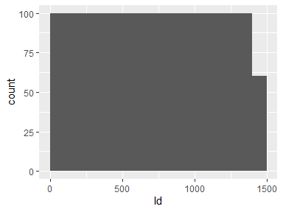

## MSSubClass

|  |  |
| --- | --- |
| Feature | Result |
| Variable type | integer |
| Number of missing obs. | 0 (0 %) |
| Number of unique values | 15 |
| Median | 50 |
| 1st and 3rd quartiles | 20; 70 |
| Min. and max. | 20; 190 |

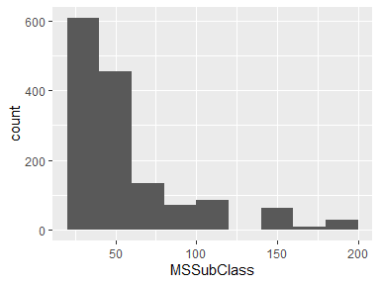

## MSZoning

|  |  |
| --- | --- |
| Feature | Result |
| Variable type | character |
| Number of missing obs. | 0 (0 %) |
| Number of unique values | 5 |
| Mode | “RL” |

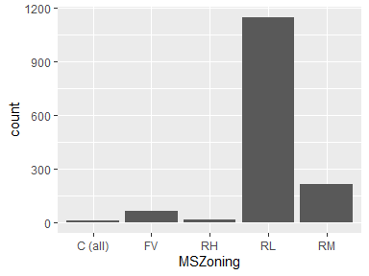

* Observed factor levels: "C (all)", "FV", "RH", "RL", "RM".

## LotFrontage

|  |  |
| --- | --- |
| Feature | Result |
| Variable type | integer |
| Number of missing obs. | 259 (17.74 %) |
| Number of unique values | 110 |
| Median | 69 |
| 1st and 3rd quartiles | 59; 80 |
| Min. and max. | 21; 313 |

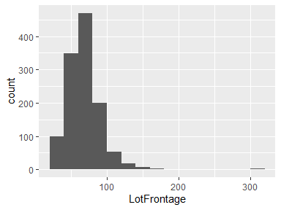

## LotArea

|  |  |
| --- | --- |
| Feature | Result |
| Variable type | integer |
| Number of missing obs. | 0 (0 %) |
| Number of unique values | 1073 |
| Median | 9478.5 |
| 1st and 3rd quartiles | 7553.5; 11601.5 |
| Min. and max. | 1300; 215245 |

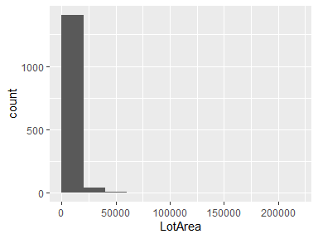

## Street

|  |  |
| --- | --- |
| Feature | Result |
| Variable type | character |
| Number of missing obs. | 0 (0 %) |
| Number of unique values | 2 |
| Mode | “Pave” |

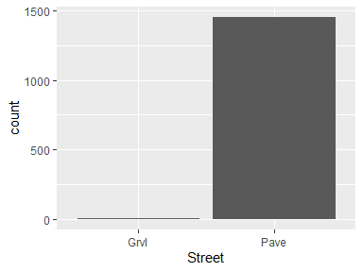

* Observed factor levels: "Grvl", "Pave".

## Alley

|  |  |
| --- | --- |
| Feature | Result |
| Variable type | character |
| Number of missing obs. | 1369 (93.77 %) |
| Number of unique values | 2 |
| Mode | “Grvl” |

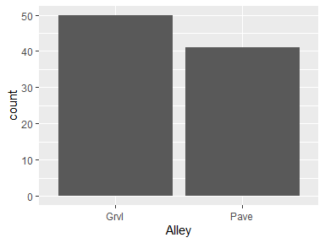

* Observed factor levels: "Grvl", "Pave".

## LotShape

|  |  |
| --- | --- |
| Feature | Result |
| Variable type | character |
| Number of missing obs. | 0 (0 %) |
| Number of unique values | 4 |
| Mode | “Reg” |

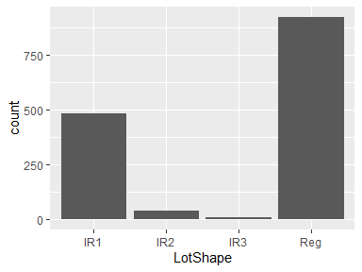

* Observed factor levels: "IR1", "IR2", "IR3", "Reg".

## LandContour

|  |  |
| --- | --- |
| Feature | Result |
| Variable type | character |
| Number of missing obs. | 0 (0 %) |
| Number of unique values | 4 |
| Mode | “Lvl” |

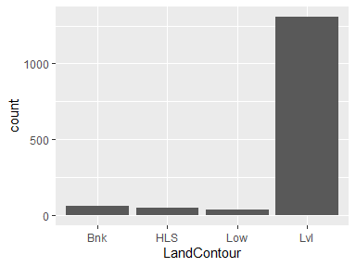

* Observed factor levels: "Bnk", "HLS", "Low", "Lvl".

## Utilities

|  |  |
| --- | --- |
| Feature | Result |
| Variable type | character |
| Number of missing obs. | 0 (0 %) |
| Number of unique values | 2 |
| Mode | “AllPub” |

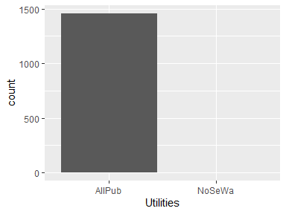

* Observed factor levels: "AllPub", "NoSeWa".

## LotConfig

|  |  |
| --- | --- |
| Feature | Result |
| Variable type | character |
| Number of missing obs. | 0 (0 %) |
| Number of unique values | 5 |
| Mode | “Inside” |

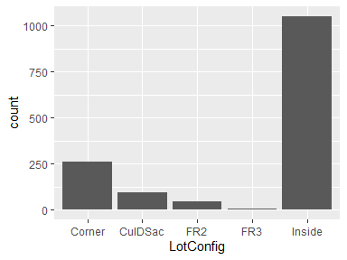

* Observed factor levels: "Corner", "CulDSac", "FR2", "FR3", "Inside".

## LandSlope

|  |  |
| --- | --- |
| Feature | Result |
| Variable type | character |
| Number of missing obs. | 0 (0 %) |
| Number of unique values | 3 |
| Mode | “Gtl” |

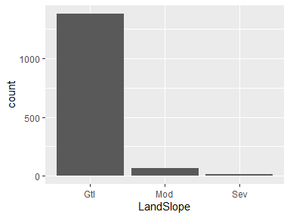

* Observed factor levels: "Gtl", "Mod", "Sev".

## Neighborhood

|  |  |
| --- | --- |
| Feature | Result |
| Variable type | character |
| Number of missing obs. | 0 (0 %) |
| Number of unique values | 25 |
| Mode | “NAmes” |

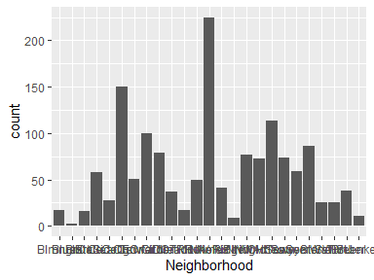

* Observed factor levels: "Blmngtn", "Blueste", "BrDale", "BrkSide", "ClearCr", "CollgCr", "Crawfor", "Edwards", "Gilbert", "IDOTRR", "MeadowV", "Mitchel", "NAmes", "NoRidge", "NPkVill", "NridgHt", "NWAmes", "OldTown", "Sawyer", "SawyerW", "Somerst", "StoneBr", "SWISU", "Timber", "Veenker".

## Condition1

|  |  |
| --- | --- |
| Feature | Result |
| Variable type | character |
| Number of missing obs. | 0 (0 %) |
| Number of unique values | 9 |
| Mode | “Norm” |

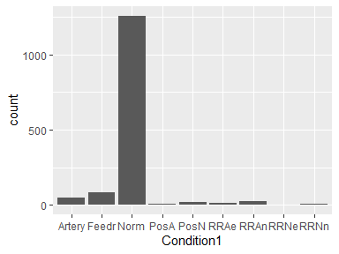

* Observed factor levels: "Artery", "Feedr", "Norm", "PosA", "PosN", "RRAe", "RRAn", "RRNe", "RRNn".

## Condition2

|  |  |
| --- | --- |
| Feature | Result |
| Variable type | character |
| Number of missing obs. | 0 (0 %) |
| Number of unique values | 8 |
| Mode | “Norm” |

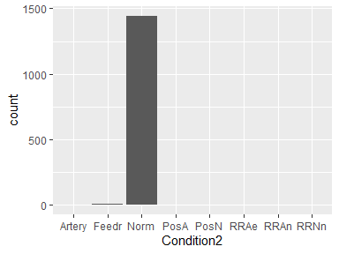

* Observed factor levels: "Artery", "Feedr", "Norm", "PosA", "PosN", "RRAe", "RRAn", "RRNn".

## BldgType

|  |  |
| --- | --- |
| Feature | Result |
| Variable type | character |
| Number of missing obs. | 0 (0 %) |
| Number of unique values | 5 |
| Mode | “1Fam” |

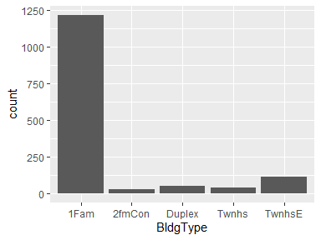

* Observed factor levels: "1Fam", "2fmCon", "Duplex", "Twnhs", "TwnhsE".

## HouseStyle

|  |  |
| --- | --- |
| Feature | Result |
| Variable type | character |
| Number of missing obs. | 0 (0 %) |
| Number of unique values | 8 |
| Mode | “1Story” |

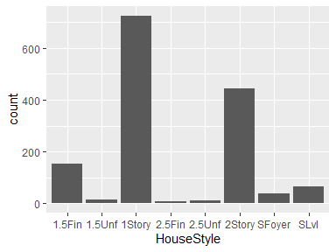

* Observed factor levels: "1.5Fin", "1.5Unf", "1Story", "2.5Fin", "2.5Unf", "2Story", "SFoyer", "SLvl".

## OverallQual

|  |  |
| --- | --- |
| Feature | Result |
| Variable type | integer |
| Number of missing obs. | 0 (0 %) |
| Number of unique values | 10 |
| Median | 6 |
| 1st and 3rd quartiles | 5; 7 |
| Min. and max. | 1; 10 |

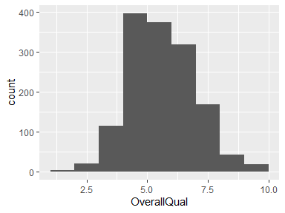

## OverallCond

|  |  |
| --- | --- |
| Feature | Result |
| Variable type | integer |
| Number of missing obs. | 0 (0 %) |
| Number of unique values | 9 |
| Median | 5 |
| 1st and 3rd quartiles | 5; 6 |
| Min. and max. | 1; 9 |

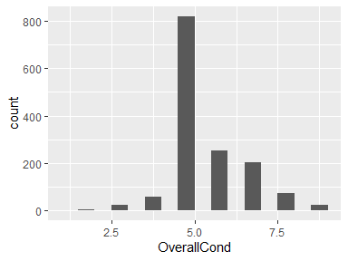

## YearBuilt

|  |  |
| --- | --- |
| Feature | Result |
| Variable type | integer |
| Number of missing obs. | 0 (0 %) |
| Number of unique values | 112 |
| Median | 1973 |
| 1st and 3rd quartiles | 1954; 2000 |
| Min. and max. | 1872; 2010 |

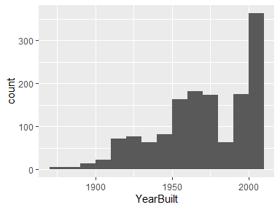

## YearRemodAdd

|  |  |
| --- | --- |
| Feature | Result |
| Variable type | integer |
| Number of missing obs. | 0 (0 %) |
| Number of unique values | 61 |
| Median | 1994 |
| 1st and 3rd quartiles | 1967; 2004 |
| Min. and max. | 1950; 2010 |

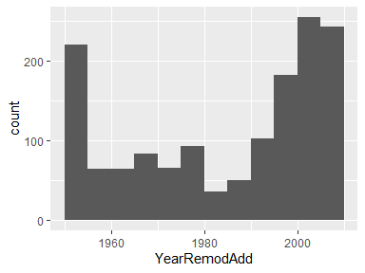

## RoofStyle

|  |  |
| --- | --- |
| Feature | Result |
| Variable type | character |
| Number of missing obs. | 0 (0 %) |
| Number of unique values | 6 |
| Mode | “Gable” |

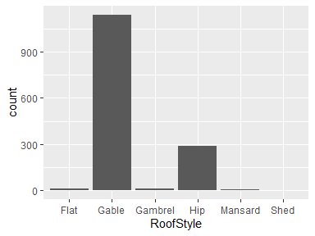

* Observed factor levels: "Flat", "Gable", "Gambrel", "Hip", "Mansard", "Shed".

## RoofMatl

|  |  |
| --- | --- |
| Feature | Result |
| Variable type | character |
| Number of missing obs. | 0 (0 %) |
| Number of unique values | 8 |
| Mode | “CompShg” |

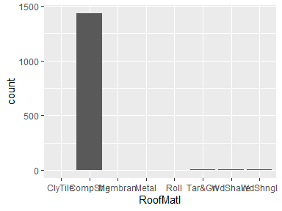

* Observed factor levels: "ClyTile", "CompShg", "Membran", "Metal", "Roll", "Tar&Grv", "WdShake", "WdShngl".

## Exterior1st

|  |  |
| --- | --- |
| Feature | Result |
| Variable type | character |
| Number of missing obs. | 0 (0 %) |
| Number of unique values | 15 |
| Mode | “VinylSd” |

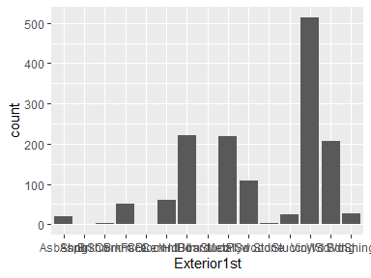

* Observed factor levels: "AsbShng", "AsphShn", "BrkComm", "BrkFace", "CBlock", "CemntBd", "HdBoard", "ImStucc", "MetalSd", "Plywood", "Stone", "Stucco", "VinylSd", "Wd Sdng", "WdShing".

## Exterior2nd

|  |  |
| --- | --- |
| Feature | Result |
| Variable type | character |
| Number of missing obs. | 0 (0 %) |
| Number of unique values | 16 |
| Mode | “VinylSd” |

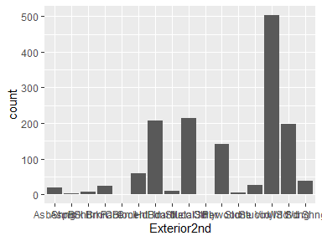

* Observed factor levels: "AsbShng", "AsphShn", "Brk Cmn", "BrkFace", "CBlock", "CmentBd", "HdBoard", "ImStucc", "MetalSd", "Other", "Plywood", "Stone", "Stucco", "VinylSd", "Wd Sdng", "Wd Shng".

## MasVnrType

|  |  |
| --- | --- |
| Feature | Result |
| Variable type | character |
| Number of missing obs. | 8 (0.55 %) |
| Number of unique values | 4 |
| Mode | “None” |

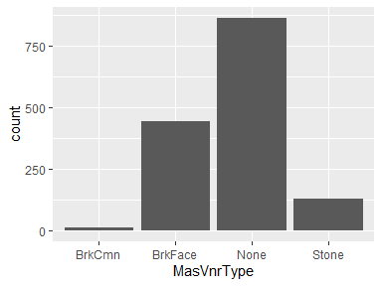

* Observed factor levels: "BrkCmn", "BrkFace", "None", "Stone".

## MasVnrArea

|  |  |
| --- | --- |
| Feature | Result |
| Variable type | integer |
| Number of missing obs. | 8 (0.55 %) |
| Number of unique values | 327 |
| Median | 0 |
| 1st and 3rd quartiles | 0; 166 |
| Min. and max. | 0; 1600 |

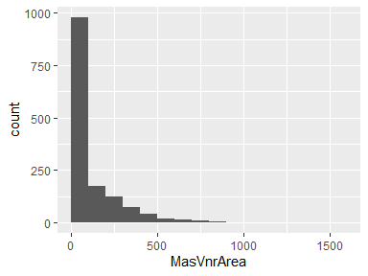

## ExterQual

|  |  |
| --- | --- |
| Feature | Result |
| Variable type | character |
| Number of missing obs. | 0 (0 %) |
| Number of unique values | 4 |
| Mode | “TA” |

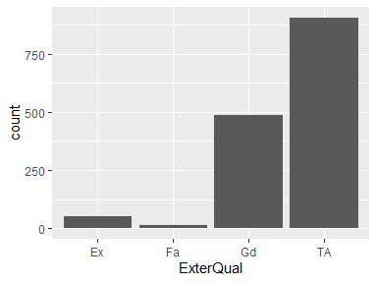

* Observed factor levels: "Ex", "Fa", "Gd", "TA".

## ExterCond

|  |  |
| --- | --- |
| Feature | Result |
| Variable type | character |
| Number of missing obs. | 0 (0 %) |
| Number of unique values | 5 |
| Mode | “TA” |

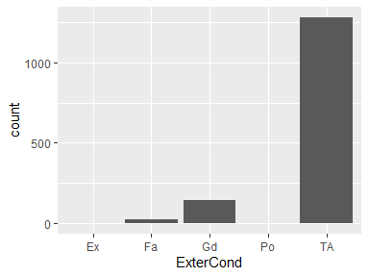

* Observed factor levels: "Ex", "Fa", "Gd", "Po", "TA".

## Foundation

|  |  |
| --- | --- |
| Feature | Result |
| Variable type | character |
| Number of missing obs. | 0 (0 %) |
| Number of unique values | 6 |
| Mode | “PConc” |

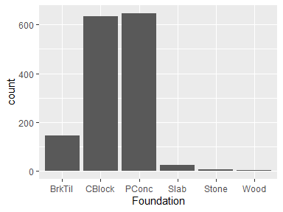

* Observed factor levels: "BrkTil", "CBlock", "PConc", "Slab", "Stone", "Wood".

## BsmtQual

|  |  |
| --- | --- |
| Feature | Result |
| Variable type | character |
| Number of missing obs. | 37 (2.53 %) |
| Number of unique values | 4 |
| Mode | “TA” |

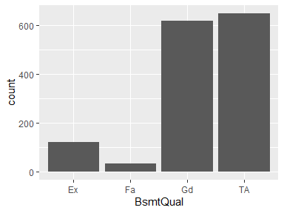

* Observed factor levels: "Ex", "Fa", "Gd", "TA".

## BsmtCond

|  |  |
| --- | --- |
| Feature | Result |
| Variable type | character |
| Number of missing obs. | 37 (2.53 %) |
| Number of unique values | 4 |
| Mode | “TA” |

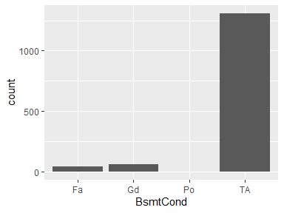

* Observed factor levels: "Fa", "Gd", "Po", "TA".

## BsmtExposure

|  |  |
| --- | --- |
| Feature | Result |
| Variable type | character |
| Number of missing obs. | 38 (2.6 %) |
| Number of unique values | 4 |
| Mode | “No” |

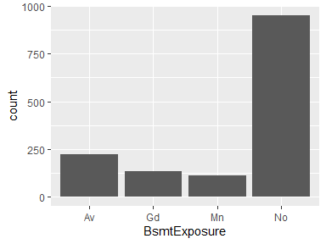

* Observed factor levels: "Av", "Gd", "Mn", "No".

## BsmtFinType1

|  |  |
| --- | --- |
| Feature | Result |
| Variable type | character |
| Number of missing obs. | 37 (2.53 %) |
| Number of unique values | 6 |
| Mode | “Unf” |

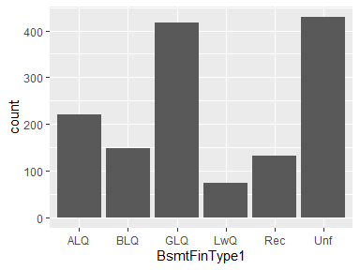

* Observed factor levels: "ALQ", "BLQ", "GLQ", "LwQ", "Rec", "Unf".

## BsmtFinSF1

|  |  |
| --- | --- |
| Feature | Result |
| Variable type | integer |
| Number of missing obs. | 0 (0 %) |
| Number of unique values | 637 |
| Median | 383.5 |
| 1st and 3rd quartiles | 0; 712.25 |
| Min. and max. | 0; 5644 |

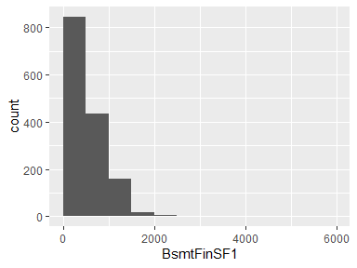

## BsmtFinType2

|  |  |
| --- | --- |
| Feature | Result |
| Variable type | character |
| Number of missing obs. | 38 (2.6 %) |
| Number of unique values | 6 |
| Mode | “Unf” |

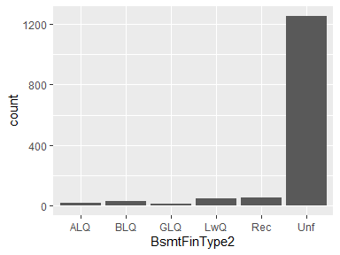

* Observed factor levels: "ALQ", "BLQ", "GLQ", "LwQ", "Rec", "Unf".

## BsmtFinSF2

|  |  |
| --- | --- |
| Feature | Result |
| Variable type | integer |
| Number of missing obs. | 0 (0 %) |
| Number of unique values | 144 |
| Median | 0 |
| 1st and 3rd quartiles | 0; 0 |
| Min. and max. | 0; 1474 |

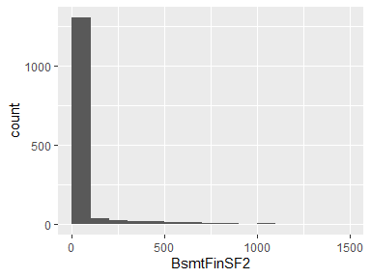

## BsmtUnfSF

|  |  |
| --- | --- |
| Feature | Result |
| Variable type | integer |
| Number of missing obs. | 0 (0 %) |
| Number of unique values | 780 |
| Median | 477.5 |
| 1st and 3rd quartiles | 223; 808 |
| Min. and max. | 0; 2336 |

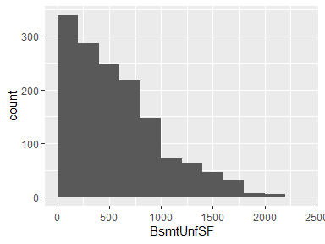

## TotalBsmtSF

|  |  |
| --- | --- |
| Feature | Result |
| Variable type | integer |
| Number of missing obs. | 0 (0 %) |
| Number of unique values | 721 |
| Median | 991.5 |
| 1st and 3rd quartiles | 795.75; 1298.25 |
| Min. and max. | 0; 6110 |

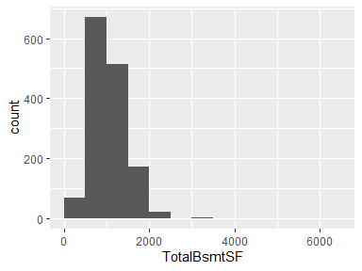

## Heating

|  |  |
| --- | --- |
| Feature | Result |
| Variable type | character |
| Number of missing obs. | 0 (0 %) |
| Number of unique values | 6 |
| Mode | “GasA” |

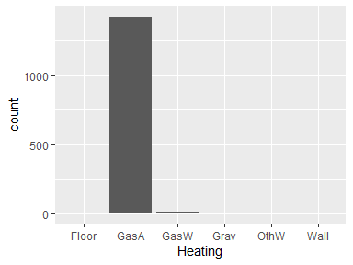

* Observed factor levels: "Floor", "GasA", "GasW", "Grav", "OthW", "Wall".

## HeatingQC

|  |  |
| --- | --- |
| Feature | Result |
| Variable type | character |
| Number of missing obs. | 0 (0 %) |
| Number of unique values | 5 |
| Mode | “Ex” |

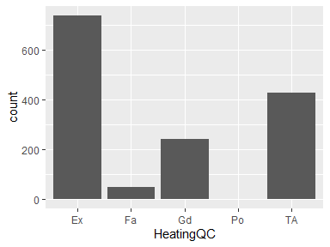

* Observed factor levels: "Ex", "Fa", "Gd", "Po", "TA".

## CentralAir

|  |  |
| --- | --- |
| Feature | Result |
| Variable type | character |
| Number of missing obs. | 0 (0 %) |
| Number of unique values | 2 |
| Mode | “Y” |

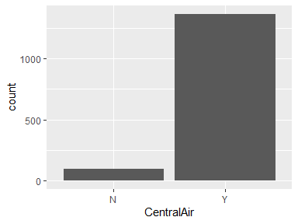

* Observed factor levels: "N", "Y".

## Electrical

|  |  |
| --- | --- |
| Feature | Result |
| Variable type | character |
| Number of missing obs. | 1 (0.07 %) |
| Number of unique values | 5 |
| Mode | “SBrkr” |

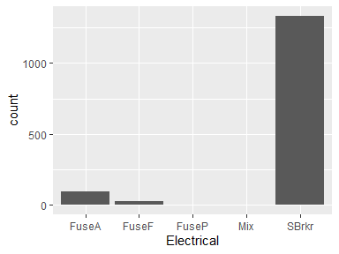

* Observed factor levels: "FuseA", "FuseF", "FuseP", "Mix", "SBrkr".

## X1stFlrSF

|  |  |
| --- | --- |
| Feature | Result |
| Variable type | integer |
| Number of missing obs. | 0 (0 %) |
| Number of unique values | 753 |
| Median | 1087 |
| 1st and 3rd quartiles | 882; 1391.25 |
| Min. and max. | 334; 4692 |

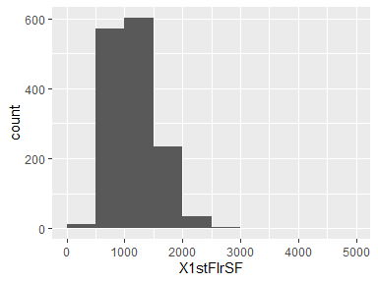

## X2ndFlrSF

|  |  |
| --- | --- |
| Feature | Result |
| Variable type | integer |
| Number of missing obs. | 0 (0 %) |
| Number of unique values | 417 |
| Median | 0 |
| 1st and 3rd quartiles | 0; 728 |
| Min. and max. | 0; 2065 |

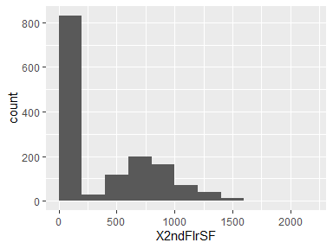

## LowQualFinSF

|  |  |
| --- | --- |
| Feature | Result |
| Variable type | integer |
| Number of missing obs. | 0 (0 %) |
| Number of unique values | 24 |
| Median | 0 |
| 1st and 3rd quartiles | 0; 0 |
| Min. and max. | 0; 572 |

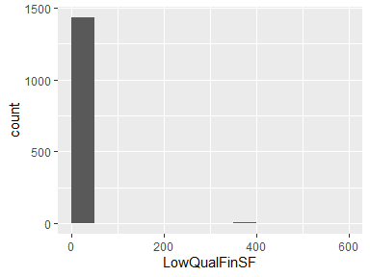

## GrLivArea

|  |  |
| --- | --- |
| Feature | Result |
| Variable type | integer |
| Number of missing obs. | 0 (0 %) |
| Number of unique values | 861 |
| Median | 1464 |
| 1st and 3rd quartiles | 1129.5; 1776.75 |
| Min. and max. | 334; 5642 |

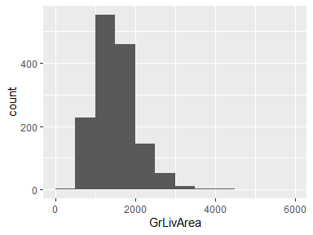

## BsmtFullBath

|  |  |
| --- | --- |
| Feature | Result |
| Variable type | integer |
| Number of missing obs. | 0 (0 %) |
| Number of unique values | 4 |
| Median | 0 |
| 1st and 3rd quartiles | 0; 1 |
| Min. and max. | 0; 3 |

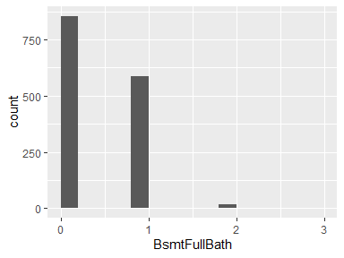

## BsmtHalfBath

|  |  |
| --- | --- |
| Feature | Result |
| Variable type | integer |
| Number of missing obs. | 0 (0 %) |
| Number of unique values | 3 |
| Median | 0 |
| 1st and 3rd quartiles | 0; 0 |
| Min. and max. | 0; 2 |

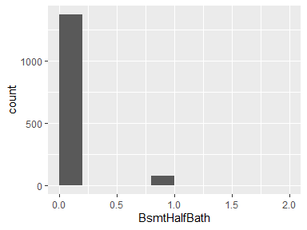

## FullBath

|  |  |
| --- | --- |
| Feature | Result |
| Variable type | integer |
| Number of missing obs. | 0 (0 %) |
| Number of unique values | 4 |
| Median | 2 |
| 1st and 3rd quartiles | 1; 2 |
| Min. and max. | 0; 3 |

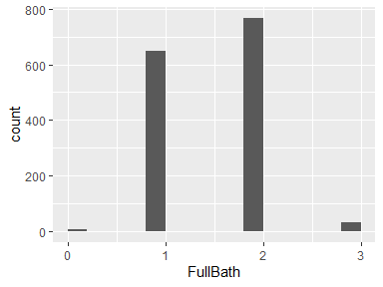

## HalfBath

|  |  |
| --- | --- |
| Feature | Result |
| Variable type | integer |
| Number of missing obs. | 0 (0 %) |
| Number of unique values | 3 |
| Median | 0 |
| 1st and 3rd quartiles | 0; 1 |
| Min. and max. | 0; 2 |

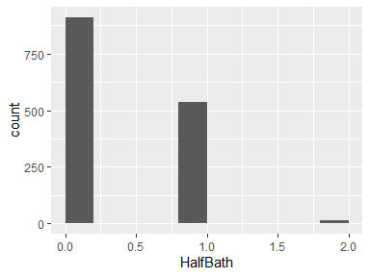

## BedroomAbvGr

|  |  |
| --- | --- |
| Feature | Result |
| Variable type | integer |
| Number of missing obs. | 0 (0 %) |
| Number of unique values | 8 |
| Median | 3 |
| 1st and 3rd quartiles | 2; 3 |
| Min. and max. | 0; 8 |

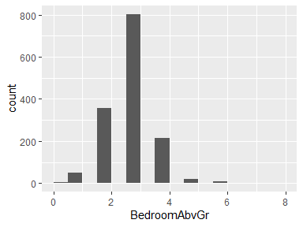

## KitchenAbvGr

|  |  |
| --- | --- |
| Feature | Result |
| Variable type | integer |
| Number of missing obs. | 0 (0 %) |
| Number of unique values | 4 |
| Median | 1 |
| 1st and 3rd quartiles | 1; 1 |
| Min. and max. | 0; 3 |

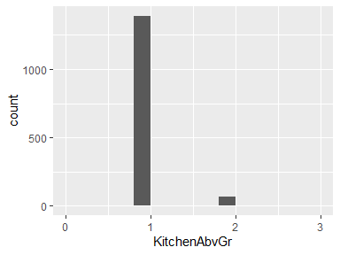

## KitchenQual

|  |  |
| --- | --- |
| Feature | Result |
| Variable type | character |
| Number of missing obs. | 0 (0 %) |
| Number of unique values | 4 |
| Mode | “TA” |

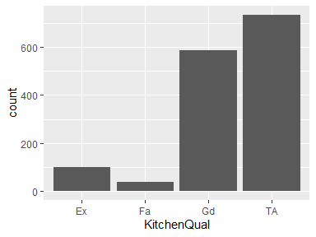

* Observed factor levels: "Ex", "Fa", "Gd", "TA".

## TotRmsAbvGrd

|  |  |
| --- | --- |
| Feature | Result |
| Variable type | integer |
| Number of missing obs. | 0 (0 %) |
| Number of unique values | 12 |
| Median | 6 |
| 1st and 3rd quartiles | 5; 7 |
| Min. and max. | 2; 14 |

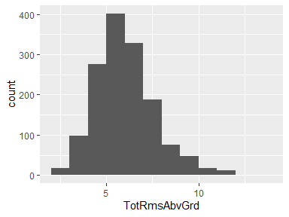

## Functional

|  |  |
| --- | --- |
| Feature | Result |
| Variable type | character |
| Number of missing obs. | 0 (0 %) |
| Number of unique values | 7 |
| Mode | “Typ” |

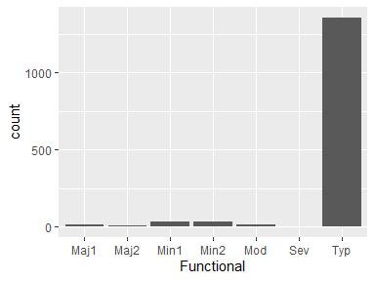

* Observed factor levels: "Maj1", "Maj2", "Min1", "Min2", "Mod", "Sev", "Typ".

## Fireplaces

|  |  |
| --- | --- |
| Feature | Result |
| Variable type | integer |
| Number of missing obs. | 0 (0 %) |
| Number of unique values | 4 |
| Median | 1 |
| 1st and 3rd quartiles | 0; 1 |
| Min. and max. | 0; 3 |

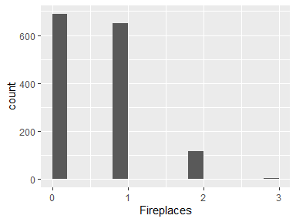

## FireplaceQu

|  |  |
| --- | --- |
| Feature | Result |
| Variable type | character |
| Number of missing obs. | 690 (47.26 %) |
| Number of unique values | 5 |
| Mode | “Gd” |

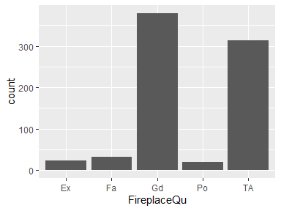

* Observed factor levels: "Ex", "Fa", "Gd", "Po", "TA".

## GarageType

|  |  |
| --- | --- |
| Feature | Result |
| Variable type | character |
| Number of missing obs. | 81 (5.55 %) |
| Number of unique values | 6 |
| Mode | “Attchd” |

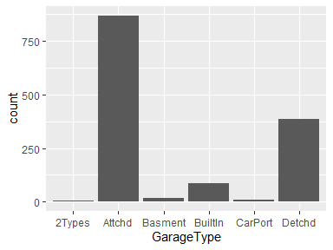

* Observed factor levels: "2Types", "Attchd", "Basment", "BuiltIn", "CarPort", "Detchd".

## GarageYrBlt

|  |  |
| --- | --- |
| Feature | Result |
| Variable type | integer |
| Number of missing obs. | 81 (5.55 %) |
| Number of unique values | 97 |
| Median | 1980 |
| 1st and 3rd quartiles | 1961; 2002 |
| Min. and max. | 1900; 2010 |

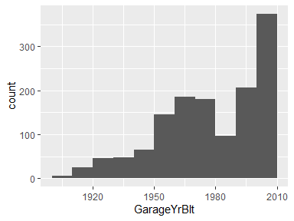

## GarageFinish

|  |  |
| --- | --- |
| Feature | Result |
| Variable type | character |
| Number of missing obs. | 81 (5.55 %) |
| Number of unique values | 3 |
| Mode | “Unf” |

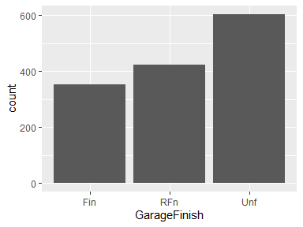

* Observed factor levels: "Fin", "RFn", "Unf".

## GarageCars

|  |  |
| --- | --- |
| Feature | Result |
| Variable type | integer |
| Number of missing obs. | 0 (0 %) |
| Number of unique values | 5 |
| Median | 2 |
| 1st and 3rd quartiles | 1; 2 |
| Min. and max. | 0; 4 |

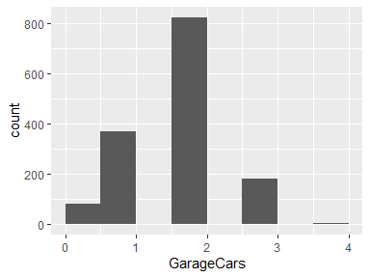

## GarageArea

|  |  |
| --- | --- |
| Feature | Result |
| Variable type | integer |
| Number of missing obs. | 0 (0 %) |
| Number of unique values | 441 |
| Median | 480 |
| 1st and 3rd quartiles | 334.5; 576 |
| Min. and max. | 0; 1418 |

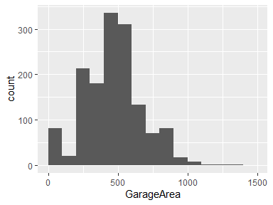

## GarageQual

|  |  |
| --- | --- |
| Feature | Result |
| Variable type | character |
| Number of missing obs. | 81 (5.55 %) |
| Number of unique values | 5 |
| Mode | “TA” |

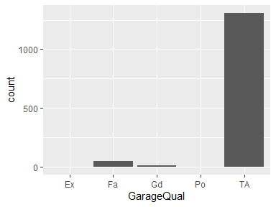

* Observed factor levels: "Ex", "Fa", "Gd", "Po", "TA".

## GarageCond

|  |  |
| --- | --- |
| Feature | Result |
| Variable type | character |
| Number of missing obs. | 81 (5.55 %) |
| Number of unique values | 5 |
| Mode | “TA” |

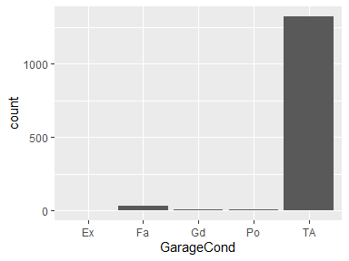

* Observed factor levels: "Ex", "Fa", "Gd", "Po", "TA".

## PavedDrive

|  |  |
| --- | --- |
| Feature | Result |
| Variable type | character |
| Number of missing obs. | 0 (0 %) |
| Number of unique values | 3 |
| Mode | “Y” |

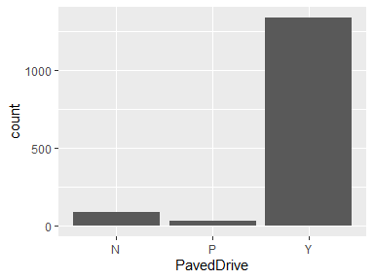

* Observed factor levels: "N", "P", "Y".

## WoodDeckSF

|  |  |
| --- | --- |
| Feature | Result |
| Variable type | integer |
| Number of missing obs. | 0 (0 %) |
| Number of unique values | 274 |
| Median | 0 |
| 1st and 3rd quartiles | 0; 168 |
| Min. and max. | 0; 857 |

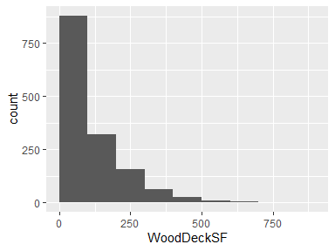

## OpenPorchSF

|  |  |
| --- | --- |
| Feature | Result |
| Variable type | integer |
| Number of missing obs. | 0 (0 %) |
| Number of unique values | 202 |
| Median | 25 |
| 1st and 3rd quartiles | 0; 68 |
| Min. and max. | 0; 547 |

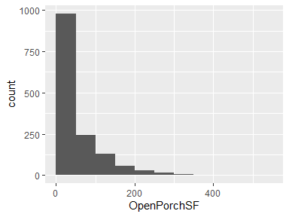

## EnclosedPorch

|  |  |
| --- | --- |
| Feature | Result |
| Variable type | integer |
| Number of missing obs. | 0 (0 %) |
| Number of unique values | 120 |
| Median | 0 |
| 1st and 3rd quartiles | 0; 0 |
| Min. and max. | 0; 552 |

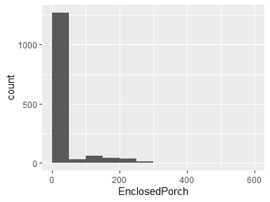

## X3SsnPorch

|  |  |
| --- | --- |
| Feature | Result |
| Variable type | integer |
| Number of missing obs. | 0 (0 %) |
| Number of unique values | 20 |
| Median | 0 |
| 1st and 3rd quartiles | 0; 0 |
| Min. and max. | 0; 508 |

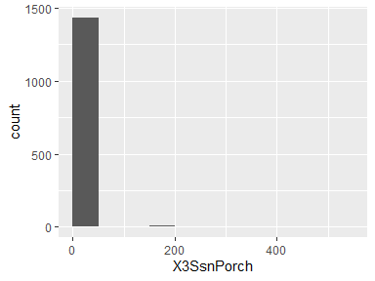

## ScreenPorch

|  |  |
| --- | --- |
| Feature | Result |
| Variable type | integer |
| Number of missing obs. | 0 (0 %) |
| Number of unique values | 76 |
| Median | 0 |
| 1st and 3rd quartiles | 0; 0 |
| Min. and max. | 0; 480 |

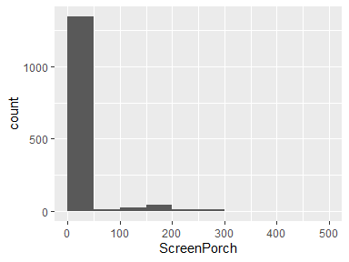

## PoolArea

|  |  |
| --- | --- |
| Feature | Result |
| Variable type | integer |
| Number of missing obs. | 0 (0 %) |
| Number of unique values | 8 |
| Median | 0 |
| 1st and 3rd quartiles | 0; 0 |
| Min. and max. | 0; 738 |

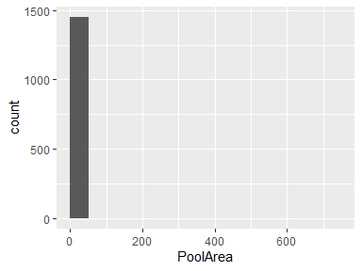

## PoolQC

|  |  |
| --- | --- |
| Feature | Result |
| Variable type | character |
| Number of missing obs. | 1453 (99.52 %) |
| Number of unique values | 3 |
| Mode | “Gd” |

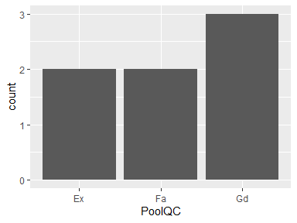

* Observed factor levels: "Ex", "Fa", "Gd".

## Fence

|  |  |
| --- | --- |
| Feature | Result |
| Variable type | character |
| Number of missing obs. | 1179 (80.75 %) |
| Number of unique values | 4 |
| Mode | “MnPrv” |

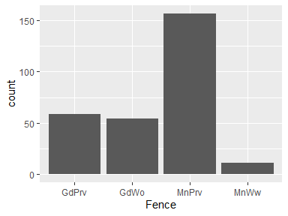

* Observed factor levels: "GdPrv", "GdWo", "MnPrv", "MnWw".

## MiscFeature

|  |  |
| --- | --- |
| Feature | Result |
| Variable type | character |
| Number of missing obs. | 1406 (96.3 %) |
| Number of unique values | 4 |
| Mode | “Shed” |

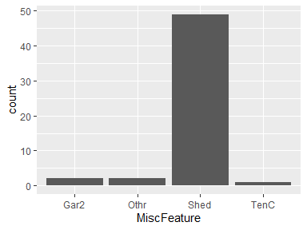

* Observed factor levels: "Gar2", "Othr", "Shed", "TenC".

## MiscVal

|  |  |
| --- | --- |
| Feature | Result |
| Variable type | integer |
| Number of missing obs. | 0 (0 %) |
| Number of unique values | 21 |
| Median | 0 |
| 1st and 3rd quartiles | 0; 0 |
| Min. and max. | 0; 15500 |

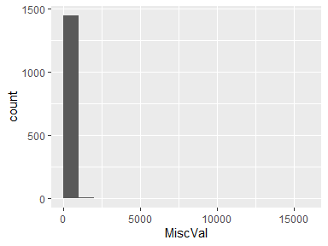

## MoSold

|  |  |
| --- | --- |
| Feature | Result |
| Variable type | integer |
| Number of missing obs. | 0 (0 %) |
| Number of unique values | 12 |
| Median | 6 |
| 1st and 3rd quartiles | 5; 8 |
| Min. and max. | 1; 12 |

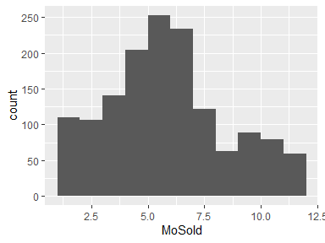

## YrSold

|  |  |
| --- | --- |
| Feature | Result |
| Variable type | integer |
| Number of missing obs. | 0 (0 %) |
| Number of unique values | 5 |
| Median | 2008 |
| 1st and 3rd quartiles | 2007; 2009 |
| Min. and max. | 2006; 2010 |

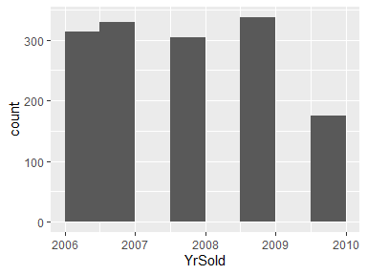

## SaleType

|  |  |
| --- | --- |
| Feature | Result |
| Variable type | character |
| Number of missing obs. | 0 (0 %) |
| Number of unique values | 9 |
| Mode | “WD” |

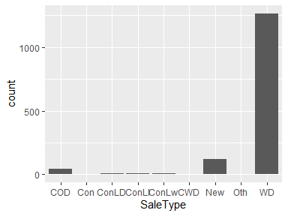

* Observed factor levels: "COD", "Con", "ConLD", "ConLI", "ConLw", "CWD", "New", "Oth", "WD".

## SaleCondition

|  |  |
| --- | --- |
| Feature | Result |
| Variable type | character |
| Number of missing obs. | 0 (0 %) |
| Number of unique values | 6 |
| Mode | “Normal” |

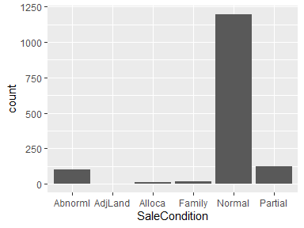

* Observed factor levels: "Abnorml", "AdjLand", "Alloca", "Family", "Normal", "Partial".

## SalePrice

|  |  |
| --- | --- |
| Feature | Result |
| Variable type | integer |
| Number of missing obs. | 0 (0 %) |
| Number of unique values | 663 |
| Median | 163000 |
| 1st and 3rd quartiles | 129975; 214000 |
| Min. and max. | 34900; 755000 |

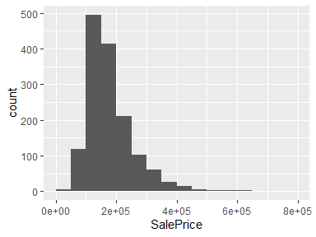

Report generation information:

* Created by: Could not determine from system (username: cesarvin).
* Report creation time: Fri Jul 23 2021 19:22:42
* Report was run from directory: X:/UVG/Data/Laboratorio 1/Lab1
* dataMaid v1.4.0 [Pkg: 2019-12-10 from CRAN (R 4.1.0)]
* R version 4.1.0 (2021-05-18).
* Platform: x86_64-w64-mingw32/x64 (64-bit)(Windows 10 x64 (build 19041)).
* Function call: dataMaid::makeDataReport(data = dataSet, mode = c("summarize", "visualize", "check"), smartNum = FALSE, file = "codebook_dataSet.Rmd", checks = list(character = "showAllFactorLevels", factor = "showAllFactorLevels", labelled = "showAllFactorLevels", haven_labelled = "showAllFactorLevels", numeric = NULL, integer = NULL, logical = NULL, Date = NULL), listChecks = FALSE, maxProbVals = Inf, codebook = TRUE, reportTitle = "Codebook for dataSet")