Theoretical exercises

1 Construct a consensus and regular expression for the alignment below

Note this is one alignment, consisting of sets of sequences that belong to the same protein family -> the positions conserved in all sequences represent functionally relevant positions.

a) What is the consensus representation of the alignment (see slide 16): it is for each column the residue that occurs most frequently. In this case this is for most columns ambiguous so one of the two options is chosen (this illustrates the drawback of a consensus). Here the consensus alignment is the last row (line next to protein X).

Consensus: CPGMWD ------------------- NITCWKPAQIGE-MVLVSCPEGFRI

b) What is the regular expression representation of the alignment above? Use the PROSITE syntax - http://www.hpabioinfotools. org.uk/ps_scan/PS_SCAN_PATTERN_SYNTAX.html (see slide 16-18)

C-[EP]-[AG]-[MV]-[EW]-[AD]-x(7)-[NR]-[EI]-[IT]-[CM]-W-[FK]-[KP]-[AT]-HRQ]-[IQV]-G-[EQ]-x-[IMV]-[AV]-[KL]-[QV]-[PS]-C-P-[AE]-[GLV]-[TF]-[IR]-[I-].

The regular expression does not provide any information on the frequency with which the residues occur in the different positions of the alignment.

2. What is the probability that a randomly chosen binding site will be TTGTGAC given the position frequency matrix below?
This is screening a sequence with a frequency matrix (slide 37 and examples_motif_representation.xls tab screening with PSSM)
Note that here we will not screen with a PSSM (log scores) but with the frequency matrix -> we first calculate the likelihood ratio a then take the log2 of this value to obtain the log likelihood ratio. The same result can be obtained by calculating the PSSM first)

Frequency matrix
Given background B: B={A,C,G,T} P(Bi) = 0.25 for all bases
Calculate the likelihood ratio for this sequence.
a) p(i = TTGTGAC | i is a site) = (.35)(.87)(.78)(.91)(.83)(.83)(.3) = 0.045
b) p(i = TTGTGAC | I is generated by a random model) =0.25⁷

c) likelihood ratio: 0.045/0.25⁷=737
d) log likelihood ratio log2(737) = 9.5

The sequence TTGTGAC is 737 times more likely to be a binding site than to be a background sequence.

The same result can be obtained by first deriving from the frequency matrix the PSSM n(see excel)

Score of the sequence according to the PSSM: TTGTGAC | = 0.48+1.79+1.64+1.86+1.73+1.73+0.26

3. Calculate the position weight matrix for the following motif instances:
AACTGGA
TACAGGT
AACAGCA
AACAGCT
TTCACCT
TACTGGA

Assume the following background model: pA=0.3, pT=0.3, pC=0.2, pG=0.2

To calculate the entries in PWM
- E.g. 0.74 = log2(0.5/0.3)=log2(entry PFM/pA), see excel solution_theoretical_exercise.xls

What is the sequence with the highest score according to the PWM?
To understand this you first need to understand the principle of screening a sequence with a PSSM (.slide 37 and examples_motif_representation.xls tab. The sequence that will score the highest is the one that has for every position the letter that scores the highest at that position. In this case because the 1 and 6, 7 positions two letters have the same score-> there are more sequences with the highest score.

What is this score?
=0.74+1.74+2.32+1.16+2.05+1.32+0.74
see excel solution_theoretical_exercise.xls

Also calculate the information content and verify your sequence logo at Weblogo.
http://weblogo.berkeley.edu/logo.cgi. The information content (=Di) is the inverse of the entropy. The higher the entropy, the lower the information content (slide 30 adapted to make this more clear + course notes p 15). fb,i is the frequency of residue b at position i

The webinterface uses the entries of the PWM to calculate the entropy and does not account for the background frequencies
e.g. for the first position: 1= 2+2*(0.5log2(0.5)).
see excel solution_theoretical_exercise.xls (tab exercise 3)

The webinterface can calculate weblogo with or without having pseudocounts (by switching on or off the correction for small sample sizes).
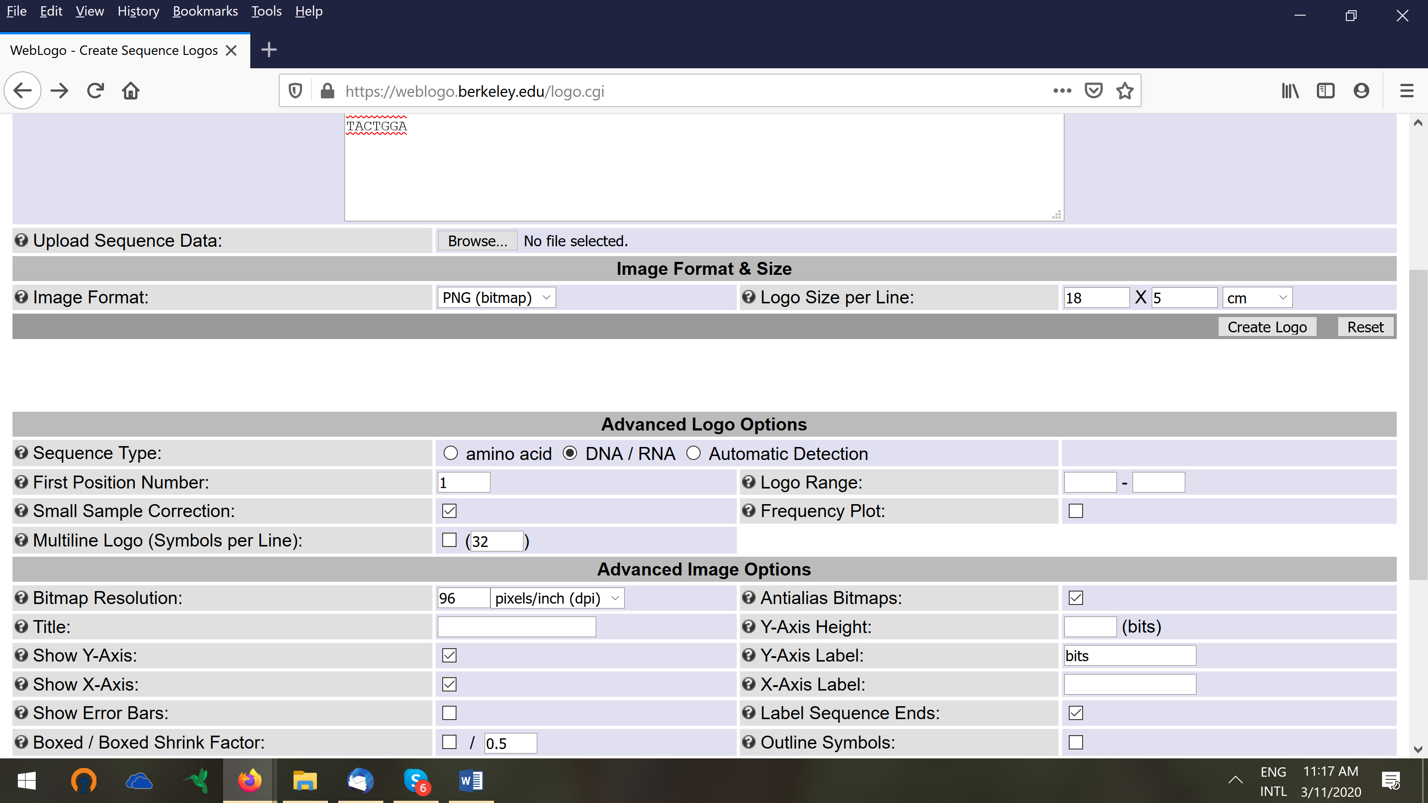

4. Retrieve the protein sequence AAD42764.1 at NCBI.

5. A simplified hidden Markov Model (HMM) is shown below. (Red square, match state; green diamond, insert state; purple circle, delete state).

a. Calculate the probability of the sequence TAG by following a path through the model starting at Begin, going through each of the three match states and ending at End. (slide 25-28, slides Part 2)

P(TAG, BM₁M₂M₃E) = a_{BM1} . e_{M1}(T) . a_{M1M2} . e_{M2}(A) . a_{M2M3} . e_{M3}(G) . a_{M3E}
=> log₂(0.7) + log₂(0.5) + log₂(0.7) + log₂(0.4) + log₂(0.7) + log₂(0.4) + log₂(0.9)
= -5.3396 of delogged (2^-5.3396)=0.024

b. Repeat step 1 for a path that, starting at Begin, goes first to the first insert state (green diamond), then to a match state (red square), then to a delete state (blue circle, probability 1 for any character in this state), then to a match state, and finishes at End.

P(TAG, BI₁M₁D₂M₃E) = a_{BI1} . e_{I1}(T) . aI_{1M1} . e_{M1(}A) . a_{M1D2} . a_{D2M3} . e_{M3}(G) . a_{M3E}
=> log₂(0.1) + log₂(0.25)+ log(1)+ log₂(0.1) + log₂(0.2) + log₂(1) + log₂(0.4) + log₂(0.9)
= 0.00018 of -12.4397 (log₂) -9.117787

c. Which of the two paths is the more probable one, and what is the ratio of the probability of the higher to the lower one? The highest-scoring path is the best alignment of the sequence with the model.
Path 1 is the more probable one, more than 137 times more likely than path 2
(0.0247/0.00018 = 137.2)

