*Francesca Gail P. Candelaria*

*AC192*

**Pseudocode and Flowcharts**

***Flowcharts***

* Its written program from the top of the page starting from the bottom. Commands are placed in each box where it has appropriate shape for it.

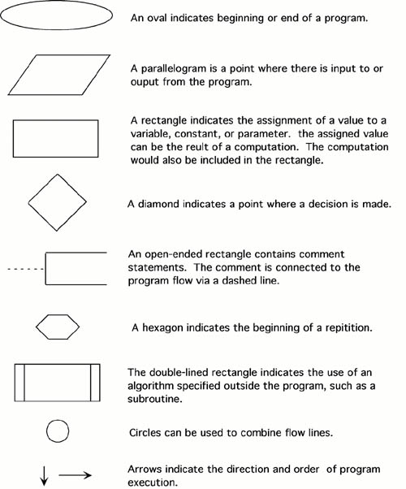\

**Use of Flowchart**

Its most important use is to depict through images on how it is performed from the beginning to the end in a consecutive order.

**When to use it?**

* To know the process of it for improvements. Also how to communicate with others on how it is done and in planning of creating a project.

**How it is used?**

First, elongated circles which signifies start of a process.

Second, rectangles that shows guide.

Third, diamonds where you can make your decision.

Fourth, parallelogram which input and output are shown which materials,services or people may be include.

***Pseudocode***

* It is a method of describing algorithms using the combination between programming language and the natural language.

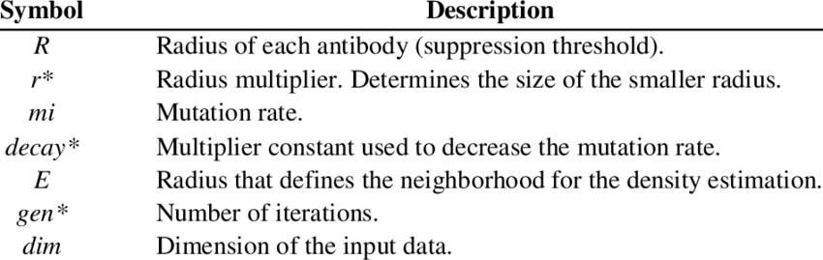

Some rules in writing pseudocode:

* The usual Fortran symobols are used for arithmetic operations (+, -, *, / , **).
* Symbolic names are used to indicate the quantities being processed.
* Certain Fortran keywords can be used, such as PRINT, WRITE, READ, etc.
* Indentation should be used to indicate branches and loops of instruction.

**Use of Pseudocode**

Because it is detailed it can be easily readable also programmers can check it to know if designs specifications are matched.

**Difference of Flowchart and Pseudocode**

**Flowchart** is a diagrammatic description of an algorithm while **Pseudocode**, on the other hand, is a textual representation of an algorithm. It lists out all the logical functions an algorithm will do including the input and the output of the program.

References:

Sampson Quain - <https://smallbusiness.chron.com/use-flowchart-43367.html>

Margaret Rouse-Simon Smith-Margaret Rouse-Margaret Rouse - <https://whatis.techtarget.com/definition/pseudocode>