Create project workspace
PS ISE run
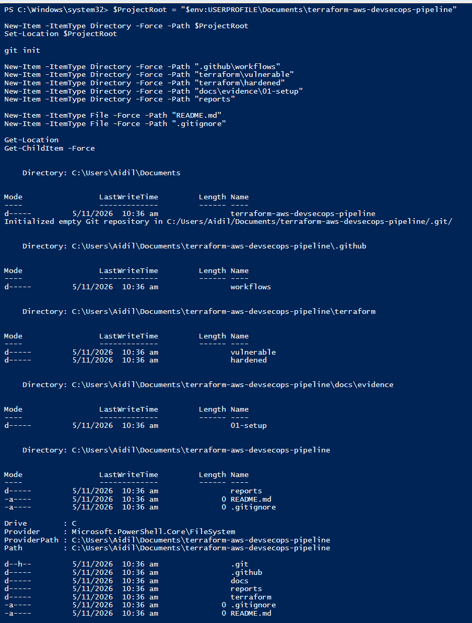
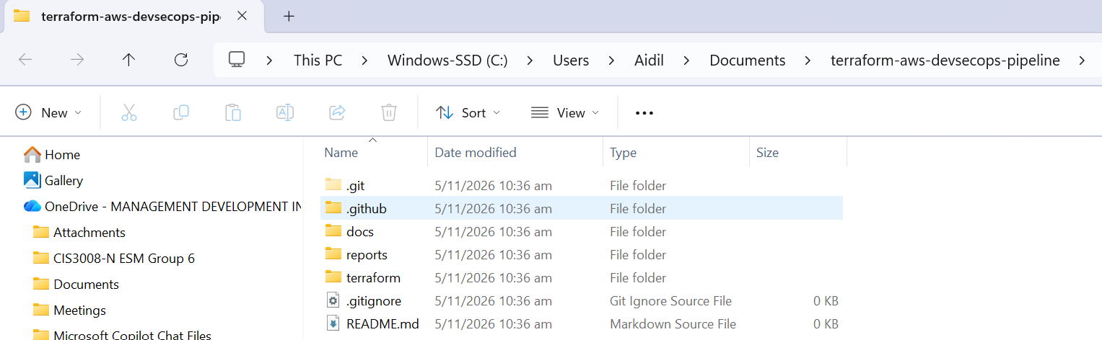
Open project in VS Code
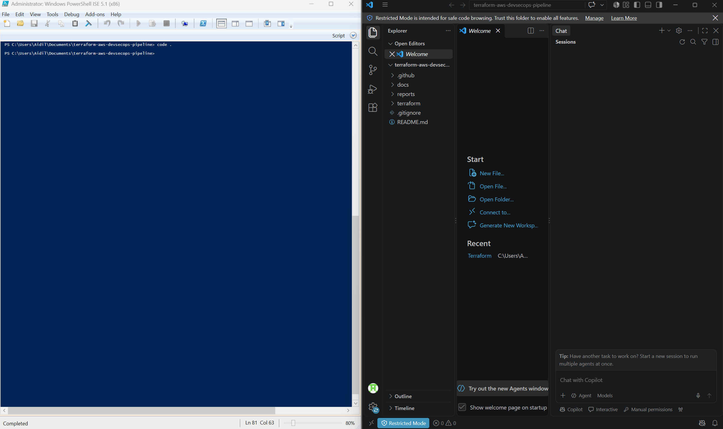
Configure .gitignore
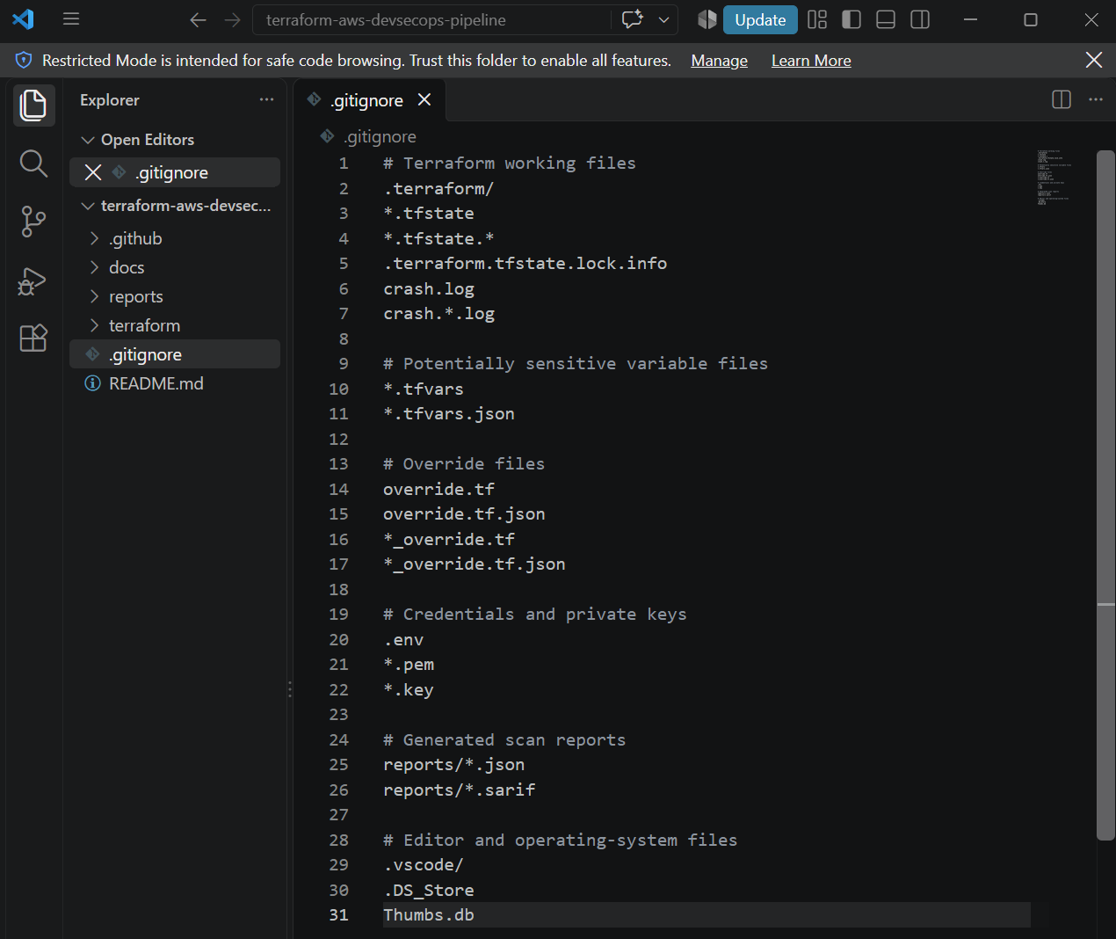
Validate project directory
Since there are no Terraform files yet, both scanners should report no detected infrastructure configurations. That is expected.
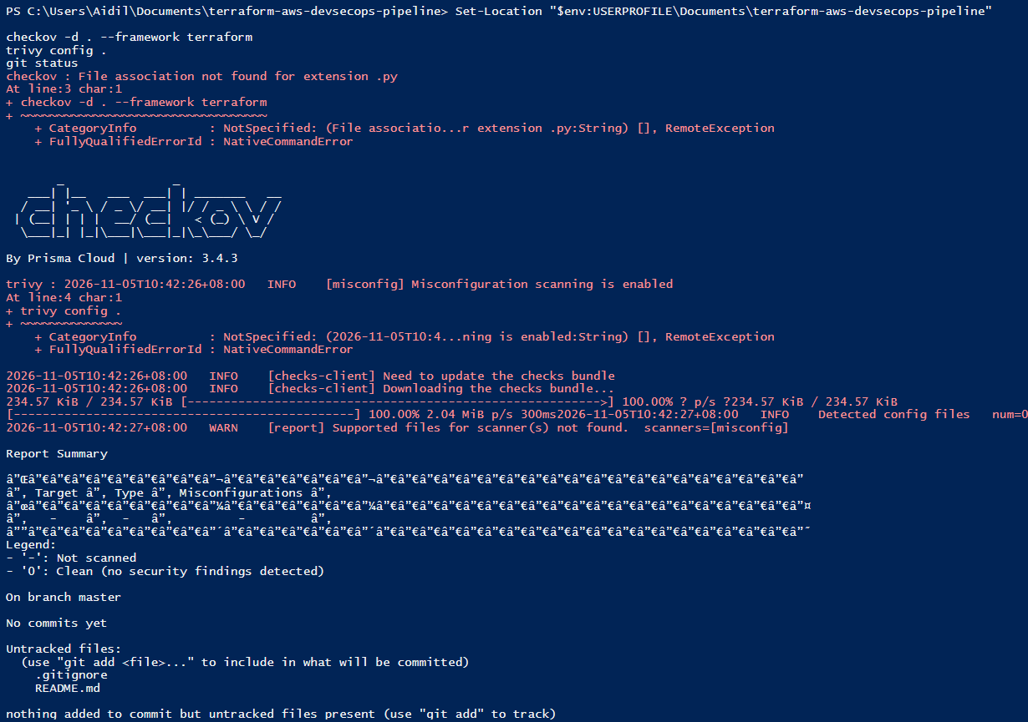
Complete Git Setup
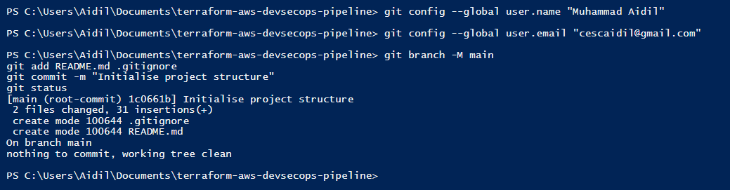

Create the proposed baseline AWS archi

Set-Location "$env:USERPROFILE\Documents\terraform-aws-devsecops-pipeline"
New-Item -ItemType Directory -Force -Path "terraform\baseline"
New-Item -ItemType File -Force -Path "terraform\baseline\versions.tf"
New-Item -ItemType File -Force -Path "terraform\baseline\providers.tf"
New-Item -ItemType File -Force -Path "terraform\baseline\variables.tf"
New-Item -ItemType File -Force -Path "terraform\baseline\network.tf"
New-Item -ItemType File -Force -Path "terraform\baseline\compute.tf"
New-Item -ItemType File -Force -Path "terraform\baseline\storage.tf"
New-Item -ItemType File -Force -Path "terraform\baseline\outputs.tf"
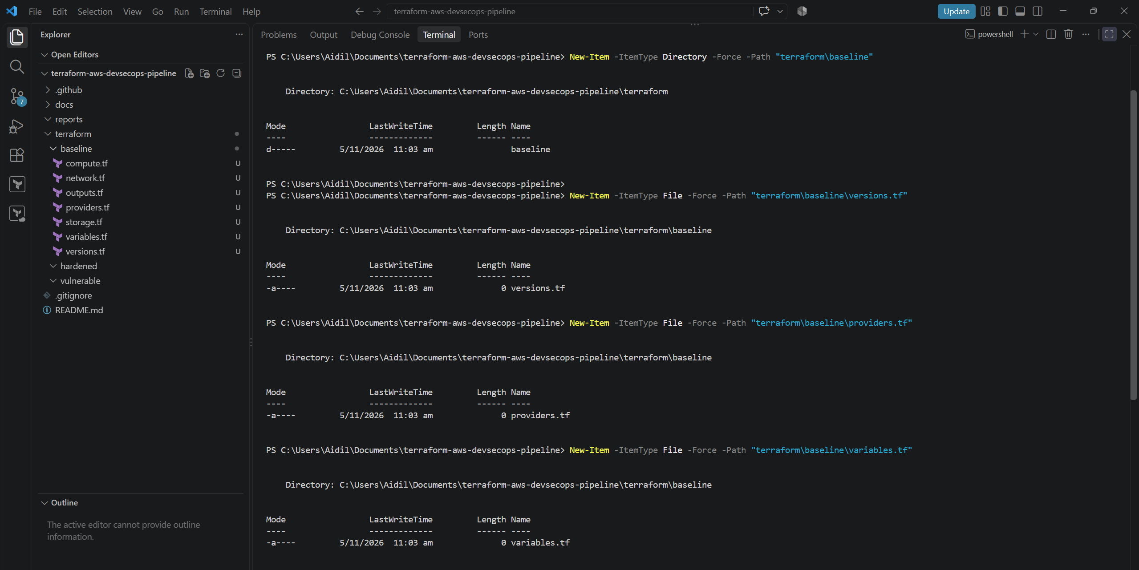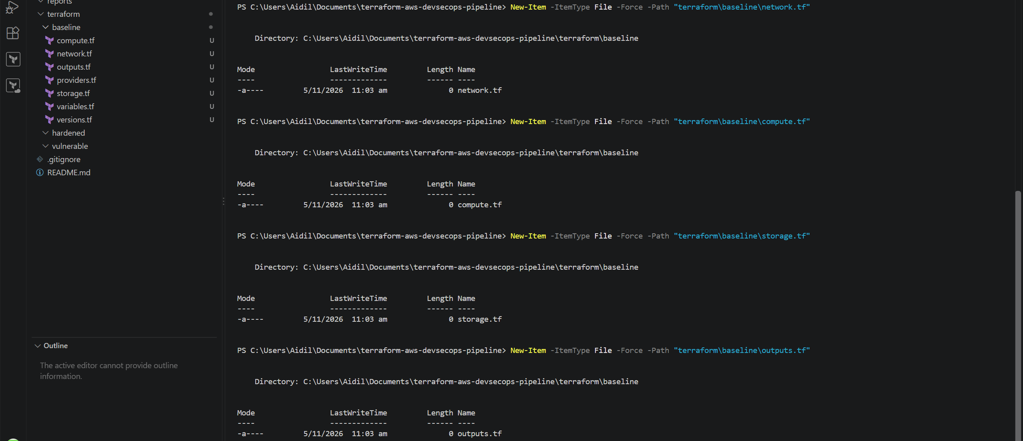
Configure terraform config files
This specifies:
- Terraform 1.16 or newer
- AWS provider version 6.x
- No automatic upgrade to Terraform 2.x

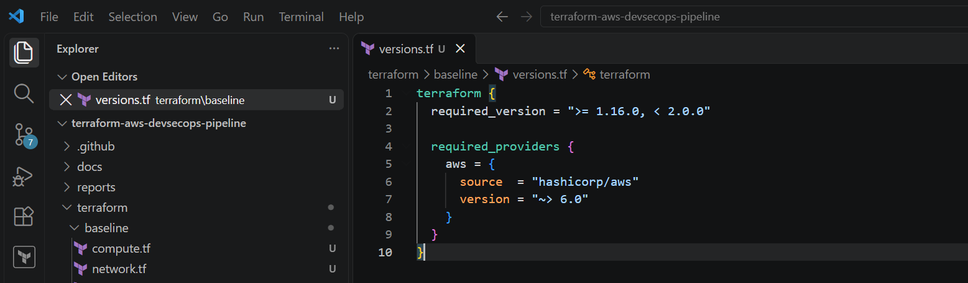
The AMI value will not create an instance. Before any optional deployment, we will verify whether that AMI remains available in Singapore.
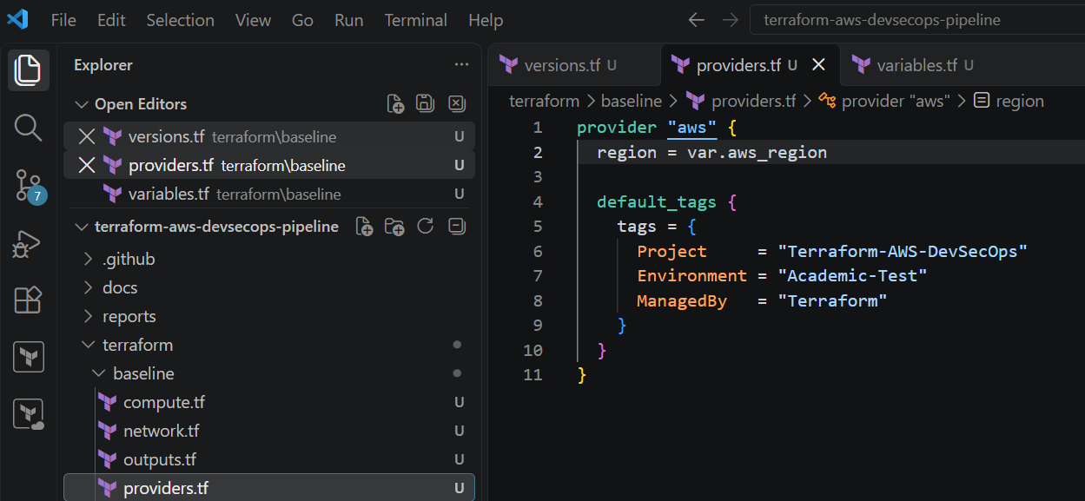

This configures AWS Singapore as the region through a variable and applies standard identification tags to supported resources.
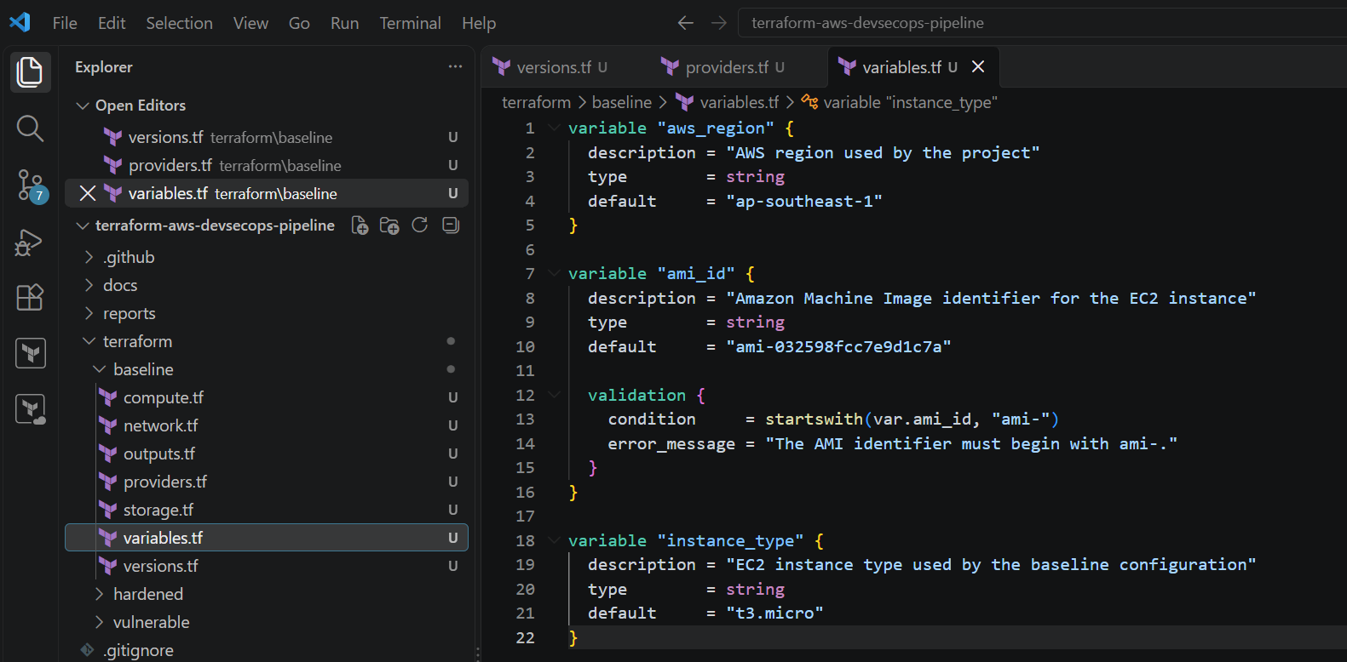

What this configuration defines
- VPC: An isolated AWS network using 10.10.0.0/16.
- Private subnet: Uses 10.10.1.0/24.
- Public IP assignment: Disabled.
- Inbound traffic: No inbound rules are configured.
- Outbound traffic: Restricted to HTTPS on TCP port 443.
- Region/AZ: Singapore, Availability Zone ap-southeast-1a.

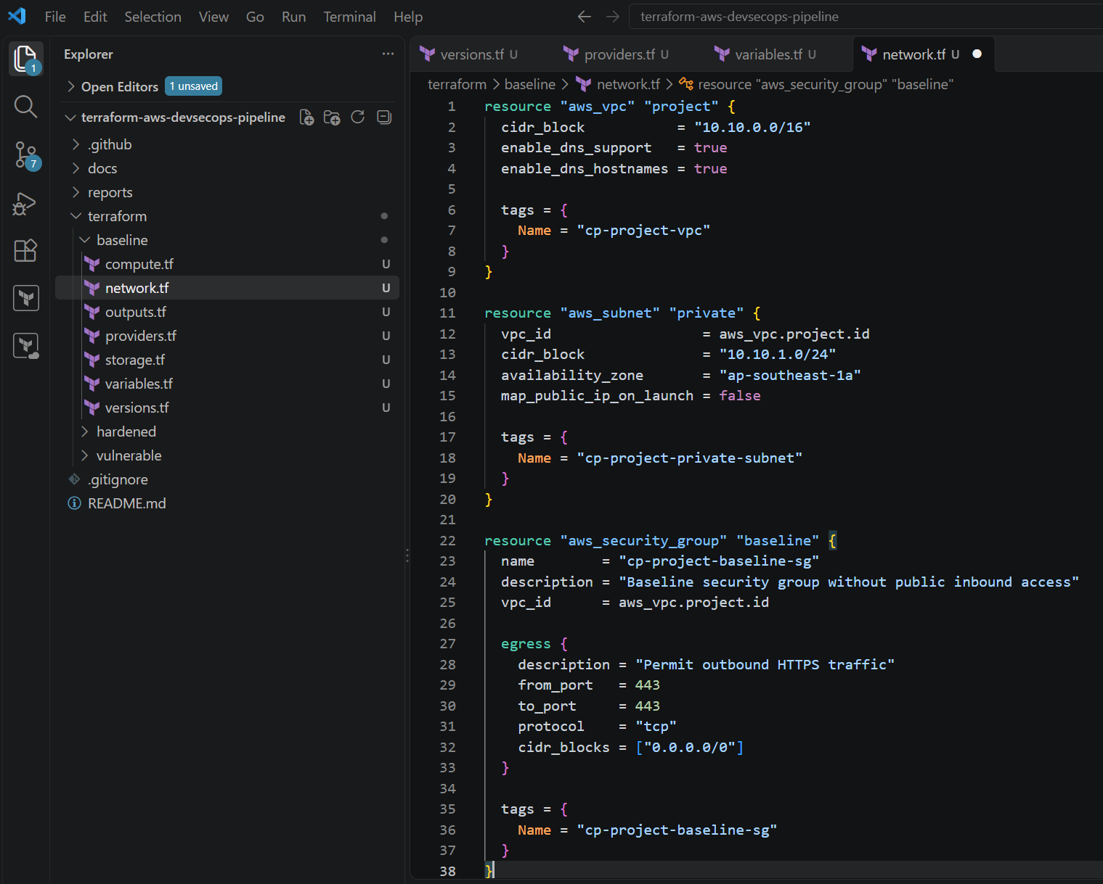
Format and verify configuration in terminal
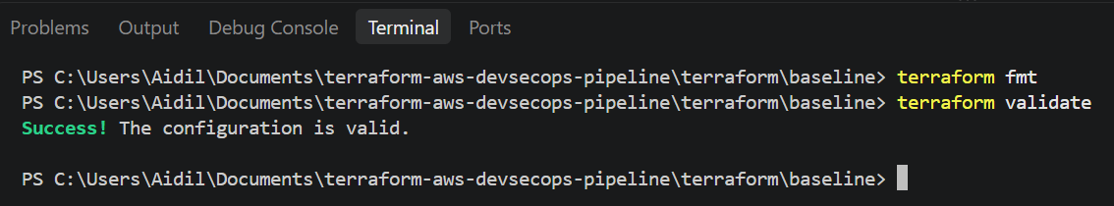
Security controls included
Configuration | Purpose
associate_public_ip_address = false | Prevents direct public internet exposure
vpc_security_group_ids | Associates the restricted security group
ebs_optimized = true | Uses optimised EBS connectivity
monitoring = true | Enables detailed EC2 monitoring
http_tokens = "required" | Enforces IMDSv2
http_put_response_hop_limit = 1 | Restricts metadata-service forwarding
encrypted = true | Encrypts the EC2 root volume
volume_type = "gp3" | Uses the current general-purpose EBS volume type
delete_on_termination = true | Prevents an unused volume remaining after termination

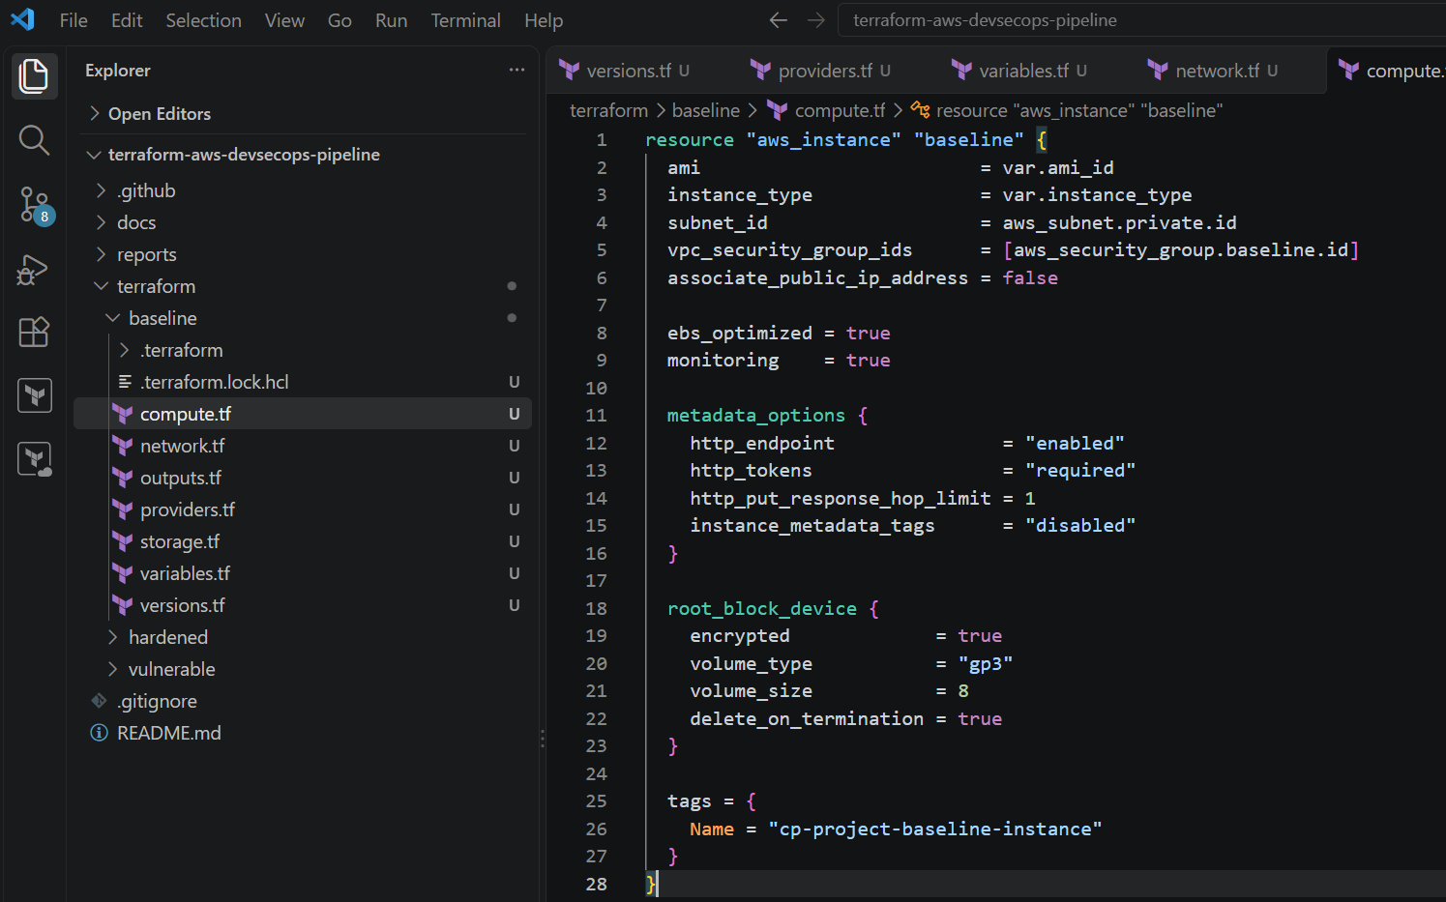
Format and verify configuration in terminal
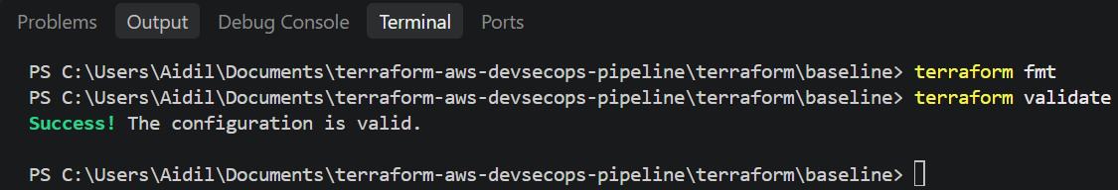

Controls included
Control | Purpose
Public access block | Prevents public ACLs and bucket policies
Bucket-owner enforcement | Disables ACL-based ownership complications
AES-256 encryption | Encrypts stored objects without a separate paid KMS key
Versioning | Protects against accidental overwriting and deletion
Lifecycle rule | Removes incomplete uploads and old versions
force_destroy = false | Prevents Terraform from deleting a non-empty bucket automatically

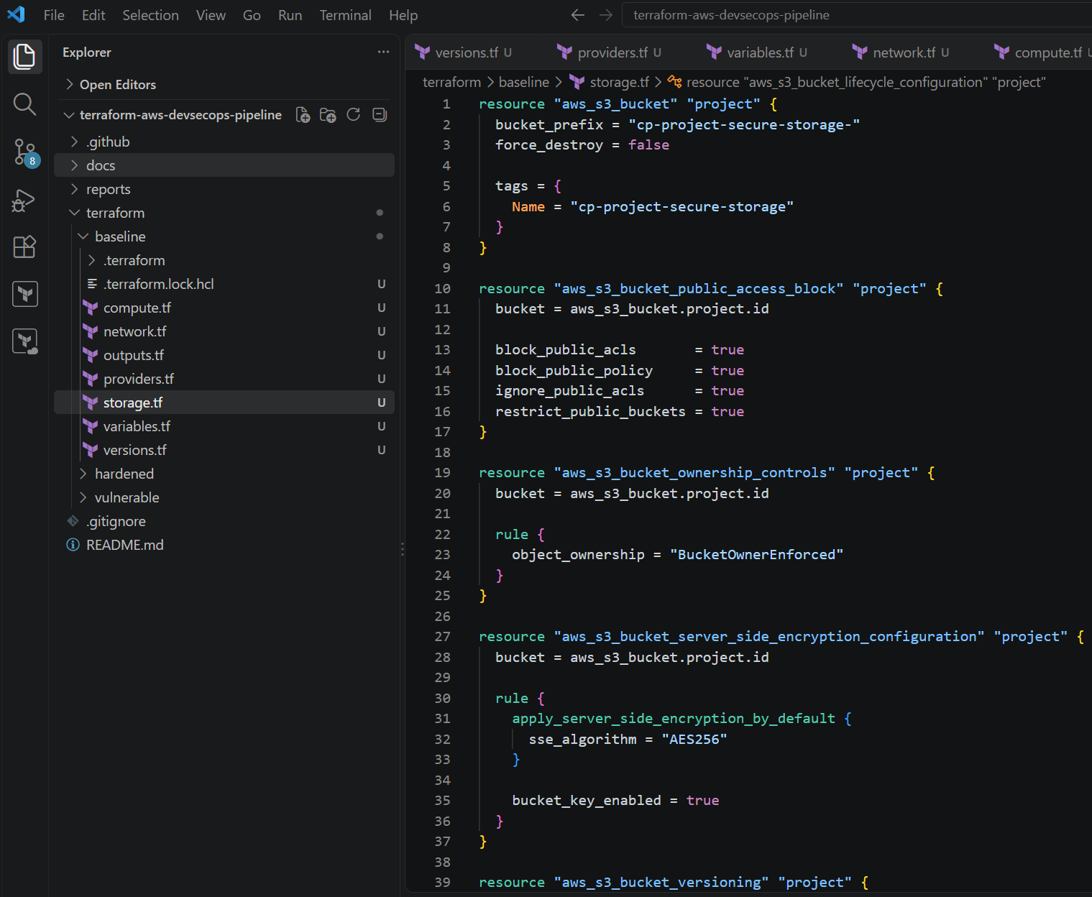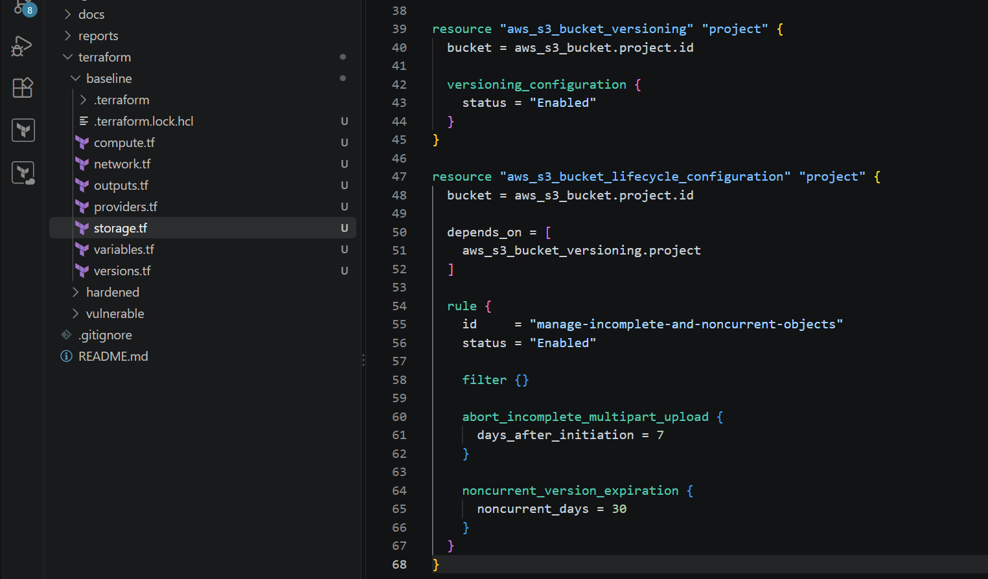
Format and validate
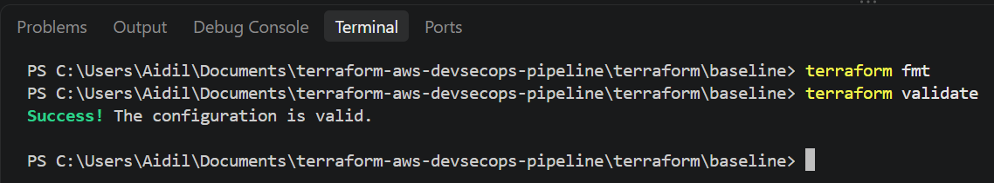
These outputs would display resource identifiers after deployment. They do not deploy or expose credentials.
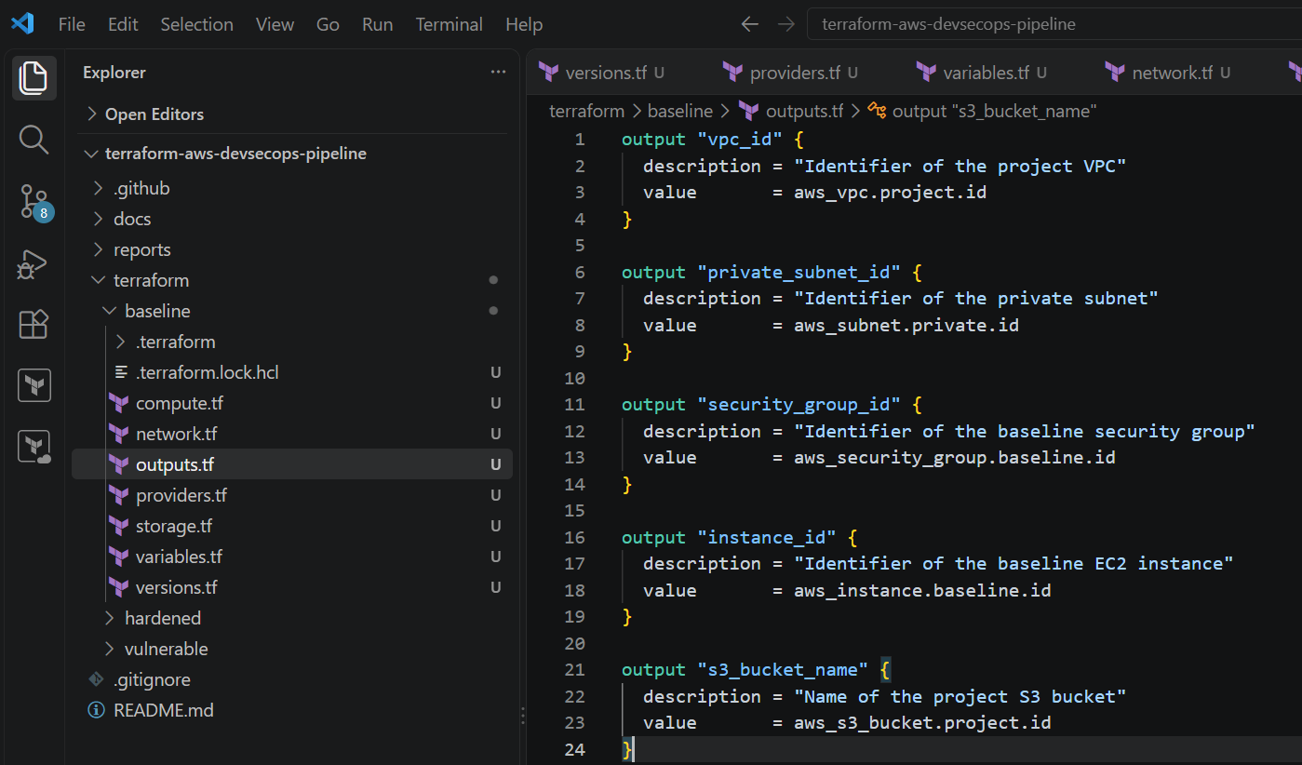

Complete
baseline validation


