Required tools
Terraform
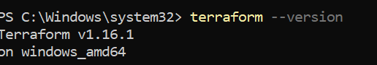
Git
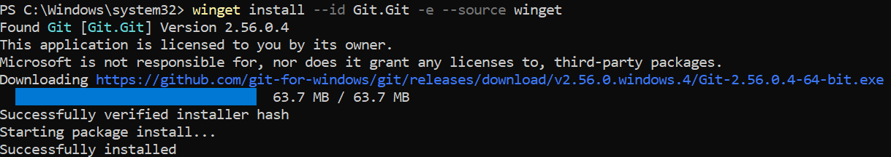
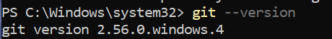
Python
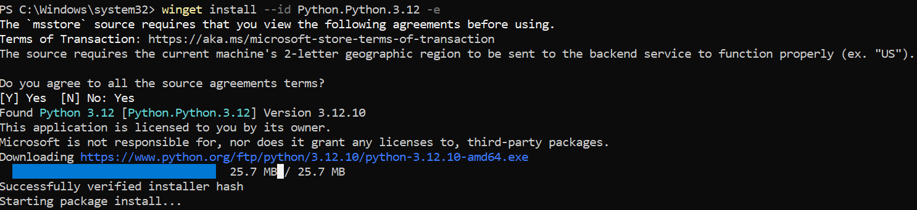
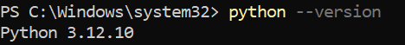
Pip
Aws
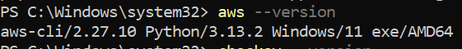
Checkov
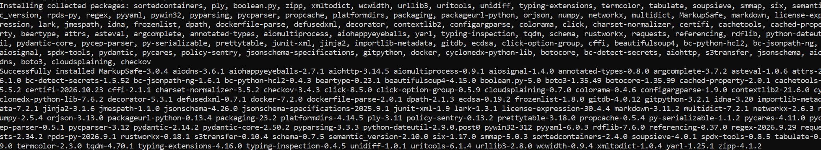
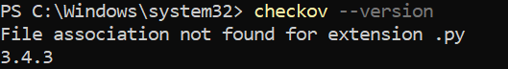
Trivy
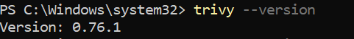
Code


