Remediation
Preserve Before baseline
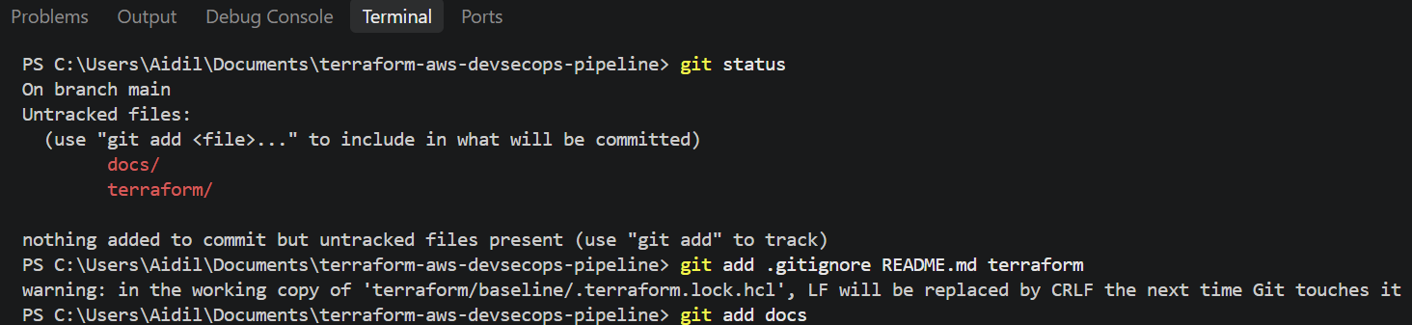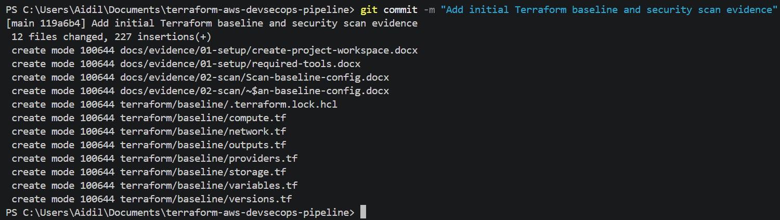

Restrict unrestricted outbound traffic — Trivy AWS-0104
Change the existing egress rule
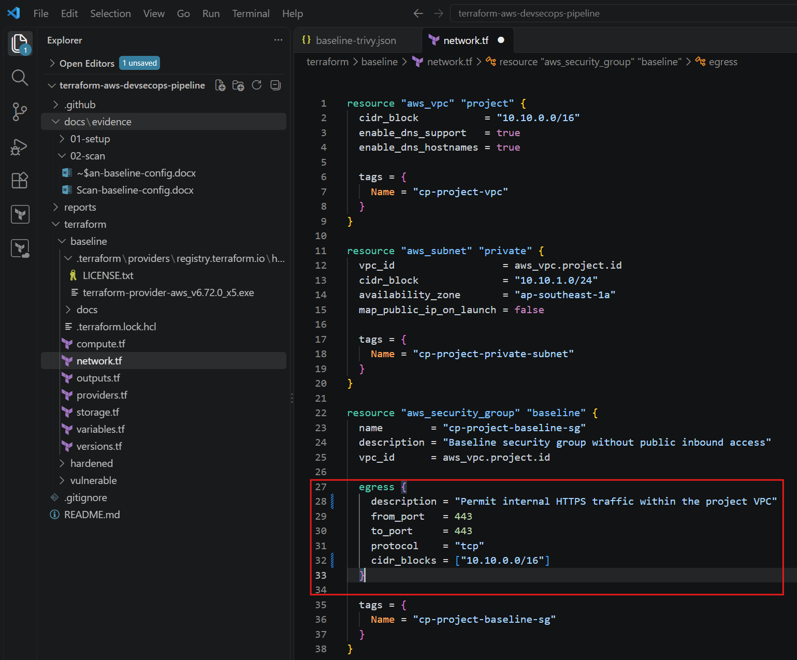
Restrict the default VPC security group — Checkov CKV2_AWS_12
Add the restricted default security group
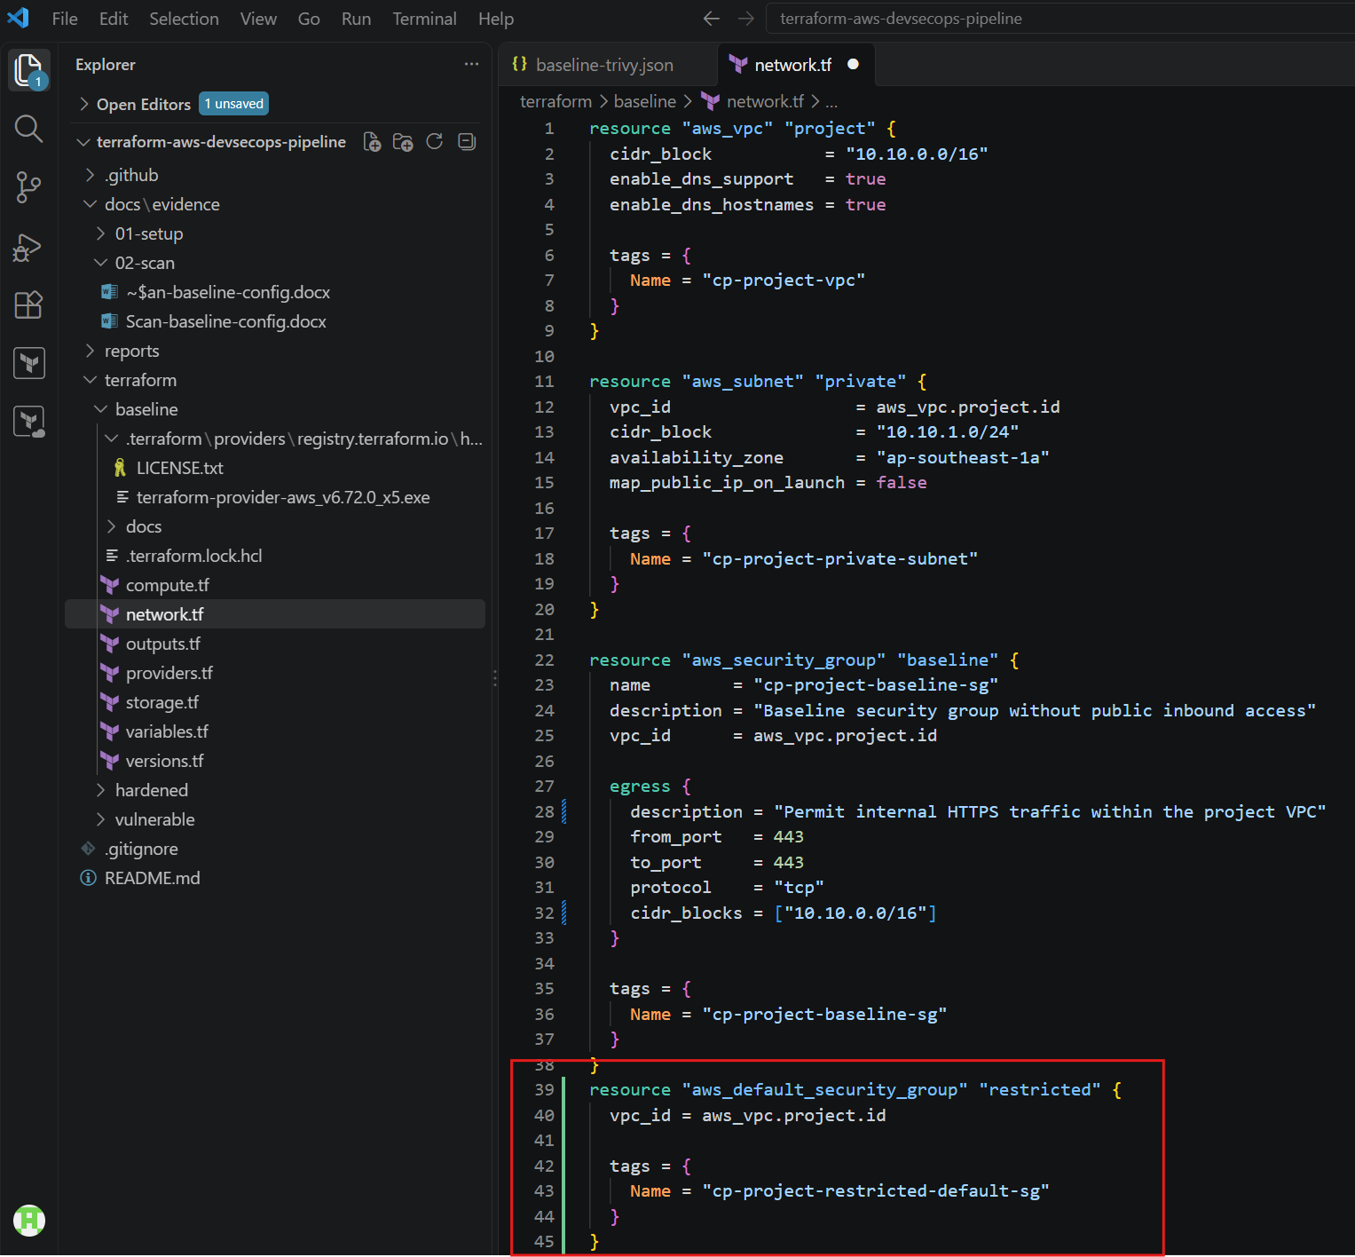
Validate
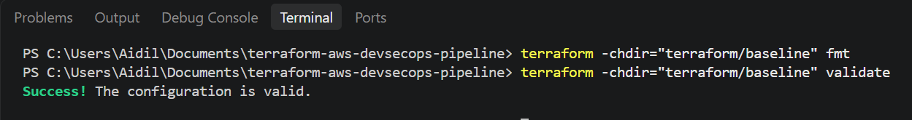
Attach an IAM role to EC2 — Checkov CKV2_AWS_41
Create identity.tf
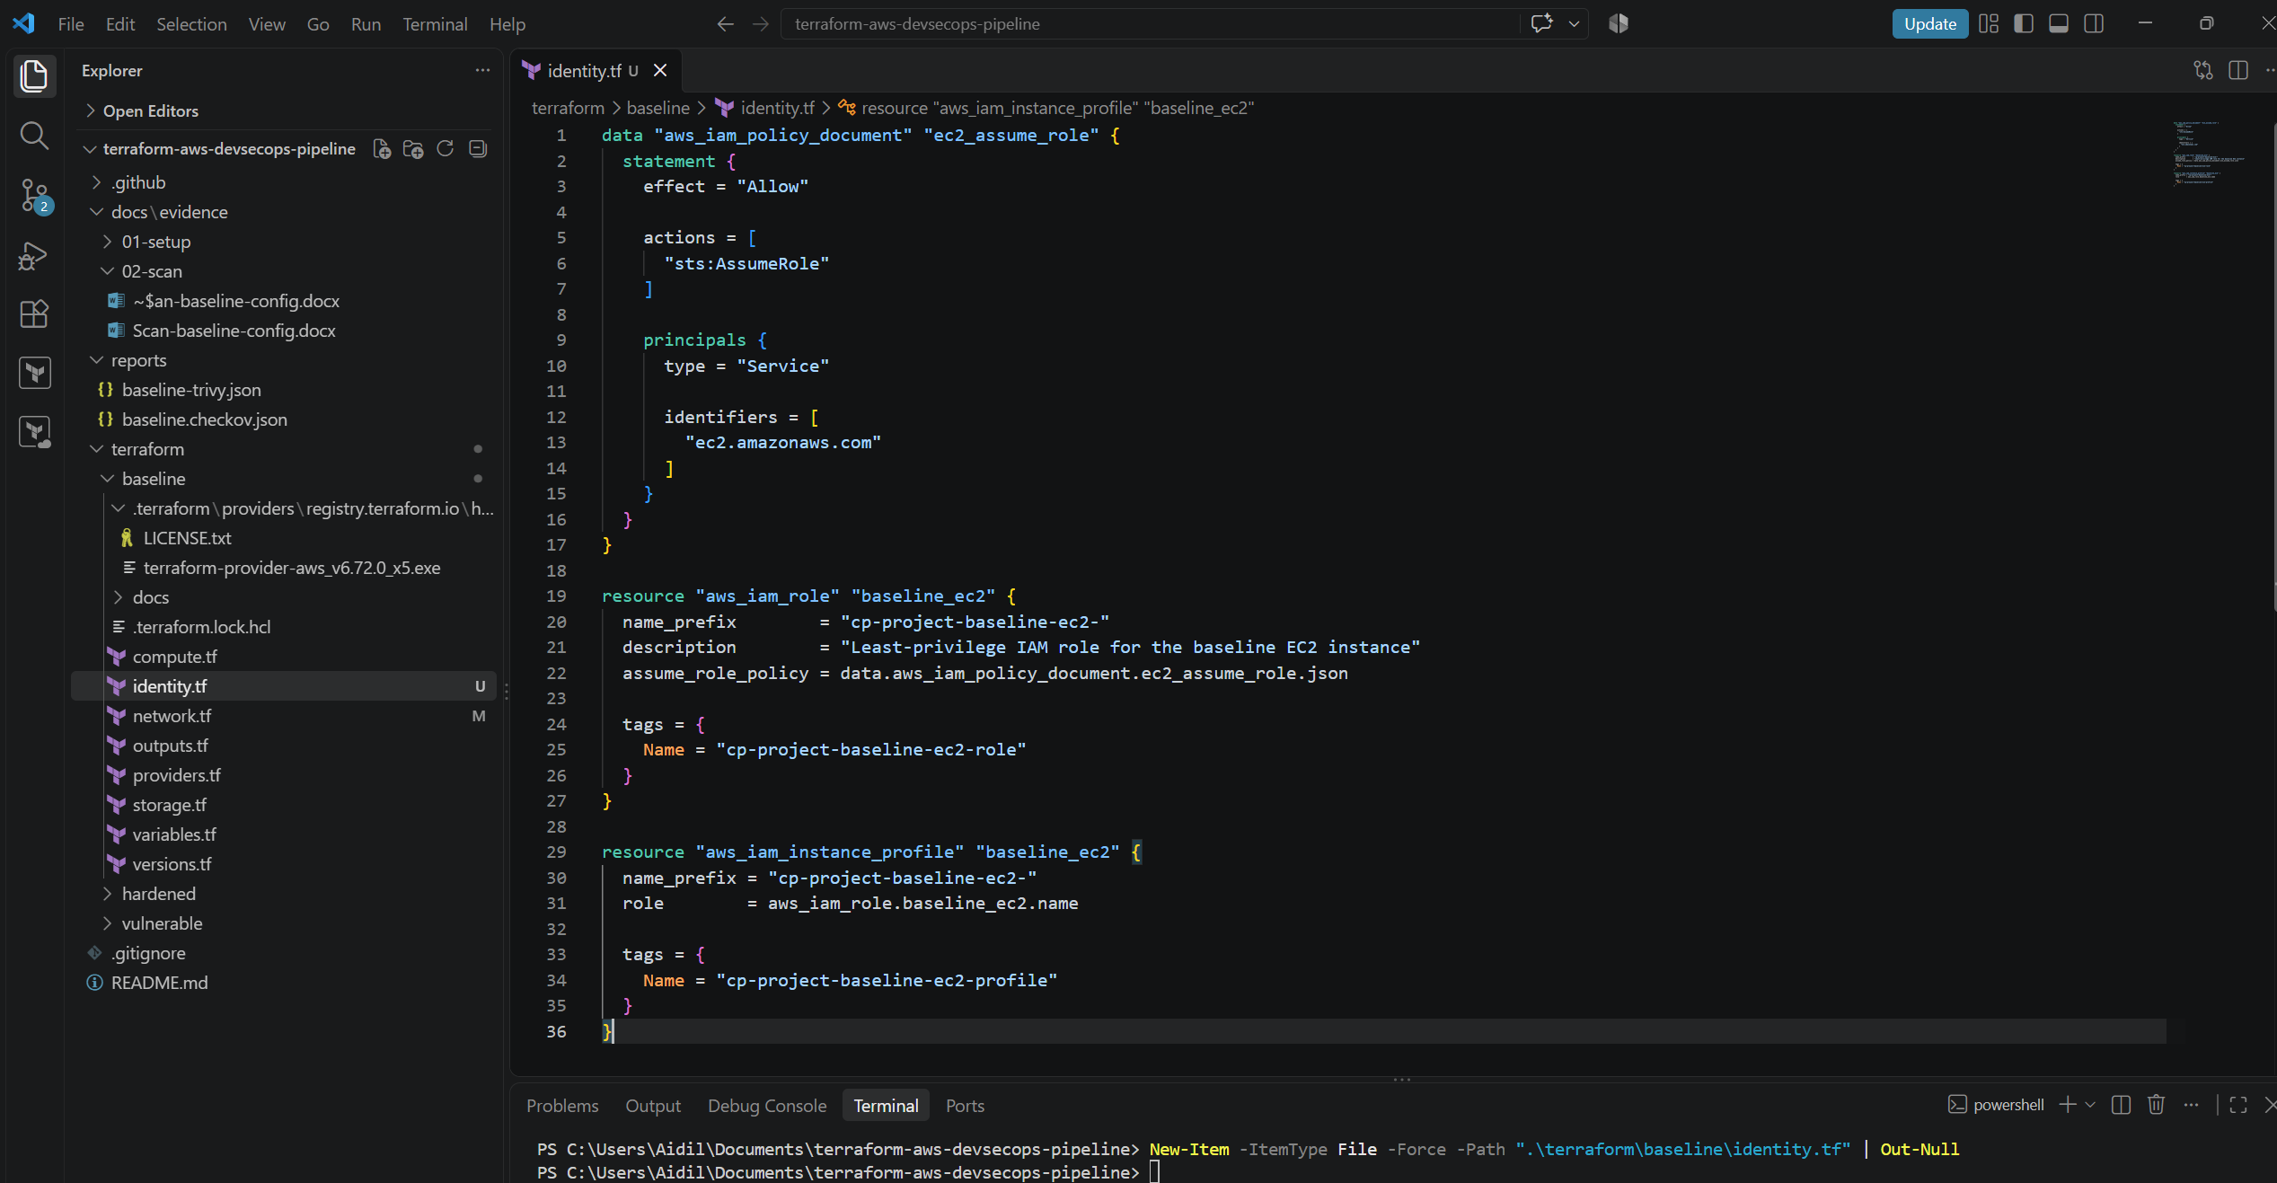
Amend compute.tf
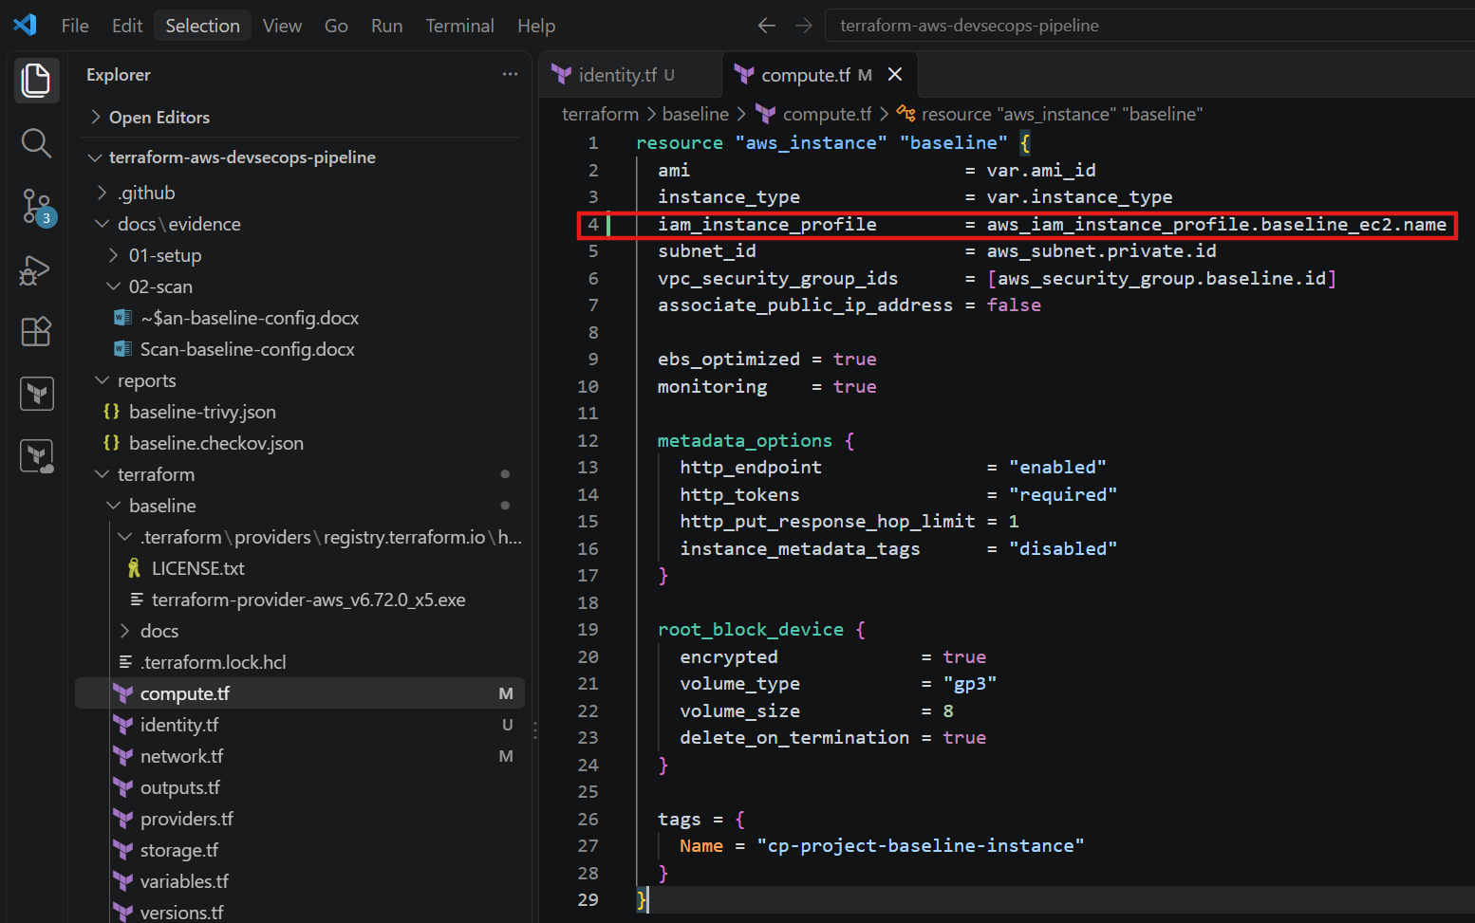
Validate


