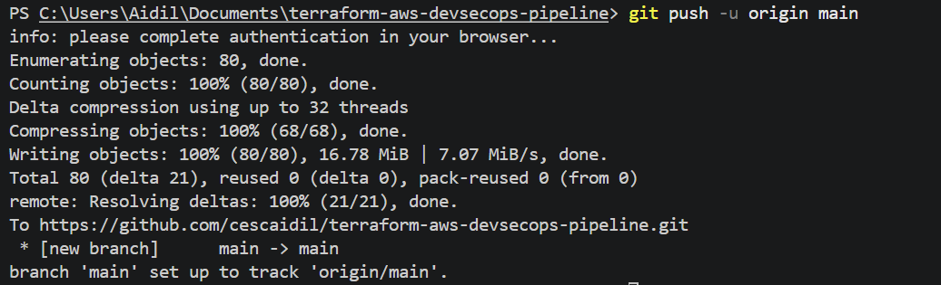
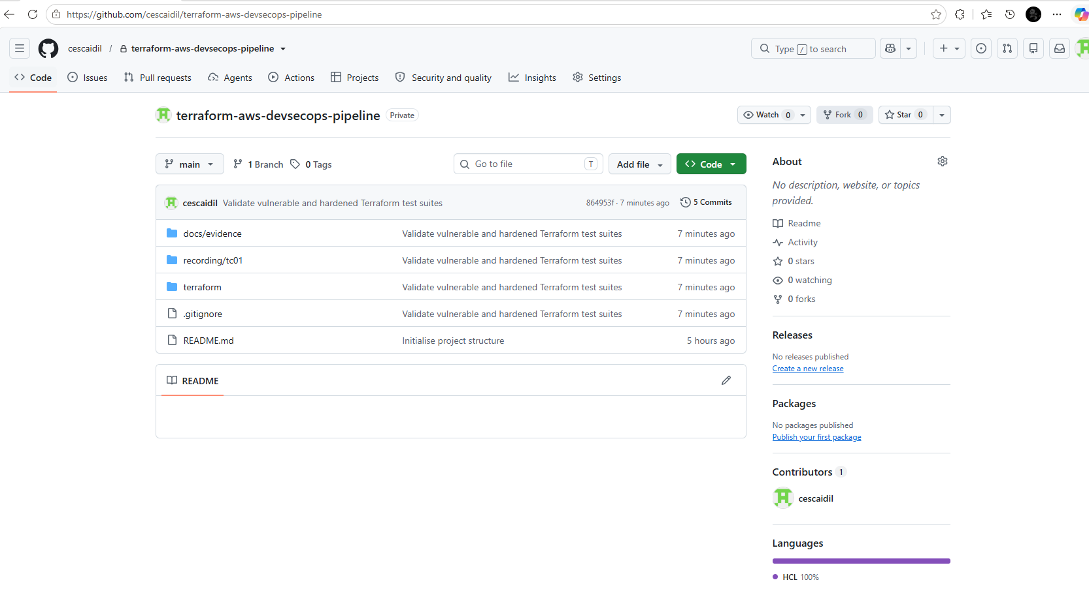
CI Stage 1 — Terraform validation
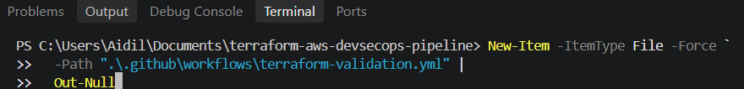
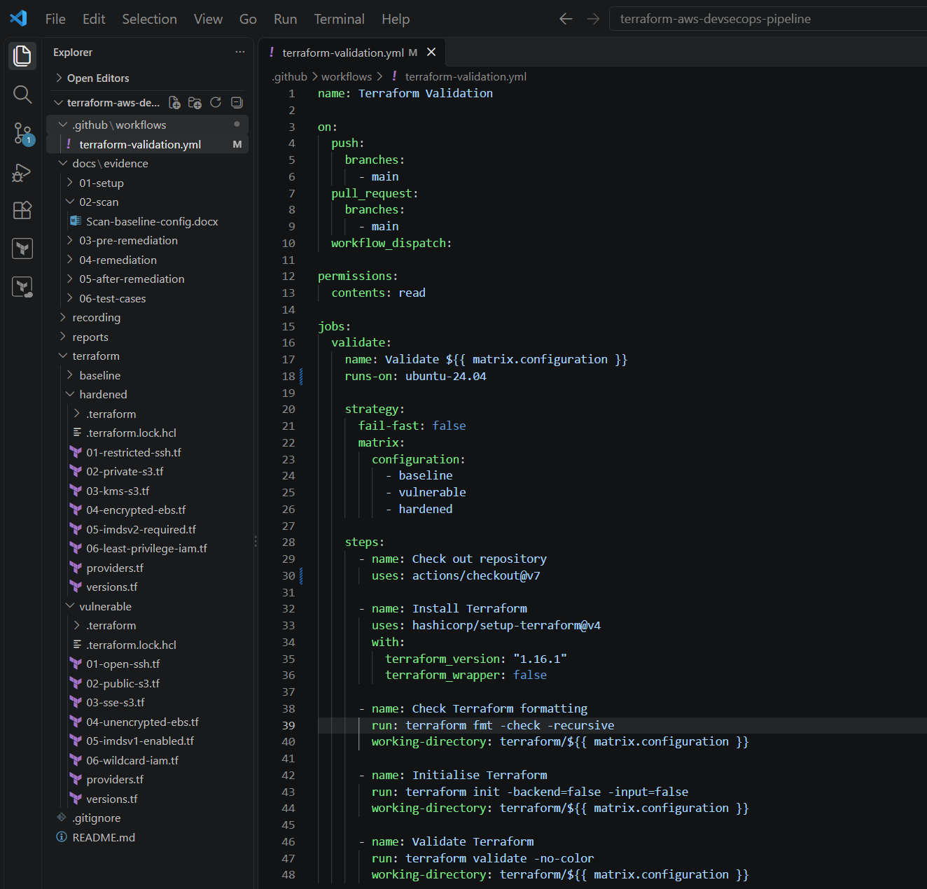
Validate locally and commit/push
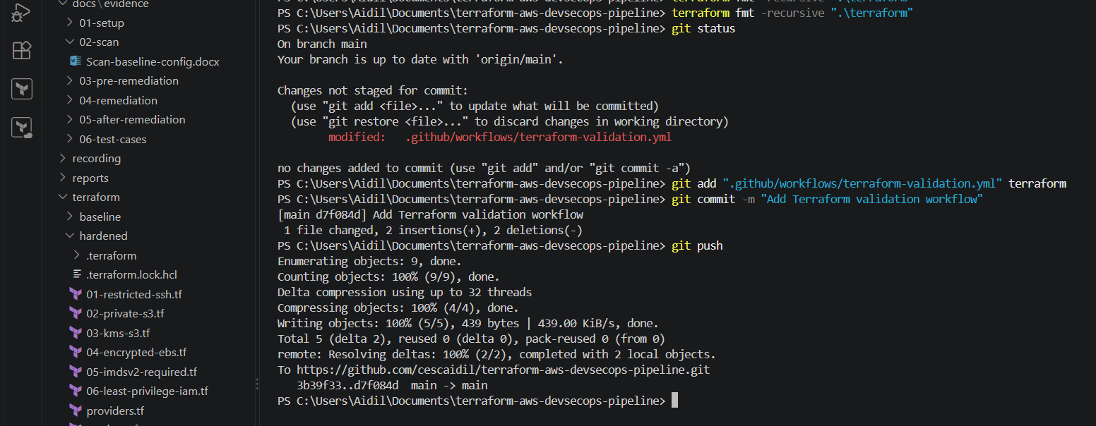
Github Actions
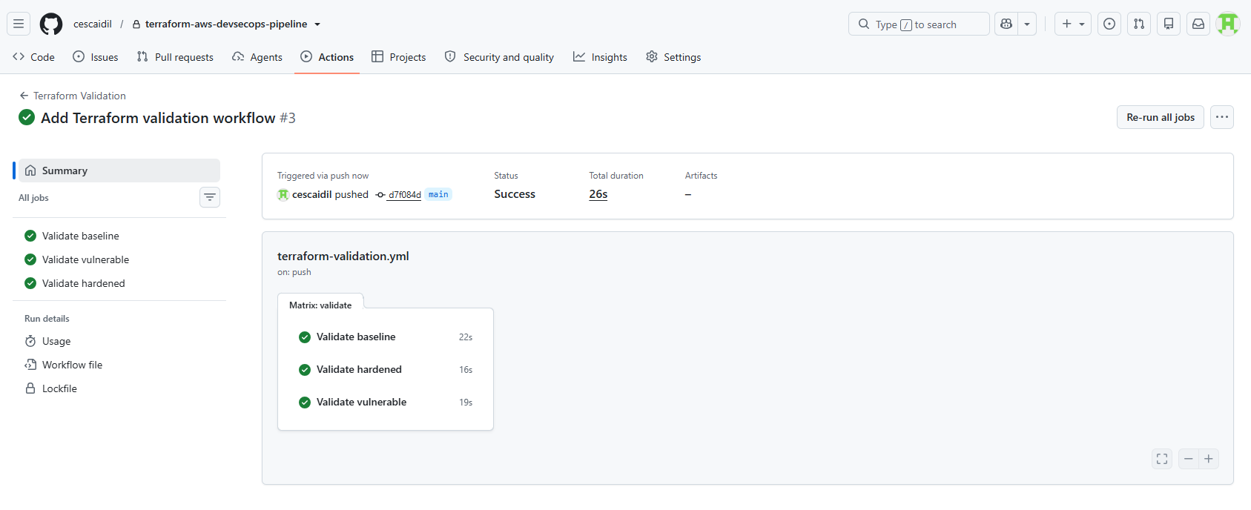
CI Stage 2 — Checkov security gate
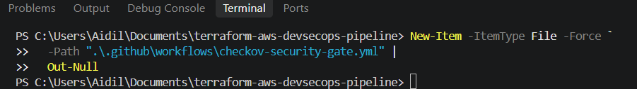
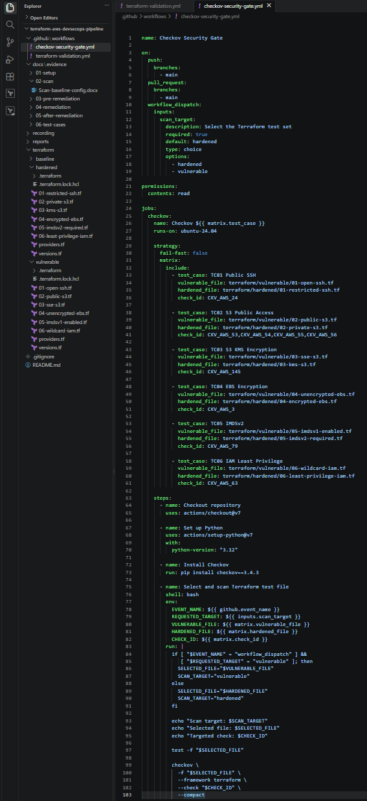
Commit and push
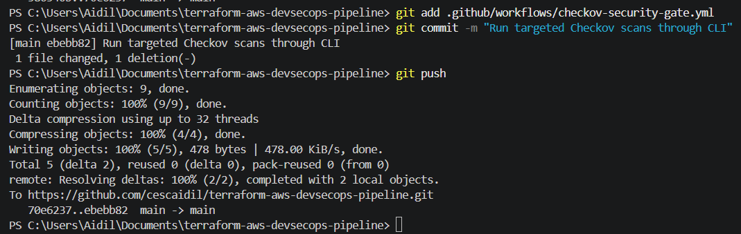
Captured evidence - hardened
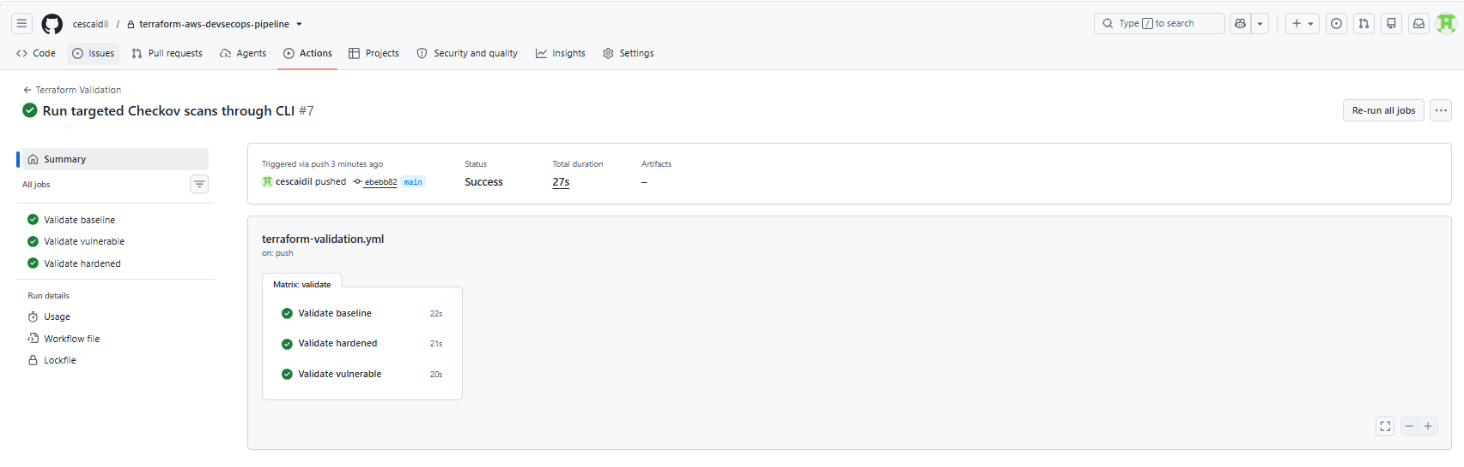
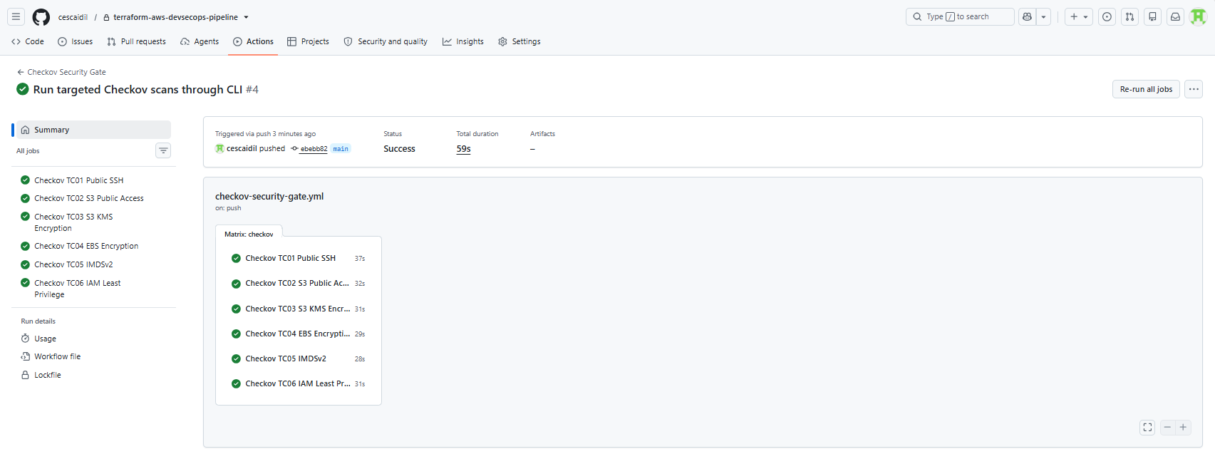
Run manual vulnerable workflow in GitHub Actions
Checkov found the selected misconfiguration and returned: Exit code 1
GitHub Actions therefore marked the job and workflow red meaning the insecure Terraform configuration was successfully blocked.
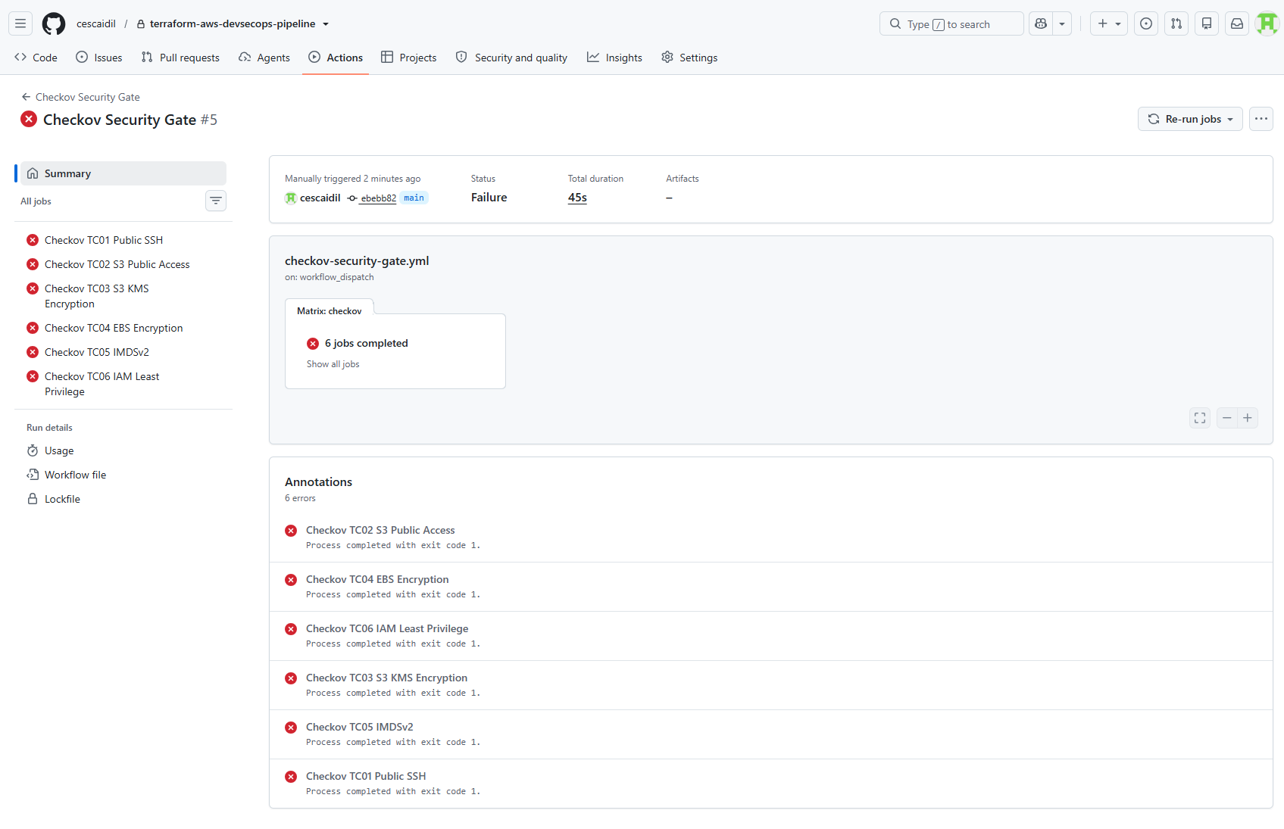
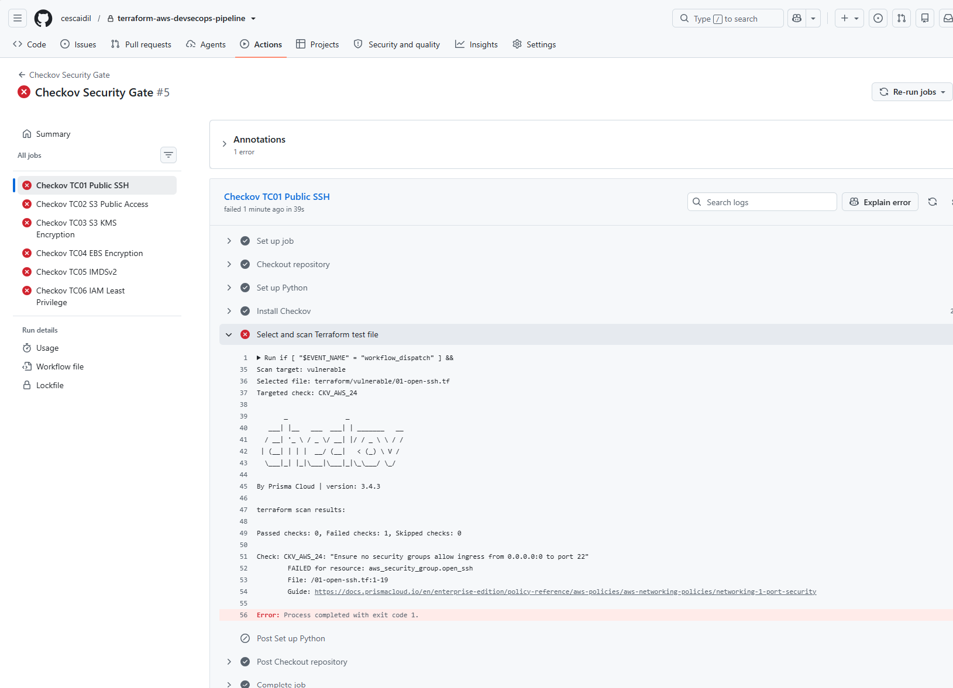
CI Stage 2 — Trivy security gate 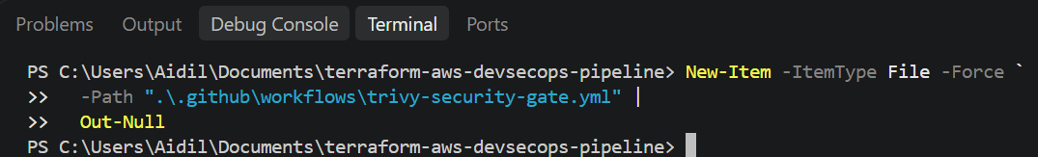
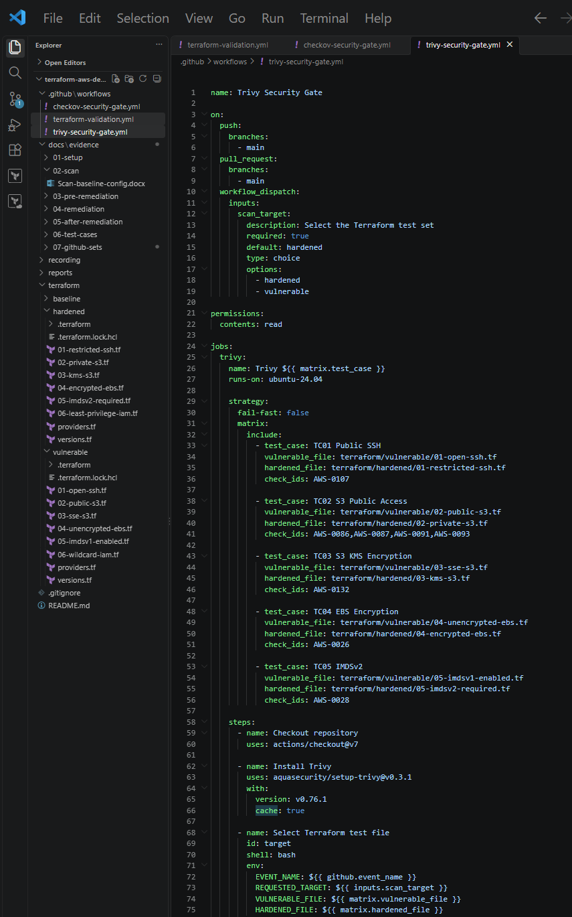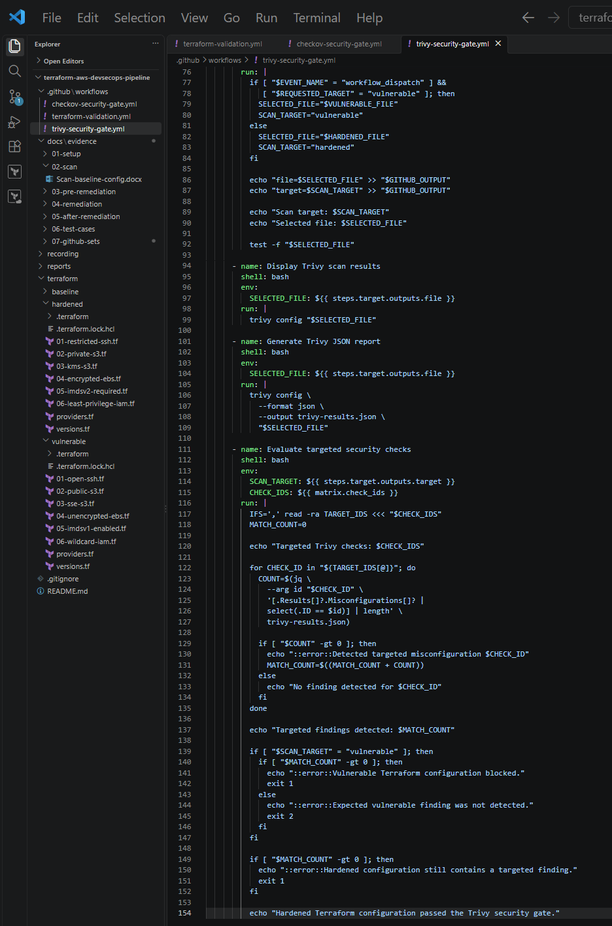
Commit and push
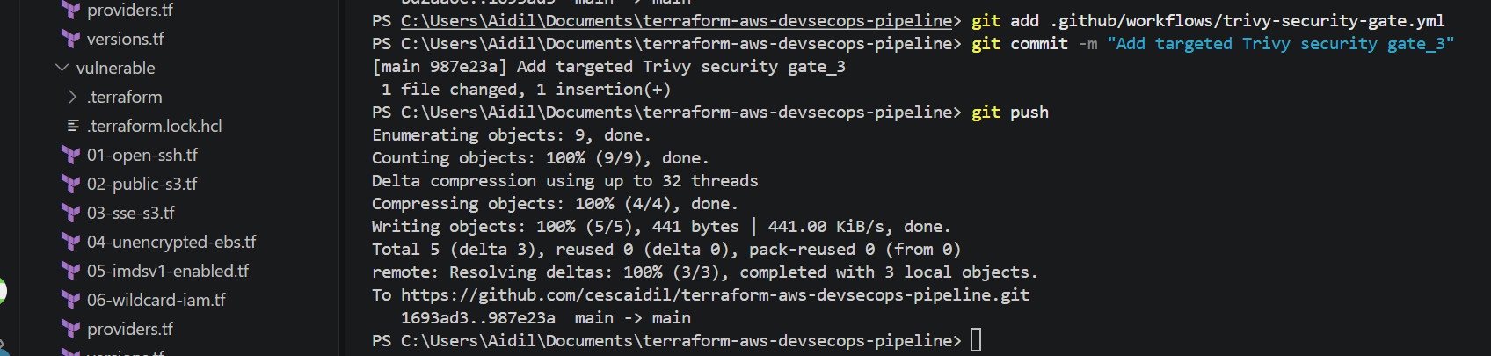
Captured evidence - hardened
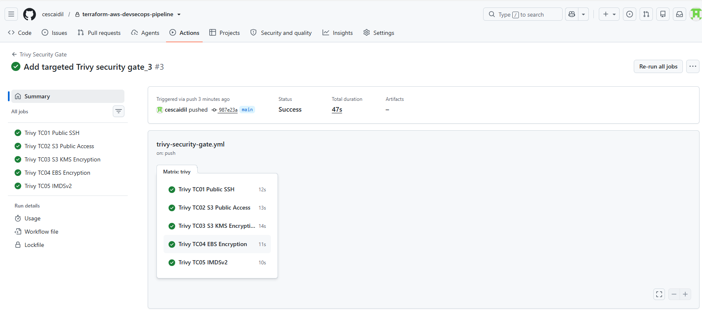
Run manual vulnerable workflow in GitHub Actions
Trivy identifies the findings, and each job ends with failure indicating of insecure configuration was blocked


