Classification test
This program evaluates the classifier by using the same function for taking samples of an image of a fixed size and evaluating the features vector
Carlos Emiliano Solórzano Espíndola- carlosemiliano04@gmail.com
ETSEIB-UPC

Initialization
Here the program clears all before running the program, also loads the previous programed classifier.
clc, close all, clear all
load('classif2.mat');

First image for classification
Loads the images and evaluates the car2() function in 20 samples of every image which will be the feature vector of 100*1 size , also displays the averaged feature vector for the samples.
im1='D101.gif';
car4=zeros(120,50);
for i=1:20
car4(i,:)=car2(im1);
close all
end
figure,subplot(121),imshow(imread(im1))
subplot(122),bar(mean(car4(1:20,:)))

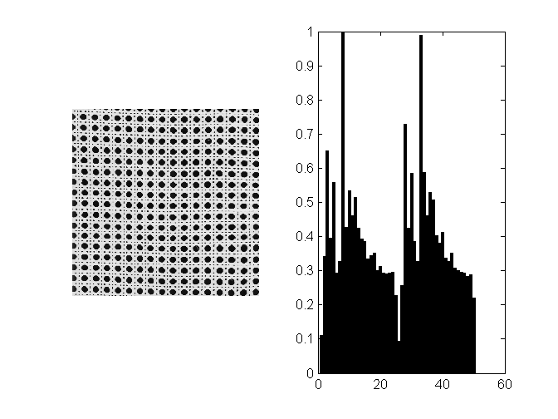

Second image for classification
im1='D1.gif';
for i=1:20
car4(i+20,:)=car2(im1);
close all
end
figure,subplot(121),imshow(imread(im1))
subplot(122),bar(mean(car4(21:40,:)))
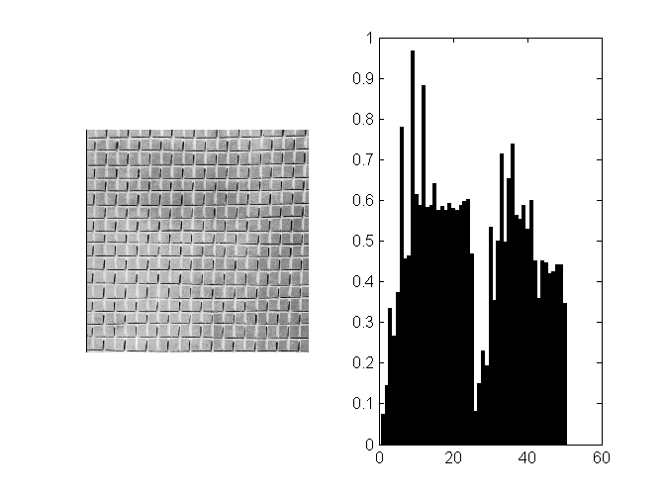

Third image for classification
im1='D52.gif';
for i=1:20
car4(i+40,:)=car2(im1);
close all
end
figure,subplot(121),imshow(imread(im1))
subplot(122),bar(mean(car4(41:60,:)))
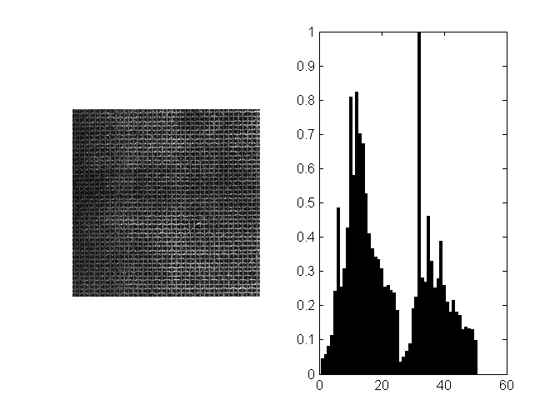

Fourth image for classification
im1='D49.gif';
for i=1:20
car4(i+60,:)=car2(im1);
close all
end
figure,subplot(121),imshow(imread(im1))
subplot(122),bar(mean(car4(61:80,:)))
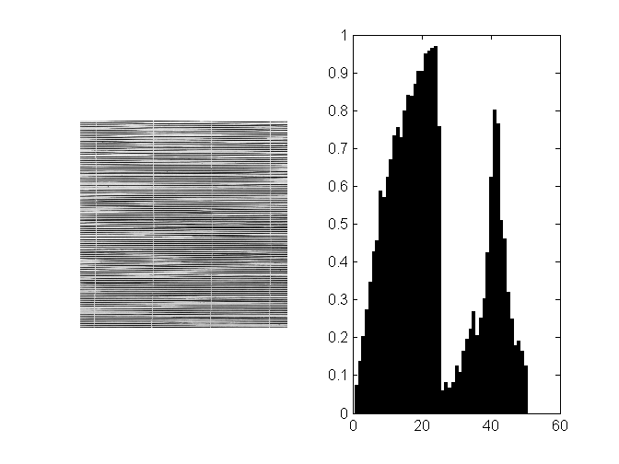

Fifth image for classification
im1='D20.gif';
for i=1:20
car4(i+80,:)=car2(im1);
close all
end
figure,subplot(121),imshow(imread(im1))
subplot(122),bar(mean(car4(81:100,:)))
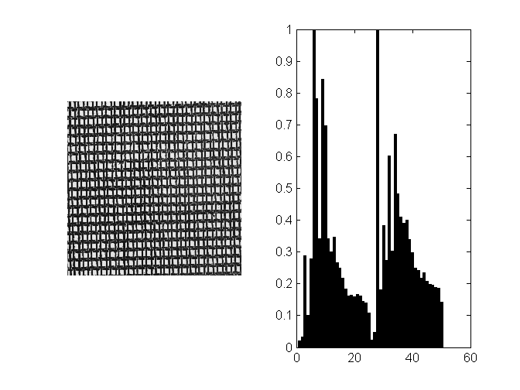

Sixth image for classification
im1='D3.gif';
for i=1:20
car4(i+100,:)=car2(im1);
close all
end
figure,subplot(121),imshow(imread(im1))
subplot(122),bar(mean(car4(101:120,:)))
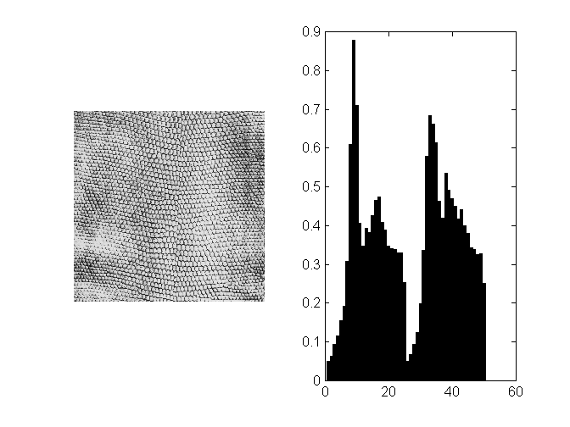

Mahalanobis distance to classes

Here the program evaluates the Mahalanobis distance for each observation to each class
dist=zeros(120,6);
for i=1:120
dist(i,:)=mahal(X,car4(i,:));
end
figure(3), subplot(321),bar(dist(:,1)),title('Distance to class 1 [1,20]')
subplot(322),bar(dist(:,2)),title('Distance to class 2 [21,40]')
subplot(323),bar(dist(:,3)),title('Distance to class 3 [41,60]')
subplot(324),bar(dist(:,4)),title('Distance to class 4 [61,80]')
subplot(325),bar(dist(:,5)),title('Distance to class 5 [81,100]')
subplot(326),bar(dist(:,6)),title('Distance to class 6 [101,120]')
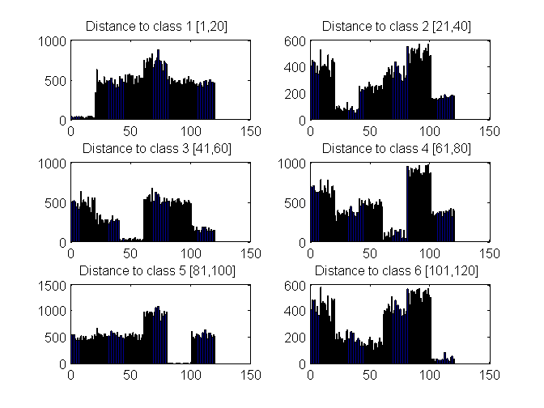

Evaluation algorithm
Compares the tagged vector from the predictor to the real tag that it should have depending on the class, each time an error occurs the eva vector gets a value of one in the corresponding observation
comp=cell(120,3);
eva=zeros(120,1);
for i=1:120
comp(i)={predict(X,car4(i,:))};
end
for i=1:20
if strcmp(comp{i},'class 1, D101')==0
eva(i)=1;
end
end
for i=1:20
if strcmp(comp{i+20},'class 2, D1')==0
eva(i+20)=1;
end
end
for i=1:20
if strcmp(comp{i+40},'class 3, D52')==0
eva(i+40)=1;
end
end
for i=1:20
if strcmp(comp{i+60},'class 4, D49')==0
eva(i+60)=1;
end
end
for i=1:20
if strcmp(comp{i+80},'class 5, D20')==0
eva(i+80)=1;
end
end
for i=1:20
if strcmp(comp{i+100},'class 6, D3')==0
eva(i+100)=1;
end
end

Result
Error Percentage
t=sum(eva)/1.2
t =
0

