car2(): Feautures extraction function
This function creates a set of ideal filters and applies them to the input images. After that, the energy is calculated for each resulting filtered image .The output is a features vector with the same size as the rings number.
function features=car2(ima)
Randomly select a pixel within the image range and create a new subimage cort.
l=randi(500);
r=randi(300);
cort=ima((l:l+99),(r:r+99));
[b c]=spect1(cort); % Calls the _spect1()_ function
[x,y]=size(b);
n=50; % Rings number
if x>=y
h=x/n;
end
Calculate energy in horizontal spectrum rings and display the reconstructed image after the applied filter.
Eh=[];
for i=1:n/2
f=0;
g=lpfilter('ideal',x,y,h*i);
g2=1-lpfilter('ideal',x,y,h*(i-1));
fi=b.*g.*g2;
d=uint8(ifft2(fi));
e=sum(d(:));
Eh(i)=e;
if i<=16
figure(4),subplot(4,4,i),imshow(d),title(e);
end
end
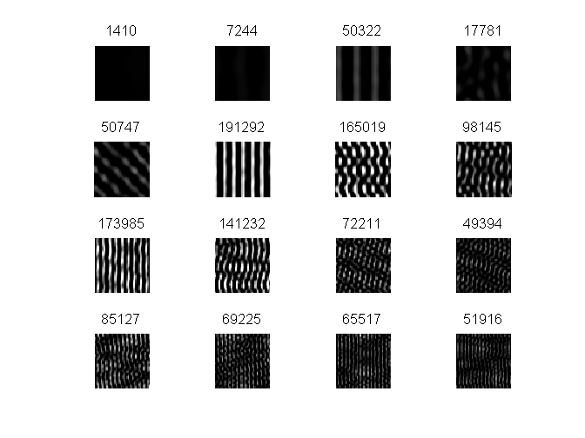
Calculate energy in vertical spectrum rings and display the reconstructed image after the applied filter.
Ev=[];
for i=1:n/2
g=lpfilter('ideal',x,y,h*i);
g2=1-lpfilter('ideal',x,y,h*(i-1));
fi=c.*g.*g2;
d=uint8(ifft2(fi));
e=sum(d(:));
if i<=16
figure(4),subplot(4,4,i),imshow(d),title(e);
end
Ev(i)=e;
end
Eh=Eh/max(Eh);
Ev=Ev/max(Ev);
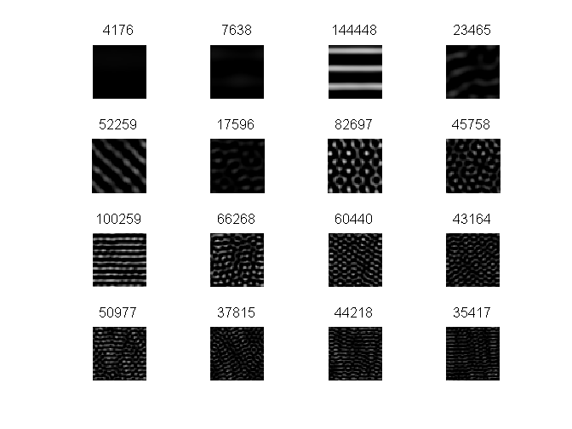
Features vector and output of the function.
features(1:25)=Eh;
features(26:50)=Ev;
figure,bar(features)
