spect1(): Fourier transform function and preprocessing of the image
This function applies a Sobel filter for 0° and 90° , after that both are transformed to the frequency domain and the outputs are the resulting images

Function declaration
In this part we declare the image is the input for the function and as result the output are two images
function [fh, fv]=spect1(ima)
ima=imresize(ima,.5);
[fil,col,capa]=size(ima);

Sobel filtering
If the image is in RGB converts to grayscale
if capa==3
grey(ima);
end
imaexp=zeros(fil+2,col+2);
[fil,col]=size(imaexp);
for i=2:fil-1
for j=2:col-1
imaexp(i,j)=double(ima(i-1,j-1));
end
end

Apply the convolution matrix for horizontal filtering
CM=[-1, 0, 1;-2, 0, 2; -1, 0, 1]
CM =
-1 0 1
-2 0 2
-1 0 1
for i=2:fil-1
for j=2:col-1
Hh(i-1,j-1)=(1*imaexp(i-1,j-1)+ 0*imaexp(i-1,j)+(-1)*imaexp(i-1,j+1)+2*imaexp(i,j-1)+(0)*imaexp(i,j)-2*imaexp(i,j+1)+(1)*imaexp(i+1,j-1)+(0)*imaexp(i+1,j)+(0-1)*imaexp(i+1,j+1));
end
end
Apply the convolution matrix for vertical filtering
CM=[1,2,1;0,0,0;-1,-2,-1]
CM =
1 2 1
0 0 0
-1 -2 -1
for i=2:fil-1
for j=2:col-1
Hv(i-1,j-1)=((-1)*imaexp(i-1,j-1)-2*imaexp(i-1,j)+(-1)*imaexp(i-1,j+1)+0*imaexp(i,j-1)+(0)*imaexp(i,j)+(0)*imaexp(i,j+1)+1*imaexp(i+1,j-1)+2*imaexp(i+1,j)+(1)*imaexp(i+1,j+1));
end
end
% imaf=Hh+Hv;

Show modified images
figure
subplot(221), imshow(uint8(Hh)),title('Horizontal filtering');
subplot(222), imshow(uint8(Hv)),title('Vertical filtering');
subplot(224), imshow(uint8(ima)),title('Original image');
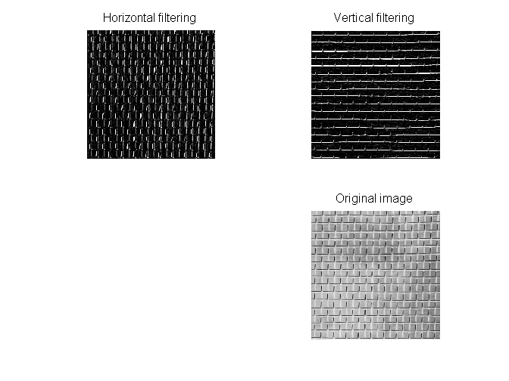

Transformation to the frequency domain
Here the program uses the Fast Fourier Transform (fft2) to obtain the spectrum of both images
%Create the horizontal filtered spectrum
fo=fft2(Hh);
fh=fo;
fr=fftshift(fo);
fos=log(1+abs(fo));
fis=log(1+abs(fr));
S=abs(fr);
figure,subplot(121), imshow(fos,[]),title('H ');
subplot(122), imshow(fis,[]),title('Shifted H');
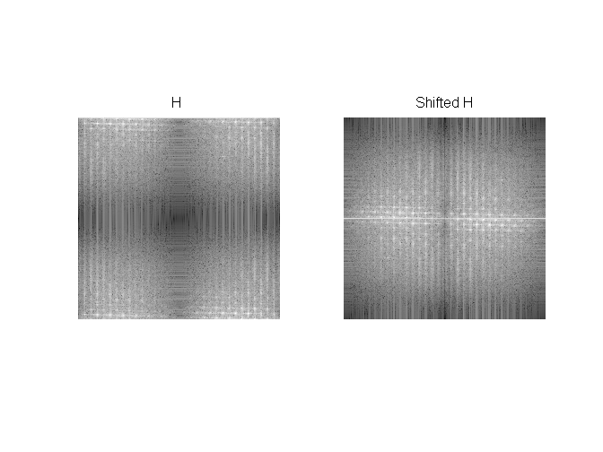
%Create the vertical filtered spectrum
fo=fft2(Hv);
fv=fo;
fr=fftshift(fo);
fos=log(1+abs(fo));
fis=log(1+abs(fr));
S=abs(fr);
figure, subplot(121), imshow(fos,[]),title('V');
subplot(122), imshow(fis,[]),title('Shifted V');
