Training
This script's main function is to create a new classifier trained with data obtained from subimages of six different pictures. the resulting classifier has the tags with the names of the classes in the order the images were loaded.
clc, close all, clear all

1st Part: Feature extraction
In this script a vector of 1200 obervations is created with 200 samples of each feature vector from random subimages of the original picture.
First image for classification
im1='D101.gif';
car4=zeros(1200,50);
for i=1:200
car4(i,:)=car2(im1);
close all
end
Second image for classification
im1='D1.gif';
for i=1:200
car4(i+200,:)=car2(im1);
close all
end
Third image for classification
im1='D52.gif';
for i=1:200
car4(i+400,:)=car2(im1);
close all
end
Fourth image for classification
im1='D49.gif';
for i=1:200
car4(i+600,:)=car2(im1);
close all
end
Fifth image for classification
im1='D20.gif';
for i=1:200
car4(i+800,:)=car2(im1);
close all
end
Sixth image for classification
im1='D3.gif';
for i=1:200
car4(i+1000,:)=car2(im1);
close all
end

2nd part: Training process
Here a cell array of 'tags' is created with the corresponding names for each observation and it's corresponding class. After that a classifier X is created
% Creates an array of type 'cell' for the classes labels
C=cell(1200,1);
C(1:200)={'class 1, D101'};
C(201:400)={'class 2, D1'};
C(401:600)={'class 3, D52'};
C(601:800)={'class 4, D49'};
C(801:1000)={'class 5, D20'};
C(1001:1200)={'class 6, D3'};
The new classifier uses the pseudoLinear type since the observation matrix is not a square matrix. For computing the covariance uses the pseudoinverse matrix
X=fitcdiscr(car4,C,'discrimType','pseudoLinear')
X =
ClassificationDiscriminant
PredictorNames: {1x50 cell}
ResponseName: 'Y'
ClassNames: {1x6 cell}
ScoreTransform: 'none'
NumObservations: 1200
DiscrimType: 'pseudoLinear'
Mu: [6x50 double]
Coeffs: [6x6 struct]

Evaluation
Compute the Mahalanobis distance from each observation to each class
dist=zeros(1200,6);
for i=1:1200
dist(i,:)=mahal(X,car4(i,:));
end
figure, subplot(321),bar(dist(:,1)),title('Distances to class 1 [1,200]')
axis([0 1200 0 inf])
subplot(322),bar(dist(:,2)),title('Distances to class 2 [201,400]')
axis([0 1200 0 inf])
subplot(323),bar(dist(:,3)),title('Distances to class 3 [401,600]')
axis([0 1200 0 inf])
subplot(324),bar(dist(:,4)),title('Distances to class 4 [601,800]')
axis([0 1200 0 inf])
subplot(325),bar(dist(:,5)),title('Distances to class 5 [801,1000]')
axis([0 1200 0 inf])
subplot(326),bar(dist(:,6)),title('Distances to class 1 [1001,1200]')
axis([0 1200 0 inf])
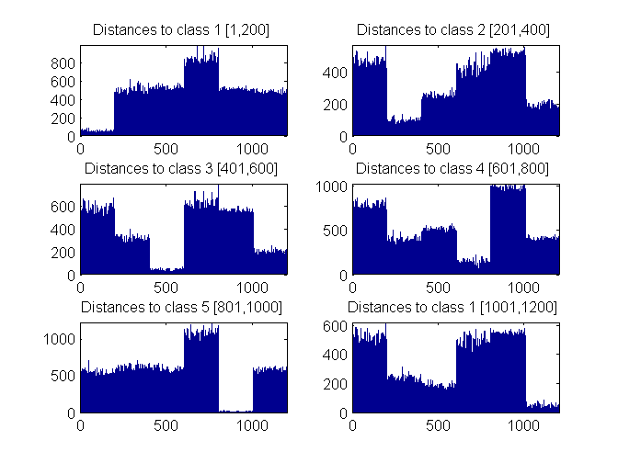
Published with MATLAB® R2014a

