|  |  |  |
| --- | --- | --- |
|  |  | TECHNICAL TRAINEE: SYSTEMS DEVELOPMENTCESHIA WILLIAMS |
| PERSONAL DETAILS **Date of birth:** 21st May 1996  **Residential Area:** Bellville South, Cape Town  **Languages:** English, Afrikaans EDUCATION Current: CapaCiTi Systems Development NQF Level 5 - Learnership  2020: CPUT – ND ICT: AppDev  2017: CPUT – HC ICT  2014: Kasselsvlei Comprehensive High School – Matric ONLINE PRESENCE **LinkedIn:**  www.linkedin.com/in/ceshia-williams-954070142 KEY SKILLS  * HTML * CSS * JavaScript * Java  INTERESTS & HOBBIES  * Video games * Football * Softball * Fishing * Puzzles |  | ABOUT ME I enjoy encouraging individuals to focus on their abilities. Working in groups taught me a lot about working with different individuals and how to communicate with them. I'm always eager to learn new things and broaden my horizons, which makes me adaptable. I am always up for a challenge, and this experience has taught me a lot about problem-solving techniques. I work well under pressure and consistently fulfil deadlines. ACHIEVEMENTS & KEY PROJECTS  * Certificate for Finance and non-financial managers * 100% attendance at CapaCiTi  WORK EXPERIENCE **Codebow Labs**  **Software Engineering intern**  February 2021 – May 2021  I've successfully   * researched and summarized specific audio product specifications, * transferred and captured data product specifications into JSON compliant data structure using Angular Front-End and C# REST API Back-End prototype Portal, * extended existing Swagger REST API to accept authorization token, * extended several existing REST API services and created new REST PI services, * created and updated JIRA tickets, and * Created and updated Confluence How-To-Wikis.   **Pick n Pay Clothing**  **Sales Assistant / Cashier**  March 2016 – August 2016  Duties included cleaning the workplace, ensuring the teller's balance, and assisting customers. |

# **TECHNICAL DEVELOPMENT**

Technical Skills and modules covered over the duration of the program

|  |  |
| --- | --- |
| **Technical Skills and Projects** | **Modules Covered** |
| * Installing and configuring mobile application. * Basic computer connection and troubleshooting. * Review and test end user tools functionality. * Data capturing, verification and validation. * Data retrieval, searching and sorting. * Application Problem solving techniques. * Assist in User interface designing. * Updating applications patches. * IT research and development. * Analyse problem situations to plan an object-oriented programming (OOP) implementation. * Helpdesk support and customer care * Market/Sell IT products. * Procurement of IT products online. * Comparing Hardware and software specifications | * Web Development * Database Design, Implementation and Development * Computer Programming and Problem Solving |

MENTOR TESTIMONIAL

PROGRAM DATA

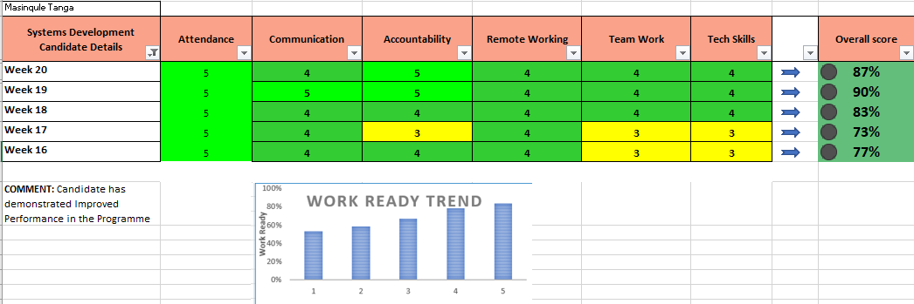

# **PROFESSIONAL DEVELOPMENT**

CapaCiTi Job Critical Skills covered over the duration of the program

|  |  |
| --- | --- |
| **Competency: Communication**  Modules   * Principles of effective verbal communication and body language * Principles of structuring and presenting information * How to listen and why it matters * Feedback: To and from | Outcome   * Aware of how to communicate impactfully * Effective presentation skills * Able to actively listen and paraphrase * Giving and receiving feedback effectively |
| **Competency: Goal Setting**  Modules   * Goal setting * Decision making * Career path mapping | Outcome   * Able to use goal setting and tracking methodology * Equipped with tools for guiding choices * See connection between course material and future goals |
| **Competency: Work Ready**  Modules   * Scorecard and Performance Management * Remote working | Outcome   * Experience of public accountability for performance * Managing working online and making use of remote tools |
| **Competency: Work Ready**  Modules   * Self-reflecting audit of strengths and weaknesses * EQ and Self-Control * Johari’s Window * Conflict Management * SWOT Analysis | Outcome   * Aware of development areas and strengths to build on * Aware of one’s own inner state * Self-awareness and development through feedback * Resolving Team Conflict - building stronger teams by facing your differences * Conducting a SWOT analysis at key points of program, focusing on areas of improvement and strengths to harness, including a SWOT Analysis of their remote working experience. |
| **Competency: Interview Fit**  Modules   * Introduction to Interviews - highlight purpose, misconceptions and fears * Job search and networking skills * Interview practice / role plays * Your professional brand | Outcome   * Experience in interview realities * Conducting own job searches * More confident managing stressors and interview questions * The importance of building a well curated online presence |

CANDIDATE MANAGEMENT TESTIMONIAL