Chad Simmerman
EE-4930
Lab 6: RTOS
2/13/20

Objectives
Lab 6’s objectives were to utilize TIRTOS libraries to add in scheduling functionality and minimize complexity. For some visual aids we included a potentiometer and LCD to update an ADC value in.

Description
The main bulk of this lab was get RTOS up and running between two different task, a HWI and SWI, and two events. The functionality below must be implemented.
- Clock object will trigger ADC to start conversion
  - Once conversion is complete a HWI must be triggered
  - Clock set to trigger every 1 second
- HWI will trigger a SWI
- SWI will read the value of the potentiometer and post event1.
- Event1 will set the setpoint
- Task 2 will pend on event1
  - Task 2 is prioritized higher than task 1
  - Scale ADC
  - Check for updated setpoint value
  - If a change, post Event2
- Task 1 will pend on Event2 and update the LCD.
  - Lower priority due to less important

Conclusions
The main issues with this lab came with the events object in TIRTOS, until I found a note in the book saying that multiple task could not be waiting on a single event. By having two different events this solved the problem and allowed the program to function as necessary. It was very interesting to see a working implementation of the TIRTOS system and how it could simply things.

Diagram
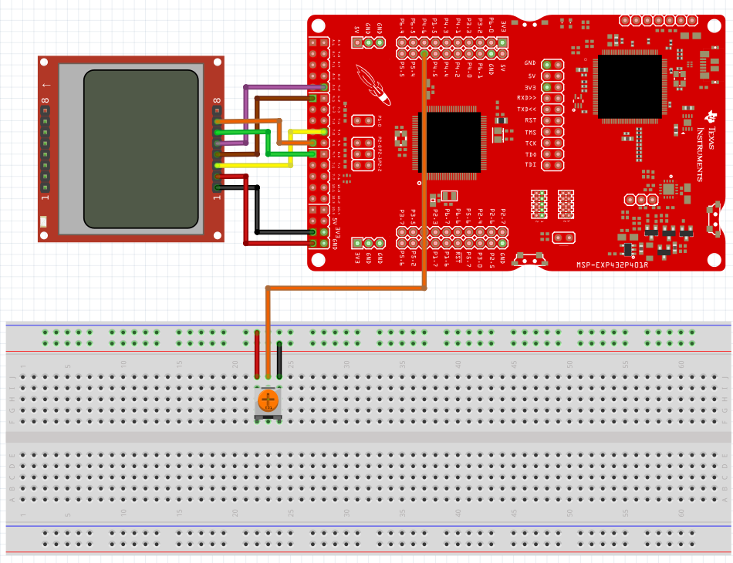

Schematic
