Hi Gina,
I don't know if you're back from egg or not yet, but hopefully you'll get this before too long.
I'm teaching Advanced Syntax at Concordia this fall. I'm trying to arrange the course as a survey of interesting topics and I'm inviting Montreal area linguists not already overburdened with too much teaching to come talk about their work. I'd really love it if you wanted to come give a guest lecture (or two) about some of the work you've been doing. It's up to you whether you'd rather just give one lecture (more like a talk) or take two classes in a row and take more time to develop the topic and explore it in depth. Prior to your lecture(s), we'd read and discuss some background literature that would make sure everyone understood the basic context/problem that was relevant to your work.
Let me know if you'd be interested, and if there are any dates that are better or worse for you (we meet Mondays and Wednesdays from 2:30-4pm).
Thanks,
Linnaea

Syntax Topics I could teach

What is “Long distance?”

Wurmbrand presents criteria for distinguishing between lexical and functional heads in the clausal domain.

CP
CP
Topic
CP/IP
Force
CP/IP
Finite
IP
vP
Tense
Cause
VP
Aspect
VP
Process
VP
Result State
Focus
Object
Non-Thematic Functional Domain
Thematic Lexical Domain

(Split IP: Pollak) (Exploded CP: Rizzi) (Split vP: Larson, Richards 2001) (Exploded VP: Ramchand)

Restructuring, Reanalysis, Clause union, Coherence are all terms which are used to describe sentences where the embedded be an entire clause, and thus the embedded clause doesn’t appear to show clause boundedness. (Crosslinguistically this is most common in the complement of ‘want’ verbs.)

- Clitic Climbing: Object clitics “climb” all the way to the left of the higher verb, rather than to the left of the lower verb where it’s interpreted.
- Long A-movement: Object of the lower verb can be moved to the subject of the passivized higher verb.

Biclausal approach: all verb forms are a clause, thus the higher and lower verbs are each a clause. Under this approach the symptoms of restructuring appear to be “long distance”

Monoclausal approach: the higher finite verb and lower infinitive are together in one clause. (Strozer 1976, 1981; Zagona, 1982; Cremers, 1983; Picallo, 1985, 1990; Haider, 1986a,b,c, 1991a,b, 1993; Rochette, 1988, 1990, 1999; Rosen, 1989, 1990; Moore, 1990, 1994; Rosengren, 1992; Cinque, 1997, 2001, 2002; Wurmbrand, 1998a,b, 2001)

Two types of restructuring

Functional Restructuring: the higher verb is an auxiliary or functional head Fº which combines with an infinitive main predicate vP . (Napoli 1981, Cinque, 1997, 2001, 2002)
- do not assign theta-roles to arguments (Cinque 2001)
- are subject to rigid ordering and co-occurrence restrictions (Cinque 2001)
- allow only one type of complementation (Cinque 2001)
- show the properties of raising verbs (no external argument)
- Cannot be passivized as they are not associated with a voiceP (?)
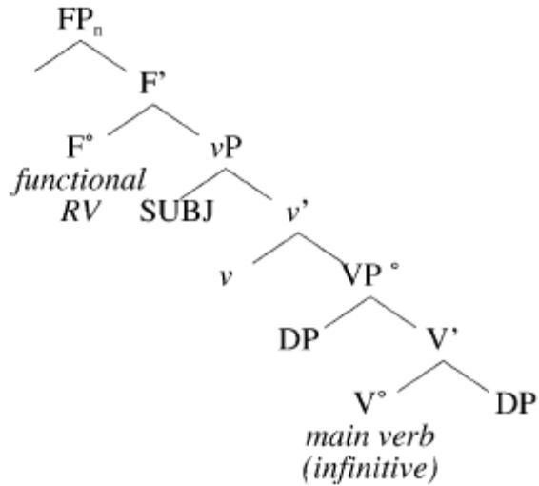
Lexical Restructuring: the higher verb is a lexical verb in Vº with a VP complement.
- establish thematic relations with arguments (Wurmbrand 2004)
- are not per se subject to syntactic ordering and co-occurrence restrictions (Wurmbrand 2004)
- show optionality in complementation (Wurmbrand 2004)
- can be passivized as the are associated with a voiceP (?)
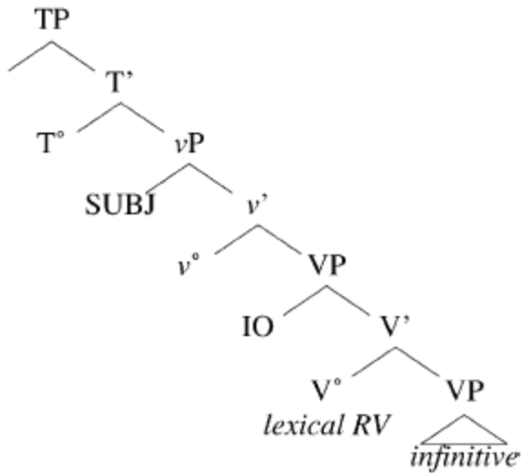

Passive Test for Raising

Unaccusative intransitives (arrive, die) do not have an external argument, and so they cannot be passivized in German.

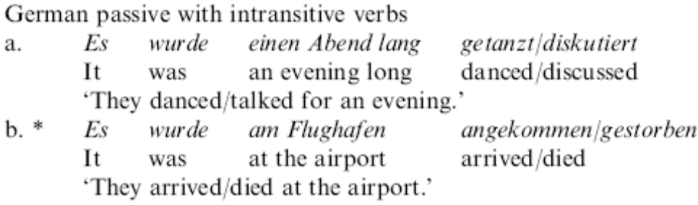

- versuchte ‘try,’ plante ‘plan,’ dare, forget, intend, forbid, recommend, allow’ (Lexical vº volition)
- Can be passivized
- Cant have weather-it, or inanimates as a subject
- ‘manage’ (Lexical vº non-volition)
- Epistemic modals:’ können ‘can,’ düfte ‘might’ scheint ‘seems’ (Functional no vº)
- Root/circumstantial modals: müssen ‘must,

----------------------Topic 2 - Chosen------------------------------------------------
Key words: clause union, restructuring, verb clusters

I wont worry about word order, or word surfacing (hence no headmovement). I assume that once the right semantic structure is built we can see how that is spelled out since linearization is not part of the structure but a separate process. I will focus just on the “semantic” structure. (or jokingly “logical syntax” ☺ of fodor and lepore1998, cited in harley this is a joke because they are semanticists and don’t want the decomposition to be in the syntax but rather in a maping rule from semantics to syntax..)

Harleys paper brings up most of the worms in the want story, in footnotes though. Control, irrealis, counterfactual worlds. In urdu, want and should are both said with the same root. Can be thought in terms of this state of affairs/thing is lacking from Ram…? Im thinking that Harleys paper might be a good backround read, it gives the decomposition, and leaves semantics for footnotes? Or should I go for semantics.. but then it owuldnt be a synatax talk.. but then again I don’t think syntax is different from compositional semantics.

- Syntactic Hierarchy: “Long distance” movement/agreement/binding domains, clitic climbing

Above the main verb:
Force, Finiteness, Topic and Focus
Rizzi 2004 The Structure of CP and IP: The Cartography of Syntactic Structures, Vol. 2

Higher aux/restructuring/bridge verbs
Wurmbrand 2004 Two types of restructuring, lexical and functional

Split vp VP/Lexical decomposition
Richards 2001 An idiomatic argument for lexical decomposition
(Larson 1988 On the double object construction)
(Hale and Keyser)

Lower light verbs (aspect, process, path)
Butt Ramchand 2000 Complex aspectual structure in Hindi Urdu
(Ramchand 2006 Verb Meaning and the lexicon, a first phase syntax)

Result Phrases/double objects/small clauses/Place

Path

Place

Below the main verb:

Non-CP complement clauses/English ing/ECM/nominalizations
Abney 1987 The English noun phrase in its sentential aspect
Pires 2001 A Minimalist Approach to Clausal Gerunds
(Chomsky 1970 Remarks on nominalization)

Specificity/object shift/Diesing’s Mapping Hypothesis/object agreement
(Enç 1991 The Semantics of Specificity)
Deising 1992 Indefinites CH2
(Rackowski and Richards 2005 Phase Edge and Extraction A Tagalog Case Study)

Switch to 070826lda.syntactic.structure.in.hindi.urdu.v2.doc

----------------------Topic 3 -----------------------------------
- Linearization:

Fox and Pesetsky 2005 Cyclic Linearization of Syntactic Structure
Kayne

but this is still pretty lexical maybe it has an inchoative little v?

