The syntactic structure for Long Distance Agreement in Hindi/Urdu

Do I need to do previous accounts or should I develop an event semantics version of the structure?
-yes, this has independent merit, and doesn’t need to wade through the crap of previous debates… right?

Assumptions:
- Syntactic Structure is Event structure (Hale and Keyser 1993; Borer 1994; Travis 1994; Son 2006)
- (Meta)physics concepts like time, space, causation can become grammaticalized and encoded in the ‘event’ element of human grammars (Vendler 1967; Davidson 1967; Dowty 1979, inter alia)
- Distributed Morphology (Halle and Marantz 1993): Verbs (and lexical items more generally) are not syntactic atoms. “The syntax does not manipulate full lexical items, unlike the theory of LGB (Chomsky 1981) and its Lexicalist descendants. Rather, the syntax proper generates structures by combining morphosyntactic features (via Move and Merge) selected from the inventory available, subject to the principles and parameters governing such combination. It is further assumed that the phonological expression of syntactic terminals is, in all cases, provided in the mapping to Phonological Form. In other words, syntactic categories are purely abstract, having no phonological content. Only after syntax are phonological expressions, called Vocabulary Items, inserted in a process called Spell-Out, i.e., Late Insertion.” (Son 2006:17)
- Content words are concepts/predicates/descriptions (ie, of the form f(x)=x has property f) and are categoryless (neither N nor V) they are roots (Marantz 1997) or √ (Pesetsky 1995)
- Syntactic heads combine with their complements and specifiers via Functional Application (Heim and Kratzer 1998) (or Predicate Modification), thus the interpretation of the sentence is compositional, type-driven and bottom up.
- Neo-Davidsonian event semantics: Verbs are one place predicates over events f(e), arguments are thematic relations/two place predicates over events and entities AGENT(e,x).

Historical Development of Syntactic Decomposition of Events
- Vendler’s 1967 ontology of conceptual events:
 | Temporally bounded complete | Progress | Internal structure | Duration
States | No (atelic) | No | No (static) | Yes(Inherently)
Activities | No (atelic) | Yes | Yes (dynamic) | Yes
Accomplishments | Yes (telic) | No | No? | No
Achievements | Yes (telic) | Yes | Yes (dynamic) | Yes
Examples of English Predicates
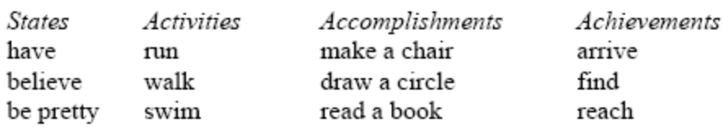

- Early Lexical Representations contain complex event structure which must be linked to syntactic structures via a Linking Theory (cf. Son 2006:5)
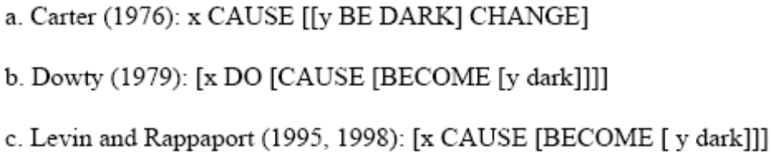
Notice, all have the structure
[Outer causing event [inner change of state event]]

- Hale and Keyser 1993 propose getting rid of the need for Linking Theories by having the syntactic structure directly reflect the semantic event structure. In their syntactic structure the semantic primitives CAUSE and BECOME are treated as abstract morphemes present in the syntax, becoming the V heads in Larson’s VP-shell theory.
John opened the window.
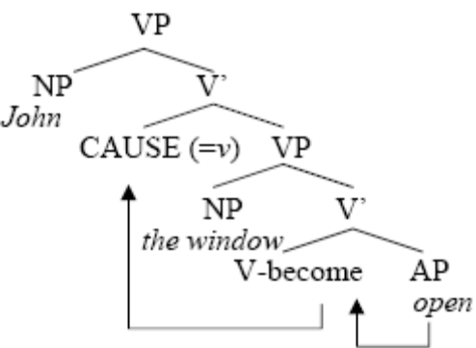(Son 2006:7)
CAUSE (Hale and Keyser 1993) = Voice (Kratzer 1996) = v (Chomsky 1995)

- Neo-Davidsonian event semantics: Verbs are one place predicates over events f(e), arguments are thematic relations/two place predicates over events and entities AGENT(e,x).
a. Buffy killed Angel.
b. ∃e.[kill (e) & Agent (e, Buffy) & Theme (e, Angel)]
Heim and Kratzer’s 1998 Semantic composition:
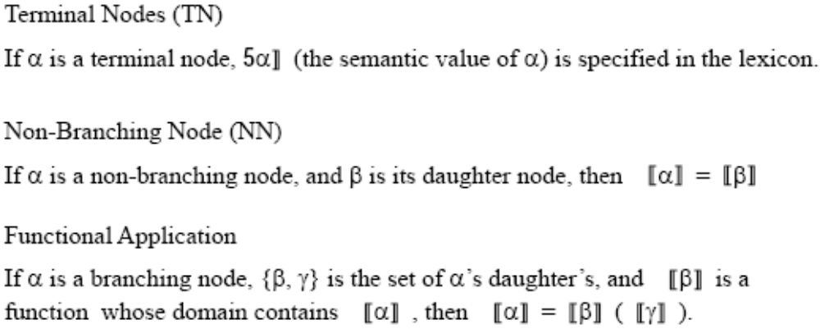
This also takes a new type of compositional process though, Event Identification (Kratzer 1996) (e for individuals, t for propositions, and s for eventualities (states/activities).)
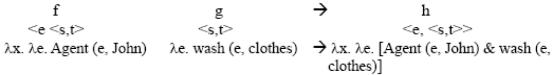
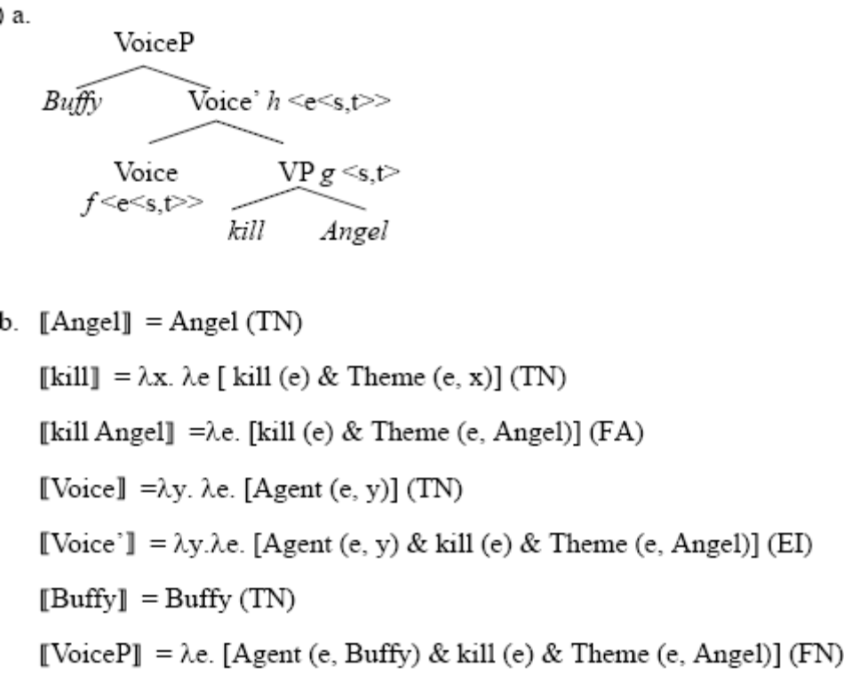

[FinProposition=1 ∃ [vCauseP(e) y [(FuncApp)] [vCauseP(e,y) [lambda.abstr(e,y) λy.λe.Agent(e,y)] (EventIdent) [ResultP(e) [dead(e) λe.dead(e) ] [(PredMod)] [Object(e) x [(FuncApp)] [Theme(e,x) λx.λe.Theme(e,x) ] ] ]] ]]
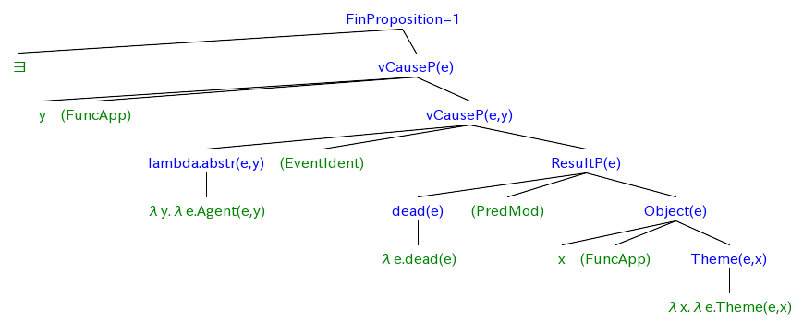

- Here I divert from Son (I think)
Son reformulates Hale and Keyser’s split, proposing that Cause and Become/Inchoatives are flavors of v, rather than become being lower than cause.

Causative and Inchoative forms both have a v, allowing for ambiguous scope of “again”, and both have result phrase, allowing both to be possible with progressive.
Im confused about where again goes, and where the “run” and progressive goes in the result phrase.
[vP [vP The dog [v' v/CAUSE/INCHO [Result [Aspect progressive ] [Result [VP run] [Result [Result R home ] [Adv again ] ] ] ] ] ] [Adv again ] ]
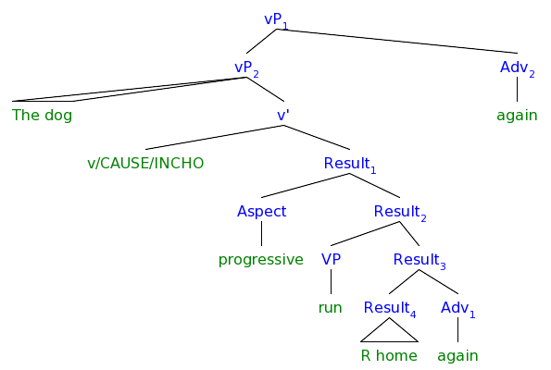

“agentive morphological causatives (agentive MCs)”
-Intransitive form: unergative
“non-agentive morphological causatives (non-agentive MCs)”
lack an external-argument-introducing v head in their underlying representation.
-Intransitive form: unaccusative
-Transitive forms: only put-on class
“Unlike in Korean, in which the meaning of causation directly correlates with an external argument, in Indonesian causation, which relates two eventualities in a causal chain, need not be coupled with an external argument.”

Korean: causal meaning comes from an external Cause head, and introduces an external argument
Indonesian: causal meaning comes from an inner Result head and introduces an internal argument

Questions about the lower participle/infinitive
German has infinitive zu ge-verb-en and participles verb-en right? (maybe the ge can be in both) would this help to decide on the size of the lower clause?

as well as the lower heads which the infinitive/participle should be spelling out.
-it’s a participle not a gerund, which means either 1-its not the head, but an adjective describgig what it agrees with, but it never agrees with the subject, only the object. Dare I say that the object is the head? Check with brazilian agreeing infinitives. Or participles for LDA. Read the girls paper from Maryland, does she say anything about agreeing participles?

I question that the English infinitival complement “to eat bread” is not what Hindi “roti khana” means, but that Hindi is closer similar items in the Balkan sprakenbund which I found out form snezana about their subjunctives being tensed but ecm or control-y….

Empirical evidence for direct Syntactic/Semantics (overt morphemes for the denotation of each semantic function) Full Picture:

FORCE/SPEECH ACT
(desideratives, eg, querer 'to want'; modals, eg, poder 'can, to be able to'; performatives, eg, recomendar 'to recommend'; transactional-situation verbs, eg, decir 'to say')

REALITY certain/true, possible, non-real, optative, subjunctive
Turkish evidentiality markers

TIME past, present, future
(have to find a language where present≠generic, past/future≠non-real (why?))

FINITE/DEFINITE, specific, nonspecific/generic
(Any languages which have finite at the same time as tense? Where infinitive≠generic)
APPLICATIVE
CAUSE
  - Miyagawa and Tsujioka 1994, Harley 1995:
CAUSE Japanese –sase
  - Travis 2000:
CAUSE Malagasy -pag-,
CAUSE Tagalog -um-
  - Davis and Demirdache 2000:
CAUSE Salish –ts
  - Son 2006:
CAUSE Korean –i-
VOLITION
Non-Volitional Cause Hidajat, Cheng, Cathcart, Cook KL Malay ter-
(GOALORIENTED telic/volitional, atelic/instrumental?) aktionsart, atelic≠infinitive?
ASPECT perfect/punctual, imperfect/process
Korean –ko iss- ‘progress’
PREDICATE result state/state
RESULT adverb English again
RESULT adverb German wieder
RESULT adverb Korean tasi

Now look on the outer edges of the clausal hierarchy
We will focus on the higher heads which “want” should be spelling out,

- Clustering Theories
Bobaljik, Jonathan David VERB CLUSTERS: A STUDY OF HUNGARIAN, GERMAN AND DUTCH, E. Kiss, Katalin, & van Riemsdijk, Henk [Eds], Amsterdam: John Benjamins, 2004, pp 121-145
“Commentary is offered on syntactic theories within three current approaches to the problems of discontinuous dependency structures seen in Dutch subordinate clause constructions of the type dat wij hem dit probleem zouden willen moeten laten oplossen 'that we should want to have to let him solve this problem', where the direct object & its selecting verb are separated by a sequence of four verbs in a five-verb cluster having the same ordering as its English equivalent - as opposed to the ordering of German, which is the mirror reverse of the Dutch ordering & permits the object & its selecting verb to form a surface constituent. As these distinctions have no effect on semantic interpretation, unlike scrambling & topicalization, the reanalysis approach of Liliane Haegeman & Henk van Riemsdijk (1986) & others, which derives discontinuous structures at a late stage of syntax or in the phonological component, is preferred to (1) the inheritance approach stemming from M. Steedman (1985) & exploited in categorial grammar & head-driven phrase structure grammar & (2) the movement approach originating with A. Evers (1975) & its radically reformulation in Richard Kayne's (1994) antisymmetry theory. 34 References. J. Hitchcock”

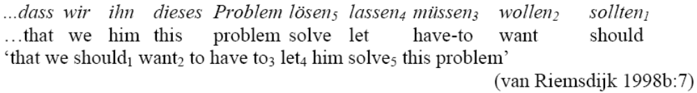

- The interaction of modality, aspect and negation in Persian
Hojatollah Taleghani, Azita Dissertation Abstracts International, A: The Humanities and Social Sciences, 2007, 67, 07, Jan, 2553
“This dissertation investigates the verbal system of Persian and is focused on the interaction of modality, tense, aspect and negation in this language. The dissertation challenges the idea that the syntactic structure maps on to the semantic interpretation or vice-versa. It is argued that modals are raising constructions in some languages (Wurmbrand 1999). Modals in Persian, which do not have subject-raising constructions, show different behavior. First, the root complex modals are generally syntactic control in Wurmbrand's (1998, 2001) proposal. There are just a few gaps with respect to dynamic root modals. Second, all epistemic modals which are either defective auxiliary modals or complex modals take default agreements and are pseudo-raising constructions. Third, the syntactic structures of modals show that there is no one-to-one correspondence between the structural positions and semantic interpretations of modals in Persian except in the auxiliary modal bayad 'must'. The second contribution of this dissertation is that the class of restructuring verbs varies across languages. German semantic control verbs are instances of restructuring constructions (Wurmbrand 2001) while the only case of restructuring in Persian is the functional restructuring which appears in auxiliary modals such as bayad 'must' and sayad 'may' since they are mono-clausal and do not have a CP. This dissertation also investigates the structure of complex verbal forms in Persian. It is argued that Persian future tense is an instance of Serial Verb Constructions. However, progressives which are bi-clausal constructions are Aspectual Complex predicates. In the case of the structural analysis of the interaction of Persian modals and negation, this dissertation shows that the syntactic structure maps on the semantic interpretation or vice-versa. There are just a few gaps with respect to the scope possibilities of particular modals. The final contribution of this dissertation is related to the problem of the word order of NV elements and LV within complex predicates. This research provides three suggestions regarding the clausal complement position in complex predicates, and suggests that the vP remnant movement is the most reasonable one, since it is compatible with the recent trends of syntactic theories and suggested for some other languages (Mahajan 2003).”
- Wanting, Having, and Getting: A Note on Fodor and Lepore 1998
Harley, Heidi Linguistic Inquiry, 2004, 35, 2, spring, 255-267
“This article takes up Fodor & Lepore's (1998) account of the meaning of [want DP] structures, according to which the verb to have is introduced at interpretation. With certain DP complements, a want to have DP paraphrase of want DP is ill-formed; the correct paraphrase uses get or give. To allow for this, F&L would have to vary the introduced verb depending on the meaning of the DP, but this would make their proposal "co-compositional," defeating its original purpose. If have, get, & give all contain the abstract preposition P(subscript HAVE) (Harley, 1995; Richards, 2001), however, F&L's treatment may be appropriately revised: the element introduced by want is not have but P(subscript HAVE). F&L can avoid co-compositionality at the price of allowing lexical decomposition. 24 References. Adapted from the source document”
- The Semantic and Syntactic Decomposition of Get: An Interaction between Verb Meaning and Particle Placement
McIntyre, Andrew Journal of Semantics, 2005, 22, 4, Nov, 401-438
“VPs with get & a PP/particle provide an argument for lexical decomposition in syntax. Get (& German kriegen) has a 'hindrance' reading, which does not denote causative events & resembles manage in that the result is portrayed as hard to achieve, & in that possibility operators do not affect the meaning under negation: I didn't (=couldn't) get the key in. These effects surprisingly follow from an analysis where hindrance-get VPs are nothing more than inchoatives of have-VPs of the type have the key in. In get out one's wallet, we see another reading which is genuinely causative & is not found with German kriegen. Hindrance-get VPs (like VPs with have, want & need, which decompose with HAVE, & unlike causative get & other causative-agentive verbs) disallow particle-object order (get/take out your wallet vs. *get/have/want/need in the key). The effects of semantics on word order are shown to be unmysterious only if the HAVE predicate in the meaning of hindrance-get is a syntactic head. 51 References. Adapted from the source document”

- Presupposition Projection in Belief Contexts
Yeom, Jae-Il Ohak Yonku/Language Research, 2003, 39, 4, Dec, 859-890
“In this paper, I review satisfaction theory & binding theory of presupposition projection in dealing with presuppositions in belief contexts & show that a presupposition triggered in a belief context can be accommodated more than once & that this is not a pragmatic matter, as Geurts (1998) claims. Behind this claim lies the assumption that belief contexts as well as the main context are information states & that a presupposition triggered in a belief context is accommodated to all accessible information states. I furthermore claim on the basis of the strongest meaning hypothesis that the preference order among the possible readings of a sentence is determined by the strength of each reading. Finally, I give the semantics of believe-statements to support the claims in this paper. I also discuss want-statements, but presuppositions from a desire context behave like those from a belief context as far as accommodation is concerned. 34 References. Adapted from the source document”
- Tense and Aspect in Periphrastic Pasts: Evidence from Iberian Romance
Juge, Matthew Lambert Dissertation Abstractcs International, A: The Humanities and Social Sciences, 2003, 63, 9, Mar, 3170-A-3171-A
“Cross-linguistic similarities can result from shared history, borrowing, or parallel development, in which case the similarities may be due to universal tendencies or coincidence. For example, many languages have auxiliary verbs meaning "be," "have," "come," or "go." In some cases, different languages' auxiliaries are very similar; for example, many future markers mean "want." Other cases are more complicated; for instance, some future auxiliaries mean "go," but some mean "come." Furthermore, divergent developments of the same verb show that these paths are not predictable simply from basic meanings. This dissertation examines the development of past tense auxiliaries from "be," "have," and "go" in the Iberian Romance languages (Catalan, Portuguese, and Spanish) with emphasis on both diachronic and synchronic patterns, specifically addressing universal versus language-specific factors and comparing developments in the Romance languages and other language families. I argue that the development of verbs with these meanings into auxiliaries is motivated by syntactic and lexical semantic characteristics of the verbs, the nature of constructions, pragmatics, and discourse patterns. I also discuss the role of valence, metonymy, inference, reanalysis, and analogy. I integrate these considerations with current understanding of grammaticalization in particular and language change in general. My research suggests that the participation of a small set of basic meanings in a wide array of constructions results from the relatedness of many of these constructions and the general nature of the processes of grammaticalization. I challenge accepted views on metaphor, unidirectionality, and grammaticalization as a problem-solving process. Because of the interaction of different grammatical components in grammaticalization, this study has implications for the nature of language change and of synchronic grammars. This is so because language change is ongoing and because the synchronic linguistic situation determines how a language will change. The study will also be useful to typologists and cognitive linguists. The dissertation will also be a source on the history of these phenomena in Iberian Romance. A detailed account of the diachronic and modern synchronic situation will interest various researchers, including those seeking parallels to developments in other language families and those investigating related phenomena in the Romance languages.”
- This Girl Wants Out! An Analysis of need/want + Prepositional Phrase and need/want + Prepositional Adverb
Benson, Erica June Michigan State U Dissertation 2004
“The aims of this dissertation are to examine the geographic, social, and stylistic distributions of the grammatical constructions need/want + prepositional phrase (e.g. Dean needs in the building) and need/want + prepositional adverb (e.g. The cat wants out) and to investigate other factors bearing on these literature on these constructions has looked at want + prepositional adverb; almost no literature has mentioned need/want + prepositional phrase and need + prepositional adverb. Several findings have emerged from questionnaire data gathered from 163 respondents, in Ohio, Michigan, and Georgia. All of these constructions show robust Midland distributions, and although need/want + prepositional phrase and need + prepositional adverb were rarely (or never) mentioned in other sources, use of them was reported by over 75% of respondents in the Midland. Furthermore, these constructions appear to be used more than previous literature had suggested in the North and the South, where some forms, e.g. want down, want in, want off, were reported by more than 60% of respondents. More importantly, the social and stylistic distributions of these constructions in the Midland challenges long held assumptions about the relationship between these two variables. Need/want + prepositional phrase and need/want + prepositional adverb show little to no variation across the social variables of urban-rural residence, gender, socioeconomic status, and age. These constructions are, however, stratified by style. Although many respondents report using need/want + prepositional phrase and need/want + prepositional adverb in all styles, in general, these constructions are much more frequent in informal styles than in formal styles. Stylistic variation without social variation calls into question not only the assumption that social and stylistic variation are inherently related (e.g. Romaine 1980; Labov 1972; Bell 1984; Finegan & Biber 1994) but also the idea that the amount of stylistic variation cannot exceed that of social variation, i.e. Bell's style axiom (1984). This study of need/want + prepositional phrase and need/want + prepositional adverb reveals their robust distribution in the Midland dialect area, which together with historical evidence, supports the idea of a distinct Midland dialect. In addition, use in the North and South is greater than expected, which would appear to be the result of spread of these constructions from the Midland. The findings also challenge long-held assumptions about the interrelated nature of social and stylistic distribution. Furthermore, this study of grammatical features raises questions about general characteristics of language variation and change, which have largely been based on studies of phonetic/phonological variables.”
- The Conditional: A Grammaticalised Marker of Politeness in Spanish
Chodorowska-Pilch, Marianna
CURRENT TRENDS IN THE PRAGMATICS OF SPANISH, Marquez Reiter, Rosina, & Placencia, Maria Elena [Eds], Amsterdam: John Benjamins, 2004, pp 57-75
“This chapter follows a Gricean implicature perspective to analyze the usage of the Spanish conditional as a grammatical marker to encode politeness in natural conversations. Data come from tape-recorded conversations between travel agents (N = 12) & their clients in two travel agencies near Madrid & one in Galicia. The use of the conditional as opposed to the present tense was observed in situations when the speaker desired interpersonal distance from a speech act that might be interpreted as impositive (ie, too forceful or direct) by the listener. This pattern of use was detected in four specific verb types (desideratives, eg, querer 'to want'; modals, eg, poder 'can, to be able to'; performatives, eg, recomendar 'to recommend'; transactional-situation verbs, eg, decir 'to say') & in six types of speech acts (direct question, impositive statement, indirect request, offer, promise, suggestion). Of the twelve most frequently used verbs in the corpus that followed this pattern, all twelve were found to encode politeness in impositive statements & most of them in direct questions. It is stressed that this noncanonical use of the conditional represents a systematic process of grammaticalization of politeness. 2 Tables, 25 References. C. Brennan”

References
Primary:
harley-2004-Wanting, Having, and Getting A Note on Fodor and Lepore 1998.pdf

Secondary:
Richards 2001
denDikken-2004-Agreement and Clause Union.pdf
bayer,schmid,bader-2005-Clause Union and clausal position.pdf
iatridou-2000-the grammatical ingredients of counterfactuality.pdf
wurmbrand

The upper area where worlds and times are introduced

What is counterfactuality, and what does it have to do with English want, and greek want+MORPH=wish and hindi urdu chah/chahiye:

Reading Iatridou and the semantic components of counterfactuality of conditionals and whishes, which has somethigns in common with wanting. She discusses the contributions of the morphology to counterfactuality
 | Common Term | Her Term
Tense | Present,past,future | NonPast,Past/ExclF
Future |  | Future
Aspect | Imperfect,Perfect | Imperfect,Perfect,Progressive,Habitual

- Past tense
- Imperfect/perfect
- Progressive
- Habitual
- (Subjunctive)

Past Morphology
English paradigm of will (Palmer 1986, Comrie 1985, Quirk et al. 1985, Abusch 1988)
will.nonpast= will
will.notense = woll
will.PAST = would
(6) a. Quotative: Mary: "It will rain."
b. Sequence of tense environment shows would is past of will (embedded verb should be same tense as main(?)
Mary said that it would rain.
Greek iχ_{ı} e past of have
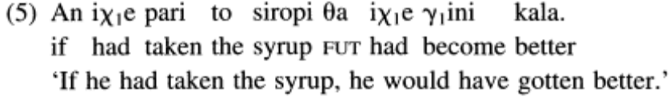

Future Morphology – Verb or Particle
English
Future is a verb (will)
Highest verb carries past in a past conditional CF, so the future will carry past
Modern Greek
Future is undeclinable particle (θα)
Highest verb carries past in a past conditional CF, not the future particle

Perfect/Imperfect Morphology
Perfect
English have take+n
Greek pari

Imperfect
English take+Ø
Greek eperne

A situation can be counterfactual to the past, present but not the future “as the future is conceptualized as not yet fact.”

(Iatridou 2000 uses “convey” in these early examples to be agnostic about whether the counterfactuality is asserted, presupposed, or implicated.)

Wishes

Non-Counterfactual Wish Formation

Counterfactual Wish Formation
- Highest verb: C°() & F°()& T°(NonPast, Past) & Asp°()
- Embedded Clause: C°() & F°()& T°(Past) & Asp°()
The subject expresses a desire for things to be different from what they are/were.

Present Counterfactual Wishes (CF)
(1a) I wish I had a car.
(conveys "I don't have a car now")

Past Counterfactual Wishes (CF)
(1b) I wish I had had a car when I was a student.
(conveys "I didn't have a car then"; nothing about whether I have one now)”

Conditionals
The counterfactuality of conditionals is a conversational implicature
- The counterfactuality of conditionals can be canceled with out producing a contradiction
(3) If the patient had the measles, he would have exactly the symptoms he has now. We conclude, therefore, that the patient has the measles.”
“a CF conditional can be used to argue for the proposition in the antecedent. It also shows that it is utterable when the speaker believes the proposition contained in the antecedent (which can also be made clearer by the fact that it is possible to append the parenthetical which he does to the antecedent).”

- The counterfactuality of conditionals is not an assertion, we can assert the falsity of the antecedent without producing redundancy/“begging the question” (Stalnaker 1975).
(4) If the butler had done it, we would have found blood on the kitchen knife. The knife was clean; therefore, the butler did not do it.
“If the first sentence of the discourse in (4) asserted (or presupposed) that the butler was not the guilty party, then the last sentence would feel like a repetition rather than a conclusion drawn from the preceding premises.”
Conditional Morphology - C°
English if (Iatridou ignores English then in her examples, see Iatridou 1994)
(2b) If he had been smart, he would have been rich.
Greek an (acts like English if)
Footnote2.i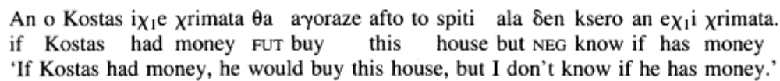
Greek na (asserts counterfactuality and so will be ignored in discussion)
Footnote2.ii

Non-Counterfactual Conditional Formation
- Antecedent: C°(if) & F°()& T°() & Asp°()
- Consequent: C°() & F°()& T°() & Asp°()
If it rains, we go to the park

Counterfactual Conditional Formation
- Antecedent: codependences in past and perfect make general form unclear
- Consequent: codependences in past and perfect make general form unclear
*If he is smart, he would be rich.
*If he was smart, he will be rich.
#If he was smart, he was rich.

Present Counterfactual (PresCF) Conditional formation
- Antecedent: C°(if) & F°()& T°(subjthing) & Asp°()
- Consequent: C°() & F°(Future)& T°(Past) & Asp°()
- Conveys that the antecedent (p) and consequent (q) of a conditional (p → q) do not hold at present.
(2a) If he were smart, he would be rich.
(conveys "he is not smart" and "he is not rich")

Past Counterfactual (PastCF) Conditional formation
- Antecedent: C°(if) & F°()& T°(Past) & Asp°(Perfect)
- Consequent: C°() & F°(Future)& T°(Past) & Asp°(Perfect)
- Conveys that p and q did not hold at a particular time in the past, and it remains neutral with respect to whether p or ~p (or q or ~q) holds at present.
- No future orientation, Cannot be uttered as instructions to a caregiver.
(2b) If he had been smart, he would have been rich.
(conveys "he was not smart" –in general or on one particular occasion-and "he was not rich")

Future neutral vivid (FNV) counterfactual conditional formation
- Antecedent: C°(if) & F°()& T°(NonPast) & Asp°(Perfect)
- Consequent: C°() & F°(Future)& T°(NonPast) & Asp°(Perfect)
- Future orientation, it can be uttered as instructions to a caregiver.
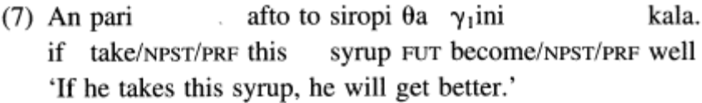
Future less vivid (FLV) counterfactual conditional formation or,
- Antecedent: C°(if) & F°()& T°(Past) & Asp°(Imperfect)
- Consequent: C°() & F°(Future)& T°(Past) & Asp°(Imperfect)
- Future orientation, it can be uttered as instructions to a caregiver.
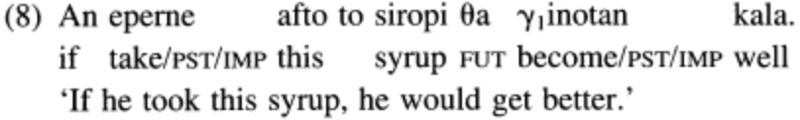
(9) Future less vivid conditional (first approximation)
Assertion: the reader's favorite semantics for an FNV conditional ‘if p, q’
Implicature: the actual world is more likely to become a ~p world than a p world
(Not Entailment: the counterfactuality remains unaffected by negation (11) ‘It is not the case that if he took the syrup, he would get better.’)
(9) conveys the meaning that the patient is less likely to drink the syrup than to not drink it. (9) does not mean that the drinking of the syrup and the healing are less likely to co-occur than to not co-occur.

The embedded clause in a Wish, the antecedent in a Conditional and the consequent in a Conditional must have past morphology. In English and Modern Greek they need future/modal too, but this is not true in other languages. Other than this English and Modern Greek seem to show sequence of tense (and aspect) the embedded clause agrees with the matrix clause in tense and aspect.

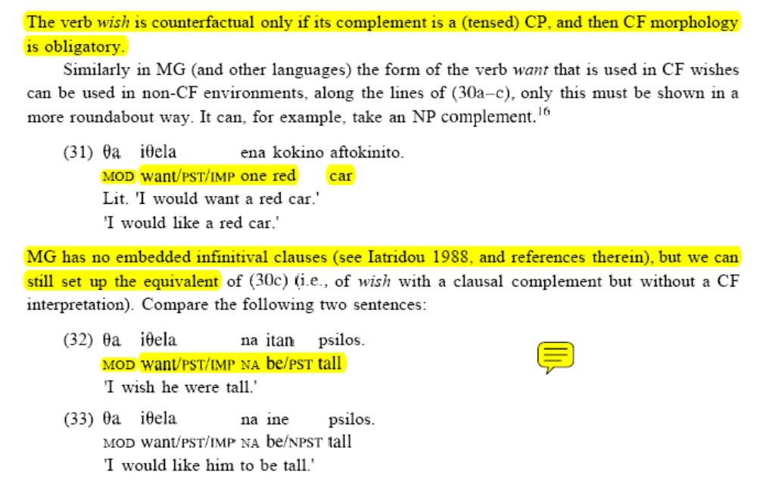

“with want, the meaning that A is not in a B world is cancelable (37)-(39), showing that A's not being in a B world is not part of the assertion of want. Such cancellation does not seem possible with wish (40)-(41).
(37) I have what I want.
(38) I live in Bolivia because I want to live in Bolivia.
(39) A: You're drunk!
B: Yes, and I want to be because only this way can I forget about . . .
(40) *I live in Bolivia because I wish I lived in Bolivia.
(41) *I am drunk and I wish I were drunk.
So the A-not-being-in-a-B-world meaning of CF wish (or of want augmented by CF morphology in languages like Greek) is stronger than that of plain want; in other words, it is not cancelable. This means that the meaning of counterfactuality associated with CF wishes is not reducible to the presence of want. I will therefore assume that the difference is located in the CF morphology, which is where CF wish differs from want.” (Iatridou 2000)

“(42) John wishes he were married to exactly the type of woman he is married to but he doesn't know it.
(43) In the movie True Lies Jamie Lee Curtis wishes she were married to an exciting person and she is.
(44) (Said by an expert on van Gogh:) Jean, who lives in Arles, wishes he lived in a place where van Gogh had spent some of his life. Poor Jean! He thinks that van Gogh was an Icelander who never left his island.
What (42)-(44) show is that the counterfactuality is subject-, not speaker-oriented. If the subject is the speaker, as in (40)-(41), then the counterfactuality appears noncancelable. If the speaker is not the subject, then the counterfactuality is cancelable with respect to the beliefs of the speaker. We might be able to capture these intuitions with paraphrases like the following:
(45) A wishes that B (CP): A thinks that if she had B, she would be happy (that she has B
(46) A wants B (INF/NP): A thinks that if she has B, she will be happy (that she has B)
These paraphrases capture the fact that the counterfactuality of CF wishes is subject-oriented and not speaker-oriented, since they contain an opacity-inducing attitude verb. In addition, they capture the fact that the desire expressed, even if it is about a situation in the past, is a desire the subject has in the present. Possibly they should make us suspect that the only true CF environment is the CF conditional and that CF wishes are counterfactual because they contain CF conditionals as part of their meaning." However, I will leave further reduction between CF wishes and CF conditionals for a different occasion.” (Iatridou 2000)

Past tense morphology in world semantics Iatridou 2000
“I propose that what we call the "past tense morpheme"-or rather, the feature whose phonetic realization we call the "past tense morpheme"-provides a skeletal meaning of the form (49).
(49) T(x) excludes C(x).
T(x) stands for "Topic(x)" (i.e., "the x that we are talking about"). C(x) stands for "the x that for all we know is the x of the speaker." From now on I will use the term exclusion feature (ExclF) to refer to the feature that, when it ranges over times, we call "past tense."
The variable x can range over times or worlds. When it ranges over times, we get
(50) T(t): the time interval (set of times) that we are talking about (I borrow the term topic time from Klein 1994)
(51) C(t): the time interval (set of times) that for all we know is the time of the speaker (i.e., utterance time)
We can now see that (49) will yield the following when its range is the time dimension:
(52) The topic time excludes the utterance time.
I will follow Palmer (1986), Vlach (1993), Kamp and Reyle (1993), and many others in treating tense as only past or present and woll as modal. It follows, then, that (52) means that the topic time is in the past with respect to the utterance time.I9 The above captures the fact that the past tense expresses a temporal relation of precedence between the topic time and the utterance time and not between the utterance time and the situation (or event) time (the interval throughout which the predicate holds).”

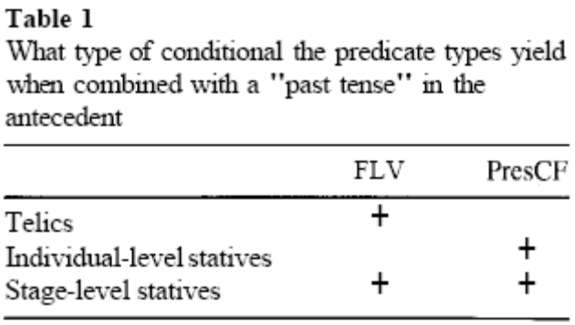

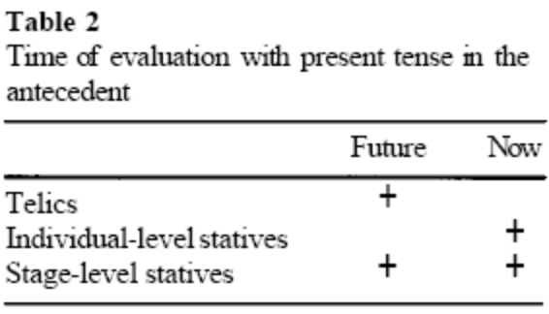
“the pattern shown in table 2 might be explained along the following lines. For nonstative predicates, the simple (i.e., nonprogressive) form in English is interpreted as a perfective (bounded). A perfective can never be interpreted as being contemporaneous with the utterance time. In fact, many languages simply lack the morphological paradigm for present perfective. In languages and environments that have this form, it is reinterpreted as past or future (Comrie 1985). Something like this may also be going on in table 2, where the telics are interpreted as perfective and the conditional construction permits them to be reinterpreted as being about the future.”

“24 Missing from this discussion are activities. They are well behaved with respect to the generalizations in tables 1 and 2; they have the " + " in the same place as telics. Activities in the bare form inside (English) conditionals are similar to telics, in that they are interpreted as inchoatives, effectively change-of-state predicates. That is, I f he pushes the cart means roughly I f he starts pushing the cart or I f he gets some pushing o f the cart done.”

“25 In many of the languages examined, FLVs and PresCFs have the same morphology-some exceptions being Hindi, Classical Greek, and Korean (see Han 1996 for the last). The languages in which PresCFs and FLVs have the same morphology are the languages where the same morphology is carried by all the predicates in table 2 (not table I!). That is, if a language needs a future marker in order to have its conditional antecedent interpreted in the future (left column of table 2), whereas it uses (e.g.) present tense in the right column of table 2, then FLVs and PresCFs will of course not have the same morphology. Such a case is Hindi (Rajesh Bhatt, personal communication).”
Example of Hindi FLV: uses future on telic and stage level
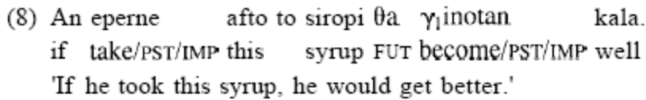
'If he took this syrup, he would get better.'
(?)Agr vo is syrup ko leta, to sahi lagega

Example of Hindi PresCFs: use present on individual level
(Iatridou 2) a. If he were smart, he would be rich. (conveys "he is not smart" and "he is not rich")
(?)Agr vo samajdar ta to vo kroro pati hoga

“How different are FLVs from PresCFs? What if they differ very little? Let us consider the present account under the following description: On the one hand, there are PastCFs, which have two ExclFs, one ranging over worlds and the other over times. On the other hand, there are conditionals that have only one ExclF, ranging over worlds. If one of these "single-ExclF conditionals" contains a telic predicate, the conditional makes reference to the future; that is, it is what I have called an FLV. If it contains an individual-level stative predicate, it is interpreted like a PresCF. If it contains a stage-level stative predicate, it can be interpreted as an FLV or as a PresCF. Under the above scenario, PresCF and FLV are names of interpretations of conditionals that have the same CF setup and differ only in the Aktionsart of their predicates”

“So far I have presented a way to treat the "fake" past tense morphology that appears in FLVs and CFs as a case of "real" morphology, by reinterpreting ExclF as an exclusion relation. Recall that CF conditionals and CF wishes in MG (as well as French, Hindi, and other languages) have one more morphological oddity; namely, they require imperfective morphology (henceforth Imp). I have argued that the actual job of counterfactuality is done by ExclF. This means that remaining elements of verbal morphology do not contribute necessary elements for the CF meaning.”

“Many languages have a form to mark an eventuality as ongoing without necessarily having to use that form in counterfactuality. Such progressive markers are used in CFs only when the speaker is truly talking about an ongoing eventuality.”

“the progressive is never "fake" in English CFs the way Imp is "fake" in MG CFs. Similarly to English, many Indo-Aryan languages (Punjabi, Nepali, Hindi, Assamese, Sindhi, Bengali) have a morpheme that marks ongoing events only, but none of those morphemes are a sine qua non of CF morphology. Similarly, in Romance the periphrastic progressive is not a necessary ingredient of CF morphology (though the imperfective is).”

“In MG, as we saw, CFs and generics have the same aspectual marking. The same holds for Romance. And in English as well, CFs and generics share the same form of the verb.
(82) If you ate this, you would get better.
(83) Dinosaurs ate kelp.
“In addition to MG and Romance, of the Indo-Aryan languages, Punjabi, Hindi, Bhojpuri, Gujarati, Bengali, and Marathi must always use their habituality marker in CF morphology, even when there is no habitual or generic meaning; that is, we are dealing with a fake Hab”

“in Hindi as well it is possible to show that Hab is fake in CFs (Bhatt 1997). Outside CFs, Hab cannot cooccur with the progressive marker, as is shown in (84a). However, Hab can cooccur with the progressive in CFs, as in (84b), with CF ongoing events. In such a case the progressive is needed to convey the semantics of the ongoing eventuality, and Hab is there because it is an obligatory part of CF morphology.
(84) a. *Meera do baje bhaashaN de rahii ho-tii (hai).
Meera 2 o'clock speech give PR0G.F be-HAB.FP RS
b. Agar [Meera kal do baje bhaashaN de rahii ho-tii] to
if Meera yesterday 2 o'clock speech give PROG.F be-HAB.Fth en
Shyam-ne us-ko zaroor dekh-aa ho-taa.
Shyam-~~hGer -ACCd efinitely see-PRF be-HAB
'If Meera had been giving a speech yesterday at 2 o'clock, Shyam would definitely have seen her.'
There are other grammatical elements that cannot cooccur with Hab except in CFs. For example, Hab cannot appear on individual-level adjectives with proper name subjects, as in (85a). However, it must appear in the related CF antecedent, as in (85b).
(85) a. Yusuf lambaa (*ho-taa) hai.
Yusuf tall be-HAB PRS
b. Agar [Yusuf lambaa ho-taa] to us-ko yeh naukrii mil
if YUSUta~ll be-HABt hen he-DATt his job.^ ~OU~~(UNACCUSATIVE)
jaa-tii.
GO-HAB.F
'If Yusuf was tall, he would have gotten this job.'
From the above discussion it becomes obvious that Hindi is like MG and other languages in which one and the same morpheme appears in generics and in CFs. This covers (84b) and (85b). The explanation for (84a) is obvious, but what about (85a)? If Hab is a marker of habitualitylgenericity, shouldn't we expect it in (85a) as well? I will suggest a solution to this once we have understood the role of ImpIHab in CFs.”

“the languages in which ongoing events and generics share the same form are a subset of the languages in which generics and CFs share the same form. As I said earlier, Imp can appear in ongoing events, generics, and CFs alike. If there is a split, then ongoing events choose a separate form (which convention would call ''progressive"), and generics and CFs go together.”

 | Language 1 | Language 2(MG,Hindi,English) | * Language 3
Progressive | B | B
Imperfective | A | B, A?
On going events | A | B | B
Generics | A | A | A
CounterFactuals | A | A | B

“The proposals by Newton, Cipria and Roberts, and Bonomi all postulate some universal force in Imp in generics, and even though genericity itself is actually not a case of universal quantification (Carlson 1989 and many others) … proceed to a suggestion that does not rely on universal force, because there is at least one more environment in MG where Imp necessarily appears and where universal quantification is clearly not the issue… footnote 34 Actually, universal force is not the appropriate characterization anyway, as Imp appears when the overt quantifier does not have universal force. Newton's "scenarios" seem a more appropriate characterization.
(i) Ekini tin epox,i piy,cna poli spania stin eklisia.
during that period went very rarely to church
'During that period I went to church very rarely.' “

“taking would to consist of ExclF and woll, in the presence of ExclF the time anchoring of the embedded clause is left ambiguous, or open. When will appears, time counts from the moment of utterance.”

“As for Indo-Aryan, at least in Hindi there do not appear to be any morphological shifts that accompany sequence of tenses (Rajesh Bhatt, personal communication).”

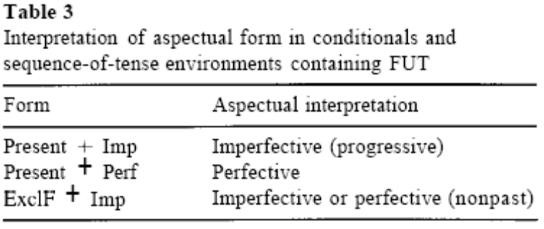

“in this particular sequence-of-tenses environment (future embedded under past), either ExclF is present, the underspecified reading is possible, and Imp can be fake (it can receive perfective interpretation), or there is no ExclF, no underspecified reading is possible, and the aspectual morphology is real (also the situation in CF environments). Table 3 contains a summary of how the aspectual morphology of the verb is interpreted in conditionals and in sequence-oftenses environments containing FUT.”

(93) When the temporal coordinates of an eventuality are set with respect to the utterance time, aspectual morphology is real; when the temporal coordinates of an eventuality are not set with respect to the utterance time, morphology is always Imp.

“The generalization in (93) is easily visible in the sequence-of-tenses facts, but we can also make it applicable to CFs and generics.”

“As has been pointed out many times (Carlson 1989 and others), a generic sentence may be true for a certain interval without the nongeneric predicate that it contains being true for that interval. As a famous example has it, the sentence Bears hibernate can be uttered truthfully in mid-August, when no bear is hibernating.”

“In other words, the predicate that the generic sentence is based on does not have any temporal coordinates, though the generic sentence that is built on it does. In still other words, temporal morphology modifies the generic sentence. The aspectual part of the verb, though, is under the level of derived genericity. The generalization in (93), then, predicts that the aspectual part of the verb is Imp in generics.
We can also now explain the mysterious Hindi fact in (85), repeated here. That (85b) (like (84b)) is acceptable, we can attribute to (93) the way we did for corresponding sentences in MG. But what about (85a), where Hab cannot appear on individual-level predicates, which is unexpected from the point of view of Imp in European Indo-European languages?”

“This behavior of tall contrasts with what we find in generic sentences based on verbs like eat, where the presence of Hab indicates that the underlying eventuality does not have a temporal specification, as in (95).
(95) Yunus machhlii khaa-taa hai.
Yunus fish eat.HAn PRS
'Yunus eats fish.'
The present tense in (95) temporally locates the habit of eating fish.”

“if a CF antecedent contains a derived generic predicate, we expect that two occurrences of Hab will be possible.
(96) Agar [Daoud roz paRhaii kar-taa ho-taa] to vo fel nahiiN ho-taa.
if Daoud daily study do-HAB be-HAB then he fail NEG be-HAB
'If Daoud studied every day (as a matter of habit), he would not have failed.'
In other words, (93) captures a variety of facts in Hindi as well. I conclude, therefore, that (93) governs the behavior of Imp in languages in which Imp appears as a necessary part of CF environments. This means that Imp does not play a necessary role in the expression of counterfactuality; instead, CF environments end up with properties that in turn dictate the presence of Imp.”

“Other languages have a subjunctive but do not use it in CF morphology (French, and all of the Indo-Aryan languages that have a subjunctive ..footnote 36 by subjunctive I will refer to the morphological paradigm different from the infinitive that appears in the complement of verbs of volition andlor command. Typically the subjunctive shows agreement for person and number and can have an overt subject.”

“Here are the facts with respect to MG [subjunctives]: it has very often been remarked that MG lacks infinitival complements. It has indicative complements introduced by the complementi~er oti or pu, and a second type of clause that contains the particle na. The issue is whether na clauses are, in fact, subjunctive, infinitival, or ambiguous between the two. But even if na clauses are subjunctive, what is relevant for our purposes is that there is no reason to believe that the subjunctive is involved in CF morphology in MG. First of all, there is no overt na particle in conditionals, and the negation, whcn present, takes the form dhen (which is the negation that appears in oti clauses) and not mi (the negation reserved for na clauses). One might consider that since the verb in MG conditionals can appear in perfectiveinonpast form, a morphological possibility only for na clauscs, not oti clauses, there are elements of nu clauses in conditionals after all, thereby raising the question of the subjunctive again. But even if this diagnostic truly tests for some "subjunctiveness," we should note that that is exactly not the form that appears in CF conditionals; instead, it is the form that appears in FNV conditionals. Therefore, for MG also there is no reason to relate the subjunctive (if it exists in this language) to counterfactuality.”

How about optative (what the speaker wishes were true ☺

“I am predicting, then, that the subjunctive will appear in CFs only if the subjunctive can cooccur with ExclF. In other words, I am predicting that the subjunctive will appear in CFs only in those languages that have a paradigm for past subjunctive. To my knowledge, this prediction is entirely verified: German, Italian, and so on, have a past subjunctive and use it in CFs. On the other hand, French, Indo-Aryan, and so on, have only a nonpast subjunctive and do not use it in CFs. I know of no exception to this rule. That is, I know no language that uses a nonpast subjunctive in (e.g.) a CF antecedent. In other words, if a language does not have a past subjunctive and must therefore choose between ExclF and plain (i.e., nonpast) subjunctive in counterfactuality, ExclF wins. All this shows that ExclF is indeed the element relevant to the meaning of counterfactuality.”

“the strong need for a subjunctive overrode other requirements (like staying loyal to the tenses of previous discourse), in CFs the opposite choice was made. This follows from the present account: the contribution of ExclF is substantive here, and without it counterfactuality could not be derived. If the subjunctive were an interpretive part of CF morphology (in the sense that it made the semantic contribution of counterfactuality), then we would expect the choice to have gone in its favor. There are varieties of Spanish that are currently losing the past subjunctive though they retain nonpast subjunctive. It appears that CF antecedents in these varieties uniformly carry the past indicative.”

“footnote 40 When the complement of such predicates is an NP, then its content is sufficiently marked as not being part of the subject's beliefs, without the issue of subjunctive arising.”

French conditional mood ends in in ait,ais that’s phonetically the same as hindi –e on chahiye.. ☺

“I will try to argue that what is referred to as "conditional mood" is in fact nothing but the indicative, that the Romance languages that are supposed to have it behave exactly the same as MG and English”
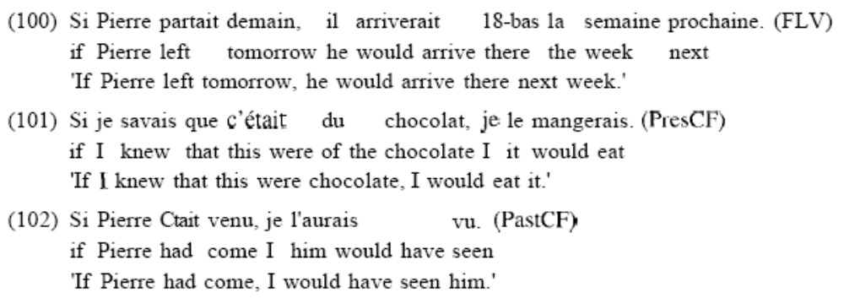

“In English the consequents of FLV, PresCF, and PastCF conditionals contain the futurelmodal verb will followed by an infinitival verb. As mentioned, however, this is not a serious difference between the languages. In MG the futurelmodal is expressed with an invariant particle, which cannot carry any morphology and therefore cannot carry ExclF either. In English the future is expressed with a verbal form, which, as the first element in a verb sequence, absorbs past tense morphology.”

“what would we expect to see in a language that (in the indicative mood) wants to put the future, ExclF, and Imp on one and the same verb? One way to combine the two would be to put imperfect ( = ExclF + Imp) endings on a stem that already has (some of) the morphology for the f ~ t u r e .I~n' short, this solution could very well look like (104), which is exactly the paradigm for what is described as "conditional mood."” …If the Mirror Principle were correct, then the forms would show that past is higher than future.
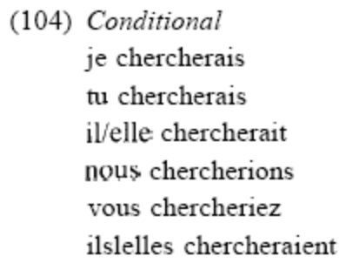

“I have argued that the past tense morphology that appears in MG and so many other languages in CFs is the main element responsible for the meaning of counterfactuality. I also argued that the designation [calling it] "past tense" is an accident of the fact that it has primarily been described in unembedded declarative sentences like John left. A closer look at a wider range of environments shows that the function of this morphology is a particular relation (exclusion) between a topic timelworld and the timelworld of utterance.”

Todos 070920: look through he references I had put in here.

-go more directly, look up semantics of “chah”
-cant find it, give up.

Compare want and give in Urdu:
Butt 2003
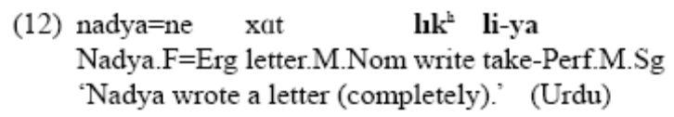Butt 2003
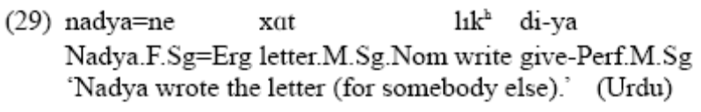Butt 2003
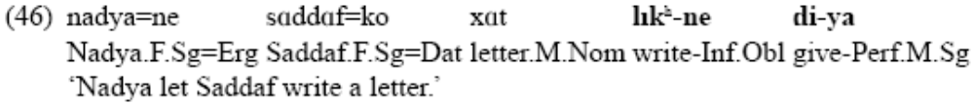
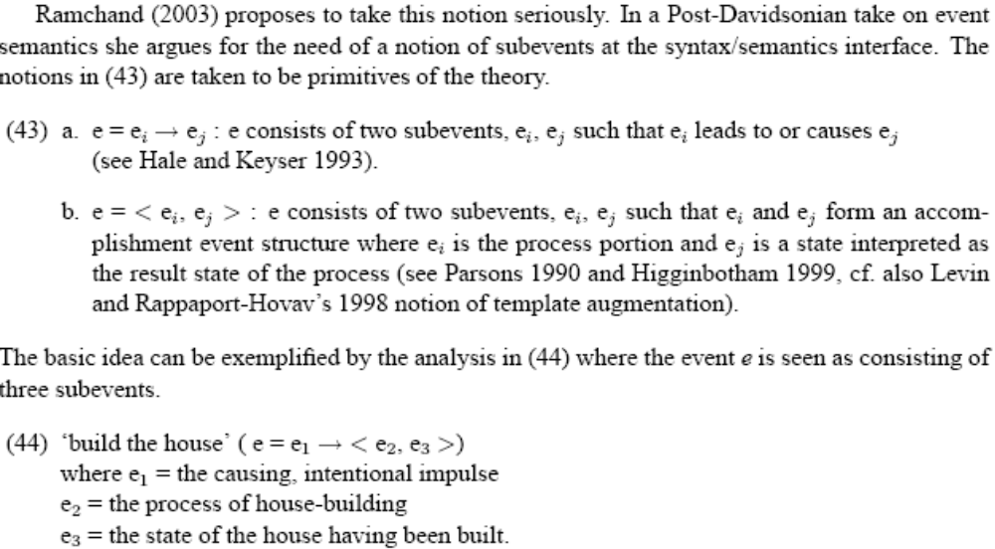
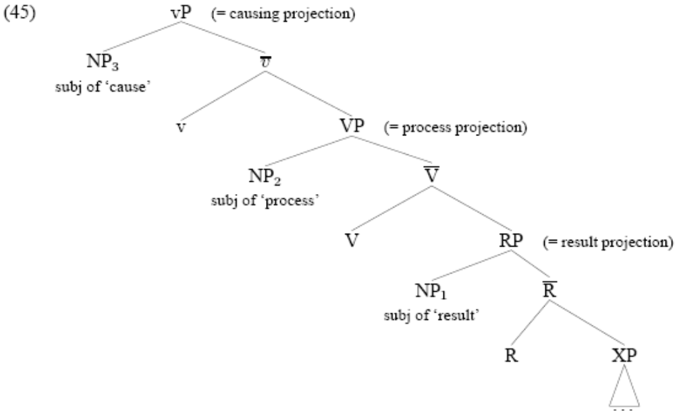
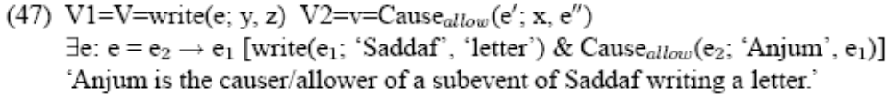
Permissives (verb-na dena) have no telic readings so there is no result in the structure in (48).
-dena takes verb-ne form
-dena can be scrambled away
-can stack on a light verb like lena

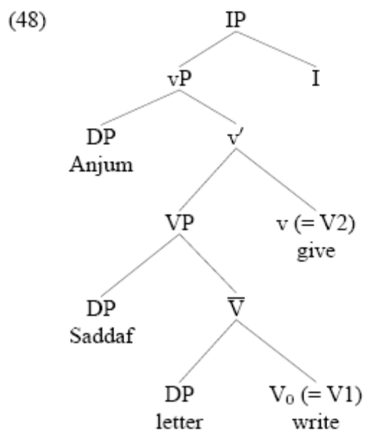
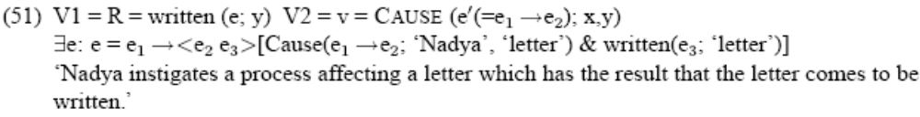
The (verb lena) has volition, lena is in V and denotes the process part of the predication.
-lena takes bare verb
-lena cant be scrambled away
-cant have an intervening
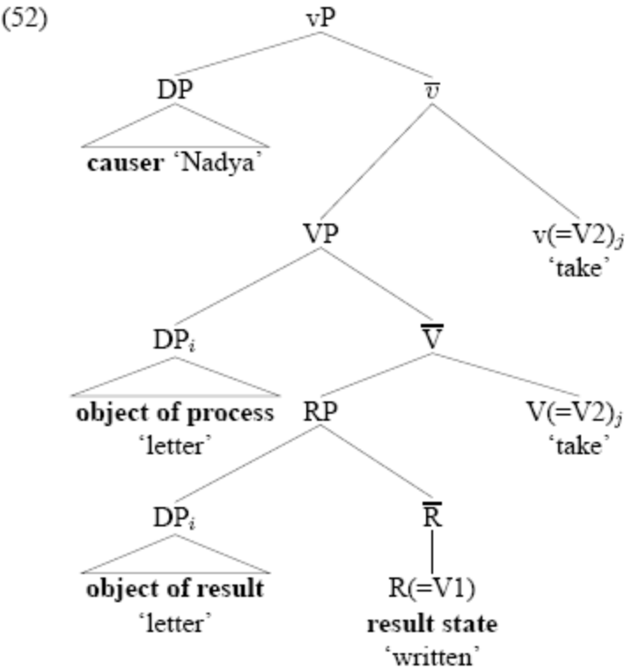
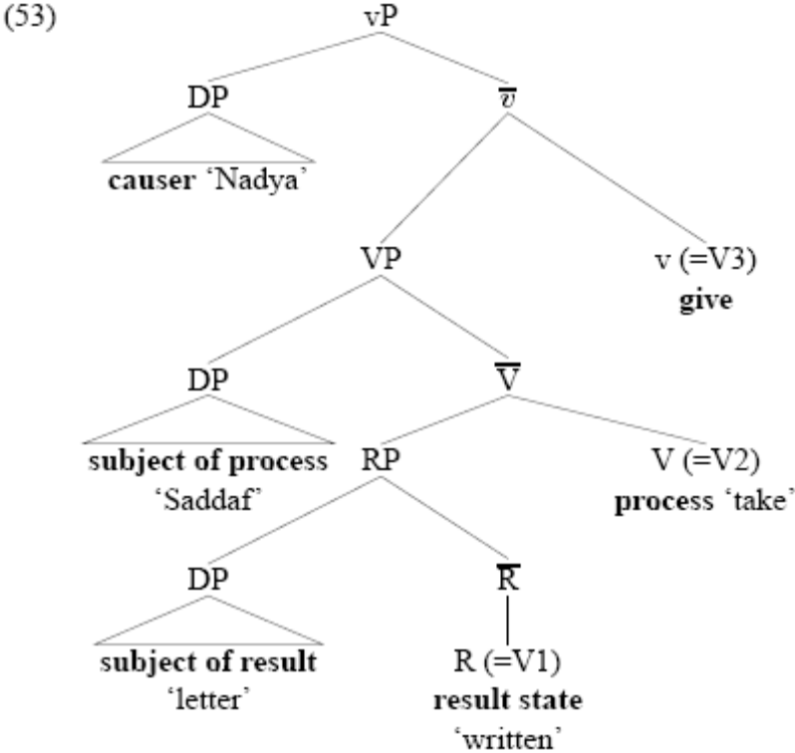

Lena doesn’t take a –na complement, lena is telic. Can it be that –na is atelic, or denotes a lack of a result phrase as butt suggests for the permissive in (48). Then the verb is in the process still or in the result?

Compare –na and bare forms
(32)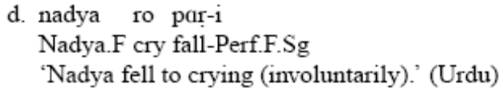
□ roni pari
□ rona para
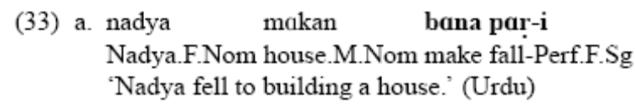

Keep reading boeckx and working on the LDA examples

References
Primary:
harley-2004-Wanting, Having, and Getting A Note on Fodor and Lepore 1998.pdf

Secondary:
Richards 2001
denDikken-2004-Agreement and Clause Union.pdf
bayer,schmid,bader-2005-Clause Union and clausal position.pdf
iatridou-2000-the grammatical ingredients of counterfactuality.pdf
.wurmbrand
Butt, M. (2003) The Light Verb Jungle. In G. Aygen, C. Bowern, and C. Quinn (eds.) Harvard Working Papers in Linguistics, 9: Papers from the GSAS/Dudley House Workshop on Light Verbs, 1-49.
-discuss V-V, differentiates auxilaires from light verbs. Not very useful.

butt-1995-The Structure of Complex Predicates in Urdu(searchable).pdf
boeckx 2004?
Appendix

The Data

Previous Structures
Mahajan 1990
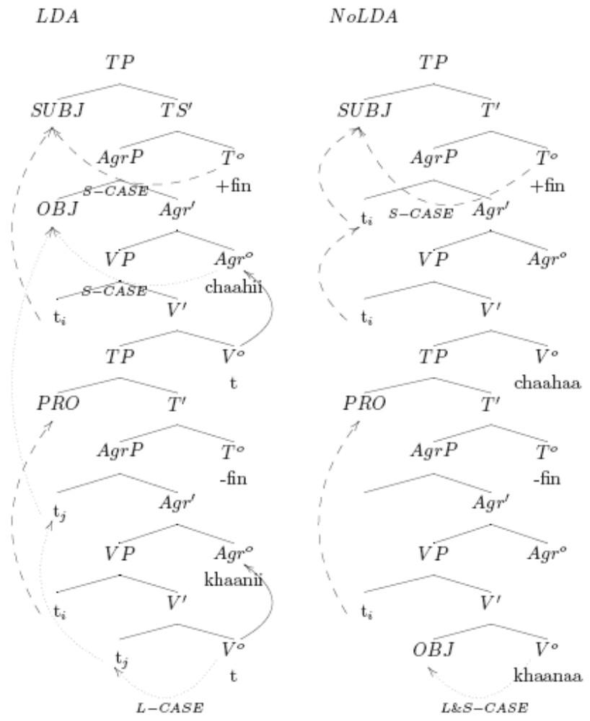

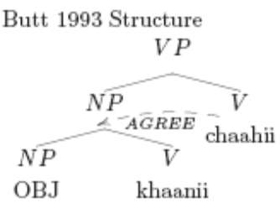
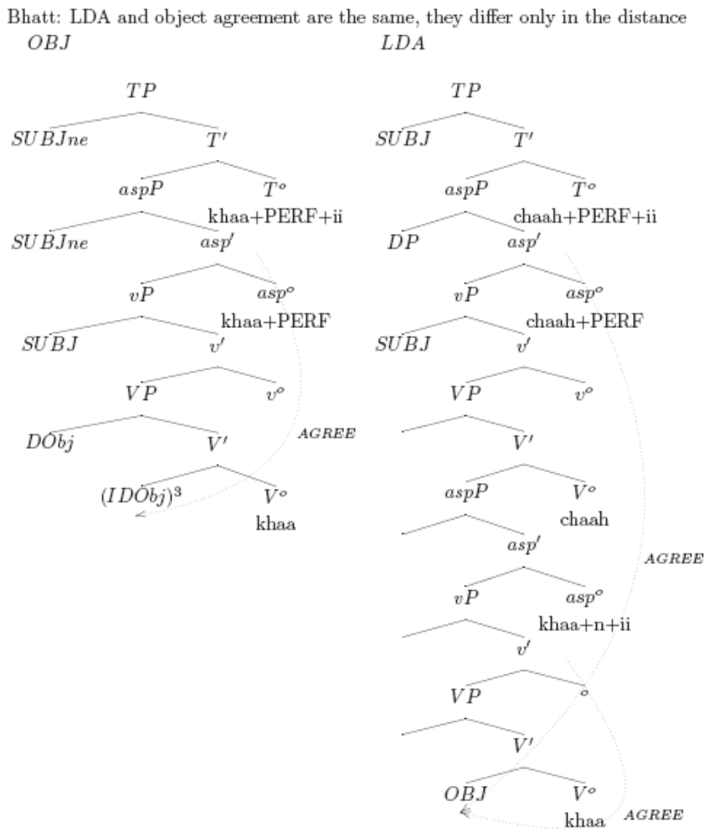

Chandra 2005-modern approach, control is movement al a hornstein
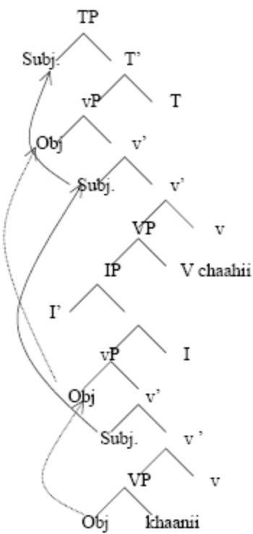

Since Chandra is the most reacent should I pay attention?
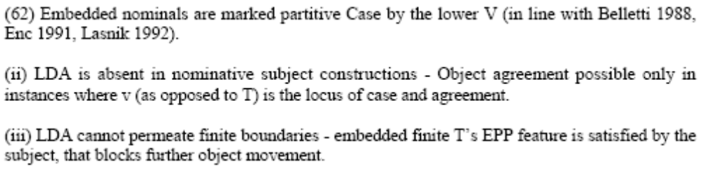

Specificity

Chandra2005
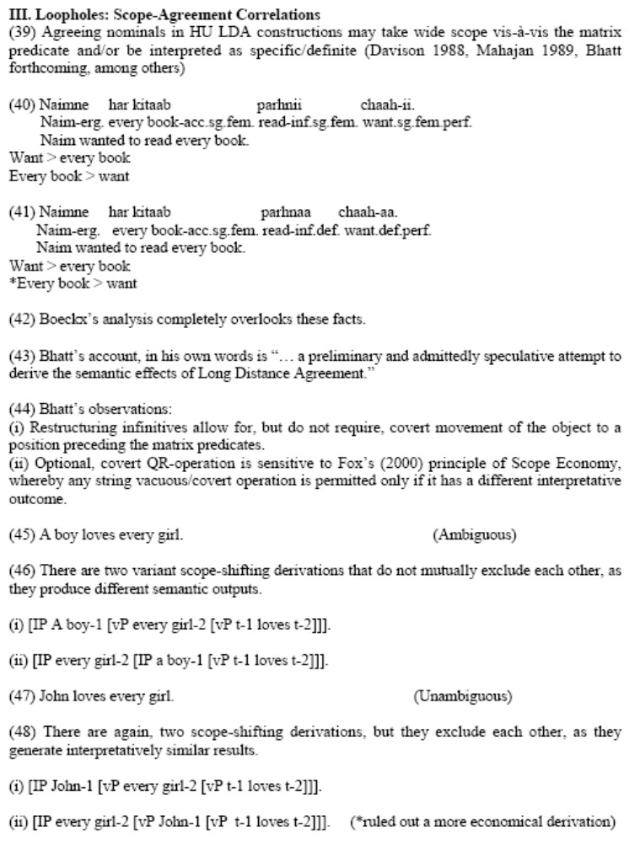
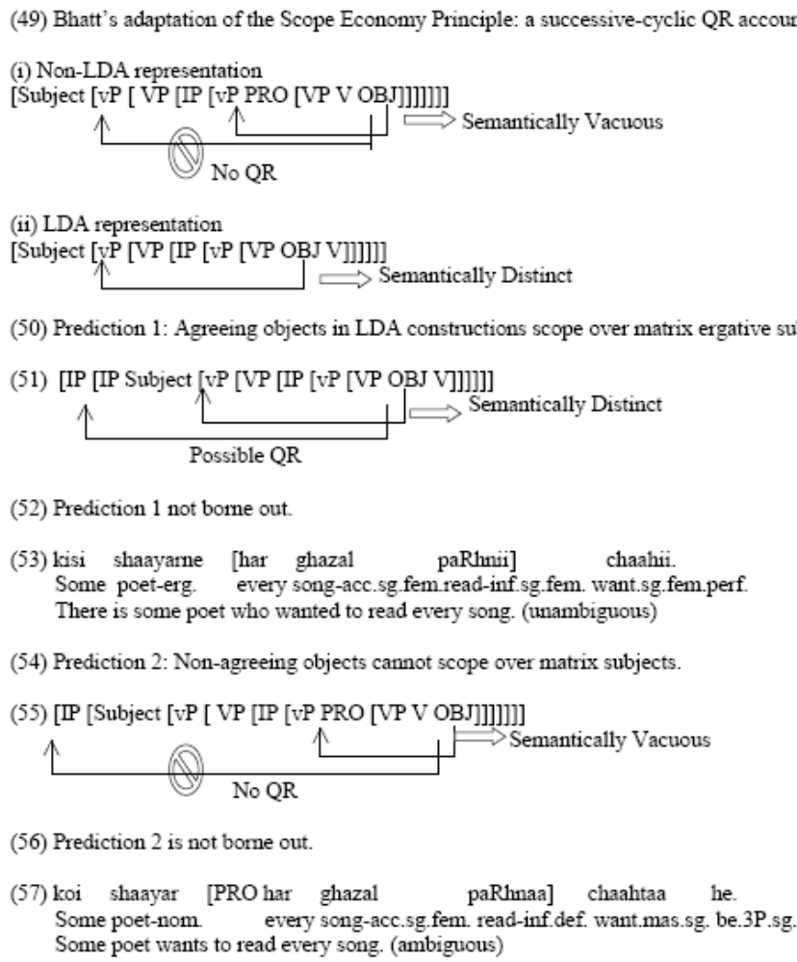
exactly
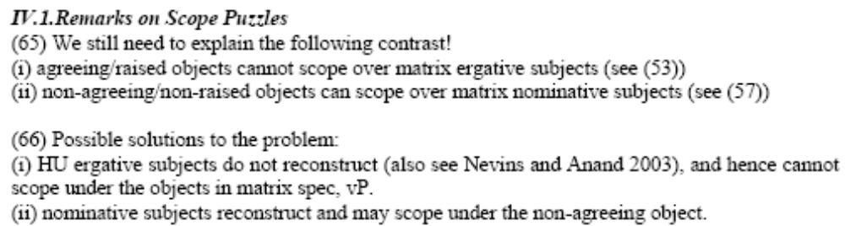

For an overview and introduction to event structure read Chapter 1 of Minjeong Son’s dissertation 2006 Causation and syntactic decomposition of events.
First linguistic discussion of events: Vendler’s 1967 ontology of event types. First philosophical discussion of events: Aristotle, Ryle (1949), Kenny (1963)
Semantic primitives CAUSE, BE, BECOME, DO? (Carter 1976; Dowty 1979; Jackendoff 1987, 1990; Levin and Rappaport 1998; Pustejovsky 1988,1991, 1995; Croft 1988; Parsons 1990)
Is this on a parallel with a generalized quantifier which takes something of type <e,t>,<<e,t>,t>? No, its more like <s,t> ,<x,<s,t>>
Mackridge (1987). (See also Philippaki-Warburton 1973, Joseph and Philippaki-Warburton 1987.)
Also called Future More Vivid

