Long distance agreement description

- review of verbs which take clausal complements
- description of LDA
- structure of ‘want’
- structure of the infinitival complement

English existential constructions (Boeckx 2004:24) seem agrees with embedded object [two men]
Icelandic LDA in existential constructions, seem agrees with embedded subject [they].
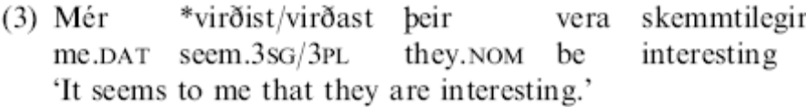

Hindi Agreement Kachru 1980:65
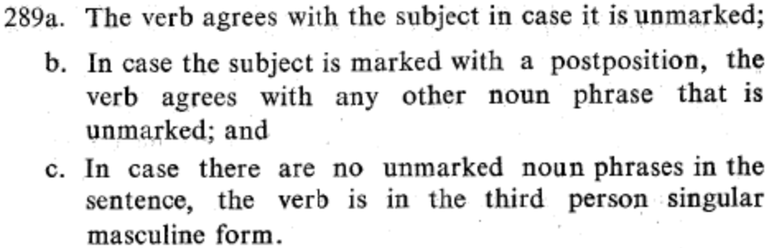

As a result, Hindi has a lot of object agreement.
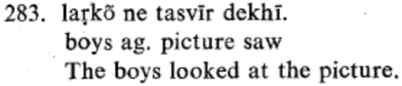

When you add an auxiliary, it also shows agreement.

Hindi LDA, past auxiliary agrees with embedded object [book]
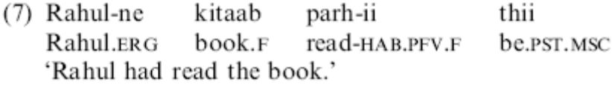

Hindi LDA, progressive auxiliary agrees with embedded object [cold]
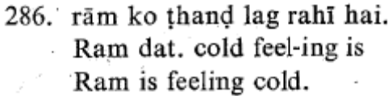(Kachru 1980:65)

The line between axillaries and main verbs is blurred in Hindi. Hindi has a number of verbs which act like auxiliaries or modals, these start to look like “long distance” as they appear more and more like lexical verbs.

Hindi LDA, get agrees with embedded object [picture]
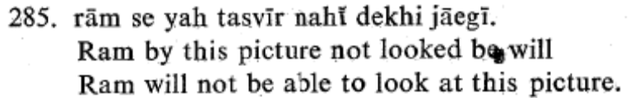(Kachru 1980:65)
‘Ram wont get to look at this picture.’

Hindi LDA, want agrees with embedded object [book] (Hindi is SOV)
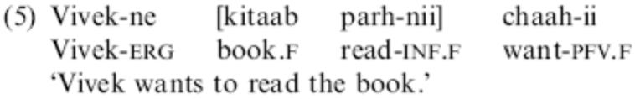
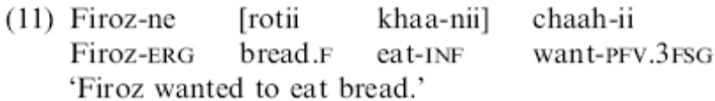

LDA can’t happen across an intervening potential goal [women] in the English existential sentence, [her] in the Icelandic LDA and [Shabnam] in the Hindi LDA below.
(relevant article to existential agreement and intervening potential referents, Kratzer agreement paper, also another case when agreement should but doesn’t happen: first conjunct agreement.) (footnote about to a woman changing the world and no long er an existential reading)
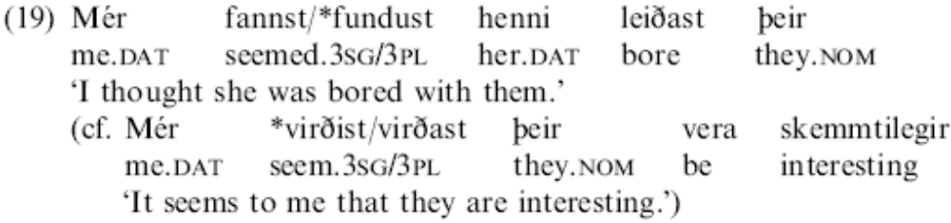
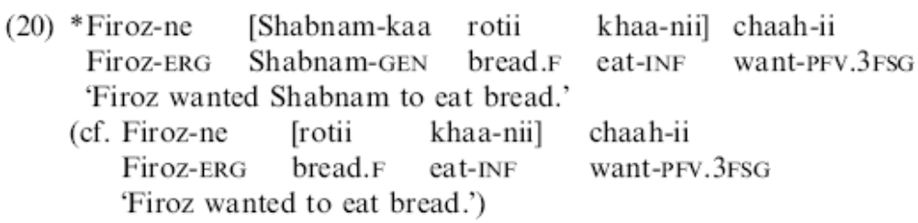

LDA can’t cross a CP (complementizer phrase) boundary.

For example

I think that john saw the dog.

[that] in English existential constructions or in Icelandic LDA. Hindi CPs are not in the typical complement position (SOV, but SVCP) and thus have no linear relationship to a sentence with a non CP. Making a test sentence doesn’t make sense (Bayer 2005).
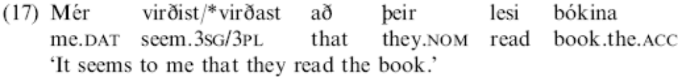
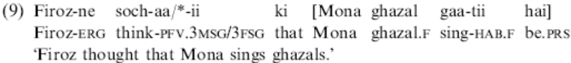

LDA happens prior to displacement: relativization of English existential constructions, topicalization in Icelandic LDA and scrambling in Hindi LDA.
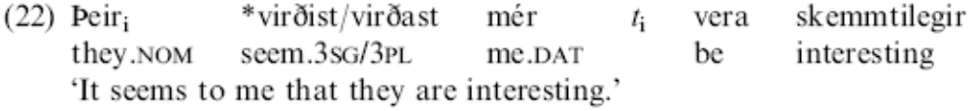
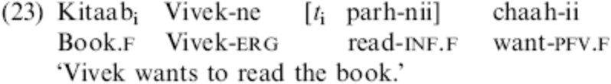

LDA can happen when [book] is sandwiched by adverbs.
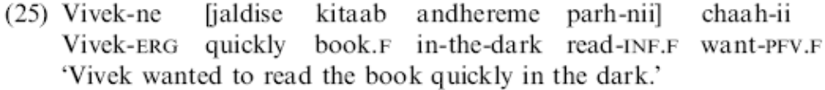

Hindi specific facts:
LDA occurs only with certain objects in Hindi:
√ Bare Object
χ Bare Object
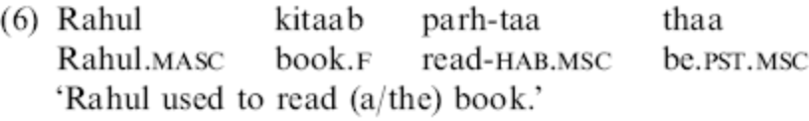
χ Case marked object
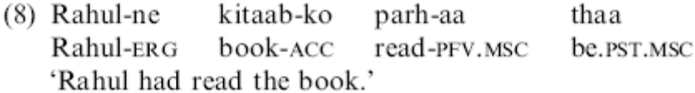

Some Hindi dialects are ‘parasitic’ (Mahajan, Bhatt), others aren’t (Butt: 14b is ok). The parasitic dialects are currently theoretically interesting as they raise questions:
1. is the intermediate agreement [cut] independent of the final agreement [want], or
2. is it part of chain formation upon the trigger for the final step of movement.
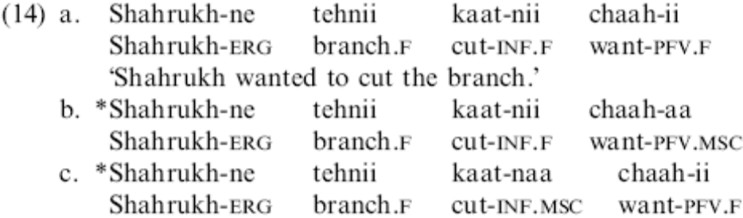

Theoretical Analysis
Feature Movement Analysis

Chomsky 2000 abandons Move-F for agree for conceptual reasons: Move-F requires feature chains, which like head chains are “at odds with optimization considerations.” (Boeckx 2004:29)

When feature movement takes place overtly the item left behind is PF defective and must raise close enough to the to the feature to be PF legible (i.e. in the spec of the head which now has the feature).

If we assume Hindi is underlyingly SOV, or if it is underlyingly SVO and becomes SOV by movement (Kayne’s LCA 1994) then at the end of the derivation [kitaab] which has lost its feminine feature will not be in the spec of the head which now has its feature [want].
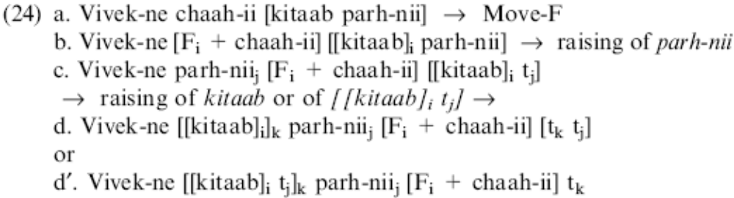

PF crashes were avoided in English existential constructions (Chomsky 1995) by doing covert feature movement.

However, covert feature movement is not possible because LDA can happen with scrambled objects. Scrambling moves the object beyond the c-command/attraction domain of [want] so want cannot covertly attract [book]’s feminine feature.

Spec-Head Analysis
LDA can occur with when the object [book] is sandwiched between adverbs.

A parallelism with romance clitic climbing

Clitic climbing: an argumental clitic from the embedded clause attaches to the matrix predicate.

Italian Clitic Climbing (Boeckx 2004:31)
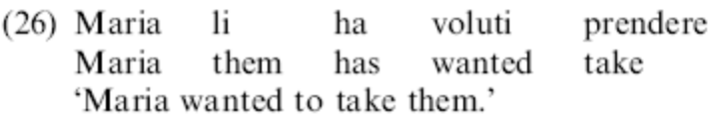

Clitic climbing can’t go over an overt subject [Gianni].
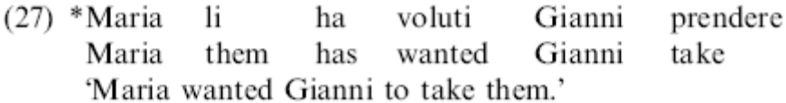

Clitic climbing can’t take place out of a CP [che]
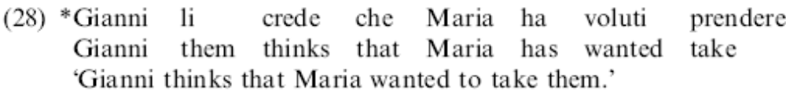

Infinitival complements are bare VPs lacking a v layer, thus no subject and no accusative case assignment (Wurmbrand 2001). Internal arguments of the lower V must ‘climb’ to get case licensed in the matrix clause.

Wurmbrand derives the optionality of clitic climbing by allowing the infinitive complement to be either VP (clitic climbing) or IP (no clitic climbing).

Boeckx claims that in Hindi LDA the infinitival complement is a VP, and the object is case licensed by the matrix predicate. In non-LDA cases the infinitival complement is an IP, and the object is case licensed in the lower IP and a (null) subject in the lower vP serves as a defective intervener and blocks agreement with [want].

Boeckx’s Agree Analysis
- Optionality is due to the presence/absence of functional heads.
- LDA’s directionality is downward, operating with in the C-command/internal domain of the attractor.
- LDA’s parasitic nature is due to Multiple agreement, which like vowel harmony all potential elements are valued due to spreading. The Probe [want] and finds [read] and a goal [book] and values both simultaneously.

Spreading in phonology is from a valued element to unvalued element. Downward spreading from the Probe [want] makes no sense, Upward spreading from the Goal [book] to all elements in its percolation domain which are unvalued for gender makes sense. We have to assume that Hindi infinitives and want are unvalued for gender. Matrix verbs are rarely valued for gender why is [want]? Is it lexically random whether a verb will agree by gender, or by person, or not at all? Or is there a systematicity in which verbs agree in gender, in person, or not at all? Are there any verbs which have forms both for genders and for persons?

“I speculate here that the infinitival verb in Hindi manifests agreement overtly because it is gerundive in character (thus more nominal than a straight infinitive, on a par with participles, which also manifest agreement).”

French past participle agreement

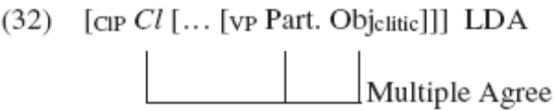

Particple agreement also happens when the object is A-bar moved (wh-movement, clitic left disclocation_

Our question: what is the structure of LDA?
How are the Hindi verbs [read-na] and [want] different from the English verb [to bareverb] and [be].

English sentences are SVO, the verb agrees with subject in person and number.
I see the dog

Generally English doesn’t have agreement with an apparent object:
*I sees the dog.

However, the data which is used when discussing LDA is not a canonical English sentence. The verb appears to agree with the object (or [there] can have covert person and number features which are the same as the features of the object).

A man is in the boat
There is a man in the boat.

Some men are in the boat.
There are some men in the boat

English Object agreement occurs in constructions which have been called Existential Inversion where there is a null expletive [there] in the subject position of [be], and the notional subject is in object position of [be]. There sentences have a tricky structure which has generated a lot of literature.

Is it surprising that in the cases where English allows apparent object agreement, English also has long-distance agreement?

There seems to be two men in the boat.

This is considered long distance because the agreement goes over the embedded verb [to be], parallel with the Icelandic and Hindi cases, except the embedded verb in Icelandic is an agreeing participle, and in Hindi it is an agreeing infinitive, and the embedded verb can be any lexical verb, its not restricted to [be]. We can assume that if infinitives showed agreement in English, we would expect the [to be] in this context to be marked as 3rd plural as well.

Unlike English, Icelandic and Hindi LDA are not restricted to existential constructions. LDA appears in what appear to be normal sentences with a variety of lexical verbs (read, eat) where no one has argued the structure is tricky.

Icelandic and Hindi LDA:
He wants to eat bread.

Although English there inversion works better when sentence contains [be] and a location, its marginally possible with a lexical verb like [walk].

The dog walks.
There walks the dog.

The dogs walk.
There walk the dogs.

My goal is to look more closely at the structures where LDA occurs. If English existential inversion indicates that the structure is exotic, maybe it is.

There is a great deal of literature on the connection between the copula (have a property), existentials (be in existence somewhere), locatives (be in existence somewhere), genitives (have a property), possession (be in existence, have an object) double objects (be in existence somewhere) and small clauses (have a property). We find that crosslinguistically, the way languages express these ideas are highly variable, often using things we would translate as have and be.

English copula is even null if its found in a small clauses.
I consider him Ø intelligent.

Russian null copula is found more often.
Ya Ø chelovek
I Ø human
I’m a human.

Hatian null copula is found in declarative sentences where the complement is an adjective phrase, prepositional phrase, or adverb phrase.
Liv-la Ø jon.
Book-the COP yellow.
The book is yellow.

Li te Ø an Ayiti.
She PAST COP in Haiti.
She was in Haiti.

Hindi and Japanese are like English in that they don’t have a null copula in these cases

Main student hoon
I student COP-1sg
I’m a student.

Neither does Japanese
Watashi wa gakusei da.
I TOP student COP
I am a student.

However, Hindi optionally has a copula in this sentence, which English doesn’t allow.

Main rotii khanii chahii hai
I bread eat want COP
I want to eat bread

I want to eat bread.
*I am want to eat bread.
*I am want eat bread.

What is this optionality of the copula?

Both the argument of the there sentences, and this optional copula may point to a need to look into this muky web of existential, locatives etc, and more crucially, my suspicion that hindi lexical verbs are not as ‘complete’ as English verbs, namely that they don’t lexicalize the V° head but are smaller.
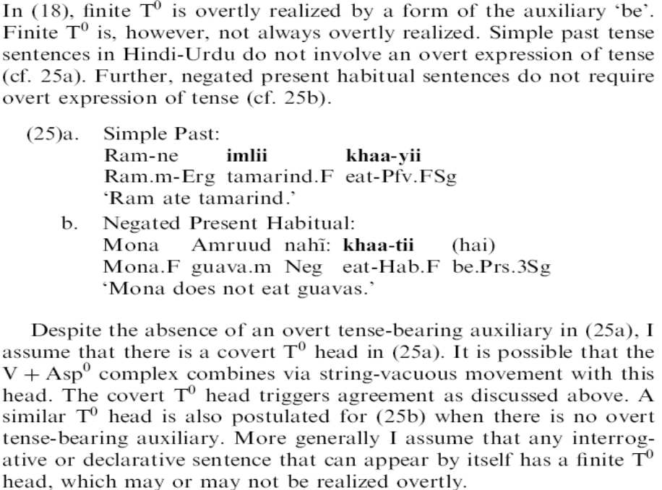
We will turn to some literature on lexical decomposition. I will argue something along the lines that Hindi verbs combine with PHAVE (the now-you-see-me-now-you-don’t mysterious morpheme that is behind the connections above) more (often) than English verbs.

Appendix
Bhaatt hai optionality

How much can there be in the object for LDA?
Pichle saal Mona apnii angutii chaahtii thii. Aj-kal, finally uske saas ki anguti us-ko sahii laktii hai.
Mona menge dupaTe bhii chaahtii thii.
Fahad to apnii angutii chaataa thaa

What other verbs are there that do LDA?

Ram-ko garii chalaa-nii attii hai.
Ram.M=DAT car-F drive-n-F come-F be.Pres.3sg
(adapted from Davison 1991)

The past auxiliary can agree with the matrix subject
Mona kutte-ko dekhtii rehtii thii

However, want can’t agree with the matrix subject.
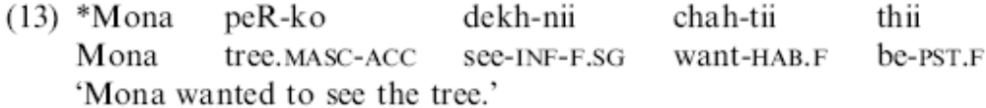
All authors use want, here are some ones to test:
- Caah ‘want’ (Bhatt/Mahajan:LDAoptional) ?
- Aataa ‘come’ (Butt:LDAoptional) Light verb
- Diaa ‘give’ (marks –naa as oblique) Light verb
- Liyaa ‘take’ Light verb
- Kiaa ‘do’ Light verb
- Lagaa put/hit/attach? Light verb
- Milaa? Meet Light verb

Auxiliaries that I’m pretty sure work:
- Thaa ‘past’ Aux
- Rahaa ‘progressive’ Aux
- Gaa ‘future’ Aux
- Huaa/hotaa ‘happen/copula” Aux?
- Gaay ‘passive/gone/went’ got X-ed(no erg) Aux?Light verb?
- baiTh `sit’ (no erg) Light verb

