The Oblique Form as a Syntactic Case in Hindi/Urdu

Goal of this paper: Show that Hindi/Urdu has an affixal case, which can be explained using an abstract syntactic case feature. This analysis implies that postpositions in Hindi/Urdu are not realizations of structural case, and thus they should not be considered when discussing case for Burzio’s Generalization, or in case and agreement anomalies. By eliminating the postpositions as structural case, my proposal simplifies case and agreement in Hindi/Urdu, and puts Hindi/Urdu inline with what we know about other languages. (Situations where Hindi/Urdu was used an example to argue for new theory of case and agremeent Mahajan 1990, Bhatt 2005, Legate to appear will be discussed later).

Proposal:

In Hindi/Urdu there are two phenomena relevant to case, the first is the realization of an abstract case feature on an argument (realized as an affixal case), the second is the realization of a functional head which introduces an argument (realized as a postposition).

- Markers of function-argument relationships, realized as case on the argument
 |  | Case Assigner
Abstract case | Ø | tº nominative
 | Ø | vº accusative
 | -e | pº oblique

- Markers of function-argument relationships, realized as functional heads
 |  | Semantic denotation | Case Equivalent
(No claim) | Ne | AGENT(x) | ergative
Functional head | Ko | APPLIC(x) | dative
 | Se | INST(x)  SOURCE(x) | instrumental, source
 | Kaa | EXISTS(x), HAVE(x) | genitive
 | me͂ | IN(x) | innessive
 | Par | ON(x) | onessive
 | Tak | TO(x) | Toward, until
 | dvaaraa | CAUSE/AGENT(x) | through, by means of

What is novel in my proposal is that the number of cases in Hindi/Urdu which are relevant to case and agreement discussions has been limited to 1, the affixal case on objects of postpositions, furthermore this is a case that has yet to be discussed in the case and agreement literature. Previous discussions of case have included all of the postpositions shown in Table 3. Only Mohanan 1994 includes the case I discuss, which she refers to as the oblique noun form.

- Previous Proposals of Hindi/Urdu Case
Mahajan 1990 | Mohanan 1994 | Butt 2004
  Ø | nom
  Ø | acc
  ne | erg
  ko | dat
  Ø | nom
  ko | acc
  ne | erg
  ko | dat
  se | instr
  kaa | gen
  me͂/par | loc
  OBL | non-nom
  Ø | Nom
  ko | Acc
  ne | erg
  ko | dat
  se | instr
  k- | gen
  me͂/pɑr/tɑk/Ø | loc

Previous proposals of Hindi/Urdu case only consider postpositions.

Davision says explicitly that “all case is realized by postpositions, except for nominative case.” (Davison 2004:202)

However, it is well known that Hindi/Urdu nouns alternate between ‘direct’ and ‘oblique’ forms. The ‘oblique’ is found on the complement of a postposition in (4a), the ‘direct’ is found when no postposition is present (5). The forms are obligatory as shown in (4b) and (5b).

- Oblique form of gahde is obligatory on objects of postpositions
a. [us gadhe se] le lo
that.OBL donkey-M.SG.OBL from take-SUBJ take-2nd.sg
‘Take it from that donkey.’
b. [*wo gadha se] le lo
that.DIR donkey.MSG.DIR from take-SUBJ take-2nd.sg
‘Take it from that donkey.’

- Direct form of gadhaa is obligatory when not an object of a postposition
a. [humaaraa gadhaa] ghaas kha rahaa hai
our.DIR donkey.MSG.DIR grass eat IMPERF.M.SG 3.SG ‘Our donkey is eating grass.’
b. [*humaare gadhe] ghaas kha rahaa hai
our.OBL donkey.MSG.OBL grass eat IMPERF.M.SG 3.SG
‘Our donkey is eating grass.’

We can consider the oblique form to be similar to the accusative -m on ‘him’ in the English structure below.

- Complements of prepositions in English are accusative
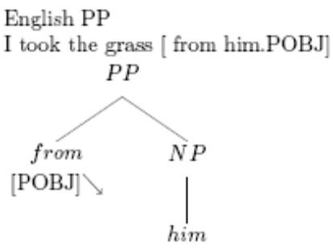
- Complements of postpositions in Urdu are oblique
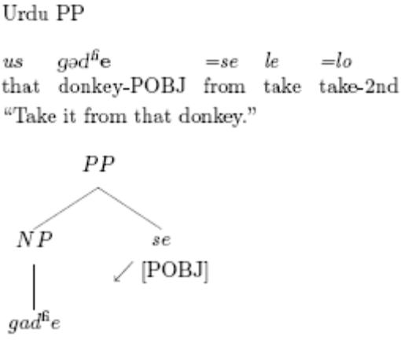

I claim that the oblique noun form should also be considered when discussing Hindi/Urdu case and agreement. The alternation in the oblique/direct forms is an instance of a affixal case rather than postpositional.

Why is this interesting?

The Hindi/Urdu data raise a question of the difference between suffixal and prepositional case. Can the exponence of case (word vs affix) be a direct indication of its reality in the syntax (head vs feature)?

Previously (a long time ago) there wasn’t supposed to be any difference, both affixes and adpositions were considered to be case markers. This was needed as adpositions such as English “to” appeared to have non-uniform semantics, and the syntactic functions of accusative case which was affixal in Latin. However in Hindi/Urdu a number of other properties align with the affix/adposition distinction.

There are two hypotheses. The first hypothesis is that both affixes and adpositions are realizations of case (features), and the spell-out differences are similar to the spell out differences of the comparative for smaller vs more intelligent.

The second hypothesis is that differing spell-out reflects a difference in the syntax; adpositions have uniform semantics and introduce arguments and are hence not case, or realizations of case features. Affixal case shows properties in common with syntactic features such as gender, it can appear on all elements in an NP/DP, thus it should be handled syntactically and at spell-out the way that gender is handled (this could be as syntactic features, although its not the only way).

What is clear is that there are two elements with differing syntactic behavior: elements which appear on all members of a DP, and elements which appear outside the DP. Whether or not the division between these two elements is head vs feature I have no claim since I think the differences can be seen as part of current debate about syntactic structure, are there feature bundles and terminal nodes are spelled out (Distributive Morphology) or are features also nodes in the syntactic hierarchy and treelettes are spelled out (Nanosyntax, and maybe kratzers agreement paper).

This also relates to the debate about whether verbs can take two arguments, or if the verb only introduces 1 argument at a time and has a separate co-element (null functional head, auxiliary verb or preposition) which serves to introduce the other arguments. There is evidence in hindi urdu that verbs never introduce arguments, they need modals and light verbs, and now im saying they need adpositions, where as English verbs can appear to introduce arguments. This is the reason why hindi-urdu doesn’t have case like English does, and why the only case in hindi urdu is that of the complement of a postposition and light verb. The light verb part is more tricky, but still kind of cool since its also realized as the oblique form. There is another hypotheseis that can be considered when I collect more data, that the oblique for is the default form for nouns, its found in a number of situations where there is no postposition to case assign it… but I need more data to know where those are.

I would also like to rename the oblique as accusative, it says I am the direct object of something.

The affix/adposition distinction might turn out to not be well-founded, but at least I’m bringing up new data for consideration.

Exponence of the “oblique”

The phonological shape of the oblique stem depends on (a) the final phonological segment, and (b) grammatical and natural gender of the word. (Mohanan 1994:61)

In (8) below the final -a ending of the ‘direct’ masculine gadha ‘donkey’ alternates with the oblique –e in gadhe ‘horse-OBL.’

- The oblique forms of nouns (Shukla 2001)
 | Singular |  | Plural
 | Direct | Oblique | Direct | Oblique
Masculine
a) | gadha | gadhe | gadhe | gadho͂ | ‘donkey’
b) | mez | mez | mez | mezo͂ | ‘table’
Feminine
c) | gadhi | gadhi | gadhia͂ | gadhio͂ | ‘female donkey’
d) | bahu | bahu | bahue͂ | bahuo͂ | ‘daughter-in-law’

Pronouns also show a ‘direct’/‘oblique alternation. In (9) below the nominative stem for 1st singular is mɛ͂ while the oblique stem is mʊj^{h}.

- The oblique forms of pronouns (Shukla 2001)
 | Singular |  | Plural
 | DP | [DP from] | DP | [DP from]
1 | mɛ͂ | mujh se | hum | hum se
2 | Tum | tum se | ap | ap se
3 Prox | Ye | is se | ye | in se
3 Dist | Vo | us se | vo | un se
3 Rel | Jo | jis se | jo | jinho se
3 wh person | kɔn | kis se | kɔn | kinho͂ se
3 wh thing | Kya | kis se | kya | kis se
Place Prox | yaha͂ | yaha͂ se | yaha͂ | yaha͂ se
Place Dist | vaha͂ | vaha͂ se | vaha͂ | vaha͂ se
Place Rel | jaha͂ | jaha͂ se | jaha͂ | jaha͂ se
Place wh | kaha͂ | kaha͂ se | kaha͂ | kaha͂ se
Quantity | itna/itni | itne
Quantity Rel | jitna/jitni | jitne
Quantity wh | kitna/kitni | kitne
Time wh | Kab | kab se | kab | kab se
3 indef person | Koi | kisi se | koi-koi | kisi-kisi se
3 indef thing | Kuch | kuch | kuch-kuch | kuch-kuch se
Place indef | kahi͂ | kahi͂ | kahi͂-kahi͂ | kahi͂-kahi͂ se
Quantity-Rel
Time indef | Kabi | Kabi se | kabi-kabi | kabi-kabi se

These forms have been described in Hindi/Urdu grammars (Kachru (1965), Kachru (1980:26), Pray (1970), McGregor (1972), Hook (1979), and in LFG literature, Mohanan (1994), Butt & King (2004)).

Yet, so far the GB/P&P/Minimalist literature on Hindi/Urdu case and agreement discuss only postpositions, overlooking the oblique forms. The oblique is not glossed in Mahajan 1990, Kidwai 2000, Davison 2004 and Dayal 2003, 2004.

- jaane kaa (Mahajan 1990:160)
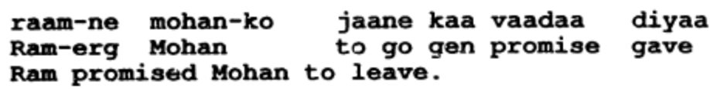
- larke-ko (Kidwai 2000:65)
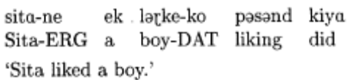
- is laRkee-koo (Davison 2004:209)
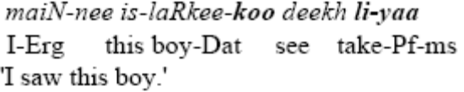
- apne kamre meN (Dayal 2003 D23)
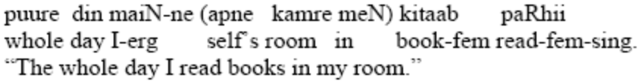
- kamre meN(Dayal 2004:403)
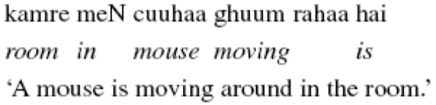

Bhatt 2005 includes it in his glossing on gerunds, but not on nouns, and doesn’t discuss its properties.

- larke-ne Sita-se [kitaab parRh-ne]-ko (Bhatt 2005:780)
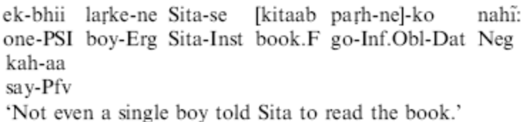

Only Mohanan 1994 includes the gloss and a discussion of its appearance. Her LG account will be discussed in the next section.

- bacce-ke liye(Mohanan 1994:62)
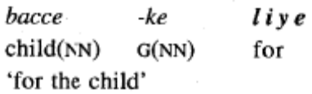

Previous Discussion of the Oblique

Previous accounts of the oblique have discussed the oblique in terms of an inflectional paradigm in the lexicon. This approach is the most straightforward as the oblique is not regular; it appears differently on nouns of different gender, and some nouns, adjectives and demonstratives don’t have an overt difference between direct and oblique forms. In this paper I will show that a uniform, syntactic analysis of the oblique’s presence can be provided, if we adopt a theory of abstract case features which are determined in the syntax, and phonological realization of the case features are determined in the morphology (following Legate to appear).

The oblique has been discussed in the LFG framework; however both LFG accounts locate the oblique formation in the lexicon.

Mohanan 1994 (Mohanan refers to the oblique as the nonnominative form):
- “just as stems carry information such as SINGULAR or PLURAL, they also bear the case features NOM, NONNOM, or VOC.” (Mohanan 1994:61)
- “NONNOM stems must take a case clitic after them” (Mohanan 1994:62)

Butt & King 2004:
- The oblique is an agreement inflection on the complement of a K head (case postposition)
- Butt & King see “this remnant of the Sanskrit system as ensuring synchronic morphological wellformedness: if the noun is in the oblique form, then modifying adjectives must also be in the oblique form.” (Butt & King 2004:168)
- The older morphological affixes (such as the oblique) may be part of the case system in other South Asian languages. (Butt & King 2004:173)

However, researchers in LFG are calling for a development in their framework to deal with case.

Butt (2005) notes that “the differing realizational possibilities for case markers … one could argue about whether all of these different morphosyntactic creatures should all be lumped together under the label case … The overt realization of case must be dealt with by some component of the theory, however, that component is often left underspecified.” (Butt 2005:11)

Butt has grouped the oblique with agreement such as gender in Hindi, rather than with case such as postpositions. She also hints that a division between the different morphsyntactic creatures (suffixal, agreement like case, and postpositional, head like case) should be distinguished.

So, a non-lexicalist analysis of the ‘direct’ and ‘oblique’ form may be brewing in the LFG literature. Until then I will turn to P&P/Minimalist accounts.

Case in the Lexicon vs. Case in the Syntax

“Chomsky (1965:221–222, footnote 35) does note that he assumes case marking to be assigned at the level of phonological realization.” (Butt 2005:29)

Both Mohanan 1994 and Butt & King 2004 take an approach where morphological processes take place in the lexicon (the “lexicalist” position).

Falk argues against having case in the lexicon in his proposal for an additional architecture projection in LFG for case: “the premise is that the syntax must be able to specify the Cases that surface in the language. In any language in which there is an accusative Case, the syntax must be able to specify it. The same is true of ergative Case. This seems to us to be an uncontroversial assumption.” (Falk 1997)

Although the syntax determines whether an NP/DP is marked nominative/accusative (in this case direct/oblique), its not clear whether the suffixes represent terminal nodes in the tree (i.e. are true syntactic objects) or whether they are syntactic features which are bundled into a terminal node with a root. Is there evidence that suffixal case must be in the syntax, does it play a role in the compositional semantics? The postpositions clearly do contribute to the compositional semantics of the sentence. They have regular interpretation and semantics and serve to introduce arguments. On the other hand, the suffixes do not clearly have any role in compositional semantics. I think if they do, they are a by product of the type of relation they have with the head, either as modifier or argument. If an NP/DP is an function/argument then it is realized with oblique, if it is a modifier/modifiee then it is realized as direct.

Arguments against the (strong) lexicalist position:
Reading list
Chomsky 1970
Marantz 1997
Arguments for inflectional morphemes in/out the syntax:

Arguments for derivational morphemes in/out the syntax:

As an alternative to “lexicalism,” I adopt Late Insertion of functional items (Halle & Marantz 1993, Marantz 1995, Chomsky 2001) where phonological material is inserted in the morphology to realize bundles of syntactic features. Under this approach the appearance of the oblique must be explained. This also allows a compromise between non-uniform paradigms containing morpheme class dependence, and obligatory appearance (productivity) of ‘oblique’ if it is available for that word.

Case feature vs. Postposition

So far I have claimed a difference between the affixal oblique case and the case postpositions. For the sake of thoughness, in the next section I will provide arguments from Butt & King (2004) that the oblique is a suffix, while the case postpositions are not.

- (a) Case postpostions =ko can scope over conjoined NPs (Butt & King 2004:174)
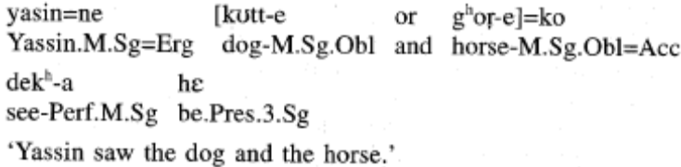
(b) The oblique cannot scope over conjoined NPs
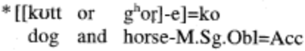
(c) The oblique cannot scope over conjoined NPs
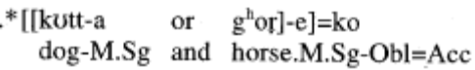
- (a) The focus particle can intervene between the NP and the case postposition (Butt & King 2004:174)
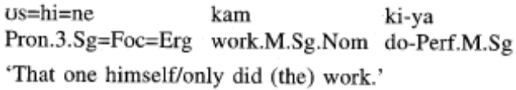
(b) The focus particle cannot intervene between the NP and the oblique
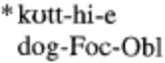

Other potential arguments, but no one to cite yet:

The realization of the oblique is dependant on morphological classes and gender. This is indicative of inflection rather than a functional head (although some functional heads show idiosyncratic realization (need to check Tim’s talk and Hayes).

If the oblique were a functional head then it would select for a syntactic category (ie noun) rather than morphological class (ie masculine singular –a class).

Summary: the oblique is a suffix, which is realized differently for different noun classes.

It’s a suffix, but is it a feature or a functional head?
A structural case that is assigned by Pº

Proposal: the oblique is a case marker. The oblique is obligatory and uniform, its morphological realization is conditioned by the noun’s class. This is no different from the accusative in English (which is found only on pronouns) and cases in German (which appear differently on masculine, feminine and neuter nouns).

The frameworks compatible with my approach:
Case assignment: Pesetsky & Torego 2001, Frampton & Gutman 2002
Feature spreading: Vuchic 1993, Frampton & Gutmann 2006, Kratzer 2006
Morphological realization: Marantz 1997, Legate to appear

I assume that the abstract case is assigned by a postposition to its DP complement (Pesetsky & Torego 2001, Frampton & Gutman 2002).

- Case assignment
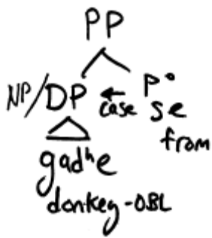

The morphology receives the bundles of features and realizes the bundles as faithfully as possible given the resources of the lexicon (Marantz 1997, Legate to appear).

- Spell out
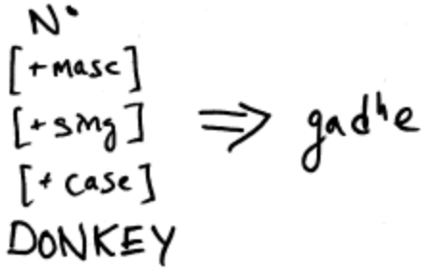

Multiple exponence on all members of a DP of just one case assignment

Like case in many languages (German for example), the oblique appears multiply on all elements of the DP which have an oblique form.

- us bare gadhe se le lo
that.OBL big-OBL donkey-OBL from take-SUBJ take-2nd.sg
‘Take it from that big donkey.’
- Nimm den Schemel für diesen großen
take-2sg.imper def-OBL stool.OBL for that-OBL big-OBL
grauen alten unbehaarten ruhigen
grey-OBL old-OBL un-?-hair-OBL quiet-OBL
sitzenden Elefanten dieses Mannes
sit-?-OBL elephant-OBL that-GEN man-GEN
‘Take the stool for this big grey old quiet hairless sitting elephant of the man.’

This structural case can be realized on pronouns, adjectives, nouns (in21), the genitive postposition, postpositions (in 23), gerunds (in 24 and 25), these are the same grammatical categories as in German (22).

- [dabbe ke nice tak]
box-OBL=GEN-OBL under-OBL until
‘up to the underneath of the box.’
- [raam ke baiThne par] mãã-ne
raam=GEN-OBL sit-NONFIN-OBL=ON mother=ERG
us=ko khaanaa diyaa
3sg.OBL=DAT food give-PERF
‘When Ram sat down, mother gave him food’ (Mohanan 1994:78)
- [Lataa-ji-ke ye gaanaa gaa-ye ho-ne ] se (Bhatt 2005:765)
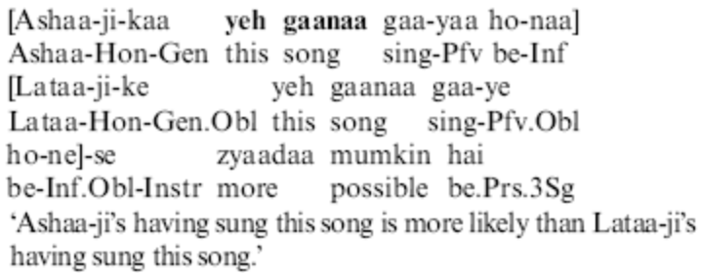

It is clear that the case and gender features are shared within the projection. One way to accomplish this feature sharing is through feature spreading (Vuchic 1993, Frampton & Gutman 2006, Kratzer 2006). This must be accomplished in a two-step process.

It is commonly assumed that the projecting sister projects its features to the mother node. As the possessor (GenP) is optional I assume it is adjoined to the NP, the same is true of the AdjectiveP. Cinque 2005 considers the DemontrativeP is also adjoined. As all elements are adjoined the features of donkey are projected.

- The features of the noun are projected/percolated through merger (Frampton & Gutman 2006)
Structure for “that big donkey,” to which the adjective and demonstrative are adjoined and the features of the head are percolated up along the spine
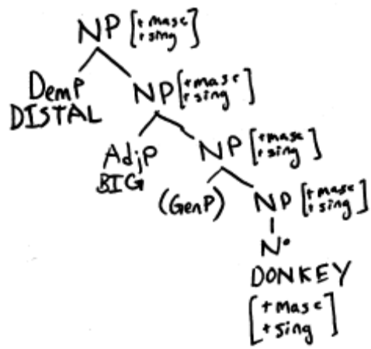
- The case feature of the complement must be spread down to all elements in the DP/NP (might be controversial, need to read more literature)

The postposition “from” is merged with the NP, assigning case to its complement. At somepoint, perhaps at linearization the features (gender number and case) of the topmost NP are spread down to all c-commanded elements which are not inside another maximal projection…
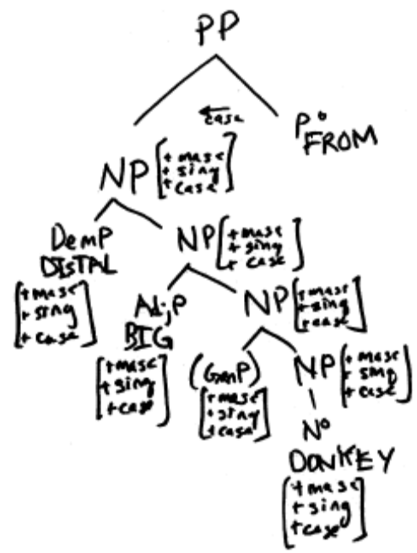

Finally, following the principles of Distributed Morphology the feature bundles are spelled out as words using the lexical item which matches the most of the features. In this case, the demonstrative us ‘that’ isn’t specified for masculine or feminine, as there is no competing demonstrative, it is inserted. The adjective bare ‘big’ and the noun gadhe ‘donkey’ are not specified for singular or plural, as there are no competing forms for singulars these are inserted.

- Lexical Insertion
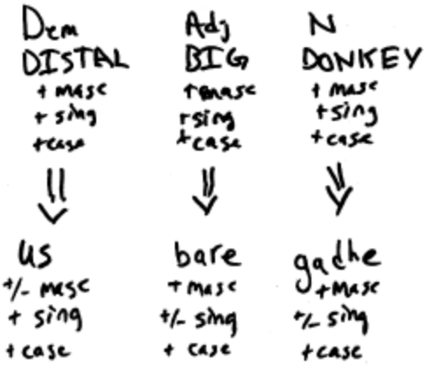

The oblique is obligatory

So far I have shown only masculine examples where the oblique is can be seen overtly. In the next section I will show that the oblique is regular and required, its appearance on some words but not on others in an oblique NP/DP is due to its morphological availability for certain words and not others.

In order to prove that the oblique is obligatory in the examples below, I will use a demonstrative, which show overtly the 4 way distinction in number and direct/oblique marking, and an adjective which show the 2 way distinction in gender marking.

- Hindi/Urdu demonstratives
 | Singular |  | Plural
 | Direct | Oblique | Direct | Oblique
Proximate | ye | is | ye | In
Distal | vo | us | vo | Un

- Hindi/Urdu adjectives
 | Singular |  | Plural
 | Direct | Oblique | Direct | Oblique
Masculine | bara | bare | bare | Bare | ‘big’
Feminine | bari | bari | bari | Bari

The morphology spells out each of these feature bundles given the resources available. If the morphology is given a masculine noun which has a lexical entry that can realize the oblique feature, the noun will surface in the oblique form, as the adjective bare ‘big’ does in (31). If the masculine noun does not have an oblique form, the noun will surface in it’s default form, as the borrowed noun mez ‘table’ does in both the direct and oblique noun phrases in (31).

- Masculine oblique surfaces as the direct form if there is no oblique
(a)[wo bara mez] gir reha hɛ
that.DIR big-MSG.DIR table.MSG.DIR fall IMPERF-M PRES-3SG
‘That big table is falling.’
(b)[us bare mez se] le lo
that.OBL big-OBL.DIR table.MSG.OBL from take-SUBJ take-2nd.sg
‘Take it from that big table.’

If the morphology is given a feminine noun with an oblique feature, it will surface the default feminine form since feminine nouns do not have a lexical entry for the oblique, as the borrowed noun kitaab ‘book’ surfaces in the same form in both direct and oblique NP/DPs below.

- Feminine oblique surfaces as the direct form if there is no oblique
(a)[wo bari kitaab] gir rehi hɛ
that.DIR big-FSG.DIR book.FSG.DIR fall IMPERF-F PRES-3SG
‘That big book is falling.
(b)[us bari kitaab se] le lo
that.OBL big-FSG.OBL book.FSG.OBL from take-SUBJ take-2nd.sg
‘Take it from that big book.’

- Spell out for feminine nouns
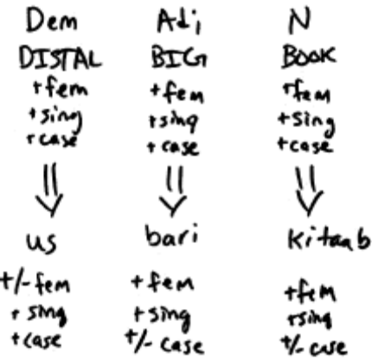

Thus the appearance and non-appearance of the oblique case is not a barrier to considering it as an obligatory case if one accepts Legate’s (to appear) proposal that the presence of abstract case should be distinguished from the presence of overt morphological case. This shouldn’t come as a surprise, we assume that “John” is marked accusative in the sentence “I see john,” even though there is no way of realizing accusative on John. We know that the accusative is there because when you replace John with a pronoun, the pronoun must be accusative “him” not the nominative “he.”

- English abstract case is also realized differently on different words:
Compare John/John and he/him.
a) John sees Bill.
NOM ACC
b) I see John.
NOM ACC
c) I see him.
NOM ACC
d) *I see he.
NOM NOM

The main goal of this paper was to show that the oblique is an affix and obligatory on all members of a DP. I have outlined a possible account for the spreading of the oblique (as well as other features such as gender and number) to all members of a DP.

In the next section I will try to sketch reasons why the oblique case is not just morphologically interesting but also important for syntacticians to consider.

Ramifications of a structural case

If postpositions in Hindi/Urdu are assigning/checking a case, then they must be functional heads in the syntax.

The data presented is only compatible with an analysis of the case postpositions as something equivalent to a PP or a KP. This can be argued for independently on the grounds that Hindi/Urdu postpositions have regular semantics, and introduce only one type of theta role (Butt & King 2004).

This provides a further argument that the case postpositions are certainly not realizations of “structural” case. Structural case is thought of a syntactic case feature, but a syntactic feature can’t assign another case.

If case postpositions in Hindi/Urdu are functional heads in the syntax, this explains why passivization and argument raising retains the postposition, (if we still consider that passives are transformationally derived from actives). The highest maximal projection is the PP, so that must be raised, postposition and all.

Look into the “to him” for English passives and compare the two passive and active sentences.

The ergative postposition is different from the others, as the pronouns complements of the ergative are in the direct not the oblique form. I wish make no claims about the syntax or semantics of the ergative postposition. Its differing behavior can be seen in the pronoun paradigms below. All other postpositions follow the “se” behavior shown in the 4th column.

- The oblique forms of pronouns (Butt & King 2004:172)
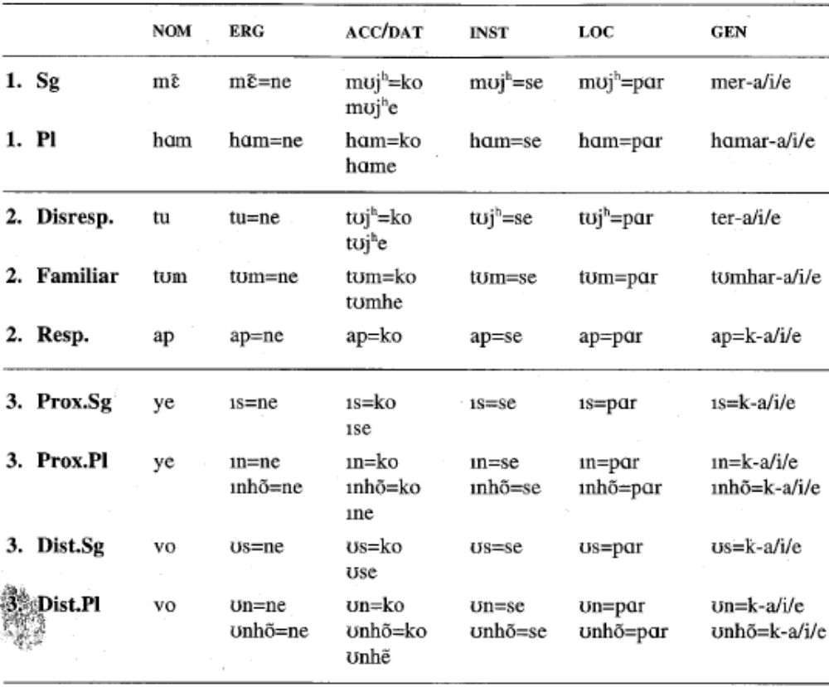

In this paper I have shown that it is possible to formalize the distribution of the oblique noun forms using a syntactic analysis. The formalization of the oblique in the syntax should be useful in analyzing the problematic Hindi/Urdu case and agreement. In the next section I will go over some of the problems Hindi/Urdu case and agreement has posed for the GB/Principles and Parameters accounts of case.

Issues Hindi-Urdu case & agreement

In this section I will briefly outline areas where the case and agreement of Hindi/Urdu is claimed to behave differently from the crosslinguistic typology.

Mahajan 1990, Bhatt 2005: Case and agreement can’t be two sides of a coin.
- Case and agreement are ideally two sides of a coin, the head probes for interpretable φ-features to check its uninterpretable φ-feature, in turn, the YP has uninterpretable case features are checked by the interpretable θ-role (Chomksy 1995). Alternatively, the functional head assigns abstract case features to its complement, and the complement shares its φ-features with the functional head. (‘Crash Proof Syntax’ Frampton & Gutmann 2006) In either a checking or an assignment approach, the features are realized as person/gender agreement on the function head, and as a case marker on the complement.

- Case and agreement are two sides of one relationship
XP
YP
Xº-gender/person
i-case
u-phi
Yº-case
u-case
i-phi
φ
casee

- Mahajan 1990: Unfortunately for the theory above, Hindi/Urdu verbs never agree with a case marked DPs. If we assume that the verb is assigning case, then the verb should agree with that DP. For Mahajan, the postpositions are case markers. Yet, if under my approach those are truly postpositions rather than case, then certainly the verb doesn’t agree with them. My proposal derives that they don’t agree.

Bhatt 2005: Hindi/Urdu is an exception to Burzio’s generalization
- Accusative Ko is retained in passives (Bhatt 2005:782)
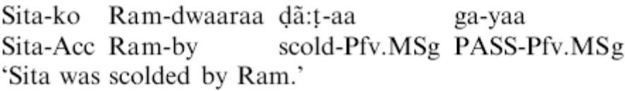
- Again, this is not an exception if –ko is not a structural case.

Bhatt 2005: Hindi/Urdu infinitives license structural case, cross linguistically they don’t.
- The complement of an infinitive must be accusative. (Bhatt 2005:782)
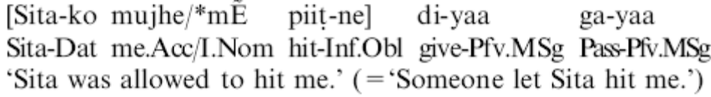
- This too is not an exception if –ko is not a structural case.

Legate 2007: Hindi/Urdu has “aggressive agreement”
- Little v will agree the subject, but if it finds no eligible DP, it will search down and agree with the object
“I propose that the pattern of agreement found in Hindi is similar in essentials to Niuean in that DPs that bear inherent ergative Case do not trigger agreement. Where the languages differ is this:
“in Hindi, after the inherent Case-marked DP fails to trigger agreement, T continues to search down the tree for a DP that may trigger agreement, i.e. a DP with structural Case. In (37c), T finds the accusative object, which then triggers subject agreement, even though it has no other relationship with T. I refer to this as aggressive agreement.31 “ (Legate p17) “Evidence for aggressive agreement comes from two sources. First, we find that (pseudo)-incorporated nominals trigger agreement in Hindi, even though such DPs crosslinguistically lack Case. (See for example, Baker (1988) on the lack of Case on incorporated nouns and Massam (2001) on the lack of Case on pseudo-incorporated NPs.) Thus, these DPs trigger agreement without bearing nominative Case or raising to [spec, T], simply based on closest c-command.” (Legate p17)
- This is not the only place where Hindi shows object agreement, object agreement is only in gender, never in person, where as subject agreement is both gender and/or person. This requires a look into the morphological realization and syntactic relationships behind agreement (both person and gender treated together and separately) in Hindi/Urdu.

For the future

The realization of agreement in Hindi/Urdu appears to be systematic, object agreement is in gender, never person. Subject agreement may be either gender or person depending on the verb, but never both. Lexical verbs show gender, light verbs show person. This agreement pattern might indicate a systematic difference, either in the agreement relations between lexical verbs and light verbs, or more simply, a difference in morphological availability between lexical verbs and light verbs. I think it may be possible that gender and person are different agreement relations in Hindi/Urdu.

References
Bhatt, R. 2005. Long distance agreement in Hindi-Urdu. Natural Language and Linguistic Theory 23.4:757-807.

Butt, M. & T. H. King. 2004. The Status of Case. In Clause Structure in South Asian Languages, ed. V. Dayal & A. Mahajan. Dordrecht: Kluwer.

Chomsky, N. 1970. “Remarks on Nominalization,” in Studies on Semantics in Generative Grammar, The Hague: Mouton, 1972, 11-61.

Chomsky, N. 1995. The Minimalist Program.

Chomsky, N.. 2000. Minimalist Inquiries: The Framework. In Step by Step. Essays on Minimalist Syntax in honor of Howard Lasnik, ed. Roger Martin, David Michaels and Juan Uriagereka, 89-155. Cambridge, MA: MIT Press.

Chomsky, N. 2001. Derivation by Phase. In Ken Hale: A life in language, ed. Michael Kenstowicz, 1-52. Cambridge, MA: MIT Press.

Corbett, Greville G.
Agreement /
Cambridge, UK ; New York : Cambridge University Press, 2006.
xviii, 328 p. : ill. ; 26 cm.
Morris Library P299.A35 C67x 2006 Normal Loan

Frampton, J. and S. Gutmann. 2002. Crash-Proof Syntax. In Derivation and Explanation in the Minimalist Program, ed. by Samuel D. Epstein and T. Daniel Seely, 90-105. Oxford: Blackwell Publishing.

Frampton, J. & S. Gutmann. 2006. 'How Sentences Grow in the Mind: Agreement and Selection in an Efficient Minimalist Syntax'. In C. Boeckx (ed.), Agreement Systems. Amsterdam: John Benjamins, 121-157.

Halle, M. and A. Marantz 1993. “Distributed Morphology and the Pieces of Inflection,” in K. Hale and S.J. Keyser, eds., The View From Building 20, Cambridge, Mass.: MIT Press, 111- 176.

Legate, J. To appear. Morphological and Abstract Case.

Mahajan, A. 1990. The A/A-bar Distinction and Movement Theory. MIT Dissertation.

Masica, C. 1991. The Indo-Aryan Languages. Cambridge: Cambridge University Press. PK115 .M37 1991

Mohanan, T. 1994. Argument Structure in Hindi. Stanford, CA: CSLI Publications.

Payne, J. 1995. “Inflecting Postpositions in Indic and Kashmiri.” in Double Case, Agreement by Suffixaufnahme. Plank, F. (ed). Oxford University Press.

Pesetsky, David & Esther Torrego. 2001. T-to-C movement: Causes and consequences. In Ken Hale: A Life in Language, ed. Michael Kenstowicz, 355-426. Cambridge, Mass: MIT Press.

Shukla, S. 2001. Hindi Morphology. München: Lincom Europa.

Vuchic, R. 1993. A study of Noun Phrase agreement in French as a second language: an autosegmental model. University of Delaware Dissertation.

http://www-uilots.let.uu.nl/ltrc/agreement.htm
Agreement Database
http://www.ling.lancs.ac.uk/staff/anna/anna.htm

References I Need to Read
(from Becker 2005 handout on accounts for Slavic feature spreading)
Carstens, Vicki. 2000. Concord in minimalist theory. Linguistic Inquiry 31:319-55.
Carstens, Vicki. 2001. Multiple Agreement and Case Deletion: Against φ (In)Completeness Syntax 4:3 147-163.
Chomsky, Noam. 1995. Categories and transformations. In The Minimalist Program, 219-394. Cambridge, Mass.: MIT Press.
Chomsky, Noam. 2000. Minimalist Inquiries: The Framework. In Martin, Michaels, Uriagereka (eds.), Step by Step: Essays on Minimalist Syntax in Honor of Howard Lasnik. Cambridge, MA: MIT Press.
Chomsky, Noam. 2001. Derivation by Phase. In M. Kenstowicz (ed.), Ken Hale: A Life in Language. Cambridge, MA: MIT Press.
Cinque, G. 1994. Evidence for Partial N-movement in the Romance DP. In G. Cinque, J. Koster, J.-Y. Pollock, L. Rizzi and R. Zanuttini (eds.), Towards Universal Grammar: Studies in Honor of Richard Kayne. Washington DC: Georgetown University Press.
Franks, Steven. 1994. The Functional Structure of Russian Numeral Phrases. In Jindřich Toman (ed.), Formal Approaches to Slavic Linguistics. Ann Arbor, MI: Michigan Slavic Publications.
Franks, Steven. 1995. Parameters of Slavic Morphosyntax. Oxford University Press.
Radford, Andrew. 1997. Syntactic Theory and the Structure of English: A Minimalist Approach. Cambridge: Cambridge University Press.
Wechsler, Stephen and Larisa Zlatić. 2000. A Theory of Agreement and its Application to Serbo-Croatian. Language. 76: 799-832.

Also downloaded:

(2002). A Jakobsonian Feature Based Analysis of the Slavic Numeric Quantifier Genitive. Journal of Slavic Linguistics 10, 141-181.
(Available for download in .pdf format.)
-revises franks 1995 work (which was based on his 1985 disseration) probably a better resource, but in terms of early theory of spreading maybe his 1985 is good to cite since it was early.

(2004). Functional Categories in the Nominal Domain. In Formal Approaches to Slavic Linguistics: The Ottawa Meeting, ed. by O. Arnaudova et al, 109-128. [Franks & Pereltsvaig]
(Available for download in .pdf format.)

Other possibilities
Alexiadou, A., 2001. Adjective syntax and noun raising: word order asymmetries in the DP as the result of adjective distribution. Studia Linguistica 55, pp. 217–248. View Record in Scopus | Cited By in Scopus (4)
Alexiadou, A., Wilder, Chris, 1998. Adjectival modification and multiple determiners. In: Alexiadou, A., Wilder, C. (Eds.), Possessors, Predicates and Movement in the DP. Benjamins, Amsterdam, pp. 303–332.
Benmamoun, E., 1992. Functional and inflectional morphology: problems of projection, representation and derivation. Ph.D. dissertation, University of Southern California.
Benmamoun, E., 1998. Apparent agreement mismatches. In: Proceedings of Semitic Syntax Conference, University of Southern California.
Benmamoun, E., 2000a. Agreement asymmetries and the PF interface. In: Lecarme, J., Lowenstamm, J., Shlonsky, U. (Eds.), Research in Afroasiatic Grammar. Benjamins, Amsterdam, pp. 23–40.
Benmamoun, E., 2000b. The Feature Structure of Functional Categories. A Comparative Study of Arabic Dialects. Oxford University Press, Oxford, New York.
Bernstein, J., 1992. On the syntactic status of adjectives in Romance. CUNYForum 17, pp. 105–122.
Bernstein, J., 1997. Demonstratives and reinforcers in Romance and Germanic. Lingua 102, pp. 87–113. Abstract | Abstract + References | PDF (1780 K) | View Record in Scopus | Cited By in Scopus (9)
Borer, H., 1989. On the morphological parallelism between compounds and constructs. In: Booij, G., van Marle, J. (Eds.), Morphology Yearbook. Foris, Dordrecht, pp. 45–64.
Borer, H., 1993. Derived nominals. University of Massachusetts at Amherst. Unpublished manuscript.
Bouchard, D., 2002. Adjectives, Number and Interfaces: Why Languages Vary? North-Holland/Elsevier, Amsterdam.
Carstens, V., 1991. The morphology and syntax of determiner phrases in Kiswahili. Ph.D. dissertation, University of California, Los Angeles.
Crisma, P., 1990. Functional categories inside the noun phrase: a study of the distribution of nominal modifiers. Laurea dissertation, Università degli studi di Venezia.
Crisma, P., 1996. On the configurational nature of adjectival modification. In: Zagona, K. (Ed.), Grammatical Theory and Romance Language. Benjamins, Amsterdam, pp. 59–71.
Engelhardt, M., 1998. The syntax of nominalized properties. Ph.D. dissertation, Hebrew University.
Hazout, I., 1995. Action nominalizations and the lexicalist hypothesis. Natural Language and Linguistic Theory 13, pp. 355–404. Full Text via CrossRef | View Record in Scopus | Cited By in Scopus (4)
Kayne, R.S., 2001. Prepositions as probes. New York University. Unpublished manuscript.
Longobardi, G., 2000. The structure of DPs: some principles, parameters and problems. In: Baltin, M.R., Collins, C. (Eds.), Handbook of Syntactic Theory. Blackwell, Oxford
Ritter, E., 1991. Two functional categories in noun phrases: evidence from Modern Hebrew. Syntax and Semantics 25, pp. 37–62.
Ritter, E., 1993. Where’s gender?. Linguistic Inquiry 24, pp. 795–803. View Record in Scopus | Cited By in Scopus (12)
Siloni, T., 1997. Noun Phrases and Nominalizations. Kluwer, Dordrecht.
Valois, D., 1991. The internal syntax of DP and adjective placement in French and English. Proceedings of the North Eastern Linguistic Society 21, pp. 367–381.
Valois, D., 1996. On the structure of the French DP. Canadian Journal of Linguistics 41, pp. 349–375.
Williams, E., 1981. On the notions ‘lexically related’ and ‘head of a word’. Linguistic Inquiry 12, pp. 245–274.

Feature Indeterminacy and Feature Resolution
Mary Dalrymple; Ronald M. Kaplan
Language, Vol. 76, No. 4. (Dec., 2000), pp. 759-798.

Cite info for Carstens:2000
Linguistic Inquiry
Spring 2000, Vol. 31, No. 2, Pages 319-355
Posted Online March 13, 2006.
(doi:10.1162/002438900554370)

Concord in Minimalist Theory

Vicki Carstens

Concord within DP argues that movement is driven by uninterpretable features of either the target or the moved item, contra Chomsky 1995. The uninterpretable f-features of which concord consists must be eliminated by LF, to satisfy Full Interpretation. But raising of inflected APs and KPs into checking relations with N0 cannot be motivated, in Chomsky's system, since N0 has no uninterpretable features that these items can check. Assuming Kayne's (1994, 1998) proposal for APs, the problem can be partially overcome, but inflected "of" constructions still lack an account. Chomsky's (1998) probe-goal approach applied to concord also encounters difficulties, avoided under revision of the (1995) system: if the f-features of APs and KPs drive them to raise for checking, correct results are obtained.

keywords
concord
agreement
feature checking
movement (theory)
Greed
Attract
Enlightened Self-Interest

Appendix

A family tree of Hypothesis B

The Family Tree of Hypothesis B
Where are inflected forms made?
In the syntax
In the lexicon
Case
Feature

Functional
Head
Inflection: lexicon vs syntax
(Chomsky 1970?)
Derivation: lexicon vs syntax
(Marantz 1997 ?)
Feature vs Functional Head
(Bayer et all 2001)
KP
(Bittner &
Hale 1996)
?
?
PlaceP
(Svenonious 2006)

Feature
Sharing/Percolation
Frampton &
Gutmann 2006
Vuchic 1993
LFG
(Butt & King
2004)
OT
(Aissen
2003)
PP
?

Two kinds of abstract case features, structural and inherent, not really relevant

Inherent case is an idiosyncratic case which depends on the lexical item which assigns the case.

If different postpositions assigned different case on a par with the oblique then it would be worthwhile investigating whether the oblique is inherent. German postpositions assign different cases, the postposition für ‘for’ assigns/checks accusative, while von ‘from’ assigns/checks dative.

However, in Urdu all postpositions assign/check oblique, as all members of a syntactic category assign/check the same case, it seems non-sensical to entertain that that case is inherent; ie an idiosyncratic case which is characteristic of a particular lexical item.

Tests for inherent case come from the verbal domain rather than the PP domain.

One test is whether the case-marked NP/DP retains its case when passivized. What the corresponding action a postposition’s compliment would be escapes me. (Ben argues against A-movement as a test since non-A-moved objects loose their structural case in Icelandic passives. Ben says that if the markedness theory of ergative marking were correct, an inherent case would be a case where a co-argument is demoted, but no grammatical function change takes place. In the antipassive the object is demoted to an oblique while the subject remains a subject. Postpositions don’t appear to have co-arguments in Urdu, so this test for inherent case is not possible.)

Since I think that the inherent/structural case is irrelevant this shouldn’t be a problem.

My claim: postpositions are functional heads which participate in event structure, they introduce arguments. In this way they are “semantic case” if anything. They are not “structural” cases, at least not in terms of the assignment/checking of “features”. They must be present as functional heads, in the syntax, because they assign a case (oblique). The oblique itself is a “structural” case in that it is a feature in the syntax, not a head.

What is agreement, can Hindi/Urdu agreement become normal if we consider (following Kratzer 2006) that gender agreement is different?

Butt 1995: there is a great deal semantic and syntactic evidence that nouns like girl in “girl-looking” are incorporated, yet the noun and verb agree.
- “pseudo-incorporated’ nouns show agreement
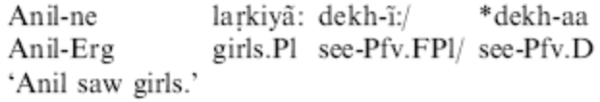
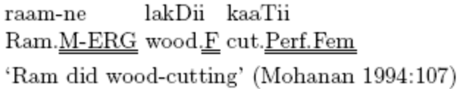
This agreement has been considered a sign that the noun cannot be pseudo incorporated by Bhatt 2005. Nouns which are incorporated are not case marked and don’t show agreement with the verb (Baker 1988, Massam 2001).
- However, the pseudo-incorporated noun and verb agree only in gender. Kratzer 2006 argues that sharing gender features is done under nonrestrictive modification, which is precisely the semantics for pseudo-incorporated nominals. I would like to argue that agreeing in gender is a sign of a modifier rather than an argument. And so this would confirm that they are modifiers, not arguments as has been suspected, the only barrier to this analysis before was that there was still agreement.

Is this structural case only on objects of prepositions?

Legate (to appear) argues that abstract structural accusative case in Hindi which is assigned by vº is the morphological default, null. This is needed for her analysis reducing absolutive to nominative or default in different languages. This is true in the verbal domain, but given the above data there does appear to be an overt realization of abstract structural case, that which is assigned by postpositions to their complements. As this these are postpositions rather than vº this doesn’t challenge Legate’s claim, rather Legate is most likely correct in analyzing Hindi/Urdu case and agreement as non-standard in that it lacks a morpheme specific to structural accusative case.

No, there are other obliques that don’t have a postposition

Now that we consider that the oblique is a case, we need to find case assigners for its appearance.

Yet, there are obliques which have no obvious postposition to assign case

- The oblique as a locative (Butt & King 2004:168)
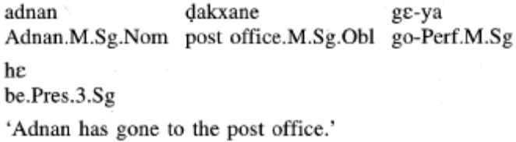

- The oblique in inalienable possession (Mohanan 1994:178)
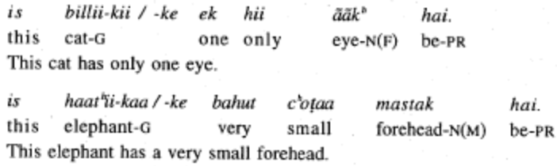

- The oblique (maybe) in an adjunct under the emphatic particle, not m.sg because the gen on the subject is also marked as oblique. What dialect is this?
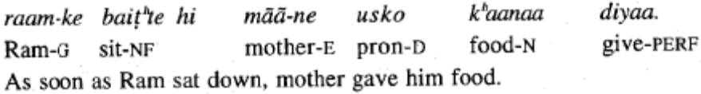

Davison 2004:202
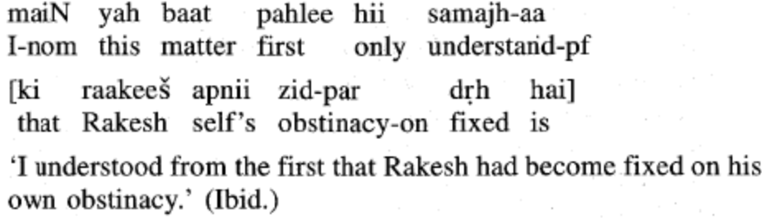

- The oblique under allow (Bhatt 2005 :778)
[Sarosh-ko gaaRii chalaa-ne] di-i
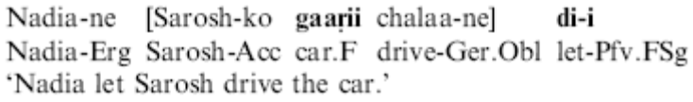
[peR kaT-ne] di-ye (Bhatt 2005:795)
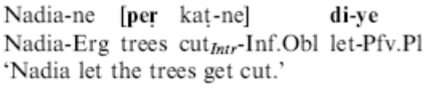

- In a conditional (collected from a web forum)
Agr mere pice kutta bhonkne laga
if 1st-GEN-OBL behind-OBL dog bark-NONFIN-OBL start-M.SG
to main zurud bhag jaoongi
then 1sg certainly run go-1sg=FUT
‘If a dog started barking after me then I would certainly run.’

Like multiple obliques with in a DP, the oblique can appear on conjoined verbs

- Multiple marking on conjuncts (collected in a web forum)
main aap ko
1.sg 2sg.FORMAL=DAT
danda dhondne ya phir jota oTarne
stick look.for-NONFIN-OBL or even shoe take.off-NONFIN-OBL
duun gaa kya?
Allow-1.SG FUT Q

It is a structural case, but is it a structural case assigned what. What unifies postpositions, locatives, inalienable possessives, permissives and focus?
An existential operator…?

Agreement markers from agha
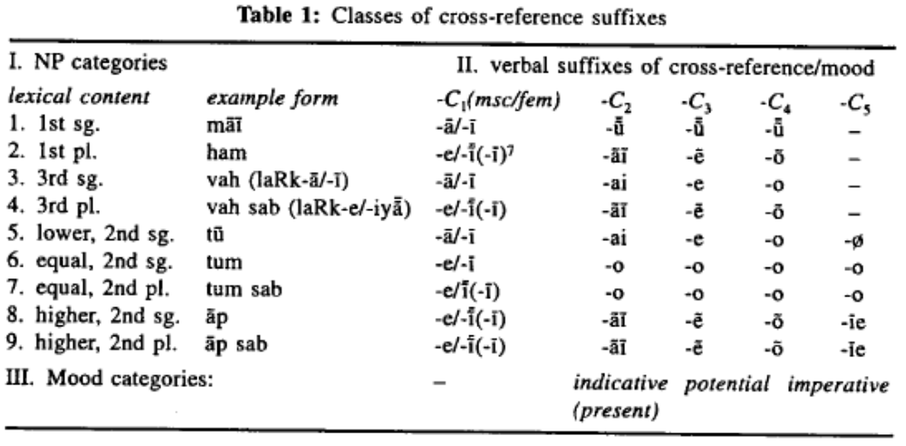
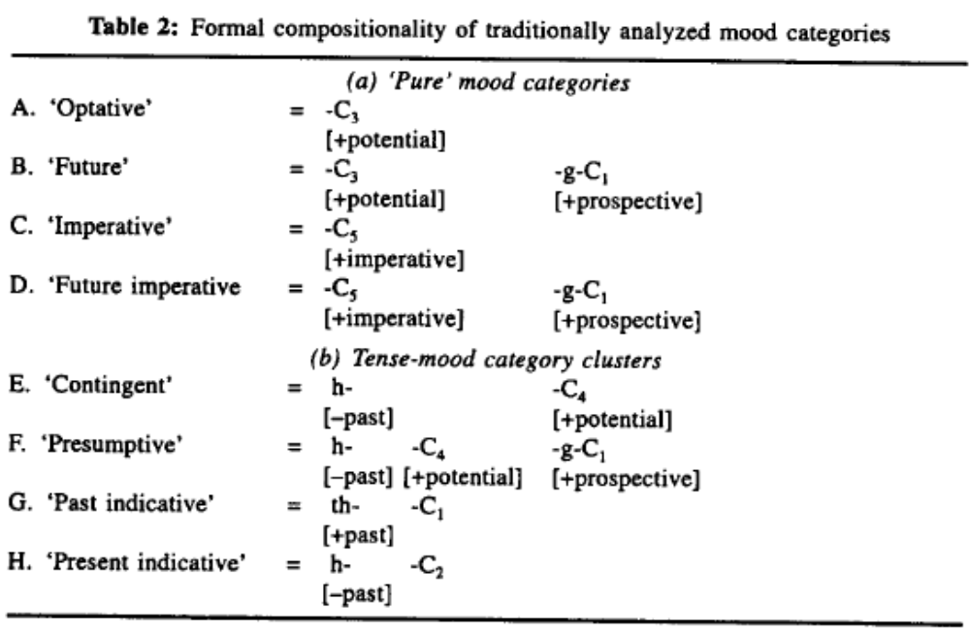
How he uses the markers: check out for what I consider the subjunctive…
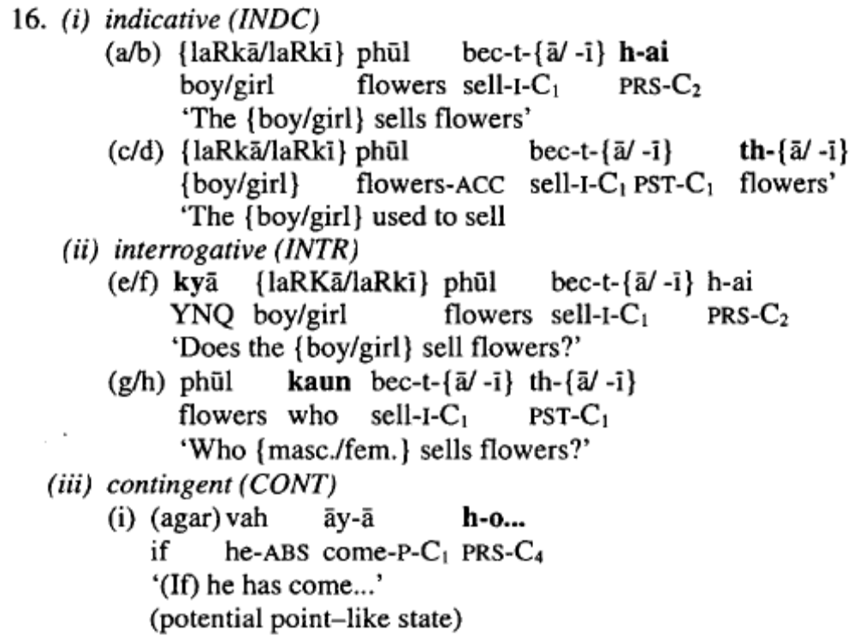
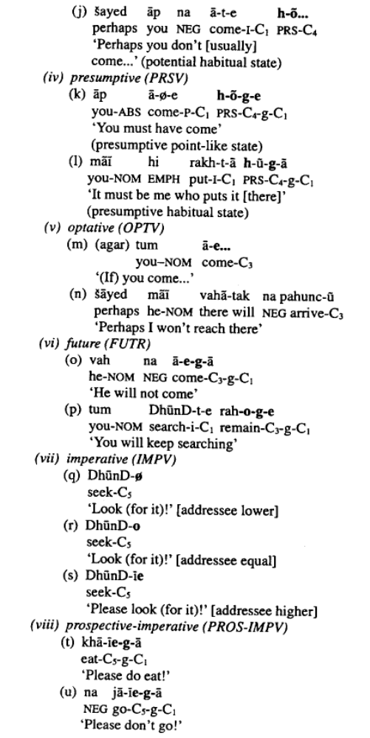
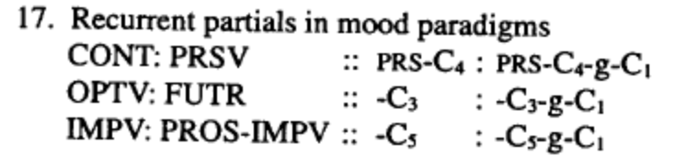

-e on arguments of verby heads

“The subjects of eligible transitive verbs were marked as oblique” (Butt & King 2004) (19)
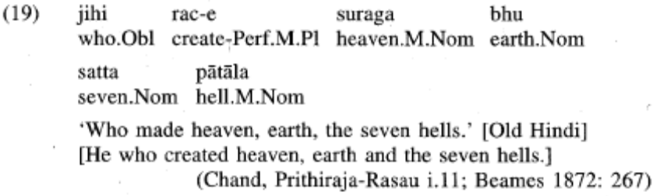

No –e
Kidwai 2000:165
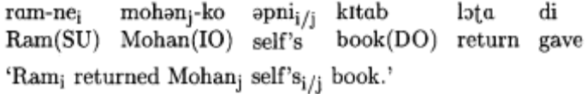

Masculine nouns
Sona, sone gold Butt& King 2004:164

Shukla 2001:6
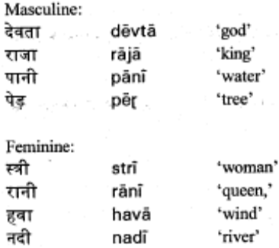

3rd singular –e
Butt& King 2004:165
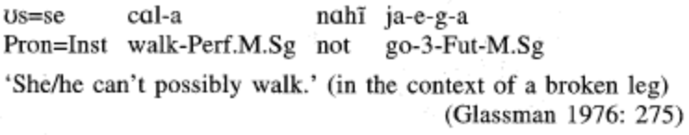
Kidwai 2000:43
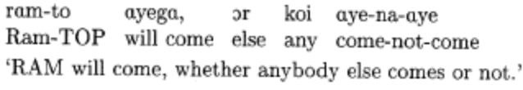

Participles (with varying gender)\
Participles (this is not oblique as it it should become –i with a fem subject) (Mohanan 1994:182)
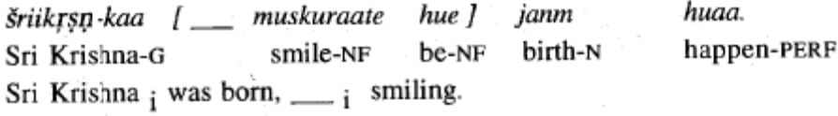
Can this be in the oblique, us aurat instead of voh aurat
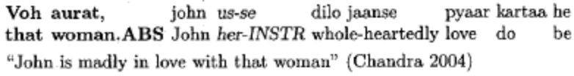

Imperfective Converb –e (bickel,yadava-2000-A fresh look at grammatical relations in Indo Aryan.pdf)
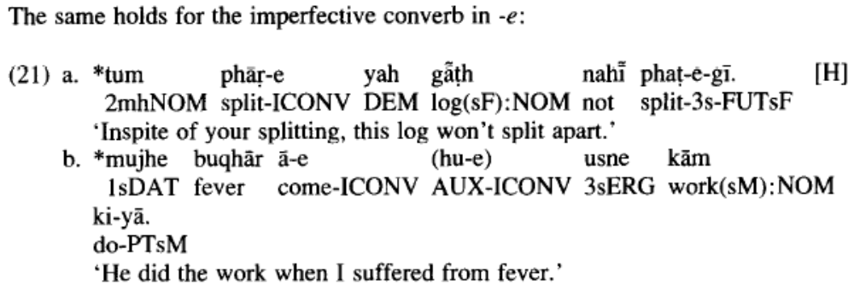
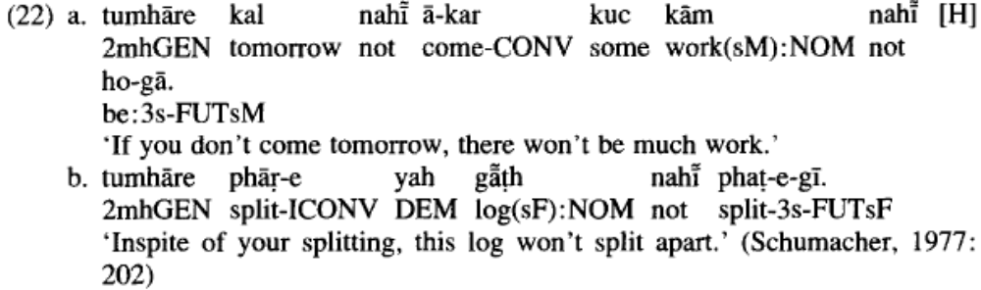

Butt 2003 the light verb jungle, Indo aryan tya ending, survives as –e in bengali on main verbs, and as –I in old Hindi. Why is it verb lena vs verb-ne dena in hindi?
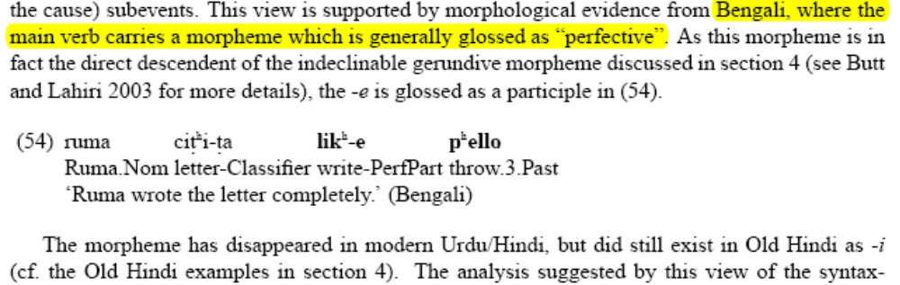

Plural –e

- (Bhatt 2005:787)
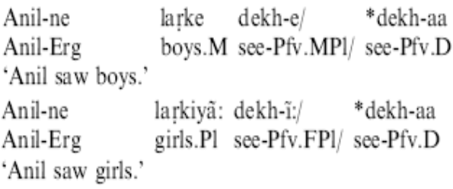
- Is that certainly plural in this example? (Bhatt 2005:796)
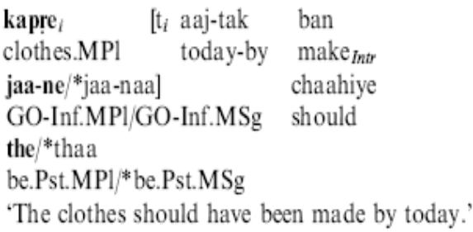

Forms of se – sa,si,se?

(Butt & King 2004:170)
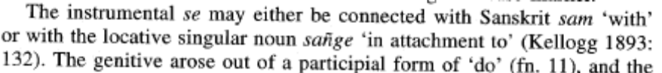
- Kon saa (Mahajan 1990:40)
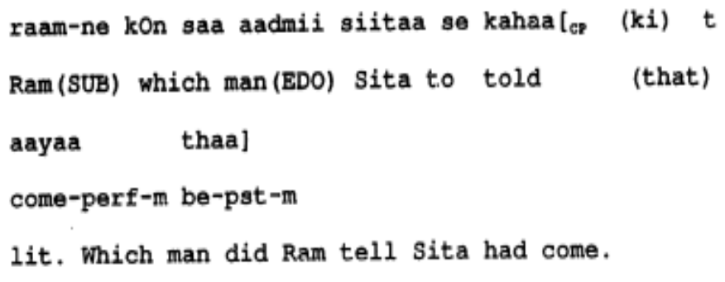
- Kon sii (Mahajan 1990:
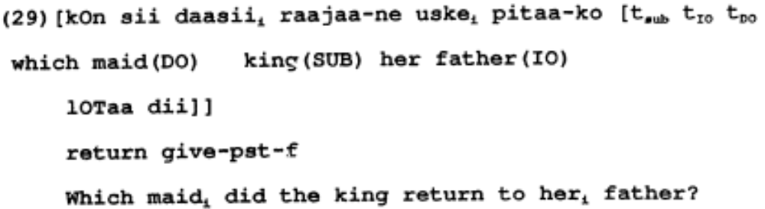
- Kon sii (Mahajan 1990 :117)
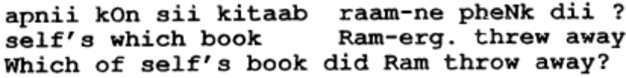

Adverbs (might show acc like in quechua)

- Dhire dhiire ‘slowly’ (Mahajan 1990:123)
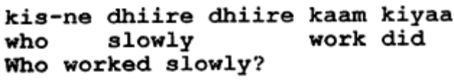
- Kese (mahajan 1990)
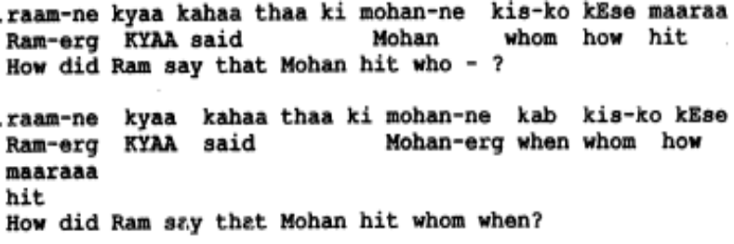
- phir se (bhatt 2005:766)
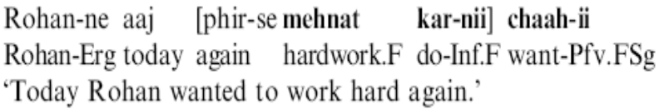
- Jaldii jaldii/jaldii se ‘quickly’
- baRi caturtaa se ‘cleverly’
- kitne ‘how many’
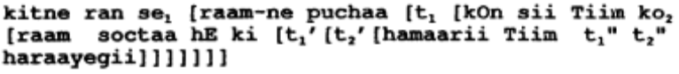

Vaalaa,vaalii,vaale

- In a possessive (Mahajan 1990:37)
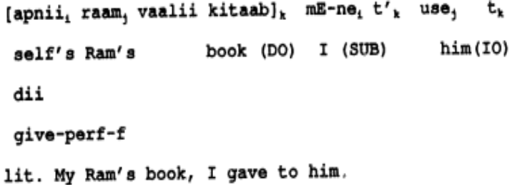

I would like to thank the Abbasi family for sharing their home and language with me. Thanks especially to Karthik Durvasula for extensive discussion and his always willing ear. Thanks also to Masahiro Yamada, Lanny Hidajat, MaryEllen Cathcart and Timothy Mckinnon. All errors and oversights are my own ☺ The following abbreviations are used in these paper: Abs – Absolutive; Acc – Accusative; Dat – Dative; Erg – Ergative; Neg – Negation; Prs – Present; LDA – Long Distance Agreement; Hon – Honorific;D– Default; PSTPRT – Past Participle;NMLZ – Nominalizer; Pass – Passive Auxiliary; PSI – Polarity Sensitive Item; Inf – Infinitive; Pst – Past; Pfv – Perfective; Impfv – Imperfective; Prog – Progressive; Hab – Habitual; Ger – Gerund; Obl – Oblique; 1 – 1st Person; 2 – 2nd Person; 3 – 3rd Person; F – Feminine; M – Masculine; N – Neuter; Sg – Singular; Pl – Plural
This is a postposition that is rarely used in spoken Urdu, but is cited in Mohanan 1994:62 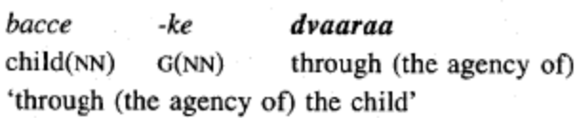
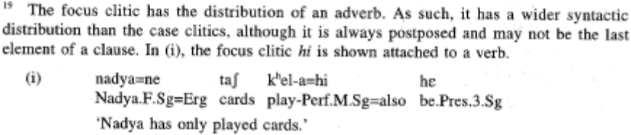
There is no evidence of a D° in Urdu, I leave open the option of a DP or an NP for the examples in this paper.
I expect feature sharing to happen whenever there is a modifier, modifiee relationship (predicate modification, rather than functional application), whether or not this would hold up in the long run remains to be seen…
If we think that the –en on participles is the same thing..
Or maybe a DP (Bleam 2005)
Butt & King discuss another use of the oblique: “The one use of the oblique marking in the modern system in which the original case function has been preserved is the use of the oblique to mark locatives as in (17). The meaning of this locative use is restricted: it can only mean 'to' or 'from', not 'in', 'towards', etc. We thus distinguish between two forms of the oblique morphemes (section 5): one as agreement inflection on the complement of a K head, and one as a locative case marker. (Butt & King 2004:168)

