Hindi/Urdu Notes – Friday November 8th 2007

In the bus line for NYC to Montreal I asked Vaibhav Choursasia from Raipur if he could help me with my data. He has lived in Philly for 3 years, did his bachelors in computer science in Raipur and has studied in English since he was little but always spoke hindi with his friends once the lectures were over. His mother and father are native Hindi speakers. His mother is not comfortable speaking English but got by while she was visiting him in Philly. Vaibhav said at first that the town was basically only hindi speaking and the location of standard hindi. After a while he said that actually his father has a twinge of an accent when he talks to people form his village. His father is an economics (professor) and has been asked to come on the state run TV. He was given advice ot learn Chatesghar, the local language in Raipur.

Summary: After presenting a context using “Raam ne film dekhni chaahi thi” Vaibhav actually created an LDA example which he said was nautral “Main ne amerikan se shaadi karni chaahi thi.” But he said that it would be more likely to hear this from a girl. Grammatically this would require that she be a lesbian, but he see that point. As he appeared to be unclear about where feminine agreement was coming from in the LDA example (attributing it to the ne marked subject, which is impossible) his specificity judgments should not be used. In fact, he didn’t give any indication that he knew it was possible for the agreement to come from an object rather than a subject. In these earlier LDA examples Vaibhav said that the feminine example was more specific while the masculine example was non-specific.

After discussing the English example “Mary wants to marry a doctor” and the two readings Vaibhav said that the habitual “Saina amerikan se shaadi karma chaahti hai” is ambiguous, it could mean that she wants to marry Rob, but the speaker forgot his name so refers to Rob as an American, or it could mean that Saina wants to move to the US, so she wants to marry an American to get immigration. For Vaibhav it was more natural to produce the specific as “amerikan ke saath” and the non-specific as “kisi bhi american se.” However it was possible to use just “american se” with both, but the intonation for the two readings would be different.

Follow-ups: Now that Vaibhav sees the two readings in for the habitual statements I would like to retest the LDA examples to see if he agrees with his earlier judgments that “Raam ne amerikan se shaadi karni chaahi thi” was nonspecific and the LDA example with no agreement “Raam ne amerikan se shaadi karnaa chaahaa thaa” was specific.

I would also like to record the two intonations for the specific/non-specific habitual statements.

I started by giving him the specificy contexts that I built with Emmy.

Raam went to the bazaar ot get movies today, he planed to watch them that night. His aunt and unckel and cousin came over in the afternoon to visit his parents. He sat on the sofa saying little. His cousin askes his brother, raam ko kya hua? His brother answers:

Raam wo picture nahin dek sakta jo uska plan ta wo ab bigaR gaya hai.

Then I wrote chaaha on the paper

Raam chaahta tha ki ratko picture dekhe.

Then I showed him the data.

Raam film dekna chaata hai/thaa

Kintu=however

Uske chacha chachi ke aane ke karan ab wo film nahin dekh saktaa

Raam ne film dekhna chaahi thi

He gave me another example that felt natural (and said that it was true actualy)

Main ne amerikan se shaadi karni chaahi thi.
Kintu nahi kar paya.

He put in Saima in the front
Saima ne amerikan se shaadi karni chaahi thi.
And said that youre more likely to hear this from a girl. I tried to joke about whether that meant she was lesbian or not. (since grammatically that must be the case) but he didn’t think so.

Main ne Amerikan larki se shaadi karna chaaha tha.
More likely, probable to hear this one (I assume cause guys say that?)

Later he said this one is the specific version, the other (LDA) is nonspecific.

I started talking about specificity.
Saina wanted to marry an Amerikan.

- any man who is American
- Rob (an American), not adnan (a desi)

2 specifc
Main saina ko zyada nahin janta hoon. Main rob ka naam nahin janta hoon. Lekin main janta hoon ki wo kisi gori ki sat shaadi karnaa thaa.

Saina kisi America se shaadi kare vali hai.

1 nonspecific

Ambigious: Saina amerikan se shaadi karna chaati hai

1 Mian janta hoon ke saina amerika jaanaa chati hai. To saina amerkan se shaadi karnaa chati hai.

He said for the specific one its better as “amerikan ke saath” and for hte non specific “american se” or “kisi bhi american se” is even better.

He said that there were intonational differences between the tow if you use just “American se” for both ☺

I wrote down a page of stories while he was on the phone. He looked them over but didn’t really check them..

Context: Specific

Mera naam Raam hai. Meri ek cousin hai, Saina. Kal uski maa ne Adnan ke ma bab ko chai ke liye bulaayaa. Main Saina ko zyaadaa nahin janta, lekin main jaanta hoon ke usak boyfriend gora hai (uska naam Rob hai lekin abhi mujhe yaad nahin hai).

Kya main yeh keh saktaa hoon?

- Saina amrikan se shaadi karnaa chaati hai.
- Saina ne amrikan se shaadi karni chaahi thi, kintu nahin kar pai.

Context: Non Specific

Mera naam Raam hai. Meri ek cousin hai, Saina. Saina psychologist banni chaahti hai, lekin India main yeh field accepted nahin hai. Saima amrika me settle karma chaati hai. Lekin green card milna bahut mushkil hia.

Kya main yeh keh saktaa hoon?

- Saina amrikan se shaadi karma chaati hai
- Saina ne amerikan se shaadi karni chaahi thi, kintu nahin kar pai.

Shahrukh ki maa larki dekna chaati thi.
Vaibhav doesn’t like dekni here.

- the girl who shahrukh likes
- She wants to marry him off soon.

Shahrukh ki maa roti khaani chaahti thi.

- there were 2 options, roti or naan
- She was hungry

Nonspecific:
Shahrukh ki maa ne larki dekhni chaahi thi, lekin 2 mahine se pehle un longon ne shift kiya to kisi logon ko nahin jaante.

Specific:
Sharukh ki girlfriend Saina hai. Shahrukh ki maa ne larki dekhi chahi thi lekin wo Amrika gaivi hai, holidays ke liye.

Nonspecific
Shahrukh ki maa ne roti khaani chaahi thi, lekin uski nokrani roti banaanaa nahin ati.

Specific:
Table pe ek naan aur ek roti paRhe the. Sharukh ne roti le liya, uska bhai ne naan le liya. Shahrukh ki maa ne roti khani chaahi thi, lekin nahin kar pai.

Shahrukh ne chithi dekhi.
Shahrukh ne Amir ko chithi dekhaa diya.
Shahrukh ne Amir ko chithi dekhaani chaahi thi.
Shahrukh ne Amir ko chithi dekhaa deni chaahi thi.

Saina ne boli.

Saina ne Amir ko bulaa liya.

Saina ne Amir ko bulaanaa chaahaa tha.

Saina ne Amir ko bulaa lenaa chaahaa tha

Saina ne roti khaai

Saina ne roti khaa li

Saina ne Amir ko roti khilaa di

Saina ne Amir ko roti kilaani chaahi thi

Saina ne Amir ko roti khilaa deni chaahi thi

He says yes, its correct but…

Now, where does negation go in that sentence?

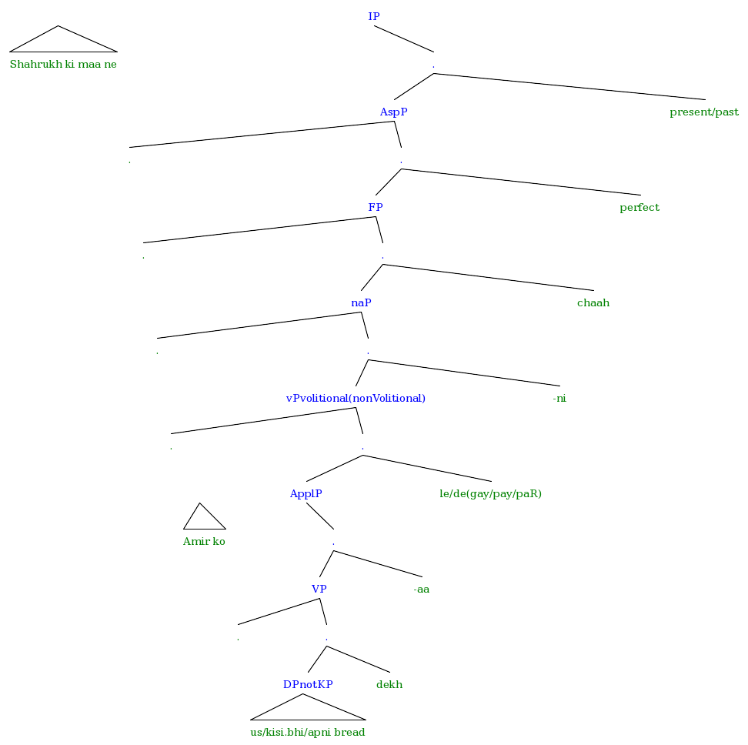
[IP Shahrukh ki maa ne [. [AspP . [. [FP . [. [naP . [. [vPvolitional(nonVolitional) . [. [ApplP Amir ko [. [VP . [. [DPnotKP us/kisi.bhi/apni bread ] dekh ] ] -aa ] ] le/de(gay/pay/paR) ] ] -ni ] ] chaah ] ] perfect ] ] present/past ] ]

Try with non-volitional light verbs…

Nadya girti hai
Nadya ne giri

Ro/gir can go with the non-volitional fall
Nadya gir gayi

Nadya ne Saima ko giraa di

Gaya cant have a ne marked subject.
*Nadya ne Saima ko giraa gayi
?Nadya Saima ko giraa jaati hai

Gaya cant have a nonmarked agent subject either.
?Saima ko giraa gay

Jaa is for non-perfect, implies an experiencer subject?
Gaa is for perfect, implies a non-volitional experiencer subject

-aa is only possible for volitional agent subjects

So –aa and Jaa shouldn’t be possible in the same sentence
?Nadya Saima ko giraa jaati hai
?Nadya Saima ko roti khilaa jaati hai

Creating the follow up:
Context: Specific
Mera naam Rahmaan hai. Mera ek cousin hai, Zahir. Kal uski maa ne ke ma bab ko chai ke liye bulaayaa. Main Zahir ko zyaadaa nahin jaantaa, lekin main jaantaa hoon ke uski girlfriend gori hai (uski naam Jennifer hai , lekin abhi mujhe yaad nahin hai).
Kya main yeh keh saktaa hoon?
a) Zahir amrikan se shaadi karnaa chaata hai.
b) Zahir ne amrikan se shaadi karni chaahi thi, kintu nahin kar paayaa.
c) Zahir ne amrikan se shaadi karnaa chaahaa thaa, kintu nahin kar paayaa.
Context: Non Specific
Mera naam Rahmaan hai . Meraa ek cousin hai, Zahir psychologist bannaa chaahtaa hai, lekin India me yeh career accepted nahin hai. Zahir amerika me settle karnaa chaahtaa hai. Lekin green card milna bahut mushkil hai.
Kya main yeh keh saktaa hoon?
a) Zahir amrikan se shaadi karna chaahta hai .
b) Zahir ne amerikan se shaadi karni chaahi thi, kintu nahin kar paayaa.
b) Zahir ne amerikan se shaadi karnaa chaahaa thaa, kintu nahin kar paayaa.

