Hypothesis 1: Palatalized consonants are significantly different than plain consonants
Test: Compare between +Coda items

Hypothesis 2: Palatalized consonants are not fundamentally different than contextually fronted consonants.
Test: Compare between +Front items while controlling for Coda

12 tokens of each segment were recorded for 3 places of articulation, labial, dental and post-alveolar. Palatalization is a secondary movement of the tongue body and thus is realized differently on different places of articulation, particularly when the primary articulation is independent of the tongue (labial) or dependant on the tongue (dental, post-alveolar).

For this reason 3 different places of articulation were gathered, but we will not be comparing between them. The places of articulation also differed in manner (stop, affricate, and fricative respectively) as well.

Technical terms:
 | +Coda | -Coda
-Front | plain | (no name)
+Front | palatalized | contextually fronted

- Labials n=48
 | +Coda | -Coda
-Front | p n=12 | pu n=12
+Front | p^{j} n=12 | pi n=12
- Dentals n=48
 | +Coda | -Coda
-Front | t^{s} n=12 | t^{s}u n=12
+Front | t^{sj} n=12 | t^{s}i n=12
- Post-alveolars n=48
 | +Coda | -Coda
-Front | ʃ n=12 | ʃ u n=12
+Front | ʃ ^{j} n=12 | ʃ i n=12

Three measurements/experiments were made on the recordings:

Measurement Set 1
Run on all three places of articulation
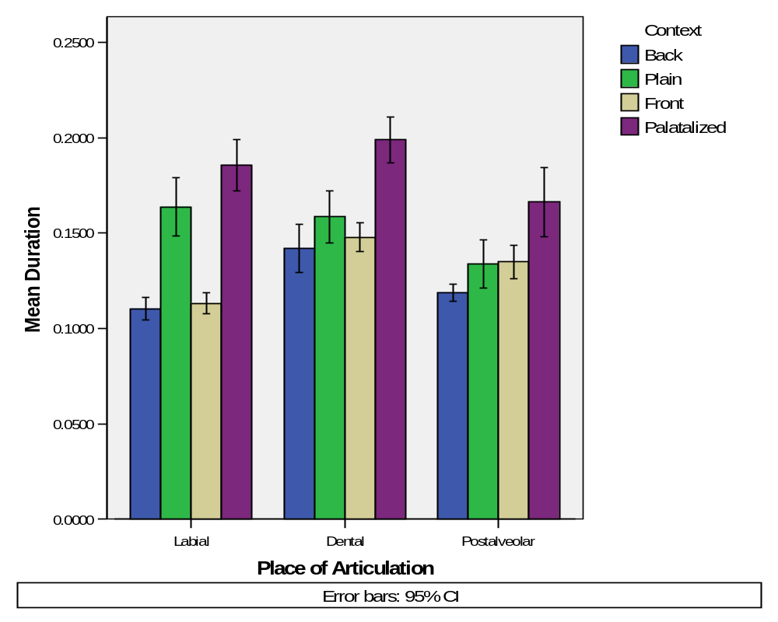

By this bar graph there appears to be an interaction in Coda and Frontness, to be sure I did Analyze > Univariate and made plots. There was an interaction for all three places of articulation:
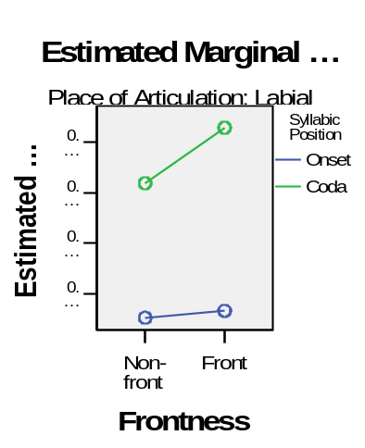 | 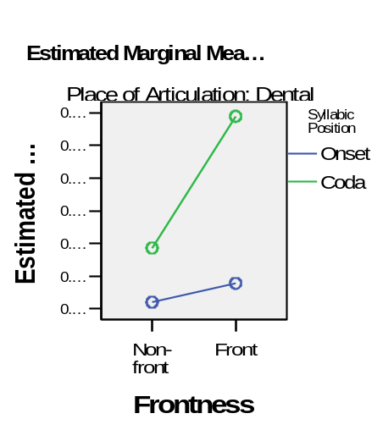 | 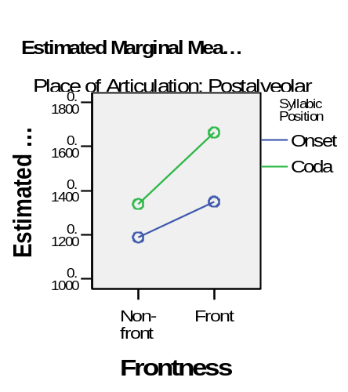

Test Hypothesis 1- Palatalized and Plain consonants are different:

The duration of the segment showed the palatalized segments were longer than other segments (this would support the hypothesis that the palatalized segments are in fact two segments, a consonant followed by a voiceless vowel).

Expect, consonants in coda position were longer than those in onset position, furthermore, palatalized consonants were longer than plain. Crosslinguistically palatalized consonants are longer than plain anyway, but are they this long?

What to do: Run a two factor anova looking for an interaction between FRONT and CODA. We expect to find an interaction, namely that if the segment is in a coda it will be longer (maybe not significant for the non-fronted) and only fronted in coda position are longer than the others.

Checking number of data points
Between-Subjects Factors

Place of Articulation |  |  | Value Label | N
Labial | Syllabic Position | 0 | Onset | 24
Labial | Syllabic Position | 1 | Coda | 24
Labial | Frontness | 0 | Non-front | 24
Labial | Frontness | 1 | Front | 24
Dental | Syllabic Position | 0 | Onset | 18
Dental | Syllabic Position | 1 | Coda | 18
Dental | Frontness | 0 | Non-front | 18
Dental | Frontness | 1 | Front | 18
Postalveolar | Syllabic Position | 0 | Onset | 24
Postalveolar | Syllabic Position | 1 | Coda | 24
Postalveolar | Frontness | 0 | Non-front | 24
Postalveolar | Frontness | 1 | Front | 24

I had to throw out a word in the dental condition If I remember correctly…

Checking assumptions:
Levene's Test of Equality of Error Variances(a)

Dependent Variable: Duration
Place of Articulation | F | df1 | df2 | Sig.
Labial | 6.156 | 3 | 44 | .001
Dental | .613 | 3 | 32 | .611
Postalveolar | 4.783 | 3 | 44 | .006
Tests the null hypothesis that the error variance of the dependent variable is equal across groups.
a Design: Intercept+coda+front+coda * front

this means that the variance in the labials and post-alveolars is significantly unequal across groups? But the variance across groups in the dentals is ok?

Checking the model for significant interaction first:
Tests of Between-Subjects Effects

Dependent Variable: Duration
Place of Articulation | Source | Type III Sum of Squares | df | Mean Square | F | Sig. | Partial Eta Squared
Labial | Corrected Model | .050(a) | 3 | .017 | 56.508 | .000 | .794
Labial | Intercept | .985 | 1 | .985 | 3308.649 | .000 | .987
Labial | coda | .048 | 1 | .048 | 159.617 | .000 | .784
Labial | front | .002 | 1 | .002 | 6.228 | .016 | .124
Labial | coda * front | .001 | 1 | .001 | 3.678 | .062 | .077
Labial | Error | .013 | 44 | .000
Labial | Total | 1.049 | 48
Labial | Corrected Total | .064 | 47
Dental | Corrected Model | .018(b) | 3 | .006 | 25.532 | .000 | .705
Dental | Intercept | .943 | 1 | .943 | 4068.285 | .000 | .992
Dental | coda | .010 | 1 | .010 | 44.379 | .000 | .581
Dental | front | .005 | 1 | .005 | 20.629 | .000 | .392
Dental | coda * front | .003 | 1 | .003 | 11.588 | .002 | .266
Dental | Error | .007 | 32 | .000
Dental | Total | .968 | 36
Dental | Corrected Total | .025 | 35
Postalveolar | Corrected Model | .014(c) | 3 | .005 | 13.178 | .000 | .473
Postalveolar | Intercept | .921 | 1 | .921 | 2537.810 | .000 | .983
Postalveolar | coda | .006 | 1 | .006 | 17.826 | .000 | .288
Postalveolar | front | .007 | 1 | .007 | 19.494 | .000 | .307
Postalveolar | coda * front | .001 | 1 | .001 | 2.216 | .144 | .048
Postalveolar | Error | .016 | 44 | .000
Postalveolar | Total | .951 | 48
Postalveolar | Corrected Total | .030 | 47
a R Squared = .794 (Adjusted R Squared = .780)
b R Squared = .705 (Adjusted R Squared = .678)
c R Squared = .473 (Adjusted R Squared = .437)

An interaction between the Front and Coda conditions was found in the dentals, but not in the postalveolars and nearly found in the labials.

Main effects for coda were found for all three, also main effects for front were found in dental and postalveoalr but only the postalveolar really counts cause it showed the least interaction between the two factors.

Do I just take the figures that I highlighted in teal above for the main effects?

If an interaction is found: do a t-test keeping coda constant, so compare +Front, and –Front bars with the diagonal lines above. I didn’t do a t-test, in options I chose to do Estimated Marginal Means Interactions for the 2 factors and the interaction factor, using the Bonferioni adjustment I got the tables below.

Now to test for Submain effects in the dental

There was a main effect for coda in the dental
Pairwise Comparisons

Dependent Variable: Duration
Place of Articulation | (I) Syllabic Position | (J) Syllabic Position | Mean Difference (I-J) | Std. Error | Sig.(a) | 95% Confidence Interval for Difference(a)
 |  |  |  |  |  | Lower Bound | Upper Bound
Labial | Onset | Coda | -.063(*) | .005 | .000 | -.073 | -.053
Labial | Coda | Onset | .063(*) | .005 | .000 | .053 | .073
Dental | Onset | Coda | -.034(*) | .005 | .000 | -.044 | -.023
Dental | Coda | Onset | .034(*) | .005 | .000 | .023 | .044
Postalveolar | Onset | Coda | -.023(*) | .005 | .000 | -.034 | -.012
Postalveolar | Coda | Onset | .023(*) | .005 | .000 | .012 | .034
Based on estimated marginal means
* The mean difference is significant at the .05 level.
a Adjustment for multiple comparisons: Bonferroni.

There was a main effect for Front in the dental.
Pairwise Comparisons

Dependent Variable: Duration
Place of Articulation | (I) Frontness | (J) Frontness | Mean Difference (I-J) | Std. Error | Sig.(a) | 95% Confidence Interval for Difference(a)
 |  |  |  |  |  | Lower Bound | Upper Bound
Labial | Non-front | Front | -.012(*) | .005 | .016 | -.022 | -.002
Labial | Front | Non-front | .012(*) | .005 | .016 | .002 | .022
Dental | Non-front | Front | -.023(*) | .005 | .000 | -.033 | -.013
Dental | Front | Non-front | .023(*) | .005 | .000 | .013 | .033
Postalveolar | Non-front | Front | -.024(*) | .005 | .000 | -.035 | -.013
Postalveolar | Front | Non-front | .024(*) | .005 | .000 | .013 | .035
Based on estimated marginal means
* The mean difference is significant at the .05 level.
a Adjustment for multiple comparisons: Bonferroni.

Whats this for:
Univariate Tests

Dependent Variable: Duration
Place of Articulation |  | Sum of Squares | df | Mean Square | F | Sig. | Partial Eta Squared
Labial | Contrast | .002 | 1 | .002 | 6.228 | .016 | .124
Labial | Error | .013 | 44 | .000
Dental | Contrast | .005 | 1 | .005 | 20.629 | .000 | .392
Dental | Error | .007 | 32 | .000
Postalveolar | Contrast | .007 | 1 | .007 | 19.494 | .000 | .307
Postalveolar | Error | .016 | 44 | .000
The F tests the effect of Frontness. This test is based on the linearly independent pairwise comparisons among the estimated marginal means.

From these stats I conclude that there is an interaction between coda and front in dentals. When the segment is in the coda position and front it is longer.

For labials there is a main effect of coda, items in the coda were longer than those in the onset. This is as expected, however the palatalized were not signifantly different from the plain ? but my hypothes wants to compare those two bars? But since I dindt find a significant interaction im not allowed?

Talk about postalveolars

Measurement Set 2
Run palatalized vs plain on dentals and postalveolars (cant do labials because the plain ones have no release)
Run palatalized vs fronted on all three consonants
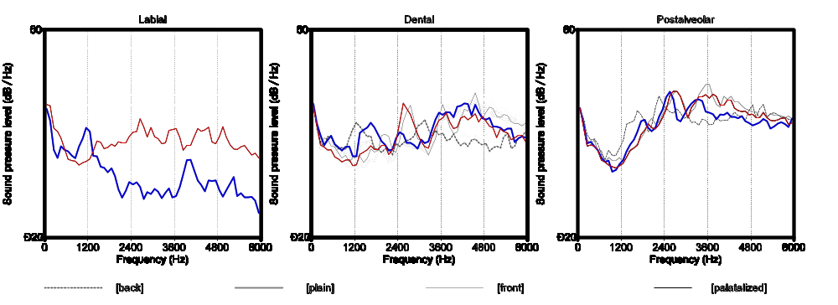

Test Hypothesis 1- Palatalized and Plain consonants are different:

The fricated release of the front consonants (in red and black) showed increased amplitude in the 2600Hz range and an antiresonance around 2000Hz, a sign of a palatal constriction. This is evidence that there is indeed a difference between palatal and plain segments.

What to do: Do a 2 factor anova for the amplitude of the peak at 2600Hz. Check for an interaction between CODA and FRONT, I don’t expect to find any.

I expect to find a “main effect” for FRONT. Show that FRONT Conditions are significantly different from the –FRONT conditions.

Test Hypothesis 2 - Palatalized and contextually fronted consonants are not fundamentally different.

The black and red lines so no significant difference in spectral prominence.

What to do: Do a t-test for the amplitude of the peak around 2600Hz between the +Front and –Front conditions, I expect to find no statistically significant difference.

(Is there a way to compare the lines overall, not just a particular point…)

Measurement Set 3
Run on all three consonants
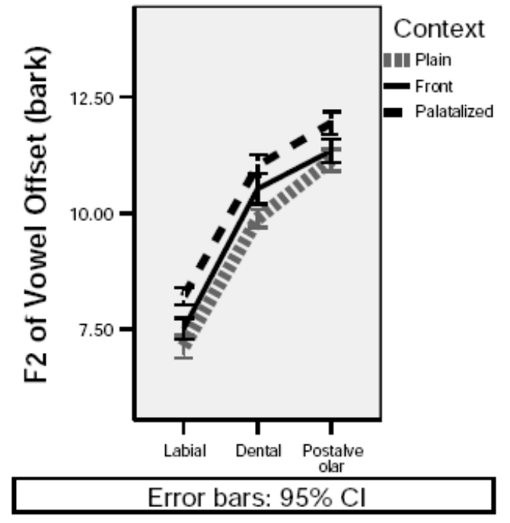
Test Hypothesis 1- Palatalized and Plain consonants are different:

Palatalized consonants showed higher F2 in the release of the preceding vowel than plain consonants, indicating an anticipation for a front articulation. This is further evidence that palatalized consonants are different from plain consonants.

What to do: Run a 2 factor anova for CODA and FRONT. Expect to find the means for +Front are higher than the –Front regardless of CODA. The –Coda,-Front segments were the most different and weren’t shown above… does that matter?

This result set seems pretty complicated to interpret to me.. Do I expect an interaction or not…

Test Hypothesis 2 - Palatalized and contextually fronted consonants are not fundamentally different.

Palatalized consonants showed higher F2 in the release of the preceding vowel than fronted consonants. This is evidence against our second hypothesis that palatalized and contextualy fronted consonants are not fundamentally different.

There is an important caviat, we think that palatalized consonants and contextually fronted consonants differ only in the fact that palatalized consonants are in coda position. In a study of Russian palatalization in coda position, secondary gestures show wider variation in timing with respect to the primary gesture. (Kochetov 2006). This is an area for further experiments.

What to do: do a t-test for the +FRONTS, they should be statistically different for the two CODA factors.

