INLAND ENC HARMONIZATION GROUP

IEHG INLAND ELECTRONIC NAVIGATIONAL CHART
PRODUCT SPECIFICATION

IEHG Publication S-401
Inland Electronic Navigational Chart Product Specification

NOTE: S-401 has various components that are in development. Therefore until it is at a final draft stage various items such as the main document, feature catalogue and encoding guide are not fully harmonized.

Version Number | Date | Author | Purpose
Initial Draft | December 2013 | J.Powell | Added in decisions from TSMAD27
Draft 0.0.0 | April/May  2014 | J.Powell | Included S-101 portrayal. Most of the portrayal is covered by the catalogue, so much of the old S-52 guidance goes into the implementation guidance annex.
Inland draft 0.0.0

Contents Page

Introduction

1 Overview
1.1 Scope
1.2 References
1.3 Terms, definitions and abbreviations
1.3.1 Use of Language
1.3.2 Terms and Definitions
1.3.3 Abbreviations
1.4 S-401 General Data Product Description
1.5 Data product specification metadata
1.5.1 IHO Product Specification Maintenance
2 Specification Scopes
3 Dataset Identification
4 Data Content and structure
4.1 Introduction
4.2 Application Schema
4.3 Feature Catalogue
4.3.1 Introduction
4.3.2 Feature Types
4.3.3 Feature Relationship
4.3.4 Information Types
4.3.5 Attributes
4.4 Feature Feature Identifier
4.5 Dataset
4.5.1 Introduction
4.5.2 Dataset rules
4.5.3 Data Coverage rules
4.5.4 Dataset size
4.6 Display Scale Range
4.7 Dataset Loading and Unloading
4.7.1 Dataset Loading and Unloading Algorithm
4.8 Geometry
4.8.1 S-100 Level 3a Geometry
4.8.2 Masking
5 Coordinate Reference Systems (CRS)
5.1 Introduction
5.2 Horizontal Coordinate Reference System
5.3 Vertical CRS for Soundings
6 Data Quality
6.1 Introduction
6.1.1 Data Compliance and Integrity
6.1.2 Bathymetric Data Quality
6.1.3 Non Bathymetric Data Quality
6.1.4 Survey Data Quality
7 Data Capture and Classification
7.1 Introduction
8 Maintenance
8.1 Introduction
8.2 Maintenance and Update Frequency
8.3 Data Source
8.4 Production Process
8.5 Feature and Portrayal Catalogue Management
9 Portrayal
9.1 Introduction
9.2 Portrayal Catalogue
9.2.1 The Portrayal Process
9.2.2 The Colour Coding Scheme
9.2.3 Symbols, Fill Styles and Line Styles
9.2.4 Text
9.2.5 Display Priorities
9.2.6 Viewing Groups
10 Data Product format (encoding)
10.1 Introduction
10.1.1 Encoding of Latitude and Longitude
10.1.2 Encoding of Depths
10.1.3 Numeric Attribute Encoding
10.1.4 Text Attribute Values
10.1.5 Mandatory Attribute Values
10.1.6 Missing Attribute Values
11 Data Product Delivery
11.1 Introduction
11.2 Exchange Set
11.3 Dataset
11.3.1 Datasets
11.3.2 Dataset file naming
11.3.3 New Editions, Re-Issues, Updates and Cancellations
11.4 Support Files
11.4.1 Support File Naming
11.4.2 Support File Management
11.5 Exchange Catalogue
11.6 Data integrity and encryption
11.6.1 ENC data integrity measures
11.6.2 Producer Identity and Authentication
11.6.3 Digital Signatures and metadata
11.6.4 ENC data encryption
12 Metadata
12.1 Introduction
12.1.1 Dataset Metadata
12.1.2 Support File Metadata
12.1.3 Exchange Catalogue File Metadata
12.2 Language

Annex A Data Classification and Encoding Guide

Data Product format (encoding)
B1.1 Data set files
B1.2 Records
B1.3 Fields
B1.4 Subfields
B1.5 Base dataset structure
B1.5.2 Data Set Identification field - DSID
B1.5.3 Data Set Structure Information field - DSSI
B1.5.4 Attribute field - ATTR
B1.5.12 2-D Integer Coordinate Tuple field structure – C2IT
B1.5.13 3-D Integer Coordinate Tuple field structure– C3IT
B1.5.24 Feature Type Record Identifier field - FRID
B1.5.25 Feature Feature Identifier field - FOID
B1.5.26 Spatial Association field - SPAS
B1.5.27 Feature Association field – FASC
B1.5.28 Theme Association field - THAS
B1.5.29 Masked Spatial Type field - MASK
B1.6 Update dataset structure
B1.6.1 Field Content
B1.6.2 Data Set Identification field - DSID
B1.6.3 Data Set Structure Information field - DSSI
B1.6.4 Attribute field - ATTR
B1.6.5 Information Association field
B1.6.6 Information Type Identifier field - IRID
B1.6.8 2-D Integer Coordinate Tuple field structure – C2IT
B1.6.9 3-D Integer Coordinate Tuple field structure – C3DI
B1.6.21 Feature Type Record Identifier field - FRID
B1.6.22 Feature Feature Identifier field - FOID
B1.6.23 Spatial Association field - SPAS
B1.6.24 Feature Association field – FASC
B1.6.25 Theme Association field - THAS
B1.6.26 Masked Spatial Type field - MASK
B1.7 Dataset cancellation structure
B1.7.1 Field Content
B1.7.2 Data Set Identification field - DSID
C1 Overview
C1.1 Introduction

C2 Portrayal
C2.1 Introduction
C2.1.1 Concept and limitations of ECDIS
C2.1.2 Function and Use of S-101 portrayal
C2.1.3 Type Approval - Minor Deviations to the S-101 Portrayal Catalogue
C2.2 Display Considerations
C2.3 SYMBOLISING AREAS, LINES & POINTS AND FOR TEXT
C2.3.2 Areas
C2.4 Text, Diagrams etc.
C2.4.2 Abbreviations
C2.7.3 Skipper’s & Navigation Information Colours
C2.7.4 Other Colours
C2.7.5 Colour Section V / Vessel Symbol & Planned Route
C2.8 Queries
C2.8 Display Priority, Radar Priority, Display Category, Viewing group
C2.8.2 RADAR Flag
C2.8.3 Display Mode
C2.8.3.1 Independent Skipper Selections
C2.8.3. Skipper’s objects
C2.10.1 Scalebar and Latitude Scale
C2.10.2 North Arrow
C2.10.3 Graticule
C2.10.4 Display Mode
C2.10.5 Shallow Water Pattern
C2.10.6 Black Level Adjustment Symbol
C2.10.7 Detection and Notification of Navigational Hazards
C2.10.8 Visualization of the Safety Contour
C2.10.9 Detection of Safety Contour
C2.11.2 Display of National Language Attributes and Content
C2.11.4 Light Description Text Strings
C2.12.1 Manual Updates
C2.12.1 Added Feature
C2.12.1 Deleted Feature
C2.12.1 Moved Feature
C2.12.1.4 Modified Feature
C2.13 Cursor Pick and Interface Panel Display
C2.13.1 Pick Report Descriptions
C2.13.2 User Defined Curser Pick Parameters
C2.13.3 Sorting by Significance
C2.13.4 Hover-over Function
C2.13.5 Unknown Attributes
C2.14 Tidal Stream Panels : S-101 feature TidalStreamPanelData
C3 Data Product Delivery
C3.1 Introduction
C3.2 Exchange Set
C3.3 Dataset
C3.3.1 Data Sets
C3.3.2 New Editions, Re-Issues and Updates

ANNEX D Feature Catalogue
Introduction

IEHG S-401 is the Inland Electronic Navigational Chart Product Specification, produced by the Inland ENC Harmonization Group (IEHG). S-401 is designed to allow content, content definition (feature catalogues) and presentation (portrayal catalogues) to be updateable without breaking system implementations.

Based on S-100, S-401 includes all the necessary pieces for both chart producers to produce Inland Electronic Navigational Charts (IENC) and OEMs to be able to ingest and properly display them. This product specification is designed to be flexible with the introduction of machine readable feature and portrayal catalogues that will allow for managed change and will enable the introduction of new navigationally significant features and their portrayal using a “just in time” methodology.

1 Overview

1.1 Scope

This document describes an S-100 compliant product specification for Inland Electronic Navigational Charts, which will form the base navigation layer for an S-100 based Inland ECDIS or ECS. It specifies the content, structure, and metadata needed for creating a fully compliant S-401 IENC and for its portrayal within an S-100 Inland ECDIS or ECS. This product specification includes the content model, the encoding, the feature catalogue, portrayal catalogue, metadata and implementation guidance for developers.

1.2 References

S-100 IHO Universal Hydrographic Data Model

FIPS 186 Federal Information Processing Standards – Digital Signature Standard

1.3 Terms, definitions and abbreviations

1.3.1 Use of Language

Within this document:
“Must” indicates a mandatory requirement. “Shall” can be used as a synonym.
“Should” indicates an optional requirement, that is the recommended process to be followed, but is not mandatory.
“May” means “allowed to” or “could possibly”, and is not mandatory.

1.3.2 Terms and Definitions

Alarm
(MSC.302/A) a high-priority alert. Condition requiring immediate attention and action by the bridge team, to maintain the safe navigation of the vessel.

Alert
(MSC.302/A) announcement of abnormal situations and conditions requiring attention. Alerts are divided in four priorities: emergency alarms, alarms, warnings and cautions. An alert provides information about a defined state change in connection with information about how to announce this event in a defined way to the system and the operator

Caution
(MSC.302/A) lowest priority of an alert. Awareness of a condition which does not warrant an alarm or warning condition, but still requires attention out of the ordinary consideration of the situation or of given information.

CIE Colours
One of the first mathematically defined colour spaces the CIE XYZ colour space was created by the International Commission on Illumination 1931.

Colour Token
A five letter, code identifying a colour and its use in ECDIS. The day and night colours which are identified by the token are given in the colour tables (in CIE colours). Note that several colour tokens may share the same colour.

Complex Line Styles
Lines that are themselves symbols, or that have symbols interlaced. Examples of a line as a symbol are a submerged pipeline LC(PIPSOL05), or the T T T lines indicating the inside of an area LC(ENTRES51). A simple or complex line may have a symbol interlaced, such as an anchor for anchorage area LC(ACHARE51).

dataset
An identifiable collection of data

NOTE A dataset may be a smaller grouping of data which, though limited by some constraint such as spatial extent or feature type is located physically within a larger dataset. Theoretically, a dataset may be as small as a single feature contained within a larger dataset. A hardcopy map or chart may be considered a dataset.

Display Category
IMO PS [2] establishes three display categories for the presentation of SENC objects.
Display base: always on the display.
Standard display: the ECDIS' default display.
Other: all other objects in the SENC.

Display Priority
Hierarchy to determine which feature is to be displayed when two features overlap. Priority 2 overwrites 1

ECDIS
A navigation information system which with adequate back-up arrangements can be accepted as complying with the up-to-date chart required by regulations V/19 and V/27 of the 1974 SOLAS Convention, as amended, by displaying selected information from a system electronic navigational chart (SENC) with positional information from navigation sensors to assist the Mariner in route planning and route monitoring, and if required display additional navigation-related information.

ECDIS Chart 1
An ECDIS version of chart 1, including all symbols, line styles and colour coding used for chart presentation. Intended for the Mariner to both familiarize himself with ECDIS and to look up specific symbols.

ECS
An electronic charting system.

ENC
The dataset, standardized as to content, structure and format, issued for use with ECDIS by or on the authority of a Government authorized Hydrographic Office or other relevant government institution, and conform to IHO standards. The ENC contains all the chart information necessary for safe navigation and may contain supplementary information in addition to that contained in the paper chart which may be considered necessary for safe navigation.

Inland ECDIS
A navigation information system, based on an ECDIS, specific for inland waterways which are regulated by regional or national regulators and that contain specific waterway signals, signs and markings.

IENC
The dataset, standardized as to content, structure and format, for use with inland electronic chart display and / or information systems operated onboard of vessels transiting inland waterways. An IENC is issued by or on the authority of a competent government agency, and conforms to standards initially developed by the International Hydrographic Organization (IHO) and refined by the Inland ENC Harmonization Group. An IENC contains all the chart information necessary for safe navigation on inland waterways and may contain supplementary information in addition to that contained in the paper chart (for example sailing directions, machine-readable operating schedules, etc.) which may be considered necessary for safe navigation and voyage planning. [IENC Encoding Guide, Edition 2.2, Feb 2010]

Feature
Abstraction of real world phenomena [ISO 19101:2003]

NOTE A feature may occur as a type or an instance. Feature type or feature instance should be used when only one is meant.

EXAMPLE The phenomenon named ‘London Eye’ may be classified with other phenomena into a feature type ‘landmark’

Geometric Primitive
A plain point, a plain curve, a plain surface as defined in geometry (i.e. without any meaning attached).

Indication
Visual indication giving information about the condition of a system or equipment. [2]

Minimum Display Scale
The smaller value of the ratio of the linear dimensions of features of a dataset presented in the display and the actual dimensions of the features represented (smallest scale) of the scale range of the dataset.

Maximum Display Scale
The larger value of the ratio of the linear dimensions of features of a dataset presented in the display and the actual dimensions of the features represented (largest scale) of the scale range of the dataset.

No symbol Feature
In some cases, the database contains information that is not intended for display. (An example might be a general area such as 'Great Australian Bight' which would be available for an answer to cursor interrogation of the sea area.)

Opaque fill
The background is completely filled with the colour fill. (for example depth area). The point and line SENC features may be overwritten. The raw RADAR image is a special case of opaque fill which overwrites all other features expect those with "priority over radar" (OVERRADAR).

Pattern fill
A method of identifying areas by large, faintly coloured symbols well spaced out across the area. A pattern spacing algorithm ensures that the pattern symbols are visible without being so dense as to cause clutter. Used to ensure pattern symbols are always visible at any display scale.

Pivot Point
The pivot point is the point around which the symbol gets scaled and rotated. When the symbol is placed in the world space, the symbol's pivot point is positioned exactly on the object's position and all elements of the symbol are geometrically related to that position.

Radar Priority
The IMO Performance Standard requires that radar can be switched off with a "single action control" in order to see SENC and Skippers info clearly. However certain other info, such as planned route, safety contour, coastline should always be written over the radar.

Radar Transparency
A method of varying the transparency of radar in a continuous progression from no radar to a totally opaque radar overlay, by merging the radar colour with the colour of the object it overlays at each pixel

SCAMIN
The smallest scale at which an object is displayed (for example a minor light, SCAMIN of 1:45,000, would not be displayed at a scale of 1:90,000).

SENC

In ECDIS means a database, in the manufacturer’s internal Inland ECDIS or ECS format, resulting from the loss-less transformation of the entire IENC contents and its updates. It is this database that is accessed by Inland ECDIS or ECS for the display generation and other navigational functions, and is equivalent to an up-to-date paper chart. The SENC may also contain information added by the skipper and information from other sources.

Simple Line Styles
Solid lines, dots and dashes.

Skin of the EARTH
A defined set of non-overlapping geographic features of geometric primitive surface, covering an area equivalent to that of meta-features Data Coverage

Symbol Size
The size is specified in normalized units of 0.01 mm. The minimum dimension is always more than 4 mm. This size applies to display on a standard minimum screen specified in PC&SS [5] and S-52 [3].

Symbology Instruction
A machine readable symbolization order used in look-up tables to link object-classes to symbols, in straight forward cases (i.e. where a conditional symbology instruction is not required)

Text Label
A textual description of an object. Can be formatted to include standard text as well as feature attribute values. For example, light descriptions, place names etc.

Transparent Fill
A method of identifying features of geometric primitive surface by covering a given percentage of each 4 pixel square with the fill colour, leaving the remainder "transparent". Used to ensure the information underneath shows through.

Warning
(MSC.302/A) alert for condition requiring immediate attention, but no immediate action by the bridge team. Warnings are presented for precautionary reasons to make the bridge team aware of changed conditions which are not immediately hazardous, but may become so if no action is taken.

1.3.3 Abbreviations
CRS Coordinate Reference System
ECDIS Electronic Chart Display Information System
Inland ECDIS Inland Electronic Chart Display Information System
ECS Electronic Chart System

EPSG European Petroleum Survey Group
ENC Electronic Navigational Chart
IEHG Inland ENC Harmonization Group
IENC Inland Electronic Navigational Chart
IHO International Hydrographic Organization
IMO International Maritime Organization
ISO International Organization for Standardization
SENC System Electronic Navigational Chart
SOLAS Safety of Life at Sea

1.4 S-401 General Data Product Description

NOTE This information contains general information about the data product.

Title: Inland Electronic Navigational Chart

Abstract: An Inland Electronic Navigational Chart (IENC) is a vector chart produced on the authority of a regional or national waterway authority. Its primary purpose is for use within an Inland Electronic Chart Display and Information Systems (Inland ECDIS) or an Electronic Chart System (ECS). The IENC contains an extraction of real world information necessary for the safe navigation of vessels on inland waterways.

Content: The Product Specification defines all requirements to which IENC data products must conform. Specifically it defines the data product content in terms of features and attributes within the feature catalogue. The display of features is defined by the symbols and rule sets contained in the portrayal catalogue. The Encoding Guide for Inland ENCs provides guidance on how data product content must be captured. (Annex A) In addition, Annex C will provide implementation guidance for developers.

Spatial Extent:
Description: Areas specific to inland navigation.
East Bounding Longitude: 180°
West Bounding Longitude: -180°
North Bounding Latitude: 90°
South Bounding Latitude: -90°

Purpose: The purpose of an IENC dataset is to provide official navigational data to an Inland Electronic Chart Display and Information System (Inland ECDIS) or an Electronic Chart System (ECS) for the safe passage and route planning of vessels between destinations on inland waterways.

1.5 Data product specification metadata

NOTE This information uniquely identifies this Product Specification and provides information about its creation and maintenance. For further information on dataset metadata see clause 12.

Title: The Inland ENC Harmonization Group (IEHG) Inland Electronic Navigational Chart Product Specification

S-100 Version: 2.0.0

S-401 Version: 0.0.1

Date: February 2015

Language: English

Classification: Unclassified

Contact: Inland ENC Harmonization Group (IEHG)

denise.r.ladue@usace.army.mil
bernd.birklhuber@bmvit.gv.at
flavia@chm.mar.mil.br
fwj@wti.ac.cn
brian.j.tetreault@usace.army.mil
pieta@serendipity.nl
angel.terry@jeppesen.com
ybaek@korea.kr

URL: http://ienc.openecdis.org

Identifier: S-401

Maintenance: Changes to the Product Specification S-401 are coordinated by the Inland ENC Harmonization Group (IEHG)and must be made available via the http://ienc.openecdis.org web site. Maintenance of the Product Specification must conform to the Terms of Reference of IEHG.
The IEHG submits Inland ENC standards for formalization to:
- Interested international organizations like IHO, the European Commission (EC), the Central Commission for Navigation on the Rhine (CCNR), the Danube Commission (DC), the Economic Commission for Europe of the United Nations (UN/ECE), the Mekong River Commission,
- National competent authorities.

1.5.1 IEHG Product Specification Maintenance

1.5.1.1 Introduction

Changes to S-401 will be released as a new edition, revision, or clarification by the different regional organizations;

1.5.1.2 New Edition

New Editions of S-401 introduce significant changes. New Editions enable new concepts, such as the ability to support new functions or applications, or the introduction of new constructs or data types.
New Editions are likely to have a significant impact on either existing users or future users of S-401. All cumulative revisions and clarifications must be included with the release of approved New Editions.

1.5.1.3 Revisions

Revisions are defined as substantive semantic changes to S-401. Typically, revisions will change S-401 to correct factual errors; introduce necessary changes that have become evident as a result of practical experience or changing circumstances. A revision must not be classified as a clarification. Revisions could have an impact on either existing users or future users of S-401. All cumulative clarifications must be included with the release of approved corrections revisions.

Changes in a revision are minor and ensure backward compatibility with the previous versions within the same Edition. Newer revisions, for example, introduce new features and attributes. Within the same Edition, a dataset of one version could always be processed with a later version of the feature and portrayal catalogues.

In most cases a new feature catalogue or portrayal catalogue will result in a revision of S-401.

1.5.1.4 Clarification

Clarifications are defined as non-substantive changes to S-401. Typically, clarifications: remove ambiguity; correct grammatical and spelling errors; amend or update cross references; and insert improved graphics. A clarification must not cause any substantive semantic change to S-401.

Changes in a clarification are minor and ensure backward compatibility with the previous versions within the same Edition. Within the same Edition, a dataset of one clarification version could always be processed with a later version of the feature and portrayal catalogues, and a portrayal catalogue can always rely on earlier versions of the feature catalogues.

Changes in a clarification are minor and ensure backward compatibility with the previous versions

1.5.1.5 Version Numbers

The associated version control numbering to identify changes (n) to S-401 must be as follows:

New Editions denoted as n.0.0

Revisions denoted as n.n.0

Clarifications denoted as n.n.n

2 Specification Scopes

Scope ID: Root scope

Level: Dataset

Level name: IENC Dataset

3 Dataset Identification

A dataset that conforms to this Product Specification may be identified by its discovery metadata as defined in clause 12.

Title: Inland Electronic Navigational Chart
Alternate Title: IENC
Abstract: S-401 IENCs must be produced in accordance with the rules defined in the S-401 Product Specification. The S-401 Product specification contains all the information necessary to enable chart producers to produce a consistent IENC, and manufacturers to use that data efficiently in an Inland ECDIS or ECS.
Topic Category: Transportation (ISO 19115 Domain Code 018)
Geographic Description: Areas specific to inland waterway navigation.
Spatial Resolution: An IENC dataset and Data Coverage must carry a value for maximum display scale. Each Data Coverage must additionally carry a value for minimum display scale. Values must be taken from the following table:

Maximum Display Scale | Minimum Display Scale
1:10,000,000 | Empty (null)
1:3,500,000 | 1:10,000,000
1:1,500,000 | 1:3,500,000
1:700,000 | 1:1,500,000
1:350,000 | 1:700,000
1:180,000 | 1:350,000
1:90,000 | 1:180,000
1:45,000 | 1:90,000
1:22,000 | 1:45,000
1:12,000 | 1:22,000
1:8,000 | 1:12,000
1:4,000 | 1:8,000
1:3,000 | 1:4,000
1:2,000 | 1:3,000
1:1,000 | 1:2,000

Table 1- ENC Minimum Display and Maximum Display Scales

Purpose: Inland Electronic Navigational Chart for use in Inland Electronic Chart Display and Information Systems or Electronic Chart Systems

Language: English (Mandatory), other (Optional)

Classification: Data may be classified as one of the following although it is not mandatory:

Unclassified
Restricted
Confidential
Secret
Top Secret

Spatial Representation Type: Vector

Point of Contact: Producing Agency

Use Limitation: Not to be used for navigation on land.

4 Data Content and structure

4.1 Introduction

An S-401 IENC is a feature-based product. The content information is described in terms of a general feature model and a feature catalogue.

4.2 Application Schema

S-401 conforms to the General Feature Model (GFM) from S-100 Part 3. The GFM is the conceptual model and the implementation is defined in the Feature Catalogue. The S-401 Application Schema is realised in the feature catalogue and the product specification only contains specific examples.

4.3 Feature Catalogue

4.3.1 Introduction

The S-401 Feature Catalogue describes the feature types, information types, attributes, attribute values, associations and roles which may be used in an IENC.

The S-401 Feature Catalogue is available as an XML file which conforms to the S-100 XML Feature Catalogue Schema and can be downloaded from the S-100 registry and http://ienc.openecdis.org. It is also available in a human readable version.

4.3.2 Feature Types
4.3.2.1 Geographic
Geographic (geo) feature types form the principle content of the IENC and are fully defined by their associated attributes and information types.
4.3.2.1.1 Skin of the Earth
Each area covered by a meta-feature Data Coverage must be totally covered by a set of geo features of geometric primitive type surface that do not overlap each other (the Skin of the Earth). Feature Types that comprise the Skin of the Earth are listed below:
DepthArea
DredgedArea
LandArea
UnsurveyedArea
DockArea
LockBasin
The geometry of coincident boundaries between Skin of the Earth features in a dataset must not be duplicated.
4.3.2.2 Meta
Meta features contain information about other features within a data set. Information defined by meta features override the default metadata values defined by the data set descriptive records. Meta attribution on individual features overrides attribution on meta features.
4.3.2.3 Cartographic
Cartographic features contain information about the cartographic representation (including text) of real world entities.
4.3.3 Feature Relationship
A feature relationship links instances of one feature type with instances of the same or a different feature type. There are four types of defined feature relationships in S-101 as described in the following sub clauses.
4.3.3.1 Information Association
An association is used to describe a relationship between an information type and a feature type that involves connections between their instances.
EXAMPLE A Supplementary Information information type provides additional information to any geo feature using an information association called additional information.

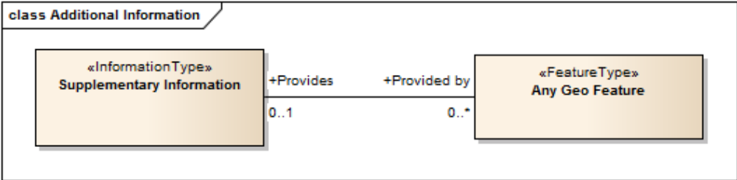
Figure 1 - Information Association

4.3.3.2 Feature Association
An association is used to describe a relationship between two feature types that involves connections between their instances.
EXAMPLE A Light feature provides additional information to the bridge feature. An association named Bridge Association is used to relate the features; roles are used to convey the meaning of the relationship.
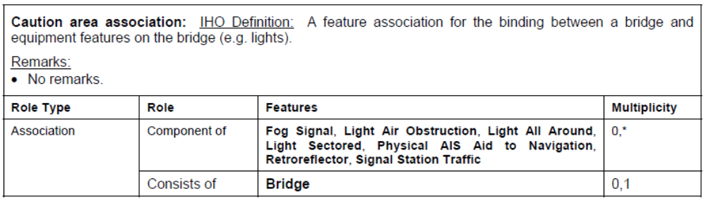
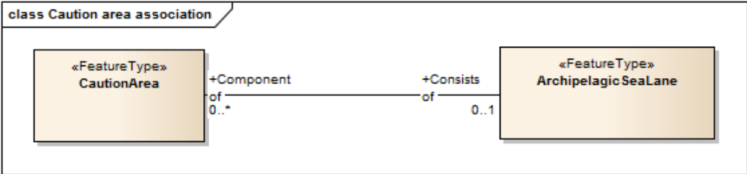
Figure 2 – Feature Association

4.3.3.3 Aggregation
An aggregation is a relationship between two or more feature types where the aggregation feature is made up of component features.
EXAMPLE An bridge feature may be composed of multiple span fixed features.
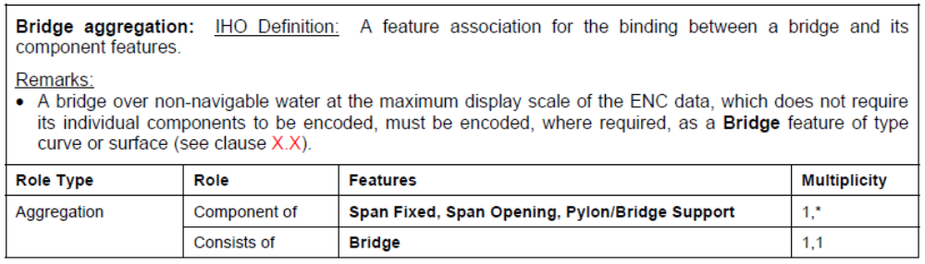
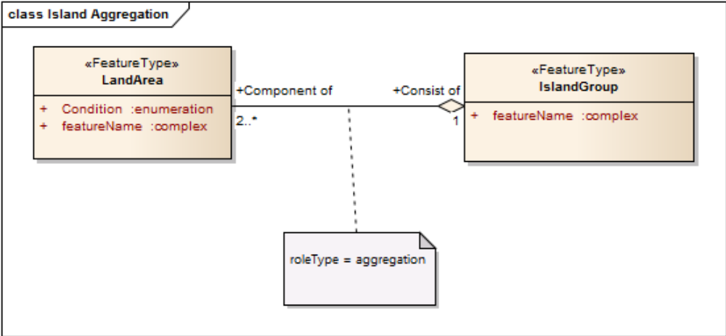
Figure 3 – Aggregation

4.3.3.4 Composition
A composition is a strong aggregation. In a composition, if a container feature is deleted then all of its containee features are deleted as well.
EXAMPLE If a feature type that is considered a structure feature, such as a beacon is deleted, then all of its component feature types that make up the equipment composition, such as lights and fog signals must be deleted as they make up the Structure/Equipment Composition.

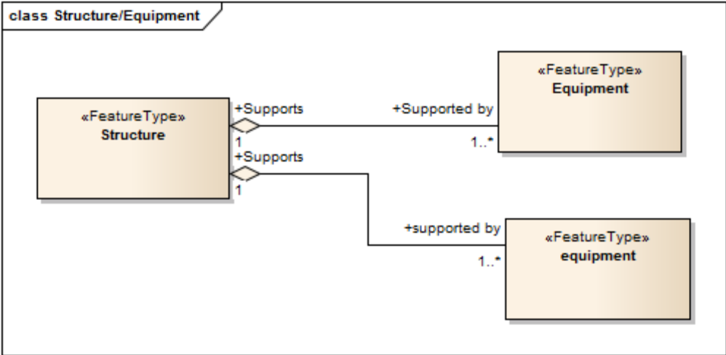
Figure 4 - Composition

4.3.4 Information
Information features are identifiable pieces of information in a dataset that can be shared between other features. They have attributes but have no relationship to any geometry; information features may reference other information features.
4.3.4.1 Spatial Quality
Spatial Quality attributes are carried in a feature class of type information. Only points, multipoints and curves can be associated with spatial quality. Currently no use case for associating surfaces with spatial quality attributes is known, therefore this is prohibited. Vertical uncertainty is prohibited for curves as this dimension is not supported by curves.

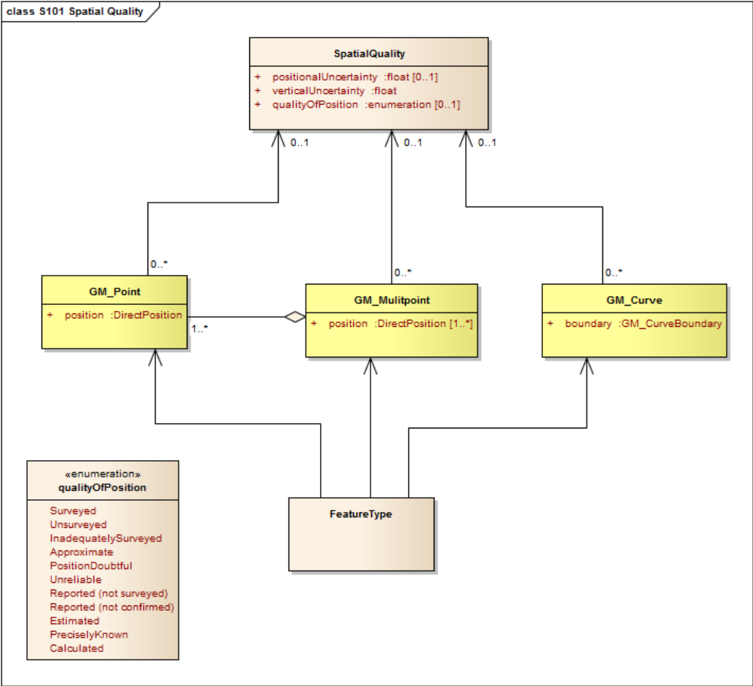
Figure 5 - Spatial Information Type

4.3.5 Attributes
S-401 defines attributes as either simple or complex.
4.3.5.1 Simple Attributes
S-401 uses eight types of simple attributes; they are listed in the following table:

Type | Definition
Boolean | the value is a logical value either ‘True’ or ‘False’
Integer | the value is an integer number
Real | the value is a floating point number
enumeration | the value is one of a list of predefined values
text | the value is general text. This is also defined as CharacterString.
dateTime | the value marks a point in time, consisting of a date in the Gregorian calendar and a 24 hour time. The time may contain a time zone.
date | the value is a date according to the Gregorian calendar.
time | the value is a 24 hour time, It may contain a time zone.
Table 2 - Simple Attribute Types

4.3.5.2 Complex Attributes
Complex attributes are aggregations of other attributes that are either simple or complex. The aggregation is defined by means of attribute bindings.

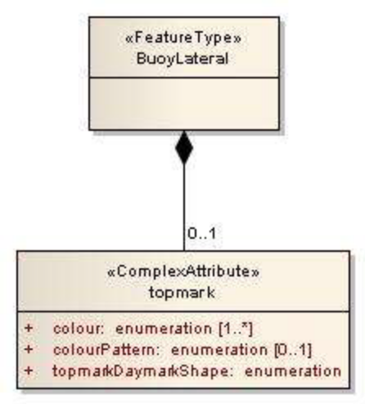
Figure 6 - Complex Attribute

EXAMPLE In this example a topmark has three sub attributes. The Buoy Lateral Feature may optionally include one instance of the complex attribute topmark.
4.4 Feature Object Identifier
Each real world feature within an IENC must have a unique universal Feature Object Identifier. This identifier, called the feature object identifier, is formed by the binary concatenation of the contents of the subfields of the “Feature Object Identifier” [FOID] field. Information types must not have a FOID.
The FOID may be used to identify that the same feature has instances in separate datasets. For example the same feature included in different maximum display scale datasets, or a feature being split by the ENC dataset limits within the same maximum display scale.
FOIDs must not be repeated in a dataset. Where a real-world feature has multiple parts within a single IENC dataset due to IENC dataset limit truncations, the feature will reference each spatial part of the feature within the dataset. This is accomplished in the 8211 encoding by including a Spatial Association for each disjoint component. When a feature’s geometry is split each component must be represented by a separate spatial feature that the feature refers to.
Where a real-world feature is repeated in datasets of different maximum display scale, the FOID must be repeated for each instance of the feature across the maximum display scale range. Where this occurs, all instances of the geo feature must be identical, i.e. same feature class and attribute values.
Feature Object Identifiers must not be reused by another feature, even when a feature has been deleted. The same feature can be deleted and added again later using the same FOID.
4.5 Dataset
4.5.1 Introduction
A Dataset is a grouping of features, attributes, geometry and metadata which comprises a specific coverage.
4.5.2 Dataset rules
In order to facilitate the efficient processing of IENC data the geographic coverage of a given maximum Display Scale may be split into multiple datasets. Each data set must be contained in a physically separate, uniquely identified file on the transfer medium.
The discovery metadata of a dataset must list all the Data Coverage features contained within that dataset and their assigned scale attributions.
An IENC update data set must not change the limit of a Data Coverage feature for the base IENC dataset. Where the limit of a Data Coverage feature for a base IENC dataset is to be changed, this must be done by issuing a new edition of the dataset.
Datasets must not cross the 180° meridian; this includes both the Data Coverage features and the boundingBox.
4.5.3 Data Coverage rules
A data set may contain more than one Data Coverage feature, but must not contain more than three total Data Coverage features. The data boundary is defined by the extent of the Data Coverage features and must be contained within the boundingBox.
NOTE: Annex CXX.X provides guidance for ENC producers regarding how to create datasets with multiple DataCoverages.
(The Data Coverage features within a dataset must not overlap)
Data Sets with the same maximum display scale may overlap, however Data Coverage features within these datasets must not overlap. This rule applies even if several producers are involved. There must be no overlapping data of the same maximum display scale, except at the agreed adjoining national data limits, where, if it is difficult to achieve a perfect join, a 5 metre overlapping buffer zone may be used; and for this situation, there must be no gaps in data.
When a dataset has multiple Data Coverage features, then the minimum Display Scale must be the same for all Data Coverage features within the dataset.

4.5.4 Dataset size
Datasets must not exceed 10MB.
Updates should not normally be larger than 1 MB and must not be larger than 5 MB.
4.6 Display Scale Range
A scale range of a dataset is used to indicate a range of scales between which a producer considers the data is intended for use. (see clause 4.7 for how datasets are to be loaded and unloaded in an Inland ECDIS or ECS) The smallest scale is defined by the minimum Display Scale and the largest scale by the maximum Display Scale . These scales must be set at one of the scales specified in clause 3 (spatial resolutions).
When the systems viewing scale is smaller than the value indicated by minimum display scale, features within the Data Coverage feature are not displayed, except where the SENC does not contain a dataset covering the area at a smaller scale, in which case the dataset will be displayed at all smaller scales. When the viewing scale is larger than the value indicated by maximum display scale, features within the Data Coverage feature are displayed with over-scale indications.

4.7 Dataset Loading and Unloading
A new algorithm based on producer defined display scales (minimum and maximum) for dataset loading and unloading is prescribed in this document. This will simplify the process for Inland ECDIS and ECS, giving clear and concise rules on how and when data is loaded and unloaded. The concept of navigation purpose is restricted for use in presenting IENCs in a visual catalogue. In order for the appropriate IENC to be viewed at the skipper’s selected viewing scale.
4.7.1 Dataset Loading and Unloading Algorithm
This clause defines the dataset loading and unloading algorithm for use on Inland ECDIS.

 | IENC data |  | Data Set X |  | Data Set Y |  | Data Set Z
 | maximumDisplayScale |  | 12000 |  | 22000 |  | 45000
 | minimumDisplayScale |  | 45000 |  | 90000 |  | 180000
Dataset Drawing order within the navigation systems memory |  |  | X |  | Y |  | Z
Condition |  | Combining Datasets
1 | SSVS = 90000  maximumDisplayScale(Y,Z)  <= SSVS <=  minimumDisplayScale(X)
1 |  |  |  |  | Y | + | Z
2 | SSVS = 45000  maximumDisplayScale(X,Y,Z)  <= SSVS <=  minimumDisplayScale(X,Y,Z)
2 |  |  | X | + | Y | + | Z
3 | SSVS = 22000  maximumDisplayScale(X,Y) <= SSVS  < maximumDisplayScale(Z)
3 |  |  | X | + | Y | + | Z
3 |  |  |  |  |  | + | Overscale  indication  of Z
Skippers Selected Viewing scale (SSVS)

Figure 7 - Data Loading and Unloading Algorithm

In order for Inland ECDIS or ECS to properly load and unload data as the skipper is zooming in and out using the skippers selected viewing scale (SSVS) the following algorithm must be used.
1. Create selection List
a. All Data Coverage areas within the graphics window within scale range (covered by the MSVS) are firstly ordered by maximum Display Scale and secondly by the largest percentage of coverage if Data Coverage areas have the same maximum Display Scale
b. All other smaller scale Data Coverage areas within the graphics window are firstly ordered by maximum Display Scale and secondly by the largest percentage of coverage if Data Coverage areas have the same maximum Display Scale
c. The display order is from the smallest maximum Display Scale to the largest maximum Display Scale , i.e. the Data Coverage area with largest maximum Display Scale will be displayed with the highest priority
2. If the SSVS is larger than the maximum Display Scale of an area within the window, turn on overscale indication.
3. If the skipper selects an individual dataset to load it must be displayed at its maximum Display Scale , i.e. SSVS is set to the maximum Display Scale of the selected dataset, and then the algorithm is used to fill the graphics window.
The example below works through four scenarios and uses four different types of Data Coverage with different maximum Display Scale and minimum Display Scale . They are denoted as areas A, B, C and D.
NOTE: this example is applicable to multiple datasets with overlapping DataCoverages.

Scenario 1
 | DataCoverage: A  maximumDisplayScale:  12000  minimumDisplayScale:  22000 |  |  | DataCoverage: B  maximumDisplayScale: 22000  minimumDisplayScale:  45000 |  | DataCoverage: C  maximumDisplayScale:  45000  minimumDisplayScale :  90000 |  | DataCoverage: D  maximumDisplayScale:  90000  minimumDisplayScale:  180000
System Graphics
Window
DataCoverage: D
Display Order: 1
 | Skippers Selected Viewing Scale = 180,000 |  |  |  |  | SSVS =180,000
 |  |  |  | Data Coverage area D must display as the appropriate coverage.
The skippers selected viewing scale (SSVS) is the user selected scale in the system
Figure 8 – Scenario 1: Simple Data Coverage Display

Scenario 2
 | DataCoverage: A  maximumDisplayScale:  12000  minimumDisplayScale:  22000 |  |  | DataCoverage: B  maximumDisplayScale:  22000  minimumDisplayScale:  45000 |  | DataCoverage: C  maximumDisplayScale:  45000  minimumDisplayScale:  90000 |  |  | DataCoverage: D  maximumDisplayScale:  90000  minimumDisplayScale:  180000
System Graphics
Window
DataCoverage: D
Display Order: 1
 | Skippers Selected Viewing Scale = 90,000 |  |  |  |  | SSVS =90,000
DataCoverage: C
Display Order: 2
 |  |  |  | The system graphics window will zoom in and pick up larger scale coverage within the window – Data Coverage area C, in addition to displaying area D. As Data Coverage area C has a better scale range the display of this Data Coverage takes priority over area D
The skippers selected viewing scale (SSVS) is the user selected scale in the system
Figure 9 - Scenario 2: Display of two different overlapping DataCoverages

Scenario 3
 | DataCoverage: A  maximumDisplayScale:  12000  minimumDisplayScale:  22000 |  |  | DataCoverage: B  maximumDisplayScale:  22000  minimumDisplayScale:  45000 |  |  | DataCoverage: C  maximumDisplayScale:  45000  minimumDisplayScale:  90000 |  |  |  | DataCoverage: D  maximumDisplayScale:  90000  minimumDisplayScale:  180000
System Graphics
Window
DataCoverage: D
Display Order: 1
 | Skippers Selected Viewing Scale = 45,000 |  |  |  |  |  | SSVS =45,000
 |  |  |  |  |  | Data Coverage: B  Display Order: 3 |  |  | Data Coverage: C  Display Order: 2
 |  |  |  | The system graphics window will zoom in and pick up larger scale coverage within the window – area B, in addition displaying area C and D. As Data Coverage for area B has a better scale range the display of this Data Coverage takes priority over area C and D. The display order for this scenario is Area D is on the bottom, followed by Area C and then Area B. However, as the MAXDSC for area D (90,000) falls outside of the SSVS – area D must display the overscale indication.
The skippers selected viewing scale (SSVS) is the user selected scale in the system
Figure 10 - Scenario 3: Display of three different overlapping DataCoverages

Scenario 4
 | DataCoverage: A  maximumDisplayScale:  12000  minimumDisplayScale:  22000 |  |  | DataCoverage: B  maximumDisplayScale:  22000  minimumDisplayScale:  45000 |  |  |  | DataCoverage: C  maximumDisplayScale:  45000  minimumDisplayScale:  90000 |  |  |  |  | DataCoverage: D  maximumDisplayScale:  90000  minimumDisplayScale:  180000
System Graphics
Window
DataCoverage: D
Display Order: 1
 | Skippers Selected Viewing Scale = 22,000
 |  |  |  |  |  |  |  |  | SSVS =22,000
DataCoverage: A
Display Order: 4
 |  |  |  |  |  |  |  |  | DataCoverage: B  Display Order: 3 |  | DataCoverage: C  Display Order: 2
 |  |  |  | The system graphics window will zoom in and pick up the larger scale coverage within the window – area A, in addition to displaying area B, C and D. As Data Coverage for area A has a better scale range the display of this Data Coverage takes priority over area B, C and D. The display order for this scenario is Area D is on the bottom, followed by Area C, B and then A. However, as the MAXDSC for area D (90,000) and Area C (45,000) falls outside of the SSVS – area D and C must display the overscale indication.
The skippers selected viewing scale (SSVS) is the user selected scale in the system
Figure 11 - Scenario 4: Display of four different overlapping coverages

4.8 Geometry
4.8.1 S-100 Level 3a Geometry
The underlying geometry of an IENC is constrained to level 3a which supports 0, 1 and 2 dimensional features (points, curves and surfaces) as defined by S-100 Part 7 – Spatial Schema.
Level 3a is described by the following constraints:
• Each curve must reference a start and end point (they may be the same).
• Curves must not self intersect. See Figure 12.
• Areas are represented by a closed loop of curves beginning and ending at a common point.
• In the case of areas with holes, all internal boundaries must be completely contained within the external boundary and the internal boundaries must not intersect each other or the external boundary. Internal boundaries may touch tangentially (i.e. at one point). See Figure 13.
• The outer boundary of a surface must be in a clockwise direction (surface to the right of the curve) and the curve orientation positive. The inner boundary of a surface must be in a counter-clockwise direction (surface to the right of the curve) and the curve orientation negative. See Figure 14.
S-401 further constrains Level 3a with the following:
• Coincident linear geometry must be avoided when there is a dependency between features.
• The interpolation of GM_CurveSegment must be loxodromic.
• Linear features must not be encoded with a distance between two consecutive vertices which is smaller than 0.3mm at maximum display scale.
The following exception applies to S-401:
• The use of coordinates is restricted to two dimensions, except in the case of soundings which use GM_Point or GM_Multipoint with three dimensional coordinates.
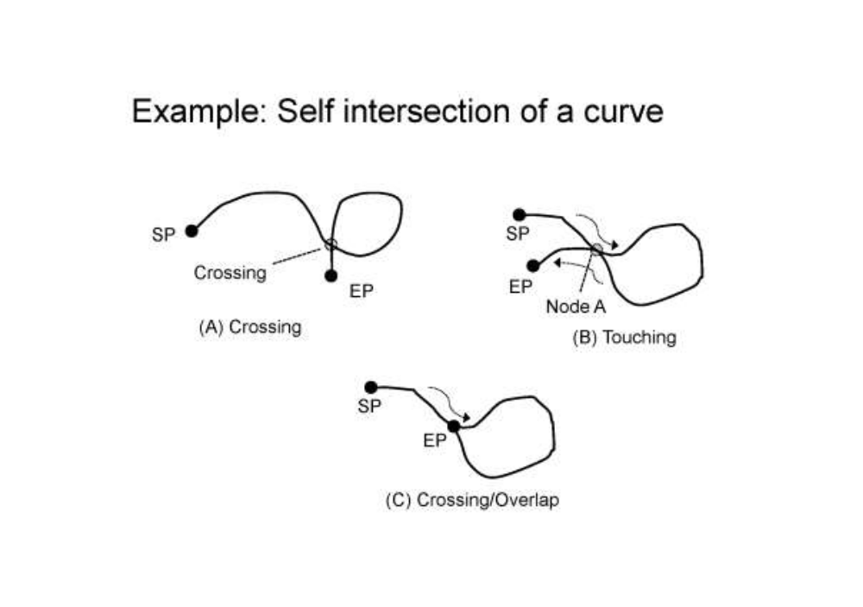
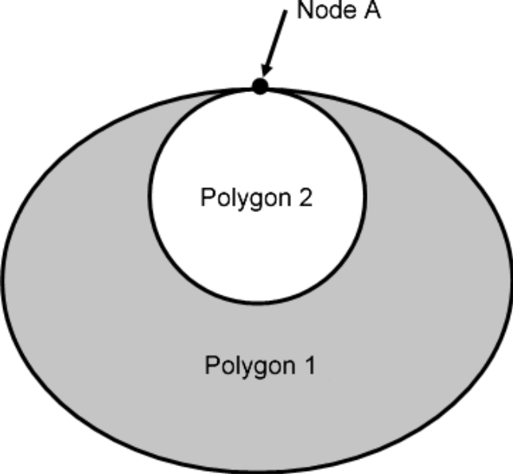
Figure 12 - Self Intersect Example
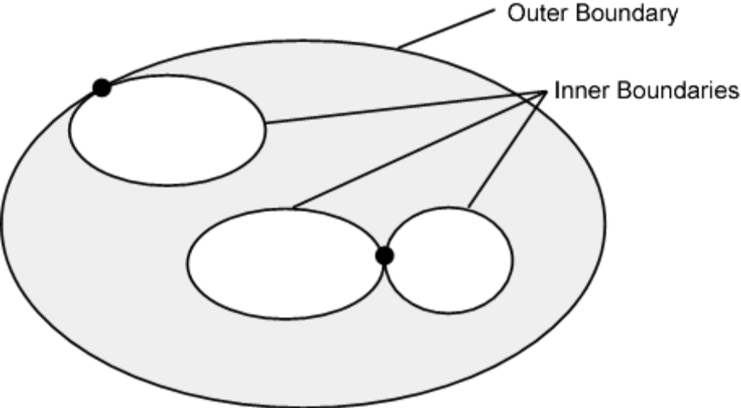
Figure 13 - Area Holes

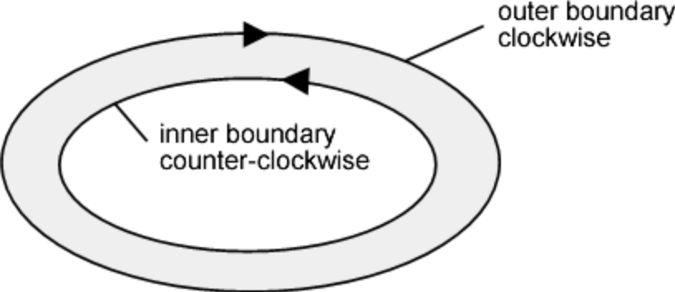
Figure 14 - Boundary Direction

4.8.2 Masking
In certain circumstances, the symbolisation of an edge may need to be suppressed. This is done using the Masked Spatial Type [MASK] field of the Feature Type record. The Mask Update Instruction [MUIN] must be set to {1} and Referenced Record name [RRNM] and Referenced Record identifier [RRID] fields must be populated with the values of the referenced spatial record. The Mask Indicator [MIND] must be set to either {1} or {2} (see Annex B – clause B1.5.29)
Figure 15 is an example without masking and Figure 16 is an example of a masked edge between Rivers and Depth Area features, where the River should be masked. In this example MIND is set to {2} – supress portrayal.

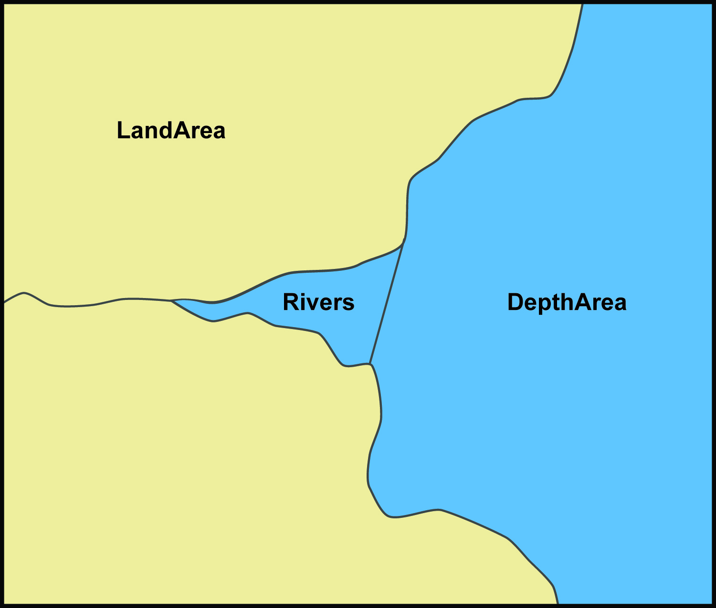
Figure 15 - Example without masking

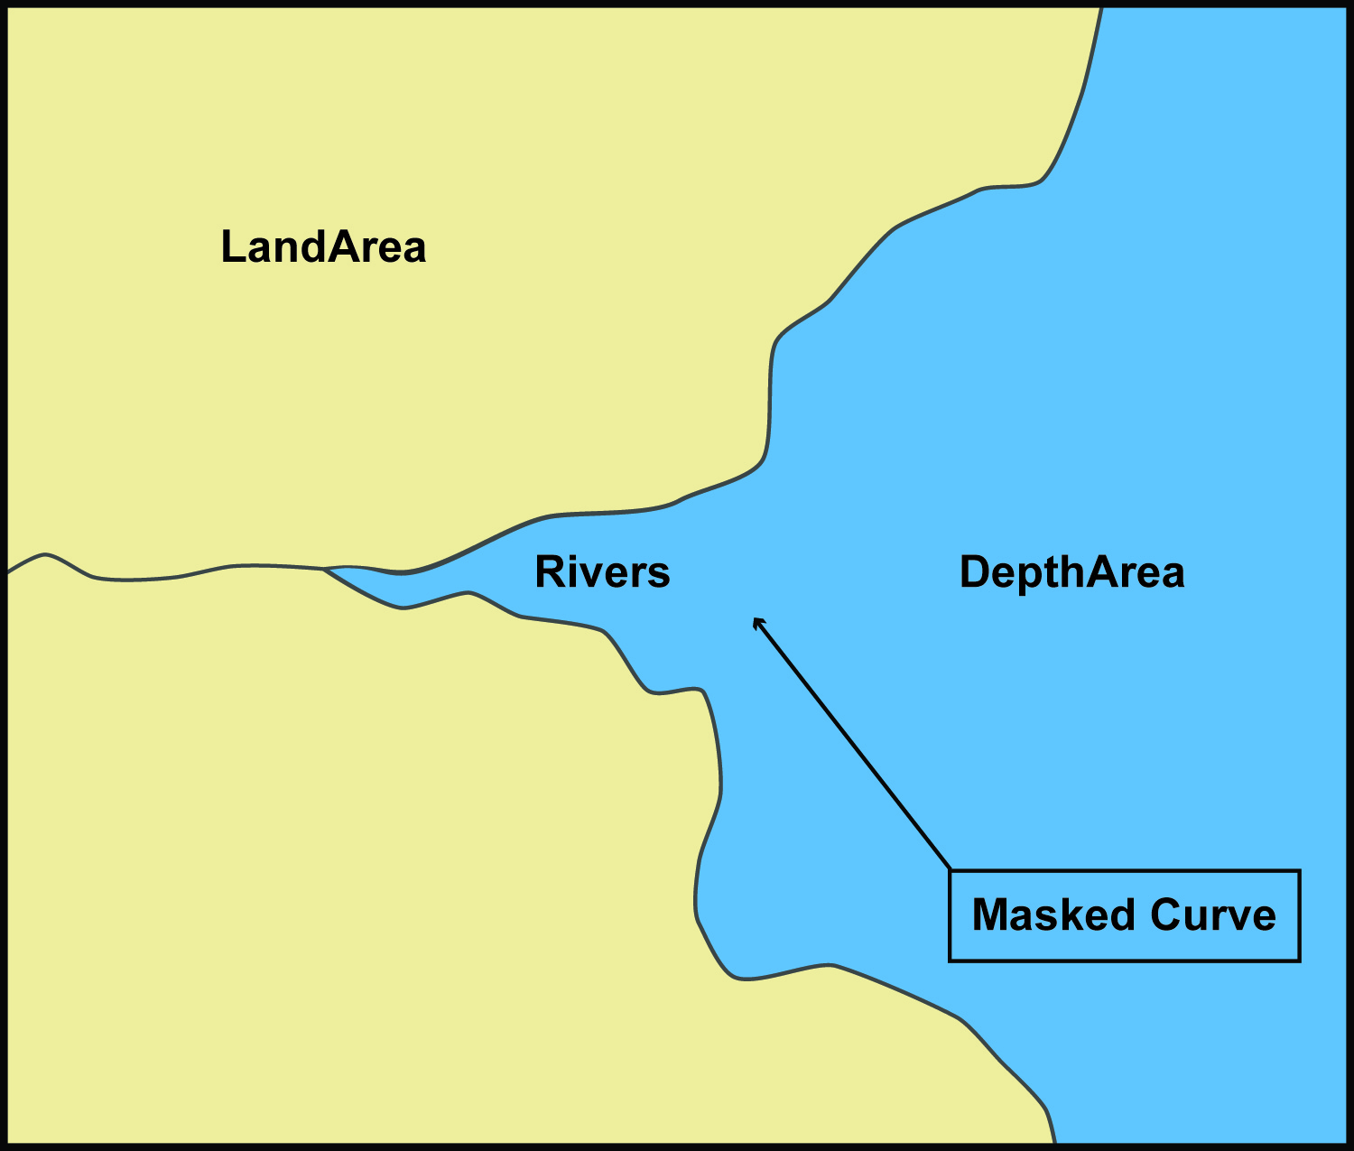
Figure 16 - Example with masking

5 Coordinate Reference Systems (CRS)
5.1 Introduction
An IENC dataset must define at least one compound CRS, which must be composed of one geodetic CRS and one vertical CRS. All compound CRSs within the same dataset must use the same geodetic CRS.
5.2 Horizontal Coordinate Reference System
For IENC the horizontal CRS must be EPSG:4326 (WGS84). The full reference to EPSG: 4326 can be found at www.epsg-registry.org.

Horizontal coordinate reference system: EPSG:4326 (WGS84)
Projection: None
Temporal reference system: Gregorian calendar
Coordinate reference system registry: EPSG Geodetic Parameter Registry
Date type (according to ISO 19115): 002- publication
Responsible party: International Organisation of Oil and Gas Producers (OGP) URL: http://www.ogp.org.uk/

5.3 Vertical CRS for Soundings

For Inland ENC the vertical CRS must be in metres. Depths are represented by positive values, while negative values indicated intertidal soundings (drying heights).
Although all coordinates in a data set must refer to the same geodetic CRS, different Vertical Datums can be used for the depth component of a coordinate tuple. Therefore the vertical CRS can be repeated. For each vertical CRS a unique identifier is defined. Those identifiers will be used to indicate which Vertical CRS is used.
The encoding of the Coordinate Reference System record will be demonstrated with the following examples. The first example specifies a compound CRS. The first component of the first example is a 2D Geographic CRS (WGS84). The second component of the first example is a Vertical CRS for depth using the Vertical Datum: Mean High Water.

Field | Subfield | Value | Description
CSID |  |  | Coordinate Reference System Record Identifier
 | RCNM | 15 | Record Name (15 = Coordinate Reference System Identifier)
 | RCID | 1 | Record Identification Number
 | NCRC | 2 | Number of CRS Components
CRSH |  |  | Coordinate Reference System Header
 | CRIX | 1 | CRS Index
 | CRST | 1 | CRS Type (1 = 2D Geographic)
 | CSTY | 1 | Coordinate System Type (1 = Ellipsoidal CS)
 | CRNM | WGS84 | CRS Name
 | CRSI | 4326 | CRS Identifier
 | CRSS | 2 | CRS Source (2 = EPSG)
 | SCRI |  | CRS Source Information (omitted)
CRSH |  |  | Coordinate Reference System Header
 | CRIX | 2 | CRS Index
 | CRST | 5 | CRS Type (5 = Vertical)
 | CSTY | 3 | Coordinate System Type (3 = Vertical)
 | CRNM | Depth - mean high water | CRS Name
 | CRSI |  | CRS Identifier (omitted)
 | CRSS | 255 | CRS Source (2 = EPSG)
 | SCRI |  | CRS Source Information (omitted)
CSAX |  |  | Coordinate System Axes
 | AXTY | 12 | Axis Type (12 = Gravity Related Depth)
 | AXUM | 4 | Axis Unit of Measure (4 = Metres)
VDAT |  |  | Vertical Datum
 | DTNM | mean high water | Datum Name
 | DTID | 16 | Datum Identifier (16 = Mean High Water)
 | DTSR | 2 | Datum Source (2 = Feature Catalogue)
 | SCRI |  | Datum Source Information (omitted)

The second example is similar to the first except that its second component is encoded with the Vertical Datum: Mean Sea Level.
Field | Subfield | Value | Description
CSID |  |  | Coordinate Reference System Record Identifier
 | RCNM | 15 | Record Name (15 = Coordinate Reference System Identifier)
 | RCID | 1 | Record Identification Number
 | NCRC | 2 | Number of CRS Components
CRSH |  |  | Coordinate Reference System Header
 | CRIX | 1 | CRS Index
 | CRST | 1 | CRS Type (1 = 2D Geographic)
 | CSTY | 1 | Coordinate System Type (1 = Ellipsoidal CS)
 | CRNM | WGS84 | CRS Name
 | CRSI | 4326 | CRS Identifier
 | CRSS | 2 | CRS Source (2 = EPSG)
 | SCRI |  | CRS Source Information (omitted)
CRSH |  |  | Coordinate Reference System Header
 | CRIX | 2 | CRS Index
 | CRST | 5 | CRS Type (5 = Vertical)
 | CSTY | 3 | Coordinate System Type (3 = Vertical)
 | CRNM | Depth - mean sea level | CRS Name
 | CRSI |  | CRS Identifier (omitted)
 | CRSS | 255 | CRS Source (2 = EPSG)
 | SCRI |  | CRS Source Information (omitted)
CSAX |  |  | Coordinate System Axes
 | AXTY | 12 | Axis Type (12 = Gravity Related Depth)
 | AXUM | 4 | Axis Unit of Measure (4 = Metres)
VDAT |  |  | Vertical Datum
 | DTNM | mean sea level | Datum Name
 | DTID | 3 | Datum Identifier (3 = Mean Sea Level)
 | DTSR | 2 | Datum Source (2 = Feature Catalogue)
 | SCRI |  | Datum Source Information (omitted)

tum: Mean Sea Level.

The second example encodes a projected CRS by defining the details

6 Data Quality
6.1 Introduction
Data Quality is considered to be meta information and for S-401 it is divided into two parts. The first part is overall data quality for the product and the second is data quality of the bathymetric, nonbathymetric and survey information within the product.
6.1.1 Data Compliance and Integrity
For S-401, the data must be validated using the Recommended Inland ENC Validation Checks for the S-401 product specification. Overall data quality for an S-401 IENC should cover the following: completeness, logical consistency, positional accuracy, temporal accuracy, thematic accuracy, and anything additional that is specifically required as defined in the Product Specifications.
6.1.2 Bathymetric Data Quality
Bathymetric data quality comprises the following:
completeness of data (for example seafloor coverage).
currency of data (for example temporal degradation);
uncertainty of data;
source of data;
Data quality can be encoded at three different metadata levels (dataset, meta feature area, feature instance). All positional (2D), vertical (1D), horizontal distance (1D) and orientation (1D) uncertainty attributes concern the 95% confidence level of the variation associated with all sources of measurement, processing and visualization error. Uncertainty due to temporal variation should not be included in these attributes.
The meta feature for Bathymetric data quality is: Quality Of Bathymetric Data,
6.1.3 Non Bathymetric Data Quality
The meta feature Quality Of Nonbathymetric Data allows for data quality to be expressed for non bathymetric items.
6.1.4 Survey Data Quality
Quality of the surveys that originated from which charted features are derived can be further expressed using the meta feature Quality Of Survey. Quality Of Survey can apply to bathymetry (for example underwater rock), non-bathymetry (for example navigational aids) and a combination of these (for example lidar survey).

7 Data Capture and Classification
7.1 Introduction
The S-401 Encoding Guide for Inland ENCs describes how data describing the real world should be captured using the types defined in the S-401 Feature Catalogue. This Guide is located in Annex A.
8 Maintenance
8.1 Introduction
This clause describes the maintenance process for datasets, source, production process and how feature and portrayal catalogues are to be managed within an S-100 Inland ECDIS or ECS.
8.2 Maintenance and Update Frequency
Datasets are maintained as needed and must include mechanisms for IENC updating designed to meet the needs of the skipper regarding safety of navigation.
8.3 Data Source
Data Producers must use applicable sources to maintain and update data and provide a brief description of the sources that were used to produce the dataset.
8.4 Production Process
Data Producers should follow their established production processes for maintaining and updating datasets. Data is produced against the Encoding Guide for Inland ENCs, checked against the Recommended Validation Checks for Inland ENCs and encapsulated in ISO/IEC 8211.
Only datasets that conform to the mandatory requirements outlined in S-401 will be considered an IENC.
8.5 Feature and Portrayal Catalogue Management
For each new version of the S-401 Product Specification a new feature and portrayal catalogue will be released. The Inland ECDIS or ECS must be able to manage datasets and their catalogues that are created on different versions of the S-401 product specification.
See the Implementation Guidance Annex for specific rules.
9 Portrayal
9.1 Introduction
S-401 portrayal is intended to contribute to the safe operation of an S-100 based Inland ECDIS or ECS by:
• Ensuring a base and supplementary levels of display for IENC data; standards of symbols, colours and their standardized assignment to features.
• Ensuring the display is clear and unambiguous,
• Establishing an accepted pattern for Inland ECDIS or ECS presentation that becomes familiar to skippers and so can be recognized instantly without confusion.
• Utilizing the S-100 portrayal model to ensure interoperability.
S-401 portrayal is covered by the portrayal model as defined in S-100. This model reflects how the portrayal catalogue is defined for use in systems. The portrayal catalogue defines symbology and the portrayal rules for each feature attribute combination contained in the feature catalogue.
9.2 Portrayal Catalogue

Item Name | Description | M/O | Card | type
portrayalLibraryCitation | Bibliographic reference to the portrayal library | O | 0..1 | CI_Citation (ISO 19115)

The portrayal catalogue contains the mechanisms for the system to portray information found in S-401 Inland ENCs. The S-401 portrayal catalogue contains the following types of mechanisms and structures:
- Product Input Schema
- Set of portrayal rules
- Set of drawing instructions
- Set of symbols, linestyles and colours

The portrayal catalogue model is defined in S-100 Part 9.
The S-401 Portrayal Catalogue will be available in an XML document which conforms to the S-100 XML Portrayal Catalogue Schema and is structured as follows:
Root ---- (contains the catalogue named “portrayal_catalogue.xml”)
|
|-- Pixmaps (contains XML files describing pixmaps)
|
|-- ColorProfiles (contains XML files with colour profiles and CSS2 style sheets)
|
|-- Symbols (contains SVG files with symbols)
|
|-- LineStyles (contains XML files with line styles)
|
|-- AreaFills (contains XML files area fills)
|
|-- Fonts (contains TrueType font files)
|
|-- Rules (contains XSLT files with templates)

10 Data Product format (encoding)
10.1 Introduction
This clause specifies the encoding for S-401 datasets. See Annex B for a complete description of the data records, fields and subfields defined in the encoding.
Format Name: ISO/IEC 8211
Character Set: ISO 10646 Base Multilingual Plane
Specification: S-100 profile of ISO/IEC 8211 (part 10A)
10.1.1 Encoding of Latitude and Longitude
Coordinates are stored as integers. Latitude and longitude are converted to integers using a multiplication factor held in the Data Set Structure Information field under [CMFX] and [CMFY] (see Annex B – clause B1.6.3).
These coordinate multiplication factors must be set to {10000000} (107) for all datasets.
EXAMPLE A longitude = 42.0000 is converted into X = longitude * CMFX = 42.0000 * 10000000 = 420000000.
10.1.2 Encoding of Depths
Depths are converted from decimal metres to integers by means of the [CMFZ] (see Annex B – clause B1.6.3). This product limits the resolution to two decimal places and therefore the [CMFZ] must be set to {100}.
10.1.3 Numeric Attribute Encoding
Floating point and integer attribute values must not contain leading zeros. Floating point attribute values must not contain non-significant trailing zeros.
10.1.4 Text Attribute Values
Character strings must be encoded using the character set defined in ISO 10646-1, in Unicode Transformation Format-8 (UTF-8). A BOM (byte order mark) must not be used.
10.1.5 Mandatory Attribute Values
There are four reasons why attribute values may be considered mandatory:
• They determine whether a feature is in the display base,
• Certain features make no logical sense without specific attributes,
• Some attributes are necessary to determine which symbol is to be displayed,
• Some attributes are required for safety of navigation.
All mandatory attributes are identified in the Feature Catalogue and described in the Encoding Guide for Inland ENCs.
10.1.6 Missing Attribute Values
In a base data set, when an attribute code is present but the attribute value is missing, it means that the producer wishes to indicate that this attribute value is unknown.
In an update data set, when an attribute code is present but the attribute value is missing it means:
• that the value of this attribute is to be replaced by an unknown value if it was present in the original data set,
• that an unknown value is to be inserted if the attribute was not present in the original data set.
11 Data Product Delivery
11.1 Introduction
This clause specifies the encoding and delivery mechanisms for an S-401 IENC. Data which conforms to this product specification must be delivered by means of an exchange set.
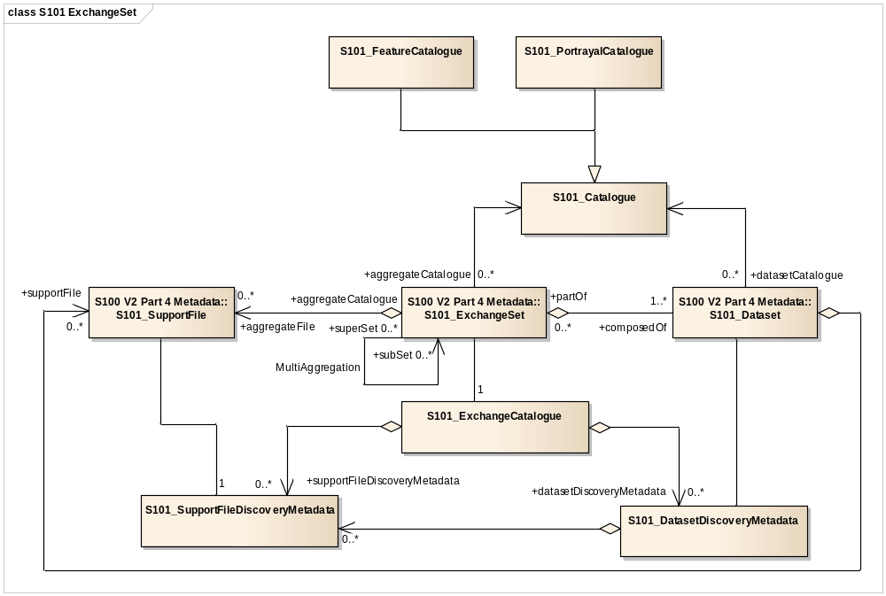
Figure 17 - Exchange Set Structure
11.2 Exchange Set
S-401 datasets are grouped into exchange sets. Each exchange set consists of one or more IENC datasets with an associated XML metadata file and a single Exchange Catalogue XML file containing metadata. It may also include one or more support files.
Units of Delivery: Exchange Set
Transfer Size: Unlimited
Medium Name: Digital data delivery
Other Delivery Information:
Each exchange set has a single exchange catalogue which contains the discovery metadata for each dataset and references to any support files.
Support files are supplementary information which are linked to the features by the following simple attributes within the dataset.
• Textual Description
• Pictoral Representation
An exchange set is encapsulated into a form suitable for transmission by a mapping called an encoding. An encoding translates each of the elements of the exchange set into a logical form suitable for writing to media and for transmission online. An encoding may also define other elements in addition to the exchange set contents (i.e media identification, data extents etc…) and also may define commercial constructs such as encryption and compression methods.
If the data is transformed in S-401 it must not be changed.
This product specification defines the encoding which must be used as a default for transmission of data between parties.
The encoding encapsulates exchange set elements as follows:
Mandatory Elements
IENC datasets – ISO 8211 encoding of features/attributes and their associated geometry and metadata.
Exchange Catalogue – the XML encoded representation of exchange set catalogue features [discovery metadata].
Optional Elements
Supplementary files – These are contained within the exchange set as files and the map from the name included within the dataset and the physical location on the media is defined within the Exchange Catalogue.
S-401 Feature Catalogue – If it is necessary to deliver the latest feature catalogue to the end user it may be done using the S-401 exchange set mechanism for datasets
S-401 Portrayal Catalogue - If it is necessary to deliver the latest portrayal catalogue to the end user it may be done using the S-401 exchange set mechanism for datasets.
11.3 Dataset
11.3.1 Datasets
Four types of dataset files may be produced and contained within an exchange set:
• New dataset and new edition of a dataset: Including new information which has not been previously distributed by updates. Each new edition of a data set must have the same name as the data set that it replaces. A new edition can also be IENC data that has previously been produced for this area and at the same maximum display scale. The encoding structure is located in Annex B1.5
- Update: Changing some information in an existing data set. The encoding structure for an update is located in Annex B1.6
• re-issue of a dataset: including all the updates applied to the original data set up to the date of the reissue. A re-issue does not contain any new information additional to that previously issued by updates. The encoding structure is located in Annex B1.5
• Cancellation: The dataset is cancelled and is deleted from the Inland ECDIS or ECS. The encoding structure for a cancellation file is located in Annex B1.7
11.3.2 Dataset file naming
CCPXXXXXXX.EEE
The main part forms an identifier where:
• CC - the first two characters identify the issuing agency.
• The third character (P) indicates the navigational purpose (see clause 2.1).
The letter “L” (in the position “usage”) indicates, that the cell is displayed as overlay over other cells within a range of usages. The range of usages of overlay cells is indicated in the Data Set Identification Field of the header of the overlay cell (see S57, Part 3, Data Structure, ch. 7.3.1.1). The 8th bit of the intended usage subfield (INTU) has to be set. The other seven bits describe the range:

Definition of range | from | to
Mathematical description | (INTU-128) div 10 | (INTU-128) mod 10
Example (INTU=207) | (207-128) div 10 = 7 | (207-128) mod 10 = 9

- The fourth to eighth characters (XXXXX) identify the waterway and the waterway distance.
- For waterways with a length of more than 999 km: for example D1923
- For waterways with a length of more than 99 km: for example RH123
- For waterways with a length of more than 9 km: for example DCC23
The use of the fourth to eighth characters is only a recommendation. In Brazilian waterways they identify the equivalent paper chart number.
The fourth to tenth characters are optional and may be used in any way by the producer to provide the unique file name. The following characters are allowed in the dataset name, A to Z, 0 to 9 and the special character _ (underscore).
• EEE – new editions and re-issues use 000, updates start at 001 and increment until a limit of 999.
• The minimum number of characters in the main part of the dataset name is three and the maximum number is ten.
Each re-issue or new edition of a dataset must have the same name as the base dataset which it replaces.
11.3.3 New Editions, Re-Issues, Updates and Cancellations
This section defines the sequencing of S-401 datasets for New Editions, Updates and Re-issues. In order to ensure that feature type updates are incorporated into an Inland ECDIS or ECS in the correct sequence without any omission, a number of parameters encoded in the data are used in the following way:
edition number when a data set is initially created, the edition number 1 is assigned to it. The edition number is increased by 1 at each new edition.
update number update number 0 is assigned to a new data set and a new edition. The first update dataset file associated with this new data set must have update number 1. The update number must be increased by one for each consecutive update, until a new edition is released.
Re-issue number A re-issue of a data set must have the update number of the last update applied to the dataset, and use the same extension as the base dataset.
update comment comment for describing the change introduced by an update.
issue date date up to which the data producer has incorporated all applicable changes. The issue date must be greater than the previous issue date of the dataset.
In order to cancel a data set, an update dataset file is created for which the edition number must be set to 0. This message is only used to cancel a base dataset file. Where a dataset is cancelled and its name is reused at a later date, the issue date must be greater than the issue date of the cancelled dataset. When the dataset is cancelled it must be removed from the system.
An exchange set may contain base dataset files and update dataset files for the same datasets. Under these circumstances the update dataset files must follow on in the correct sequential order from the last update applied to the base dataset file.
11.4 Support Files
Data set support files offer supplementary information that can be included in an IENC exchange set.
Text files must contain only general text as defined by this standard. (Extensible mark-up
language (XML) supports UTF-8 character encoding). (TXT), (XML), (HTM)
Picture files must be in TIFF 6.0 specification (TIFF)

File Types | Extensions | Comment
Text | TXT
 | HTM | HTML files must only include inline or embedded Cascading Style Sheet (CSS) information and must not embed Javascript or other dynamic content for example DHTML, Flash etc.
 | XML | XML documents must only be included in accordance with guidance provided within the Encoding Guide for Inland ENCs. This may include a schema for the validation of XML documents.
Picture | TIF | Baseline TIFF 6.0
Table 4 – Support file extensions

11.4.1 Support File Naming
All support files must have unique universal file identifiers. The file identifier of support information should not be used to describe the physical content of the file. The support file metadata that accompanies the file will inform the user of the name and purpose of the file (i.e. new, replacement and deletion).
In this encoding the support files are named according to the specifications given below:
CCXXXXXXXX.EEE
The main part forms an identifier where:
• the first two characters identify the issuing agency.
• the third to tenth characters can be used in any way by the producer to provide the unique file name. The following characters are allowed in the dataset name, A to Z, 0 to 9 and the special character _ (underscore).
US: Format is AARRMMMXNN.EXT where:
AA = 2-character Producer Code
RR = 2-character river code
MMM = 3-digit river mile or river km, 000-999
X = tenth of river mile/km; preceding decimal point implied; use zero if river mile/km known only to the nearest mile.
NN = 01-99; unique identifier for text file at the particular river mile/km.
For example, if three TXTDSC files exist at the same river mile/km, 01, 02, and 03 would be used.
EXT = 3-character file extension for Hypertext Metafile (HTM), ASCII text (TXT), or Standardized External XML file with communication information.
EU: The ISRS Location Code can be used for the file name of the external XML files, for example DEXXX039000000005023.XML.
• .EEE – support file extension. (TXT, HTM, XML or TIF)
11.4.2 Support File Management
When a support file is created or a subsequent version is issued it must carry its own issue date and it may be supported with a digital signature which authenticates it against the producer’s public key included in the exchange set metadata.
The type of support file is indicated in the “purpose” field of the discovery metadata. Support files carrying the “deletion” flag should be removed from the Inland ECDIS or ECS. When a feature pointing to a text, picture or application file is deleted or updated so that it no longer references the file, the Inland ECDIS or ECS software must check to see whether any other feature referenced the same file, before that file is deleted.
Support files should be stored in a separate folder within the exchange set.
11.5 Exchange Catalogue
The exchange catalogue acts as the table of contents for the exchange set. The catalogue file of the exchange set must be named CATALOG.401. No other file in the exchange set may be named CATALOG. The contents of the exchange catalogue are described in Clause 12.
11.6 Data integrity and encryption
11.6.1 IENC data integrity measures
Normally IENCs are produced without data integrity measures. If a producer decides that there is a high impact on the integrity of data as a result of data corruption, such as to IENC data, there is a need for a mechanism within the IENC data itself to ensure it has not changed during transmission/delivery. The mechanism chosen for this assurance is a Digital Signature as defined by IHO S-63 edition 2.0 Part(C). File integrity checks are based on the Digital Signature Algorithm (DSA) as defined in the Federal Information Processing Standard FIPS 186-4.
S-401 discovery metadata includes a mandatory field for each included dataset file’s digital signature (both data and auxiliary files are included) called “digitalSignature”. This contains a base64 encoding of the hexadecimal numbers comprising the digital signature itself. The content of these fields are defined, along with the algorithms for their calculation, in S-63 ed2.0 Part (C). This also defines how chains of signatures may be defined. The digital signature uniquely authenticates the dataset content against the individual producer’s public key issued and authenticated by the IHO. The combination of the digital signature, the dataset file and the producer’s identity allows the end user to be assured of the origin of the IENC data.
11.6.2 Producer Identity and Authentication
In order to produce a digital signature a producing agency must first have a certified identity as described in S-63 ed2.0 part (C). This describes how to define a public/private keypair specific to the producer and how a data producer or distributor is able to have their identity (as embodied in the public / private keypair) certified by the IHO acting as the data protection scheme administrator.
11.6.3 Digital Signatures and metadata
In addition to the metadata included for each dataset file and its digital signature, an exchange set must also provide a public key for every dataset data producer included within the Exchange Set in case of data integrity measures. The public key is termed “public” because its existence is not kept confidential. Each producer’s public key is included in a “publicKeys” field within the exchange set. These keys are referred to by the digital signature.
Authentication is done in two stages:
1. verifying that the public key information included in the exchange set validates correctly against the IHO’s root level certificate
2. Verifying that the exchange set IENC data has not changed and the file based digital signatures are valid against the producer’s public key. The IHO’s root certificate (certifying the IHOs identity) should be held externally on the implementing system and is not part of the dataset metadata.
11.6.4 IENC data encryption
If data encryption is required then it must be provided only by the mechanisms provided in IHO S-63 edition 2.0 Part(A) – it is not mandatory. If it is used then the entire dataset file is encrypted using the Blowfish algorithm (as defined in S-63 edition 2.0) and is included in its encrypted form. IHO S-63 also allows dataset files to be compressed using the zip algorithm prior to encryption. This is dealt with in IHO S-63 as well (Part (A)).
12 Metadata
12.1 Introduction
For information exchange, there are several categories of metadata required: metadata about the overall exchange catalogue, metadata about each of the datasets contained in the catalogue, and metadata about the support files that make up the package.
This clause defines the mandatory and optional metadata needed for S-401. In some cases the metadata may be repeated in a national language. If this is the case it is noted in the Remarks column.
Figures 18 to 21 outline the overall concept of an S-401 exchange set for the interchange of geospatial data and its relevant metadata. Figure 1 depicts the realization of the ISO 19139 classes which form the foundation of the exchange set. The overall structure of S-401 metadata for exchange sets is modelled in Figures 19 and 20. More detailed information about the various classes is shown in Figure 16 and a textual description in the tables at clause 12.3.
The discovery metadata classes have numerous attributes which enable important information about the datasets and accompanying support files to be examined without the need to process the data, for example decrypt, decompress, load etc. Other catalogues can be included in the exchange set in support of the datasets such as feature, portrayal, coordinate reference systems, code lists etc. The attribute “purpose” of the support file metadata provides a mechanism to update support files more easily.
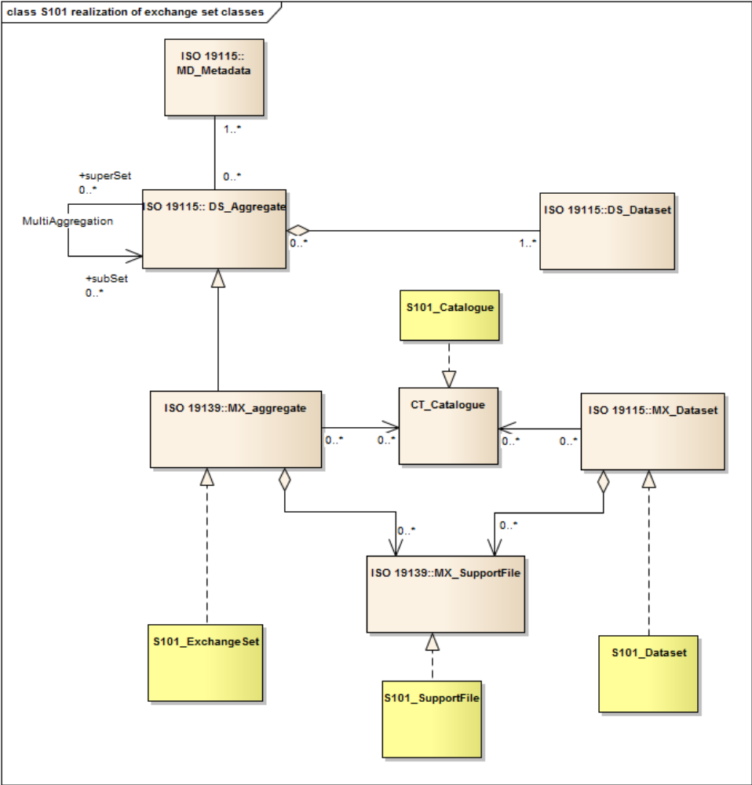
Figure 19 Realization of the Exchange Set Classes
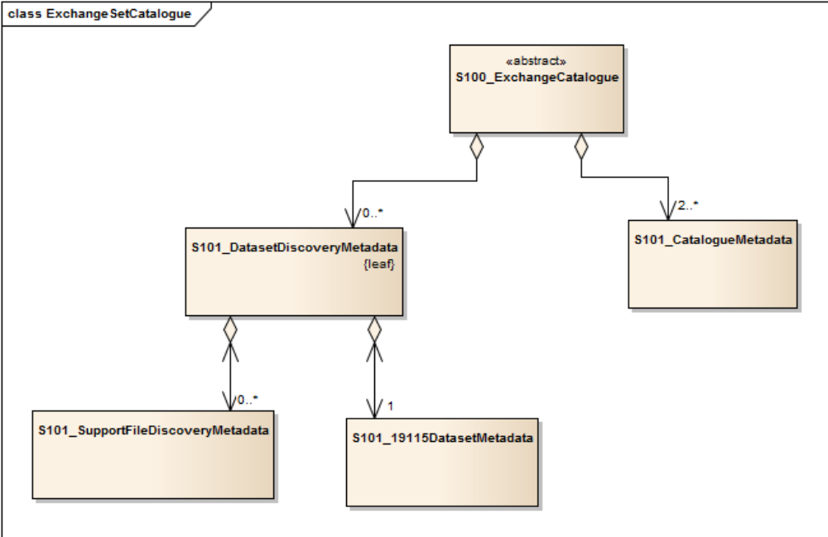
Figure 20 – S-401 ExchangeSet Catalogue

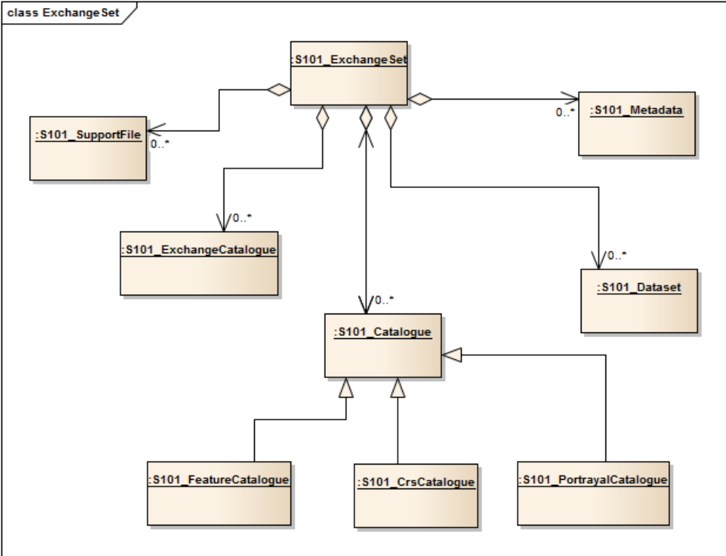
Figure 21 - S-401 Exchange Set

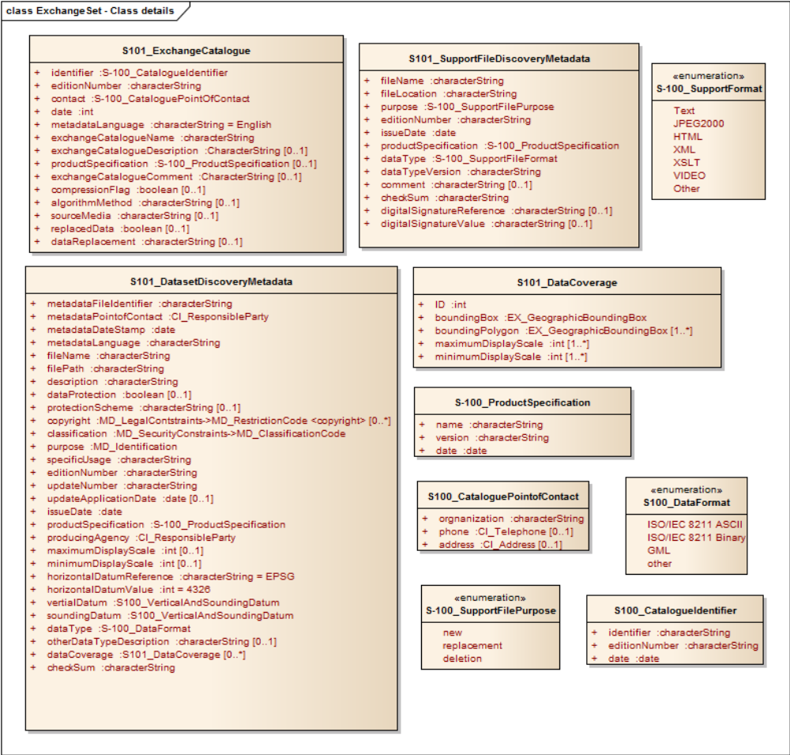
Figure 22 S-401 Exchange Set - Class Details
The following clauses define the mandatory and optional metadata needed for S-401. In some cases the metadata may be repeated in a national language. If this is the case it is noted in the Remarks column.

12.1.1 Dataset Metadata

Name | Multiplicity | Value | Type | Remarks
S401_DataSetDiscoveryMetadata | - |  | - | -
metadataFileIdentifier | 1 |  | CharacterString | The file name must be unique. Each file name must have a MD (prefix) added to the S-401 file name.  Dataset:  GB45678.000  Metadata:  MD_GB45678_000.xml  Update 1:  GB45678.001  Metadata:  MD_GB45678_001.xml
metadataPointOfContact | 1 |  | CI_ResponsibleParty
metadataDateStamp | 1 |  | Date
metadataLanguage | 1 | English | CharacterString | All data sets conforming to S-401 PS must use English language
fileName | 1 |  | CharacterString | Dataset file name
filePath | 1 |  | CharacterString | Path to the dataset file, relative to the root directory of the exchange set. The location of the dataset file after the exchange set is unpacked into directory <EXCH_ROOT> will be: <EXCH_ROOT>/<filePath>/<fileName>
description | 1 |  | CharacterString | Short description of the area covered by dataset harbour or port name, between two named locations etc.  NATIONAL LANGUAGE enabled
dataProtection | 1 |  | Boolean | True = Encrypted  False = Unencrypted  (A value of True indicates the presence of encryption. Otherwise, the value mus be False)
protectionScheme | 0..1 |  | CharacterString | for example S-63
digitalSignature | 1
copyright | 0..* |  | MD_LegalConstraints -> MD_RestrictionCode <copyright> (ISO 19115)
classification | 0 | {1} to {5} | Class  MD_SecurityConstraints>MD_ClassificationCode  (codelist) | 1. unclassified  2. restricted  3. confidential  4. secret  5. top secret
purpose | 1 | {1} to {5} | CharacterString  MD_Identification>purpose (character string) | 1. New Dataset  2. New Edition  3. Update  4. Re-issue  5.Cancellation
specificUsage | 1 | {A}, {B}, {C}, {D}, {1} to {3} | CharacterString  MD_USAGE>specificUsage (character string)  MD_USAGE>userContactInfo  (CI_ResponsibleParty) | A. Overlay - Overlay cell to be displayed in conjunction with skin cells  B. River berthing – Detailed data to aid berthing maneuvering in inland navigation (skin cell).  C. River harbor - Navigating within ports and harbours on inland waterways (skin cell).  D. River - Navigating the inland waterways (skin cell).  1. Port Entry – A dataset containing data required:  For navigating the approaches to ports  for navigating within ports, harbours, bays, rivers  and canals, for anchorages  as an aid to berthing  or any combination of the above.  2.Transit – A dataset containing data required for :  navigating along the coastline either inshore or  offshore  navigating oceans, approaching coasts  route planning  or any combination of the above.  3.Overview – A dataset containing data required:  for Ocean Crossing  route planning
editionNumber | 1 |  | Integer | When a data set is initially created, the edition number 1 is assigned to it. The edition number is increased by 1 at each new edition. Edition number remains the same for Update and Re-issue.
updateNumber | 1 |  | CharacterString | Update number 0 is assigned to a new data set.
updateApplicationDate | 0..1 |  | Date | this date is only used for the base dataset files (i.e. new data sets, re-issue and newedition), not update dataset files. All updates dated on or before this date must have been applied by the producer
issueDate | 1 |  | Date | Date on which the data was made available by the data producer.
productSpecification | 1 | S-401 version X.X.X | S100_ProductSpecification | This must be encoded as S-401.X.X.X – with the X representing the version number
producingAgency | 1 |  | CI_ResponsibleParty | Agency responsible for producing the data.
maximum Display Scale | 1 | {1} to {15} | Integer | 1: 1,000  2: 2,000  3: 3,000  4: 4,000  5: 8,000  6: 12,000  7: 22,000  8: 45,000  9: 90,000  10: 180,000  11: 350,000  12: 700,000  13: 1,500,000  14: 3,500,000  15: 10,000,000
horizontalDatumReference | 1 | EPSG | CharacterString
horizontalDatumValue | 1 | 4326 | Integer | WGS84
verticalDatum | 1 | {1} to {30} | S100_VerticalAndSoundingDatum | 1 : Mean low water springs  2 : Mean lower low water springs  3 : Mean sea level  4 : Lowest low water  5 : Mean low water  6 : Lowest low water springs  7 : Approximate mean low water springs  8 : Indian spring low water  9 : Low water springs  10 : Approximate lowest astronomical tide  11 : Nearly lowest low water  12 : Mean lower low water  13 : Low water  14 : Approximate mean low water  15 : Approximate mean lower low water  16 : Mean high water  17 : Mean high water springs  18 : High water  19 : Approximate mean sea level  20 : High water springs  21 : Mean higher high water  22 : Equinoctial spring low water  23 : Lowest astronomical tide  24 : Local datum  25 : International Great Lakes Datum 1985  26 : Mean water level  27 : Lower low water large tide  28 : Higher high water large tide  29 : Nearly highest high water  30 : Highest astronomical tide (HAT)  43: Dutch High Water reference level,
soundingDatum | 1 | {1} to {30} | S100_VerticalAndSoundingDatum | 1 : Mean low water springs  2 : Mean lower low water springs  3 : Mean sea level  4 : Lowest low water  5 : Mean low water  6 : Lowest low water springs  7 : Approximate mean low water springs  8 : Indian spring low water  9 : Low water springs  10 : Approximate lowest astronomical tide  11 : Nearly lowest low water  12 : Mean lower low water  13 : Low water  14 : Approximate mean low water  15 : Approximate mean lower low water  16 : Mean high water  17 : Mean high water springs  18 : High water  19 : Approximate mean sea level  20 : High water springs  21 : Mean higher high water  22 : Equinoctial spring low water  23 : Lowest astronomical tide  24 : Local datum  25 : International Great Lakes Datum 1985  26 : Mean water level  27 : Lower low water large tide  28 : Higher high water large tide  29 : Nearly highest high water  30 : Highest astronomical tide (HAT)  43: Dutch High Water reference level (MHW),
dataType | 1 | ISO 8211 BINARY | S100_DataFormat
otherDataTypeDescription | 0..1 |  | CharacterString
dataCoverage | 0..3 |  | S401_Data Coverage | Provides information about data coverages within the dataset

12.1.1.1 S401_DataCoverage

Name | Multiplicity | Value | Type | Remarks
S401_dataCoverage | - | - | - | -
ID | 1 |  | Integer | Uniquely identifies the coverage
boundingBox | 1 |  | EX_GeographicBoundingBox
boundingPolygon | 1..* |  | EX_BoundingPolygon
maximum Display Scale | 1 | {1} to {15} | Integer | 1: 1,000  2: 2,000  3: 3,000  4: 4,000  5: 8,000  6: 12,000  7: 22,000  8: 45,000  9: 90,000  10: 180,000  11: 350,000  12: 700,000  13: 1,500,000  14: 3,500,000  15: 10,000,000
minimum Display Scale | 1 | {1} to {15} | Integer | 1: 1,000  2: 2,000  3: 3,000  4: 4,000  5: 8,000  6: 12,000  7: 22,000  8: 45,000  9: 90,000  10: 180,000  11: 350,000  12: 700,000  13: 1,500,000  14: 3,500,000  15: 10,000,000

12.1.2 Support File Metadata

Name | Multiplicity | Value | Type | Remarks
S401_SupportFileDiscoveryMetadata | - |  | - | -
fileName | 1 |  | CharacterString
fileLocation | 1 |  | CharacterString | Full location from the exchange set root directory
purpose | 1 | {1} to {3} | class  S100_SupportFilePurpose | - New – A file which is new  - Replacement – A file which replaces an existing file  - Deletion – deletes an existing file
editionNumber | 1 |  | Integer | When a data set is initially created, the edition number 1 is assigned to it. The edition number is increased by 1 at each new edition. Edition number remains the same for a re-issue.
issueDate | 1 |  | Date | Date on which the data was made available by the data producer.
productSpecification | 1 |  | S100_ProductSpecification | Version of S-401
dataType | 1 | {1} to {4} | class  S100_SupportFileFormat | - TXT =Text files  - XML = Text files  - HTM = Text files  - TIFF = Picture files
dataTypeVersion | 1 |  | CharacterString | The version number of the datatype
Comment | 0..1 |  | CharacterString | Any additional Information  NATIONAL LANGUAGE enabled
dataProtection | 1 |  | Boolean | True = Encrypted  False = Unencrypted
digitalSignature | 0..1 |  | CharacterString

S100_SupportFormat
Role Name | Name | Description | Mult | Type | Remarks
Class | S100_SupportFormat | The format used in the support file | - | - | -
Value | Text |  | - | -
Value | HTML |  | - | -
Value | XML |  | - | -
Value | TIFF |  | - | -

S100_SupportFilePurpose
Role Name | Name | Description | Mult | Type | Remarks
Class | S100_SupportFilePurpose | The reason for inclusion of the support file in this exchange set | - | - | -
Value | new | A file which is new | - | - | Signifies a new file.
Value | replacement | A file which replaces an existing file | - | - | Signifies a replacement for a file of the same name
Value | deletion | Deletes an existing file | - | - | Signifies deletion of a file of that name

12.1.3 Exchange Catalogue File Metadata
The catalogue file is defined in XML schema language. The Exchange catalogue inherits the dataset discovery metadata and support file discovery metadata.

Name | Multiplicity | Value | Type | Remarks
S401_ExchangeCatalogue | - |  |  | An exchange catalogue contains the discovery metadata about the exchange datasets and support files
identifier | 1 |  | CharacterString  S100_CatalogueIdentifier | Uniquely identifies this exchange catalogue
editionNumber | 1 |  | CharacterString | The edition number of this exchange catalogue
contact | 1 |  | S100_CataloguePointofContact  CI_ResponsibleParty
catalogueDate | 1 |  | Date | Creation date of the exchange catalogue
metadataLanguage | 1 | English | CharacterString | All data sets conforming to S-401 PS must use English language
exchangeCatalogueName | 1 | CATALOG.401 | CharacterString | Catalogue filename
exchangeCatalogueDescription | 1 |  | CharacterString | Description of what the exchange catalogue contains NATIONAL LANGUAGE enabled
productSpecification | 1 |  |  | S-401 Version Number
exchangeCatalogueComment | 0..1 |  | CharacterString | Any additional Information  NATIONAL LANGUAGE enabled
publicKeys | 1..*
sourceMedia | 1
replacedData | 1 |  |  | If a data file is cancelled is it replaced by another data file
dataReplacement | 0..1 |  |  | Dataset name

S100_CatalogueIdentifier
Role Name | Name | Description | Mult | Type | Remarks
Class | S100_CatalogueIdentifier | An exchange catalogue contains the discovery metadata about the exchange datasets and support files | - | - | -
Attribute | identifier | Uniquely identifies this exchange catalogue | 1 | CharacterString
Attribute | editionNumber | The edition number of this exchange catalogue | 1 | CharacterString
Attribute | date | Creation date of the exchange catalogue | 1 | Date

S100_CataloguePointOfContact
Role Name | Name | Description | Mult |  | Type | Remarks
Class | S100_CataloguePointOfContact | Contact details of the issuer of this exchange catalogue | - | - |  | -
Attribute | organization | The organization distributing this exchange catalogue | 1 | CharacterString |  | This could be an individual producer, value added reseller, etc.
Attribute | phone | The edition number of this exchange catalogue | 0..1 | CI_Telephone
Attribute | address | The address of the organization | 0..1 | CI_Address

12.2 Language
The exchange language must be English. Other languages may be used as a supplementary option. National geographic names can be left in their original national language using the complex attribute Feature Name.
Character strings must be encoded using the character set defined in ISO 10646-1, in Unicode Transformation Format-8 (UTF-8). A BOM (byte order mark) must not be used.
Annex A - Data Classification and Encoding Guide
ANNEX B - NORMATIVE
Data Product format (encoding)
B1 Introduction
S-401 uses the S-100 8211 to encapsulate data. This annex specifies the interchange format to facilitate the moving of files containing data records between computer systems. It defines a specific structure which can be used to transmit files containing data type and data structures specific to S-401.
B1.1 Data set files
The order of data in each base or update dataset file is described below:
Data set file
Data set general information record
Data set structure information field structure
Data set Coordinate Reference System record structure
Information records
Information
Vector records
Point
Multi point
Curve
Composite Curve
Surface
Feature records
Meta features
Geo features
Aggregated features
Theme features
This order of records will enable the import software to check that the child record exists each time the parent record references it (i.e. it will already have read the child record so it will know if it exists or not).
B1.2 Records
Records and fields that do not appear in the following tree structure diagrams are prohibited. The order of records in the files must be the same as that described in these tree structure diagrams.
The combination of the file name and the “Name” of the record must provide a unique world-wide identifier of the record.
B1.3 Fields
For base dataset files, some fields may be repeated and all of their content may be repeated (indicated by *). In order to reduce the volume of data, the encoder should repeat the sequence of subfields, in preference to creating several fields.
B1.4 Subfields
Mandatory subfields must be filled by a non-null value.
Prohibited subfields must be encoded as missing subfields values. The exact meaning of missing attribute values is defined in Annex A.
In the tables following the tree structure diagrams, prescribed values are indicated in the “values” column. The “comment” column contains general comments and an indication of whether the subfield is ASCII or binary coded.
When encoding new base data sets the record update instruction (RUIN) is always set to insert. When encoding updates it can be set to insert, modify or delete.
B1.5 Base dataset structure
NOTE: The number contained in parenthesis () is the number of subfields that are contained in the field.
Base dataset file
|
|--<1>- Data Set General Information record
| |
| |--<1>-DSID (13\\*1): Data Set Identification field
| |
| |--<1>-DSSI (13): Data Set Structure Information field
| |
| |--<0..*>-ATTR (*5): Attribute field (Metadata)
|
|
|--<1>--Data Set Coordinate Reference System record
| |
| |--<1>-CSID (3): Coordinate Reference System Record Identifier field
| |
| |--<1..*>-CRSH (7): Coordinate Reference System Header field
| |
| |--<0..1>-CSAX (*2): Coordinate System Axes field
| |
| |--<0..1>-VDAT (4): Vertical Datum field
|
|
|--<0..*>--Information record
| |
| |--<1>-IRID (5): Information Type Record Identifier field
| |
| |--<0..*>- ATTR (*5): Attribute field
| |
| |--<0..*>- INAS (5\\*5): Information Association field
|
|
|--<0..*>-- Point record
| |
| |--<1>-PRID (4): Point Record Identifier field
| |
| |-<0..*>-INAS (5\\*5): Information Association field
| |
| | alternate coordinate representations
| |
| *-<1>-C2IT (2): 2-D Integer Coordinate Tuple field
| |
| *-<1>-C3IT (4): 3-D Integer Coordinate Tuple field
|
|
|--<0..*>-- Multi Point record
| |
| |--<1>-MRID (4): Multi Point Record Identifier field
| |
| |-<0..*>-INAS (5\\*5): Information Association field
| |
| | alternate coordinate representations
| |
| *-<0..*>-C2IL (*2): 2-D Integer Coordinate List field
| |
| *-<0..*>-C3IL (1\\*3): 3-D Integer Coordinate List field
|
|
|--<0..*>-- Curve record
| |
| |--<1>-CRID (4): Curve Record Identifier field
| |
| |-<0..*>-INAS (5\\*5): Information Association field
| |
| |-<1>-PTAS (*3): Point Association field
| |
| |-<1>-SEGH (1): Segment Header field
| |
| |-<1..*>-C2IL (*2): 2-D Integer Coordinate List field
|
|
|--<0..*>-- Composite Curve record
| |
| |--<1>-CCID (4): Composite Curve Record Identifier field
| |
| |-<0..*>-INAS (5\\*5): Information Association field
| |
| |-<0..*>-CUCO (*3): Curve Component field
|
|
|--<0..*>-- Surface record
| |
| |--<1>-SRID (4): Surface Record Identifier field
| |
| |-<0..*>-INAS (5\\*5): Information Association field
| |
| |-<1..*>-RIAS (*5): Ring Association Field
|
|
|--<0..*>-- Feature Type record
|
|--<1>-FRID (5): Feature Type Record Identifier field
|
|-<1>-FOID (3): Feature Feature Identifier field
|
|-<0..*>-ATTR (*5): Attribute field
|
|-<0..*>-INAS (5\\*5): Information Association field
|
|-<0..*>-SPAS (*6): Spatial Association field
|
|-<0..*>-FASC (5\\*5): Feature Association field
|
|-<0..*>-THAS (*3): Theme Association field
|
|-<0..*>-MASK (*4): Masked Spatial Type field
B1.5.1 Field Content
B1.5.2 Data Set Identification field - DSID

Subfield name | Label | Value | Format | Comment
Record name | RCNM | {10} | b11 | {10} - Data Set Identification
Record identification number | RCID | {1} | b14 | Only one record
Encoding specification | ENSP | ‘S-100 Part 10a’ | A() | Encoding specification that defines theencoding
Encoding specification edition | ENED | “1.1” | A() | Edition of the encoding specification
Product identifier | PRSP | “INT.IEHG.S-401.1.0” | A() | Unique identifier for the data product as specified in the product specification
Product edition | PRED | “1.0” | A() | Edition of the product specification
Application profile | PROF | “1” | A() | “1” – EN Profile
Dataset file identifier | DSNM |  | A() | The file name including the extension but excluding any path information
Dataset title | DSTL |  | A() | The title of the dataset
Dataset reference date | DSRD |  | A(8) | The reference date of the dataset  Format: YYYYMMDD according to ISO 8601
Dataset language | DSLG | “EN” | A() | The (primary) language used in this dataset
Dataset abstract | DSAB | omitted | A() | The abstract of the dataset
Dataset edition | DSED |  | A() | See clause ??
Dataset topic category | *DSTC | {14}{18} | b11 | A set of topic categories

B1.5.3 Data Set Structure Information field - DSSI
Subfield name | Label | Value | Format | Comment
Dataset Coordinate Origin X | DCOX | {0.0} | b48 | Shift used to adjust x-coordinate before encoding
Dataset Coordinate Origin Y | DCOY | {0.0} | b48 | Shift used to adjust y-coordinate before encoding
Dataset Coordinate Origin Z | DCOZ | {0.0} | b48 | Shift used to adjust z-coordinate before encoding
Coordinate multiplication factor for x-coordinate | CMFX | {10⁷} | b14 | Floating point to integer multiplication factor for the x-coordinate or longitude
Coordinate multiplication factor for y-coordinate | CMFY | {10⁷} | b14 | Floating point to integer multiplication factor for the y-coordinate or latitude
Coordinate multiplication factor for z-coordinate | CMFZ | {100} | b14 | Floating point to integer multiplication factor for the z-coordinate or depths or height
Number of Information Type records | NOIR |  | b14 | Number of information records in the data set
Number of Point records | NOPN |  | b14 | Number of point records in the data set
Number of Multi Point records | NOMN |  | b14 | Number of multi point records in the data set
Number of Curve records | NOCN |  | b14 | Number of curve records in the data set
Number of Composite Curve records | NOXN |  | b14 | Number of composite curve records in the data set
Number of Surface records | NOSN |  | b14 | Number of surface records in the data set
Number of Feature Type records | NOFR |  | b14 | Number of feature records in the data set

B1.5.4 Attribute Codes field structure - ATCS
Subfield name | Label | Value | Format | Comment
Attribute Code | ATCD |  | A | The code as defined in the feature catalogue
Attribute Numeric Code | ANCD |  | b12 | The code used within the NATC subfield

B1.5.5 Information Type Codes field structure - ITCS
Subfield name | Label | Value | Format | Comment
Information Type Code | ITCD |  | A | The code as defined in the feature catalogue
Information Type Numeric Code | ITNC |  | b12 | The code used within the NITC subfield

B1.5.6 Feature Type Codes field structure - FTCS
Subfield name | Label | Value | Format | Comment
Feature Type Code | FTCD |  | A | The code as defined in the feature catalogue
Feature Type Numeric Code | FTNC |  | b12 | The code used within the NFTC subfield

B1.5.7 Information Association Codes field structure - IACS
Subfield name | Label | Value | Format | Comment
Information Association Code | IACD |  | A | The code as defined in the feature catalogue
Information Association Numeric Code | IANC |  | b12 | The code used within the NIAC subfield

B1.5.8 Feature Association Codes field structure - FACS
Subfield name | Label | Value | Format | Comment
Feature Association Code | FACD |  | A | The code as defined in the feature catalogue
Feature Association Numeric Code | FANC |  | b12 | The code used within the NFAC subfield

B1.5.9 Association Role Codes field structure - ARCS
Subfield name | Label | Value | Format | Comment
Association Role Code | ARCD |  | A | The code as defined in the feature catalogue
Association Role Numeric Code | ARNC |  | b12 | The code used within the NARC subfield

B1.5.10 Attribute field - ATTR

Subfield name | Label | Value | Format | Comment
Attribute label/code | *ATLB |  | b12 | A valid attribute code
Attribute index | ATIX |  | b12 | Index (position) of the attribute in the sequence of attributes with the same code and the same parent (starting with 1).
Parent index | PAIX |  | b12 | Index (position) of the parent complex attribute within this ATTR field (starting with 1). If the attribute has no parent (top level attribute) the value is 0.
Attribute Instruction | ATIN | {1} | b11 | {1} - Insert
Attribute value | ATVL |  | A() | A string containing a valid value for the domain of the attribute specified by the subfields above.

B1.5.11 Information Association field - INAS

Subfield name | Label | Value | Format | Subfield content and specification
Referenced Record name | *RRNM | 150 | b11 | Record name of the referenced record
Referenced Record identifier | RRID |  | b14 | Record identifier of the referenced record
Information Association code | IASS |  | b12 | A valid code for the information association
Role code | ROLE |  | b12 | A valid code for the role
Information Association Update Instruction | IUIN |  | b11 | {1} - Insert  {2} – Delete  {3} - Modify
Attribute label/code | *ATLB |  | b12 | A valid attribute code
Attribute index | ATIX |  | b12 | Index (position) of the attribute in the sequence of attributes with the same code and the same parent (starting with 1).
Parent index | PAIX |  | b12 | Index (position) of the parent complex attribute within this INAS field (starting with 1). If the attribute has no parent (top level attribute) the value is 0.
Attribute Instruction | ATIN |  | b11 | {1} - Insert  {2} - Delete  {3} - Modify
Attribute value | ATVL |  | A() | A string containing a valid value for the domain of the attribute specified by the subfields above.

B1.5.12 Coordinate Reference System Record Identifier field - CSID

Subfield name | Label | Value | Format | Comment
Record name | RCNM | {15} | b11 | {15} - Coordinate Reference System Identifier
Record identification number | RCID | {1} | b14 | Only one record
Number of CRS Components | NCRC |  | b11 | {1} - Single CRS  >{1} - Compound CRS

B1.5.13 Coordinate Reference System Header field - CRSH

Subfield name | Label | Value | Format | Comment
CRS index | CRIX |  | b11 | 1 – for the horizontal CRS  >1 – for the vertical CRS’s
CRS Type | CRST | {1} or {5} | b11 | {1} – 2D Geographic  {5} - Vertical
Coordinate System Type | CSTY | {1} or {3} | b11 | {1} - Ellipsoidal CS  {3} - Vertical CS
CRS Name | CRNM | “WGS84” for horizontal CRS  “Depth - *” for vertical CRS  where * is the name of the vertical datum | A()
CRS Identifier | CRSI | “4326” – for horizontal CRS  “omitted for vertical CRS | A()
CRS Source | CRSS | {2} for horizontal CRS  {255} for vertical CRS | b11 | {2} - EPSG  {255} - Not Applicable
CRS Source Information | SCRI | omitted | A()

Coordinate B1.5.14 System Axes field - CSAX
This field is only used for vertical CRS.

Subfield name | Label | Value | Format | Comment
Axis Type | *AXTY | {12} | b11 | {12} – Gravity related depth (orientation down)
Axis Unit of Measure | AXUM | {4} | b11 | {4} - Metre

B1.5.15 Vertical Datum field – VDAT
This field is only used for vertical CRS.

Subfield name | Label | Value | Format | Comment
Datum Name | DTNM |  | A() | Name of the enumeration value of the attribute VERDAT
Datum Identifier | DTID |  | A() | Enumeration value of the attribute VERDAT
Datum Source | DTSR | {2} | b11 | {2} - Feature Catalogue
Datum Source Information | SCRI | omitted | A()

B1.5.16 Information Type Identifier field - IRID

Subfield name | Label | Value | Format | Comment
Record name | RCNM | {150} | b11 | {150} - Information Type
Record identification number | RCID |  | b14 | Range: 1 to 2³²-2
Feature code | OBJC |  | b12 | A valid information type code from the FC
Record version | RVER |  | b12 | RVER contains the serial number of the record edition
Record update instruction | RUIN | {1} | b11 | {1} - Insert

B1.5.17 Point Record Identifier field - PRID

Subfield name | Label | Value | Format | Comment
Record name | RCNM | {110} | b11 | {110} - Point
Record identification number | RCID |  | b14 | Range: 1 to 2³²-2
Record version | RVER |  | b12 | RVER contains the serial number of the record edition
Record update instruction | RUIN | {1} | b11 | {1} – Insert

B1.5.18 2-D Integer Coordinate Tuple field structure – C2IT

Subfield name | Label | Value | Format | Comment
Coordinate in Y axis | *YCOO |  | b24 | Y-coordinate or latitude
Coordinate in X axis | XCOO |  | b24 | X-coordinate or longitude

B1.5.19 3-D Integer Coordinate Tuple field structure– C3IT

Subfield name | Label | Value | Format | Comment
Vertical CRS Id | VCID |  | b11 | Internal identifier of the Vertical CRS
Coordinate in Y axis | *YCOO |  | b24 | Y- coordinate or latitude
Coordinate in X axis | XCOO |  | b24 | X- coordinate or longitude
Coordinate in Z axis | ZCOO |  | b24 | Z - coordinate (depth)

B1.5.20 Multi Point Record Identifier field - MRID

Subfield name | Label | Value | Format | Comment
Record name | RCNM | {115} | b11 | {115} - Multi Point
Record identification number | RCID |  | b14 | Range: 1 to 2³²-2
Record version | RVER |  | b12 | RVER contains the serial number of the record edition
Record update instruction | RUIN | {1} | b11 | {1} - Insert

B1.5.21 2-D Integer Coordinate List field structure – C2IL

Subfield name | Label | Value | Format | Subfield content and specification
Coordinate in Y axis | *YCOO |  | b24 | Y-coordinate or latitude
Coordinate in X axis | XCOO |  | b24 | X-coordinate or longitude

B1.5.22 3-D Integer Coordinate List field structure – C3IL

Subfield name | Label | Value | Format | Subfield content and specification
Vertical CRS Id | VCID |  | b11 | Internal identifier of the Vertical CRS
Coordinate in Y axis | *YCOO |  | b24 | Y- coordinate or latitude
Coordinate in X axis | XCOO |  | b24 | X- coordinate or longitude
Coordinate in Z axis | ZCOO |  | b24 | Z - coordinate (depth or height)

B1.5.23 Curve Record Identifier field - CRID

Subfield name | Label | Value | Format | Comment
Record name | RCNM | {120} | b11 | {120} - Curve
Record identification number | RCID |  | b14 | Range: 1 to 2³²-2
Record version | RVER |  | b12 | RVER contains the serial number of the record edition
Record update instruction | RUIN | {1} | b11 | {1} - Insert

B1.5.24 Point Association field - PTAS

Subfield name | Label | Value | Format | Comment
Referenced Record name | *RRNM |  | b11 | Record name of the referenced record
Referenced Record identifier | RRID |  | b14 | Record identifier of the referenced record
Topology indicator | TOPI |  | b11 | {1} - Beginning point  {2} - End point  {3} - Beginning & End point

B1.5.25 Segment Header field - SEGH

Subfield name | Label | Value | Format | Comment
Interpolation | INTP | {4} | b11 | {4} - Loxodromic

B1.5.26 Composite Curve Record Identifier field - CCID

Subfield name | Label | Value | Format | Comment
Record name | RCNM | {125} | b11 | {125} - Composite Curve
Record identification number | RCID |  | b14 | Range: 1 to 2³²-2
Record version | RVER |  | b12 | RVER contains the serial number of the record edition
Record update instruction | RUIN | {1} | b11 | {1} - Insert

B1.5.27 Curve Component field - CUCO

Subfield name | Label | Value | Format | Comment
Referenced Record name | *RRNM |  | b11 | Record name of the referenced record
Referenced Record identifier | RRID |  | b14 | Record identifier of the referenced record
Orientation | ORNT |  | b11 | {1} - Forward  {2} - Reverse

B1.5.28 Surface Record Identifier field - SRID

Subfield name | Label | Value | Format | Comment
Record name | RCNM | {130} | b11 | {130} - Surface
Record identification number | RCID |  | b14 | Range: 1 to 2³²-2
Record version | RVER |  | b12 | RVER contains the serial number of the record edition
Record update instruction | RUIN | {1} | b11 | {1} - Insert

B1.5.29 Ring Association field - RIAS

Subfield name | Label | Value | Format | Comment
Referenced Record name | *RRNM |  | b11 | Record name of the referenced record
Referenced Record identifier | RRID |  | b14 | Record identifier of the referenced record
Orientation | ORNT |  | b11 | {1} - Forward  {2} - Reverse
Usage indicator | USAG |  | b11 | {1} - Exterior  {2} - Interior
Ring Association update instruction | RAUI | {1} | b11 | {1} – Insert

B1.5.30 Feature Type Record Identifier field - FRID

Subfield name | Label | Value | Format | Comment
Record name | RCNM | {100} | b11 | {100} - Feature type
Record identification number | RCID |  | b14 | Range: 1 to 2³²-2
Feature code | OBJC |  | b12 | A valid feature type code from the FC
Record version | RVER |  | b12 | RVER contains the serial number of the record edition
Record update instruction | RUIN | {1} | b11 | {1} - Insert

B1.5.31 Feature Feature Identifier field - FOID

Subfield name | Label | Value | Format | Comment
Producing agency | AGEN |  | b12 | Agency code
Feature identification number | FIDN |  | b14 | Range: 1 to 2³²-2
Feature identification subdivision | FIDS |  | b12 | Range: 1 to 2³²-2

B1.5.32 Spatial Association field - SPAS

Subfield name | Label | Value | Format | Comment
Referenced Record name | *RRNM |  | b11 | Record name of the referenced record
Referenced Record identifier | RRID |  | b14 | Record identifier of the referenced record
Orientation | ORNT |  | b11 | {1} Forward  {2} Reverse  {255} NULL (Not Applicable)
Scale Minimum | SMIN |  | b14 | Denominator of the largest scale for which the feature type can be depicted by the referenced spatial feature.If the value is 0 it does not apply.
Scale Maximum | SMAX |  | b14 | Denominator of the smallest scale for which the feature type can be depicted by the referenced spatial feature.If the value is 232-1 it does not apply.
Spatial Association Update Instruction | SAUI | {1} | b11 | {1} – Insert

B1.5.33 Feature Association field – FASC

Subfield name | Label | Value | Format | Comment
Referenced Record name | *RRNM |  | b11 | Record name of the referenced record
Referenced Record identifier | RRID |  | b14 | Record identifier of the referenced record
Feature Association Code | ASCD |  | b12 | A valid code for the feature association
Role Code | RLCD |  | b12 | A valid code for the role
Feature Association Update Instruction | FAUI | {1} | b11 | {1} - Insert
Attribute label/code | *ATLB |  | b12 | A valid attribute code
Attribute index | ATIX |  | b12 | Index (position) of the attribute in the sequence of attributes with the same code and the same parent (starting with 1).
Parent index | PAIX |  | b12 | Index (position) of the parent complex attribute within this FASC field (starting with 1). If the attribute has no parent (top level attribute) the value is 0.
Attribute Instruction | ATIN |  | b11 | {1} - Insert  {2} - Delete  {3} - Modify
Attribute value | ATVL |  | A() | A string containing a valid value for the domain of the attribute specified by the subfields above.

B1.5.34 Masked Spatial Type field - MASK

Subfield name | Label | Value | Format | Comment
Referenced Record name | *RRNM |  | b11 | Record name of the referenced record
Referenced Record identifier | RRID |  | b14 | Record identifier of the referenced record
Mask Indicator | MIND | {1} or {2} | b11 | {1} – Truncated by the dataset limit  {2} – Supress portrayal
Mask Update Instruction | MUIN | {1} | b11 | {1} - Insert

B1.6 Update dataset structure
Update dataset file
|
|--<1>- Data Set General Information record
| |
| |--<1>-DSID (13\\*1): Data Set Identification field
| |
| |--<1>-DSSI (13): Data Set Structure Information field
| |
| |--<0..*>-ATTR (*5): Attribute field (Metadata)
|
|
|--<0..*>--Information record
| |
| |--<1>-IRID (5): Information Type Record Identifier field
| |
| |--<0..*>- ATTR (*5): Attribute field
| |
| |--<0..*>- INAS (5\\*5): Information Association field
|
|
|--<0..*>-- Point record
| |
| |--<1>-PRID (4): Point Record Identifier field
| |
| |-<0..*>-INAS (5\\*5): Information Association field
| |
| | alternate coordinate representations
| |
| *-<1>-C2IT (2): 2-D Integer Coordinate Tuple field
| |
| *-<1>-C3IT (4): 3-D Integer Coordinate Tuple field
|
|
|--<0..*>-- Multi Point record
| |
| |--<1>-MRID (4): Multi Point Record Identifier field
| |
| |-<0..*>-INAS (5\\*5): Information Association field
| |
| |-<0..1>-COCC (3): Coordinate Control field
| |
| | alternate coordinate representations
| |
| *-<0..*>-C2IL (*2): 2-D Integer Coordinate List field
| |
| *-<0..*>-C3IL (1\\*3): 3-D Integer Coordinate List field
|
|
|--<0..*>-- Curve record
| |
| |--<1>-CRID (4): Curve Record Identifier field
| |
| |-<0..*>-INAS (5\\*5): Information Association field
| |
| |-<1>-PTAS (*3): Point Association field
| |
| |-<0..1>-SECC (3): Segment Control field
| |
| |-<1>-SEGH (1): Segment Header field
| |
| |-<0..1>-COCC (3): Coordinate Control Field
| |
| |-<1..*>-C2IL (*2): 2-D Integer Coordinate List field
|
|
|--<0..*>-- Composite Curve record
| |
| |--<1>-CCID (4): Composite Curve Record Identifier field
| |
| |-<0..*>-INAS (5\\*5): Information Association field
| |
| |-<0..1>-CCOC (3): Curve Component Control field
| |
| |-<0..*>-CUCO (*3): Curve Component field
|
|
|--<0..*>-- Surface record
| |
| |--<1>-SRID (4): Surface Record Identifier field
| |
| |-<0..*>-INAS (5\\*5): Information Association field
| |
| |-<1..*>-RIAS (*5): Ring Association Field
|
|
|--<0..*>-- Feature Type record
|
|--<1>-FRID (5): Feature Type Record Identifier field
|
|-<1>-FOID (3): Feature Feature Identifier field
|
|-<0..*>-ATTR (*5): Attribute field
|
|-<0..*>-INAS (5\\*5): Information Association field
|
|-<0..*>-SPAS (*6): Spatial Association field
|
|-<0..*>-FASC (*5): Feature Association field
|
|-<0..*>-THAS (*3): Theme Association field
|
|-<0..*>-MASK (*4): Masked Spatial Type field
B1.6.1 Field Content
B1.6.2 Data Set Identification field - DSID

Subfield name | Label | Value | Format | Comment
Record name | RCNM | {10} | b11 | {10} - Data Set Identification
Record identification number | RCID | {1} | b14 | Only one record
Encoding specification | ENSP | ‘S-100 Part 10a’ | A() | Encoding specification that defines the encoding
Encoding specification edition | ENED | “1.1” | A() | Edition of the encoding specification
Product identifier | PRSP | “INT.IEHG.S-401.1.0” | A() | Unique identifier for the data product as specified in the product specification
Product edition | PRED | “1.0” | A() | Edition of the product specification
Application profile | PROF | “2” | A() | “2” – ER Profile
Dataset file identifier | DSNM |  | A() | The file name including the extension but excluding any path information
Dataset title | DSTL |  | A() | The title of the dataset
Dataset reference date | DSRD |  | A(8) | The reference date of the dataset  Format: YYYYMMDD according to ISO 8601
Dataset language | DSLG | “EN” | A() | The (primary) language used in this dataset
Dataset abstract | DSAB | omitted | A() | The abstract of the dataset
Dataset edition | DSED |  | A() | See clause ??
Dataset topic category | *DSTC | {14}{18} | b11 | A set of topic categories

B1.6.3 Data Set Structure Information field - DSSI

Subfield name | Label | Value | Format | Comment
Dataset Coordinate Origin X | DCOX | {0.0} | b48 | Shift used to adjust x-coordinate before encoding
Dataset Coordinate Origin Y | DCOY | {0.0} | b48 | Shift used to adjust y-coordinate before encoding
Dataset Coordinate Origin Z | DCOZ | {0.0} | b48 | Shift used to adjust z-coordinate before encoding
Coordinate multiplication factor for x-coordinate | CMFX | {10⁷} | b14 | Floating point to integer multiplication factor for the x-coordinate or longitude
Coordinate multiplication factor for y-coordinate | CMFY | {10⁷} | b14 | Floating point to integer multiplication factor for the y-coordinate or latitude
Coordinate multiplication factor for z-coordinate | CMFZ | {100} | b14 | Floating point to integer multiplication factor for the z-coordinate or depths or height
Number of Information Type records | NOIR |  | b14 | Number of information records in the data set
Number of Point records | NOPN |  | b14 | Number of point records in the data set
Number of Multi Point records | NOMN |  | b14 | Number of multi point records in the data set
Number of Curve records | NOCN |  | b14 | Number of curve records in the data set
Number of Composite Curve records | NOXN |  | b14 | Number of composite curve records in the data set
Number of Surface records | NOSN |  | b14 | Number of surface records in the data set
Number of Feature Type records | NOFR |  | b14 | Number of feature records in the data set

B1.6.4 Attribute field - ATTR

Subfield name | Label | Value | Format | Comment
Attribute label/code | *ATLB |  | b12 | A valid attribute code
Attribute index | ATIX |  | b12 | Index (position) of the attribute in the sequence of attributes with the same code and the same parent (starting with 1).
Parent index | PAIX |  | b12 | Index (position) of the parent complex attribute within this ATTR field (starting with 1). If the attribute has no parent (top level attribute) the value is 0.
Attribute Instruction | ATIN | {1}, {2} or {3} | b11 | {1} - Insert  {2} - Delete  {3} - Modify
Attribute value | ATVL |  | A() | A string containing a valid value for the domain of the attribute specified by the subfields above.

B1.6.5 Information Association field

Field Tag: INAS | Field Name: Information Association

Subfield name | Label | Value | Format | Subfield content and specification
Referenced Record name | *RRNM |  | b11 | Record name of the referenced record
Referenced Record identifier | RRID |  | b14 | Record identifier of the referenced record
Information Association | IASS |  | b12 | A valid code for the information association
Role | ROLE |  | b12 | A valid code for the role
Information Association Update Instruction | IUIN |  | b11 | {1} - Insert  {2} – Delete  {3} - Modify
Attribute label/code | *ATLB |  | b12 | A valid attribute code
Attribute index | ATIX |  | b12 | Index (position) of the attribute in the sequence of attributes with the same code and the same parent (starting with 1).
Parent index | PAIX |  | b12 | Index (position) of the parent complex attribute within this ATTR field (starting with 1). If the attribute has no parent (top level attribute) the value is 0.
Attribute Instruction | ATIN |  | b11 | {1} - Insert  {2} - Delete  {3} - Modify
Attribute value | ATVL |  | A() | A string containing a valid value for the domain of the attribute specified by the subfields above.

B1.6.6 Information Type Identifier field - IRID

Subfield name | Label | Value | Format | Comment
Record name | RCNM | {150} | b11 | {150} - Information Type
Record identification number | RCID |  | b14 | Range: 1 to 2³²-2
Feature code | NITC |  | b12 | A valid information type code from the FC
Record version | RVER |  | b12 | RVER contains the serial number of the record edition
Record update instruction | RUIN | {1},{2} or {3} | b11 | {1} – Insert  {2} - Delete  {3} – Modify

B1.6.7 Point Record Identifier field - PRID

Subfield name | Label | Value | Format | Comment
Record name | RCNM | {110} | b11 | {110} - Point
Record identification number | RCID |  | b14 | Range: 1 to 2³²-2
Record version | RVER |  | b12 | RVER contains the serial number of the record edition
Record update instruction | RUIN | {1},{2} or {3} | b11 | {1} – Insert  {2} - Delete  {3} – Modify

B1.6.8 2-D Integer Coordinate Tuple field structure – C2IT

Subfield name | Label | Value | Format | Comment
Coordinate in Y axis | *YCOO |  | b24 | Y-coordinate or latitude
Coordinate in X axis | XCOO |  | b24 | X-coordinate or longitude

B1.6.9 3-D Integer Coordinate Tuple field structure – C3DI

Subfield name | Label | Value | Format | Comment
Vertical CRS Id | VCID |  | b11 | Internal identifier of the Vertical CRS
Coordinate in Y axis | *YCOO |  | b24 | Y- coordinate or latitude
Coordinate in X axis | XCOO |  | b24 | X- coordinate or longitude
Coordinate in Z axis | ZCOO |  | b24 | Z - coordinate (depth)

B1.6.10 Multi Point Record Identifier field - MRID

Subfield name | Label | Value | Format | Comment
Record name | RCNM | {115} | b11 | {115} - Multi Point
Record identification number | RCID |  | b14 | Range: 1 to 2³²-2
Record version | RVER |  | b12 | RVER contains the serial number of the record edition
Record update instruction | RUIN | {1},{2} or {3} | b11 | {1} – Insert  {2} - Delete  {3} – Modify

B1.6.11 2-D Integer Coordinate List field structure – C2IL

Subfield name | Label | Value | Format | Subfield content and specification
Coordinate in Y axis | *YCOO |  | b24 | Y-coordinate or latitude
Coordinate in X axis | XCOO |  | b24 | X-coordinate or longitude

B1.6.12 3-D Integer Coordinate List field structure – C3IL

Subfield name | Label | Value | Format | Subfield content and specification
Vertical CRS Id | VCID |  | b11 | Internal identifier of the Vertical CRS
Coordinate in Y axis | *YCOO |  | b24 | Y- coordinate or latitude
Coordinate in X axis | XCOO |  | b24 | X- coordinate or longitude
Coordinate in Z axis | ZCOO |  | b24 | Z - coordinate (depth or height)

B1.6.13 Coordinate Control field - COCC

Subfield name | Label | Value | Format | Comment
Coordinate Update Instruction | COUI | {1},{2} or {3} | b11 | {1} - Insert  {2} - Delete  {3} - Modify
Coordinate Index | COIX |  | b12 | Index (position) of the addressed coordinate tuple within the coordinate field(s) of the target record
Number of Coordinates | NCOR |  | b12 | Number of coordinate tuples in the coordinate field(s) of the update record

B1.6.14 Curve Record Identifier field - CRID

Subfield name | Label | Value | Format | Comment
Record name | RCNM | {120} | b11 | {120} - Curve
Record identification number | RCID |  | b14 | Range: 1 to 2³²-2
Record version | RVER |  | b12 | RVER contains the serial number of the record edition
Record update instruction | RUIN | {1},{2} or {3} | b11 | {1} – Insert  {2} - Delete  {3} – Modify

B1.6.15 Point Association field - PTAS

Subfield name | Label | Value | Format | Comment
Referenced Record name | *RRNM |  | b11 | Record name of the referenced record
Referenced Record identifier | RRID |  | b14 | Record identifier of the referenced record
Topology indicator | TOPI |  | b11 | {1} - Beginning point  {2} - End point  {3} - Beginning & End point

B1.6.16 Segment Control field - SECC

Subfield name | Label | Value | Format | Comment
Segment update instruction | SEUI | {1},{2} or {3} | b11 | {1} - Insert  {2} - Delete  {3} - Modify
Segment index | SEIX |  | b12 | Index (position) of the addressed segment in the target record
Number of segments | NSEG |  | b12 | Number of segments in the update record

B1.6.17 Segment Header field - SEGH

Subfield name | Label | Value | Format | Comment
Interpolation | INTP | {4} | b11 | {4} - Loxodromic

B1.6.18 Composite Curve Record Identifier field - CCID

Subfield name | Label | Value | Format | Comment
Record name | RCNM | {125} | b11 | {125} - Composite Curve
Record identification number | RCID |  | b14 | Range: 1 to 2³²-2
Record version | RVER |  | b12 | RVER contains the serial number of the record edition
Record update instruction | RUIN | {1},{2} or {3} | b11 | {1} – Insert  {2} - Delete  {3} – Modify

B1.6.19 Curve Component Control field - CCOC

Subfield name | Label | Value | Format | Comment
Curve Component update instruction | CCUI |  | b11 | {1} - Insert  {2} – Delete  {3} - Modify
Curve Component index | CCIX |  | b12 | Index (position) of the addressed Curve record pointer within the CUCO field(s) of the target record
Number of Curve Components | NCCO |  | b12 | Number of Curve record pointer in the CUCO field(s) of the update record

B1.6.20 Curve Component field - CUCO

Subfield name | Label | Value | Format | Comment
Referenced Record name | *RRNM |  | b11 | Record name of the referenced record
Referenced Record identifier | RRID |  | b14 | Record identifier of the referenced record
Orientation | ORNT |  | b11 | {1} - Forward  {2} - Reverse

Surface Record Identifier field - SRID

Subfield name | Label | Value | Format | Comment
Record name | RCNM | {130} | b11 | {130} - Surface
Record identification number | RCID |  | b14 | Range: 1 to 2³²-2
Record version | RVER |  | b12 | RVER contains the serial number of the record edition
Record update instruction | RUIN | {1},{2} or {3} | b11 | {1} – Insert  {2} - Delete  {3} – Modify

Ring Association field - RIAS

Subfield name | Label | Value | Format | Comment
Referenced Record name | *RRNM |  | b11 | Record name of the referenced record
Referenced Record identifier | RRID |  | b14 | Record identifier of the referenced record
Orientation | ORNT |  | b11 | {1} - Forward  {2} - Reverse
Usage indicator | USAG |  | b11 | {1} - Exterior  {2} - Interior
Ring Association update instruction | RAUI | {1} or {2} | b11 | {1} - Insert  {2} - Delete

B1.6.21 Feature Type Record Identifier field - FRID

Subfield name | Label | Value | Format | Comment
Record name | RCNM | {100} | b11 | {100} - Feature type
Record identification number | RCID |  | b14 | Range: 1 to 2³²-2
Feature code | OBJC |  | b12 | A valid feature type code from the FC
Record version | RVER |  | b12 | RVER contains the serial number of the record edition
Record update instruction | RUIN | {1},{2} or {3} | b11 | {1} – Insert  {2} - Delete  {3} – Modify

B1.6.22 Feature Feature Identifier field - FOID

Subfield name | Label | Value | Format | Comment
Producing agency | AGEN |  | b12 | Agency code
Feature identification number | FIDN |  | b14 | Range: 1 to 2³²-2
Feature identification subdivision | FIDS |  | b12 | Range: 1 to 2¹⁶-2

B1.6.23 SpatialAssociation field - SPAS

Subfield name | Label | Value | Format | Comment
Referenced Record name | *RRNM | {1} to {5} | b11 | Record name of the referenced record  {1} - 110  {2} - 115  {3} - 120  {4} - 125  {5} - 130
Referenced Record identifier | RRID |  | b14 | Record identifier of the referenced record
Orientation | ORNT |  | b11 | {1} Forward  {2} Reverse  {255} NULL (Not Applicable)
Scale Minimum | SMIN |  | b14 | Denominator of the largest scale for which the feature type can be depicted by the referenced spatial feature.  If the value is 0 it does not apply.
Scale Maximum | SMAX |  | b14 | Denominator of the smallest scale for which the feature type can be depicted by the referenced spatial feature.  If the value is 2³²-1 it does not apply.
Spatial Association Update Instruction | SAUI | {1} or {2} | b11 | {1} - Insert  {2} - Delete

B1.6.24 Feature Association field – FASC

Subfield name | Label | Value | Format | Comment
Referenced Record name | *RRNM |  | b11 | Record name of the referenced record
Referenced Record identifier | RRID |  | b14 | Record identifier of the referenced record
Association Code | FASS |  | b12 | A valid code for the association
Role Code | ROLE |  | b12 | A valid code for the role
Feature Association Update Instruction | FAUI | {1} ,{2} or {3} | b11 | {1} - Insert  {2} – Delete  {3} - Modify
Attribute label/code | *ATLB |  | b12 | A valid attribute code
Attribute index | ATIX |  | b12 | Index (position) of the attribute in the sequence of attributes with the same code and the same parent (starting with 1).
Parent index | PAIX |  | b12 | Index (position) of the parent complex attribute within this ATTR field (starting with 1). If the attribute has no parent (top level attribute) the value is 0.
Attribute Instruction | ATIN | {1},{2} or {3} | b11 | {1} - Insert  {2} - Delete  {3} - Modify
Attribute value | ATVL |  | A() | A string containing a valid value for the domain of the attribute specified by the subfields above.

B1.6.25 Masked Spatial Type field - MASK

Subfield name | Label | Value | Format | Comment
Referenced Record name | *RRNM |  | b11 | Record name of the referenced record
Referenced Record identifier | RRID |  | b14 | Record identifier of the referenced record
Mask Indicator | MIND | {1} or {2} | b11 | {1} – Truncated by the dataset limit  {2} – Supress portrayal
Mask Update Instruction | MUIN | {1} or {2} | b11 | {1} - Insert  {2} - Delete

B1.7 Dataset cancellation structure
Dataset cancelation file
|
|--<1>- Data Set General Information record
|
|--<1>-DSID (13\\*1): Data Set Identification field

B1.7.1 Field Content
B1.7.2 Data Set Identification field - DSID

Subfield name | Label | Value | Format | Comment
Record name | RCNM | {10} | b11 | {10} - Data Set Identification
Record identification number | RCID | {1} | b14 | Only one record
Encoding specification | ENSP | ‘S-100 Part 10a’ | A() | Encoding specification that defines the encoding
Encoding specification edition | ENED | “1.1” | A() | Edition of the encoding specification
Product identifier | PRSP | “INT.IEHG.S-401.1.0” | A() | Unique identifier for the data product as specified in the product specification
Product edition | PRED | “1.0” | A() | Edition of the product specification
Application profile | PROF | “2” | A() | “2” – ER Profile
Dataset file identifier | DSNM |  | A() | The file name including the extension but excluding any path information
Dataset title | DSTL |  | A() | The title of the dataset
Dataset reference date | DSRD |  | A(8) | The reference date of the dataset  Format: YYYYMMDD according to ISO 8601
Dataset language | DSLG | “EN” | A() | The (primary) language used in this dataset
Dataset abstract | DSAB | omitted | A() | The abstract of the dataset
Dataset edition | DSED | “0” | A() | 0 - indicates the cancelation
Dataset topic category | *DSTC | {14}{18} | b11 | A set of topic categories

Annex C – Normative
Implementation Guidance
C1 Overview
C1.1 Introduction
The purpose of this Normative Annex is to provide additional implementation guidance for S-401. While the product specification provides the main rules, this annex will provide additional information and use cases for implementation.

C2 Portrayal
C2.1 Introduction
This section contains additional guidance for the implementation of portrayal within an S-401 enabled Inland ECDIS and ECS.

C2.1.1 Concept and limitations of Inland ECDIS and ECS
The concept of ECDIS which is the basis for Inland ECDIS is outlined in the introduction section of the IMO Performance Standards. The following contains additional Inland ECDIS related considerations.
•
• Chart information may be used in conjunction with a radar overlay on Inland ECDIS. Integration of tracked radar targets provided for collision avoidance radar (ARPA) and targets tracked by AIS (Automatic Identification System) into the Inland ECDIS display is another option. In addition, in certain cases the chart information may be displayed in conjunction with other S-100 based product specifications such as surface currents, ocean weather or ice information.
• The colours and symbols defined in the S-401 portrayal catalogue are conceptually based on the familiar symbology of conventional paper charts. However, due to the special conditions of the Inland ECDIS and ECS chart display as a computer generated image, the Inland ECDIS or ECS presentation of Inland ENC data does not match the appearance of a conventional paper chart closely. Instead, there are considerable differences in symbology in shape, colour and size, and in the placement of text in particular. The display of the IENC data and the conventional paper chart do not necessarily have to be identical in their appearance.
• Inland ECDIS combines chart and navigational positioning information. It should be noted that modern navigation systems (for example differential GPS) may offer a more accurate positioning than was available to position some of the surveys from which the digital chart data IENC was derived.
• The display categories and the priorities of the various types of chart information (alarms, updates, skippers and non-official chart data, etc.) are applied to every feature by the display category and draw priority assignments that are contained within the S-401 portrayal catalogue.
• Depth information in IENCs is referred to a reference water level. The depth values in the IENC have to be corrected to show the actual water depth if water level information is provided in the standardized XML format.
• For some features the display is depending on the region and is based on the value of the attribute marsys.

C2.1.2 Function and Use of S-401 portrayal
The IEHG has produced S-401, in order to ensure that hydrographic data is used in a manner that will enhance the safety and efficiency of navigation on inland waterways.
Users of these Specifications should also refer to publications of the International Electrotechnical Commission (IEC) and regional regulations (such as the European Inland ECDIS standard) when dealing with equipment design and tests.

C2.1.3 Type Approval - Minor Deviations to the S-401 Portrayal Catalogue
It is acknowledged that the manufacturers of navigational equipment and software are in constant contact with Inland ECDIS and ECS users. To allow for fast response to suggestions for improvement to the chart display, the IEHG S-401 Product Specification for Inland ENCs is designed to provide a framework and guideline for chart symbolization from which the Inland ECDIS or ECS manufacturer may derive a customized presentation. The following criteria should serve as a guide for judging whether any symbolization on an Inland ECDIS or ECS which is visibly different from the symbolization provided by the IEHG S-401 Portrayal Catalogue is still compliant. The symbolization used:
• should be the same in general shape and size as the IEHG version;
• should be clear and sharp so that there is no uncertainty over meaning;
• should avoid ambiguity in meaning between that model and any other model of Inland ECDIS;
• should use only the colours as specified in S-401;
• should comply with the priority of prominence on the display in proportion to importance to safety of navigation which is built into the portrayal catalogue, and
• should avoid any increase in clutter.
Any symbolization which does not meet these criteria is not compliant.
The type-approval authority is strongly encouraged to contact the IEHG in any case of uncertainty over differences in symbolization, ideally attaching graphics to illustrate the situation. The IEHG will give the reason for the particular symbolization, and will comment on any perceived advantages or disadvantages of the manufacturer's version, with reasons.
Manufacturers, type-approval authorities, and above all skippers, are always encouraged to contact the IEHG over any improvements, criticisms, questions or comments that they may have about the Inland ECDIS display, in order that the specifications can be kept effective and up to date.

C2.2 Display Considerations
C2.2.1 The diversity and flexibility of Inland ECDIS and ECS
The challenge presented by the versatility of Inland ECDIS and ECS is illustrated below:
The diversity of information may include:
• physical chart information, (for example coastline, depth contours, buoys),
• traffic routeing; specified areas; cautions; etc.,
•
• skipper’s notes; additional local chart information; manufacturer's information,
• chartwork such as planned route; electronic bearing lines and range rings; etc.,
• own vessel’s position and velocity vector; vessel’s heading and rate of turn; past track,
• fix accuracy, or position check from secondary positioning system,
• possibly, shiphandling options, based on vessel’s characteristics, alphanumeric navigation information (river km, heading, course, etc.),
• information from radar and other sensors,
• information from AIS,
• navigational indications and alarms generated by Inland ECDIS or ECS,
• possibly, telemetered information from shore authorities, (traffic, real-time tides, Notices to Skippers, etc.),
• possibly, ice information,
• reminders, (for example time to contact pilot station),
• possibly, messages from other displays (for example alarm on engine room display).
The flexibility of portrayal may include:
• displaying/removing various types of chart and non-chart information,
• selecting standard chart display or a thinned out display, and full or simplified symbols,
• using cursor interrogation for further detail,
• overlaying/removing radar video or radar target information (in order to: confirm vessel’s positioning; aid radar interpretation; show the entire navigation situation on one screen),
• overlaying/removing various other sensor information, or information telemetered from shore,
• changing the scale or orientation of the display,
• selecting true motion or relative motion,
• applying standardized water level information in XML format to the depth information and vertical clearance information in the Inland ENC to display actual depths and actual vertical clearances,
• changing screen layout with windowed displays, text information in the margins, etc.,
• possibility of pull-down menus and other operator interaction devices being alongside the operational navigation display and so interacting with it,
• giving navigation and chart warnings such as "too close approach to safety contour"; "about to enter prohibited area"; "overscale display"; "more detailed (larger scale) data available"; etc.,
• possibly, a diagrammatic representation of a computer evaluation of grounding danger,
• possibly, a diagrammatic representation of the immediate vicinity of the vessel to aid in close quarters manoeuvring,
• other future developments. (Further presentation requirements and techniques appropriate to Inland ECDIS and ECS are likely to be developed in future).

C2.2.2 Display of non-chart information
C2.2.2.1 Distinguishing between chart data and additional data
The SENC may contain information from other sources than IENCs. Inland ECDIS must distinguish between chart data and additional data from users (skippers) and manufacturers. The following colour and symbol usage for skippers and manufacturers data is designed to implement this while ensuring the display remains clear and uncluttered.
The XXXX describes "Skipper’s Navigational Features" for route planning and route monitoring, and for adding skipper’s and manufacturer's information to the SENC. The descriptions are in the same format as chart features, in order to avoid the Inland ECDIS or ECS having to deal with two differently coded types of data. The colours, symbols, categories and display procedures that apply to all these features are included in the S-401 Portrayal Catalogue, along with the procedures for chart features.
Skippers may alter the categories for Skipper’s Features (but not for chart features). Note, however, that the own vessel must always appear on the route monitoring display, and must therefore remain in Display Base.
Note that Skipper’s Features should be kept independent of chart data in the SENC, and that skippers information does not need to be split into cells.
In referring to Skipper’s Features it is important to distinguish between:
• "Add/Enter", "Revise" or "Delete" skipper’s or manufacturer's information; this refers to the contents of the SENC, and:
• "Display" or "Remove" the information; this refers to the Inland ECDIS or ECS display.

C2.2.2.2 Skipper’s Information on the route monitoring display
In addition to the ability to enter manual chart corrections and to carry out route planning and route monitoring, the skipper should be provided with the capability of adding at least the following symbols, lines and areas to the SENC, and should be able to revise or delete them:
• the caution “(!)” or information “[i]” symbol, used to call up a note on the text display by cursor picking,
• simple lines and areas with or without colour fill, set up for cursor picking to give an explanatory note in the text display,
• any of the chart symbols from the portrayal catalogue,
• text notes.
Non-IENC chart information added by the skipper should be in normal chart colours as specified in the portrayal catalogue
Other information added by the skipper should be distinguished by the colour orange (colour token NINFO) except for colour fill, which should use transparent yellow (colour token ADINF).
Skipper’s information should not overwrite IENC information.

C2.2.2.3 Manufacturer’s Information on the route monitoring display
If the manufacturer should add non-chart information to the SENC, they should use the following symbols, lines and areas:
• the circled “!” caution symbol SY(CHINFO11), or boxed “i” information symbol SY(CHINFO10), used to call up a note on the alphanumeric display by cursor picking,
• simple lines, or areas without colour fill, set up for cursor picking to give an explanatory note in the alphanumeric display (colour fill should not be used).
• Non-chart information entered by the manufacturer should be distinguished by the colour yellow (colour token ADINF). It should not overwrite official IENC information.
If the manufacturer should add non-official (non- IENC) chart information to the SENC it should be symbolised in the same way as official chart information and distinguished from official chart information as described for the various cases below:
- Limited non-official data is added to existing official data to augment the chart information. Each feature should be marked by the special identifiers.
- An area of non-official data is located in waters for which official chart data exists; it is superimposed on the official data. In some cases the non-official data may be more appropriate for the intended purpose, for example it may be more detailed.
- In this situation it is at the skipper’s discretion whether to use the official or the non-official data.
- If the skipper selects the non-official data, the boundary of this data should be identified on the Inland ECDIS or ECS display by the line LC(NONHODAT) and the warning “Unofficial data displayed” should be displayed.
- An area of non-official data is located wholly outside the area covered by official data (although it may share a boundary with the official data) but is shown on the same display as official data.
- The entire display contains nothing but non-official data. The warning “No official data available; .” should be displayed. In this case, special identifiers need not be used."
The skipper should be able to remove all manufacturer's information if the need should arise.

C2.2.2.4 Supplemental Display Items
The following information should be shown on demand on the same screen as the chart display or on an additional graphic or text display:
• Positional data and time;
• legend;
• feature description and associated attributes (result of "cursor query") in human readable language, including the meaning given in the portrayal catalogue for any symbol selected by cursor-pick; textual information from IENC, for example cell name, compilation date, date of issue;
• record of IENC-updates;
•
• [colour differentiation diagram];
• [black adjust symbol for contrast adjustment];
• list of categories which are removed from Standard Display;
• Edition number of S-401 Product Specification in use
• application of water level information to the displayed depth and vertical clearance information.

C2.2.2.5 Units
The units listed below should be indicated in the display legend:
Position: latitude and longitude in degrees, minutes and decimal minutes.
Depth: metres .
Height: metres.
Distance: nautical miles, statute (decimal) miles, or km.
Speed: knots and decimal knots, km/h.

C2.2.2.6 Legend
A standard legend of general information relating to the area displayed, applicable to the position selected by the skipper, should be shown on a graphic or text display. This legend should contain at minimum:
(1) units for depth
(2) units for height
(3) scale of display; in addition overscale indication where appropriate
(4) data quality indicator
(5) sounding/vertical datum
(6)
(7) the value of the safety depth if used
(8) the value of the safety contour selected by the skipper, as well as the value of the safety contour displayed (which may be different from that selected by the skipper)
(9) magnetic variation
(10) date and number of last update affecting the chart cells currently in use
(11) edition number and date of issue of the IENC
(12) chart projection, if there is the possibility of different projections

C2.2.3 Priority of information
C2.2.3.1 Priority layers
SENC information is divided into three categories that determine what data is to be on the display: Display Base (always present on the display); Standard Display (the default display); and Other Information (displayed on demand). .
There are 10 priority layers for the drawing sequence of the data on the display:
(1) Inland ECDIS visual alarms/indications (for example caution, overscale)
(2) official data: points/lines and areas + official updates
(3) NtMs and NtSs, manual input and Radio Navigational Warnings
(4) official caution (IENC cautions)
(5) official colour-fill area data
(6) Official on demand data
(7) Radar information
(8) Skippers data: points/lines and areas
(9) Manufacturer's data: points/lines and areas
(10) Skippers colour-fill area data
This list is not intended to indicate a drawing sequence, but to specify that the information content of category n+1 must not obscure the information content of category n, or any higher category (i.e. n-1 etc.).

The portrayal catalogue assigns a category, and a display priority (drawing sequence), to every feature (feature-attribute combination) in the IENC.

C2.2.3.2 Radar priority
When present, the radar data is always written over the eight opaque area fills. Chart curve and point features should normally be written over the radar image, with some exceptions, as described in the "over-radar" field of the portrayal catalogue. But in order to meet the requirements to adjust the vessel’s position, the Inland ECDIS may incorporate the capability of changing the radar priority of the portrayal catalogue. Operation of this feature should be clearly indicated.

C2.2.4 Display categories
C2.2.4.1 categories
The "Standard Display" is a list of features that the skipper may either add further features to, or remove features (except Display Base) from, in deciding what is to be displayed. As soon as any feature on this list is removed from the display, or any feature not on this list is added to the display, the display no longer shows the "Standard Display".
The "Display Base" is that part of the Standard Display that must never be removed. It is a list of basic features which are required at all times, in all geographic areas and under all circumstances. Display Base is not sufficient for safe navigation on its own
The category "Other Information" contains every feature in the SENC .
The skipper should be able to remove information selectively from "Standard Display", except that they cannot remove any feature of the "Display Base". And they should be able to add selectively to the Standard Display any items of the "Other" category.
The portrayal catalogue assigns the category in detail to every feature in the SENC, including Skipper’s Navigational Features. The skipper may override the category for skipper’s features, but not for chart features.

C2.2.4.2 Selecting features for the route monitoring display
It should be easy to add or remove information from the ECDIS display. For example, the skippers might want to retain "caution areas" from the Standard Display (see Table 4 of this document) but remove the remaining thirteen areas, including such as protected areas (for example "game preserve"). Another example is that they might want to add soundings from "Other", but omit submarine cables (which cause serious clutter at certain terminals).
As an aid to adding and removing information from the display, the portrayal catalogue also assigns every feature in the SENC to a viewing set, and these sets are arranged in groups of ten which are related to the lettered groups of INT 1 for the paper chart.
The manufacturer is responsible for organising SENC features, viewing sets and viewing groups for display in such a way that the skipper has reasonable flexibility in selecting what he sees without the selection process becoming too complex. Note that it is not necessary to provide access to each feature, viewing set or even viewing group individually.
Note that combined groups which include features from different categories should not be linked permanently, since doing so would, in effect, drag additional features into the Display Base or Standard Display. For example, if a combined group includes soundings (which are "Other") and lights (which are "Standard Display"), this link should not cause soundings to be shown with the Standard Display on first switching on the Inland ECDIS or ECS.

C2.2.4.3 Selecting text for the route monitoring display
The Inland ECDIS or ECS manufacturer should provide the skipper with control over the selection and display of text on the route monitoring display.
Text should not appear automatically whenever the feature it is associated with appears on the display. It should always be possible to remove text independently of the feature. The Display Category for text is "other".

C2.2.4.3 Linkages in selecting skipper’s options
Because vessels vary widely in their requirements and their operational procedures, linkages between options which reduce the flexibility of the Inland ECDIS or ECS must be avoided.

C2.2.5 Displaying Inland ECDIS or ECS updates
This section deals with how updates should be displayed.
Automatic and semi-automatic updates: these should be displayed in the same manner as ENC information, using standard colours and symbols.
Manual updates: these should be displayed in standard colours and symbols and distinguished as described in the portrayal catalogue
The skipper should be able to display updates for review as follows:

C2.2.5.1 Automatic updates
The manufacturer must provide a means of distinguishing automatic updates. The S-401 feature catalogue provides encoders with an UpdateInformation feature that is used to represent a change to the information shown.
EXAMPLE: The IENC update contains updates to various features that adjoined the feature that was actually updated. In this case, the producer might use an UpdateInformation feature to indicate the actual feature that was affected and a brief description of the changes.

C2.2.5.1 Manual Updates
The manual updates should be distinguishable.

C2.3 SYMBOLISING AREAS, LINES & POINTS AND FOR TEXT
C2.3.1 Skipper’s options in symbols and linestyles
The portrayal catalogue therefore provides, as a skipper’s option, symbolised area boundary linestyles for use on large scale displays. These make the areas easier to figure out than the plain linestyles recommended for small scale displays, where symbolised lines would cause clutter. Two options are provided within the portrayal catalogue, to display either symbolised or plain area boundary linestyles.
The skipper should be given the option of selecting the buoy symbols and area boundary linestyles that best fit the situation, without linkages. For example, boundary linestyle should be selectable independent of the choice of buoy symbol, and independent of the actual display scale.

C2.3.2 Areas
Areas can be identified both by symbolising the area itself and by symbolising its boundary.
The portrayal catalogue provides large transparent symbols for centred symbols and small symbols for pattern coverage:
• Centred symbols are used where it is important to avoid clutter, particularly in traffic lanes. The symbol must be placed within the area.
• For a pattern of small symbols, the spacing between the symbols lies within the limits:
minimum distance apart: 2 cm.
maximum distance apart: 10 cm.
• It would be ideal to space the symbols further apart for a large area and closer together for a smaller area. However reliable symbolising is more important, and a constant fixed-space symbol pattern should be used.
• Pattern symbols need not line up exactly between cells; and they need not stay in the same geographic position on re-draw.
• It should always be possible to identify an area by cursor picking on any point within the area.
• If the Inland ECDIS or ECS offers a vessel-centred display mode, the manufacturer should avoid overwriting between the vessel symbol and a centred symbol for an area which wholly encloses the display (for example the traffic direction arrow (TSSLPT) in a very restricted area).

C2.3.2.1 Symbolising the area boundary
To help clarify this situation, the portrayal catalogue includes two area rules for areas: (i) the "symbolised area boundaries" rules, using symbolised and "one-sided" versions of the boundary lines of important areas. This is for use at large scale as a skipper-optional alternative to (ii) the "plain area boundaries" rules, which uses simple linestyle area boundaries. This will normally be preferred at smaller scales to avoid clutter.

C2.3.2.2 Symbolised complex linestyles
To identify the area, symbols (or letters acting as symbols) are embedded in the line, for example:
anchoring prohibited or restricted - LC(ACHRES 51)

C2.3.2.3 One-sided complex linestyles
To identify the side of the boundary line on which the area lies, restricted areas use the traditional "T" linestyle of the paper chart, for example:
entry prohibited or restricted - LC(ENTRES 51).
Other important areas use a boundary linestyle like the cold front on a weather map, for example:
waiting area - LC(CTYARE 51)
fairway - LC(NAVARE 51)

C2.3.2.4 Simple linestyles
Dashed lines are generally used for area boundaries. In Inland ECDIS or ECS, the dotted line is reserved for the danger line around foul areas, etc.

C2.3.2.5 Colours
The colour magenta is used for important areas, grey for less important areas, for example:
traffic areas, caution areas – magenta (CHMGD)
harbour limits – grey (CHCRF)

C2.3.3 Symbol Specifications
All symbols are specified in the S-401 Portrayal Catalogue and are in the Scalable Vector Graphics (SVG) format.
Some object classes do not have a symbol (for example territorial sea). Such "no symbol" objects may be picked up by cursor interrogation of the area.
Should an "unknown object" occur in the SENC which is not adequately defined or for which no symbol exists, its presence should be indicated on the display by a magenta"?" SY(QUESMRK1) with the category "Standard Display".
Some objects are symbolised differently depending on circumstances (for example the symbol for a contour depends on whether it is the safety contour.) The portrayal catalogue includes XSLT code for features whose symbols cannot be supplied by a simple XML.

C2.3.4 Size of lines, symbols and text; fonts
Lines and symbols and text should be large enough that they can be easily interpreted at the operational viewing distance. This will be about 70 cm for route planning, but experience to date indicates that the viewing distance for important features during route monitoring may be several metres.
The minimum sizes for all symbols should be as shown in the portrayal catalogue.
When the display scale is enlarged by zooming in, it should be possible to hold symbol size constant. The same applies to text. Symbol and text size should never be decreased when zooming out.
The text on the Inland ECDIS or ECS should be readable from 1 metre.* Sans serif, non-italic fonts should be used. The computer ø should not be used.
- The font size must be appropriate for the viewing distance from user positions (i.e.. with respect to reading distance and viewing angles) likely to be experienced in the wheelhouse of a vessel.
- The character height and the size of AIS symbols in millimetres must not be less than 3,5 times the nominal viewing distance in metres.
- The minimum size of AIS symbols and the minimum character height of AIS information should be 3,5 mm.
- The manufacturer’s documentation must identify the nominal viewing distance for the display equipment.

C2.3.5 Display Orientation
In navigation mode the chart shall be automatically positioned and oriented in the relative motion, head-up orientation with the own vessel’s position in the screen centre or off-centred. Other orientations are permitted in systems with an additional maritime ECDIS type approval. If such a system is used in true motion and/or north-up mode on European inland waterways, it is considered to be working in information mode. In information mode all kinds of chart orientation are allowed.
Symbols and text should always be drawn screen-up, no matter what the orientation of the screen may be. Symbols which include “rotate” in the symbology instruction (eg light flares) should be rotated with respect to the top of the screen. However symbols that are oriented according to an S-401attribute such as ORIENT should be oriented with respect to true north.

C2.3.6 IENC scale; Graphical Index of IENCs by Navigational Purpose; Limit of official data
C2.3.6.1 IENC scale
The minimum Display Scale and maximum Display Scale of the IENC is the range of scales at which the IENC was designed to be displayed. It may not be the same as the scale of the source data. An overscale indication should be shown whenever the skipper selects a display scale that is larger than maximum Display Scale .

C2.3.6.2 Overscale
Overscale is where the skipper has zoomed larger than the largest maximum Display Scale of the IENC data that is shown in the skipper’s viewing window.

C2.3.6.2.1 Overscale Indication
The overscale indication is intended to remind the skipper that the size of chart errors is magnified when they increases the display scale. A 1 mm error at compilation scale of 1/20,000 becomes a 1.3 mm error at a display scale of 1/15,000 and a 2 mm error at 1/10,000.
The overscale factor shall be calculated as [denominator of the compilation scale] / [denominator of the display scale], expressed as, for example "X1.3", or "X2" (using the figures in the example above.)
This shall be indicated on the same screen as the chart display, and treated as display base. Use colour SCLBR.
This overscale indication is required whenever the display scale exceeds the compilation scale.
NOTE If the display is compiled from more than one IENC of the same maximum Display Scale , and if the skipper deliberately chooses to zoom in so that the display scale exceeds the maximum Display Scale , then only the "overscale indication" shall be shown. The "overscale pattern" AP(OVERSC01) shall not be shown

C2.3.6.3 Scale boundary
This shows where the maximum Display Scale of the IENC data available changes. The Inland ECDIS should warn the skipper of upcoming IENC scale change. Only the major changes in maximum Display Scale resulting from the scale jumping more than three maximum Display Scale s should be shown.
The "chart scale boundaries", where the maximum Display Scale of the data changes, shall be symbolised on the Inland ECDIS display by a simple linestyle LS(SOLD,1,CHGRD). Alternatively linestyle LC(SCLBDYnn) may be used, with the double line (indicating better resolution) on the side of the larger scale data. The display priority is 3; over-radar; standard display; viewing group 21030.

C2.3.6.4 Overscale area at scale boundary
All the chart data on the display must be shown at the same scale. In order to avoid leaving part of the display blank, the chart display may extend beyond the edge of a relatively large scale IENC to include information from an adjoining smaller scale IENC, which may be from a maximum Display Scale . The smaller scale data will normally be enlarged to match the larger scale IENC, and in this case the "overscale area" symbol should be used to identify any part of the chart display shown outside the range that is between the maximum Display Scale and the minimum Display Scale .
NOTE This symbol applies only to the automatic overscaling performed by the Inland ECDIS or ECS in matching IENCs at different maximum Display Scale s. It should not be applied to an overscale display deliberately requested by the skipper, which should trigger the overscale indication.
A different overscale situation arises when the vessel approaches a scale boundary from a larger to a smaller scale IENC, typically when leaving harbour. In combining data from the large scale and the small scale IENCs to generate a display at the larger scale, the Inland ECDIS or ECS will have "grossly enlarged" the small scale data.
In addition to drawing the scale boundaries, the "grossly overscale" part of the display shall be identified with pattern AP(OVERSC01), as illustrated. Its display priority is 3; over-radar; standard display; viewing group 21030.
In this context, "grossly enlarged" and "grossly overscale" shall be taken to mean that the display scale is enlarged/overscale by X2 or more with respect to the maximum Display Scale . For example, at the left edge of Fig 5 the display scale of 1/12,500 is X4 the maximum Display Scale of 1/50,000, and so the overscale pattern is required.
Note that in this situation the pattern AP(OVERSC01) shall only be shown on the area compiled from the smaller scale IENC. If the area from the larger scale IENC is also overscale, this shall be indicated by the "overscale indication". The pattern AP(OVERSC01) shall not be shown on the part of the display taken from the larger scale IENC. For example if the display scale of the situation in the data coverage diagram was 1/3,500 the area of compilation scale 1/12,500 would have an overscale indication of X 3.6 but would have no pattern AP(OVERSC01).

C2.3.6.5 Automatic overscale at a scale boundary
Where IENCs of different maximum Display Scale ’s overlap, the Inland ECDIS or ECS display of the overlap area should show two “chart compilation scale boundaries”, at the beginning and end of the overlap. Beyond one boundary the part of the display taken from the smaller scale IENC will often be grossly overscale.
Only the major changes in compilation scale resulting from a change in “navigational purpose” should be shown as scale boundaries on the display. Small changes in compilation scale within a navigational purpose should not be shown.
When the display cannot be completely covered with IENC data for the selected maximum Display Scale , the remaining part of the display should be filled with data from the next smaller maximum Display Scale (if available).

C2.3.6.3 Larger Scale Data Available
As the skippers display window moves begins to cover an IENC that is of a larger maximum Display Scale , the Inland ECDIS or ECS must indicate that larger scale data will shortly become available.

C2.3.6.4 Graphical Index of IENCs by maximum Display Scale
Without cursor enquiry of the chart area it will not always be clear what maximum Display Scale applies to a given part of a mixed source display. S-401 requires a graphical index of the maximum Display Scale of the data to clarify the situation. The navigational purpose metadata field in the IENC catalogue file must only be used for folio purposes.

C2.3.6.5 Limit of official data
The end of official chart data on this graphical index defines the limit of official IENC coverage.
Since the competent authorities will not issue a data coverage diagram, the Inland ECDIS shall compile a graphical index of the official IENC data available, classified by maximum Display Scale , and make it available to the skipper.
The end of official data need not be identified on the display. The appearance of the “No data” colour (NODTA) and fill pattern AP(NODATA03) will indicate the end of data.
If non-official data is shown on the Inland ECDIS display, its boundary shall be identified by the linestyle LC(NONHODAT). The display priority is 3; over radar; display base; viewing group 11060. Note that the LC(NONHODAT) is a “one-sided” line and the boundary of the non-official data must be drawn according to S-401 rules to ensure that the diagonal stroke of the line is on the non-official data side of the line.

C2.3.6.6 Data from non-official sources
The non-official data boundary LC(NONHODAT) serves to separate IENC data from non-official chart information.

C2.3.6.7 No data areas
The first action of the Inland ECDIS or ECS display re-draw should be to cover the entire screen with the NODTA area colour fill and the AP(NODATA03) area pattern. These will remain to identify any area not subsequently covered by chart information as a no data area.
An indication "refer to the official chart" is required if the display includes waters for which no official IENC at appropriate scale exists.
If a scale boundary is shown on the display, the information in an overscale area should be identified, and should not be relied on.
A graphical index of available data should be shown on demand.
An indication that the skipper must refer to the official chart shall be given whenever line LC(NONHODAT) appears on the display, or whenever the display is comprised of other than official IENC data.

C2.3.7 Chart data quality indicator
A bathymetric data quality indicator will cover the entire area of depth data or bathymetry for the IENC.

C2.3.8 Cursor enquiry
It should be possible to call up any of the information associated with an object by cursor enquiry on its symbol. This should extend to areas (restricted area, depth area, etc.) and to "no symbol" areas (territorial seas, etc.) and meta-areas (information about the area such as compilation scale, etc.). The search for area information needs to extend only to the cell boundaries enclosing the position of the cursor.

C2.3.8 Special Inland ECDIS and ECS chart symbols to identify unsafe depths
The Inland ECDIS and ECS highlights four features that are important for safe navigation. These are the safety contour, depth shades, the safety depth and isolated dangers.

C2.3.8.1 Safety Contour
The own-vessel safety contour, selected by the skipper from among the contours in the SENC, is double-coded by a thick line and a prominent change in depth shade.
If the safety contour selected by the skipper is not available in the SENC, the ECDIS should default to next deeper contour and inform the skipper. If, when the vessel moves onto a new chart, the safety contour previously in use is no longer available, the Inland ECDIS should again select the next deeper contour, and inform the skipper.
If the skipper does not select a safety contour, the value should default to a preset value that must be set during installation on the basis of the maximum required safety depth of the vessel.

C2.3.8.2 Depth zone shades
Depth zone shades are defined by the safety contour and selected shallow and deep contours and the drying line.
The safety contour defines two depth zone shades and the drying line a third:

deep water: | deeper than the safety contour (colour token DEPDW),
shallow water: | shallower than the safety contour (colour token DEPVS),
intertidal area: | area exposed at low water (colour token DEPIT).

A "depth less than safety contour" pattern is provided in the portrayal catalogue to reinforce the depth shade. It is optional for the manufacturer to provide this feature, but its inclusion is strongly recommended as a safety feature.
The skipper should be given the option of whether to use this pattern, by night or by day (although it is not strictly necessary by day when the shallow water can be clearly identified by the difference in depth shade).
It is recommended that the Inland ECDIS or ECS should also allow the skipper the option of selecting a deep contour and a shallow contour from among the contours in the SENC, thus establishing the following five depth zones:

deep water: | deeper than the deep contour (colour token DEPDW),
medium-deep water: | depths between the deep contour and the safety contour (DEPMD),
medium-shallow: | depths between the safety contour and the shallow contour (DEPMS),
very shallow water: | depths between the shallow contour and zero metre contour (DEPVS)
drying foreshore: | intertidal area (DEPIT)

The following depth zones may be used as default values:

deep water: | deeper than 30 m (deep draught vessels)
medium deep: | own-vessel safety contour to 30 m
medium shallow: | 2 m to the own-vessel safety contour
very shallow: | 0 to 2 m (defines waters accessible to small craft)
intertidal: | exposed at low water

C2.3.8.3 Safety Depth
The own-vessel safety depth is intended as an aid when no appropriate safety contour is available in the SENC. Soundings equal to or less than the safety depth selected by the skipper are made more conspicuous than deeper soundings. A separate set of sounding figures is provided in the portrayal catalogue.

C2.3.8.4 Isolated dangers
Isolated dangers (small shoals, rocks, wrecks, obstructions) of depth less than the safety contour, and also lying within the 'safe' water defined by the safety contour, are highlighted by a special symbol. Because the skipper may sometimes have to navigate in water shallower than a default safety contour, the skipper may also select to show isolated dangers in the 'unsafe' water between the displayed safety contour and the zero metre contour.

C2.3.9 Other Inland ECDIS symbols and their use
C2.3.9.1 Skippers Caution Notes
Point cautions and notes entered by the skipper and the manufacturer are distinguished by the colours orange and yellow respectively.

C2.3.9.2 Unknown object
A magenta "?" marks the position of an object which cannot be identified or for which there is no rule set in the portrayal catalogue.

C2.3.9.3 Change of horizontal (geodetic) datum
The use of non-WGS 84 IENC data does not comply with IEHG S-401, and the boundary at which the local geodetic datum changes is not symbolized by the portrayal catalogue.

C2.3.9.4 Scale bar or latitude scale
An indication of scale and range as part of the Display Base is required. The display scale decides which should be used:
• for display scales larger than 1/50,000: always display the 1 km scale bar provided in the portrayal catalogue
• for display scales at 1/50,000 or smaller: always display the 10 km latitude scale provided in the portrayal catalogue.
The scale bar or latitude scale should always be drawn vertically at the left side of the chart display, just clear of the border of the display.
The skipper should be able to remove any labels on the scales to avoid clutter.

C2.3.9.5 North arrow
It should be possible to display the north arrow at the top left corner of the chart display, just clear of the scale bar or latitude scale.

C2.3.9.6 Manual chart correction
Small orange identifiers are used to distinguish hand-entered chart corrections, which are subject to human error, from corrections entered automatically by electronic means. The original chart object should not be removed or altered.

C2.3.9.7 One-sided linestyle
A one-sided linestyle is provided for use on large-scale displays to indicate the side of an area boundary on which the area lies, when only a part of the boundary can be seen on the display.

C2.3.9.8 Special identifiers
Identifiers are provided for low accuracy chart data and for IENC objects which have additional information for cursor picking utilizing the S-401 information type supplementaryInformation that is associated to the feature using the information association additionalInformation. The latter may cause clutter, and should only be displayed temporarily.

C2.4 Text, Diagrams etc.
C2.4.1 Text as part of the display
Text information should be used on the route monitoring display only when unavoidable, since it has to be written large to be readable and so causes clutter.
The complex attribute featureName has a Boolean sub-attribute displayName. When the IENC data is encoded with a displayName as true then it is intended for that featureName to be displayed on the Inland ECDIS or ECS. This is intended to declutter much of the text display on an Inland ECDIS or ECS. The other alternative featureNames must be able to be queried by the pick report.
Soundings are treated by the portrayal catalogue as symbols to ensure they are legible and correctly located.
In addition the following guidance should be used for text:
1. Text is normally coloured black, to give best readability under all light conditions.
2. Text shall only be displayed when the object it applies to is displayed.
3. Text shall always have display priority 8, to ensure it is readable, independent of the object it applies to.
4. The manufacturer shall provide the capability to select "Important Text" and "Other Text", and they may also provide further text groupings if they so wish.
The display of text must be controlled independently of the display of the object it applies to and the skipper must have full control over the display of text. All text is in the Category "Other Information".

C2.4.2 Text Groupings

Value of Text Group | Text Group Description | S-401 Features and Attributes
00-10 | reserved for future assignment by IEHG.
IMPORTANT Text
10
11 | Vertical Clearance of Fixed Spans | Span fixed,  vertical clearance fixed  Vertical clearance value
11 | Vertical Clearance of Open Spans | Span Opening  Vertical Clearance Closed  Clearance Value Vertical  Vertical Clearance open  Clearance Value vertical
11 | Vertical Clearance of Overhead Cable | Cable Overhead  Vertical Clearance fixed  Clearance Value Vertical  Vertical Clearance Safe  Clearance Value Vertical
11 | Vertical Clearance of Overhead Pipeline | Pipeline overhead  Vertical Clearance fixed  Clearance Value Vertical
11 | Vertical Clearance of Conveyor | Conveyer  Vertical Clearance Fixed  Clearance Value Vertical
11 | Bearing of Navline | Navigation Line  Orientation
11 | Recommended Route | Recommended route centreline
11 | Recommended Track | Recommended track
11 | Name and Communications Channel of Radio Calling-In Point | Radio Call in Point  Feature Name  Communications Channel
Other Text
20
21 | Name or Number of Buoys | Buoy xxx  Feature Name
21 | Name or Number of Beacons | Beacon xxx  Feature Name
21 | Name or Number Daymarks | Daymark  Feature Name
21 | Name or Number Light Vessel | Light Vessel  Feature Name
21 | Name or Number Light Float | Light Float  Feature name
21 | Name or Number Offshore Platform | Offshore Platform  Feature Name
22 | Na (Not Allocated)
23 | Light Description String
24 | Note on chart data (INFORM) or  nautical publication (TXTDSC) | Supplementary Information
25 | Nature of Seabed | Seabed Area  Surface Characteristics  Nature of surface
26 | Geographic Names | Anchorage Area  Feature Name
26 | Geographic Names | Bridge  Feature Name
26 | Geographic Names | Builtup Area  Feature Name
26 | Geographic Names | Building Single  Feature Name
26 | Geographic Names | Dock Area  Feature Name
26 | Geographic Names | Fairway  Feature Name
26 | Geographic Names | Landarea  Feature Name
26 | Geographic Names | Landmark  Feature Name
26 | Geographic Names | Land Region  Feature Name
26 | Geographic Names | Sea Area  Feature Name
26 | Geographic Names | Tideway  Feature Name
26 | Geographic Names | Pilot Boarding Place  Feature Name
27 | Value of Magnetic Variation | Magnetic Variation  Value of magnetic variation
27 | Value of Swept Depth | Swept Area  Depth range minimum value
28 | Height of Islet Or Land Feature | Landarea  Height
29 | Berth Number | Berths  Feature Name
29 | Berth Number | Anchor Berth  Feature Name
30 | Na
*31 | National Language Text | Feature Name  Language  Name
32-49 | Reserved For IHO
50-69 | Skippers’ Text, Including Planned Speed Etc.
70-79 | Manufacturer’s Text
80-99 | Future Requirements

C2.4.2 Inland ECDIS and ECS Text Group Implementation
To enable the skipper to make selections regarding the text visible in the chart display the Inland ECDIS or ECS must use the individual text groups collected under text group layer.
For standardization of the Inland ECDIS Human Machine Interface (HMI) and to facilitate generic training of skippers as a minimum the following text group layers must be implemented to control the display of text. An Inland ECDIS may provide more textual on/off controls than are available in this table, but OEMs must use the names of text group layer contained in this table.
An example of more detailed selections;
The table has text group layer “Other text”. An OEM may wish to subdivide this category into “names”, “light description” and “other”.

Text Group Layer | Name of Text group layer in the ECDIS | Text groups included
1 | Important text | 11
2 | Other text | 20-49, 0-10
2.1 | Names | 21, 26, 29
2.2 | Light description | 23
2.3 | All other | 0-10, 25, 27, 28, 32-49

C2.4.2 Abbreviations
The abbreviations listed below must be used on the Inland ECDIS display. The meanings of the abbreviations must be available to the skipper through the pick report.

C2.4.2.1 'TE' text command abbreviations
The following abbreviations are used with the “TE” command word:

Prefixes | Suffixes | ‘C’ Format Command
Bn = beacon (INT1)  By = buoy  Clr = overhead clearance  clr cl = clearance closed  clr op = clearance open  sf clr = safe clearance  No = number (INT1)  Plt = pilot  Prod = offshore production (INT1)  LtV = light vessel  Varn = magnetic variation  Ch = communication channel  NMT = not more than “CLEARING BEARING”  NLT = not less than “CLEARING BEARING” | Kn = knots (INT1)  Miles per hour  Km/h  Deg = degrees | % = instruction follows,  %s = text string,  %d = integer number,  %n.mlf = floating point number with n haracters (including the decimal), m of which come after the decimal point.

C2.4.2.2 Nature of seabed abbreviations ('TX')
The following abbreviations for values of natureOfSurface:

Attribute ID | Description | ECDIS Abbreviation
1 | mud | M
2 | clay | Cy
3 | silt | Si
4 | sand | S
5 | stones | St
6 | gravel | G
7 | pebbles | P
8 | cobbles | Cb
9 | rock | R
11 | lava | R
14 | coral | Co
17 | shells | Sh
18 | boulder | R

To reduce undue clutter in the Inland ECDIS and ECS chart display, it is recommended that Inland ECDIS and ECS manufacturers use the abbreviations of the NATSUR attribute.

C2.5 XML Display Examples
C2.5.1 Text
NEED to add XML example for displaying text and then rework the table as a so show what attributes are being called from the model.

Name |  | Description | Inland ECDIS or ECS Display
Inland ECDIS or ECS Textual Output | featureName  displayName | Charmouth | 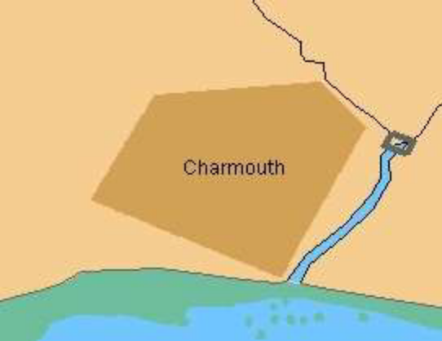

C2.5.2 Alphanumeric Examples
NEED to add XML example for displaying text and then rework the table as a so show what attributes are being called from the model.

Name |  | Description | Inland ECDIS or ECS Display
Inland ECDIS or ECS Textual Output | Nr (string from Attribute OBJNAM) |  | 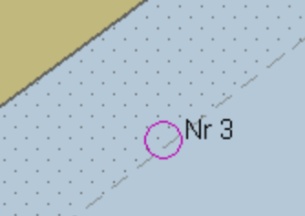

NEED to add XML example for displaying text and then rework the table as a so show what attributes are being called from the model.

Name |  | Description | Inland ECDIS Display
Inland ECDIS Textual Output |  | Floating point number from attribute ORIENT followed by deg | 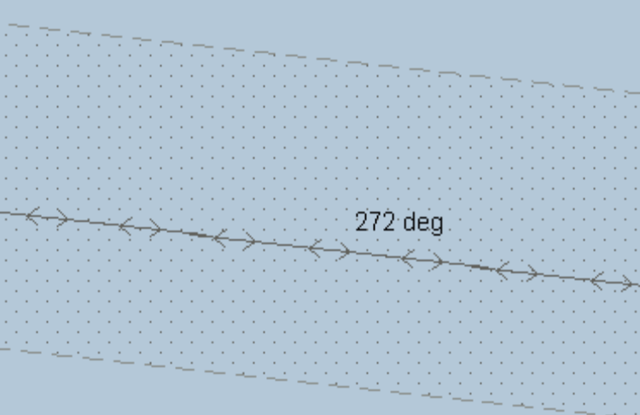

C2.5.3 Point
NEED to add XML example.

S-401 Symbol | Description | Inland ECDIS Example
BOYCAR01 | Simplified symbol - North Cardinal Mark | 
LIGHTDEF, 135 | LIGHTDEF is a symbol selected by a conditional symbology procedure (LIGHTS06). The command string “SY(LIGHTDEF,135)” selects a default light flare rotated by 135 degrees

NEED to add XML example.

S-401 Symbol | Description | Inland ECDIS Example
CURENT01 | Current feature, current symbol rotated by value from the ORIENT attribute.  In the example ORIENT = 297.3 | 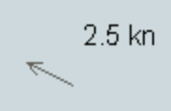

C2.5.3 Curve
NEED to add XML example
LS(DASH,2,CHMGD). Displays a dashed line in "chart magenta, dominant", 0.6 mm (2 x 0.3 mm) width.
LC(ACHARE51). Displays the complex line-style called ACHARE51 defined for borders of anchorage areas. (see below).


C2.5.3 Surface
NEED to add XML example

S-401 | Description | Example
AC(CHBRN) | area filled with opaque colour 'chart brown'
AP(DQUALA21);LS(DASH,2,CHGRD) | area filled with pattern for ‘category of zone of confidence; bordered by a dashed line in 'chart grey , dominant', 0.6 mm width | 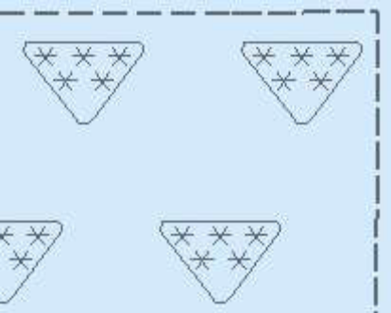

C2.6 Specification for Colours
C2.6.1 General
The colours are specified in CIE (Commission Internationale de l'Eclairage) xy chromaticity coordinates and luminance L. The Inland ECDIS colour scheme based on specification of colour tokens and color conversion tolerances.
The Colour Tables are in the portrayal catalogue.
Note that these colour specifications apply to both the operational chart display (for route planning and route monitoring), and also to any text on the same screen as the chart display.

C2.6.2 The colour tables
There are three colour tables, all of which shall be made available to the skipper. They are specified as part of the portrayal catalogue. They are as follows:
DAY The "Day" table uses a white background as a result of a comparative test outdoors in bright sunlight which showed that a display background of maximum luminance gives the best contrast achievable under near-washout conditions. This conclusion has been confirmed by subsequent sea experience.
DUSK The "Dusk" colour table is a black background table, which may also be used by day as a skipper’s option.
NIGHT At night the light emitted by the display must be strictly limited to avoid impairing night vision. In case the luminance needs to be further reduced, the "Night" colour table may be augmented by a luminance-reducing neutral density filter which should have 8 times attenuation, designated (logarithmically) "0.9 ND". (This is a manufacturer's option).

C2.6.3 Transparency
Transparent fill can be achieved in two ways:
• with a given percentage of the pixels having the transparent fill
• by mixing the fill and underlying colour at each pixel to give a continuous transparency change from 0% to 100%. This shall be done in such a way that no appearance of colour or shape change occurs in any SENC feature on the display, at any intermediate transparency value. The underlying SENC information shall remain distinguishable, except when the overlay colour approaches 100%.

C2.7 General Colour Assignment for Inland ECDIS and ECS Features

Colour | Comment
black/white | (black by day / white by night) is used for critical navigation features which need highlighting by contrast against their background to give them adequate prominence. Examples are the own-vessel symbol, dangerous soundings less than the safety depth, buoys, conspicuous objects on land etc. It is also used for text, which is less clear in any other colour.
white/black | (white by day / black by night) as a background area shade is used for deep, safe, water.
magenta | is used to highlight critically important features such as isolated dangers, traffic routes, anchorages; and for restricted areas, submarine cables, gas pipelines etc. It is also used for aids to navigation and services such as daymarks, racons, and pilot stations.
grey | is used for many features which are black on the paper chart. It is used with thick lines for critical physical objects such as bridges and overhead cables, and with thin lines for important but less critical physical features such as non-dangerous soundings, sandwaves, overfalls, water pipelines and fish farms. It is similarly used for chart features such as fairways, harbour areas, tidal information and for information about the chart such as quality of chart data, overscale areas, etc.
grey | as a background area shade is used with a prominent pattern for no-data areas.
blue | as a background area shade is used to distinguish depth zones.
blue | as foreground colour for AIS and VTS information; also reserved for future requirements.
green | is used for the radar image and synthetics, and for buoy and lights colours
blue-green | is used for transferred ARPA.
yellow-green | ('moss-green') as a background area shade is used for the intertidal area between high and low waterlines,
yellow | is used as the manufacturer's colour; for the skipper’s transparent colour fill; and for buoy and lights colours.
red | is used for the important planned route, for the skipper’s danger highlight, and for buoy and lights colours.
orange | is the skipper’s colour, for notes, chartwork, chart corrections. The scale bar, north arrow, and skipper’s navigation objects such as EBLs and VRMs are also orange.
brown | as a background area shade is used for the land, and dark brown is used for features on land and in the intertidal area that do not have any strong significance for navigation.

C2.7.1 Colour Tokens for S-401 IENCs
The colours in this section are specifically designed for chart display.

Token | Colour, day/night | Usage
CHBLK | black/ grey | general
CHGRD | grey dominant | general
CHGRF | grey, faint | general
CHRED | red | general
CHGRN | green | general
CHYLW | yellow | general
CHMGD | magenta, dominant | general
CHMGF | magenta, faint | general
CHBRN | brown | general
CHWHT | white | general
OUTLW | black | symbol outline on sea area background
OUTLL | pale/dark brown | symbol outline on land area background
LITRD | red | red lights
LITGN | green | green lights
LITYW | yellow | white/yellow/orange/amber lights
ISDNG | magenta | isolated danger
DNGHL | red | danger highlight
TRFCD | magenta, dominant | traffic control features
TRFCF | magenta, faint | traffic control features
LANDA | brown | Land areas
LANDF | brown | Landforms, land features
CSTLN | black/grey | Coastline, shoreline constructions
SNDG1 | grey | deep soundings > safety depth
SNDG2 | black/white | shallow soundings <= safety depth
DEPSC | grey | safety contour
DEPCN | grey | depth contours
DEPDW | white/black | deeper than selected deep contour
DEPMD | pale/dark blue | safety contour to selected deep contour
DEPMS | light/medium blue | shallow contour to selected safety contour
DEPVS | medium/light blue | zero meter contour to shallow contour
DEPIT | yellow-green | high water line to zero meter contour

CHBLK, CHGRD, CHGRF, CHRED, CHGRN, CHYLW, CHMGD, CHMGF, CHBRN, CHWHT – This selection of colours is used in general to design symbols and chart line features as well as fill styles. They are not used in cases where other colours are available for a special usage.
OUTLW, OUTLL - These colours are used to outline symbols depending on which background they are normally shown (water/land).
LITRD, LITGN, LITYW - Light symbols have their own colours to give the opportunity to influence their colour luminance individually. Yellow (LITYW) is used for white, yellow, orange and amber lights because it might be difficult to distinguish these colours from each other on a badly calibrated monitor. It also follows the tradition to show up white lights with a yellow flare or coloured arc.
ISDNG - Since the isolated danger symbol forms one of the most important items on the Inland ECDIS screen, it is given a separate colour.
DNGHL - This colour is used for symbology that highlights skipper selected dangers. The skipper decides during route planning which features are highlighted by this colour.
TRFCD, TRFCF - Traffic separation schemes are complex chart features. The navigator is confronted with important elements of the schemes and with less important elements as well.
TRFCD is used to distinguish important traffic routeing features.
LANDA - This colour is used for land areas in general.
LANDF - Landforms and land features are given a contrasting brown.
CSTLN - The coastline (shoreline) is a very important feature of the chart. If a radar image is combined with the chart picture it is required that coastline elements clearly show up on top of the green radar picture (see also RADHI/RADLO). To have full control over this combination under all conditions (day/night) a separate colour is reserved for coastline features.
SNDG1 - This colour is used for soundings that are deeper than the selected safety depth ("safe" soundings).
SNDG2 - This colour is used for soundings that are shallower than or equal to the selected safety depth ("unsafe" soundings).
DEPSC - This colour is reserved for the selected safety contour.
DEPCN - All depth contours other than the safety contour shall use this colour.
DEPDW, DEPMD, DEPMS, DEPVS, DEPIT - These are depth shades. The depth zones are:
DEPDW: areas deeper than the skipper-selected deep contour;
DEPMD: areas between deep contour and the skipper-selected safety contour;
DEPMS: areas between safety contour and the skipper-selected shallow water contour;
DEPVS: areas between shallow water contour and the low water line (zero meter contour);
DEPIT: areas between zero meter contour and coastline (intertidal).
For route monitoring it may be desirable to distinguish only two water shades, plus DEPIT: deeper than own-vessel’s safety contour and shallower than safety contour. In that case DEPDW and DEPVS shall be used. At night it may be difficult to distinguish between DEPMD and DEPDW.

C2.7.2 Radar Image Overlay Colours

Token | Colour | Usage
RADHI | green | high intensity echo or single int. echo
RADLO | green | low intensity echo & target trail
ARPAT | green, dashed | ARPA, target symbols & infos

The radar image overlay has to be generated by using a range of intensities with a minimum of 8 steps. The corresponding colour intensities shall be interpolated between the colour for high echo intensity (RADHI) and the colour for low echo intensity (RADLO). A separate colour token is used for ARPA targets and information tagged on them (ARPAT).
The manufacturer should allow to vary the radar green overlay by making it transparent.

C2.7.3 Skipper’s & Navigation Information Colours

Token | Colour | Usage
SCLBR | orange | scalebar
CHCOR | orange | chart corrections
NINFO | orange | Navigators Notes
ADINF | yellow | Skipper’s transparent area fill and manufacturers' points and lines

SCLBR Used to generate the scalebar.
CHCOR Hand-entered chart corrections are marked by the colour.
NINFO Skippers notes of any form (Symbols, Text) are generated using the colour.

C2.7.4 Other Colours

Token | Colour | Usage
RESBL | blue | AIS features and symbols (if not otherwise specified)
RESGR | grey | reserved for line features & screened areas
BKAJ1 | black | black level test symbol background
BKAJ2 | grey | black level test symbol foreground

C2.7.5 Colour Section V / Vessel Symbol & Planned Route

Token | Colour,day/night | Usage
SHIPS | black/white | own vessel, course over ground and speed over ground (course and speed made good, Co&SpMG) vector
PSTRK | black/white | Past Track
SYTRK | grey | Secondary Track
PLRTE | red | planned route & notations
APLRT | orange | alternate planned route

C2.8 Queries
To successfully use S-401 Inland ECDIS must be capable of performing spatial queries on IENC data during import and symbolisation. Spatial query is understood as possibility to inspect graphical position and numerical value of spatial coordinates associated with a charted object. Spatial query could be available as a part of cursor pick or as an independent function.

C2.8 Display Priority, Radar Priority, Display Category, Viewing group
C2.8.1 Display Priority (Drawing Priority)
Display priorities control the order in which the output of the portrayal functions is processed by the rendering engine. Priorities with smaller numerical values will be processed first. In the S-401 Portrayal Catalogue the display priority is known as the drawing priority.
The display priority shall be used to ensure that objects that overlap each other are drawn in the right sequence. Thus, an object with a higher priority shall be drawn after (on top of) an object with a lower display priority. However, if two curve features, or two surface boundaries, or a curve and an surface boundary, are located at the same position and share the same extent (their coordinates are identical), then the line symbolization with the higher display priority shall suppress the line symbolization of the other feature (curve or surface). Therefore only the line symbolization of the feature (curve or surface) of the higher display priority is drawn. Where two features share the same spatial edge and both have the same display priorities each line shall be symbolized.

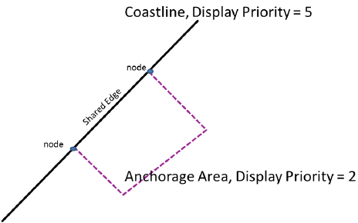

The coastline feature is symbolized with a solid line while the anchorage area is bordered with a dashed line. Both features share an edge that is part of the coastline. The symbolization of the coastline feature suppresses the border of the anchorage area since the display priority of the coastline symbolization is higher. Note that priorities have to be evaluated again, if the skippers selected viewing scale changes.
This suppression only applies to curve features and surface boundaries. The rule for centered symbols, area patterns and point symbols is that all symbols shall be drawn with the highest priority object being drawn last independent of the geometric primitive (point, curve or surface).
There is one exception to this rule for suppressing overlapping lines. The manual chart correction lines LC(CHCRIDnn) and LC(CHCRDELn) shall coexist with the underlying line. Both LC(CHCRIDnn) or LC(CHCRDELn) and the underlying line shall be drawn.
Overdrawing may be essential, for example in the case of a buoy, and its name and light flare. These are given offsets in the symbol library to avoid the symbols being drawn over each other.

C2.8.2 RADAR Flag
The display plane indicates whether features are shown on top of the raw radar picture. Two different values can occur in this field:

Value | Description
O | puts the features presentation over radar
U | the presentation is suppressed by radar

As a fail-safe, features are automatically assigned ‘O’ OVERRADAR if the displayPlane field in the portrayal catalogue is empty.
When the RADAR overlay is present on the ECDIS chart display the OVERRADAR flag takes precedence over the objects display priority relative to the radar image.

C2.8.3 Display Mode
The portrayal catalogue assigns every feature a display mode that is based on the Display Categories.
The "display categories" are as follows:
Display Base is that part of the Standard Display which shall be permanently retained on the display.
Standard Display information is that part of the SENC which shall be presented when the Inland ECDIS display is first switched on, and at any time by a single operator action.
All Other Information includes all SENC information that is not in the Standard Display, to be displayed on demand by the Skipper.

C2.8.3.1 Independent Skipper Selections
There are a number of settings in Inland ECDIS and ECS that can be operated by the Skipper that will alter the charted display. Each of these features has a display mode assigned but shall only be shown in that display mode if the Skipper has decided to select this option. Listed alphabetically below are the Skipper selectors that shall be available in Inland ECDIS and ECS, the name of the selector in the Inland ECDIS or ECS GUI and a functional description. There are a number of other optional extra Skipper selectors that can be included in Inland ECDIS or ECS at the bottom of the table.

Clause | Inland ECDIS  Implementation | Name of Selector  in Inland ECDIS | Function Description
 | Mandatory | Accuracy | Independent pattern selection of CATZOC, viewing group 31010. Symbol LOWACC01, viewing group 31011
 | Mandatory | Date dependent | Date Dependent Features – to turn on and off the display of temporal features by viewing a date range.
 | Mandatory | Full light lines | Full Light Sector Lines
 | Mandatory | Highlight date dependent | Indication of date dependent features – to turn on and off the display of symbol CHDATD01
 | Mandatory | Highlight info  Highlight document | Additional Information - viewing group 31030  SupplementaryInformation Information type.
 | Mandatory | Unknown | Unknown Features - to turn on the display of features which are not specified in S-401 standard – viewing group 21010
 | Mandatory | Update review | Review of Updates – This function turns on colour highlighting for the UpdateInformation feature which have undergone modification in the process of the latest accepted correction;
 | Mandatory | Scale min | Turn SCAMIN Off
 | Mandatory | Shallow pattern | Shallow Water Pattern
 | Mandatory | Shallow water dangers | Isolated Dangers in Shallow Water – to turn on the display of isolated danger objects which are located in the unsafe waters – viewing group 24050
 | Optional | Contour label | Contour Labels – to turn on the display of contour labels (incl. label of safety contour) – viewing group 33021, 33022
 | Optional | Four shades | Four Colour Depth Shades
 | Optional | National language | National Language, text group 31
 | Mandatory | Paper chart / simplified symbols | Point symbol style
 | Mandatory | Plain / Symbolized  boundaries | Line symbol style

C2.8.3.2 Skippers’ objects
All Skippers’ navigational objects, which are listed in the look-up table under “Non-standard classes”, are assigned in the look-up tables to a “Skippers”category.
The display of Skippers’ objects is independent of the Inland ECDIS or ECS display category (Display Base, Standard and All Other).

C2.8.4 Viewing Groups
The Skipper shall have effective control over which features appear on the display (subject to the overriding requirements of category).
The minimum mandatory Inland ECDIS and ECS implementation is described in 14.3 and 14.5.
Viewing groups are 'on' or 'off' switches for use by the Skipper to control the information appearing on the display. An item in the viewing group table may be a chart object; a Skippers’ or other time-variable object; a special symbol such as the "depth less than safety contour" pattern; or a non-IENC feature such as the shallow water pattern. In edition 3.3 further 'symbol viewing groups' have been added, to allow auxiliary symbols such as contour labels, the 'low accuracy' symbol, etc., to be switched on or off without affecting the primary symbolisation of the object.
Items in the viewing group tables are arranged in numbered groups (for example group 26230 consisting of the items pipeline area and cable area) which in turn are arranged in layers (for example layer 26000 consisting of cautionary areas). The groups are arranged by Category, in the sequence of INT 1 [1].

C2.8.4.1 Viewing Groups Layers

DISPLAY BASE | STANDARD DISPLAY | OTHER INFORMATION
00000-09999 reserved for administrative purposes
10000 reserved  40000 reserved | 20000 reserved  50000 reserved | 30000 reserved  60000 reserved
11000 A,B information about the chart display  41000 tools | 21000 A,B  51000 tool | 31000 A,B  61000 tools
12000 C, D, E, F land features  42000 own vessel, planned route | 22000 C, D, E, F  52000 own vessel etc | 32000 C, D, E, F  62000 own vessel etc
13000 H, I depths & currents  43000 Skippers’ features | 23000 H,I  53000 Skippers’ features | 33000 H,I  63000 Skippers’ features
14000 J,K,L obstructions, pipelines  44000 other vessels | 24000 J,K,L  54000 other vessels | 34000 J,K,L  64000 other vessels
15000 M traffic,routes  45000 manufacturers' features | 25000 M  55000 manufacturers' features | 35000 M  65000 manufacturers’ features
16000 N special areas  46000 Skippers’ assignments | 26000 N  56000 Skippers’ assignments | 36000 N  66000 Skippers’ assignments
17000 P,Q,R,S buoys, beacons, lights, radar  47000 reserved for Skippers‘ information | 27000 P,Q,R,S  57000 reserved | 37000 P,Q,R,S  67000 reserved
18000 T,U services & small craft facilities  48000 reserved for Skippers’ information | 28000 T,U  58000 reserved | 38000 T,U  68000 reserved
19000-19999 reserved  49000-49999 reserved | 29000-29999 reserved  59000-59999 reserved | 39000-39999 reserved  69000-69999 reserved
70000-99999 reserved for future use.

Numbering scheme for viewing groups (Skippers’ information in italics)

C2.8.4.1.1 Display Base

RESERVED
10000-10999 | Reserved for chart information
A, B CHART FURNITURE
11000 | Information about the Chart Display
11010  11020 | cursor [symbol SY(CURSRA01)]  na (not assigned)
11030 | scalebar, latitude scale [SY(SCALEB10),SY( SCALEB11)]
11040 | north arrow [SY(NORTHAR1)]
11050 | no data [colour NODTA, AP(NODATA03)], unsurveyed (UNSARE), incompletely surveyed area
11060 | Non-official data boundary LC(NONHODAT)
C, D, E, F TOPOGRAPHY AND INFRASTRUCTURE
12000 | Land area
12010 | land area (LANDARE)
12200 | Dangers above water
12210 | bridge (BRIDGE), pylon (PYLONS), overhead cable (CBLOHD), conveyor (CONVYR), overhead pipeline (PIPOHD), offshore platform (OFSPLF)
12400 | Shoreline
12410 | coastline (COALNE), shoreline construction (SLCONS), tie-up wall, dolphin (MORFAC), gate (GATCON, pile (PILPNT), crib, wellhead, ice boom (OBSTRN), floating dock (FLODOC), hulk (HULKES), pontoon (PONTON), oilboom (OILBAR), flood barrage (DAMCON, CATDAM3)
12420 | lock (LOKBSN), canal (CANALS), river (RIVERS)
H, I HYDROGRAPHY
13000 | Safety Contour
13010 | safety contour (from conditional symbology procedure DEPCNT03)
13020 | na
13030 | depth area (DEPARE), dredged area (DRGARE),
J, K, L SUBSEA FEATURES
14000 | Dangers under water
14010 | isolated underwater dangers in water deeper than the displayed safety contour (rocks, wrecks, obstructions, mooring cables from conditional symbology procedure)
M TRACKS AND ROUTES
15000-15999 | na (not assigned)
N SPECIAL AREAS
16000-16999 | na (not assigned)
P, Q, R, S AIDS TO NAVIGATION
17000-17999 | na (not assigned)
T, U SERVICES
18000-18999 | na (not assigned)
RESERVED
19000-19999 | Reserved for chart information

The groupings are given to illustrate the contents of the Display Base. All objects of this category shall be permanently retained on the Inland ECDIS or ECS display.

C2.8.4.1.2 Standard Display

RESERVED
20000 | Reserved for chart information
A, B INFORMATION ABOUT THE CHART DISPLAY
21000 | Information about the Chart Display
21010 | Unknown object (magenta question mark)
21020 | Generic Object (NEWOBJ01)
21030 | Chart scale boundary, overscale data [AP(OVERSCO1)]
21040 | na
21050 | na
21060 | Place-holder for geographic names (LNDRGN, SEAARE)
C, D, E, F NATURAL & MAN-MADE FEATURES, PORT FEATURES
22000 | Major Coastal Features
22010 | Lake (LAKARE), sloping ground (SLOGRD), slope top (SLOTOP), dyke (DYKCON), dam (DAMCON),
22200 | Conspicuous landmarks:
22210 | Radar conspicuous object - (any object with attribute CONRAD 1)
22220 | Visually conspicuous object (any object with attribute CONVIS 1)
22230 | na
22240 | Built up area (BUAARE)
H, I DEPTHS, CURRENTS, etc.
23000 | Depths
23010 | Area of depth less than the safety contour (DIAMON01 pattern)
23020 | na
23030 | na
J, K, L SEABED, OBSTRUCTIONS, PIPELINES
24000 | na
24010 | Mooring cables (MORFAC, CATMOR6), (CBLSUB, CATCBL6), tunnel on Seabed (TUNNEL, BURDEP=0), sandwaves (SNDWAV)
M TRAFFIC ROUTES
25000 | Routes and Tracks
25010 | Leading line, clearing line (NAVLNE), traffic separation area (TSEZNE), traffic separation line (TSELNE), traffic crossing (TSSCRS), precautionary area (PRCARE), traffic separation scheme boundary (TSSBND), two way route part (TWRTPT), inshore traffic zone (ISTZNE).
25020 | Recommended track (RECTRC), recommended traffic lane (RCTLPT), recommended route centreline (RCRTCL)
25030 | Ferry route (FERYRT)
25040 | Radar line (RADLNE),
25060 | Radio calling in point (RDOCAL)
N SPECIAL AREAS
26000 | Restricted and Cautionary Areas
26010 | Restricted area (RESARE)
26020 | na
26030 | na
26040 | Military practice area (MIPARE), sea plane landing area (SPLARE), offshore production area (OSPARE)
26050 | Fairway (FAIRWY)
26150 | Caution area (CTNARE)
26200 | Information Areas. Protected Areas
26210 | marine farm (MARCUL), Fishing Facility (FSHFAC)
26220 | Anchorage area (ACHARE), anchor berth (ACHBRT),
26230 | na
26240 | Dumping ground (DMPGRD),
26250 | na
26260 | na
P, Q, R, S BUOYS & BEACONS, LIGHTS, FOG SIGNALS, RADAR
27000 | Buoys, Beacons, Topmarks, Lights, Fog Signals
27010 | Buoy (BOYxxx), light float (LITFLT), mooring buoy (MORFAC, CATMOR7)
27011 | na
27020 | Beacon (BCNxxx)
27025 | Daymark (DAYMAR)
27030 | Distance mark (DISMAR)
27040 | Direction of buoyage IALA buoyage regions (M_NSYS)
27050 | topmarks (TOPMAR) - for paper chart symbols
27060 | na
27070 | light (LIGHTS)
27080 | fog signal (FOGSIG),
27200 | Radar
27210 | racon (RTPBCN)
27220 | na
27230 | radar reflector (RADRFL)
T, U SERVICES & SMALL CRAFT FACILITIES
28000 | Services
28010 | pilot boarding point (PILBOP)
28020 | signal station, traffic (SISTAT), sig. stn. warning (SISTAW)
RESERVED
29000 | reserved for chart information

C2.8.4.1.3 Other Chart Information

RESERVED
30000 | Reserved for chart information
A, B INFORMATION ABOUT THE CHART DISPLAY
31000 | Information about the Chart Display
31010 | accuracy of data (M_ACCY), survey reliability (M_SREL), quality of data (M_QUAL)
31011 | symbol LOWACC01, identifying low accuracy data, applied to the spatial object of point and area wrecks, rocks and obstructions and to point land areas
31020 | nautical publication (M_NPUB)
31030 | Supplementary Information
31031 | Additional Documents NTXTDS, TXTDSC, PICREP
31040 | dataCoverage
31050 | na
31060 | na
31070 | na
31080 | magnetic variation (MAGVAR)
C, D, E, F NATURAL & MAN-MADE FEATURES, PORT FEATURES
32000 | Natural Features
32010 | dunes , hills (SLOGRD), ridge, clifftop (SLOTOP), contours and elevation (LNDELV)
32020 | na
32030 | trees , vegetation, mangrove (VEGATN), marsh (LNDRGN)
32040 | na
32050 | river (RIVERS) or lake (LAKARE);
32060 | Na
32070 | tideway (TIDWAY)
32080 | na
32200 | Shore Structures
32210 | na
32220 | any of the following not classified as CONVIS1 (conspicuous): landmark (LNDMRK), building (BUISGL), tank, silo, water tower (SILTNK), wall (FNCLNE), fort (FORSTC)
32230 | na
32240 | airport (AIRARE), runway (RUNWAY)
32250 | railway (RAILWY), road (ROADWY), tunnel (TUNNEL), control point (CTRPNT)
32260 | na
32270 | quarry, refinery, power station, tank farm, wind farm, factory, timber yard  (PRDARE)
32280 | na
32400 | Port Features
32410 | harbour type (HRBFAC), customs check point (CHKPNT) [note: "small craft facilities" (SMCFAC) is in group 38210]
32420 | Na
32430 | na
32440 | berth number (BERTHS), mooring facility (such as bollard) (MORFAC), , gate (such as lock gate) (GATCON) , dry dock (DRYDOC), crane (CRANES)
32450 | na
32460 | na
H, I DEPTHS, CURRENTS, etc.
33000 | Depths, Currents, Tide rips, etc
33010 | Soundings (SOUNDG)
33020 | depth contours (DEPCNT) other than the safety contour
33021 | label for the safety contour
33022 | label for contours other than the safety contour
33030 | na
33040 | water turbulence (WATTUR)
33050 | na
33060 | current and tidal stream information (CURENT, TS_FEB, TS_PAD, TS_PNH, TS_PRH, TS_TIS)
J, K, L SEABED, OBSTRUCTIONS, PIPELINES
34000 | Seabed Information: rocks, wrecks & obstructions, pipes & cables
34010 | nature of seabed (SBDARE)
34020 | sea weed (WEDKLP)
34030 | Pipeline area (PIPARE), cable area (CBLARE)
34040 | na
34050 | rocks (UWTROC), wrecks (WRECKS), obstructions (OBSTRN), which are not a danger to own-vessel's navigation (these are all Display Base if a danger to own-vessel)
34051 | non-dangerous rocks (UWTROC), wrecks (WRECKS) and obstructions (OBSTRN) which have a VALSOU attribute and are not a danger to own-vessel’s navigation (these objects are all Display Base if a danger to own-vessel)
34060 | na
34070 | submarine cable (CBLSUB), submarine pipeline (PIPSOL)
M TRAFFIC ROUTES
35000 | Routes
35010 | na
N SPECIAL AREAS
36000 | Administrative Areas, (by cursor enquiry)
36010 | na
36020 | harbour area (HRBARE) free port area (FRPARE),
36030 | na
36040 | fishery zone (FSHZNE)
36050 | national territorial area (NATARE), administration area (ADMARE)
P, Q, R, S BUOYS & BEACONS, LIGHTS, FOG SIGNALS, RADAR
37000-37999 | na
T, U SERVICES & SMALL CRAFT FACILITIES
38000 | Services
38010 | radar station (RADSTA), radio station (RDOSTA)
38020 | na
38030 | coastguard station (CGUSTA), rescue station (RSCSTA)
38200 | Small craft facilities
38210 | small craft facilities (SMCFAC)
RESERVED
39000 | reserved for chart information

C2.8.4.2 Skipper’s Information – Display Base

RESERVED
40000 | Reserved for Skippers’ information
TOOLS
41000-41999 | na
OWN-SHIP, PLANNED ROUTES, PAST TRACKS
42000 | Own vessel
42010 | Own vessel (ownship), symbol or scaled version, together with heading line, beam bearing line and course and speed vector
42200 | Selected Planned Route
42210 | way points (waypnt, select 1)
42220 | na
SKIPPER’S FEATURES
43000 | na
OTHER VESSELS
44000 | na
MANUFACTURERS' FEATURES
45000-45999 | Manufacturers’ Features
SKIPPER’S ASSIGNMENTS TO DISPLAY BASE
46000-46999 | Skippers’ and manufacturers' objects assigned to Display Base by the Skipper
RESERVED
47000-49999 | reserved for Skippers’ information

C2.8.4.3 Skipper’s Information – Standard Display

RESERVED
50000 | Reserved for Skippers’ information
TOOLS
51000-51999 | na
OWN-VESSEL, PLANNED ROUTES, PAST TRACKS
52000 | Notations on Selected Planned Route
52010 | wheel-over line (wholin), selected route
52020 | course to make good on leglines (leglin, select 1) of selected route
52030 | planned position (pinpos), distance to go, and other notations on selected planned route
52200 | Alternate Planned Route
52210 | leglin (leglin, select 2), waypoint (waypnt, select 2) of alternate planned route
52220 | na
52230 | wheel-over line (wholin), alternate route
52240 | other notations, alternate route
52400 | Past Track
52410 | event (events)
52420 | na
52430 | primary past track (pastrk, catpst 1)
52440 | notations on primary past track
52450 | na
52460 | secondary past track (pastrk catpst 2)
SKIPPERS’ FEATURES
53000 | Skippers’ features
53010 | danger highlight (dnghlt)
53030 | Skippers’ information note (marnot catnot 1)
53040 | Skippers’ cautionary note (marnot catnot 2)
53050 | Skippers’ feature (marfea)
53060 | na
53070 | na
53080 | tidal current observed (tidcur, catcur 2), tidal current predicted (tidcur, catcur 1)
OTHER VESSELS
54000 | Other Vessels
54010 | other vessels from radar
54020 | notations on other vessels (acqsta)
54030 | other vessels from other sources or undefined sources
MANUFACTURERS' FEATURES
55000 | Manufacturers’ Features
55010 | manufacturers' feature (mnufea, catnot 1)
55020 | manufacturers' feature (mnufea, catnot 2)
SKIPPERS’ ASSIGNMENTS TO STABDARD DISPLAY
56000-66999 | Skippers’ and manufacturers' Objects Assigned to Standard Display by the Skipper
RESERVED
57000-59999 | reserved for Skippers’ information

C2.8.4.4 Skipper’s Information – Other Information

RESERVED
60000 | Reserved for Skippers’ information
TOOLS
61000 | Tools
61010 | electronic bearing line (ebline), variable range marker (vrmark)
61020 | na
61030 | range rings (rngrng)
61040 | cursor, style B (cursor, cursty2)
61050 | cursor reference point (refpnt)
OWN-VESSEL, PLANNED ROUTES, PAST TRACKS
62000 | Position fixes
62010 | position fix (positn)
62020 | position line (poslin)
SKIPPERS’ FEATURES
63000-63999 | na
OTHER VESSELS
64000-64999 | na
MANUFACTURERS' FEATURES
65000-65999 | Manufacturers’ Features
SKIPPERS’ ASSIGNMENTS TO OTHER INFORMATION
66000-66999 | Skippers’ and manufacturers' objects assigned to other information by the Skipper
RESERVED
67000-69999 | reserved for Skippers’ information

C2.8.5 Inland ECDIS and ECS Viewing Group Implementation
For standardization of the Inland ECDIS or ECS Human Machine Interface (HMI) and to facilitate generic training of Skippers as a minimum the following viewing group layers shall be implemented to control display of charted objects. An Inland ECDIS or ECS may provide more display on/off controls than are available in this table, but OEM shall use the viewing group layer names contained in this table.

Viewing Group Layer | Name of viewing group layer in the Inland ECDIS or ECS | Viewing groups included
1 | Display Base | 10000 - 19999
Standard Display:
2 | Drying line | 22010
3 | Buoys, beacons, aids to navigation | 21020, 22200 – 22240, 27000, 27010, 27011, 27020, 27025, 27040, 27050, 27070, 27080, 27200, 27210, 27230, 27030, 27060
3.1 | Buoys, beacons, structures | 21010, 21020, 22200 - 22240, 27000-27050, 27080, 27200 – 27230, 27030, 27060
3.2 | Lights | 27070
4 | Boundaries and limits | 23030, 26050, 26220, 26240, 26250
5 | Prohibited and restricted areas | 26000, 26010, 26040
6 | Chart scale boundaries | 21030
7 | Cautionary notes | 26150
8 | Vessels’ routeing systems and ferry routes | 25010-25060
9 | na | 26260
10 | Miscellaneous | Switches on and off all not covered objects by viewing group layers 20000-29999
Other
11 | Spot soundings | 33010
12 | Submarine cables and pipelines | 34030, 34070
13 | All isolated dangers | 34050, 34051
14 | Magnetic variation | 31080
15 | Depth contours | 33020
16 | na | 34010, 34020, 33040
17 | Tidal | 33050, 33060
18 | Miscellaneous | Switches on and off all not covered objects by viewing group layers 30000-39999 or not covered cases by independent skipper selections (see 10.3.4.4)

C2.9 Display of features – Date Dependent and Display Scale
C2.9.1 Date dependent IENC Features
There are a number of objects within the inland waterway environment, which are seasonal, such as racing buoys. These objects are only to be displayed over a certain period, S-401 uses the complex attribute periodicDateRange with the sub attributes dateStart and dateEnd to indicate the periodic nature of the feature. Other objects, such as traffic separation schemes, use the complex attribute fixedDateRange with the sub attributes dateStart and dateEnd to indicate their introduction or removal. In order for the Skipper to receive important changes to traffic separation schemes before the event chart producers are required to provide updates or new editions containing the alterations at least one month before they come into force. Any S-401 feature with one of the above complex attributes must not be displayed outside its effective dates unless requested by the Skipper.
To provide the Skipper with effective route planning capabilities and for the look-ahead function during route monitoring Inland ECDIS must display date dependent chart data based on a Skipper selected date or date range (start viewing date and end viewing date).
During route planning and monitoring the Skipper must be able to select a date or date range to display all date dependent chart objects. The display of date dependent information is indicated by the symbol SY(CHDAT01).
All objects for which any of the values for the complex attributes periodicDateRange and fixedDateRange are within the Skipper selected date range shall be indicated using SY(CHDATD01)
Example: A new traffic separation scheme is coming into effect on 01.01.2013, it has been encoded by the IENC producer using the attribute date start (DATSTA). The current date is 12.12.2012 and the Skipper is planning a route that will cross this area over the effective start period.
The Inland ECDIS or ECS shall be capable of providing the Skipper the ability to set the date he will be in the area (02.01.2013) and the system shall show the new traffic scheme.

C2.9.2 Scale-Dependent Features
To reduce screen clutter most objects within IENC will carry the attribute scaleMinimum to specify the smallest display scale at which they shall be drawn. At display scales smaller than scaleMinimum the feature must not be drawn. For example, an object with a scaleMinimum value of 50,000, indicating a scale of 1/50,000, shall not be drawn on an Inland ECDIS or ECS display of 1/60,000.

C2.10 Presentation Instructions not handled by the portrayal catalogue
In some cases S-401 does not provide a symbology instruction in the portrayal catalogue that specifies how to present a specific feature on the Inland ECDIS or ECS screen. The reason is, that such a feature cannot be clearly identified as an S-401 feature class or it appears to be illogical to include it to the Skippers’ navigational feature classes.
Therefore, the following presentation instructions are in free text in order to assist the manufacturer to set up a satisfactory and comprehensive Inland ECDIS display.

C2.10.1 Scalebar and Latitude Scale
For maximum Display Scale s larger than 1/90,000 (for example a scale of 1/50,000) draw symbol 'SCALEB10' on the left side of the chart display, bottom justified and 3mm in from the border of the display. Make sure the symbol is properly sized by your software to represent 1 unit of distances (nautical mile (1852 m), statute mile or km) at the scale of the display. For display scales of 1/80,000 or smaller (for example 1/250,000) use symbol 'SCALEB11', similarly located, and scaled to represent 10 units (nautical miles, statute miles or km) at the scale of the display.

Symbol | SCALEB10  SCALEB11
Display Priority | 9
Over Radar | O
Display Category | Base
Viewing Group | 11030

C2.10.2 North Arrow
Use symbol 'NORTHAR1' to indicate true north. Place it in the top left corner of the chart display, inside the scalebar. Rotate the symbol to true north if the display is other than north up, and make sure it is clear of the scalebar even if the latter extends the full height of the display
Symbol | NORTHAR1
Display Priority | 9
Over Radar | O
Display Category | Base
Viewing Group | 11040

C2.10.3 Graticule
If the Inland ECDIS or ECS shows a graticule the lines shall be one unit wide, CHBLK.

C2.10.4 Display Mode
The Inland ECDIS or ECS manufacturer shall provide the indication of display mode required in the display base.

C2.10.5 Shallow Water Pattern
When the entire water area on the Inland ECDIS or ECS display is of less depth than the safety contour, it is not possible for the Skipper to easily detect this problem. The issue is exacerbated when the Inland ECDIS or ECS is set to night mode due to the small differences between the depth area shades in the Inland ECDIS or ECS chart display. Therefore S-401 provides a faint lattice pattern DIAMOND1 to distinguish shallow water.
The Skipper shall be provided with a selection to turn the shallow water pattern on or off from within the Inland ECDIS or ECS.

Symbol | DIAMOND1
Display Priority | 3
Over Radar | S
Display Category | Standard
Viewing Group | 23010

C2.10.6 Black Level Adjustment Symbol
Unless the brightness and contrast controls of the monitor, are properly adjusted there is a danger that information may be lost from the chart display, particularly at night. Symbol BLKADJ is provided for checking correct adjustment and for re-adjusting as necessary. It shall be available for call-up by the Skipper as required.

C2.10.7 Detection and Notification of Navigational Hazards

An indication should also be given if the Skipper plans a route closer than a user-specified distance from a point object, such as a fixed or floating aid to navigation or isolated danger.

An indication should be given to the Skipper if, continuing on its present course and speed, over a specified time or distance set by the Skipper, own vessel will pass closer than a user-specified distance from a danger (for example obstruction, wreck, rock) that is shallower than the Skipper’s safety contour or an aid to navigation.
The following table lists the S-401 features and their attributes that satisfy the conditions above and shall precipitate an indication within the Inland ECDIS or ECS. The point, curve or surfaces shall be graphically indicated using the instructions contained in the portrayal catalogue named “indhlt”. “indhlt” is not an IENC charted feature class, but an feature that shall be created by the Inland ECDIS or ECS. See Fig XX for example.

S-401 Features | Condition (if any) | Geometric primitive
BeaconCardinal |  | POINT
BeaconIsolatedDanger |  | POINT
BeaconLateral |  | POINT
BeaconSafeWater |  | POINT
BeaconSpecialPurpose |  | POINT
BuoyCardinal |  | POINT
BuoyInstallation |  | POINT
BuoyIsolatedDanger |  | POINT
BuoyLateral |  | POINT
BuoySafeWater |  | POINT
BuoySpecialPurpose |  | POINT
SpanOpening |  | POINT,CURVE, SURFACE
CableOverhead |  | LINE
Daymark |  | POINT
PipelineOverhead |  | LINE
Conveyor |  | LINE, AREA
MooringFacility |  | POINT,CURVE, SURFACE
VirtualAISAidToNavigation |  | POINT
FishingFacility |  | POINT,CURVE, SURFACE
LandArea |  | POINT, CURVE
OffshoreOilPlatform |  | POINT, SURFACE
OilBarrier |  | CURVE
PilePoint |  | POINT
Pylons |  | POINT, SURFACE
Obstruction | defaultClearanceDepth < safety contour value | POINT,CURVE, SURFACE
UnderwaterRock | defaultClearanceDepth < safety contour value | POINT
Wrecks | defaultClearanceDepth < safety contour value | POINT, SURFACE
Sounding | EXPSOU=2 and VE3D subfield< safety contour value | POINT
* The safety contour value is set by the user.

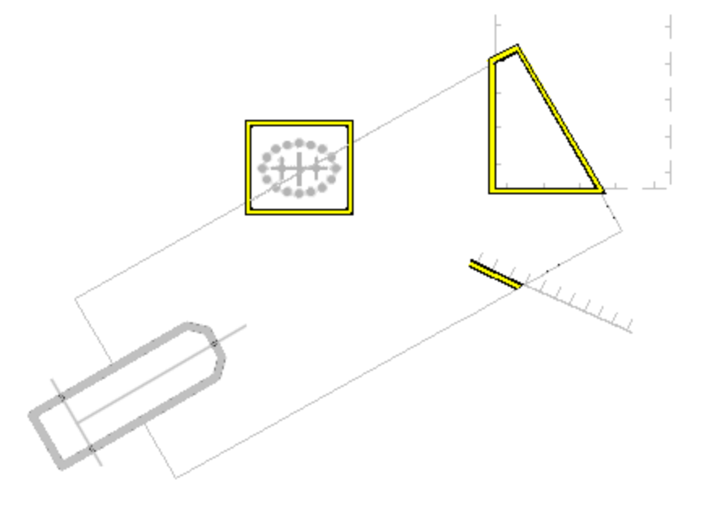
Fig 7. Example of indication highlight in Inland ECDIS or ECS 10.5.9 and 10.5.10

C2.10.7 Detection of Areas, for which Special Conditions Exist.

An indication should be given if the Skipper plans a route closer than a user-specified distance from the boundary of a prohibited area or a geographic area for which special conditions exist.

Inland ECDIS should give an alarm or indication, as selected by the Skipper, if, within a specified time set by the Skipper, own vessel will cross the boundary of a prohibited area or area for which special conditions exist".
Inland ECDIS and ECS shall detect the following areas and provide an alert or indication.
• Traffic separation zone
• Inshore traffic zone
• Restricted area
• Caution area
• Offshore production area
• Areas to be avoided
• Military practice area
• Seaplane landing area
•
• Anchorage area
• Marine farm/aquaculture
•
The following table provides an authoritative mapping between these areas and S-401 features, their attributes and geometric primitives. The point, curve or surface features shall be graphically indicated using the presentation named as “indhlt” in the look-up tables.

Special condition | S-401 Feature | Attribute | Geometry
Traffic separation zone | TrafficSeparationZone |  | SURFACE
Inshore traffic zone | InshoreTrafficZone |  | SURFACE
Restricted area | RestrictedArea | restriction !=14 and categoryOfRestriction != 28 | SURFACE
Caution area | CautionArea |  | SURFACE, POINT
Offshore production area | OffshoreProductionArea |  | SURFACE
Areas to be avoided | RestrictedArea | restriction = 14 | SURFACE
Military practice area | MilitaryPracticeArea |  | SURFACE, POINT
Seaplane landing area | SeaplaneLandingArea |  | SURFACE, POINT
Anchorage area | AnchorageArea |  | SURFACE, POINT
Marine farm/aquaculture | MarineFarmCulture |  | SURFACE, CURVE, POINT

C2.10.8 Visualization of the Safety Contour
The safety contour is defined as an edge between safe and unsafe skin of the earth objects.

C2.10.9 Detection of Safety Contour

An indication is required if the Skipper plans a route across an own vessel’s safety contour

Inland ECDIS should give an alarm if the vessel, within a specified time set by the Skipper, is going to cross the safety contour.
The following table specifies the S-401 features, conditions and geometry that constitute the safety contour and shall therefore be used when raising the safety contour alarm.
The point, line or area shall be graphically indicated using the presentation named as “dnghlt” in the portrayal catalogue.

S-401 Feature | Condition | Geometry
DepthArea | *DEPARE03 “UNSAFE=TRUE” | SURFACE
DredgedArea | *DEPARE03 “UNSAFE=TRUE” | SURFACE
FloatingDock | - | CURVE, SURFACE
Hulkes | - | POINT, SURFACE
LandArea | - | POINT,CURVE, SURFACE
Pontoon | - | CURVE, SURFACE
UnsurveyedArea | - | SURFACE
ShorelineConstruction | - | POINT,CURVE, SURFACE
BunkerStation | - | POINT, SURFACE

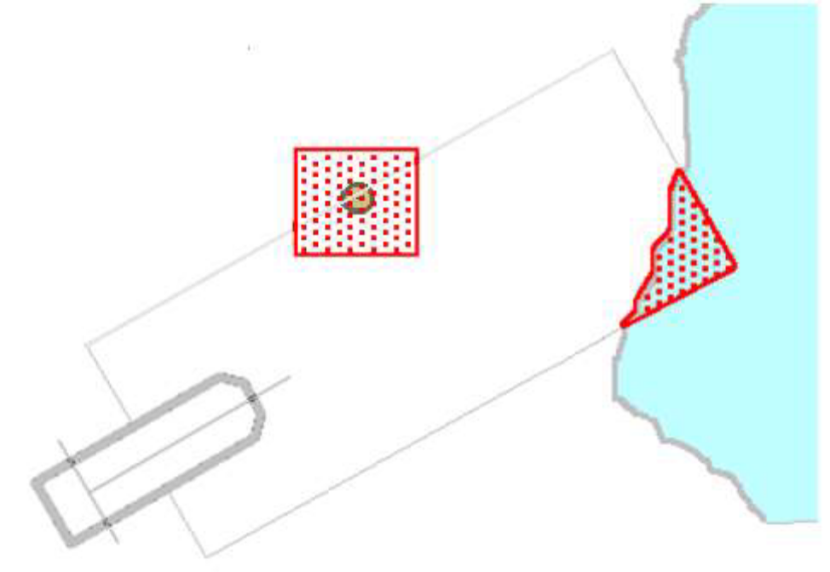
Fig 8. Example Danger Highlight in Inland ECDIS and ECS

C2.11 Authority Specified Display Features
C2.11.1 Supplementary Information
Additional chart content is encoded using the information type SupplementaryInformation. This information type is associated to S-401 features suing the information association, AdditionalInformation. The information type SupplementaryInformation carries attributes that must be discoverable.
The pivot point of SY(INFORM01) shall be placed at the position of a point object, at the midpoint of a line object, or at the centre of an area object. SY(INFORM01) is intended as a temporary overlay. The display priority is 8, overradar, category other, viewing group 31030.

Symbol (SY) | INFORM01
Display Priority | 8
Over Radar | O
Display Category | Other
Viewing Group | 31030

NOTE The Inland ECDIS or ECS manufacturers shall provide appropriate solutions that enable PICREP and other ancillary files to be displayed without affecting the night vision of the user.

C2.11.2 Display of National Language Attributes and Content
In S-401 national language may be encoded using the complex attributes featureName, Information, and TextualDescription. A sub attribute of the complex is language, which will enable the chart producer to note that the text is in the national language in addition to English. Information contained in the secondary featureName or Information can be encoded in a number of formats. It is strongly recommended that OEMs support all text formats contained in the national language attributes and files.

C2.11.3 Inland ECDIS and ECS Legend
The Inland ECDIS or ECS chart legend containing the following elements shall be available for display at the position selected by the Skipper. The following table indicates which IENC data elements shall be used.

Inland ECDIS and ECS Legend | Values
Scale of display | Selected by Skipper. (The default display scale is defined by the maximum Display Scale , contained within the IENC metadata file).
Data quality indicator | a. CATZOC attribute of the M_QUAL feature (if available) for bathymetric data.  b. POSACC attribute of the M_ACCY feature (if available) for non-bathymetric data.
Note: Due to the way quality is encoded in the IENC, both values (a and b) shall be used.
Sounding/vertical datum | The soundingDatum and verticalDatum fields of the metadata catalogue for the dataset or the verticalDatum attribute of the SoundingDatum feature and VerticalDatum feature when available.  (verticalDatum attributes of individual features shall not be used for the legend.)
Value of safety depth | Selected by Skipper. Default is 30 metres.
Value of safety contour | Selected by Skipper. Default is 30 metres.
Note: If the Skipper has selected a contour that is not available in the IENC and the Inland ECDIS or ECS displays a default contour, both the contour selected and the contour displayed shall be quoted.
Magnetic variation | referenceYearForMagneticVariation, valueofAnnualChangeInMagneticVariation, valueOfMagneticVariation Item shall be displayed as;  valueOfMagneticVariation referenceYearForMagneticVariation (referenceYearForMagneticVariation)  e.g., 4°15W 1990 (8’E)
Date and number of latest update affecting chart cells currently in use. | ISDT and UPDN subfields of the DSID field of the last update cell update file (ER data set) applied.
Edition number and date of the IENC. | EDTN and UADT subfields of the DSID field of the last EN data issue of current IENC issue of the IENC set.
Chart projection | Projection used for the Inland ECDIS display (for example, oblique azimuthal). This shall be appropriate to the scale and latitude of the data in use.

The list above is the minimum that shall be available, but the complete list need not always be shown. Individual items may be picked by the Skipper for display for a period; examples are magnetic variation, data quality for depths etc.

C2.11.4 Light Description Text Strings
This section defines the syntax, layout and map of the S-401 attributes to the Inland ECDIS or ECS text string.
To produce textual light descriptions in Inland ECDIS or ECS, the Inland ECDIS or ECS system shall use an abbreviated form of the S-401 attributes of the Lights feature in a particular order. The number next to the attribute denotes the draw order in which the Inland ECDIS or ECS shall output the light description text string. Overall structure:
1 Category of Light
2 Light Characteristic
3 Signal Group
4 Colour
5 Signal Period
6 Height (HEIGHT)
7 Value of Nominal Range (VALNMR)
8 Status (STATUS)
NOTE: lightCharacteristic, signalGroup, and signalPeriod are part of the rhythmOfLight complex attribute.
The following tables define a map between the IENC attribute values and the required Inland ECDIS or ECS textual output.
S-401 Attribute CATLIT - Category of Light

IENC Input |  | Inland ECDIS or ECS Output
S-401 Attribute Code ID | S-401 Category of Light Attribute Value | Abbreviation
1 | directional function | Dir
5 | aero light | Aero
7 | fog detector light | Fog Det Lt
NOTE In S-401 Fog Detector Light is a separate feature
S-401 Attribute - Status

IENC Input |  | Inland ECDIS or ECS Output
S-401 Attribute Code ID | S-401 Status Attribute Value | Abbreviation
2 | occasional | occas
7 | Temporary | temp
8 | Private | priv
11 | extinguished | exting
17 | un-watched | U

S-401 Attribute - Light Characteristic

IENC Input |  | Inland ECDIS or ECS Output
S-401 Attribute Code ID | S-401 Light Characteristic Attribute Value | Abbreviation
1 | Fixed | F
2 | Flashing | Fl
3 | long-flashing | LFl
4 | quick-flashing | Q
5 | very quick-flashing | VQ
6 | ultra quick-flashing | UQ
7 | Isophased | Iso
8 | Occulting | Oc
9 | interrupted quick-flashing | IQ
10 | interrupted very quick-flashing | IVQ
11 | interrupted ultra quick-flashing | IUQ
12 | Morse | Mo
13 | fixed/flashing | FFl
14 | flash/long-flash | Fl+LFl
15 | occulting/flashing | OcFl
16 | fixed/long-flash | FLFl
17 | occulting alternating | AlOc
18 | long-flash alternating | AlLFl
19 | flash alternating | AlFl
20 | group alternating | Al
25 | quick-flash plus long-flash | Q+LFl
26 | very quick-flash plus long-flash | VQ+LFl
27 | ultra quick-flash plus long-flash | UQ+LFl
28 | Alternating | Al
29 | fixed and alternating flashing | AlF Fl
Wrong | alternating occulting/flashing | AlOc Fl

Units of measure suffixes

S-401 Attribute | Description | Units of Measure
Signal Period | Seconds | s
Height | Metres | m
Value of Nominal Range | Nautical miles, statute miles or kilometres | M, mi, km

When the signal group value is set to or include “()” and/or “(1)” there is no requirement for this to be populated in the light description text. Only when the signal group value differs from the above mentioned values shall the value be output on the Inland ECDIS or ECS screen.
The default presentation for each numeric value: signal period, height and value of nominal range is no decimals. If the value of the attribute has non-zero decimal part then the value is displayed to one decimal place.
Example: Given a light with the following attributes;

Feature | LIGHTS
Light Characteristic | Flashing
Signal Group | (1)
Colour | White
Signal Period | 30 seconds
Height | 7 metres
Value of Nominal Range | 10 miles

The Inland ECDIS or ECS shall display the lights textual description as follows: FL W 30s7m10M

C2.12 Displaying Manual and Automatic Updates and Added Chart Information
C2.12.1 Manual Updates
Manual updates of IENC information shall be displayed using the same symbology as IENC information and shall be distinguished from IENC information as follows:

C2.12.1.1 Added Feature
Point object: superimpose SY(CHCRIDnn)*
Line object: overwrite with line LC(CHCRIDnn)*
Area object: overwrite area boundary with line LC(CHCRIDnn) and superimpose SY(CHCRIDnn) on any centred symbol.

C2.12.1.2 Deleted Feature
The object shall remain on the display and shall be marked as follows:
Point object: Superimpose SY(CHCRDELn)*
Line object: Overwrite with line LC(CHCRDELn)* (do not remove the original line)
Area object: Overwrite area boundary with line LC(CHCRDELn) and superimpose SY(CHCRDELn) on any centred symbol.
*SY(CHCRIDnn) means the current version of symbol CHCRID, i.e., CHCRID01 in 1997. CHCRID and CHCRDEL symbols have the category and viewing group of the object they are attached to, display priority ”8”, radar priority ”O”.

C2.12.1.3 Moved Feature
As for deleted feature, followed by added feature.

C2.12.1.4 Modified Feature
a) If the only modification is an addition(for example, an existing buoy has a retro-reflector added with no other change): superimpose SY(CHCRIDnn) or LC(CHCRIDnn)
b) If the only modification is a deletion of a part (for example,an area has a «fishing prohibited» restriction removed), then this creates both a change and a deletion and both shall be symbolized:
Point: superimpose SY(CHCRIDnn) and SY(CHCRDELn)
Line: overwrite with LC(CHCRIDnn) and LC(CHCRDELn)
Area: overwrite the boundary with LC(CHCRIDnn) and LC(CHCRDELn) and also superimpose SY(CHCRIDnn) and SY(CHCRDELn) on any centred symbol.
c) If the modification is an addition and a deletion then it is handled as in 10.7.1.4 b above.
A deleted feature shall appear on the display only when its category and viewing group are displayed.
A manually updated feature must be capable of the same performance in feature selection, response to cursor-picking, etc., as an IENC feature. In addition, it shall provide updating information (identification and source of update, when and by whom entered, etc.) on cursor picking.

C2.12.2 Identifying Automatic Chart Corrections On Skippers Demand
The Inland ECDIS or ECS manufacturer shall provide a means of identifying chart corrections to the SENC on demand by the Skipper.
On skippers demand automatic chart corrections of IENC information shall be highlighted as follows:
S-401 utilizes the UpdateInformation feature that is associated using the updatedInformation association to indicate which features have been affected by the IENC update. This feature can be either a point, curve or surface and contains a description what has been updated.

C2.12.3 Non-official Chart Information
Limited non-official data added to existing official IENC data to augment the chart information shall be distinguished from the official IENC information as follows:
Point object: superimpose SY(CHCRIDnn)
Line object: overwrite with line LC(CHCRIDnn)
Area object: overwrite area boundary with line LC(CHCRIDnn) and superimpose SY(CHCRIDnn) on any centred symbol.
Non-official data shall be distinguished from manually updated chart information, which uses the same identifiers, by cursor picking.
Non-official chart information may be updated by any systematic procedure. A record of updates shall be maintained.
The Skipper shall be able to remove all non-official chart information if the need should arise.

C2.13 Cursor Pick and Interface Panel Display
There are a number of rules that must be applied to all Inland ECDIS and ECS cursor pick reports.

No | Cursor Pick Rules
1 | Full S-401 feature and Attribute names shall be displayed
2 | Enumerate value names shall be displayed
3 | There shall not be any padding of attribute values, for example a height of 10 metres shall not be padded to 10.000000 metres as this could potentially confuse or mislead the Skipper.
4 | Units of measure shall be included after all attribute values which are weights or measures.
5 | Cursor enquiry shall extend to include both information association, feature associations, aggregations and compositions, that may care additional information such a featureName.
6 | Dates shall be given in the form “Day Month Year” DD-MMM-YYYY. JAN, FEB, MAR, APR, MAY, JUN, JUL, AUG, SEP, OCT, NOV,DEC
7 | The pick report shall only return information about the visible objects on the Inland ECDIS or ECS display.  If the viewing group is turned on all objects even no symbol objects without visible presentation within that viewing group are available via the cursor pick report
8 | Cursor enquiry shall extend to the spatial object, which carries accuracy  attributes qualityOfPosition and positionalAccuracy. It shall

C2.13.1 Pick Report Descriptions
A plain language explanation of each symbol is included in the portrayal catalogue. This gives the Skipper quick and understandable information which is not always obvious from the object class and attribute information. The manufacturer shall always provide explanations to the Skipper in response to a cursor pick on the symbol.
Attribute values provided in addition to the above explanation shall be connected to their meaning, and the definitions shall also be available.

C2.13.2 User Defined Curser Pick Parameters
The Skipper shall be able to configure the content displayed in the pick report.

C2.13.3 Sorting by Significance
A general cursor enquiry shall be sorted by the drawing priority of the feature as defined in the portrayal catalogue. When the drawing priority of features is equal the geometric primitive will be used to order the information, points followed by curves and finally surfaces.

C2.13.4 Hover-over Function
OEMs may wish to include hover-over functions for Skippers to access important charted feature details without having to select a pick report. If this function is implemented within an Inland ECDIS or ECS the Skipper shall be able to configure the system function on and off.
The hover-over function shall only be used on the following features and for the symbols SYINFORM01 and (SY - Pol’s new date symbol);

Features | S-57 Acronym
Lights | LightsAllAround  LightsSectored  LightFogDetector  LightAirObstruction
Beacon, cardinal | BeaconCardinal
Beacon, isolated danger | BeaconIsolatedDanger
Beacon, lateral | BeaconLateral
Beacon, safe water | BeaconSafeWater
Beacon, special purpose/general | BeaconSpecialPurpose
Buoy, cardinal | BuoyCardinal
Buoy, installation | BuoyInstallation
Buoy, isolated danger | BuoyIsolatedDanger
Buoy, lateral | BuoyLateral
Buoy, safe water | BuoySafeWater
Buoy, special purpose/general | BuoySpecialPurpose
Landmarks | Landmark
Notice marks | notmrk

C2.13.5 Unknown Attributes
When the Inland ECDIS or ECS encounters an unknown attribute not present in the S-401 feature catalogue its value shall be available via the Inland ECDIS or ECS cursor pick.

C2.14 Tidal Stream Panels : S-401 feature TidalStreamPanelData
When a TidalStreamPanelData feature is encoded within IENC, the data from the attribute tidalS shall be formatted for display in the Inland ECDIS or ECS cursor pick report. The following section describes the template that shall be used for displaying the values.
S-401 has modelled the tidal stream panel data as a series of complex attributes. Complex attributes are in italics and encoded values are in blue text.

Tide Stream Panel Data (feature)
Station name |  | PLYMOUTH (DEVONPORT)
Station number |  | 0014
Tide stream panel values
Reference tide | high water
Reference tide type | springs
Tide stream value | Orientation |  | Orientation Value | 113
Tide stream value | Time relative to tide |  |  | -6
Tide stream value | Velocity maximum |  |  | 0.1
Tide stream value | Orientation |  | Orientation Value | 332
Tide stream value | Time relative to tide |  |  | -5
Tide stream value | Velocity maximum |  |  | 0.6
Tide stream value | Orientation |  | Orientation Value | 331
Tide stream value | Time relative to tide |  |  | -4
Tide stream value | Velocity maximum |  |  | 1.1
Tide stream value | Orientation |  | Orientation Value | 342
Tide stream value | Time relative to tide |  |  | -3
Tide stream value | Velocity maximum |  |  | 1.0
Tide stream value | Orientation |  | Orientation Value | 347
Tide stream value | Time relative to tide |  |  | -2
Tide stream value | Velocity maximum |  |  | 0.7
Tide stream value | Orientation |  | Orientation Value | 333
Tide stream value | Time relative to tide |  |  | -1
Tide stream value | Velocity maximum |  |  | 0.5
Tide stream value | Orientation |  | Orientation Value | 317
Tide stream value | Time relative to tide |  |  | 0
Tide stream value | Velocity maximum |  |  | 0.3
Tide stream value | Orientation |  | Orientation Value | 178
Tide stream value | Time relative to tide |  |  | 1
Tide stream value | Velocity maximum |  |  | 0.3
Tide stream value | Orientation |  | Orientation Value | 146
Tide stream value | Time relative to tide |  |  | 2
Tide stream value | Velocity maximum |  |  | 0.6
Tide stream value | Orientation |  | Orientation Value | 140
Tide stream value | Time relative to tide |  |  | 3
Tide stream value | Velocity maximum |  |  | 1.0
Tide stream value | Orientation |  | Orientation Value | 143
Tide stream value | Time relative to tide |  |  | 4
Tide stream value | Velocity maximum |  |  | 1.1
Tide stream value | Orientation |  | Orientation Value | 143
Tide stream value | Time relative to tide |  |  | 5
Tide stream value | Velocity maximum |  |  | 0.8
Tide stream value | Orientation |  | Orientation Value | 138
Tide stream value | Time relative to tide |  |  | 6
Tide stream value | Velocity maximum |  |  | 0.3

C3 Data Product Delivery
C3.1 Introduction
C3.2 Exchange Set
The Inland ECDIS or ECS must be able to carry multiple versions of the feature catalogue. It is keyed to the version number of the Product Specification and Catalogues. For example, it will need to carry all valid catalogues that are to be used for datasets that have been produced from a different edition of the product specification. Need to clarify that only major catalogue changes need to have multiple catalogues, but minor changes should not have to need a have a replacement catalogue.
Major – what is a major change – Everything needs to be replaced.
Minor – correction which would warrant a new catalogue that sits next to the old one because you can’t cater for legacy data.
Very Minor
Scenerios –
New Attribute
New ennumarant
New Feature
Feature changes type.

C3.3 Dataset
C3.3.1 Data Sets
NEED WORKED EXAMPLES OF NON OVERLAPPING DATASETS
Placeholder for replacement of dataset
Placeholder for termination of dataset

C3.3.2 New Editions, Re-Issues and Updates
When a feature pointing to a text, picture or application file is deleted or updated so that it no longer references the file, the Inland ECDIS or ECS software should check to see whether any other feature referenced the same file, before that file is deleted.
NOTE FROM TSMAD25: (NO)Currently says that The issue date must be greater than the previous issue date of the data set. If this goes for updates as well I would like to allow for the issue date of an update to be the same as the previous update. We sometimes have to make more than one update to a dataset on the same day, this could be just for technical reasons or to fulfil the requirement in clause 4.5.2.1 regarding size on update files.
ANNEX D – S-101 Validation Checks

